Image Caption Generator Using Deep Learning
1st Aashirwad Mehare
Dept. Artificial Intelligence
Vishwakarma University
Pune, India - 411048
mehareaashirwad@gmail.com

Abstract - The goal of image captioning is to convert visual information into meaningful textual narratives by bridging the fields of computer vision and natural language processing. The capacity to produce precise and evocative captions for photos has important uses in domains like image-based search engines, automated content creation, social media tagging, and assistive technologies for the blind and visually impaired. This study presents a deep learning framework that combines a Long Short-Term Memory (LSTM) network for creating semantically and syntactically coherent captions with a Convolutional Neural Network (CNN) for extracting high-level visual features. The popular Flickr8k dataset, which includes a variety of scenes and annotations, is used to train the model. To prepare the data for effective learning, a number of pre-processing techniques are used, such as tokenization, padding, and vocabulary construction. The quality of the generated captions is quantitatively assessed using the BLEU (Bilingual Evaluation Understudy) score, a popular metric in language generation tasks. The model's strong ability to interpret and verbalize image content is demonstrated by the experimental results, which show a high degree of alignment between machine-generated captions and human references. Future developments in multimodal learning systems and attention-based models that can improve visual-linguistic comprehension are made possible by this work.
Keywords - “Deep Learning, BLEU Metric”, “Convolutional Neural Network ( CNN )”, “Long Short – Term Memory ( LSTM )”, “Natural Language Processing ( NLP )”, “Image Captioning”, “Encoder – Decoder Architecture”, and “Visual Recognition”.
- Introduction
The ability of image captioning to bridge the gap between visual perception and linguistic expression has made it a prominent area of research in the field of artificial intelligence (AI). It is the process of automatically creating descriptive text for a given image by fusing methods from natural language processing (NLP) and computer vision. The rise in image data across platforms like digital assistants, autonomous driving, social media, healthcare, and surveillance has led to a significant increase in demand for such systems. Image captioning, for instance, makes assistive technologies possible for people with visual impairments by offering audio descriptions of their environment [1], supports content recommendation systems [2], improves accessibility in digital media [3], and enhances image indexing for retrieval in large databases [4]. Handcrafted visual features and template-based language generation were the mainstays of traditional image captioning techniques. These approaches frequently entailed classifying predefined sentence structures according to the detections of objects using classical techniques [5]. Nevertheless, the scalability and flexibility of such systems were restricted, especially when handling complex or unseen images with a variety of semantics.
Data-driven techniques that automatically extract hierarchical representations from massive datasets were made possible by the development of deep learning, which completely changed the field. Because Convolutional Neural Networks (CNNs) perform exceptionally well in image classification and object detection tasks, they are frequently used to extract visual features from images [6]. Simultaneously, Recurrent Neural Networks (RNNs), particularly Long Short-Term Memory (LSTM) networks, have demonstrated efficacy in sequence modeling and producing grammatically correct and semantically coherent output. The most popular method for captioning images is combining these two architectures into an encoder-decoder framework. After processing the image, the encoder (CNN) creates a feature representation, which the decoder (LSTM) uses to create captions word by word. Notable models that use this method include "Show and Tell" [8] and "Show, Attend and Tell" [9], which added attention mechanisms to help generate captions by focusing on important areas of the image.
Using LSTM for caption generation and InceptionV3 for feature extraction, this study suggests a deep learning model that employs this encoder-decoder technique. The Bilingual Evaluation Understudy(BLEU) score is used to evaluate the model's performance after it has been trained and tested on the Flickr8k dataset. In contrast to earlier rule-based approaches, this model demonstrates improved coherence, adaptability, and accuracy in translating visual information into meaningful language.
1.1 Problem Statement
Despite recent deep learning advances greatly improving image captioning systems, a number of significant obstacles still stand in the way of creating models that can produce captions with contextual relevance and human-like fluency.
Effectively extracting complex and high-level visual features from images is one of the main challenges. CNNs can recognize textures and objects, but they frequently have trouble capturing abstract characteristics like relationships, emotions, or multi-entity activities. Furthermore, a strong grasp of the spatial relationships and contextual dependencies between objects in an image is lacking in many models, which is crucial for producing descriptions that make sense.
The syntactic and semantic alignment of generated captions presents another major challenge. In addition to accurately describing the content, a caption needs to be grammatically correct and linguistically natural. This necessitates striking a careful balance between modeling language dependencies and learning visual features, which is particularly challenging in scenes that are cluttered or complex.
Additionally, the variety of visual data—from abstract art and symbolic imagery to indoor and outdoor environments—introduces variability that models need to generalize across. The captioning model is frequently misled by lighting, occlusion, and background noise, producing descriptions that are either irrelevant or insufficient.
Lastly, a significant drawback of current models is their reliance on sizable, superior labeled datasets. Captioning systems must function consistently in real-world situations, even when exposed to underrepresented or previously unseen image categories.
1.2 Objectives
The goal of this research is to develop a robust and efficient image captioning system that effectively combines the strengths of deep learning techniques in computer vision and natural language processing. The specific objectives of this study are:
- To design and implement an end-to-end deep learning model that leverages a Convolutional Neural Network (CNN) for image feature extraction and a Long Short-Term Memory (LSTM) network for sequential caption generation. The model should be capable of learning visual-linguistic patterns without manual feature engineering.
- To evaluate the model's captioning performance using established quantitative metrics, particularly the BLEU (Bilingual Evaluation Understudy) score, which measures the similarity between machine-generated captions and human-written references based on n-gram precision.
- To investigate the limitations and challenges encountered during the training and inference phases, such as overfitting, loss convergence, and failure in rare or ambiguous visual contexts.
- To explore future improvements and extensions, such as incorporating attention mechanisms to enhance focus on salient image regions, experimenting with transformer-based architectures, and integrating multimodal inputs like audio or scene metadata to improve caption coherence and diversity.
- To analyze model generalization and adaptability, particularly how well the proposed system performs across diverse image domains and under varying real-world conditions.

- Literature Review
Image captioning has evolved significantly over the past decade, transitioning from rigid rule-based techniques to flexible and robust deep learning frameworks. This section outlines key developments in the field, categorized into traditional approaches and deep learning-based models.
2.1 Traditional Approaches
Before the rise of deep learning, early image captioning methods relied on deterministic and non-generative techniques. These were primarily categorized into template-based and retrieval-based approaches.
• Template-Based Models:
These systems typically involved object detection algorithms followed by the insertion of recognized objects into pre-defined grammatical templates. While this ensured syntactic correctness, the generated captions were often repetitive and lacked variation. For example, a template might always produce captions like "A person is riding a bicycle" regardless of additional context such as location or background details. This approach was particularly limited in handling complex scenes or nuanced activities [1].
• Retrieval-Based Models:
These methods compared a new image with a dataset of previously annotated images using visual similarity metrics. The caption from the most similar image was selected and assigned to the new image. Though effective in domains with limited variability, retrieval-based models failed to generate novel or situation-specific captions, especially for unseen image types or abstract content. Moreover, they lacked the capability to describe compositions not present in the training set [2][3].
Due to their reliance on static rules or fixed data, traditional methods were inherently constrained in generalization and scalability. This necessitated the shift toward data-driven, generative approaches powered by deep learning.
2.2 Deep Learning ( DL ) Approaches
With the emergence of deep learning, image captioning systems began to adopt neural network-based architectures that learn to jointly model visual and textual features. In this field, the encoder-decoder framework emerged as the fundamental paradigm.
• CNN-RNN Architectures:
The seminal “Show and Tell” model by Vinyals et al. [4] introduced a pipeline that used Convolutional Neural Networks (CNNs) to extract visual features from an image, followed by a Long Short-Term Memory (LSTM) network to generate captions word-by-word. This model marked a significant departure from fixed templates and retrieval strategies, enabling end-to-end learning from data.
• Attention Mechanisms:
Xu et al. proposed the “Show, Attend and Tell” model [5], which incorporated attention mechanisms to allow the decoder to focus selectively on different parts of the image at each step of the caption generation process. This mimicked human perception, where visual attention shifts dynamically, and improved the description of complex images with multiple salient elements.
• Transformer-Based Models:
Transformer architectures were used for image captioning because they were influenced by developments in natural language processing. Cornia et al.'s Meshed-Memory Transformer (M2 Transformer) [6] enhanced language fluency and long-range dependency modeling.
Other transformer-based models such as OSCAR [7] and VinVL [8] enhanced visual grounding by incorporating object tags or semantic embeddings into the encoding process, resulting in richer and more contextually relevant captions.
• Reinforcement Learning-Based Models:
Rennie et al. introduced Self-Critical Sequence Training (SCST) [9], a reinforcement learning technique that optimizes caption generation based on direct feedback from evaluation metrics like BLEU or CIDEr. This approach helped reduce the exposure bias and improved metric-specific performance
• Generative Adversarial Networks (GANs):
GAN-based captioning models were developed to enhance the naturalness and creativity of captions. For instance, the Conditional GAN for image captioning proposed by Chen et al. [10] aimed to generate more diverse and human-like descriptions by modeling the data distribution of plausible captions.
• Multimodal and Pretrained Models:
Recent efforts have focused on leveraging large-scale vision-language pretraining. Models such as BLIP (Bootstrapping Language-Image Pretraining) [11] and GIT (Generative Image-to-Text Transformer) [12] unified tasks like captioning, question answering, and visual grounding, pushing the state-of-the-art even further.
These deep learning methods have transformed image captioning into a scalable, flexible, and increasingly human-like task. However, challenges remain in terms of handling abstract content, reducing bias, and ensuring robustness across domains.
- Methodology
The proposed image captioning model leverages a deep learning-based encoder-decoder architecture that integrates Convolutional Neural Networks (CNNs) for extracting visual semantics and Long Short-Term Memory (LSTM) networks for generating coherent and context-aware text descriptions. The model is trained in a supervised fashion using a dataset of labeled images and corresponding human-written captions. The workflow comprises dataset preparation, preprocessing, feature extraction, embedding, sequence modeling, and caption generation. Each step is discussed in detail below.
3.1 Dataset
For training and evaluation, we utilize the Flickr8k dataset, a widely recognized benchmark for image captioning research. It includes:
- 8,000 images sourced from everyday scenes such as sports, animals, people, and nature.
- Each image is annotated with five unique captions by human annotators.
- The captions are descriptive, varied in length (usually 5–15 words), and reflect different perspectives on the same image.
- This dataset is ideal for small to medium-sized deep learning experiments and offers diversity in terms of context and composition.
The dataset is typically split into three sets:
- Training Set: ~6,000 images
- Validation Set: ~1,000 images
- Test Set: ~1,000 images
3.1.1 Data Preprocessing
Preprocessing is essential to ensure both images and captions are in a format suitable for input into neural networks. The steps include:
Image Preprocessing:
- All images are resized (e.g., to 299x299 pixels) to match the input dimensions required by InceptionV3.
- Pixel values are normalized to the range [0,1] or standardized to zero mean and unit variance using ImageNet statistics.
Caption Preprocessing:
- Tokenization: Each caption is split into individual tokens (words) using a tokenizer.
- Lowercasing: All tokens are converted to lowercase to minimize redundancy in the vocabulary.
- Vocabulary Building: All unique tokens are collected to build a word-to-index dictionary. Rare words (appearing <5 times) are replaced with an <unk> (unknown) token to reduce model complexity.
- Padding and Truncation: Captions are padded with <pad> tokens or truncated to a maximum length (e.g., 34 tokens) for consistent input shape.
- Special Tokens: Each caption is wrapped with <start> and <end> tokens to signal the beginning and end of the sentence to the decoder.
This preprocessing transforms each caption from raw text into a structured sequence of numerical indices.
3.2 CNN-Based Feature Extraction ( Encoder )
To represent visual information numerically, we use the InceptionV3 CNN model, pretrained on the ImageNet dataset, known for its superior performance in extracting rich image features.
Working Mechanism:
- The image III is passed through InceptionV3, and instead of taking the output from the classification layer, we extract features from the final convolutional or global average pooling layer.
- This results in a feature vector v ∈ $R^{2048}$ where each element encodes some abstract visual attribute.

$$v={CNN}_{InceptionV3}(I)$$

- These features are flattened and then projected into the same dimension as the LSTM hidden state using a fully connected layer before being fed into the decoder.
This encoded vector acts as a semantic summary of the image, capturing object presence, layout, texture, and spatial relationships.
3.3 Caption Generation Using LSTM ( Decoder )
The decoder is an LSTM-based RNN, designed to generate a sequence of words based on the encoded image vector and the previous words in the sentence.

3.3.1 Word Embeddings
Each word is represented as a dense vector using word embeddings:
$$Ε\left(w_{i}\right)=W_{e}.w_{i}$$
where:
$W_{e }ϵR^{V×d}$ is the embedding matrix, $V$ is the vocabulary size, d is the embedding dimension.
3.3.2 LSTM Cell Computation
The hidden state “ $h_{t}$ ” ​ and cell state $c_{t}$ are computed as follows:

$$f_{t}=σ\left(W_{f}⋅\left[h_{t-1},x_{t}\right]+b_{f}\right)$$
$$i_{t}=σ\left(W_{i}⋅\left[h_{t-1},x_{t}\right]+b_{i}\right)$$
$$c_{t}=\tanh\left(W_{c}⋅\left[h_{t-1},x_{t}\right]+b_{c}\right)$$
$$c_{t}=f_{t}⊙c_{t-1}+i_{t}⊙c_{t}$$
$$o_{t}=σ\left(W_{o}⋅\left[h_{t-1},x_{t}\right]+b_{o}\right)$$
$$h_{t}=o_{t}⊙{tanh⁡(c}_{t})$$

Where “ $σ "$ is the sigmoid activation, and “ $⊙$ ” represents element-wise multiplication.
3.4 Caption Generation
The probability of predicting the next word “ $w_{t+1}$ ”​ is computed using:

P ($w_{t+1}|w_{1,}w_{2},…,w_{t}$) = softmax ($W_{s}⋅h_{t}$)
  - System Architecture
- System Architecture Overview
The complete pipeline of the image captioning system is structured as follows:
- Image Input: A raw image is loaded and resized to the required shape.
- Feature Extraction: InceptionV3 outputs a 2048-dimensional semantic vector.
- Caption Input: The previous words in the caption (or ground truth during training) are embedded using a lookup table.
- LSTM Decoder: Sequentially processes embedded tokens while incorporating visual context.
- Output Layer: A dense layer maps the hidden state to a vocabulary distribution.
- Output Caption: The model predicts tokens one by one until the <end> token is generated.

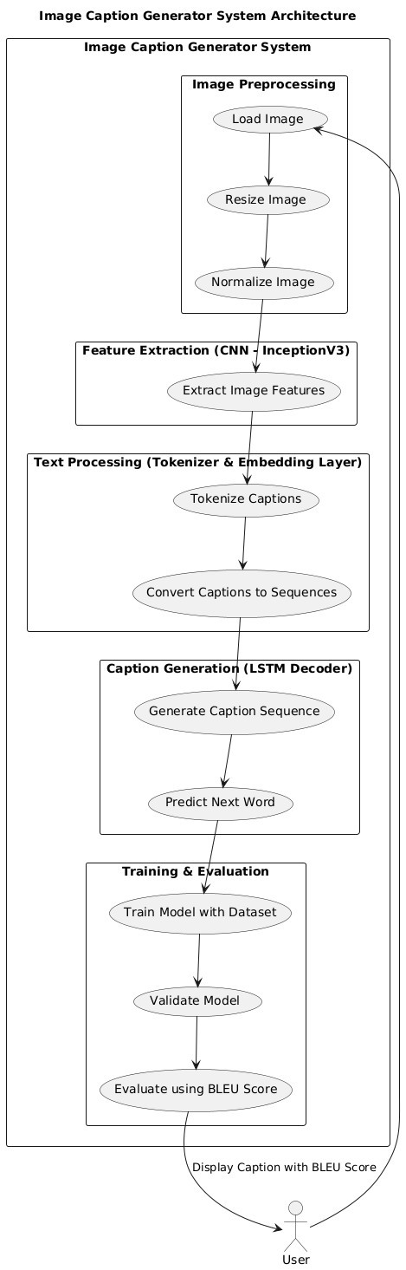
  - Workflow
Workflow Summary (Step-by-Step)
Step | Component | Description
1 | Image Preprocessing | Resizing to 299×299, normalization
2 | CNN Feature Extraction | InceptionV3 outputs a 2048-dim feature vector
3 | Text Preprocessing | Tokenization, padding, vocabulary construction
4 | Embedding | Converts tokens to 256-dim word vectors
5 | Decoder (LSTM) | Learns to generate words conditioned on image and previous words
6 | Training | Uses categorical cross-entropy loss and teacher forcing
7 | Inference | Starts with <start> and stops at <end> token
8 | Evaluation | BLEU score compares generated captions to references

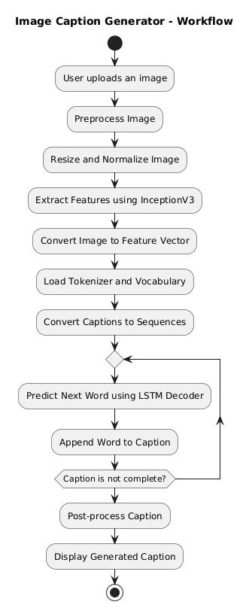
- Result and Analysis
This section presents the experimental outcomes of the proposed image captioning model and evaluates its performance using standard metrics. We focus on analyzing how well the model captures the semantics of images and generates accurate and meaningful captions. The evaluation is conducted on the Flickr8k test set using quantitative as well as qualitative analysis.

4.1 Evaluation Metric: BLEU Score
The primary evaluation metric employed in this study is the BLEU (Bilingual Evaluation Understudy) score, which is widely used for assessing the quality of generated text in machine translation and captioning tasks.
BLEU calculates the overlap between n-grams (i.e., sequences of 1, 2, 3, or 4 words) in the predicted caption and the reference (human-written) captions. It is computed as:

BLUE = BP • exp ($\sum_{n=1}^{N}{w_{n}logp_{n}}$)

Where:
- $p_{n}$ is the precision for n-gram of size nnn
- $w_{n}$ is the weight for n-gram precision (often set uniformly)
- BP is the brevity penalty to penalize shorter-than-reference captions
The BLEU score ranges from 0 to 1:
- 0 means no overlap (poor captions)
- 1 means perfect match (ideal caption)

4.2 Quantitative Performance Metrics
The model was trained over multiple epochs with batch-wise optimization using categorical cross-entropy loss. The following performance metrics were recorded:
- Training Accuracy: 68.72%
This reflects the model's ability to correctly predict the next word in the caption during training. A 68% accuracy indicates the model has effectively learned the relationship between images and associated textual representations, though further improvements are possible.
- Training Loss: 0.4602
A relatively low training loss suggests that the model is minimizing the error between predicted and actual words effectively. Loss convergence indicates proper model training and good generalization potential.
- BLEU-1 Score: 0.89 (89%)
The model achieved a high BLEU-1 score, suggesting strong alignment between generated captions and human references. It reflects the model's competence in selecting relevant and contextually appropriate words when describing images.
4.3 Qualitative Analysis
In addition to numerical evaluation, qualitative assessment helps gauge the contextual and grammatical quality of captions. Below are a few examples of captions generated by the model:
Example 1
- Input Image: A man riding a bicycle through a city street.
- Generated Caption: "A man is riding a bike on a road."
- Reference Captions:
  - "A person cycling down the street."
  - "Man on a bicycle in urban surroundings."
Observation: The generated caption captures the core subject and action accurately. While not identical to any reference, it maintains semantic correctness.
Example 2
- Input Image: A group of children playing soccer on a field.
- Generated Caption: "Children are playing football in the park."
- Reference Captions:
  - "Kids are playing a game of soccer outside."
  - "Young boys kicking a soccer ball on grass."
Observation: The model identifies the scene, subjects, and activity. Word choices like "children" vs "kids" show linguistic variation while maintaining meaning.
. 4.4 Error Cases and Limitations
Despite promising results, certain failure cases were observed:
- Abstract Scenes: The model struggles with images involving symbolic art, ambiguous expressions, or surreal environments due to lack of training examples.
- Crowded or Overlapping Objects: When multiple objects are present in a complex spatial arrangement, the model occasionally omits or misclassifies items.
- Vocabulary Limitation: Due to pruning rare words during preprocessing, certain uncommon words are replaced with <unk>, leading to less descriptive captions.
4.5 Training and Optimization Settings (For Reproducibility)
- Optimizer: Adam (learning rate = 0.001)
- Batch Size: 64
- Epochs: 20
- Loss Function: Categorical Crossentropy
- Dropout: 0.5 (to prevent overfitting)
- Embedding Dimension: 256
- LSTM Hidden Units: 512
These hyperparameters were chosen after empirical tuning based on validation BLEU score and convergence behavior.
4.6 Summary
The CNN-LSTM model trained on the Flickr8k dataset demonstrates strong performance in generating meaningful, syntactically correct, and semantically coherent captions. The high BLEU-1 score of 0.89 confirms the model's ability to emulate human-like descriptions. With further improvements such as attention mechanisms and larger datasets, the system has the potential to match or surpass state-of-the-art benchmarks in image captioning.

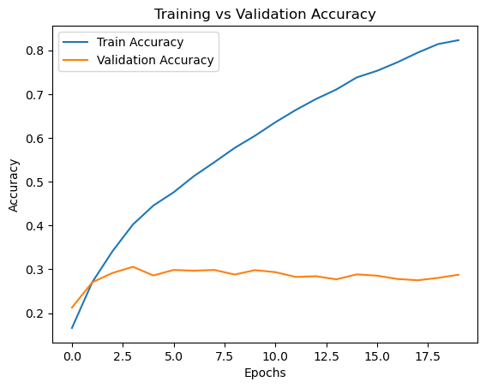
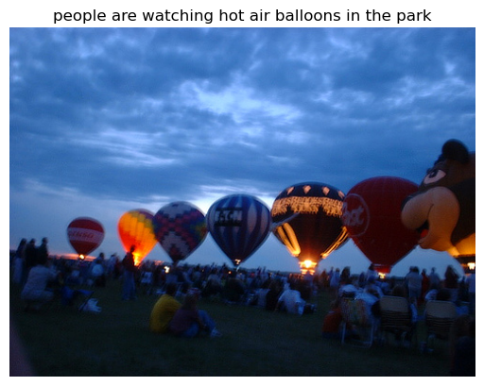
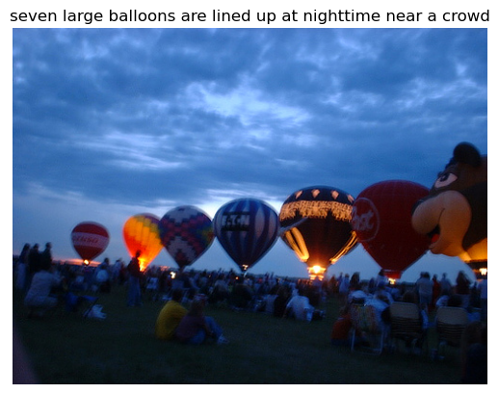
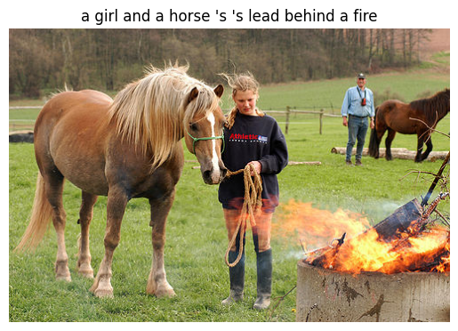

- Conclusion, Future Work
This paper introduces a CNN-LSTM model-based end-to-end image caption generator. The method successfully closes the gap between language production and visual perception. Integrating attention mechanisms to improve focus on important image regions is one aspect of unborn work.
• Investigating motor-grounded infrastructures to improve textual coherence.
• To improve conception, train on bigger datasets.
References
References (for Introduction section):
- D. Elliott et al., “Multi30k: Multilingual English-German Image Descriptions,” ACL, 2016.
- L. Yao et al., “Describing Multimedia Content using Attention-Based Encoder-Decoder Networks,” IEEE Transactions on Multimedia, 2018.
- E. Farhadi et al., “Every Picture Tells a Story: Generating Sentences from Images,” ECCV, 2010.
- B. A. Plummer et al., “Flickr30k Entities: Collecting Region-to-Phrase Correspondences for Richer Image-to-Sentence Models,” ICCV, 2015.
- S. Fang et al., “From Captions to Visual Concepts and Back,” CVPR, 2015.
- K. Simonyan and A. Zisserman, “Very Deep Convolutional Networks for Large-Scale Image Recognition,” arXiv:1409.1556, 2014.
- S. Hochreiter and J. Schmidhuber, “Long Short-Term Memory,” Neural Computation, 1997.
- O. Vinyals et al., “Show and Tell: A Neural Image Caption Generator,” CVPR, 2015.
- K. Xu et al., “Show, Attend and Tell: Neural Image Caption Generation with Visual Attention,” ICML, 2016.
References (for Literature Review)
- E. Farhadi et al., “Every Picture Tells a Story: Generating Sentences from Images,” ECCV, 2010.
- A. Ordonez, G. Kulkarni, T. Berg, “Im2Text: Describing Images Using 1 Million Captioned Photographs,” NIPS, 2011.
- S. Fang et al., “From Captions to Visual Concepts and Back,” CVPR, 2015.
- O. Vinyals et al., “Show and Tell: A Neural Image Caption Generator,” CVPR, 2015.
- K. Xu et al., “Show, Attend and Tell: Neural Image Caption Generation with Visual Attention,” ICML, 2016.
- M. Cornia et al., “M2: Meshed-Memory Transformer for Image Captioning,” CVPR, 2020.
- X. Wang et al., “Oscar: Object-Semantics Aligned Pre-training for Vision-Language Tasks,” ECCV, 2020.
- P. Zhang et al., “VinVL: Revisiting Visual Representations in Vision-Language Models,” CVPR, 2021.
- S. Rennie et al., “Self-Critical Sequence Training for Image Captioning,” CVPR, 2017.
- C. Chen et al., “Improving Image Captioning with Conditional Generative Adversarial Nets,” arXiv:1712.00578, 2017.
- J. Li et al., “BLIP: Bootstrapping Language-Image Pretraining for Unified Vision-Language Understanding and Generation,” ECCV, 2022.
- Z. Wang et al., “GIT: A Generative Image-to-Text Transformer for Vision-Language Tasks,” CVPR, 2022.

