1.Write a C++ Program to implement Method Overriding with shape of rectangale and circle.

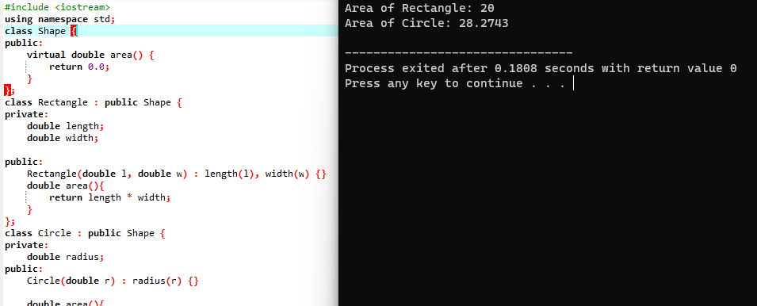

2.Write a C++ Program to implement Friend Function with object and value of x.

