FinSage: AI Smart Expense & Payroll Management System

1. PROBLEM STATEMENT
Startups struggle with:
• Manual payroll calculations causing errors and missed payments
• No real-time visibility into expenses and cash flow
• Difficult categorizing expenses across multiple vendors
• Lack of predictive insights for financial planning
• Time-consuming financial reporting and decision-making
- Result of Problem: Financial chaos, compliance risks, poor resource allocation.
- Approach for the problem:
We focus on smart integration over unnecessary complexity. Instead of rebuilding existing systems, we combine robust services with intelligent automation to deliver a clean, scalable, and user-focused solution — efficiently and within tight timelines.
✅ Delegate heavy lifting to proven services (databases, APIs)
✅ Use AI (Claude API) for intelligent categorization and insights
✅ Focus on clean UI and seamless data flow
✅ Build and deploy in 24 hours.
Key Philosophy: Compose existing tools, don't build from scratch
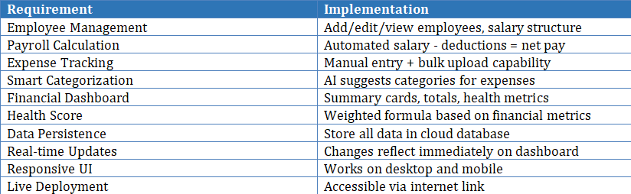
- Core Requirements:

- Tools Required:
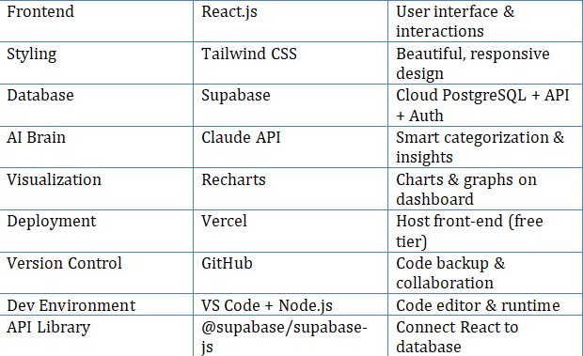

5. TECH STACK SUMMARY
Frontend: React.js + Tailwind CSS
Backend: Supabase (no custom backend code)
Database: PostgreSQL (via Supabase)
AI Layer: Claude API (categorization & insights)
Charts: Recharts
Deployment: Vercel (frontend) + Supabase (backend)

6.Project Flow Architecture:
┌─────────────────────────┐
│ React Frontend UI │ ◄─ Dashboard, Forms, Charts
└────────────┬────────────┘
│ HTTP Requests
▼
┌─────────────────────────────────┐
│ Supabase (PostgreSQL) │ ◄─ Stores Employees, Expenses, Payroll
│ • Real-time database │
│ • Built-in authentication │
│ • Auto-generated REST API │
└────────────┬────────────────────┘
│ Triggered on expense add
▼
┌─────────────────────────────────┐
│ Claude API (AI Layer) │ ◄─ Smart categorization
│ • NLP for categorization │
│ • Anomaly detection │
│ • Financial insights │
└─────────────────────────────────┘

7. FEATURES :
# | Feature | Why Important
1 | Employee Management | Core requirement
2 | Payroll Calculator | Automated calculations
3 | Expense Tracking | Data collection
4 | AI Categorization | Smart feature
5 | Dashboard/Metrics | Visualization
6 | Health Score | AI insight
7 | Live Deployment | Accessible online
8 | Responsive Design | Mobile-friendly

8. MVP (Minimum Viable Product) Scope:

Must-Have Features
- Basic employee and payroll management (salary, deductions, net pay calculation)
- Expense entry and AI-based category suggestion
- Monthly financial summary dashboard with total income, expenses, and net
- Basic anomaly detection for unusual expenses
- Financial health score and basic dashboard.

9. Success Metrics:
- Payroll accuracy: 100% match with manual calculations
- Expense categorization: > 85% accuracy with AI
- Anomaly detection: Precision > 80%, Recall > 60%
- Forecasting accuracy: MAPE < 15% for 3-month prediction
- System uptime: 99%
User satisfaction: Intuitive UI with minimal on-boarding.

10. RISK MITIGATION:
Risk | Impact | Mitigation
Supabase downtime | Low | Use sample data, ready to demo offline
Claude API rate limit | Low | Free tier, sufficient
Deployment issue | Medium | Manual app still works locally
Time overrun | Low | MVP features done by hour 8

Conclusion
This AI Smart Expense & Payroll Management System addresses a critical pain point for startups by automating financial operations and providing intelligent insights. By combining robust payroll calculations, intelligent expense categorization, and predictive analysis, the system enables founders to make data-driven financial decisions and maintain better control over company finances. The phased implementation approach ensures a solid MVP can be delivered within the given timeline while laying the groundwork for advanced features.

Prepared By :
Team Name : WEB SCRAPERS
Team ID: 11012
Members:
- Aashish Kumar Sahoo- 12505467
- Aaditya Kumar- 12526487
- Bhojraj Sahu- 12517589
- Ashutosh Raj- 12520146

