

**CRM Laptop-Rental-Management-System Submitted By-Aashish Raj**

**Email:**[**aashish.raj.21@gmail.com**](mailto:aashish.raj.21@gmail.com)

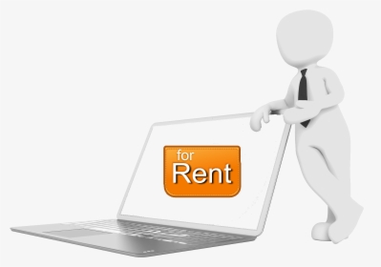

# A CRM Application of Laptop Rentals

# Project Overview

To develop a robust **Customer Relationship Management (CRM)** applicationspecifically designed for businesses offering laptop rental services. The applicationwill streamline operations, improve customer service, and enhancethe managementof rental processes.

## Purpose of the CRM Application for Laptop Rentals

The primary purpose of developing a CRM application for laptop rentals is to streamline and optimise the rental process while enhancing the customer experience. This application is tailored to address the specific needsof laptop rental businesses by providing centralised tools for customer management, inventory tracking, and operational efficiency.Some of the key purposesofthis application are provided below:

**Eﬃcient Rental Management:** Automates the rental process by streamliningbooking,invoicing, and tracking, reducing manual errors and saving time on routinetasks.

**Enhanced CustomerExperience:** Provides personalised support and easy accesstolaptop availability, specifications, and reservations, ensuring a smoothand

user-friendly experience.

**Data-Driven Decision Making:** Generates reports and analyses trends to optimiserentals,improve inventory management, and tailor services to customer preferences. **Operational Transparency:**Ensures clearaccess controls, maintains detailed transaction records, and promotesaccountability across all operations.

**Increased RevenuePotential:** Enhances revenue throughdynamic pricing, upselling,promotions, and customer retention strategies like loyalty programs.

# Key Features

### Customer Management:

This feature enablesthe storage and management of detailed customerinformation,including contact details,rental history, and preferences. It ensures businesses canoffer personalised services and maintainbetter relationships with customers.

### Laptop Inventory Management:

This feature tracks the status, availability, and conditionof each laptop in the

inventory. It includes specifications, rental rates, and maintenance history,helping businesses manage their stock efficientlyand prevent overbooking.

### Order and Rental Management:

Simplifies the entirerental process, from bookinga laptop to generating rentalagreements and invoices. The system automatically updates the inventoryandsends remindersfor overdue rentals,ensuring smooth operations.

### 4 .Reporting and Analytics:

Provides the ability to generate reports and analyse rental trends, revenue, andinventory usage. This featurehelps businesses identify patterns,make informeddecisions, and optimise operations to boost profitability.

### 5. Communication Tools:

Automates communication with customers throughemail and SMS notifications forbooking confirmations, rental reminders, and promotional offers. This feature enhancescustomer engagement and ensures timelyupdates.

# Objectives

The objective of this project is to create a comprehensive CRM application specifically designedfor businesses that offer laptoprental services.The goal is to streamline and automate the rental process, improve customer relationship management and increase the efficiency for the organisation.

**AutomatingRental Processes:** Simplifying and automating booking, invoicing,inventory management, and rental trackingto reduce manualwork and errors.

**Enhancing** **Customer Experience:** Providing personalised servicesand easyaccessto rental information, improving customer satisfaction and retention.

**Improving Revenue and Business Insights:** Leveraging reporting tools and analytics to optimise pricing,identify trends, and make data-driven decisions that increase profitability.

**Effective Communication:** Integrate automated communication tools to send timelyemail and SMS notifications for booking confirmations, rental reminders, and promotions, ensuringcontinuous customer engagement and enhancing communication betweenthe business and its customers.

# Benefits of this Application

### Time and Cost Savings:

|  |  |
| --- | --- |
|  |  |
|  |  |

Automating repetitive tasks such as order management, inventory updates, and payment processing helps businesses save time and reduce operational costs. Thisleads to betterresource allocation and optimised workflows.

### Seamless Customer Management:

|  |  |
| --- | --- |
|  |  |
|  |  |

The CRMsystem centralised customer data, allowing businesses to

trackrentalhistory, preferences, and interactions. This enables more targeted marketing, better customer support, and personalised offersthat enhance customerloyalty.

### Enhanced Reporting and Analytics:

|  |  |
| --- | --- |
|  |  |
|  |  |

The ability to generate detailed reports on rental usage, customer trends, and financialperformance helps businesses identify areas for improvement, optimisepricing strategies, and make more informed decisions about inventory and promotions.

### Reduced Risk of Errors:

|  |  |
| --- | --- |
|  |  |
|  |  |

By minimising manual input, the system reducesthe chances of human errorin taskslike invoicing, payment processing, and inventory tracking, which ensuresgreater accuracy in financial and operational data.

# Example Workflow

### Customer Registration & Booking:

|  |  |
| --- | --- |
|  |  |
|  |  |

Customers create an account, browseavailable laptops, selecta model, and bookthe rental online.

### Payment & OrderConfirmation:

|  |  |
| --- | --- |
|  |  |
|  |  |

The customer confirmsthe rental, makesa secure payment,and receives an orderconfirmation and invoice.

### Inventory Management & Assignment:

|  |  |
| --- | --- |
|  |  |
|  |  |

The system updates laptop availability, and staff assigns the rented laptopfordelivery or pickup.

### Rental Monitoring & Notifications:

|  |  |
| --- | --- |
|  |  |
|  |  |

Automated reminders are sent for rental periodend, with optionsfor extension or return.

### Laptop Return& Feedback:

|  |  |
| --- | --- |
|  |  |
|  |  |

The customer returnsthe laptop, inventory is updated, and feedback is collected forimproved service.

# Summary

The CRMapplication for laptop rentalsstreamlines the rentalprocess by enabling customersto easilybrowse, book, and pay for laptopsonline.It automates inventory management, updatesavailability, and notifies customers about rentalperiods. After the rental,the system handles laptop returns, updates inventory, and collects customerfeedback to enhanceservice

## 

## 

## 

## 

## 

## 

## 

## 

## Salesforce Key Features and Concepts Utilised

1. **Customer Relationship Management(CRM):** Centralised customer data, including contact information, purchase history,andinteractions, to enhanceservice and buildstronger relationships.

### Sales Cloud:

Automates sales processessuch as lead generation, opportunity management, and pipelinetracking, improving efficiency and conversion rates.

### Service Cloud:

Provides tools for managing customer support, including case tracking,knowledge bases, and omnichannel communication.

### Marketing Cloud:

Enables personalised marketing campaigns through email, socialmedia, andanalytics, ensuring targeted customerengagement.

### Einstein Analytics:

Leverages AI-powered insightsfor predictive analytics, helping businesses make data-driven decisions and optimiseperformance.

### Custom Object and App Development:

Supports the creation of custom objects and workflows tailoredto uniquebusiness needs,ensuring flexibility and scalability.

### Process Automation:

Automates repetitive tasks with tools like Process Builder, Flow, and Apextriggers, enhancing productivity and reducingerrors.

### Reports and Dashboards:

Provides real-time visualisations of data to monitor performance, track KPIs,and identify trends.

### Collaboration Tools(Chatter):

Enhances team collaboration by allowing users to communicate, share files,and update projectstatuses within the platform.

### Integration Capabilities:

Integrates seamlessly with third-party apps and systems,including ERP, payment gateways, and email services, ensuring a unifiedworkflow.

### Role-Based Access Control:

Manages user permissions and data visibility based on roles,ensuringsecurity and compliance.

## Detailed Steps to Solution Designin Salesforce

### Requirements Gathering and Analysis

**Objective:** Understand the business needs and challenges.Identifykey use cases,workflows, and pain points.

Document functional and non-functional requirements. Prioritiserequirements based on business impact and feasibility.

### Design Data Model

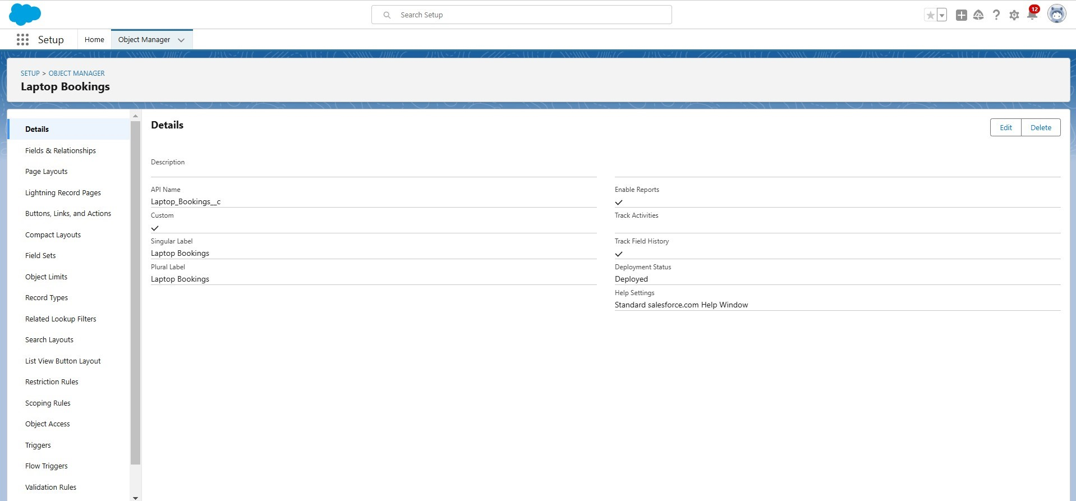

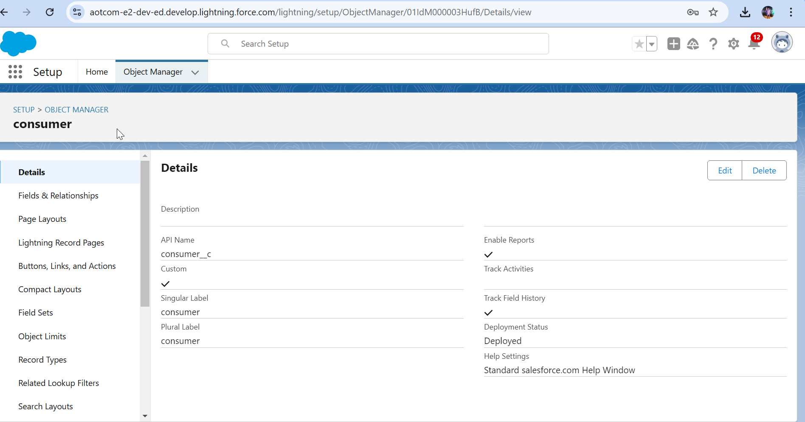

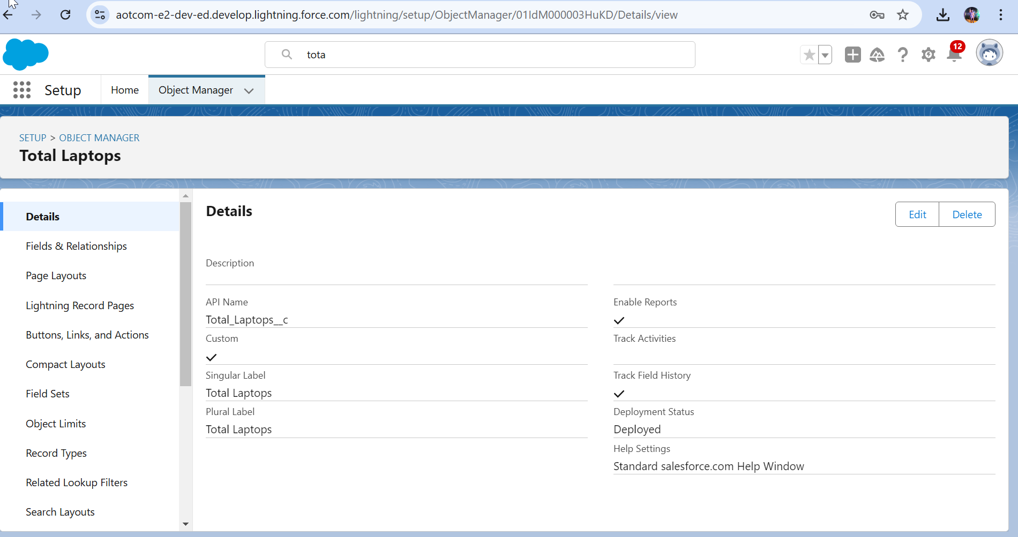

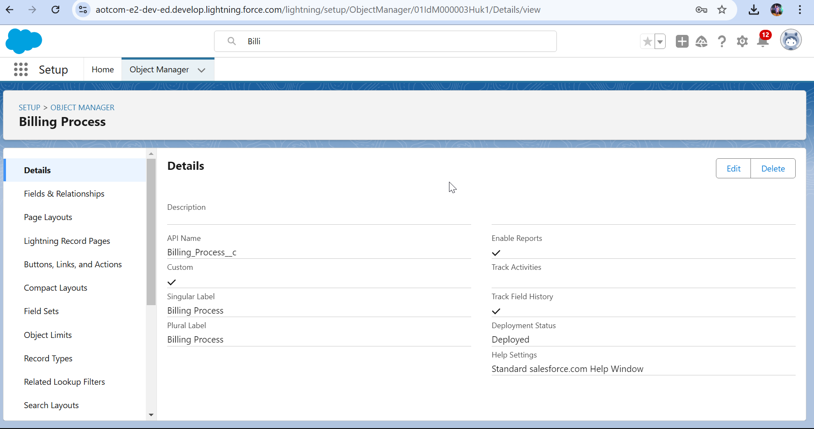

**Objective:** Define how data will be stored, organized, and related.

**Steps:**

* 1. Identify standard Salesforce objects to use (e.g., Total Laptops, consumer,LaptopBookings, Billing Process).
  2. Create custom objects for specific businessneeds.
  3. Establish relationships betweenobjects (e.g.,master-detail, lookup).
  4. Define field-level detailssuch as field types, picklists, and validation rules.

|  |  |
| --- | --- |
|  |  |
|  |  |

### User Interface Design

Using tabs in a User Interface(UI) is a common design approach to organize and displayinformation efficiently. Tabs allow users to navigate between different sections or functionalities without leaving the current page, ensuring a clean and user-friendly experience.

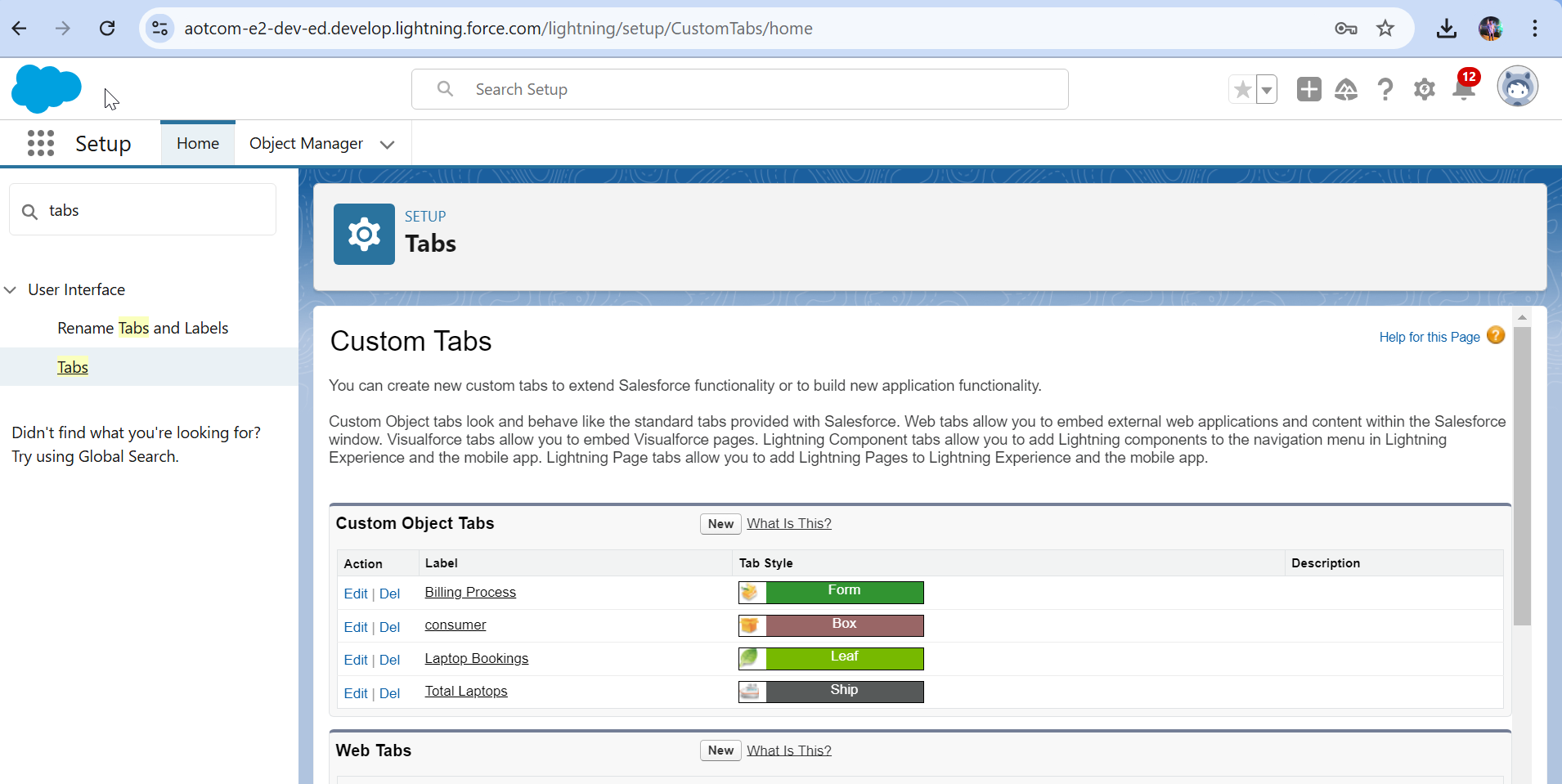

### Flow Design

When designing a Flow in Salesforce, it’s important to ensure it is efficient,scalable,and user-friendly.

## Flow BuilderLayout

1. **Start Element:**

Define the Flow trigger(e.g., button click,record change, or schedule).

### Decisions:

Add conditional logic to branch the Flow based on criteria(e.g., laptop availability).

### Assignments:

Set or update variables to store or calculate data dynamically.

### Loops:

Iterate over collections of data

### Actions:

Invoke externalsystems, send emails,or run custom Apex actions.

### Record Elements:

Perform database operations like creating, reading,updating, or deletingrecords.

This structuredapproachensuresalogicalanduser-friendlyFlowdesign.

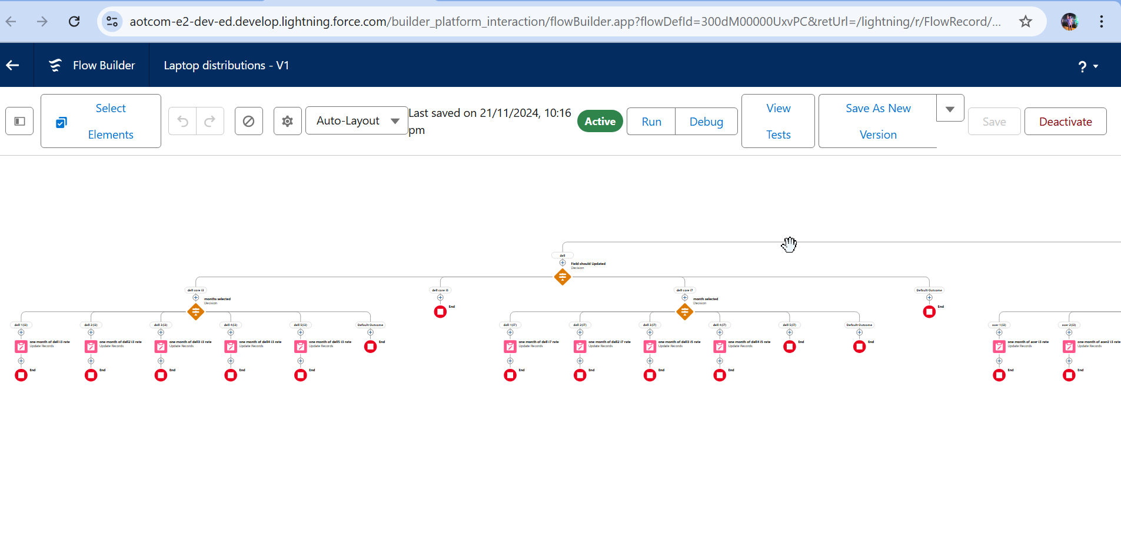

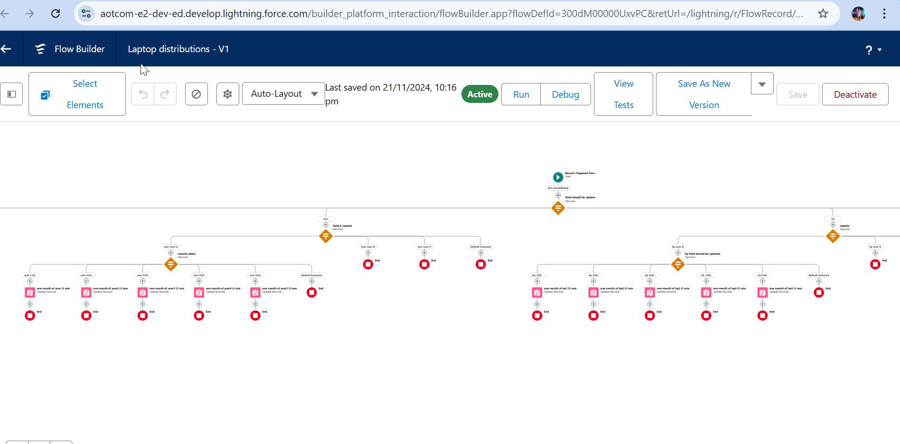

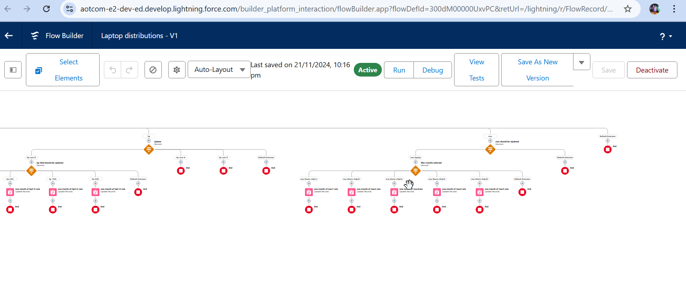

|  |  |
| --- | --- |
|  |  |
|  |  |

### Validation Rule For Phone Number Field in CustomerObject

The validation rule checks if the phone number enteredin the Consumer object follows the required format using regular expressions. It ensures that only valid phone numbersare stored, improvingdata consistency and user experience.

## Reports and Dashboards

In Salesforce, **Reports** and **Dashboards** are essential tools for data analysis and visualisation. **Reports** allowusers to displayand organise data from Salesforce, with types including **Tabular**, **Summary**, **Matrix**, and **Joined Reports**. These reports can be customised using filters, grouping, summaries, and charts to provide meaningfulinsights. They help users track key business data such as customer activity,sales, and inventory, facilitating better decision-making.

On the otherhand, **Dashboards** provide a visual representation of the data from reports, offeringa high-level view of key metricsthrough components like charts, tables, gauges, and metrics. Dashboards can be customised with filters to show real-timeinsights and help monitor business performance. They allow users to quickly understand trends, track progress towardgoals, and make informed

decisions. Together, reportsand dashboards are powerfultools for managingandvisualising data, improving operational efficiency, and fostering data-driven collaboration within teams.

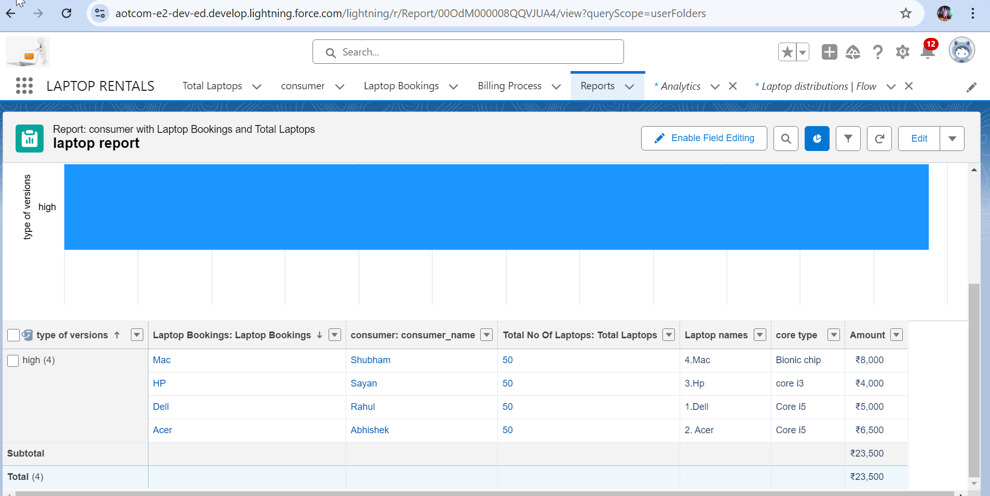

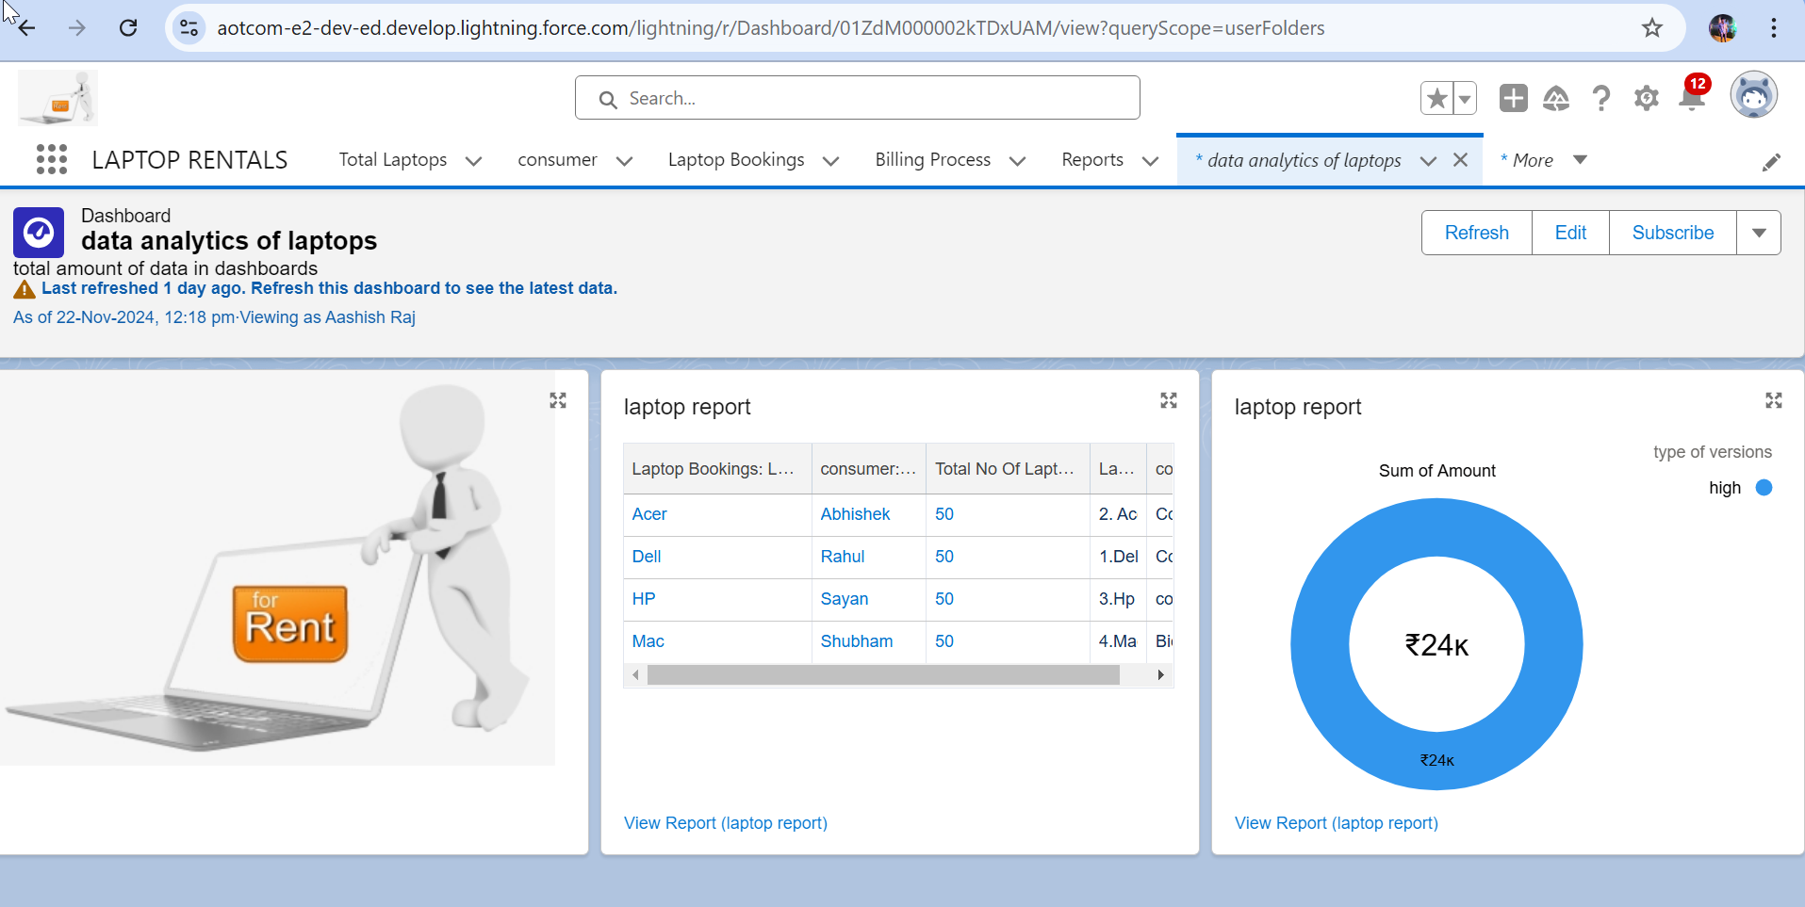

|  |  |
| --- | --- |
|  |  |
|  |  |

# Conclusion

The **Laptop Rental CRM Application** is a centralised platform designed to streamline the laptoprental process for both customers and administrators. Built with Salesforce, it leverages core CRM featuresand automation tools to manage

inventory, track rentals, enhance customer communication, and optimise operations. The system enablesusers to performkey functions such as booking laptops, tracking rentaldurations, and generating reports.

Administrators can efficiently handle inventory updates,approve requests, and send notifications. Customersbenefit from a seamless booking experience, guided workflows, and timely reminders.

This project integratesuser-friendly UI componentslike tab navigation and

interactive forms, coupled with powerful backend automation using Flows, ensuring a smooth, error-free process. Additionally, it fosters effective communication throughintegrated email and notification tools.

The application ultimately aims to enhance customer satisfaction, improve operational efficiency, and provide real-timeinsights for better decision-making in laptop rental management.