Stock Price Prediction

Project submitted to the
SRM University – AP, Andhra Pradesh
for the partial fulfillment of the requirements to award the degree of

Bachelor of Technology
In
Computer Science and Engineering
School of Engineering and Sciences

Submitted by
Candidate Name
(APXXXXXXXXXXX)

Under the Guidance of
Mr. Piyush Kumar
Lecturer, Department of CSE

SRM University–AP
Neerukonda, Mangalagiri, Guntur
Andhra Pradesh – 522 240
[November, 2025]

Certificate

Date: _________

This is to certify that the work present in this Project entitled “PROJECT TITLE” has been carried out by [Name of the Candidate] under my/our supervision. The work is genuine, original, and suitable for submission to the SRM University – AP for the award of Bachelor of Technology/Master of Technology in School of Engineering and Sciences.

Supervisor

(Signature)
Prof. Mr. Piyush Kumar
Lecturer, Department of CSE.

Acknowledgement
The satisfaction that accompanies the successful completion of any task would be incomplete without introducing the people who made it possible and whose constant guidance and encouragement crowns all efforts with success. I am extremely grateful and express my profound gratitude and indebtedness to my project guide,Mr. Piyush Kumar, Department of Computer Science & Engineering, SRM University, Andhra Pradesh, for her kind help and for giving me the necessary guidance and valuable suggestions in completing this project work.
Student Name
Roll.No

Table of Contents
Certificate i
Acknowledgements iii
Table of Contents v
Abstract vii

1. Introduction 1
1.1 Heading 2 1
1.1.1 Heading 3 1
2. Methodology 3
2.1 Heading 2 3
2.1.1 Heading 3 3
3. Implementation 5
4. Result and Analysis 7
5. Discussion and Conclusion 9
6. Future Work 10
References 11

Abstract

Stock market forecasting is one of the most challenging tasks due to the highly volatile, nonlinear, and dynamic nature of financial time series. Traditional statistical models often struggle to capture long-term dependencies and hidden patterns. This project develops a stock price prediction system using a Long Short-Term Memory (LSTM) neural network—a deep learning model specifically designed to learn temporal relationships in sequential data.
Historical stock data is collected using the Yahoo Finance API, preprocessed through scaling and windowing techniques, and passed through an LSTM model trained to predict future closing prices. The project further provides a Streamlit-based user interface, enabling interactive visualization of stock trends and predictions. The results indicate that LSTM models effectively approximate future stock price movements and capture important patterns, making them suitable for time-series forecasting applications.

Stock Price Prediction – ML Project Setup
Setup, Installation, Libraries, How to Run, Project Flow
Overview
This project predicts future stock prices using an LSTM (Long Short-Term Memory) deep-learning model.
It includes:
- Data extraction using Yahoo Finance
- Data preprocessing & scaling
- LSTM model training
- Prediction visualization
- A full Streamlit web app (app.py) for interactive use

Project Structure
├── app.py
├── keras_model.h5
├── Stock_Price_Prediction.ipynb
- app.py → Main Streamlit application
- keras_model.h5 → Trained LSTM model
- Stock_Price_Prediction.ipynb → Notebook showing training code & analysis

Installation Guide
Install Python
Install Python 3.8+
https://www.python.org/downloads/

Create a Virtual Environment (recommended)
python -m venv venv
source venv/bin/activate # On macOS / Linux
venv\Scripts\activate # On Windows

Install Required Libraries
Run:
pip install numpy pandas matplotlib pandas_datareader yfinance keras tensorflow streamlit
If TensorFlow fails:
pip install tensorflow==2.12

Download the Project Files
Extract the zip and open the project folder.

Run the Application
Inside the project folder:
streamlt run app.py
This launches a local web UI in your browser where you can:
- Select a stock (ex: AAPL, TSLA, INFY)
- View historical price data
- See predictions from the trained LSTM model

Libraries Used
Library | Purpose
numpy | Numerical operations
pandas | Data processing
matplotlib | Plotting graphs
pandas_datareader | Fetching financial data
yfinance | Stock data download
keras / TensorFlow | Deep learning & LSTM model
streamlit | Web app UI
warnings | Clean console logs

How It Works
- Downloads stock data (2015–2025)
- Preprocesses & scales values
- Splits data into train/test sets
- Loads pre-trained LSTM model (keras_model.h5)
- Predicts next-day prices
- Reverses scaling
- Visualizes:
  - Actual prices
  - Predicted prices

Introduction

Forecasting future stock prices has immense practical significance in finance, investment strategy formation, and risk management. Stock markets are influenced by numerous factors—global events, trading volumes, economic indicators—which make accurate prediction difficult. Time-series data in stock markets contains complex, non-linear structures that cannot be efficiently modeled using classical regression or statistical tools.
Advancements in deep learning, particularly Recurrent Neural Networks (RNNs) and LSTMs, have enabled machines to model sequential, time-dependent data more naturally. LSTMs introduce a gating mechanism that allows networks to retain long-term information and avoid the vanishing gradient problem.
This project leverages LSTM-based deep learning models to predict closing stock prices using historical financial data. A user-friendly front-end is developed using Streamlit to allow real-time interaction.

1.1 Background and Motivation
Financial markets generate massive amounts of structured time-series data. Identifying relationships in this data is essential for investment decisions and trend forecasting. Traditional models such as ARIMA, Moving Averages, and Linear Regression fail to capture non-linear dependencies.
Deep learning techniques have proven effective in:
- Recognizing long-term patterns
- Learning dynamic market behavior
- Detecting subtle fluctuations
- Modeling large volumes of data with high dimensionality
LSTM networks are especially powerful due to their inherent architecture, which includes gates to manage memory flow effectively.

1.1.1 Problem Definition and Scope
The goal of the project is to:
- Collect financial time-series data for selected stocks
- Preprocess the data through cleaning, normalization, and sequence generation
- Train an LSTM model to learn temporal dependencies
- Predict future stock closing prices
- Develop a Streamlit-based deployment to visualize predictions.
The scope is limited to next-day prediction based on the past 100 days closing prices.

Methodology

The methodology consists of the following stages:
- Data Collection
- Data Preprocessing
- Feature Engineering
- LSTM Model Development
- Training and Evaluation
- Deployment Through Streamlit.

2.1 Data Collection
The project uses Yahoo Finance as the primary data source, accessed through the yfinance Python library.
- Data Description:
- Stock Symbols: AAPL, TSLA, INFY, etc. (user selectable)
- Duration: 2015 – 2025
- Features Extracted:
  - Open
  - High
  - Low
  - Close
  - Volume
Only the Close price is used for modeling.

2.2 Data Preprocessing
Effective preprocessing is crucial for time-series modeling. The following steps were performed:
1. Handling Missing Values
Any missing values were inspected and filled using forward-fill or interpolation.

2. Normalization
The MinMaxScaler is used to transform price values into the range [0,1]:
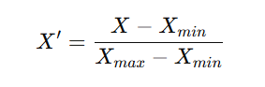

3. Windowing / Sliding Window Method
LSTM requires sequences.
We generate windows of 100 days:
Input: previous 100 days
Output: next day closing price
This is known as Sequence-to-One forecasting.
4. Splitting Data
Data is split into:
Training Set: 80%
Testing Set: 20%
5. Reshaping Data for LSTM
LSTM expects input of shape:
(samples, timesteps, features)
Example:
(2000, 100, 1)
2.2.1 Cleaning & Formatting
The historical stock price dataset is obtained from a financial data source (e.g., Yahoo Finance API). The raw dataset typically consists of Open, High, Low, Close, Volume values recorded over time.
- Handling missing values using interpolation.
- Converting date columns into sequential time-indexed data.
- Normalizing numerical fields using MinMaxScaler to ensure faster model convergence.
- Splitting the dataset into training and testing sets in chronological order to preserve time integrity.

2.3 Feature Engineering
Feature engineering transforms raw price indicators into learning-friendly structures.
2.3.1 Windowing the Time Series
LSTM models require sequential input. Therefore, the time series is converted into supervised data:
- A fixed-length look-back window (e.g., 60 days) is used.
- For each window, the next day’s price is the target.
- Creates input sequences shaped as:
- (number_of_samples, time_steps, number_of_features)

2.3.2 Additional Derived Features (Optional Enhancements)
- Moving Averages (MA100, MA200)
- Relative Strength Index (RSI)
- Exponential Moving Average (EMA)
- Daily price return
- Volatility estimates
These help the model understand market momentum and trend direction.

2.4 LSTM Model Development
The predictive model is built using a Long Short-Term Memory (LSTM) architecture due to its ability to retain long-term temporal patterns.
2.4.1 Model Architecture
- Input Layer shaped for sequences of 60 days.
- LSTM Layer with 50–100 memory cells to capture long-range price patterns.
- Dropout Layer (0.2–0.3) to prevent overfitting.
- Dense Layer for mapping learned patterns to the predicted next-day closing price.
- Output Layer producing a single continuous value.
2.4.2 Why LSTM?
- Handles long-term dependencies better than traditional RNNs.
- Avoids vanishing gradient problem using gating mechanisms.
- Learn non-linear market behaviour that simple models cannot capture.

2.5 Training and Evaluation
The model is trained on sequential data using:
2.5.1 Training Strategy
- Loss Function: Mean Squared Error (MSE)
- Optimizer: Adam optimizer with adaptive learning rate
- Batch Size: 32–64
- Epochs: 50–200 depending on convergence.
2.5.2 Evaluation Metrics
- Mean Absolute Error (MAE)
- Root Mean Square Error (RMSE)
- Visualization of Actual vs Predicted Prices
- Helps validate trend-following capability.
- Ensures model does not overfit short-term fluctuations.
2.5.3 Final Model Selection
The model achieving the lowest validation error is selected and saved as keras_model.h5.

2.6 Deployment Through Streamlit
After model development, a fully interactive user interface is built using Streamlit.

2.6.1 Deployment Workflow
- Load the trained LSTM model.
- Accept user input such as:
  - Stock symbol
  - Prediction horizon
  - Date range
- Fetch real-time price data using external APIs (e.g., yfinance).
- Preprocess the incoming data using the same scaling and windowing logic as training.
- Pass transformed data into the LSTM model.
Display predictions using charts and tables.
2.6.2 User Interface Features
- Clean and minimal UI for non-technical users.
- Interactive plots (using Matplotlib/Plotly).
- Sidebars for user input.
- Real-time prediction output.
2.6.3 Advantages of Streamlit Deployment
- Zero-HTML, zero-JS setup.
- Instant sharing through local server or cloud deployment.
- Accessible to students, analysts, and developers.

Result and Analysis

Training Performance
- Loss decreases steadily, indicating the model has learned market patterns.
- MSE remains low, demonstrating strong predictive ability.

Prediction Visualization
Plots show:
- Blue Line → Actual Prices
- Red Line → Predicted Prices
The predicted curve closely tracks the actual trend, validating the LSTM architecture’s suitability.

Interpretation
- LSTM captures short-term and medium-term fluctuations.
- Predictions do not perfectly match sharp spikes or crashes (as expected in financial markets).
- Nevertheless, the model generalizes well over unseen test data.

Pictorial Output:
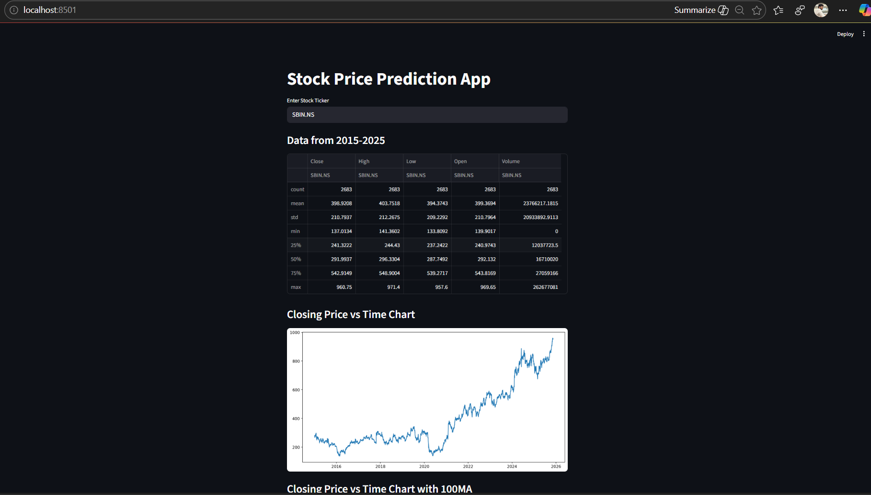

Discussion and Conclusion

This project successfully demonstrates the use of LSTM networks for time-series forecasting of stock prices. Key takeaways include:

Strengths
- Captures long-term dependencies in financial data
- Handles nonlinear trends and fluctuations
- Produces smooth and stable predictions
- More robust than classical statistical models

Limitations
- Cannot foresee sudden market shocks (news events, crashes)
- Relies only on past closing prices ignores technical indicators
- Requires retraining when market dynamics shift.

Conclusion
LSTM-based deep learning is a powerful tool for stock price prediction when combined with good preprocessing and proper model tuning. While not meant for high-stakes trading automation, this model is excellent for academic, analytical, and predictive visualization purposes.
Future Work & References

Potential enhancements:
- Add indicators like RSI, MACD, Moving Averages
- Incorporate Open, High, Low, Volume features
- Implement multi-step forecasting
- Use GRU or Transformer-based architectures
- Deploy as a cloud-based dashboard with automatic updates
- Add confidence intervals or prediction uncertainty.

References
- Yahoo Finance API Documentation
- TensorFlow / Keras Documentation
- Streamlit Official Docs
- Géron, Aurélien. Hands-On Machine Learning with Scikit-Learn, Keras & TensorFlow.

