Mini Project Report on

Vehicle Number Plate Detection and Recognition using Python

Submitted in partial fulfillment of the requirement for the award of the degree of

BACHELOROFTECHNOLOGYI
and
COMPUTERSCIENCE&ENGINEERING

Submitted By:

StudentName:Aashish Subedi
UniversityRollNo:
2118052


DepartmentofComputerScienceandEngineering

GraphicEra(Hill University)

Dehradun,Uttarakhand

January2023

CANDIDATE’SDECLARATION

I hereby certify that the work which is being presented in the project report entitled“Vehicle

NumberPlateDetectionandRecognitioninPython”in partial fulfillment of the

requirements for the award of the Degree of Bachelor of Technology in Computer Science

and Engineeringof the Graphic Era (Hill University), Dehradun shall be carried

out by the under the mentorship of ________________________________,AssistantProfessor,

Department of Computer Science and Engineering, Graphic Era (Deemed to be University),

Dehradun.

Name:Aashish Subedi
UniversityRollNo. Signature2118052

2

TableofContents

ChapterNo.

Chapter 1.

Chapter 2.

Chapter 3.

Chapter 4.

Chapter 5.

Chapter 6.
Description

Introduction

Literature Survey

Methodology

Result and Discussion

Conclusion and Future Works

References
PageNo.

4-5

6-7

8-12

13

14

15

3

Chapter1

Introduction

Vehicle NumberPlateRecognitionSystemUsingTESSERACT-OCR

Abstract:With theincreaseinthenumber of vehicles,automatedsystemstostorevehicle

informationare becomingincreasinglynecessary. Communicationis criticalfortraffic

managementandcrimereduction,and itcannotbeoverlooked.Automaticvehicle

identificationusingnumberplate recognitionis areliablemethod ofidentifyingvehicles.It

requires alengthytimeandalot ofpracticetodevelopsatisfactoryresultsusingpresent

algorithms thatarebasedon theideaof learning.Evenso,accuracy isnota significant

concern.

•Ithasbeendevisedasanefficientapproachforrecognizingvehiclenumberplates,which

isincludedinthesuggestedalgorithm.Thetechniqueisintendedtoaddressthedifficulties

ofscalingandrecognitionofthepositionofcharactersaslongasthe accuracyis

maintained.AutomaticNumberPlateDetectionisauniqueapplicationinMachine

Learningas it detects imagesand convertsthemto textform.

•Thealgorithmdetectsandcapturesthevehicleimageandextractsthevehiclenumber

plateusingimagesegmentation.Theextractedimageislatersenttoopticalcharacter

recognitiontechnologyforcharacterrecognition.Thissystemisimplementedinareaslike

trafficsurveillance,militaryzones,apartments,etc.

•Keywords:OpticalCharacterRecognition,tesseractOCR,matplotlib,NumberPlate

Recognition.

4

The rapid increaseinthenumberofautomobilesontheroadbegan inthe late1900s.Due

tothehigh numberofvehiclesontheroad,license plateidentificationhas becomea time-

consumingoperation, astheinformationreceivedfromlicenseplatesis largelyusedin

traffic monitoring,parking, border monitoring,law enforcement,and otherapplications,

amongotherthings.Thisrecognitionchallengecanbedividedinto five steps,eachof

whichisdiscussedbelow.

Picturerecognition,imagepreprocessing,licenseplatelocalization,charactersegmentation,

andopticalcharacterrecognition. Theprocessof capturingan imageofalicensefrom a

vehicleimageiscalledimagerecognition.Theprocessofbrightening,normalizing,and

modifying apictureis calledimagepreprocessing.Theprocessof finding and recognizing

symbolsin a picture iscalled imagesegmentation.

AndthetechnologyusedforimagetotextconversionisOCR.Wheretrafficnormsand

standardsdifferfromonecountrytothe

next,eachcountryhasitsownsetof guidelines tofollow.In turn,this results inthe

algorithmbeingtuned to aspecificregion.Forexample, there are 12different typesof

fonts that canbeused onIndianlicenseplates, andthere areeven moreoptionsforlicense

platesfromother nations. ThegeneralstructureofanIndianlicenseplateconsistsoftwo

lettersforthestatecode,threelettersforthedistrictcode,and fourdigitsforthevehicle

code. In contrast,incountriessuchastheUnitedStatesofAmerica,there isnostandard

whenitcomestofonts,andtheyaredesigned witha greatdealofvariationinthecontrast

between text andbackground. Incases where thenumberplate and thebackground are

nearlyidentical,it isdifficulttodetermine thelocation,andvariationsinthebrightness and

contrastofthe imagealsoresultininaccurateresults. The use ofmorphologicaltechniques

helps toget the rightinformationandget accurateresults.

Thework isbrokenintonumeroussections,which areasfollows:

1. Rawimageshould beusedasinput.


2. Imagebinarizationistheprocessofdividinganimageinto twohalves.

3. Using themid-filteringmethod,you mayreducenoise.

4. Thehistogramequalizercanbe usedtoimprovecontrast. 5 5.Localizationofthe plate Segmentationofcharacters

Chapter2

LiteratureSurvey

•Vehicledetectionhasbecomeanintegralpartofthedigitalworldforfindingthepenalties

ofthevehicle.Acollectionofstudieshavebeenperformedtoclassifythevehiclessuchas

bicycles,trucks,cars,etc.TheOpticalCharacterRecognition(OCR)technique was

employed,whichisapopularutilizedmechanismthatconvertsscannedpicturesof

handwrittenorprintedtextintomachineencodedtextandisacommonlyusedtechnology.It

issuggestedheretoemployafeed-forwardneuralnetworktoperformopticalcharacter

recognition.Twouniqueactualimagedatasetsofthecharactersareoftenusedfor testingand

trainingtheclaimedneuralnetwork.Atotaloftwouniquepicturedata-setswereemployed

tosimulateouter-world circumstancesthattheneuralnetworkwillbeexposedtothroughout

thetestingphase.ArtificialNeuralNetworks(ANNs)areatypeofintelligentcomputer

architecturethatiscommonlyemployedinpatternrecognitionapplications.Themultilayer

feed-forwardneuralnetworkisthemostoftenusedartificialneuralnetwork(ANN),and

containsthefundamentalinternaldesignthatcansortoutthegiveninputstoalistofgoal

categories.Toorganizetheinputsofneuralnetworks,thetasksperformedinandtypically

useFeatureextractionandBinarypixel;

•Theprioristheregularlyexecutedmethodforneuralnetworksandresultsinaccurate

performanceeveninthetoughconditions;thelatteristhelatestmethodforneuralnetworks

andaccomplishagreatresultsinthearduousenvironments.Although,featureextractionis

typicallyatime-consumingprocessthatrequiresextensivecomputingornumerousphasesto

complete.

6

•Similarapproachesareavailablethatemploy additionalprocessesinthetrainingphaseor

laterreceivingtheoutcomesofaneuralnetworkin orderto dealwithtoughcharactersthat

aremembersof ambiguous charactersets, andthesemethods arealsoavailable.Specifically,

forConfusingcharacters(forexample,I/1,B/8andO/D),additionaltrainingis employed.In

addition,thecomparisonof distinctsections ofambiguouscharactersisconductedin. Single

stageclassifiersand multistageclassifiersaretwotypesofstatisticalclassifiersthatmaybe

distinguished.Charactercharacteristicsarerecoveredfromtheelasticmeshinthework, and

thefulladdresscharacterstringis usedasthe targetofinvestigation.TheSVM(Support

VendorMachine)program wastestedonJapanesevehiclenumberplates, and theattributes

todetectKana(Japanesescript),numbers,and thegroupofcharactersthatdescribe thearea

wereused to traintheSVMintegration.The identificationpercentagesforstrings of

characters,numerals,Kana,andare97.8percent,99.5percent,98.6 percent,respectively,

accordingto theresults. Atwo-stagehybridopticalcharacterrecognitionsystemis

introducedwiththegoal ofimproving therecognitionrate.

7

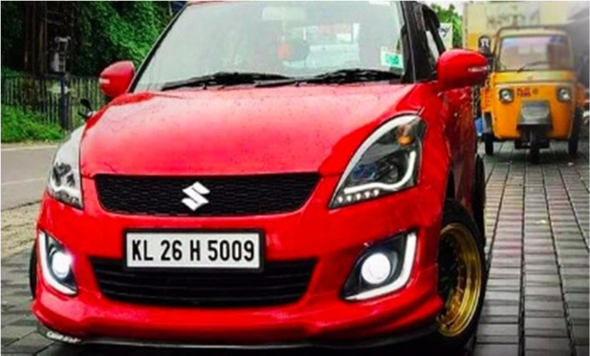
Chapter3

Methodology

PROCESSOFANPR

3.1ImageAcquisition

Inputimage captured through camera.

Fig.1CapturedImage

3.2ImagePre-Processing

3.2.1RGBToGRAYConversion:Theuse of color imagesdoesnot aidinthe identificationofsignificantedges andothercharacteristics.ProcessinganRGB imageis complicated andtakes a longtime,thereforewemust firstconvertthecoloredimageto a grayscaleimage.

8

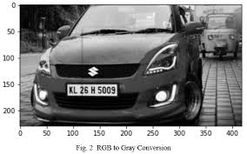

Fig.2RGBtoGrayConversion

3.2.2ImageEnhancement:Thepurposeof adaptivehistogramequalizationis to improvethecontrastofapicture(graycolorimage).Inthis step,wewill createmany histograms, eachrepresenting adifferentpart oftheimage.Incontrast toatypicalhistogram, whichshowsjustonehistogram forthewhole image,this one showsthecomplete image.

3.2.3NoiseRemoval:Toremove noisein theimage.

3.3EdgeDetection:

Anedge is a linedrawnbetween two places thathave greylevelqualitiesthat are significantlydifferent from one another.Itiscapableof detectingdiscontinuitiesinthe intensitylevels.Thefirststageintherecognitionofa plate is todeterminethe sizeofthe plate(whichis a rectangle); thus,wemustdetermine theedge of arectangularplate.The edgesof theimage areemphasizedwiththehelpofthesobaloperator.Asa result, the quantity of datainthe image isreduced,and the necessarydataisprocessedforsubsequent use.9

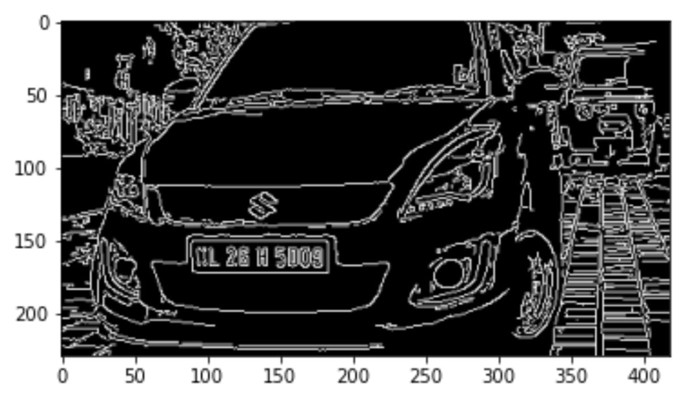

Fig.3Afteredgedetection

3.4MorphologicalImageProcessing

Theoutput of thestructuringelement mustbethesame sizeas theinput. Byusingdilation and byaddingpixels to theobject'sborder,wemaymaketheboundariesappearthickerthan they actually are.UsingtheShrinkingprocess,thinning the picture toremove any unnecessarybits isaccomplished.

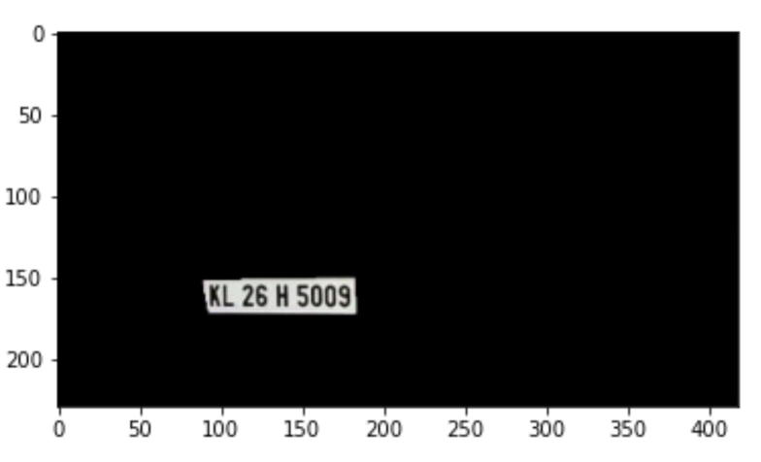
Fig.4Numberplaterecognized 10

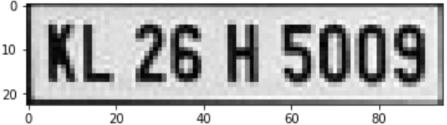

3.5Threshold

If thespecifiedthresholdvalue isexceededornot, twoseparatelevels areassignedto pixels that fallaboveandbelow the thresholdvalue.In ordertodistinguishanitemfromabackground image,theimageistransformedtobinaryform.Thetechniqueof
determiningthegreylevelthreshold is straightforward.Tocomparepixelsina picture,thevalue of thethreshold(T) isdeterminedandused.Asidefromthat, itconverts theinput binary image(K) intoanoutput binaryimage(F)thatis thensegmented.Globalthreshold isusedto segmentthe histogramofanimageusinga single thresholdvalue,asopposedto localthreshold. Whenwetalk about threshold, wearereferring to thevolume of greylevel that fallsbetweenthe baselineborder, whichis locatedbetweenthepixelsfoundin theforeground andthe background.

3.6Segmentation

In betweenthenumber plateextractionandcharacterrecognition,charactersegmentationservesasatransitionalstep.There areseveralsegmentsforthedifferentcharactersona numberplateregion. Variousfactors,suchasilluminationvariations, plateframes,and rotation,allcontributeto the inability tocompletethesegmentationtask.Asegmentationapproachissometimesreferredto asa boundaryboxanalysis in somecircles.Charactersareallocatedto relatedcomponentsusingthis approach,andthesecharacters arethenextractedusingtheboundaryboxanalysis. Whenthe amountofnoise in theimagehasbeenreduced,thesegmentationprocedureiscomplete.

Fig.5Numberplatesegmentedimage

11

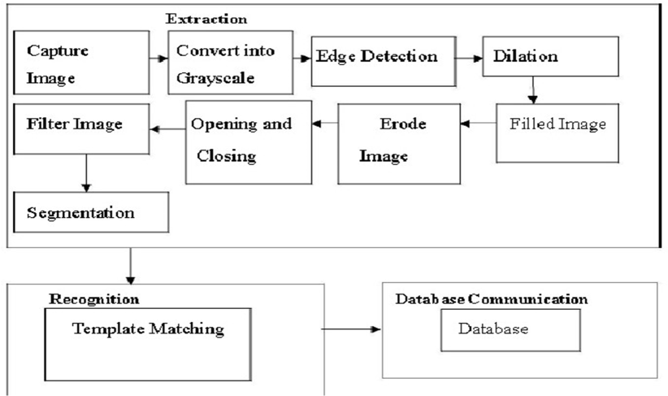
3.7CharacterRecognition

Characterrecognitionis accomplishedbyemployingfeatureextractiontoextractthe characteristicsofcharacters andtheir differentcategorizationprocedures, whichis a stepin thecharacterrecognitionprocess.Theidentificationofcharactersfromthenumberplateis accomplishedthroughtheuse ofamachine learningsystem.

Fig.6PyTesseractOCRoutput

Fig.6FlowchartofAutomaticNumberPlateRecognition

12

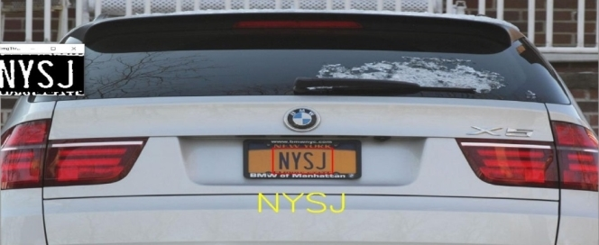
Chapter4

ResultandDiscussions

Initially, the camera will be used to capture the image. Once the image is captured, the

algorithm will process it by converting it into grayscale, followed by extracting the possible

number plates and finally recognizing the registration number of the vehicle. The final

registration details will be searched from the database and will be displayed on the screen

13

Chapter5

ConclusionsandFutureWorks

CONCLUSIONS

•Afterreviewinganumberofstudies,we'vecometotheconclusionthatthereareanumberof

methodsforidentifyingavehicle'slicenseplate.InconjunctionwiththeSobeledgedetection

methodandautomaticlicenseplaterecognitionfordetectingedgesandfillspacesfewerthan8

pixels, employedto identifyandrecognizeautomotivelicenseplates.

•Inordertoidentifythecar,thesystemusesavarietyofimageprocessingalgorithmsthatare

storedonthecomputer'sharddrive. Inorder to assesstheprogram'scapabilities,Matlabisused,

andphotodatafromaroundtheworldisused.Accordingtothecounterfilefindings,therearea

widevarietyofilluminationsituationsinwhichthesystemmayidentifyandrecognizeacar

usingitslicenseplate.Inaddition,statisticalanalysiscanbeusedtoassessthelikelihoodthata

vehicle'slicense platewill be observedandrecognized.

14

Chapter6

References

[1] Bishop, PatternRecognitionandMachineLearning, 2006

[2] Ripley,PatternRecognitionandNeuralNetworks, 1996

[3] Handwritten digits, faces and texts in Matlab format – Data Repository

[4] Alberto, Túlio C, Johannes V Lochter, and Tiago A Almeida. “Tubespam: comment

spam filtering on YouTube.” In Machine Learning and Applications (Icmla), Ieee 14th

International Conference on, 138–43. IEEE. (2015).

[5] Cook, R. Dennis. “Detection of influential observation in linear regression.”

Technometrics 19.1 (1977): 15-18.

[6] Friedman, Jerome H. “Greedy function approximation: A gradient boosting machine.”

Annals of statistics (2001): 1189-1232.

[7] Friedman, Jerome, Trevor Hastie, and Robert Tibshirani. “The elements of statistical

learning”. www.web.stanford.edu/~hastie/ElemStatLearn/ (2009).

[8] Wikipedia and YouTube

15

