KADANE’S ALGORITHM

The simplest idea of kadan’s algorithm is to look for all positive contiguous segment of array and keep the track of maximum sum contiguous segment among all positive segments.

**Sub-array**

An array is a contiguous memory block, as well know.

So, a subarray is a slice of a contiguous array that maintains the order of the elements.

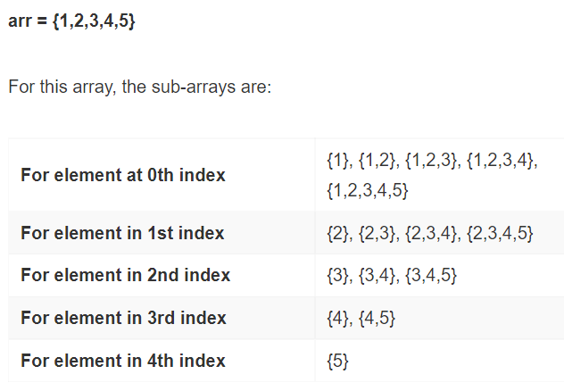

<https://www.geeksforgeeks.org/largest-sum-contiguous-subarray/>