HTML= used to give structure of web content

CSS= used for page's appearance

JAVASCRIPT= functionality or behaviour of page

what is html

HTML is the language in which most websites are written. HTML is used to create pages and make then function

it was created by Tim Berner lee. it stands for hypertext markup language

A markup language is a way that computers speak to each other to control how text is processed and presented

to do all this HTML uses two things

hypertext refer to the link that connect web pages to one another, either in the single websites and or multiple websites

->tags

->attributes

what are HTML tags

tags are used to mark up the start of an HTML element and they are usually enclosed in angle brackets.eg <h1> </h1>

what are HTML attributes

attributes contains additional piece of information. attributes take the form of an opening tag and additional info is placed inside.

<img src="img.jpg"></img>

here src is the attributes

GOLDEN RULES

the vast majority of tags must be opened(<tag>)and closed(</tag>) with the element information such as title or text resting between the tags

when using multiple tags, the tags must be closed in the order in which they were opened

tags

<html>:this tag is used to tell from here on we are going to write the HTML code

|  |  |  |
| --- | --- | --- |
| **Attribute** | **Value** | **Description** |
| [charset](https://www.w3schools.com/tags/att_meta_charset.asp) | *character_set* | Specifies the character encoding for the HTML document |
| [content](https://www.w3schools.com/tags/att_meta_content.asp) | *text* | Specifies the value associated with the http-equiv or name attribute |
| [http-equiv](https://www.w3schools.com/tags/att_meta_http_equiv.asp) | content-security-policy content-type default-style refresh | Provides an HTTP header for the information/value of the content attribute |
| [name](https://www.w3schools.com/tags/att_meta_name.asp) | application-name author description generatorkeywords viewport |  |

<head>: this is where metadata for the pages goes- stuff mostly meant for search engines and other computer programs. Meta data is not displayed. Meta data typically define the document title , character sets, styles, script, and other info.

* [<title>](https://www.w3schools.com/tags/tag_title.asp) (required in every HTML document)
* [<style>](https://www.w3schools.com/tags/tag_style.asp)
* [<base>](https://www.w3schools.com/tags/tag_base.asp)
* [<link>](https://www.w3schools.com/tags/tag_link.asp)
* [<meta>](https://www.w3schools.com/tags/tag_meta.asp)
* [<script>](https://www.w3schools.com/tags/tag_script.asp)
* [<noscript>](https://www.w3schools.com/tags/tag_noscript.asp)

<meta>: define metadata about an html document. meta tag always goes inside head tag.

<title>: this is where we insert the page name as it appear at the top of the browser window or tab.

<body>: this is where the content of the page goes.

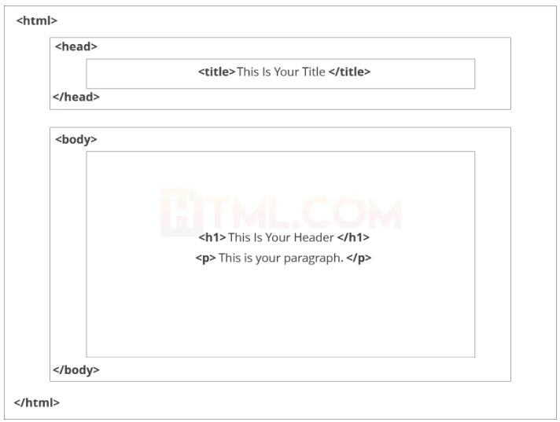

HOW TO ADD HEADING TO YOUR WEB PAGE

We use

* <h1>
* <h2>
* <h3> decrease in size
* <h4>
* <h5>
* <h6>

<p> : this tag defines a paragraph. Always starts with new line and browser automatically

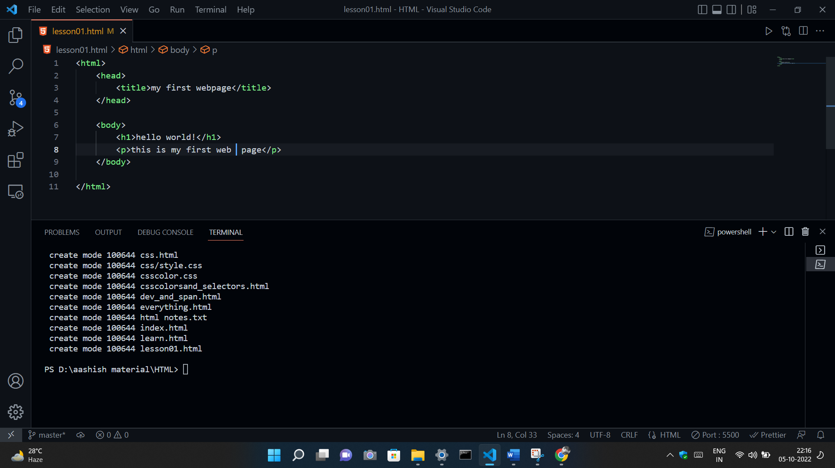

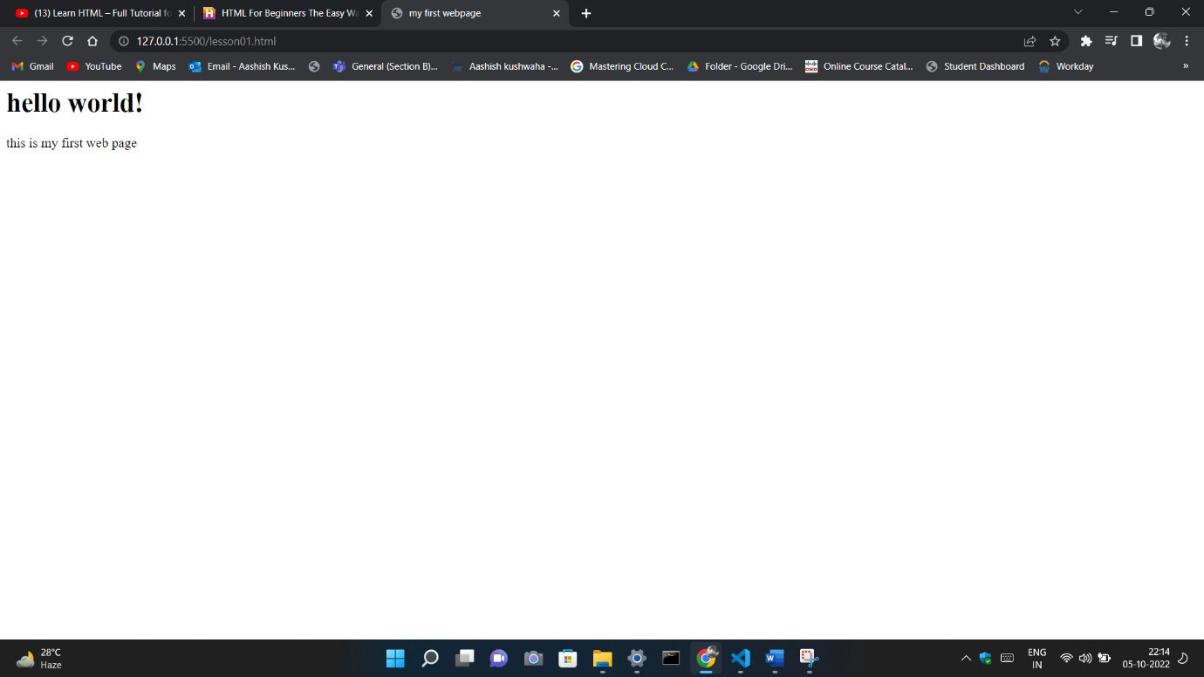

After validating our page in w3c validator we got some error and suggestion that is too

* include lang attribute in <html> tag.
* Include <!doctype>
* Include some metadata inside <head> tag

After all correction

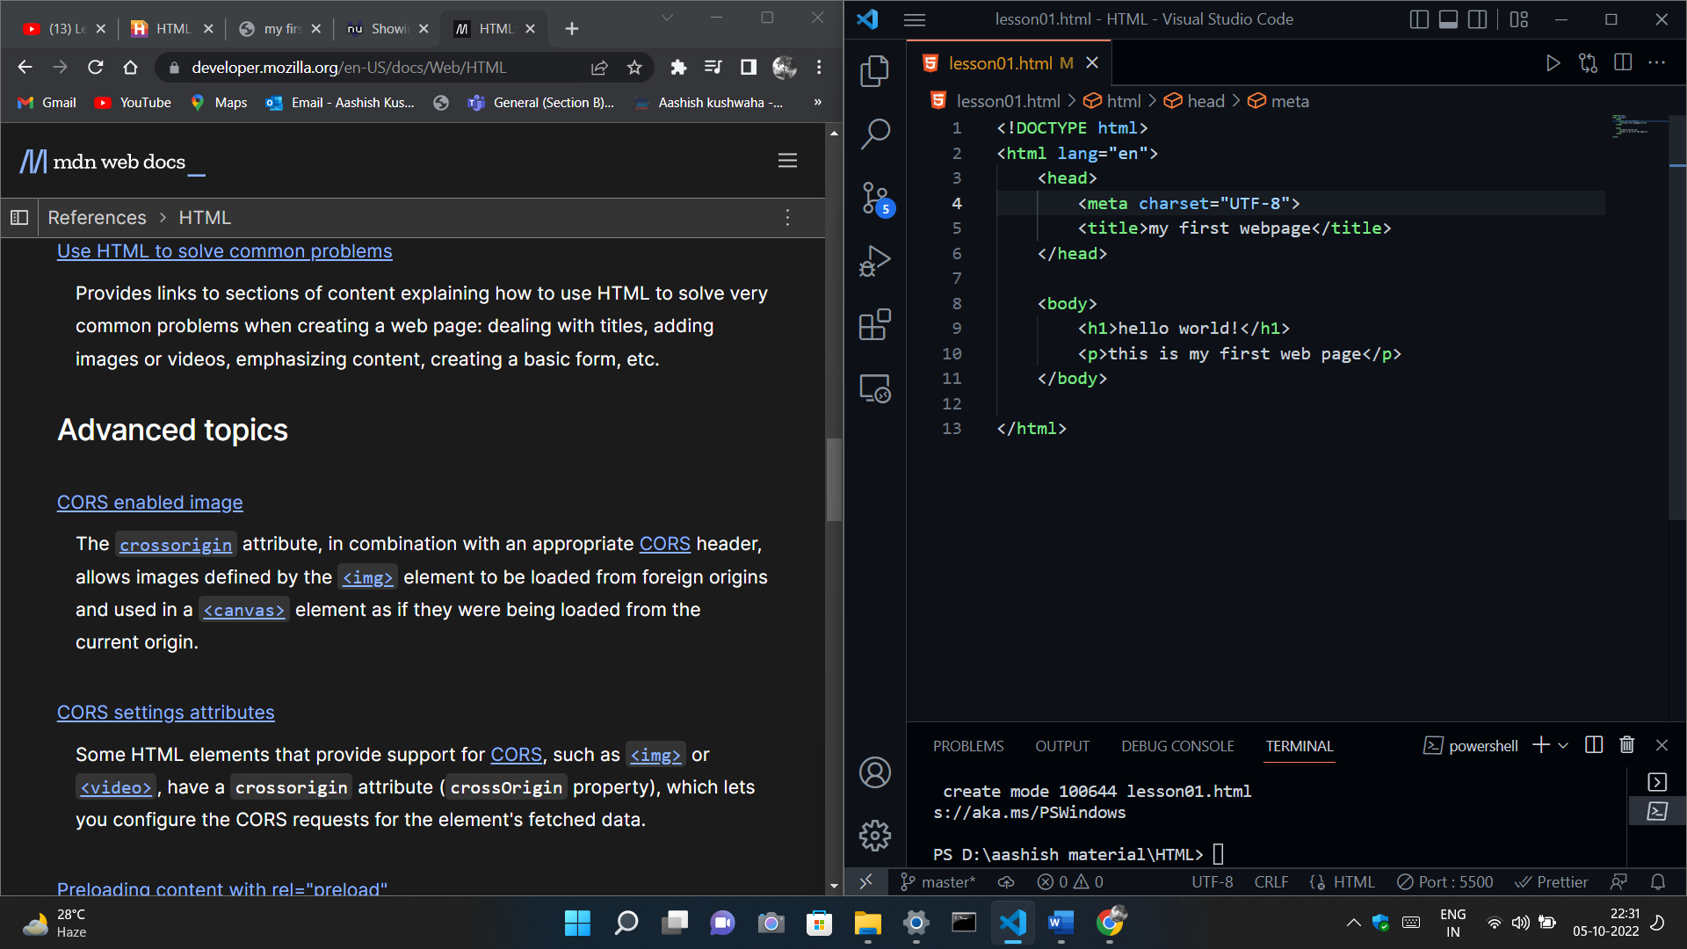

Now we add icon in the webpage

<link rel=”icon” href=”html.png”>

<link> :link tag define the relationship between the current document and an external resources

Also used to link to external stylesheet or to add a favicon to your website. A favicon is a small image displayed next to the page title in the browser.

* The rel attribute defines the relationship between the current page and the linked resource
* The re=”icon” value defines the web page icon or favicon which is visually represent the website
* The icon URL (uniform resources locator) is specified in the href attribute

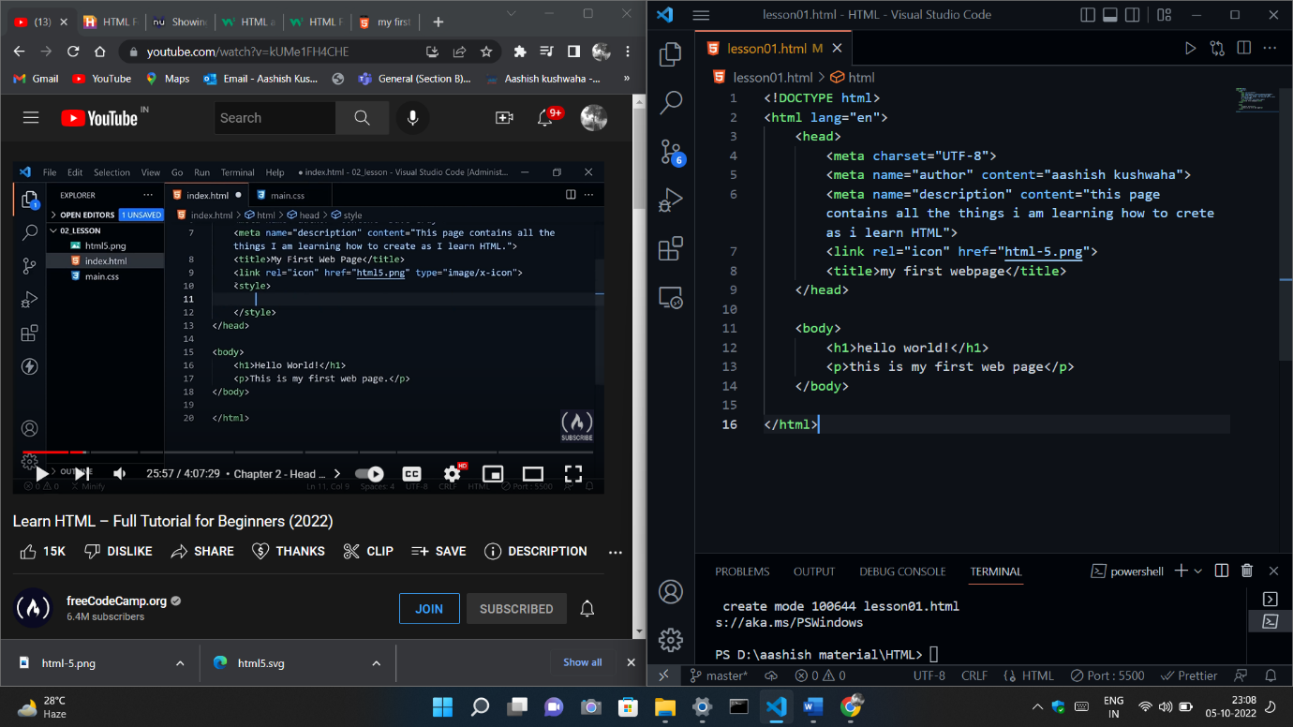

<br>: this tag is used for line break