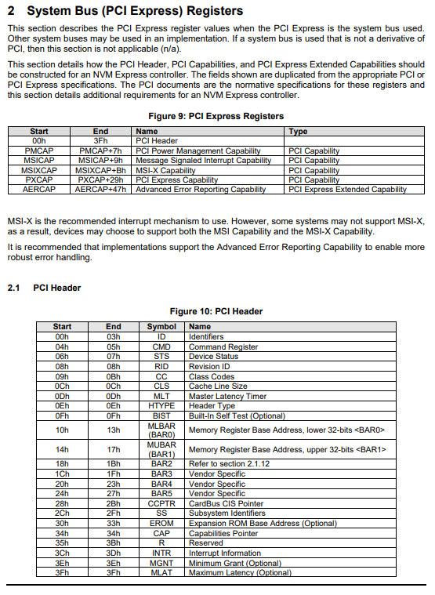
  - CPU = Boss
  - NVMe SSD = Worker
  - PCIe Registers = Communication notebook
When NVMe uses PCIe (which it always does), it must follow PCIe register structure.
👉 These registers are standardized by PCIe, not invented by NVMe.
So:
  - NVMe reuses PCIe structures
  - Then adds its own rules on top
1. PCI Header (00h – 3Fh)
👉 This is the basic identity card of the device
Contains:
  - Vendor ID
  - Device ID
  - Command register
  - Status
📌 Think:
“Who are you?” → answered here

2. PMCAP (Power Management Capability)
👉 Handles power states like:
  - Active
  - Sleep
  - Low power
📌 Like:
Laptop putting SSD into power-saving mode 🔋

3. MSICAP (MSI - Message Signaled Interrupts)
👉 Old interrupt mechanism (but still used)
Instead of physical interrupt lines:
  - Sends a message to CPU
📌 Like:
“Hey CPU, I finished a task!”

4. MSIXCAP (MSI-X Capability)
👉 Advanced version of MSI
✔ Supports:
  - More interrupts
  - Better performance
  - Parallel handling
📌 NVMe prefers this ✅

5. PXCAP (PCI Express Capability)
👉 Contains PCIe-specific info
Like:
  - Link speed
  - Link width
  - Device capabilities
📌 Think:
“How fast and wide is my PCIe connection?”

6. AERCAP (Advanced Error Reporting)
👉 Handles error detection + reporting
✔ Helps detect:
  - Data corruption
  - Link issues
📌 Very important for reliability ⚠️

👉 PCI/PCIe registers are inside the device hardware itself
(e.g., your NVMe SSD controller chip)
📌 So:
  - They are not in RAM
  - They are inside the SSD controller silicon

🧠 Think of it like this:
  - NVMe SSD = a small computer
  - PCI registers = control panel inside it 🎛️

🔹 Then how does CPU access them?
👉 Through PCIe configuration space + memory mapping
There are 2 types of access:

1️⃣ Configuration Space (First 256 Bytes / 4KB)
This includes:
  - PCI Header
  - Capabilities (MSI, MSI-X, etc.)
📌 Accessed via:
  - Special CPU instructions (earlier: I/O ports)
  - Now: memory-mapped config access (MMCONFIG)

2️⃣ BAR (Base Address Register) → MOST IMPORTANT 🔥
This is the key concept.
👉 BAR tells:
“My device registers are available at THIS memory address”

🔥 Flow:
  - Device has internal registers (inside SSD)
  - It exposes them via BAR
  - BIOS/OS assigns a physical memory address
  - CPU uses that address to talk to device

🧠 Example (Super Important)
Let’s say:
  - BAR0 = 0x80000000
Now CPU does:

*(0x80000000) = some_value;
👉 That write does NOT go to RAM
👉 It goes directly to NVMe controller registers

🔹 Who tells the CPU about these registers?
👉 Answer: PCI Enumeration Process

🚀 Step-by-step (Boot Process)
1️⃣ System powers ON
  - CPU starts BIOS/UEFI

2️⃣ BIOS scans PCIe bus
It checks all possible:
  - Bus
  - Device
  - Function numbers

3️⃣ Reads Vendor ID
Each device responds with:
  - Vendor ID
  - Device ID
📌 That’s how CPU "detects" device exists

4️⃣ Reads PCI Header
From configuration space:
  - Finds BARs
  - Finds capabilities

5️⃣ Assigns Memory Addresses to BARs
Example:
  - BAR0 → 0x80000000
  - BAR1 → 0x80001000

6️⃣ OS uses these addresses
Now OS knows:
👉 “If I access 0x80000000 → I am talking to NVMe SSD”

🔹 Two Types of Registers (VERY IMPORTANT ⚠️)
You should mentally separate them into:

1️⃣ PCIe Configuration Registers (What your page shows)
👉 These are used for device setup + management
Located in:
  - PCI Configuration Space (first 256B / extended 4KB)
✔ What they do:
  - Identify device (Vendor ID, Device ID)
  - Enable features (bus mastering, memory access)
  - Configure interrupts (MSI/MSI-X)
  - Set BAR addresses
  - Power management
  - Error reporting (AER)
📌 So yes — these are mainly for configuration

🔥 Example
  - CMD register → enable memory access
  - BAR → tell CPU where device memory is
  - MSI-X → setup interrupts

2️⃣ Device Operational Registers (NVMe Registers)
👉 These are NOT in PCI config space
They are:
  - Located in memory pointed by BAR (usually BAR0)
✔ What they do:
  - Actually run the device
Examples (NVMe):
  - CAP → capabilities
  - CC → controller config
  - CSTS → status
  - SQ/ CQ → queues
📌 These are used for real operation, not just config

🔹 What is a BAR (Base Address Register)?
👉 A BAR is a register inside the PCI configuration space
👉 It stores the base memory address where the device exposes its internal registers
🔹 Where is BAR located?
  - Inside PCI Header (you saw BAR0, BAR1 in your page)
  - Typically:
    - BAR0 → main register space
    - BAR1 → sometimes extended space
🔹 What is actually behind BAR?
👉 Behind the BAR address lies:
✔ Device registers (NVMe registers like CAP, CC, CSTS)
✔ Device memory (in some devices)

Your Doubt
👉 “Why is PMCAP shown with Start–End like normal registers?”
Good observation — because PMCAP is NOT a single register.

🔹 What PMCAP actually is
👉 PMCAP = Power Management Capability Structure
It is:
A block (structure) of multiple registers grouped together

🧠 So instead of:
  - One register → fixed offset
You have:
  - A group of registers → occupying a range

🔹 Why Start–End is used here?
Because:
👉 PMCAP occupies a continuous chunk of memory
Example:
Start | End
40h | 4Fh
👉 Means:
  - Entire PMCAP structure lies between these offsets
  - Inside it → multiple small registers exist

🔹 What’s inside PMCAP?
Typically includes:
  - Power Management Capabilities
  - Power Management Control/Status
📌 So it's like:

PMCAP Block:
├── Register 1
├── Register 2
├── Register 3

🔹 Important Twist ⚠️ (Very Important Concept)
👉 These capability blocks are not fixed in position

🧠 How CPU finds PMCAP?
Using:
👉 Capabilities Pointer (CAP field in PCI header)

Flow:
1️⃣ CPU reads CAP pointer (e.g., 0x40)
2️⃣ Goes to offset 0x40
3️⃣ Finds PMCAP structure

🔥 This is called a Linked List of Capabilities
Each capability contains:
  - ID (what type: PM, MSI, etc.)
  - Pointer to next capability

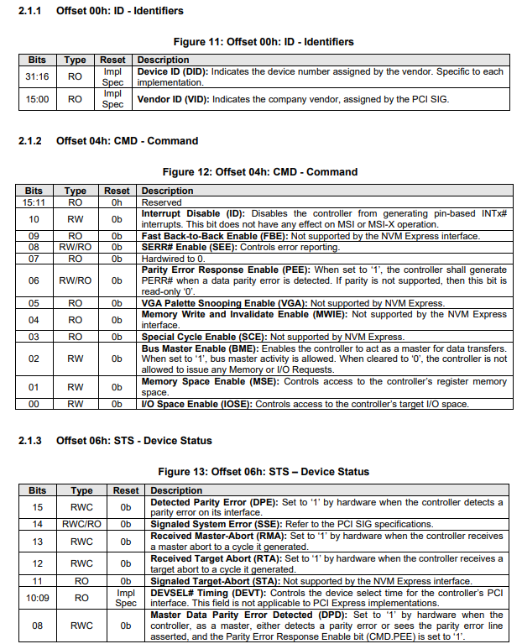

🔹 2.1.1 Offset 00h: ID – Identifiers
👉 This is the first thing CPU reads during PCI enumeration

🧠 Structure
Bits | Field
31:16 | Device ID (DID)
15:0 | Vendor ID (VID)

🔹 What it means
✔ Vendor ID (VID)
  - Assigned by PCI-SIG
  - Identifies company
📌 Examples:
  - Intel → 8086h
  - Samsung → specific ID

✔ Device ID (DID)
  - Assigned by vendor
  - Identifies specific product
📌 Example:
  - Samsung NVMe SSD vs SATA controller

🔥 Why this is important?
👉 OS uses this to:
  - Identify device type
  - Load correct driver

🧠 Flow
CPU → reads 00h
→ sees Vendor ID + Device ID
→ loads NVMe driver

🔹 2.1.2 Offset 04h: CMD – Command Register
👉 This is one of the MOST IMPORTANT registers
👉 It controls whether the device is even allowed to work

🔥 Key Bits You MUST understand

🟢 Bit 2 — Bus Master Enable (BME)
👉 Allows device to do DMA (Direct Memory Access)
📌 Meaning:
  - SSD can directly read/write system RAM
  - Without CPU intervention
❗ If 0 → NVMe cannot transfer data

🟢 Bit 1 — Memory Space Enable (MSE)
👉 Enables access to BAR (MMIO registers)
📌 Meaning:
  - CPU can access NVMe registers via BAR
❗ If 0 → BAR is useless

🟢 Bit 0 — I/O Space Enable (IOSE)
👉 Old I/O port mechanism (not used in NVMe)

🟡 Bit 8 — SERR Enable
👉 Enables error reporting

🔴 Bit 10 — Interrupt Disable
👉 Disables legacy interrupts
✔ Does NOT affect MSI/MSI-X

❌ Unsupported in NVMe
These are marked “Not supported”:
  - Fast Back-to-Back
  - VGA snooping
  - Special cycles
👉 Ignore these for NVMe

🔥 Most Important Bits (Remember This)
👉 For NVMe to work:
MSE = 1 (enable MMIO via BAR)
BME = 1 (enable DMA)

🧠 Real Flow
  - OS sets:
    - MSE = 1
    - BME = 1
  - Now:
    - CPU can access NVMe registers (via BAR)
    - NVMe can access system memory

🔹 2.1.3 Offset 06h: STS – Status Register
👉 This shows what happened in the device

🔥 Important Bits

🔴 Bit 15 — Detected Parity Error (DPE)
👉 Hardware detected data corruption

🟡 Bit 14 — Signaled System Error (SSE)
👉 Device reported a serious system error

🟡 Bit 13 — Received Master Abort (RMA)
👉 Device tried accessing memory → no response

🟡 Bit 12 — Received Target Abort (RTA)
👉 Transaction was aborted

🟡 Bits 10:9 — DEVSEL Timing
👉 Timing info (not relevant for PCIe/NVMe)

🔴 Bit 8 — Master Data Parity Error
👉 Another form of data integrity error

🧠 Key Idea
👉 CMD = control
👉 STS = feedback

🔹 Putting It All Together (VERY IMPORTANT)

🚀 Full Initialization Flow
Step 1: Detect device
Read 00h → VID + DID

Step 2: Enable device
Write CMD:
MSE = 1
BME = 1

Step 3: Check status
Read STS → check for errors

Step 4: Use BAR
Access NVMe registers via BAR

🔹 So WHO is checking all this?
👉 Answer:
✔ PCIe controller hardware (on both CPU and NVMe side)
NOT software ❌
NOT NVMe logic directly ❌

🔹 Where does NVMe come in?
👉 NVMe sits above PCIe

🧠 Relationship
Layer | Role
PCIe | Moves data
NVMe | Defines commands

🔥 Example Flow
Step 1: NVMe command

CPU → "Read block"

Step 2: PCIe sends it
  - Converted into PCIe packet

Step 3: PCIe checks transfer
👉 If error happens:
  - STS bits are set

Step 4: NVMe may never see it properly ❗
Because:
  - Transfer itself failed

🔹 Important Insight (Very Important)
👉 These errors are below NVMe level
So:
  - PCIe errors → transport failure
  - NVMe errors → command failure

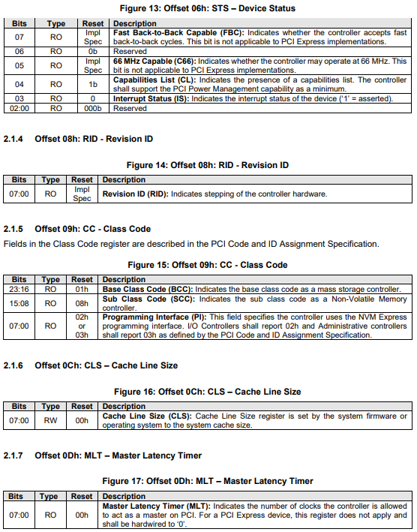
🟢 Bit 4 — Capabilities List (CL)
👉 Very important bit
👉 If CL = 1:
Device supports capabilities list (PMCAP, MSI, MSI-X, etc.)
📌 This means:
  - You can use Capabilities Pointer (CAP) to traverse them

🧠 Why important?
Without this:
  - No MSI/MSI-X
  - No advanced features
👉 NVMe requires this to be 1

🟢 Bit 3 — Interrupt Status (IS)
👉 Indicates:
“Is an interrupt currently active?”
  - 1 → interrupt pending
  - 0 → no interrupt
📌 Mostly legacy interrupt indication

❌ Bits not relevant for PCIe/NVMe
  - Fast Back-to-Back (FBC)
  - 66 MHz Capable
👉 These are old PCI (not PCIe) features → ignore

🔹 2.1.4 Offset 08h: RID – Revision ID
👉 Very simple but important

🧠 What it means
  - Identifies hardware revision/version
📌 Example:
  - Rev 1.0
  - Rev 2.1

🔹 Why needed?
👉 Driver may:
  - Apply workarounds for specific revisions
  - Handle hardware bugs

🧠 Real-world example
If (device revision == buggy_version)
apply workaround

🔹 2.1.5 Offset 09h: CC – Class Code
👉 This tells the OS:
“What type of device am I?”

🧠 Fields
Bits | Meaning
23:16 | Base Class
15:08 | Subclass
07:00 | Programming Interface

🔥 For NVMe
Field | Value | Meaning
Base Class | 01h | Mass Storage
Subclass | 08h | NVM Controller
Prog IF | 02h | NVMe

🧠 Why important?
👉 OS uses this to:
  - Load NVMe driver automatically

🔥 Example
Class Code = 01 08 02
→ OS says: "This is an NVMe SSD"
→ Loads nvme driver

🔹 2.1.6 Offset 0Ch: CLS – Cache Line Size
👉 Old concept (not very relevant today)
cache line is the fundamental unit of data transfer between main memory (RAM) and the CPU cache.

🧠 What it means
  - Size of cache line (in bytes / DWORDs)
📌 Set by:
  - BIOS or OS

🔹 Why it existed?
👉 For optimizing:
  - Memory transfers
  - Cache alignment

❗ For NVMe
👉 Mostly ignored / not critical

🔹 2.1.7 Offset 0Dh: MLT – Master Latency Timer
👉 Another legacy PCI concept

🧠 What it means
  - How long device can hold bus

❗ For PCIe
👉 Not applicable (always 0)
Because:
  - PCIe is point-to-point (not shared bus)

🔹 Big Picture (Very Important)

🧠 What these registers collectively do
Register | Purpose
STS | Status + capability presence
RID | Hardware version
CC | Device type (NVMe detection)
CLS | Cache tuning (legacy)
MLT | Bus timing (legacy)

🔹 Where NVMe comes in here?
👉 ONLY in Class Code (CC)
This is where system identifies:
“This is an NVMe device”

🔥 Full Detection Flow
1. CPU reads ID (VID/DID)
2. CPU reads Class Code
3. Sees: Mass Storage + NVM
4. Loads NVMe driver
5. Driver uses BAR → accesses NVMe registers

🔹 What You Should Remember (Important)
✔ CL bit → tells capabilities exist
✔ CC → tells OS it's NVMe
✔ RID → hardware version
✔ CLS & MLT → mostly irrelevant for PCIe

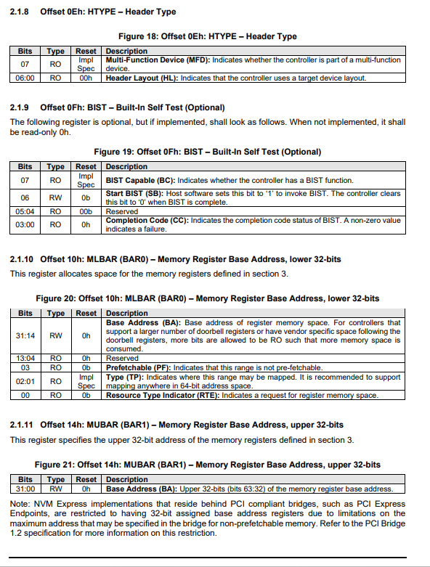
1. HTYPE — Header Type (Offset 0Eh)
This register tells the system what kind of PCIe device it is dealing with and if the device has multiple functions.
  - Bit 07: Multi-Function Device (MFD)
    - Understanding: If this bit is 1, the physical SSD contains multiple independent "functions." For example, a single PCIe card might host two separate NVMe controllers.
    - NVMe Context: Most consumer NVMe SSDs are single-function (Bit 07 = 0). However, high-end enterprise SSDs or RAID controller cards often set this to 1 because they present multiple logical controllers to the OS.
  - Bits 06:00: Header Layout (HL)
    - Understanding: This defines the format of the rest of the configuration space.
    - NVMe Context: For NVMe SSDs (which are "Endpoints"), this is almost always 00h. This tells the OS to expect a "Type 0" header, which includes things like BARs (Base Address Registers).

2. BIST — Built-In Self Test (Offset 0Fh)
BIST is an optional feature used to check the hardware integrity of the PCIe controller itself.
  - Bit 07: BIST Capable (BC)
    - Understanding: Indicates if the hardware supports this legacy PCIe self-test.
  - Bit 06: Start BIST (SB)
    - Understanding: The Host writes a '1' here to tell the SSD to start its internal hardware diagnostic.
  - Bits 03:00: Completion Code (CC)
    - Understanding: After the test, the SSD writes a code here. 0h means "Pass," and anything else is a hardware failure.
  - NVMe Emphasis: In modern SSDs, this specific PCIe BIST register is rarely used. Instead, NVMe uses the "Device Self-test" Admin Command, which is much more sophisticated and can test the NAND flash, controller, and DRAM.

3. MLBAR (BAR0) — Lower 32-bits (Offset 10h)
This is arguably the most important register for an NVMe driver. It defines where the NVMe Controller Registers (like the Doorbell registers) "live" in the system's memory map.
  - Bits 31:14: Base Address (BA)
    - Understanding: These bits hold the physical address assigned by the BIOS/OS.
    - NVMe Context: When you write a command to a "Submission Queue," you notify the SSD by writing to a Doorbell Register. The address of that doorbell is calculated based on the value in this BA field.
  - Bit 03: Prefetchable (PF)
    - Understanding: Indicates if the CPU can "pre-read" this data.
    - NVMe Context: For NVMe, this is usually 0 (Non-prefetchable). Why? Because reading an NVMe register can have "side effects" (like clearing an interrupt). If the CPU pre-reads it, it might accidentally trigger a hardware state change.
  - Bits 02:01: Type (TP)
    - Understanding: 10b indicates a 64-bit address space.
    - NVMe Context: Because modern servers have massive amounts of RAM, NVMe SSDs almost always use 64-bit addressing to avoid being "stuck" in the lower 4GB of memory. This "links" BAR0 and BAR1 together.
  - Bit 00: Resource Type Indicator (RTE)
    - Understanding: 0 means Memory Space; 1 means I/O Space.
    - NVMe Context: NVMe is strictly Memory Mapped I/O (MMIO), so this is always 0.

4. MUBAR (BAR1) — Upper 32-bits (Offset 14h)
This register works in tandem with MLBAR when 64-bit addressing is used.
  - Bits 31:00: Base Address (BA)
    - Understanding: This holds the "high" part (bits 63:32) of the 64-bit memory address.
    - Example: If the OS decides to map your SSD's registers to the physical address 0x00000004_FEE00000:
      - MUBAR (BAR1) will be set to 0x00000004.
      - MLBAR (BAR0) will be set to 0xFEE00000 (plus the attribute bits like TP and RTE).
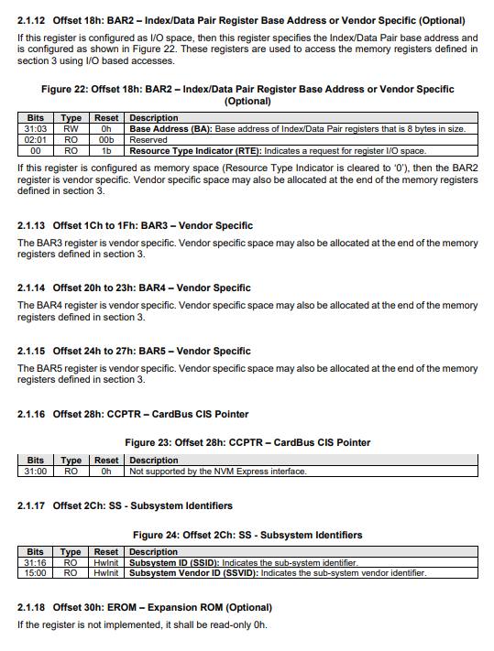
2.1.12 Offset 18h: BAR2 – Index/Data Pair or Vendor Specific
This is a "flexible" register. It can behave in two very different ways depending on how the manufacturer designed the SSD.
Scenario A: I/O Space (Index/Data Pair)
If the Resource Type Indicator (Bit 00) is set to 1b, this BAR is used for a legacy method of accessing the SSD registers.
  - The Mechanism: Instead of mapping the whole 16KB+ of NVMe registers into memory, it creates an 8-byte "window."
    - Index (4 bytes): You write the address of the register you want to see here.
    - Data (4 bytes): You read or write the actual value here.
  - NVMe Context: This is rarely used today. It was originally a workaround for older systems that had limited memory address space.
Scenario B: Memory Space (Vendor Specific)
If Bit 00 is 0b, this BAR is reserved for the manufacturer (e.g., Samsung, Western Digital, Toshiba).
  - Example: A vendor might use this space to provide a "backdoor" for their own firmware update tools or hardware debugging utilities that aren't part of the standard NVMe command set.

2.1.13 to 2.1.15: BAR3, BAR4, BAR5 (Vendor Specific)
These three registers follow the same logic as the "Vendor Specific" version of BAR2.
  - Understanding: In the PCIe standard, a Type 0 header has 6 BARs. NVMe uses BAR0 and BAR1 for its main operations. That leaves BAR2 through BAR5 free.
  - NVMe Context: For most standard SSDs, these are Read-Only 0h. If an SSD does use them, it’s usually for highly specialized enterprise features, like internal telemetry or secondary controller functions.

2.1.16 Offset 28h: CCPTR – CardBus CIS Pointer
  - The Field: A legacy pointer used for old "PC Cards" (CardBus).
  - NVMe Context: NVMe is a modern high-speed standard that does not support the ancient CardBus interface. Therefore, the specification explicitly states it is not supported and hardcoded to 0h. You can safely ignore this when writing modern drivers.

2.1.17 Offset 2Ch: SS – Subsystem Identifiers
This is a critical section for identifying the exact hardware assembly.
Field | Description
Subsystem Vendor ID (SSVID) | Identifies the manufacturer of the entire board/card.
Subsystem ID (SSID) | Identifies the specific model or SKU of the card.
  - Difference between Vendor ID and Subsystem Vendor ID:
    - Vendor ID: Identifies who made the controller chip (e.g., Marvell or Phison).
    - Subsystem Vendor ID: Identifies who made the final SSD product (e.g., Dell or HP).
  - NVMe Context: If a laptop manufacturer (like Dell) buys an SSD from a supplier, they might change the SSVID to "Dell" so that their specific Windows Update drivers can identify and update that specific drive, even if the internal chip is generic.

2.1.18 Offset 30h: EROM – Expansion ROM
This register points to a small piece of code stored on the SSD itself, often called "Option ROM."
  - The Field: It contains the base address of the ROM image in memory.
  - Understanding: When your computer first turns on, the CPU has no idea how to talk to an NVMe drive. It only knows how to talk to PCIe.
  - NVMe Context: The Expansion ROM contains the UEFI Driver for the SSD. The BIOS reads this ROM into memory and executes it. This "teaches" the BIOS how to access the file system on the SSD so it can find and launch the Operating System (Windows/Linux) loader. Without this, you couldn't boot your PC from an NVMe drive.

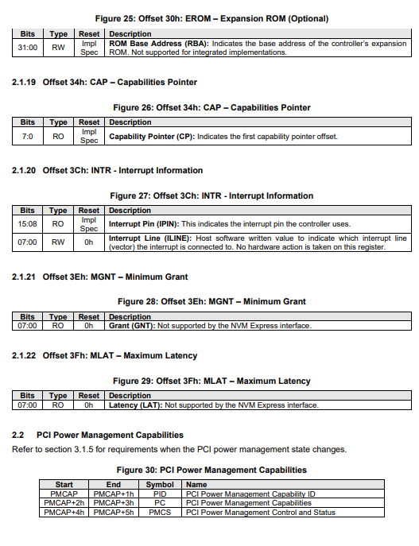
2.1.18 Offset 30h: EROM – Expansion ROM
This register provides the address for the Option ROM code stored on the SSD.
  - Bits 31:00: ROM Base Address (RBA)
    - Understanding: This is the memory address where the SSD's boot code is mapped.
    - NVMe Context: For "Integrated" SSDs (like those soldered onto a motherboard), this is often not used. For "Add-in Cards" (M.2 or U.2 drives), this is vital. It contains the UEFI driver that allows your motherboard to "see" the drive and boot Windows/Linux from it before the OS has even loaded.

2.1.19 Offset 34h: CAP – Capabilities Pointer
This is one of the most clever parts of the PCIe design. It acts as the start of a "Linked List."
  - Bits 07:00: Capability Pointer (CP)
    - Understanding: PCIe has many optional features (Power Management, MSI-X, Express Capabilities). Instead of having a fixed spot for every possible feature, PCIe uses a linked list. This register points to the offset of the first feature.
    - NVMe Context: The system follows this pointer to find the MSI-X capability. Since NVMe relies heavily on MSI-X for high-speed interrupts, this pointer is the "gateway" the driver uses to set up high-performance communication.

2.1.20 Offset 3Ch: INTR – Interrupt Information
These fields handle Legacy Interrupts (INTx).
  - Bits 15:08: Interrupt Pin (IPIN)
    - Understanding: Tells the system which physical wire (INTA, INTB, etc.) the device uses to signal an interrupt.
  - Bits 07:00: Interrupt Line (ILINE)
    - Understanding: A "scratchpad" where BIOS/OS can write the IRQ number. Hardware doesn't use this; it’s just for software bookkeeping.
  - NVMe Emphasis: NVMe almost never uses these. Modern NVMe SSDs use MSI-X (Message Signaled Interrupts), which sends a small data packet over the PCIe bus instead of toggling a physical pin. This allows for thousands of separate interrupt queues, which is why NVMe is so much faster than older SATA drives.

2.1.21 & 2.1.22: MGNT (Minimum Grant) & MLAT (Maximum Latency)
  - The Fields: These were used in old "Parallel PCI" days to help the bus arbiter decide how long a device could hold onto the bus.
  - NVMe Context: PCIe is a point-to-point serial link, not a shared bus. Therefore, these timing concepts are obsolete. The specification hardcodes these to 0h and ignores them.

2.2 PCI Power Management Capabilities
This section defines how the SSD enters low-power states to save energy (especially important for laptops).
Symbol | Name | Description
PID | Capability ID | Hardcoded to 01h to identify this block as "Power Management."
PC | Power Management Capabilities | Tells the OS which "D-states" (D0, D1, D2, D3) the SSD supports.
PMCS | Control and Status | The "Switch." The OS writes to this register to tell the SSD to "Go to sleep" (D3) or "Wake up" (D0).
  - NVMe Context: When you close your laptop lid, the OS writes to the PMCS register. The SSD then flushes its cache to the NAND flash and enters a low-power state.
  - Crucial Difference: This is PCIe-level power management (D-states). NVMe also has its own internal power management (NVM Express Power States or "PS0" through "PS4"), which is much more granular. The SSD must coordinate both.

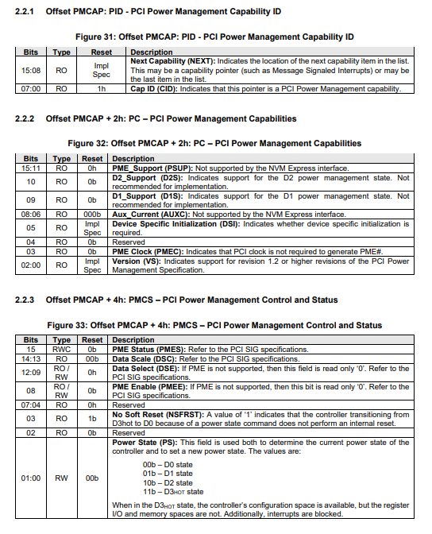
2.2.1 Offset PMCAP: PID – Capability ID
This register identifies this block of memory as belonging to the Power Management feature.
  - Bits 15:08: Next Capability (NEXT)
    - Understanding: Remember the "Linked List" we discussed? This field contains the address of the next capability in the chain (likely MSI-X or PCI Express Capabilities). If this is the last item in the list, it will be 00h.
  - Bits 07:00: Cap ID (CID)
    - Understanding: This is hardcoded to 01h. When the OS follows the linked list and sees 01h, it knows: "Aha, these next few bytes control the power settings."

2.2.2 Offset PMCAP + 2h: PC – Power Management Capabilities
This register tells the OS what the SSD hardware is actually capable of doing regarding power saving.
  - Bit 10 (D2S) & Bit 09 (D1S): D1/D2 Support
    - Understanding: These are intermediate "light sleep" states.
    - NVMe Context: Most modern NVMe SSDs set these to 0b (Not supported). In the SSD world, we usually care about either being "Full On" (D0) or "Deep Sleep" (D3). Intermediate states add complexity without much extra power saving.
  - Bit 05: Device Specific Initialization (DSI)
    - Understanding: If this is 1, it tells the OS that the SSD needs a special command/software sequence to work after it wakes up.
  - Bits 02:00: Version (VS)
    - Understanding: Indicates which version of the PCI Power Management spec the hardware follows (usually version 1.2 or higher).

2.2.3 Offset PMCAP + 4h: PMCS – Control and Status
This is the most "active" register on this page. This is where the OS actually commands the drive to change states.
  - Bit 03: No Soft Reset (NSFRST)
    - Crucial NVMe Detail: This is very important for performance. If this bit is 1b, it means that when the SSD moves from D3hot (sleep) back to D0 (active), the internal registers and state of the SSD are not reset.
    - Example: If this is 1, the drive wakes up almost instantly. If it were 0, the drive would have to go through a "Soft Reset," making the wake-up process much slower for the user.
  - Bits 01:00: Power State (PS)
    - Understanding: This is the "Gear Shifter." The OS writes to these bits to change the drive's power state:
      - 00b (D0): Full Power. The SSD can process commands.
      - 11b (D3hot): Deep Sleep. The drive consumes very little power, but its configuration space is still "visible" to the CPU.
    - Note: When the drive is in D3hot, it cannot perform any I/O. If the OS tries to read a file, it must first write 00b to these bits to "wake up" the controller.

SSD Engineering Insight
There is often a confusion between PCIe Power States (D-states) and NVMe Power States (PS-states):
  - D-States (D0, D3): These are handled by the PCIe Link. They control whether the "wires" between the CPU and SSD are active.
  - NVMe PS-States (PS0 - PS4): These are handled by the SSD Firmware. They control whether the internal NAND flash and controller components are powered down.
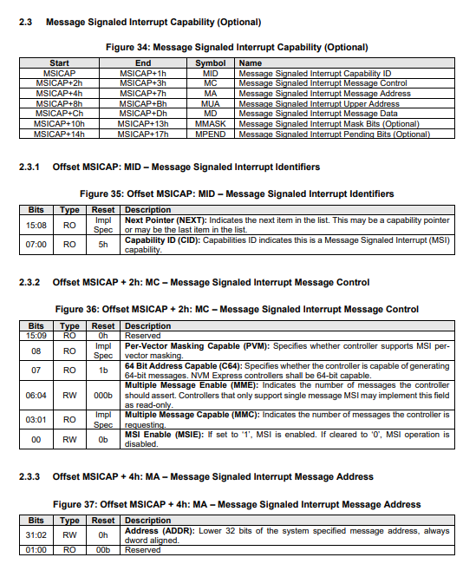
the Message Signaled Interrupt (MSI) capability. In the world of NVMe, interrupts are the "doorbell" the SSD rings to tell the CPU, "Hey, I've finished the data transfer you asked for; come check the completion queue!"
While traditional PCIe devices used physical wires (INTx pins) to signal the CPU, NVMe SSDs use MSI or MSI-X. Instead of a physical pulse, the SSD simply performs a small memory write to a specific address.

2.3.1 Offset MSICAP: MID – Message Signaled Interrupt Identifiers
This is the header for the MSI capability block.
  - Bits 15:08: Next Pointer (NEXT)
    - Understanding: This is the next link in the Capabilities Linked List. It points to the next feature (like MSI-X or the PCIe Express capability).
  - Bits 07:00: Capability ID (CID)
    - Understanding: Hardcoded to 05h. When the OS sees "05h," it knows this block of registers is for configuring MSI.

2.3.2 Offset MSICAP + 2h: MC – Message Control
This is the "Control Panel" for MSI. It determines how many different "rings" the SSD can use.
  - Bit 07: 64 Bit Address Capable (C64)
    - NVMe Context: For NVMe SSDs, this is always 1b. Modern systems have more than 4GB of RAM, so the SSD must be able to write its interrupt message to a 64-bit memory address.
  - Bits 06:04: Multiple Message Enable (MME)
    - Understanding: The OS writes to this field to tell the SSD how many separate interrupt "vectors" it is actually allowed to use.
  - Bits 03:01: Multiple Message Capable (MMC)
    - Example: If the SSD hardware wants 8 separate interrupt lines (one for each CPU core, perhaps), it sets this to 011b ($2^3 = 8$).
  - Bit 00: MSI Enable (MSIE)
    - The Master Switch: If the driver sets this to 1, the SSD stops using legacy pins and starts using memory-write interrupts.

2.3.3 Offset MSICAP + 4h: MA – Message Address
This defines the "Target."
  - Bits 31:02: Address (ADDR)
    - Understanding: This is the lower 32-bit memory address provided by the OS.
    - NVMe SSD Example: When the SSD firmware finishes an I/O command, it looks at this register. If the address is 0xFEE00000, the SSD will send a PCIe write packet to that exact location in system RAM. The CPU monitors that location and triggers the interrupt service routine immediately.

Summary of the "Message" Flow
In an NVMe SSD, the process looks like this:
  - Initialization: The OS reads MMC to see how many interrupts the SSD wants. It then writes to MME to grant them and sets MSIE to 1.
  - Configuration: The OS writes the destination address into MA (Message Address) and the data payload into MD (Message Data).
  - Operation:
    - The SSD completes a 4KB Read from NAND.
    - The SSD controller sends a "Message" (the value in MD) to the address in MA.
    - The CPU sees this "Write" and knows exactly which NVMe queue has finished its task.
Why this matters for NVMe:
Legacy interrupts are "shared," meaning the CPU has to ask every device on the bus, "Was it you who interrupted me?" This creates massive latency. MSI is direct and dedicated to the SSD, which is why NVMe can achieve such low latency and high IOPS.

Note on MSI-X: You might notice this page says "Optional." This is because most high-performance NVMe SSDs actually prefer MSI-X (Capability ID 11h), which allows for up to 2,048 different interrupts, compared to the 32 allowed by the standard MSI explained here.
think of the MSI (Message Signaled Interrupt) as a specialized "Push Notification." In old computers, a device had to pull a physical wire to get the CPU's attention. With MSI, the SSD just sends a tiny packet of data to a specific address in RAM, and the CPU "sees" it as an interrupt.
Here is the breakdown of those specific fields with an NVMe-focused deep dive.

2.3.2 Offset MSICAP + 2h: MC – Message Control
This register is the "negotiation" table between the SSD hardware and the Operating System.
  - Bit 07: 64 Bit Address Capable (C64)
    - The "Why": If this is 1b, the SSD is telling the OS, "I can handle long 64-bit addresses."
    - NVMe Context: In modern servers (where NVMe is most common), the "Interrupt Controller" in the CPU is often mapped to a high memory address far above the 4GB limit. Because NVMe is a modern standard, it must support 64-bit addressing to ensure it works in these high-end systems.
  - Bits 03:01: Multiple Message Capable (MMC)
    - The SSD's Request: This is Read-Only. The SSD hardware designer hardcodes this to say how many "doorbell rings" it wants.
    - The Math: It uses a power-of-2 scale.
      - 000b = 1 message
      - 011b = $2^3 = 8$ messages
      - 101b = $2^5 = 32$ messages (the maximum for standard MSI)
    - NVMe Detail: An SSD wants multiple messages so it can assign a different interrupt to different CPU cores. This prevents "bottlenecks" where one CPU core is overwhelmed managing all the SSD's traffic.
  - Bits 06:04: Multiple Message Enable (MME)
    - The OS's Answer: This is Read-Write. The OS looks at the MMC (what the SSD wants) and then writes to MME to say what the SSD actually gets.
    - Example: If your SSD asks for 32 interrupts (MMC = 5) but the OS is low on resources, the OS might write 010b ($2^2 = 4$) into MME. The SSD must then "cram" its notifications into only 4 lines.
  - Bit 00: MSI Enable (MSIE)
    - The Master Switch: When this is 0, the SSD is in "Legacy Mode" (using physical INTx wires). When the driver sets this to 1, the physical wires are ignored, and the "Message" system starts working.

2.3.3 Offset MSICAP + 4h: MA – Message Address
This is the "Phone Number" the SSD calls when it needs to talk to the CPU.
  - Bits 31:02: Address (ADDR)
    - Understanding: This is the destination in system memory. It is DWORD aligned (the last two bits are reserved/0) because PCIe memory writes must start on 4-byte boundaries.
    - NVMe Example: 1. The OS sets ADDR to 0xFEE00000.
2. The SSD finishes a "Read" command.
3. The SSD looks at the MA register and sends a PCIe "Memory Write" packet to 0xFEE00000.
4. The system's Interrupt Controller (APIC) sees a write to that specific "magic" address and immediately tells the CPU: "Stop what you're doing, the NVMe drive has a message for you!"

Putting it Together: An Example Scenario
Imagine a high-performance SSD inside a 16-core server:
  - Hardware (MMC): The SSD says, "I have 16 queues for 16 cores, I want 16 messages (100b)."
  - Software (MME): The Windows/Linux driver says, "I'll give you all 16 messages (100b)."
  - Target (MA): The OS gives a specific address for the CPU's interrupt handler.
  - The Result: When Core #5 sends a command to the SSD, the SSD finishes the work and "rings the bell" specifically for Core #5. This allows the server to process millions of IOPS (Input/Output Operations Per Second) without the CPU cores fighting over who gets the interrupt.

Comparison Note: MSI vs. MSI-X
In your spec, this is section 2.3. Most NVMe drives also have a section 2.4 (MSI-X).
  - MSI (what we just discussed) is limited to 32 messages and uses one single address.
  - MSI-X can have up to 2,048 messages, and each message can have its own unique address.
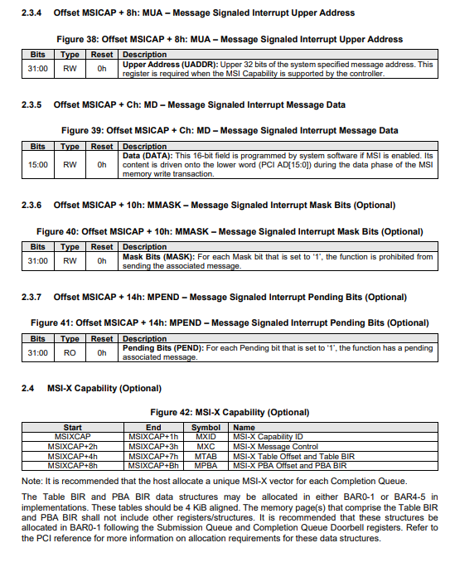
2.3.4 Offset MSICAP + 8h: MUA – Message Signaled Interrupt Upper Address
This register is the companion to the MA (Message Address) we discussed earlier.
  - Bits 31:00: Upper Address (UADDR)
    - Understanding: If the SSD is 64-bit capable (which all NVMe drives are), this register holds the top 32 bits of the memory address.
    - NVMe Context: In modern systems, the CPU's "mailbox" for interrupts is often at a very high address like 0x00000000_FEE00000. If it were even higher, like 0x00000001_FEE00000, the 1 would go in this MUA register, and the FEE00000 would go in the MA register.

2.3.5 Offset MSICAP + Ch: MD – Message Signaled Interrupt Message Data
If the Address is the "Phone Number," the Message Data is the "Voice Message."
  - Bits 15:00: Data (DATA)
    - Understanding: This is a 16-bit value assigned by the OS.
    - How it works: When the SSD sends an interrupt, it performs a PCIe memory write. It writes the value in this MD register to the Address (MA/MUA).
    - NVMe SSD Example: The CPU sees this specific 16-bit number and knows exactly which device is calling. If you have multiple SSDs, the OS gives them different Data values so it can tell them apart.

2.3.6 Offset MSICAP + 10h: MMASK – Mask Bits (Optional)
Think of this as a "Muzzle" for the SSD.
  - Bits 31:00: Mask Bits (MASK)
    - Understanding: There is one bit for each possible interrupt "vector" (up to 32).
    - Function: If the OS sets a bit to 1, the SSD is forbidden from sending that specific interrupt.
    - NVMe Context: This is used during critical driver updates or when the CPU is too busy and needs to temporarily "silence" the SSD without actually stopping the work.

2.3.7 Offset MSICAP + 14h: MPEND – Pending Bits (Optional)
This is the SSD's "Reminder List."
  - Bits 31:00: Pending Bits (PEND)
    - Understanding: If the SSD tried to send an interrupt but it was Masked (blocked), the SSD flips a bit here to 1.
    - Function: As soon as the OS clears the Mask, the SSD looks at the Pending bit and says, "Oh right, I still need to send that!" and fires the interrupt immediately.

2.4 MSI-X Capability (Optional but Recommended)
This is the "Pro" version of interrupts. Standard MSI (Section 2.3) is limited and shared. MSI-X is what almost every high-end NVMe drive uses in the real world.
Field | Symbol | Description
MSI-X Table Offset | MTAB | Tells the OS where the "Interrupt Table" is located in memory.
PBA Offset | MPBA | Tells the OS where the "Pending Bit Array" is.
Why is MSI-X better for your work at Toshiba?
  - More Vectors: While standard MSI only allows 32 interrupts, MSI-X allows up to 2,048.
  - Unique Addresses: In standard MSI, all interrupts go to the same address. In MSI-X, every single interrupt can have its own unique address and unique data.
  - One-to-One Mapping: As noted in your snippet, it is recommended to have a unique MSI-X vector for each Completion Queue. This means if your SSD has 64 queues (for a 64-core CPU), each core gets its own private interrupt line. This is the secret to NVMe's incredible speed.

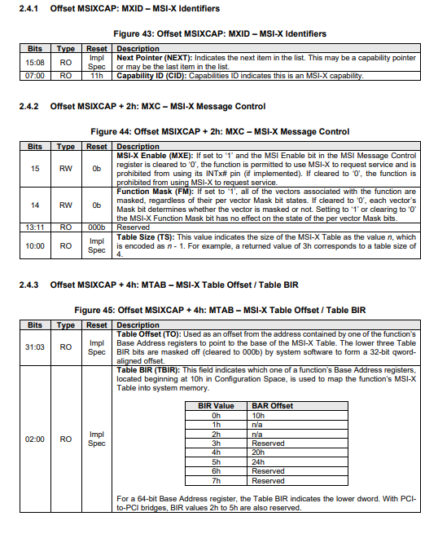
2.4.1 Offset MSIXCAP: MXID – MSI-X Identifiers
This is the "entry point" for the MSI-X capability in the linked list.
  - Bits 15:08: Next Pointer (NEXT)
    - Understanding: Points to the next feature (like PCIe Express Capabilities).
  - Bits 07:00: Capability ID (CID)
    - Understanding: Hardcoded to 11h. When the OS sees 11h, it knows it has found the advanced MSI-X setup.

2.4.2 Offset MSIXCAP + 2h: MXC – MSI-X Message Control
This register acts as the "General Manager" for all the drive's interrupts.
  - Bit 15: MSI-X Enable (MXE)
    - The Master Switch: If set to 1, the SSD uses MSI-X.
    - Crucial Rule: The OS must ensure that "Standard MSI" (Section 2.3) is disabled before enabling this. You can't have both active at the same time.
  - Bit 14: Function Mask (FM)
    - The "Global Mute": If the OS sets this to 1, all interrupts from this SSD are blocked, no matter what. This is like a physical "kill switch" for the drive's ability to talk to the CPU.
  - Bits 10:00: Table Size (TS)
    - Understanding: This tells the OS how many entries (interrupts) are in the drive's interrupt table.
    - The Math ($n-1$): If this register reads 003h, the table size is 4. If it reads 03FFh, the size is 1024.
    - NVMe Context: High-end SSDs often have hundreds of these so every CPU core can have its own dedicated "finish line" for commands.

2.4.3 Offset MSIXCAP + 4h: MTAB – Table Offset / Table BIR
This is perhaps the most technical part of the configuration. Since an MSI-X table can be very large (up to 2,048 entries), it cannot fit in the tiny "Configuration Space" (which is only 4KB). Instead, the table is stored in the Memory Space defined by your BARs.
  - Bits 02:00: Table BIR (TBIR)
    - Understanding: BIR stands for BAR Indicator Register. It tells the OS which BAR contains the table.
    - Look at the Table in the image:
      - 0h means the table is located in the memory range pointed to by BAR0 (the same place the Doorbell registers are).
      - 4h means it's in BAR4.
    - NVMe Context: Most SSDs use BIR = 0h because it keeps the control registers and the interrupt table in the same memory region for efficiency.
  - Bits 31:03: Table Offset (TO)
    - Understanding: This is the "start line" inside that BAR.
    - Example: If BAR0 points to address 0x90000000 and the Table Offset is 0x2000, the OS knows the MSI-X table actually starts at 0x90002000.

Why this is a "Level Up" for your work at Toshiba:
In the previous MSI section, you saw that all interrupts shared one address. In MSI-X, because there is a Table, the OS can give every single interrupt its own unique destination.
  - Queue 1 (assigned to CPU Core 0) sends an interrupt to Address A.
  - Queue 2 (assigned to CPU Core 1) sends an interrupt to Address B.
This prevents "Interrupt Storms" where one CPU core gets bogged down doing all the work while others sit idle. By understanding the BIR and Table Offset, you can debug exactly where the hardware is looking for its "instructions" on how to ring the CPU's doorbell.

