INT404 – ARTIFICIAL INTELLIGENCE



SUBMISSION REPORT

Project Title: AI in Fashion Industry

# Submitted by:

|  |  |  |
| --- | --- | --- |
| **Name** | **Reg. No.** | **Roll No.** |
| V Abhinav Reddy | 12100397 | 52 |
| Ramavath Sanjay | 12113173 | 04 |
| Ashish Bharti | 12109333 | 28 |

**Submitted to:** Ankita Wadhawan mam.

nitesh

|  |
| --- |
| INDEX PAGE N0 |
| 1. **Acknowledgement 3** |
| 2. **Abstract 3** |
| 3. Introduction 4 |
| 4. Data Set 4 |
| 5. **Advantages And Disadvantages 5** |
| 6. **Human intelligence VS Artificial intelligence 6** |
| 7. **OUTPUTS 7** |
| 8. **CODE EXPLANATION 7** |
| 9. **CONCLUSION 8** |
| 10.**REFRENCES 9** |

**Acknowledgement:**

I would like to express my sincere gratitude to the advancements in Artificial Intelligence (AI) that have revolutionized the fashion industry. The integration of AI in fashion has not only led to improved efficiency but has also enabled fashion businesses to offer personalized experiences to their customers.

AI-powered tools such as virtual assistants, chatbots, and recommendation engines have significantly transformed the way we shop for clothes. By analyzing customer data, AI algorithms can predict the customer's preferences, sizes, and styles, making online shopping a more personalized and hassle-free experience.

Moreover, AI-powered visual search engines have enabled customers to find similar styles or items just by taking a picture or uploading an image, making the search process much faster and more efficient.

Therefore, I would like to acknowledge the significant contributions of AI to the fashion industry, and I believe that the future of fashion will continue to be shaped by the advancements in AI technology.

**Abstract:**

Artificial Intelligence (AI) has the potential to revolutionize the fashion industry by transforming the entire value chain from design and production to retail and marketing. With the help of AI algorithms, fashion designers can create better products that cater to the needs and preferences of their target audience. AI can also optimize inventory management and supply chain operations, enabling businesses to reduce waste and increase efficiency.

AI-powered virtual try-on technology enhances the online shopping experience by enabling customers to try on clothes and accessories without physically visiting a store. Personalization at scale is also possible with the help of AI, allowing brands to create personalized recommendations and tailored experiences for each customer.

Furthermore, AI can help identify counterfeit products, protect intellectual property rights, and enhance sustainability in the fashion industry. As AI technology continues to advance, we can expect to see more innovative applications of AI in fashion that will benefit both businesses and customers.

# Introduction

Artificial intelligence (AI) has been increasingly used in the fashion industry in recent years, revolutionizing the way we shop, design, and manufacture clothing. From product recommendations to personalized styling, AI has the potential to transform the fashion industry by improving the shopping experience, reducing waste, and increasing efficiency.

One of the most popular applications of AI in the fashion industry is the use of machine learning algorithms to analyse large amounts of data, such as social media trends, customer behaviors, and sales data, to predict fashion trends and consumer demand. This enables designers and retailers to make data-driven decisions on what products to create and stock, reducing the risk of overstocking or understocking and minimizing waste.

* Technologies in AI in fashion industry
  1. **Recommendation systems**: These use machine learning algorithms to analyze customer data and provide personalized product recommendations. This can help fashion retailers increase sales and improve customer satisfaction.
  2. **Virtual try-on**: This technology allows customers to try on clothes virtually, using augmented reality (AR) or 3D modeling. This can help customers make more informed purchase decisions and reduce the rate of returns.
  3. **Sustainability**: AI can be used to help fashion brands improve their sustainability efforts, for example by identifying ways to reduce waste or improve the environmental impact of production processes.

# Data Set:

Data set used in making machine learning and ai model is from below link https://[www.kaggle.com/datasets/zalando-research/fashionmnist](http://www.kaggle.com/datasets/zalando-research/fashionmnist)

Artificial intelligence (AI) has the potential to revolutionize the fashion industry in a number of ways. Here are some advantages and disadvantages of using AI in fashion:

**Advantages:**

1. Personalized Shopping Experience: AI can be used to analyze customer data and provide personalized recommendations based on their preferences and purchasing history. This can improve the shopping experience for customers and increase their satisfaction.
2. Design and Production Efficiency: AI can assist in designing and creating new products quickly and efficiently. By analyzing customer trends and preferences, AI can help designers create clothing and accessories that are more likely to be successful.
3. Improved Inventory Management: AI can help retailers manage their inventory more efficiently, reducing waste and increasing profits. By analyzing sales data and predicting demand, retailers can order the right amount of stock and avoid overstocking.
4. Enhance Sustainability: AI can help the fashion industry become more sustainable by predicting and reducing waste in production and helping to create more sustainable materials.

**Disadvantages:**

1. Lack of Creativity: While AI can help improve efficiency and accuracy in certain aspects of the fashion industry, it may lack the creativity and intuition of human designers.
2. Limited Input Data: AI algorithms can only analyze the data that they are given, which may not capture the full range of customer preferences and behaviors.
3. Cost: The implementation of AI technologies can be expensive, and many smaller fashion companies may not have the resources to invest in them.
4. Ethical Concerns: There are concerns about the ethical implications of using AI in the fashion industry, including issues related to privacy and potential job losses for human workers.

**Human intelligence VS Artificial intelligence:**

Human intelligence and artificial intelligence both have their own strengths and weaknesses when it comes to the fashion industry. Here are some key differences between human and artificial intelligence in fashion:

**1.Creativity:**

Humans have a natural ability to think creatively and outside of the box, which is essential in the fashion industry where trends are constantly evolving. While AI can help with certain aspects of the creative process, such as identifying patterns and predicting trends, it may lack the ability to come up with truly unique and innovative designs.

**2.Efficiency:**

AI can analyze data and identify patterns much faster and more accurately than humans, which can lead to more efficient production processes and faster turnaround times. However, humans may be better equipped to deal with unexpected challenges or changes in the production process.

**3.Personalization:**

Humans can provide a more personalized experience for customers, as they are able to take into account individual preferences and style. AI can provide recommendations based on data analysis, but it may not be able to provide the same level of personalization as a human stylist or sales associate.

**4.Ethics:**

There are ethical considerations when it comes to using AI in the fashion industry, including issues related to privacy and potential job losses for human workers. Additionally, there are concerns about the impact of fast fashion on the environment and human rights, which AI may not be equipped to address on its own.

Overall, while AI can be a powerful tool in the fashion industry, it is unlikely to completely replace human intelligence and creativity. Instead, the most successful fashion companies will likely find ways to integrate AI into their existing processes and workflows in a way that complements and enhances human skills and abilities.

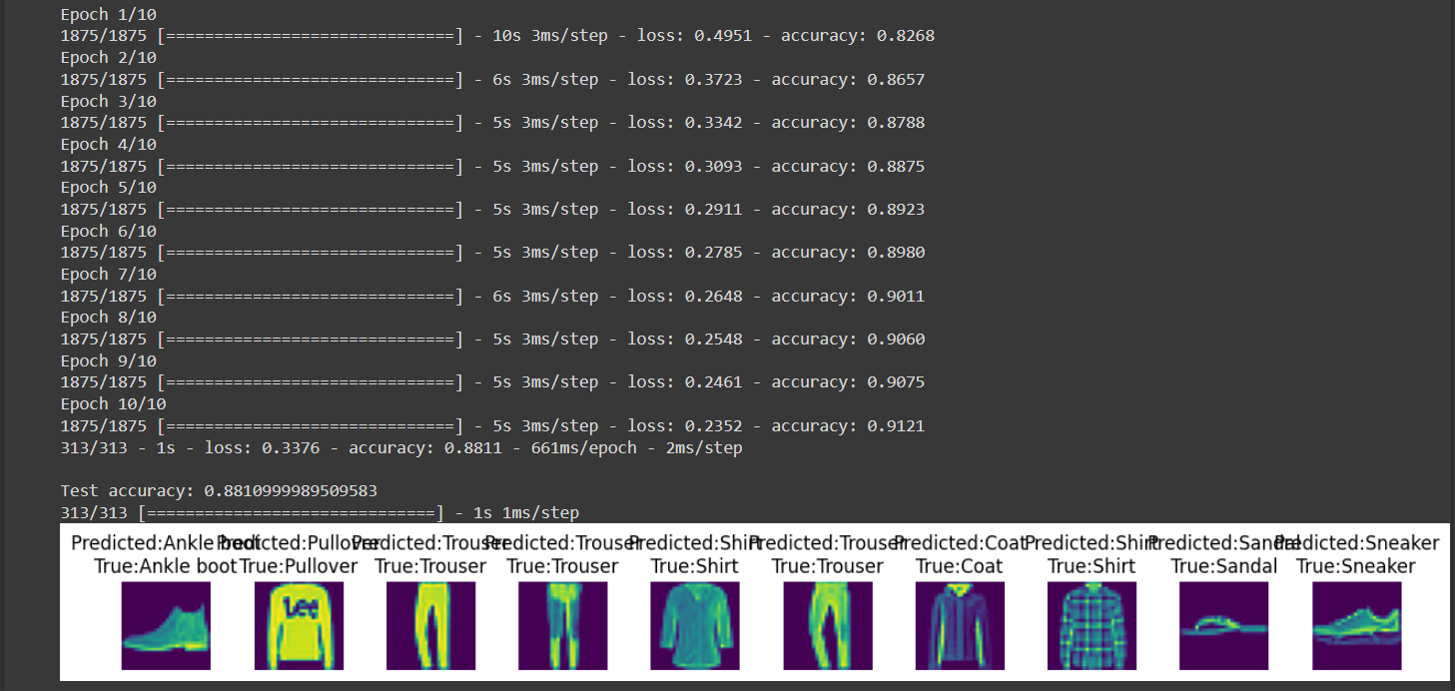**OUTPUTS:**

**CODE EXPLANATION:**

This code uses TensorFlow to build and train a neural network to classify images of clothing from the Fashion MNIST dataset. Here is an overview of each section:

1. Import necessary libraries: The code imports TensorFlow, Keras (a high-level API for building and training neural networks), NumPy (a library for numerical computing), and Matplotlib (a library for plotting graphs and charts).
2. Load the Fashion MNIST dataset: This code loads the Fashion MNIST dataset, which consists of 70,000 grayscale images of clothing items in 10 categories.
3. Define class names: The code defines a list of class names corresponding to the 10 categories in the dataset.
4. Preprocess the data: This code scales the pixel values of the images between 0 and 1 to normalize them.
5. Build the model: This code defines a sequential neural network with two layers: a flattened input layer and a dense layer with 128 neurons and a ReLU activation function.
6. Compile the model: This code compiles the model using the Adam optimizer, SparseCategoricalCrossentropy loss function, and accuracy as the evaluation metric.
7. Train the model: This code trains the model using the training data for 10 epochs.
8. Evaluate the model: This code evaluates the model's performance on the test data and prints the test accuracy.
9. Make predictions: This code uses the trained model to make predictions on the test images.
10. Plot the results: This code plots the first 10 test images, their predicted labels, and the true labels using Matplotlib.

The output of this code is a plot of the first 10 test images with their predicted and true labels displayed underneath them. The accuracy of the model on the test set is also printed.

**CONCLUSION:**

* In this Report, we discussed the role of AI in the fashion industry. We highlighted some of the benefits of AI in fashion, such as increased efficiency, cost savings, and improved customer experiences, and provided specific examples of how these benefits have been realized in the industry. We also discussed some of the challenges of implementing AI in fashion, such as data privacy concerns, bias in algorithms, and technological barriers, and provided specific examples of how these challenges have been addressed by industry leaders.
* Looking to the future, AI is expected to continue to play a significant role in the fashion industry. We can expect to see further advancements in the development of AI-powered tools, such as virtual try-on and product recommendation systems, that will enhance the customer experience and improve operational efficiency. Additionally, AI can be used to improve sustainability in the fashion industry by optimizing the supply chain, reducing waste, and lowering carbon emissions.
* Overall, AI has already begun to revolutionize the fashion industry, and we can expect to see even more exciting developments in the years to come. By embracing AI and addressing the challenges that come with its implementation, the fashion industry can continue to grow and innovate in exciting new ways.

**References:**

**1.Google**

**2.W3SCHOOL**

**3.Kaggle**

**4.GFG**