[Computers and Chemical Engineering 180 (2024) 108476](https://doi.org/10.1016/j.compchemeng.2023.108476)



Contents lists available at [ScienceDirect](https://www.elsevier.com/locate/cace)

Computers and Chemical Engineering

journal homepage: [www.elsevier.com/locate/cace](http://www.elsevier.com/locate/cace)

[](http://crossmark.crossref.org/dialog/?doi=10.1016/j.compchemeng.2023.108476&domain=pdf)Artificial intelligence for enhanced flotation monitoring in the mining industry: A ConvLSTM-based approach

Ahmed Bendaouia a,b,∗, El Hassan Abdelwahed a, Sara Qassimi d, Abdelmalek Boussetta c,

Intissar Benzakour c, Oumkeltoum Amar b, Oussama Hasidi a,b

a *Computer Systems Engineering Laboratory (LISI), Computer Science Department, Faculty of Sciences Semlalia, Cadi Ayyad University, Marrakech, Morocco*

b *Analytics Lab, Mohammed VI Polytechnic University, Rabat, Morocco*

c *R&D and Engineering Center, Reminex, Managem Group, Marrakech, Morocco*

d *Computer and Systems Engineering Laboratory (L2IS), FSTG, Cadi Ayyad University, Marrakech, Morocco*

A R T I C L E I N F O A B S T R A C T

*Keywords:*

Deep learning Flotation froth Mining industry 4.0 Real time Monitoring

Chemical composition

In the mining industry, accurate monitoring of the elemental composition in the flotation froth is crucial for efficient minerals separation. The hybrid deep learning algorithms offer powerful computational intelligence for real-time monitoring of froth quality in flotation processes. This soft sensor tool can provide valuable information for process control, including predictions of the elemental chemical composition. In this study, we propose a novel approach based on a Convolutional Long Short-Term Memory (ConvLSTM) neural network for real-time monitoring of chemical composition grades in flotation froth. The proposed model effectively extracts spatial and temporal patterns from video data, providing a better understanding of the dynamic behavior of the froth surface in flotation processes. Our proposed approach includes a deployment architecture that enables real-time monitoring of elemental concentrate grades, allowing for the adjustment of flotation parameters for accurate process efficiency.

The results of our study show that The proposed approach is accurate, with a mean absolute error (MAE) of 4.52 in the cleaners of the zinc differential flotation circuit. The use of the ConvLSTM neural network provides an accurate and reliable model for monitoring the flotation froth quality. The proposed approach has the potential to improve the operational performance and efficiency of complex polymetallic flotation circuits in mineral processing. Additionally, we propose a deployment architecture in the industrial scale of a differential flotation circuit. This architecture offers advantages such as portability, scalability, consistency, and isolation for efficient use for the flotation monitoring. This study demonstrates the potential of using a deployed deep learning model to provide a practical and efficient solution for real-time monitoring of flotation froth quality in the mining industry. This approach can be used to optimize the flotation process and increase productivity, potentially leading to significant flotation performances improvement and cost saving for mining companies.

# Introduction

The mining industry has been experiencing a significant increase in mineral reserve consumption owing to the depletion of existing resources and unforeseeable decreases in raw materials. To address these challenges, there is a growing demand for innovation across various mining operations, such as exploration, processing, logistics, and marketing. The emergence of Industry 4.0 has further hastened the drive towards innovation, with the integration of digital technologies and physical systems, leading to the development of smart factories that are highly efficient and productive (Rao et al., 2022). Consequently, the

mining industry has undergone a transformation, with a greater em- phasis on the use of disruptive technologies (Qassimi and Abdelwahed, 2022) to improve productivity, efficiency, and safety (Fig. 1). This shift towards a ‘‘Smart Mine’’ has been propelled by advancements in arti- ficial intelligence, machine learning, and data analytics, which enable mining firms to gather and analyze vast amounts of data in real-time, leading to improved operational performances and better decision- making. The mining industry has been slow in adopting these emerging technologies, despite the vast potential for increased productivity and

∗ Corresponding author at: Computer Systems Engineering Laboratory (LISI), Computer Science Department, Faculty of Sciences Semlalia, Cadi Ayyad University, Marrakech, Morocco.

*E-mail address:* [ahmed.bendaouia@ced.uca.ma](mailto:ahmed.bendaouia@ced.uca.ma) (A. Bendaouia).

<https://doi.org/10.1016/j.compchemeng.2023.108476>

Received 7 June 2023; Received in revised form 19 October 2023; Accepted 21 October 2023

Available online 27 October 2023

0098-1354/© 2023 Elsevier Ltd. All rights reserved.

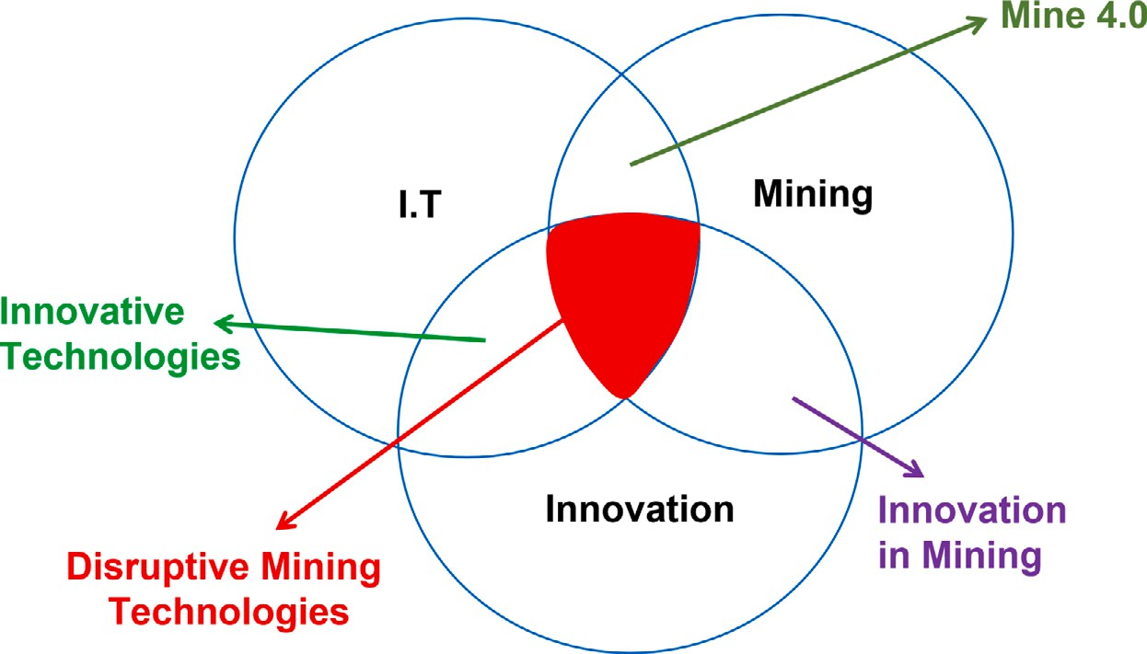

**/ig. 1.** Disruptive mining technologies.

efficiency. However, recent studies have demonstrated that the incorpo- ration of these innovative solutions can lead to significant benefits. For example, the use of artificial intelligence in mineral processing has been shown to improve the accuracy and reliability of concentrate grade measurements, leading to more efficient mineral separation (Annamalai and Gurumurthy, 2020). The application of machine learning in predic- tive maintenance has permitted a reduction of equipment downtime, leading to increased productivity and profitability. Additionally, the use of autonomous vehicles in mining has enhanced worker safety, as it eliminates the need for miners to work in hazardous and chal- lenging environments. Therefore, it is essential to continue exploring and implementing these technologies to enhance mining operations’ sustainability, competitiveness, better decision-making and improved operational performances (Xu et al., 2021).

The use of artificial intelligence in the mining industry is a key component of the push towards a ‘‘Smart Mine’’. In this context, our study is part of a larger project known as the ‘‘Smart Connected Mine’’ (See Fig. 2), which involves collaboration between academic institutions, research centers and industrial companies in Morocco to develop innovative solutions in the mining industry based on artificial intelligence. The aim of this consortium is to achieve process optimiza- tion, improve operator safety in the underground mines (Clero et al., 2022; Imam et al., 2023), increase energy efficiency (Hasidi et al., 2022), enable predictive maintenance of industrial machines (Rihi et al., 2022), and develop efficient solutions throughout the mining production chain (Bendaouia et al., 2022). This project aligns with the goals of the Fourth Industrial Revolution (Industry 4.0), which seeks to integrate advanced technologies and Process Systems Engineering (PSE) into all aspects of industry to model, analyze, optimize, and control physicochemical and metallurgical systems, providing a foundation for addressing challenges in energy, environment and sustainability (Pis- tikopoulos et al., 2021). As part of the ‘‘Smart Connected Mine’’ project, we investigate the application of artificial intelligence for real-time monitoring and control of chemical composition grades in the flota- tion froth. The proposed approach, which uses Convolutional Long Short-Term Memory (ConvLSTM) neural networks, has the potential to improve operational efficiency in complex polymetallic flotation circuits, contributing to the sustainability; by saving raw materials, and profitability; by improving recovery, concentrate quality and optimiz- ing the chemical reagents during the flotation. Flotation separation is a mineral processing method that has gained attention in mining industry for its ability to extract valuable minerals from ores. This method exploits the differences in surface properties of minerals and gangue elements for their separation. To further optimize flotation monitoring, this study proposes a new monitoring technique based on artificial intelligence. With the backdrop of the digital transformation of the

mining industry and the need for increased productivity and efficiency, this proposed innovative solution has the potential to offer a more accurate and reliable monitoring technique. Our proposed monitoring solution uses ConvLSTM neural networks, a type of artificial intelli- gence that combines the properties of Convolutional Neural Networks (CNNs) and Long Short-Term Memory (LSTM) networks, to extract spatial and temporal patterns from flotation froth. This approach has the potential to contribute to the sustainability and profitability of the mining activities by improving operational performance and reducing costs.

The proposed approach focuses on monitoring the flotation froth and provides a low-cost and low-maintenance solution that enables real-time measurement of chemical composition grades. To achieve this goal, the study employs artificial intelligence and deep learning tech- niques in the mineral processing flotation-based. The present article is organized into five sections, including an introduction that outlines the research context. The state of the art in flotation froth monitoring and the use of deep learning techniques is presented in Section 2. The methodology employed, data types, preprocessing steps, model architecture, and experimental process are described in Section 3. The results section provides the application of the proposed approach for the identification of the final concentrate grades in the Zinc froth flotation along with the performance evaluation, discussion of the findings and the deployment architecture. The final section is dedicated to conclusion and perspectives. The study’s findings demonstrate the potential of artificial intelligence to optimize flotation monitoring and improve efficiency and productivity in the mining operations.

# /lotation monitoring techniques: Challenges and opportunities

* 1. *Existing flotation monitoring techniques*

Accurate monitoring of the flotation concentrate grades is crucial for the optimization and control of the flotation process. There are several existing monitoring techniques, but they can be expensive to implement and may have high maintenance requirements in addition to their latency. One of the most used techniques is laboratory analysis, specifically the Atomic Absorption (AA) method, which is considered among the most accurate analysis techniques. However, it has lim- itations because it is a lengthy process that requires several stages before proceeding to analysis, including sample collection, drying, preparation, and analysis, leading to latency issues. Another technique is the online analysis control method using X-ray fluorescence (XRF) detection, specifically the XRF-based Courier 6G, which is used at the Compagnie Minière de Guemassa (CMG) flotation factory where this study was conducted. This method can measure up to six individual

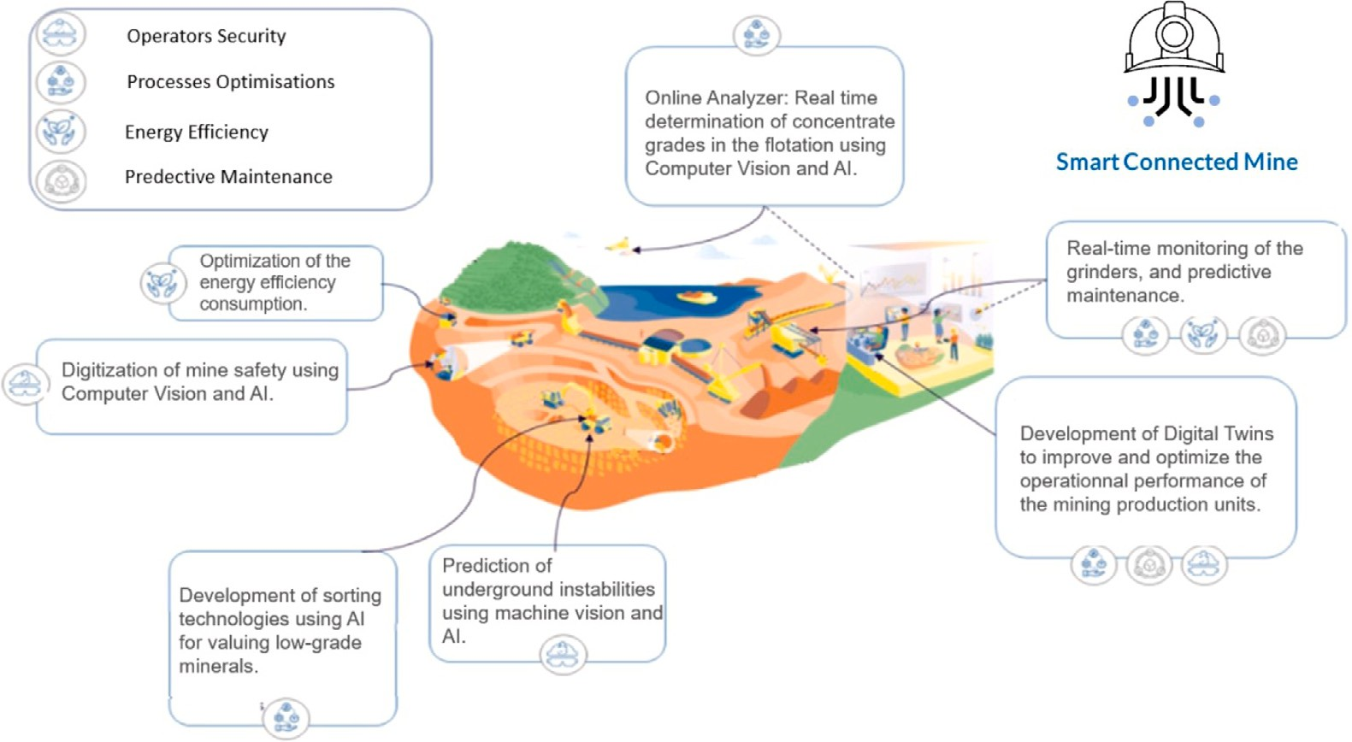

**/ig. 2.** The different research and development axis of the Smart Connected Mine project.

process streams, making it suitable for monitoring complex polymetal- lic flotation circuits that contain lead, copper, iron and zinc. However, XRF analysers require continuous and high-cost maintenance and suffer from insufficient detection of lightweight materials (Uusitalo et al., 2020).

Despite the usefulness of laboratory analysis and XRF-based mon- itoring techniques, they have certain limitations that affect their ef- fectiveness. Laboratory analysis can lead to inaccurate results and latency issues, while XRF analysers require continuous and high-cost maintenance and have insufficient detection of lightweight materials. Additionally, these techniques have limited capability for real-time monitoring, making them less useful for rapid response in dynamic flotation processes. These limitations create the need for alternative monitoring techniques that are cost-effective, low-maintenance, and provide real-time measurement of the chemical composition grades. In recent years, machine vision-based monitoring techniques using deep learning have emerged as a promising alternative for flotation moni- toring, leveraging the visual characteristics of the froth surface (Aldrich et al., 2022; Citir et al., 2004).

* 1. *Enhancing flotation control through predictive monitoring*

The integration of manipulated and independent variables holds the potential to yield a more comprehensive and accurate model, capable of capturing the intricate interplay of factors affecting flotation performance. As we explore avenues for control actions, we are actively considering the implementation of advanced control strategies that harness the predictive capabilities of our model. Through the amalga- mation of image properties and process variables within our combined model, we can potentially formulate control actions aimed at sustaining the desired concentrate grades amidst varying operational conditions. Such an approach stands to contribute significantly to process stability enhancement, heightened operational efficiency, and the mitigation of variations in the final product.

It is important to note, however, that immediate control actions

may not always be feasible within the dynamic context of an operating flotation site. Therefore, we propose the utilization of our predictive monitoring system for real-time monitoring of concentrate grades. This approach, while not directly effecting control, offers valuable insights for industrial applications. By providing continuous and up-to-date information on concentrate grades, our system serves as a crucial tool for monitoring and optimizing the flotation process within an industrial setting, enabling timely adjustments and informed decision-making.

* 1. *Applications of deep learning in flotation monitoring*

Over the years, it has been widely accepted in literature and practi- cal experience that the visual features of the froth surface are strongly correlated with the quality of the flotation froth (Aldrich et al., 2022; Liu et al., 2020; Farrokhpay, 2011; Kaartinen et al., 2006). Machine Vision-based solutions for flotation monitoring have emerged as a cost-effective and low-maintenance alternative. In addition, visual in- spection of the flotation froth allows for real-time measurement of chemical composition grades, which is an improvement over current monitoring techniques such as XRF-fluorescence and laboratory analy- sis. Artificial Neural Networks (ANNs) are used to achieve maximum extraction rates of valuable elements (Annamalai and Gurumurthy, 2020). Convolutional Neural Networks (CNN) are widely used for froth classification due to their capacity to extract rich hierarchical sets of features from images (Zhang and Gao, 2021; Zarie et al., 2020; Cao et al., 2022; Wen et al., 2021). The ability of CNNs to extract features from froth images for classification has been found to be more accurate than classical Machine Learning methods in determining chemical com- position grades with supervised features extraction from the flotation froth (Bendaouia et al., 2022). CNNs are also used for flotation froth segmentation and bubble size measurement (Gharehchobogh et al., 2023). Long Short-term-memory based (LSTM) networks have also been used for mineral grade monitoring using flotation froth video sequences (Zhang et al., 2021). LSTM architecture has been applied in various fields, such as damage detection in pipelines (Huang et al., 2022), anomaly detection for technical systems (Lindemann et al., 2021), investigation of process engineering problems (Aliabadi et al., 2020), and predicting electric power consumption (Cascone et al., 2023). LSTM was employed in conjunction with froth image features to construct phenomenological models aimed at describing the underlying physicochemical principles of the flotation process (Sun et al., 2021). Researchers and engineers have benefited from LSTM’s ability to extract temporal patterns in time series data.

In this study, we propose the use of ConvLSTM, a type of neural network that combines the properties of CNNs and LSTMs. The use of ConvLSTM allows the model to analyze both spatial and temporal patterns in image data, making it useful for understanding the dy- namic behavior of the froth surface in flotation processes. The froth flotation video sequence is considered temporal information that can improve monitoring accuracy. By employing ConvLSTM, we created a more accurate and reliable model for monitoring and controlling the flotation froth quality. The following sections of the paper will detail the methodology and the results of our proposed solution.

* 1. *Image analysis for concentrate grades monitoring*

Image analysis has emerged as a powerful tool for real-time mon- itoring and predictive assessment of concentrate grades in various flotation processes. Numerous research efforts have been dedicated to harnessing image analysis for Zinc concentrate grade prediction in single column flotation (Zhang et al., 2023b). The tailing grade and flotation recovery were also a matter of study as a key per- formance index in addition to the concentrate grade (Zhang et al., 2022). Studies have investigated froth image characteristics, such as texture, bubble size and color variations to develop predictive models for concentrate grade (Zhang et al., 2023a; Nakhaei et al., 2023; Aldrich et al., 2022). The application of image analysis in froth flotation has demonstrated its efficacy in estimating the concentrate grades. By analyzing froth images, researchers have established correlations between froth characteristics and Coal (Tan et al., 2016), Iron (Zhang et al., 2022), Copper (Wang et al., 2022), Zinc and Lead compositions in single column flotation (Zhang et al., 2020; Popli et al., 2018). These findings have led to the development of predictive models that aid in achieving improved chemical recovery rates and enabling ac- curate predictions of the chemical composition, and contributing to enhanced process optimization. While the aforementioned studies have significantly advanced the application of image analysis for concen- trate grades monitoring in single column flotation, our study takes a pioneering step by addressing the intricate challenge of predicting chemical composition within a complex differential flotation site. This novel context involves the simultaneous processing of multiple miner- als, including Zinc, Lead, Iron, and Copper, through distinct flotation circuits. This research introduces ConvLSTM to tackle this complex scenario. By extending the application of CNN and LSTM to complex differential flotation, our study transcends the boundaries of single mineral prediction, offering a comprehensive solution for accurate, real-time prediction of multiple mineral grades. This study is addressing the challenge of predicting chemical composition within a complex differential flotation site, ushering in a new era of advanced process optimization and monitoring in the mining sector.

# Methodology

The differential flotation circuits at CMG (Compagnie Minière de Guemassa; a subsidiary of Managem group in Morocco), process a com- plex ore in order to valuate the three elements Lead (Pb), Copper (Cu), and Zinc (Zn). Each element has a specified flotation circuit containing roughing, scavenging, and cleaning stages in the flotation process to maximize the grade and recovery of valuable minerals and separate them from the gangue. In this study, we focus on the cleaners of the Zinc flotation circuits (Fig. 3) as it represents the final concentrate of the differential flotation of CMG.

The froth flotation process is a complex physio-chemical process that is influenced by several parameters (Rajapakse et al., 2022) (Fig. 4). Mineralurgist operators monitor the flotation froth’s color and texture to determine the mineral types and assess the flotation performance (Aldrich et al., 2022; Farrokhpay, 2011). In this study, we propose a digital approach that replicates the expertise of human operators in visually monitoring the flotation froth. Our approach uses Convolutional Long Short-Term Memory (ConvLSTM) networks to process video frames of the froth and extract sequential characteristics. By identifying the mineral types based on the color and texture of the froth surface, this approach enables a more accurate assessment of the froth chemical composition and optimization of the flotation process.

* 1. *Experimental process*

To estimate the concentrate grades in flotation cells using a ConvL- STM network, we followed the experimental process below:

* + - Data Collection: We collected a large dataset of labeled video frames of the flotation froth of the Zn circuit. Each video frame was labeled with the corresponding percentages of the four chem- ical elements (Zn, Cu, Fe, and Pb) in the flotation froth.
    - Data Preprocessing: The collected video frames were preprocessed by resizing them to a consistent size and format and splitting them into sequences of frames that could be used as input to the ConvLSTM network.
    - Model Architecture: The model architecture was defined using the Sequential class, and the hyperparameters were selected after several training and evaluation operations.
    - Model Training: The model was trained using the labeled video sequences as input and the corresponding percentages of the minerals as output. The model was trained for several epochs using the Adam optimizer and the mean squared error (MSE) as the loss function.
    - Model Evaluation: The trained model was evaluated using a sep- arate test dataset of video sequences and corresponding elements percentages. We used metrics such as accuracy and mean squared error to measure the model’s performance.
    - Model Deployment: The trained model was deployed for use in the flotation froth cells to predict the concentrate grades of the elements in real-time. The predictions were utilized for moni- toring the flotation process and improving the efficiency of the separation of the minerals.
  1. *Data collection and sample analysis procedure*

We collected a real-world dataset from the differential flotation circuits of the industrial complex of CMG, a subsidiary of Managem group in Morocco as shown in Fig. 5. The dataset includes visual aspect parameters and the chemical elemental grades of Pb, Cu, Zn, and Fe (Fig. 6). During the data collection phase, we collected a sample from the flotation froth and analyzed it in the laboratory using atomic absorption. Additionally, we recorded a video of the flotation froth using an RGB camera under stable luminosity to capture the visual aspect parameters (Fig. 7).

The data employed in this study were organized in sequences con- sisting of seven consecutive frames, each representing a specific time interval. Each sequence was accompanied by a corresponding set of la- bels denoting the concentrations of Cu, Pb, Fe, and Zn. The dataset was collected over a continuous span of six consecutive months. During a period of two days, equivalent to six shifts, the data was randomly split for training and testing purposes. Specifically, within this timeframe, four shifts were allocated for training data, one shift for testing data, and the remaining shift for validation data. This partitioning strategy ensures the effectiveness of the models in capturing temporal dynamics and the process changes while maintaining a balance between training and testing samples.

The distribution of froth properties on the surface is a potential chal- lenge related to representativeness, especially when capturing images from a relatively small area. To address this issue, we conducted a thorough assessment of various areas on the froth surface and metic- ulously compared their characteristics. The aim was to identify the area that best encapsulates the overall behavior and properties of the froth. Following our comprehensive evaluation of multiple regions across the froth surface, we have obtained a mean value of 42.65 for Zinc concentrate, accompanied by a standard deviation of 0.37. These outcomes have informed our decision to synchronize our data augmentation approach with the imperative of achieving representa- tiveness. This involved analyzing the dynamics of bubble movement, froth velocity, and distribution patterns across the entire surface. This selection process aligned closely with industrial practices. We opted to capture images from the same area where industrial practitioners routinely take their samples for monitoring purposes. This approach ensures alignment between our analysis and the practical context of

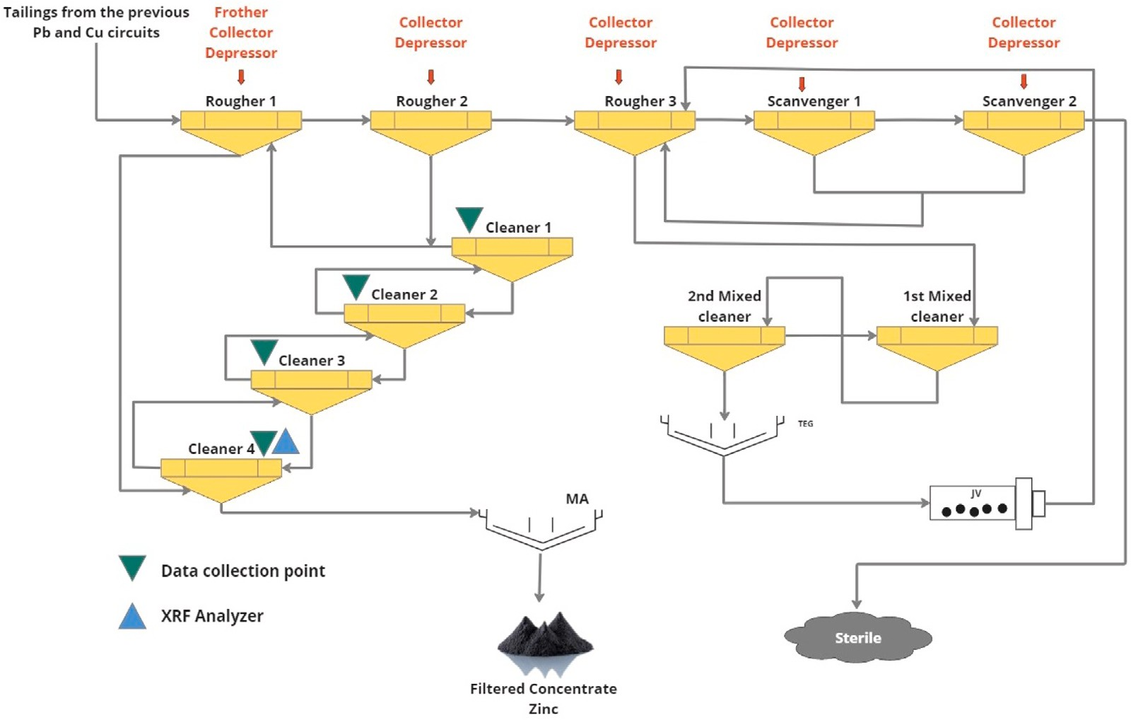

**/ig. 3.** The Zinc flotation circuit at Compagnie Minière de Guemassa CMG, Morocco.

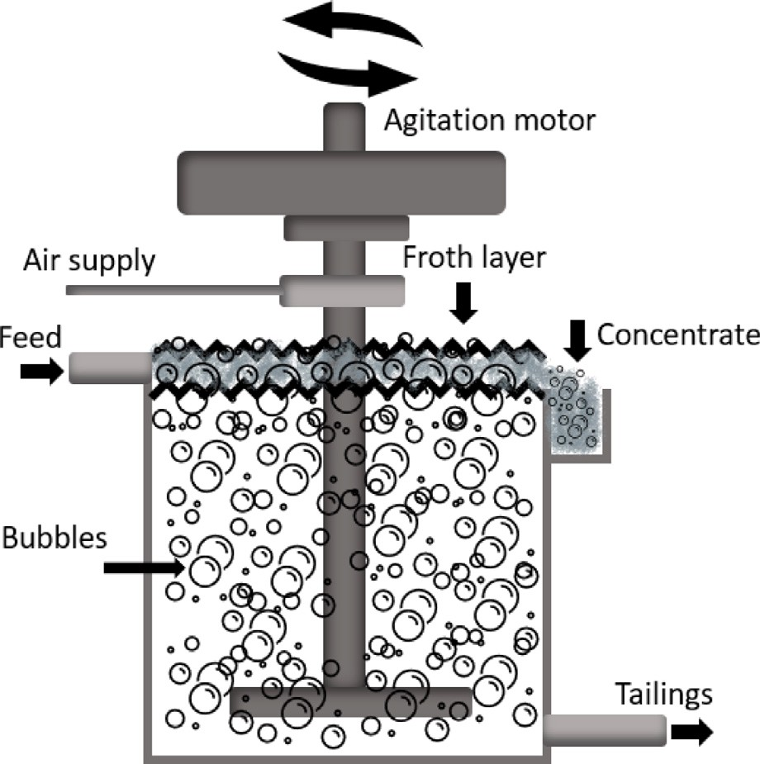

**/ig. 4.** Froth flotation separation technique.

the flotation process. While the selected image area is indeed smaller than the total froth surface, the comprehensive analysis and alignment with industry practices led to a representative area that effectively encapsulates the froth’s behavior and properties.

The procedure for analyzing the samples begins with manual col- lection from the flotation froth. The collected mixture is filtered and rinsed before being dried in an oven at 105 Celsius (Figs. 8, 9). The dried samples are ground into a powdery material and placed into labeled plastic bags for transportation to the Reminex research center for chemical analysis. The reception phase in the laboratory involves three important steps: sample preparation, labeling, and classification of samples. The samples are carefully unpacked, sorted according to their respective test requests, and labeled with unique identification

numbers, test types, and relevant details. The samples are then clas- sified and stored on shelves for easy accessibility during the analysis phase. In the Chemical Preparation Laboratory, the samples undergo preliminary preparation involving attacking the samples with chemical products and agitation. These steps are designed to break down the sample, remove any impurities or unwanted materials, and ensure that the sample is homogeneous for accurate analysis. Once the preliminary preparation process is complete, the samples are ready for analysis, specifically for chemical analysis of Lead, Copper, Zinc and Iron con- centrations, which are taken to the Atomic Absorption Spectrometry laboratory. This technique uses the absorption of light by metallic elements in the sample to determine their concentrations.

* 1. *Enhancing the dataset with data augmentation*

*Samples representation.* To account for the challenges of sample repre- sentation, we conducted a study of the evolution of concentrate grades throughout the two-minute duration of video data collection. This study allowed to capture the dynamic nature of the flotation process and variations in concentrate grades over time. As a result of this analysis, we performed data augmentation with a factor of 0.5, which effectively expands the training dataset by introducing variations and capturing the inherent fluctuations within the process. This artificially increases the dataset size and introduces variability and diversity into the labels, while still preserving the overall structure and meaning of the data. Our dataset comprised 960 video sequences from the industrial com- plex of CMG, a subsidiary of the Managem group. These videos were transformed into sequences of seven frames, each frame characterized by dimensions of 400 × 400 × 3. These sequences served as the input for a recurrent neural network (RNN) developed to predict the concentrations of copper (Cu), iron (Fe), lead (Pb), and zinc (Zn) within the sequences. Following augmentation, the total dataset expanded to encompass 6720 sequences, with a division 3840 for training, 1440 testing and 1440 for validation. Each target value encapsulated the concentrations of Cu, Fe, Pb, and Zn.

*Frame selection.* The selection of the sampling time between frames was informed by the dynamics of the flotation froth within the cleaners of the Zinc circuit. To capture the relevant characteristics and patterns, we set the camera’s frame rate to 49 frames per second (fps). This

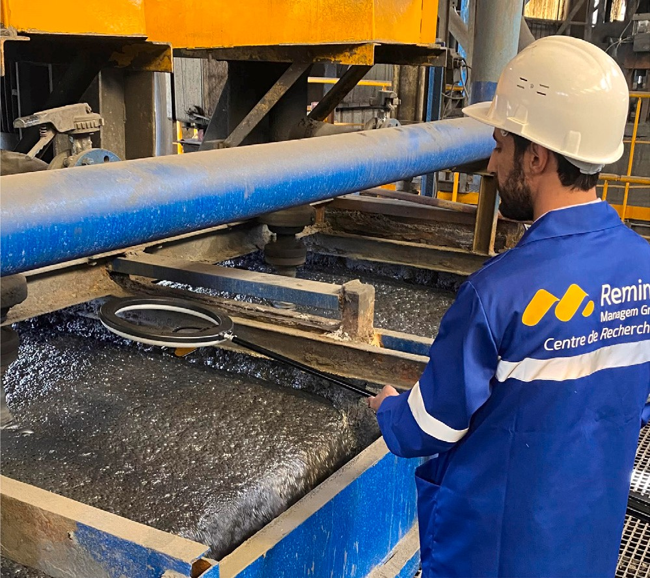

**/ig. 5.** The data acquisition system of the flotation froth videos.

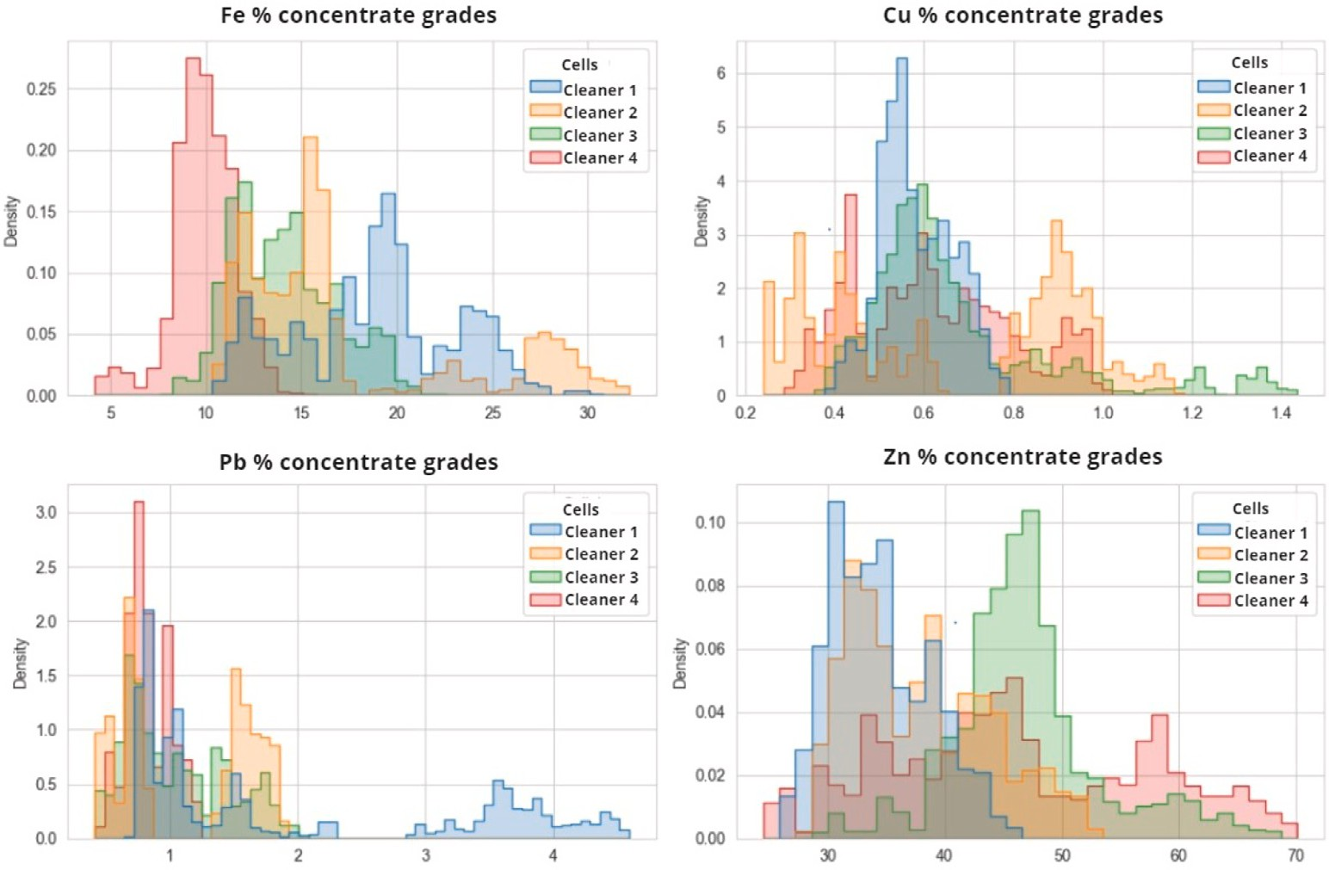

**/ig. 6.** The data distribution of the four targeted elemental compositions Cu, Fe, Pb, Zn.

rate aligns with the velocity of the froth and allows us to gather a comprehensive sequence of images. To have a balance between data volume and meaningful insights, we adopted a strategy of observing 1 frame from every 10 consecutive frames. This approach ensures that we capture the evolution of the froth over time while avoiding excessive redundancy in the dataset.

*Image sequences.* Through the fusion of the seven-frame sequences with the target chemical composition grades, the model adeptly forecasted mineral concentrations by discerning patterns and interdependencies within the data. The deliberate introduction of noise during data aug- mentation contributed to an even more refined model performance. This augmentation strategy provided the model with an enriched array of diverse instances to learn from, ultimately enhancing its accuracy and capacity to respond to various real-world scenarios.

* 1. *ConvLSTM for spatial and temporal pattern extraction*

We implemented a ConvLSTM-based neural network to extract both spatial and temporal patterns from the flotation froth data. ConvLSTM is a type of recurrent neural network that combines the strengths of Convolutional Neural Networks (CNNs) and Long Short-Term Memory (LSTM) networks. This unique combination enables ConvLSTM to pro- cess both spatial and sequential data effectively, making it a powerful tool for tasks such as video prediction and time-series forecasting.

In a ConvLSTM, convolutional operations are applied to the input, forget, and output gates of an LSTM cell. This allows the network to learn spatial and temporal patterns simultaneously. The key equation of ConvLSTM can be formulated as bellow:

𝑖𝑡 = 𝜎(𝑊𝑥𝑖 ∗ 𝑥𝑡 + 𝑊ℎ𝑖 ∗ ℎ𝑡−1 + 𝑊𝑐𝑖 ⊙ 𝑐𝑡−1 + 𝑏𝑖) (1)

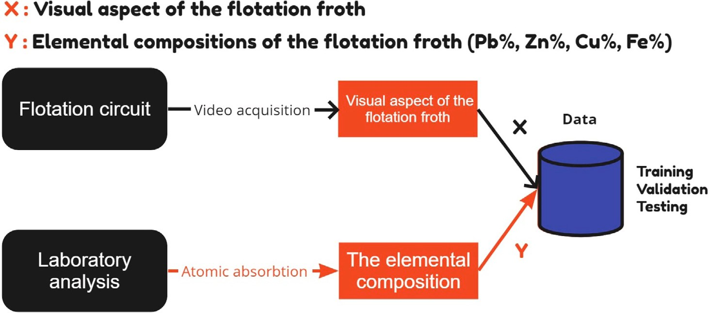

**/ig. 7.** The data sources and types.

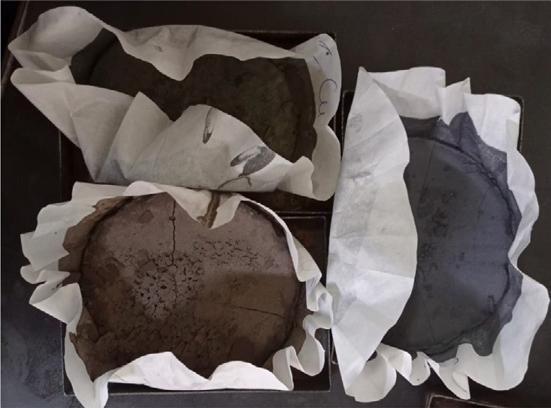

**/ig. 8.** Dried samples under a temperature of 105 degrees Celsius.

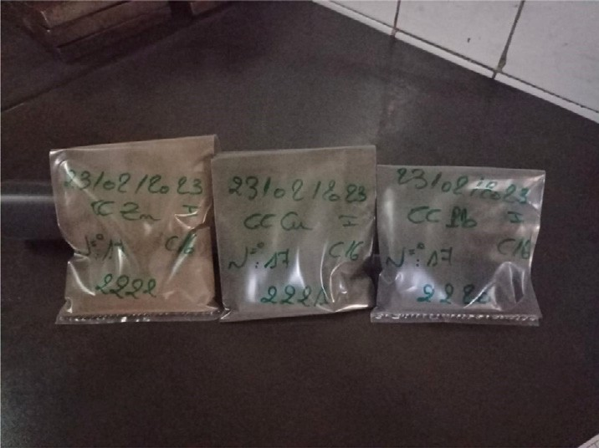

**/ig. 9.** Plastic packaging with the corresponding labels.

Eq. (1): Calculation of the input gate activation (𝑖𝑡) in a Long Short- Term Memory (LSTM) cell. It governs the information to be stored in

the cell state.

𝑓𝑡 = 𝜎(𝑊𝑥𝑓 ∗ 𝑥𝑡 + 𝑊ℎ𝑓 ∗ ℎ𝑡−1 + 𝑊𝑐𝑓 ⊙ 𝑐𝑡−1 + 𝑏𝑓 ) (2)

Eq. (2): Computation of the forget gate activation (𝑓𝑡) in an LSTM cell. It regulates what information from the previous cell state should be

discarded.

𝑐𝑡 = 𝑓𝑡 ⊙ 𝑐𝑡−1 + 𝑖𝑡 ⊙ tanh(𝑊𝑥𝑐 ∗ 𝑥𝑡 + 𝑊ℎ𝑐 ∗ ℎ𝑡−1 + 𝑏𝑐 ) (3)

Eq. (3): Calculation of the new cell state (𝑐𝑡) in an LSTM cell, combining the previous cell state with new information based on the input gate (𝑖𝑡) and forget gate (𝑓𝑡) activations.

𝑜𝑡 = 𝜎(𝑊𝑥𝑜 ∗ 𝑥𝑡 + 𝑊ℎ𝑜 ∗ ℎ𝑡−1 + 𝑊𝑐𝑜 ⊙ 𝑐𝑡 + 𝑏𝑜) (4)

Eq. (4): Determination of the output gate activation (𝑜𝑡) in an LSTM cell, controlling the information to be output from the cell state.

ℎ𝑡 = 𝑜𝑡 ⊙ tanh(𝑐𝑡) (5)

Eq. (5): Computation of the hidden state (ℎ𝑡) in an LSTM cell, which is the cell’s output. It is influenced by the output gate (𝑜𝑡) and the hyperbolic tangent of the cell state (𝑐𝑡).

* 𝑥𝑡 is the input at time step 𝑡
* ℎ𝑡−1 is the hidden state at time step 𝑡 − 1
* 𝑐𝑡−1 is the cell state at time step 𝑡 − 1
* 𝑖𝑡, 𝑓𝑡, 𝑜𝑡 are the input, forget, and output gates, respectively, at time step 𝑡
* 𝜎 is the sigmoid activation function
* ∗ denotes convolution operation
* ⊙ denotes element-wise multiplication
* 𝑊 and 𝑏 are the weight matrices and bias vectors, respectively, for the input, hidden state, and cell state

The ConvLSTM captures underlying spatial features over long se- quences of input data. By using ConvLSTM, this model could effectively capture the complex relationships between the various elements con- centrations in the flotation froth data (Fig. 10). The model could learn and recognize spatial and temporal patterns that are crucial in accu- rately predicting the elemental concentrations. This made it possible to develop a model that could assist in concentrate grades identification in the flotation froth

* 1. *Real-time online application framework for flotation froth analysis*

The online application of our developed model introduces a real- time processing framework for videos captured from the flotation froth.

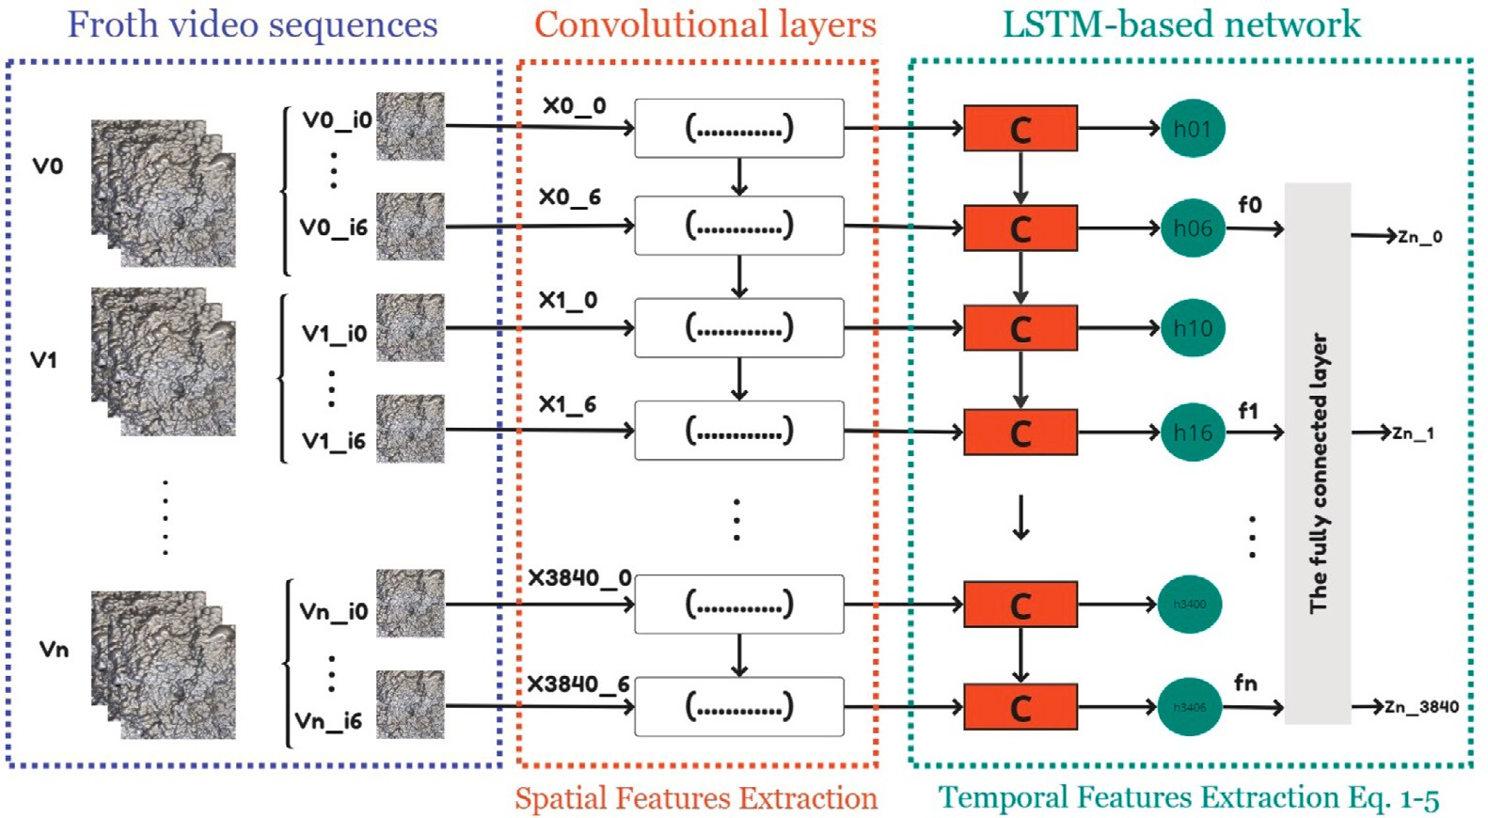

**/ig. 10.** The framework of the LSTM-based mineral grade monitoring system using the froth flotation video data.

Unlike the traditional offline approach where data is analyzed after its collection, the online implementation involves the continuous integra- tion of data into a pipeline that feeds into the predictive model. This allows for instantaneous analysis and prediction of mineral grades as new data becomes available online, ensuring up-to-the-minute insights into the flotation process.

The online prediction in our system is specifically aimed at real- time estimation of chemical compositions. Unlike the offline approach, which can be exemplified by traditional laboratory analyses where a sample undergoes a procedure to determine its chemical composition, our online prediction continually updates the estimated concentrate grades. Specifically, the system refreshes its predictions every 2 s and offers an average of the concentrate grades derived from the most recent 130 s of predictions. The core difference between of- fline and online methodologies hinges on their approach to temporal data analysis. While offline systems accumulate data and analyze it in periodic batches, online systems process data instantaneously as it arrives. This immediacy is vital in industrial contexts where swift responses to dynamic conditions are paramount for optimal process control and enhancement. Complementing this real-time analysis is a graphical user interface (GUI), presenting the immediate predictions visually. Industrial operators can engage with the GUI to track the flotation process’s progression, examine forecasted mineral grades, and evaluate the influence of specific operational factors. Such real-time data visualization empowers industrial staff with the insights needed for on-the-spot decision-making, bolstering the overall efficiency and effectiveness of flotation monitoring.

# ConvLSTM and CNN for the flotation monitoring

* 1. *ConvLSTM model architecture*

The present study aim to develop a predictive model that could de- termine the concentration of zinc (Zn), iron (Fe), copper (Cu), and lead (Pb) elements in flotation cells from video data (Fig. 11). To achieve this objective, we developed a ConvLSTM network architecture that effectively processed both spatial and temporal information present in the video frames and sequences. The model architecture also included several layers, such as BatchNormalization layer, MaxPooling3D layer, Dropout layer, Flatten layer, and Dense layer, to increase the accuracy of predictions. To train the model, we chose the Adam optimizer with a low learning rate of 0.0001 due to its ability to adjust the learning rate for each parameter and prevent overshooting the optimal solution.

The selection of these hyperparameters was the result of an extensive testing and tuning process to achieve the best possible performance of the predictions.

* 1. *CNN model architecture*

The used CNN architecture has an input of 400 × 400 × 3 as height, weight and depth of the images with RGB color channels Fig. 12. The model uses a rectified linear unit (ReLU) activation function, which allows for non-linearity in the model. The Adam optimizer is used for training, with a learning rate of 0.001, which helps the model converge faster. The loss function used is ‘mean absolute percentage error’ which measures the mean absolute percentage error between the predicted and actual values. The batch size used is 32, which means that the model updates its parameters after processing 32 images. The model is trained for 100 epochs using a GPU. The model has a total of 47,538,628 trainable parameters, which represents the number of weights and biases that are updated during the training.

* 1. *Performance evaluation*

The developed models were trained on froth flotation image data collected from the cleaners of the Zn flotation circuits. We used a separate test dataset to evaluate the performance of the ConvLSTM model in predicting chemical composition grades. We evaluated the model’s performance using various metrics, including accuracy, mean squared error (MSE) and mean absolute error (MAE). The evaluation is crucial for this study because it allows us to determine the model’s accuracy in predicting the chemical composition grades and to identify the key factors that influence the model’s performance. As new data is collected, it is essential to assess the model’s performance to ensure that it continues to make accurate predictions.

Fig. 13 shows a comparison between the measured and predicted chemical composition grades using the proposed ConvLSTM and CNN- based network. The results indicate that the model accurately predicted the chemical composition grades, as the measured and predicted values were highly correlated. Additionally, Table 1 presents the evaluation metrics of the ConvLSTM and CNN models, which shows that the ConvLSTM model’s performance was excellent, particularly for main targeted mineral, which is the Zinc, with an MAE of 4.52.

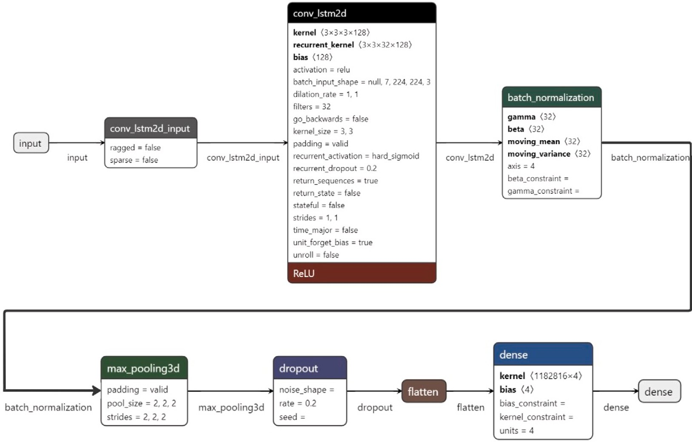

**/ig. 11.** The ConvLSTM architecture used for predicting the percentages of Zn, Fe, Cu, and Pb minerals in flotation cells from video data.

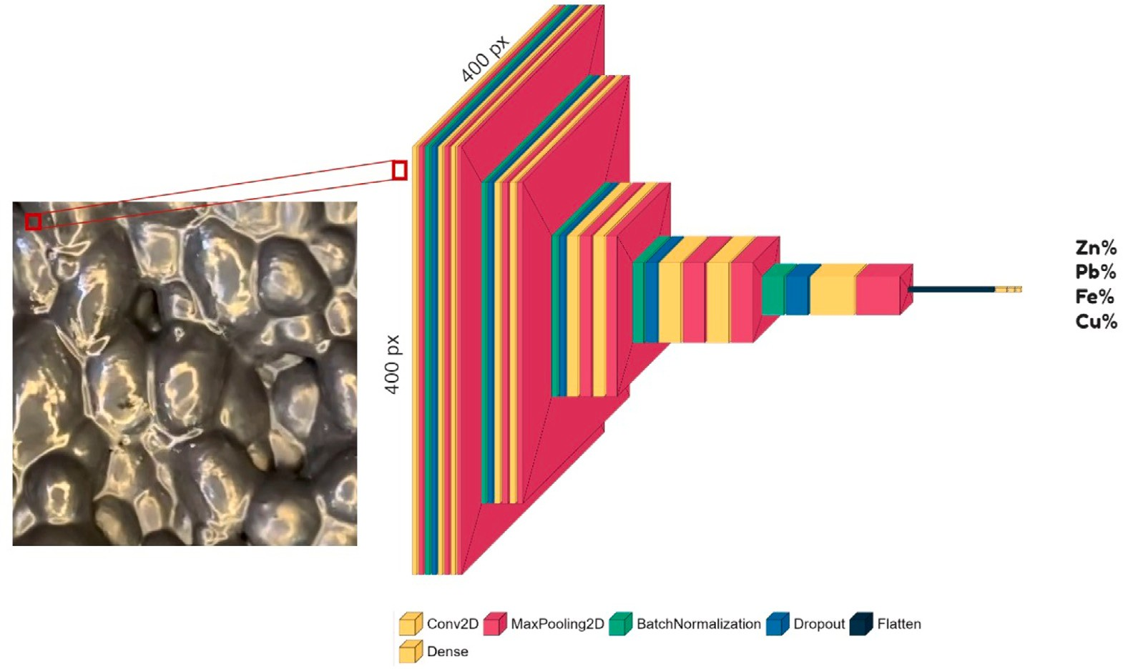

**/ig. 12.** The CNN architecture used for predicting the concentration grade of Zn, Fe, Cu, and Pb minerals in flotation cells from video data.

* 1. *Discussion of the results*

**Table 1**

Comparison of CNN and ConvLSTM model performance metrics for each elemental composition on deployment data test.

|  |  |  |  |  |  |  |
| --- | --- | --- | --- | --- | --- | --- |
| Elements | STD | CNN |  |  | ConvLSTM |  |
|  |  | MSE | MAE |  | MSE | MAE |
| Zinc (Zn) | 16.10 | 55.82 | 6.42 |  | 34.16 | **4.52** |
| Copper (Cu) | 0.31 | 0.03 | **0.13** |  | 6.73 | 2.11 |
| Iron (Fe) | 10.54 | 82.59 | 7.21 |  | 89.46 | 7.26 |
| Lead (Pb) | 0.78 | 0.28 | **0.37** |  | 8.62 | 2.41 |

This study delves into the thorough evaluation of the ConvLSTM model’s performance in predicting chemical composition grades within a real industrial flotation circuit. The metrics of mean squared error (MSE) and mean absolute error (MAE), which are indicative of model accuracy, are summarized in Table 1 for each elemental composition. These metrics shed light on the model’s effectiveness in predicting the concentrate grades of various minerals in comparison with the CNN model.

The table reveals a distinctive pattern in the model’s performance across different elements. Notably, the CNN model exhibits better pre- dictive capabilities for copper (Cu) and lead (Pb) minerals, as evident in Fig. 13 and from the lower MSE and MAE values associated with

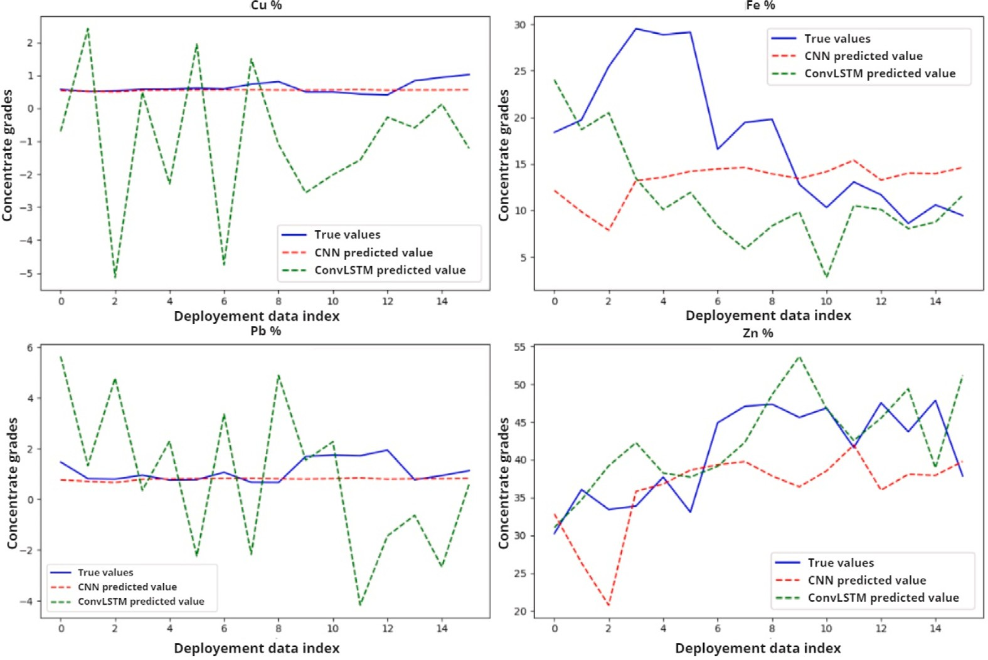

**/ig. 13.** Measured and predicted chemical composition grades of the four elements Cu, Fe, Pb and Zn in the final concentrate of the Zinc flotation circuits.

these elements in Table 1. In contrast, the model’s performance for zinc (Zn) mineral appears to be relatively accurate by the ConvLSTM model, as indicated by the MAE and MSE values. It is important to consider the higher standard deviation (STD) value for zinc mineral, which might suggest that the model’s predictions are accommodating the inherent variability of cleaners zinc concentrate grades within the flotation circuit. This suggests that while the model’s predictions might appear less accurate based on MAE alone, they could indeed be more accurate in the context of the variations present in the data.

To provide a comprehensive visualization of the model’s perfor- mance, we present the measured and predicted mineral concentrations for four key elements – Copper (Cu), Iron (Fe), Lead (Pb), and Zinc (Zn) – in Fig. 13. This visualization underlines that the ConvLSTM model’s predictions are notably accurate for Zn and Fe minerals, with the predicted values closely aligning with the measured concentrations. In contrast, for Cu and Pb minerals, the ConvLSTM model’s predictions show a deviation from the measured values, indicating the need for improvement in these cases.

The observed deviations in the predictions of the ConvLSTM model for low grade minerals can be attributed to a deliberate adjustment in the model’s training strategy. This adjustment is particularly influenced by the loss function we employed during the training process. The primary intention behind this adaptation is to prioritize the accurate prediction of the main targeted mineral, which, in this study, is zinc (Zn). The loss function is designed to accommodate the adjustments necessary to enhance the prediction accuracy of Zn concentrate grades. This targeted optimization strategy inherently implies that the model’s predictive performance for other minerals, especially low grade miner- als like copper (Cu) and lead (Pb), may exhibit some degree of deviation from actual values. The study’s findings, thus, highlight the nuances in the model’s performance with different minerals and offer insights into areas where improvements could be targeted. The combined results of the performance evaluation, as depicted in Table 1 and Fig. 13, provide a view of how the ConvLSTM model performs across various elemental compositions. This analysis is crucial for understanding the strengths and limitations of the model, enabling us to make informed decisions for refining and optimizing its predictive capabilities. The distinction between ConvLSTM and 3D CNN in our work arises from the inherent

properties of LSTM units. LSTMs possess memory cells capable of re- taining and forgetting patterns over extended sequences, making them well-suited for time series or sequential data. Consequently, while CNNs excel in processing spatial–temporal data, the ConvLSTM’s ability to capture temporal patterns over longer intervals provides a competitive advantage, particularly when dealing with the gradual evolution and intricate patterns observed in flotation froth monitoring. This LSTM property resulted in superior performance compared to using CNN alone.

The ConvLSTM network architecture was well-performing in pre- dicting chemical composition grades from video data, and the perfor- mance evaluation indicated that the model’s predictions were relatively accurate. The results suggest that this approach can be used to opti- mize the mineral recovery process in the differential flotation circuits. Further studies can explore the applicability of this approach in other mineral processing applications. Our findings suggest that the model’s performance in predicting chemical composition grades is dependent on the target mineral and the distribution of concentrate grades. The results also demonstrate that the model can relatively predict chemical composition grades for low-grade minerals such as Cu and Pb. The limitations of the model’s accuracy for Fe and Zn minerals highlight the need for further research and more data to develop more accurate models.

* 1. *On-Premises deployment of ConvLSTM in the flotation*

To deploy the online analyzer on-premises, we propose to use a hardware setup consisting of a GigE camera connected to an NVIDIA Jetson Nano, which processes the frames from the camera in real-time (Fig. 14). The Jetson card sends the frames to the on-premise server for further processing using a WLAN card that allows for real-time wireless transmission of the video data. The on-premise server communicates using a WLAN card that allows for real-time wireless transmission of the data to be processed by the ConvLSTM model. The predictions can be displayed after the process is finished using a web-based dashboard and a mobile application, allowing users to monitor the system and receive alerts when certain thresholds are exceeded (Fig. 15).

In the proposed deployment architecture, the predictive model of chemical composition grades is encapsulated within a container that

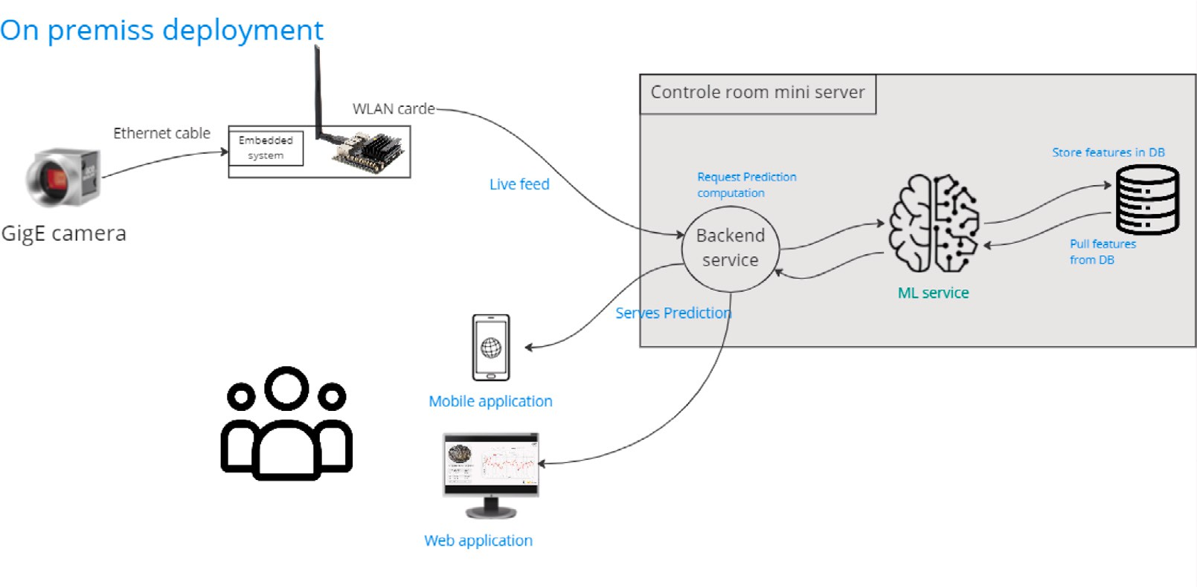

**/ig. 14.** On-Premises deployment architecture of the model in the flotation.

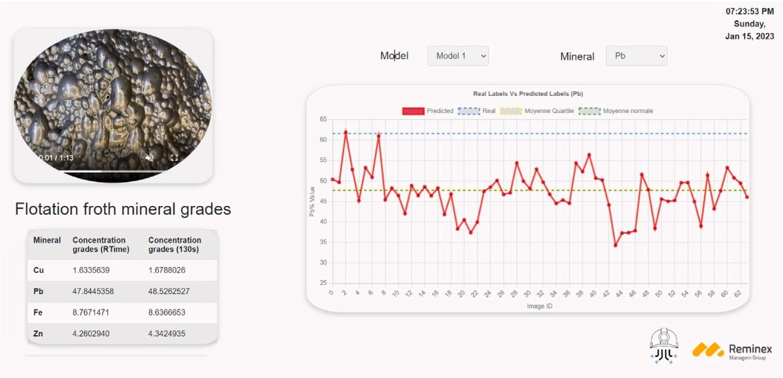

**/ig. 15.** The monitoring application interface of the flotation froth at CMG site, Morocco.

includes all the necessary dependencies and libraries required to run the model. One of the advantages of the On-Premises deployment is the portability. The Deep Learning models deployed as containers can be easily moved and deployed across different platforms and environ- ments through the flotation site without any compatibility issues. This is because the container includes all the dependencies and libraries required to run the model. Another advantage of this architecture is scalability. The ConvLSTM model deployed as container can be easily replicated and deployed across multiple instances to handle high volumes of data. This allows for better resource utilization and can improve the performance of the system. On-Premises deployment also provides consistency to Deep Learning models. Since the container includes all the necessary dependencies and libraries required to run the model, the model runs consistently across different environments. Finally, this approach provides isolation to machine learning models. Since the model is encapsulated within a container, it does not interfere with other applications or processes running on the same machine. The online application of our model involves the continuous process- ing of videos captured from the flotation froth through a real-time data pipeline. The results are presented in a graphical user interface (Fig. 15), offering industrial practitioners immediate insights into the flotation process’s dynamics and enabling timely interventions. In sum- mary, On-Premises deployment is a powerful approach for deploying

the Deep Learning models that offers advantages such as portability, scalability, consistency, and isolation for efficient use in the flotation sites.

# Conclusions

In conclusion, this study demonstrates the potential of Convolu- tional Long Short-Term Memory (ConvLSTM) networks in the determi- nation of the chemical elemental composition in the flotation froth. By accurately predicting concentrate grades in real-time, the proposed ap- proach provides significant advantages over existing monitoring tech- niques in terms of cost, maintenance, and real-time information on chemical composition grades.

Our study primarily aimed at predicting Zinc (Zn) grades due to its crucial role in the flotation process. While the ConvLSTM model effectively predicted Zn grades, our work also included predictions for Copper (Cu), Iron (Fe) and Lead (Pb) to understand their behavior dur- ing flotation as low-grade minerals. Though the accuracy for Cu and Pb predictions may not match that of Zn, they offer insights into flotation performance and help in real-time process monitoring. Such predictions can alert operators about ore feed composition changes, aiding prompt decision-making in industry settings. Moreover, the model’s ability to effectively process both spatial and temporal information suggests that

it has the potential to be applied to other industrial applications that require similar processing capabilities. The success of this model in accurately predicting mineral compositions for different base elements in the Zinc cleaners of CMG differential flotation circuit, highlights the importance of considering variations in concentrate grades distribution when evaluating the model’s performance for different minerals. Mov- ing forward, the proposed approach has the potential to be extended to other stages of flotation circuits such as roughing and scavenging with different mineral compositions and operating conditions.

Further research could explore the applicability of our model in other mining operations, such as mineral sorting. By combining froth features, physio-chemical sensors, and intelligent control techniques, this innovative approach has the potential to become a reliable and effective flotation monitoring system. We believe that combining both froth image features and physicochemical parameters could yield even more accurate and robust predictive models. Overall, this study con- tributes to the development of more efficient and accurate mineral processing methods, and we believe that the proposed approach has significant potential for future industrial applications for classification or forecasting using video data.

We acknowledge that explicit relationships between froth properties and manipulated variables are essential for effective process control. In this study, we recognize the limitations of solely relying on neural network models to address this complex challenge. While our approach is primarily focused on predicting mineral grades based on froth images using machine vision techniques, we believe that the model’s real- time monitoring capability can contribute significantly to addressing this problem. By enabling real-time monitoring of concentrate grades, this model provides continuous insights into the process dynamics. This real-time information empowers operators and process engineers to make informed decisions and take timely actions to maintain tar- get concentrate grades. Moreover, as part of future work, we plan to explore the integration of physicochemical parameters and other manipulated variables to enhance the accuracy and robustness of the predictions.

**CRediT authorship contribution statement Ahmed Bendaouia:** Conceptualization, Methodology, Software, Val-

idation, Formal analysis, Investigation, Data curation, Writing – orig- inal draft. **El Hassan Abdelwahed:** Conceptualization, Methodology, Validation, Software, Writing – review & editing, Supervision, Project administration. **Sara Qassimi:** Writing – review & editing, Visual- ization, Supervision. **Abdelmalek Boussetta:** Data curation, Super- vision. **Intissar Benzakour:** Writing – review & editing, Validation, Supervision, Project administration. **Oumkeltoum Amar:** Supervision. **Oussama Hasidi:** Software, Validation, Data curation.

# Declaration of competing interest

The authors declare the following financial interests/personal rela- tionships which may be considered as potential competing interests: Ahmed Bendaouia reports access to data was provided by Groupe Managem.

# Data availability

The authors do not have permission to share data.

# Acknowledgments

This research is conducted within the framework of the **Smart Connected Mine** project, which has been supported by the Moroc- can Ministry of Higher Education, Scientific Research and Innovation, the Digital Development Agency (DDA) and the National Center for Scientific and Technical Research of Morocco (CNRST) through the Al-Khawarizmi program. This article is part of the work undertaken by different partners composed of MASCIR (Moroccan Foundation for Advanced Science, Innovation and Research, non profit association related to UM6P), REMINEX R&D, Engineering and project manage- ment subsidiary of MANAGEM Group, UCA (Cadi Ayyad University), ENSMR (National School of Mines of Rabat), and ENSIAS (Ecole Na- tionale Supérieure d’Informatique et d’Analyse des Systèmes (ENSIAS), Mohammed V University). We would like to thank MANAGEM Group and its subsidiary CMG for allowing us to conduct research, data collection and validation on site as an industrial partner in this project. A special thanks to Abdelatif Halim, Khalil Jabbahi, Kaoutar Oubouhss, Oussama Lachihab and Achraf Soulala for their collaboration in the data collection campaign.

# References

Aldrich, C., Avelar, E., Liu, X., 2022. Recent advances in flotation froth image analysis.

Miner. Eng. 188, 107823. <http://dx.doi.org/10.1016/j.mineng.2022.107823>.

Aliabadi, M.M., Emami, H., Dong, M., Huang, Y., 2020. Attention-based recurrent neural network for multistep-ahead prediction of process performance. Comput. Chem. Eng. 140, 106931. <http://dx.doi.org/10.1016/j.compchemeng.2020.106931>.

Annamalai, M., Gurumurthy, K., 2020. Neural network prediction of bioleaching of metals from waste computer printed circuit boards using Levenberg-Marquardt algorithm. Comput. Intell. 36 (4), 1548–1568. [http://dx.doi.org/10.1111/coin.](http://dx.doi.org/10.1111/coin.12288)

[12288](http://dx.doi.org/10.1111/coin.12288).

Bendaouia, A., Abdelwahed, E.H., Qassimi, S., Boussetta, A., Benhayoun, A., Benza- kour, I., Amar, O., Zennayi, Y., Bourzeix, F., Baïna, K., Baïna, S., Khalil, A., Cherkaoui, M., Hasidi, O., 2022. Digital transformation of the flotation monitoring towards an online analyzer. In: Hamlich, M., Bellatreche, L., Siadat, A., Ventura, S. (Eds.), Smart Applications and Data Analysis. In: Communications in Computer and Information Science, Springer International Publishing, Cham, pp. 325–338. <http://dx.doi.org/10.1007/978-3-031-20490-6_26>.

Cao, W., Wang, R., Fan, M., Fu, X., Wang, H., Wang, Y., 2022. A new froth image classification method based on the MRMR-SSGMM hybrid model for recognition of reagent dosage condition in the coal flotation process. Appl. Intell. [http://dx.doi.](http://dx.doi.org/10.1007/s10489-021-02328-z) [org/10.1007/s10489-021-02328-z](http://dx.doi.org/10.1007/s10489-021-02328-z).

Cascone, L., Sadiq, S., Ullah, S., Mirjalili, S., Siddiqui, H.U.R., Umer, M., 2023. Predicting household electric power consumption using multi-step time series with convolutional LSTM. Big Data Res. 31, 100360. [http://dx.doi.org/10.1016/j.bdr.](http://dx.doi.org/10.1016/j.bdr.2022.100360) [2022.100360](http://dx.doi.org/10.1016/j.bdr.2022.100360).

Citir, C., Aktas, Z., Berber, R., 2004. Off-line image analysis for froth flotation of coal. Comput. Chem. Eng. 28 (5), 625–632. [http://dx.doi.org/10.1016/j.compchemeng.](http://dx.doi.org/10.1016/j.compchemeng.2004.02.007)

[2004.02.007](http://dx.doi.org/10.1016/j.compchemeng.2004.02.007), ESCAPE 13.

[Clero,](http://refhub.elsevier.com/S0098-1354(23)00346-0/sb8) [K., Ed-Diny, S., Cherkaoui, M., Soror, T., Rziki, S., Achalhi, M., Fkihi, S.E.,](http://refhub.elsevier.com/S0098-1354(23)00346-0/sb8) [Boanarijesy, A., 2022. A review of geotechnical instabilities identification and](http://refhub.elsevier.com/S0098-1354(23)00346-0/sb8) [monitoring at deep underground mines: Case of draa sfar mine in Morocco. Int. J.](http://refhub.elsevier.com/S0098-1354(23)00346-0/sb8) [Civ. Infrastruct. 5, 51–59.](http://refhub.elsevier.com/S0098-1354(23)00346-0/sb8)

Farrokhpay, S., 2011. The significance of froth stability in mineral flotation — A review. Adv. Colloid Interface Sci. 166, 1–7. <http://dx.doi.org/10.1016/j.cis.2011.03.001>.

Gharehchobogh, B.K., Kuzekanani, Z.D., sobhi, J., Khiavi, A.M., 2023. Flotation froth image segmentation using Mask R-CNN. Miner. Eng. 192, 107959. [http://dx.doi.](http://dx.doi.org/10.1016/j.mineng.2022.107959) [org/10.1016/j.mineng.2022.107959](http://dx.doi.org/10.1016/j.mineng.2022.107959).

Hasidi, O., Abdelwahed, E.H., Qazdar, A., Boulaamail, A., Krafi, M., Benzakour, I., Bourzeix, F., Baïna, S., Baïna, K., Cherkaoui, M., Bendaouia, A., 2022. Digital twins-based smart monitoring and optimisation of mineral processing industry. In: Hamlich, M., Bellatreche, L., Siadat, A., Ventura, S. (Eds.), Smart Applications and Data Analysis. In: Communications in Computer and Information Science, Springer International Publishing, Cham, pp. 411–424. [http://dx.doi.org/10.1007/978-3-](http://dx.doi.org/10.1007/978-3-031-20490-6_33) [031-20490-6_33](http://dx.doi.org/10.1007/978-3-031-20490-6_33).

Huang, L., Hong, X., Yang, Z., Liu, Y., Zhang, B., 2022. CNN-LSTM network-based damage detection approach for copper pipeline using laser ultrasonic scanning. Ultrasonics 121, 106685. <http://dx.doi.org/10.1016/j.ultras.2022.106685>.

Imam, M., Baïna, K., Tabii, Y., Benzakour, I., Adlaoui, Y., Ressami, E.M., Abdelwa- hed, E.H., 2023. Anti-collision system for accident prevention in underground mines using computer vision. In: Proceedings of the 6th International Conference on Ad- vances in Artificial Intelligence. ICAAI ’22, Association for Computing Machinery, New York, NY, USA, pp. 94–101. <http://dx.doi.org/10.1145/3571560.3571574>.

Kaartinen, J., Hätönen, J., Hyötyniemi, H., Miettunen, J., 2006. Machine-vision-based control of zinc flotation—A case study. Control Eng. Pract. 14, [http://dx.doi.org/](http://dx.doi.org/10.1016/j.conengprac.2005.12.004) [10.1016/j.conengprac.2005.12.004](http://dx.doi.org/10.1016/j.conengprac.2005.12.004).

Lindemann, B., Maschler, B., Sahlab, N., Weyrich, M., 2021. A survey on anomaly detection for technical systems using LSTM networks. Comput. Ind. 131, 103498. <http://dx.doi.org/10.1016/j.compind.2021.103498>.

Liu, J., Gao, Q., Tang, Z., Xie, Y., Gui, W., Ma, T., Niyoyita, J.P., 2020. Online monitoring of flotation froth bubble-size distributions via multiscale deblurring and multistage jumping feature-fused full convolutional networks. IEEE Trans. Instrum. Meas. 69, 9618–9633. <http://dx.doi.org/10.1109/TIM.2020.3006629>.

Nakhaei, F., Irannajad, M., Mohammadnejad, S., 2023. A comprehensive review of froth surface monitoring as an aid for grade and recovery prediction of flotation process. Part A: structural features. Energy Sources A 45 (1), 2587–2605. [http:](http://dx.doi.org/10.1080/15567036.2019.1663313)

[//dx.doi.org/10.1080/15567036.2019.1663313](http://dx.doi.org/10.1080/15567036.2019.1663313).

Pistikopoulos, E.N., Barbosa-Povoa, A., Lee, J.H., Misener, R., Mitsos, A., Reklaitis, G.V., Venkatasubramanian, V., You, F., Gani, R., 2021. Process systems engineering – The generation next? Comput. Chem. Eng. 147, 107252. [http://dx.doi.org/10.1016/j.](http://dx.doi.org/10.1016/j.compchemeng.2021.107252) [compchemeng.2021.107252](http://dx.doi.org/10.1016/j.compchemeng.2021.107252).

Popli, K., Afacan, A., Liu, Q., Prasad, V., 2018. Development of online soft sensors and dynamic fundamental model-based process monitoring for complex sulfide ore flotation. Miner. Eng. 124, 10–27. [http://dx.doi.org/10.1016/j.mineng.2018.](http://dx.doi.org/10.1016/j.mineng.2018.04.006) [04.006](http://dx.doi.org/10.1016/j.mineng.2018.04.006).

Qassimi, S., Abdelwahed, E.H., 2022. Disruptive innovation in mining industry 4.0. In: Distributed Sensing and Intelligent Systems. In: Studies in Distributed Intelligence, Springer International Publishing, pp. 313–325. [http://dx.doi.org/10.1007/978-3-](http://dx.doi.org/10.1007/978-3-030-64258-7_28) [030-64258-7_28](http://dx.doi.org/10.1007/978-3-030-64258-7_28).

[Rajapakse,](http://refhub.elsevier.com/S0098-1354(23)00346-0/sb21) [N., Zargar, M., Sen, T., Khiadani, M., 2022. Effects of influent physicochem-](http://refhub.elsevier.com/S0098-1354(23)00346-0/sb21) [ical characteristics on air dissolution, bubble size and rise velocity in dissolved air](http://refhub.elsevier.com/S0098-1354(23)00346-0/sb21) [flotation: A review. Sep. Purif. Technol. 289.](http://refhub.elsevier.com/S0098-1354(23)00346-0/sb21)

Rao, T.V.N., Gaddam, A., Kurni, M., Saritha, K., 2022. Reliance on artificial intelligence, machine learning and deep learning in the era of industry 4.0. In: Smart Healthcare System Design. John Wiley & Sons, Ltd, pp. 281–299. [http://dx.doi.org/10.1002/](http://dx.doi.org/10.1002/9781119792253.ch12) [9781119792253.ch12](http://dx.doi.org/10.1002/9781119792253.ch12).

Rihi, A., Baïna, S., Mhada, F.-z., Elbachari, E., Tagemouati, H., Guerboub, M., Benzak- our, I., 2022. Predictive maintenance in mining industry: grinding mill case study. Procedia Comput. Sci. 207, 2483–2492. [http://dx.doi.org/10.1016/j.procs.2022.09.](http://dx.doi.org/10.1016/j.procs.2022.09.306)

[306](http://dx.doi.org/10.1016/j.procs.2022.09.306).

Sun, B., Yang, W., He, M., Wang, X., 2021. An integrated multi-mode model of froth flotation cell based on fusion of flotation kinetics and froth image features. Miner. Eng. 172, 107169. <http://dx.doi.org/10.1016/j.mineng.2021.107169>.

Tan, J., Liang, L., Peng, Y., Xie, G., 2016. The concentrate ash content analysis of coal flotation based on froth images. Miner. Eng. 92, 9–20. [http://dx.doi.org/10.1016/](http://dx.doi.org/10.1016/j.mineng.2016.02.006) [j.mineng.2016.02.006](http://dx.doi.org/10.1016/j.mineng.2016.02.006).

[Uusitalo,](http://refhub.elsevier.com/S0098-1354(23)00346-0/sb26) [S., Soudunsaari, T., Sumen, J., Haavisto, O., Kaartinen, J., Huuskonen, J.,](http://refhub.elsevier.com/S0098-1354(23)00346-0/sb26) [Tuikka, A., Rahkamaa-Tolonen, K., Paaso, J., 2020. Online analysis of minerals](http://refhub.elsevier.com/S0098-1354(23)00346-0/sb26) [from sulfide ore using near-infrared Raman spectroscopy. J. Raman Spectrosc. 51](http://refhub.elsevier.com/S0098-1354(23)00346-0/sb26) [(6), 978–988.](http://refhub.elsevier.com/S0098-1354(23)00346-0/sb26)

Wang, X., Zhou, J., Wang, Q., Liu, D., Lian, J., 2022. An unsupervised method for extracting semantic features of flotation froth images. Miner. Eng. 176, 107344. <http://dx.doi.org/10.1016/j.mineng.2021.107344>.

Wen, Z., Zhou, C., Pan, J., Nie, T., Zhou, C., Lu, Z., 2021. Deep learning-based ash content prediction of coal flotation concentrate using convolutional neural network. Miner. Eng. 174, 107251. <http://dx.doi.org/10.1016/j.mineng.2021.107251>.

Xu, Y., Liu, X., Cao, X., Huang, C., Liu, E., Qian, S., Liu, X., Wu, Y., Dong, F., Qiu, C.-

W., Qiu, J., Hua, K., Su, W., Wu, J., Xu, H., Han, Y., Fu, C., Yin, Z., Liu, M.,

Roepman, R., Dietmann, S., Virta, M., Kengara, F., Zhang, Z., Zhang, L., Zhao, T.,

Dai, J., Yang, J., Lan, L., Luo, M., Liu, Z., An, T., Zhang, B., He, X., Cong, S.,

Liu, X., Zhang, W., Lewis, J.P., Tiedje, J.M., Wang, Q., An, Z., Wang, F., Zhang, L., Huang, T., Lu, C., Cai, Z., Wang, F., Zhang, J., 2021. Artificial intelligence: A powerful paradigm for scientific research. Innovation 2 (4), 100179. [http://dx.doi.](http://dx.doi.org/10.1016/j.xinn.2021.100179) [org/10.1016/j.xinn.2021.100179](http://dx.doi.org/10.1016/j.xinn.2021.100179).

Zarie, M., Jahedsaravani, A., Massinaei, M., 2020. Flotation froth image classification using convolutional neural networks. Miner. Eng. [http://dx.doi.org/10.1016/j.](http://dx.doi.org/10.1016/j.mineng.2020.106443) [mineng.2020.106443](http://dx.doi.org/10.1016/j.mineng.2020.106443).

Zhang, D., Gao, X., 2021. Soft sensor of flotation froth grade classification based on hybrid deep neural network. Int. J. Prod. Res. [http://dx.doi.org/10.1080/](http://dx.doi.org/10.1080/00207543.2021.1894366) [00207543.2021.1894366](http://dx.doi.org/10.1080/00207543.2021.1894366).

Zhang, D., Gao, X., Qi, W., 2022. Soft sensor of iron tailings grade based on froth image features for reverse flotation. Trans. Inst. Meas. Control 44 (15), 2928–2940. <http://dx.doi.org/10.1177/01423312221096450>.

[Zhang,](http://refhub.elsevier.com/S0098-1354(23)00346-0/sb33) [D., Gao, X., Wang, H., 2023a. Prediction model of iron reverse flotation tailings](http://refhub.elsevier.com/S0098-1354(23)00346-0/sb33) [grade based on multi-feature fusion. Measurement 206, 112062.](http://refhub.elsevier.com/S0098-1354(23)00346-0/sb33)

Zhang, J., Tang, Z., Xie, Y., Ai, M., Gui, W., 2020. Convolutional memory network-based flotation performance monitoring. Miner. Eng. 151, 106332. [http://dx.doi.org/10.](http://dx.doi.org/10.1016/j.mineng.2020.106332) [1016/j.mineng.2020.106332](http://dx.doi.org/10.1016/j.mineng.2020.106332).

Zhang, H., Tang, Z., Xie, Y., Gao, X., Chen, Q., Gui, W., 2021. Long short-term memory- based grade monitoring in froth flotation using a froth video sequence. Miner. Eng. 160, 106677. <http://dx.doi.org/10.1016/j.mineng.2020.106677>.

Zhang, H., Tang, Z., Xie, Y., Yin, Z., Gui, W., 2023b. ES-net: An integration model based on Encoder–Decoder and siamese time series difference network for grade monitoring of Zinc tailings and concentrate. IEEE Trans. Ind. Electron. 70 (11), 11819–11830. <http://dx.doi.org/10.1109/TIE.2022.3227274>.