**CS5540**

**PRINCIPLES OF BIG DATA MANAGEMENT**

**(FALL 2018)**

**INTERIM PROJECT REPORT**

**DUE DATE – NOV 11th, 2018**



**BY**

**Aashish Thota (16274334)**

**Abilash Pandit (16272863)**

**Sai Teja Penugonda (16275546)**

**OBJECTIVE:**

* To collect tweets related to Game Of Thrones Tv Series .
* To analyze the collected tweets and develop interesting analysis on them.
* Create Visualisations on the analysis done.

**Queries:**

* Number of Tweets by Top 11 verified users

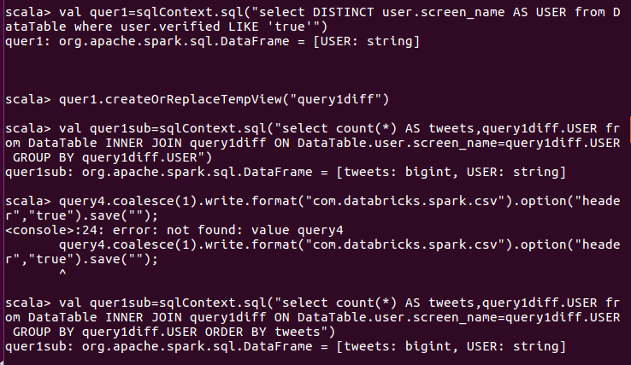

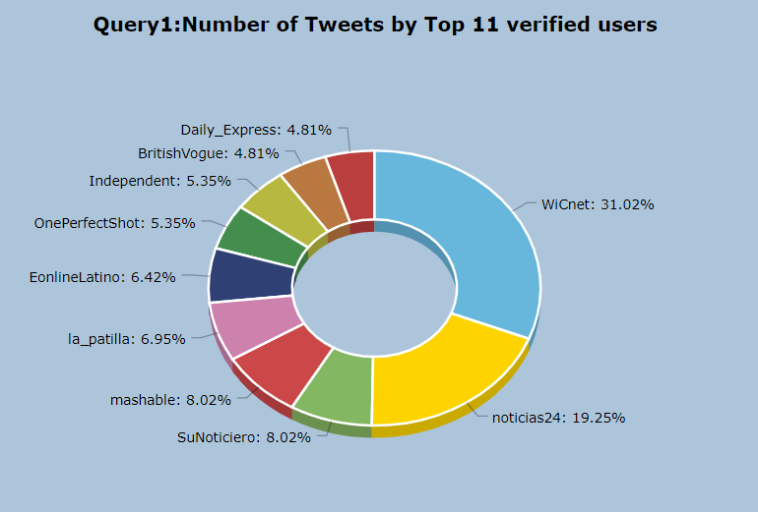

* Tweets from top 20 locations

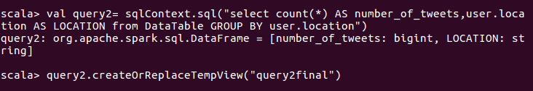

* 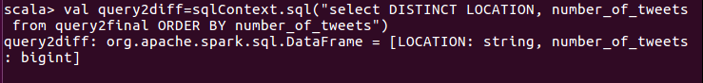

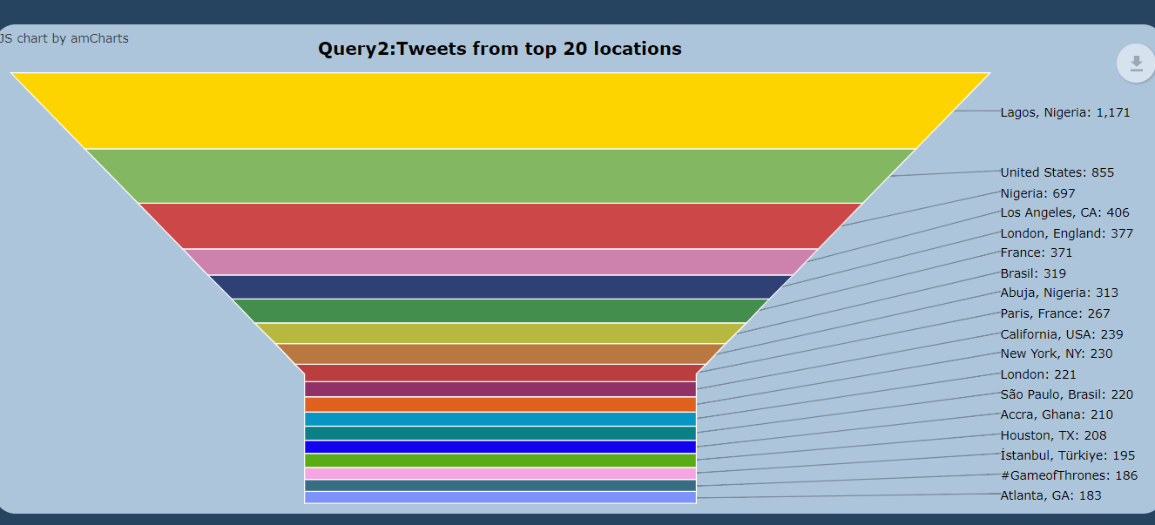

* Number of Tweets about top 5 characters

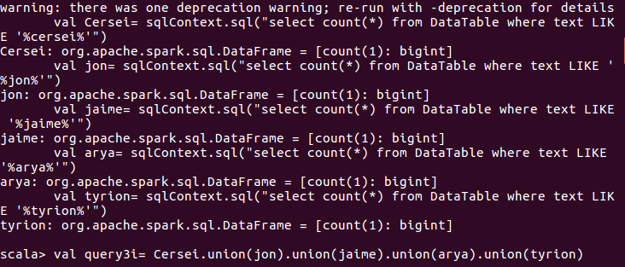

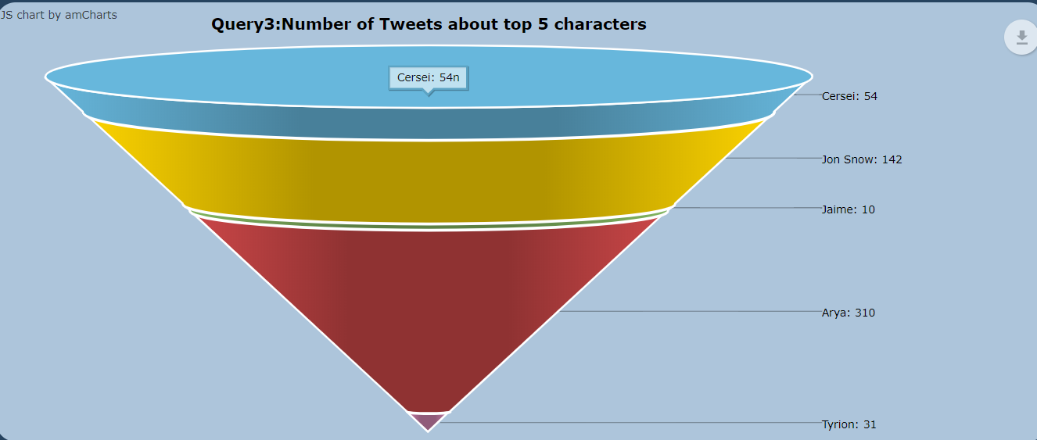

* Number of tweets on different dates

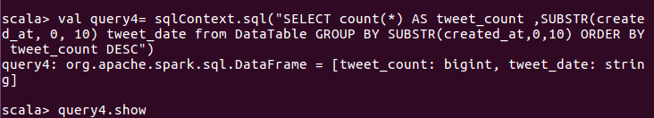

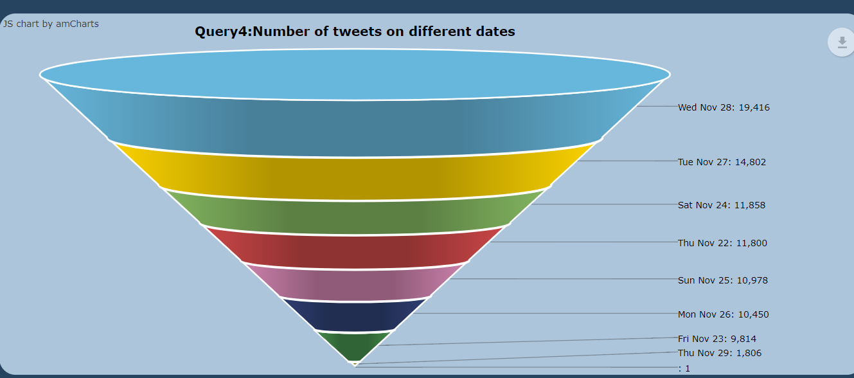

* Number of tweets about all the seasons

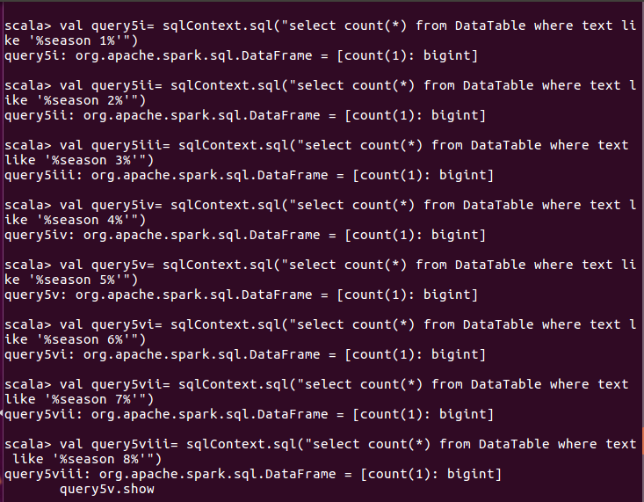

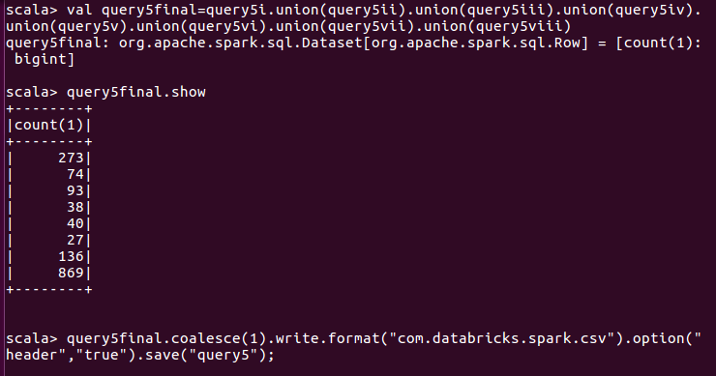

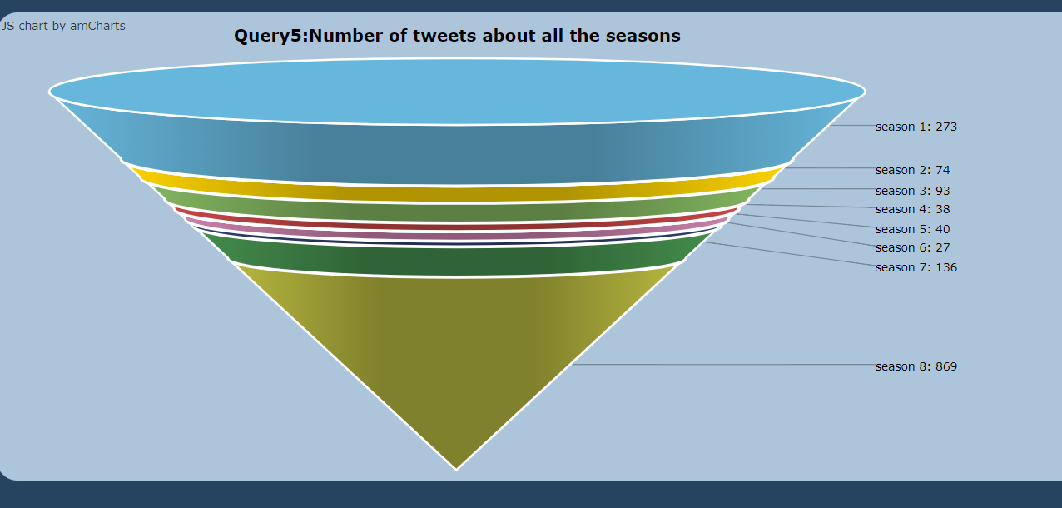

* Number of tweets tweeted from different OS Devices

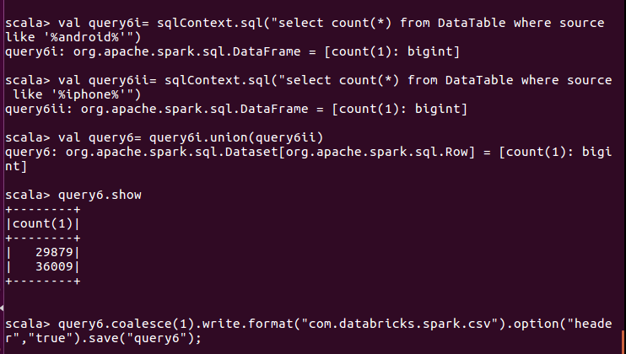

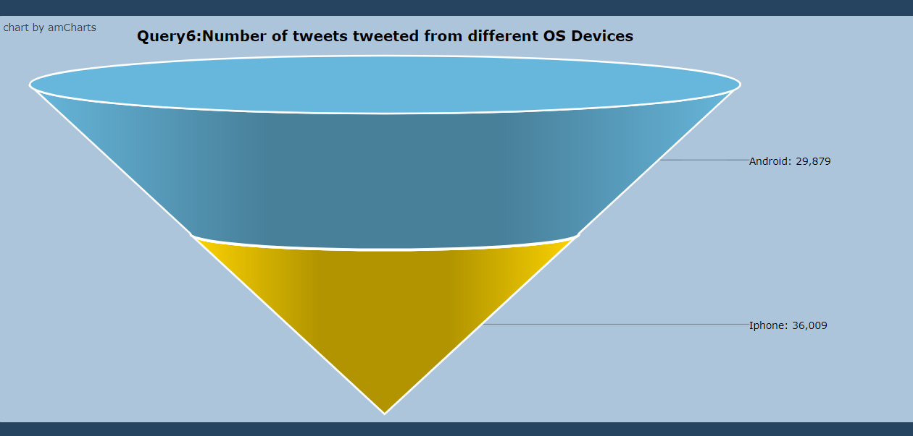

* Number of tweets in different languages

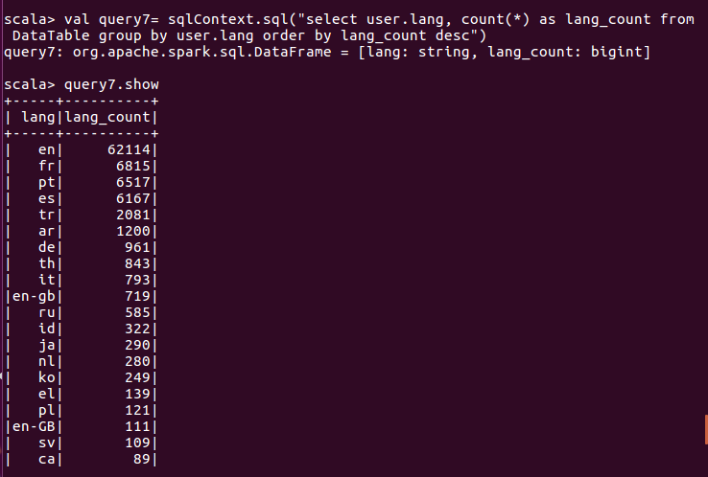

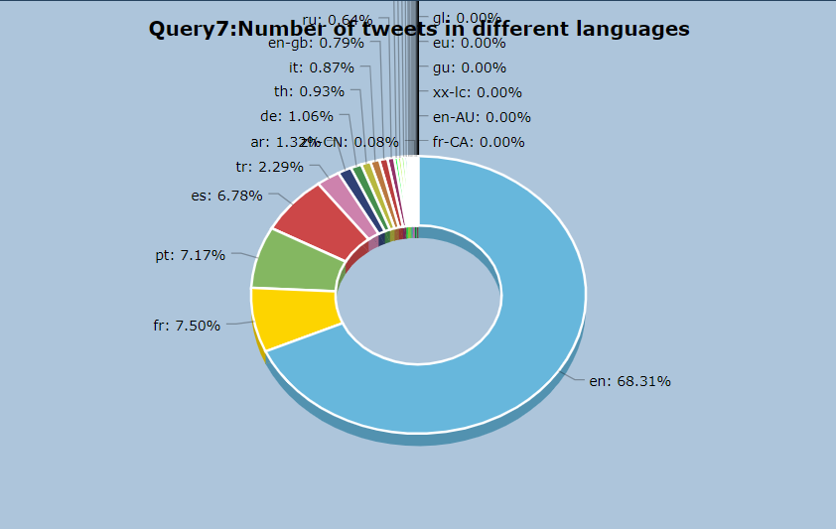

* Number of retweet count for top tweets

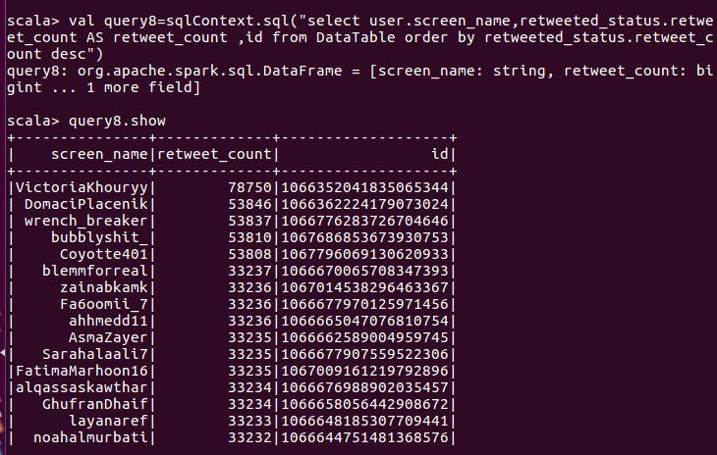

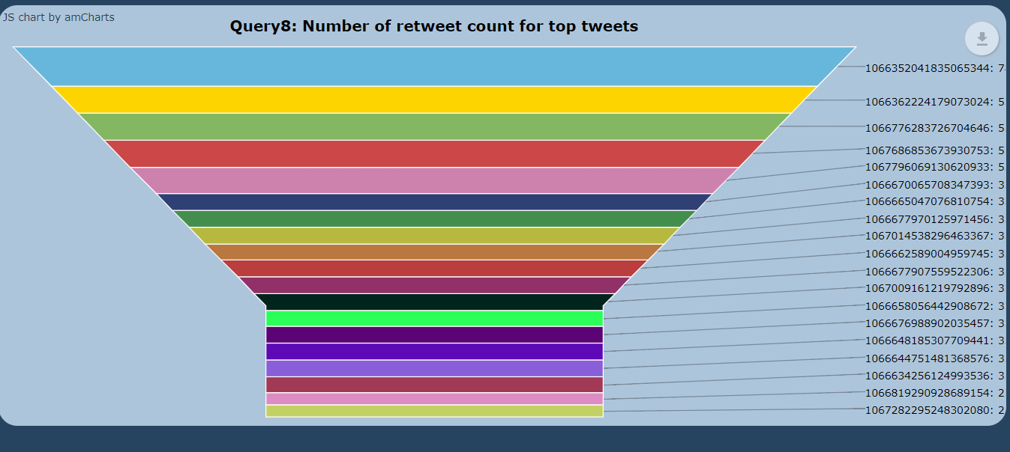

* Followers_count based on Location

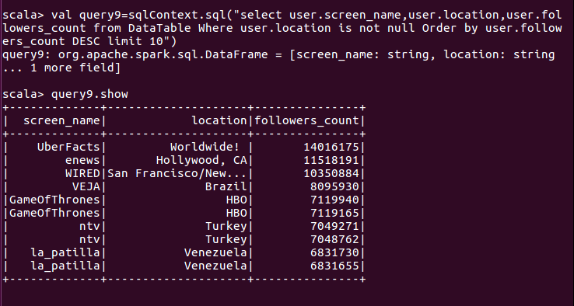

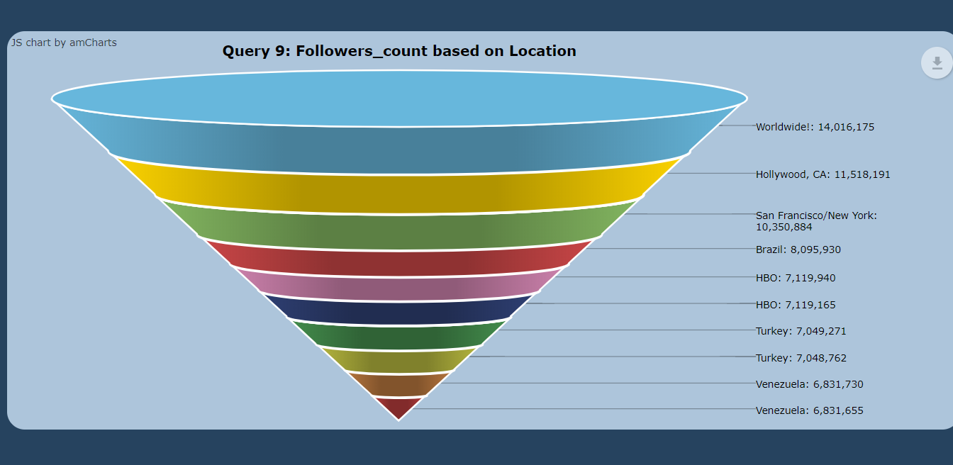

* Favourite Count of top Users

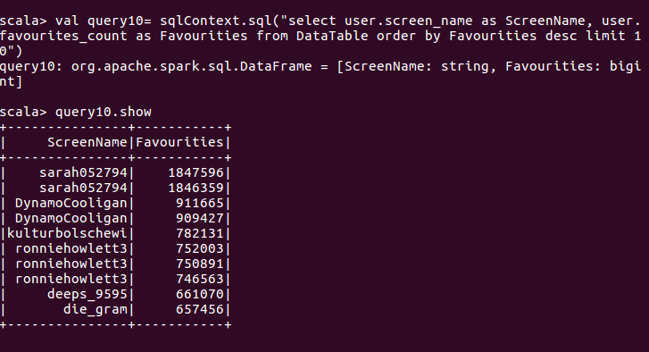

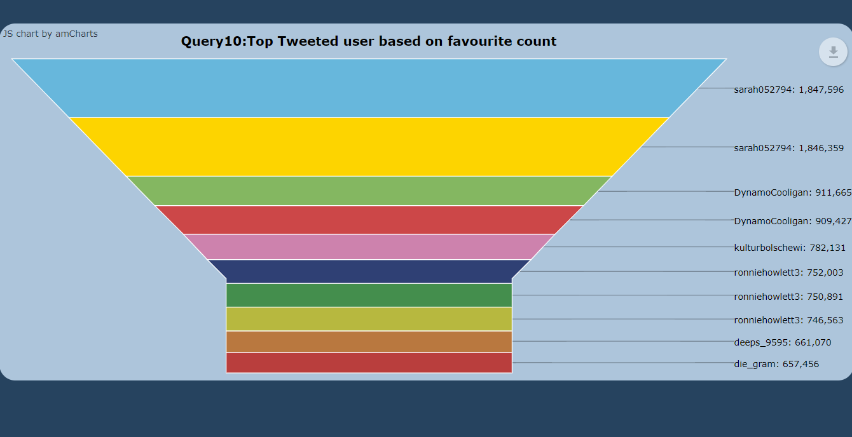

CODE LINK:

<https://github.com/AashishThota/PBProject/tree/master/pbphase2>