# 

# IoT PROJECT

## ON

Automated Soap Dispenser

**Aim :**

In this project, we are making the automatic soap dispenser using Arduino. Themajor benefit of this project is that if you will use this project you will wash your hand automatically. We use two servo motors in our project, one is for the display timer and the other one is for dispensing the soap. This project detects your hand automatically and after ejecting some soap drops the sensor stops.

There is an ultrasonic sensor that can detect your hands.

Keywords: IOT, Arduino UNO, Ultrasonic sensing, Home automation.

# Introduction:

“Home automation” refers to the automatic and electronic control of household features, activity, and appliances. In simple terms, it means you can easily control the utilities and features of your home via the Internet to make life more convenient and secure, and even spend less on household bills. Basically we are automating the handwash thing by using iot. Arduino UNO is a microcontroller board based on the ATmega328P. It has 14 digital input/output pins (of which 6can be used as PWM outputs), 6 analog inputs, a 16 MHz ceramic resonator, aUSB connection, a power jack, an ICSP header and a reset button. It contains everything needed to support the microcontroller; simply connect it to a computer with a USB cable or power it with a AC-to-DC adapter or battery to get started. You can tinker with your UNO without worrying too much about doing something wrong, worst case scenario you can replace the chip for a few dollars and start over again. We are also using ultrasonic sensor, basically As the name indicates, ultrasonic / level sensors measure distance by using ultrasonic waves.The sensor head emits an ultrasonic wave and receives the wave reflected back from the target. ultrasonic / level sensors measure the distance to the target by measuring the time between the emission and reception. An optical sensor has a transmitter and receiver, whereas an ultrasonic / level sensor uses a single ultrasonic element for both emission and reception. In a reflective model ultrasonic

/ level sensor, a single oscillator emits and receives ultrasonic waves alternately. This enables miniaturisation of the sensor head. Another important component of project is server motor, A servo motor is a type of motor that can rotate with great precision. Normally this type of motor consists of a control circuit that provides

feedback on the current position of the motor shaft, this feedback allows the servo motors to rotate with great precision. If you want to rotate an object at some specific angles or distance, then you use a servo motor. It is just made up of a simple motor which runs through a servo mechanism. If motor is powered by a DCpower supply then it is called DC servo motor, and if it is AC-powered motor then it is called AC servo motor. For this tutorial, we will be discussing only aboutthe DC servo motor working. Apart from these major classifications, there are many other types of servo motors based on the type of gear arrangement and operating characteristics. A servo motor usually comes with a gear arrangementthat allows us to get a very high torque servo motor in small and lightweight packages. Due to these features, they are being used in many applications like toy car, RC helicopters and planes, Robotics etc.

**Implementation:**

Components Required for automatic soap dispenser:

1. Arduino Uno
2. HC-SR04 Ultrasonic Sensor
3. Servo Motors
4. Jumper Wires
5. Battery source

**Circuit Diagram**

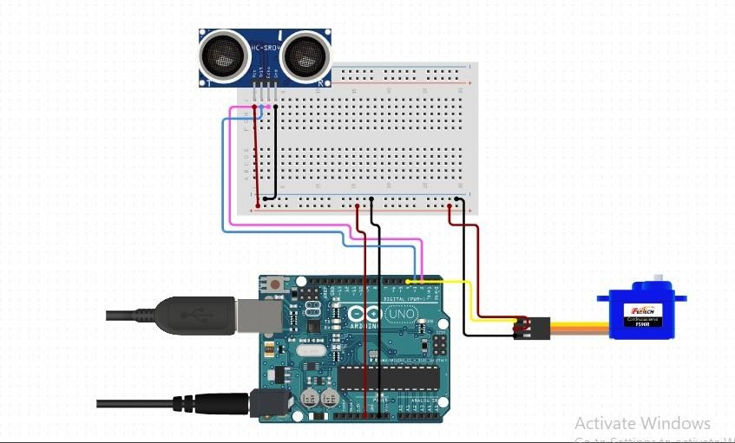

**Code :**

#include <Servo.h> #define trigPin 3

#define echoPin 2 Servo servo;

int sound = 250; void setup() { Serial.begin (9600);

pinMode(trigPin, OUTPUT); pinMode(echoPin, INPUT); servo.attach(4);

}

void loop() {

long duration, distance; digitalWrite(trigPin, LOW); delayMicroseconds(2); digitalWrite(trigPin, HIGH); delayMicroseconds(10); digitalWrite(trigPin, LOW); duration = pulseIn(echoPin, HIGH); distance = (duration/2) / 29.1;

if (distance < 5) {

Serial.println("the distance is less than 5"); servo.write(90);

}

else { servo.write(0);

}

if (distance > 60 || distance <= 0){ Serial.println("The distance is more than 60");

}

else { Serial.print(distance); Serial.println(" cm");

}

delay(500);

}

# Image:

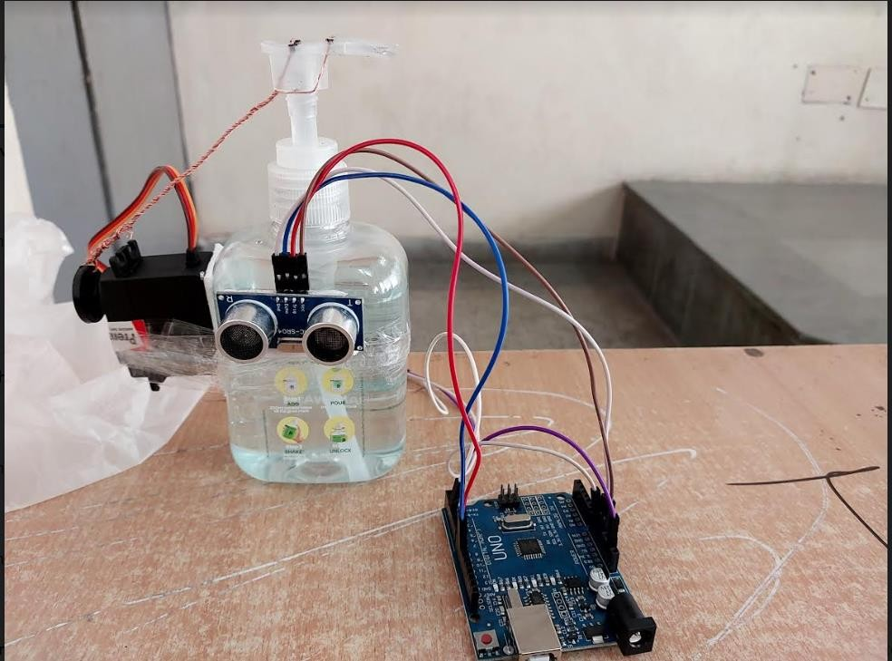

## Advantages:

* Reduction of the risk for infectious diseases:

By touching the hand wash there is a chance that infectious disease can be spreaded to one to another and by using our automated soap dispenser there is no touching on the handwash so it is totally safe and there is no chance in spreading ofdisease.

* Reduction in consumption and cost efficiency:

By using the automated soap dispenser there is reduction in consumption becauseit excrete out a specific quantity of soap and due to this cost of consumption is alsodecreased.

* Convenient operation and reduced cleaning effort:

It is easy to operate because whole device is operated through the ultrasonic sensorand due to this cleaning effort is decreasing.

## Conclusion:

As described in this project we have made a smart home automation device called as Soap dispenser. Final output is an Iot device in which various components like Arduino, ultrasonic sensor, G-90 server motor, breadboard. All these get combined and a circuit is made to applied it on a hand wash bottleand convert it into automated soap dispenser.