Border Gateway Protocol (BGP) Analysis

Ofori Kwadwo
Agbeko Komla
Renle Xia
Wednesday, July 30, 2003

Table of Contents

Table of Contents 2
Introduction 3
1. Overview of Project and its Goals 4
1.1 Task and Goal of our Project 4
1.2 Motivation 4
2. Background 5
2.1 Internet Navigation 5
2.2 Routing Instability 5
2.3 Effect of Internet Routing Instability 6
3. Overview of Data Collected 6
3.1 Data Collection Points 6
3.2 Data Format 7
3.3 Data Summary 9
4. Related Work 9
5. Data Import 10
5.1 Methodology 10
5.2 Problems and Results 11
6. Sample MySQL Queries 13
7. Current Results 14
8. Future Work 17
9. Conclusion 17
10. Acknowledgements 17
References 18
Appendix A 19

Introduction

As of January 2003, the Internet Software Consortium reported that there were 171,638, 297 hosts on the Internet [ISC03]. Not surprisingly, the process of directing or routing data from one Internet host to another can be complicated. Routing is done by special machines in the Internet called routers. These machines receive incoming packets and forward the packets one step closer to their destinations. On a typical path from source machine to destination, a packet of data may pass through many routers. For example, one path from the machine crux.clarkson.edu to www.google.com passed through 15 intermediate router machines.
It is interesting to consider the property of such paths through the Internet. How long is a typical path? How stable are these paths or how often does the path from machine X to machine Y change? Is the path from machine X to machine Y the exact reverse of the path from machine Y to machine X?
It is also interesting to consider the way in which these paths are established. In other words, how do these router machines know how to forward data one-step closer to its destination? How do routers learn the necessary “directions” for navigating through the Internet? Routers in the Internet communicate with each other via specialized languages called routing protocols. Through these routing protocols, they exchange information with each other about the location of destinations that are close to them. They also pass on information about the location of destinations they have learned about from other routers. In this way, information about paths to all destinations spreads to all routers in the Internet.
One specific routing protocol is the Border Gateway Protocol [RWL+95] or BGP. In the Internet, machines are assembled into groups called Autonomous Systems (ASes). The AS structure reflects the administrative domains in the Internet. For example, all the machines belonging to a university or a company would likely be in the same AS. Routers at the “border” of each AS use the Border Gateway Protocol to exchange information about the machines that are reachable within and through their AS.
Conventional wisdom suggests that the Internet is reasonably stable due to the fact that physical routing is not expected to change frequently. However, research and several previous investigations on this topic have shown that there is a significant amount of instability in the Internet and that this instability is usually caused by router misconfiguration or malfunctioning routers, inaccurate path updates spread among routers and also delayed relay or response to changes in paths by the routers.
In order to investigate these and other questions about routing in the Internet, we have collected 178.3 GB of data representing over 1.5 billion BGP routing messages. This data was collected from 5 different monitoring points at major backbone routers within the Internet [reference data sites]. We have loaded this data in an SQL database to facilitate fast queries over this volume of data.
Our research is not the first on this topic; several researchers had previously worked on a similar project as ours. Such researchers are Vern Paxson from the University of California on “End-to-End Routing Behavior in the Internet“[Pa96], Craig Labovitz from the University of Michigan on Internet Routing Instability,” [LRM+97] and Timothy Griffin along with Gordon Wilfong from Bell Laboratories of Lucent Technologies on “An Analysis on BGP Convergence Properties.”[GW99]
In Section 1 of this paper, we give an overview of our project and its goals. In Section 2, we expand on the background in BGP routing. In Section 3 of this paper, we will give an overview of the data we collected, the logistics of loading it into our database. In Section 4, we summarize related work and compare them to our work. In Section 5, we discuss our methodology utilized to derive at our results. In Section 6, we detail the SQL queries we have run and present the results. In Section 7, we describe some of the future work that will be facilitated by the experimental platform we have established.

1. Overview of Project and its Goals

1.1 Task and Goal of our Project

- Read several published articles similar to our project to acquire better comprehension of what it is that we were doing and how to go about it
- Collect raw data from MCI’s Mae-East, MCI’s Mae West, AADS, PAIX, and PB.
- Import these BGP Data into our database
- Design and test intelligent queries
- Verify or disprove hypothesis, analyze results and compare results to other published work on this topic
- Create a web interface for people to see our work

The steps provided above are the approach we took in accomplishing our task. Our overall project objectives were to analyze actual traces of BGP conversations, to use this data to really understand how BGP behaves in practice and not jut learn the definition of BGP, also, to examine the implication of BGP data on the stability of Internet routing and to read and validate existing research in this area on this data set.

1.2 Motivation

Our motivation was what drove us from the beginning of the project to the very end. After reading some of the published reports on this topic, we came to a realization that the Internet is large and cumbersome and that became the problem for our research. The Federal Networking Council (FNC) agrees that the following language reflects our definition of the term "Internet." The Internet refers to the global information system that --
(i) is logically linked together by a globally unique address space based on the Internet Protocol (IP) or its subsequent extensions or follow-ons;
(ii) is able to support communications using the Transmission Control Protocol/Internet Protocol (TCP/IP) suite or its subsequent extensions or follow-ons, and/or other IP-compatible protocols; and
(iii) provides, uses or makes accessible, either publicly or privately, high level services layered on the communications and related infrastructure described herein" (http://www.ccic.gov/fnc/Internet_res.html) [FNC95].

According to a web page by NetSizer, the Internet is composed of nearly 200 million hosts worldwide. With this in perspective, we asked ourselves as researchers how packets find their way from source machine to destination with 200 million hosts composed to form the Internet? For example, you sent an HTTP get request to www.google.com, how does the packet find its way to google.com?

2. Background

2.1 Internet Navigation

There is always a simpler way to dealing with a complicated situation. A packet finding its way around 200 million hosts is certainly complicated situation. On the course of our research, we came to find that for packets to reach their destination from a specific source, the computer uses a method called divide and conquer. Instead of the packets going through all 200 million hosts, there is a device or in some cases software that helps to deliver these packets to their various destinations. These software or devices are called routers.
Routers determine the next network point for a packet. The routers have been aggregated or grouped into regions or units called autonomous systems (ASes) to help expedite to delivering of packets. It makes it easier for the packets to reach their destinations a little faster with the routers being broken up into separate ASes. However, we still found it to be a problem because there are over 65,000 ASes for a packet to go through to reach its destination.
The good news is that the routers facilitate to make packet delivery a bit easier. Just like a person driving from Potsdam to the Bronx will stop a gas station to seek directions to his/her destination, the routers behave in similar manner. Every router does not know the whole topology or structure of the Internet just as the person from the gas station does not know every route to every destination.
However, every router has information about their neighbor. The routers gossip information to each other about good paths and a good path typically means less delay for packets to reach their destination and also low cost. This process helps make packet delivery a bit faster and simpler because these routers always help a packet get one step closer to their destination; therefore, a packet does not go through the whole 200 million hosts to reach its destination. In a similar sense, just like a person will speak English to obtain driving directions at the gas station, the language spoken by the routers between ASes is BGP.

2.2 Routing Instability

Upon further reading of other published literature regarding our project, we found three issues that can lead to Internet routing instability. The first is inaccurate gossip by routers. A router can pass on information to its neighbor and it could be that the information passed on is not accurate. This can cause delay or high cost in several packets delivery. The Second issue is changes in paths; the question we asked ourselves was how fast do the routers respond and report a change in path to the ASes? This could be a significant factor for instability because the AS might rely on old information to operate which might not be the best to utilize at that moment. Thirdly, malfunctioning or misconfigured routers, what if a router is not operating properly?

2.3 Effect of Internet Routing Instability

According to James C. Lu’s thesis, routers have limited capacities and as more individuals tend to use the Internet, the less stable it becomes. It was reported by www.glreach.com that there are over 560 million people worldwide who made use of the Internet about three years ago. Presently, over 760 million people are using the Internet today. Due to the routers limited capacities, as more people join into the use of the Internet, it can be the cause of the “death of the Internet.” As more people connect their computers to the Internet, the overall traffic increases and this may also increase the likelihood of the routers exceeding their capacities.
The downside of routers exceeding their capacities could be that messages or packets that attempt to pass through heavy overall network traffic could be dropped and never reach its destination, which can cause massive packet loss. Although it has been said by researchers that there is a much less likelihood of a global Internet collapse occurring anytime soon. James C. Lu stated, “in reality, the likelihood of a global Internet collapse occurring anytime soon is near zero.”

3. Overview of Data Collected

3.1 Data Collection Points

As mentioned previously, we have collected over 170 GB of data totaling about 1.5 billion BGP data routing messages from five different monitoring points, Mae-East, Mae West, AADS, PAIX and PB.
  - Mae-East: This facility is located in the Washington D.C. metropolitan area. They provide traffic exchange facilities where Internet Service Providers (ISPs) connect may interconnect to exchange Internet traffic [http://www.mae.net/ATM/MAE_East.htm].
  - Mae West: This facility is located in California’s Silicon Valley. They provide a second interconnection point linking major ISPs in that area [http://www.mae.net/ATM/MAE_West.htm].
  - AADS: This monitoring point is own by Ameritech. It is located in Chicago. The entire network is fully switched and utilizes the Border Gateway Protocol Version 4 (BGP4) over Cisco 12000 series GSR routers. This ensures that bandwidth can be routed through the best carrier [http://www.aads-filing.com].
  - PAIX: This facility is also known as Palo Alto Internet Exchange. It is situated in Palo Alto, California. It is a facility where Internet service providers exchange data between their networks.
  - PB: The full name of PB is Pacific Bell and it is owned by SBC. Through its world-class networks, SBC companies such as Pacific Bell provide a full range of voice, data, networking and e-business services, as well as directory advertising and publishing.

3.2 Data Format

All the data collected from the different network exchange points (MCI’s Mae-East, MCI’s Mae West, AADS, PAIX, and PB) described above are located at ftp.merit.edu/statistics/ipma/data/ and between January, 1997 and December, 2002 has the following structure defined by James C. Lu:
<yyyy.mm>/<ixp>/[bgp.yymmdd.hh:ss.gz | rsd_dump.yymmdd.gz]
where yyyy represents the four digit year, yy the two digit year, mm the month, dd the day, hh the hour, ss the second, and ixp the network exchange point. Data exists for dates outside this range, however the format varies, and so we omit it from consideration.
The BGP files we used, are compressed (gzip) binary logs of all BGP update packets exchanged with the probe machines located at the network exchange points. In order to make the data usable, it must be converted into ASCII format. When this is done, we can notice two different text formats are different from the ones Kai Wen Chung and San- Yiu Chen described in their paper as follow:

Protocol | Time | Type | PeerIP | PeerAS | Prefix | <update dependent info>

where Protocol is either BGP or BGP4, Time is the number of seconds since epoch that the packet was recorded, Type is either A for announcement or W for withdrawal, PeerIP and PeerAS are the IP address and AS number from where the update was received, and Prefix is the route prefix being announced or withdrawn.

For withdrawals, the <update dependent info> is irrelevant, but for announcements it is structured as,

ASPath | Origin | NextHop | Local_Pref | MED | Community

where ASPath is the autonomous system path of the update, Origin is IGP, EGP, or Unknown, and Local_Pref, MED, and Community are some other BGP specific attributes that are interpreted uniquely per autonomous system. These attributes are usually used to influence BGP path selection.

The following is an example of a BGP update message:

BGP | 884831402 | W | 204.70.7.53 | 3561 | 198.163.111.0/24

In this example, a withdraw message was received by the probe machine from a peer located at 204.70.7.53 which resides in autonomous system 3561. The message specifies that it is no longer possible to reach the prefix 198.163.111.0/24 through 204.70.7.53.

Another example:

BGP | 884831401 | A | 144.228.107.1 | 1239 | 205.113.0.0/16 | 1239 6453 5769 |
IGP | 192.41.177.241 | 0 | 91

Since this is an announcement message, significantly more information is provided as part of the <update dependent info>. In this example, a withdraw message was received by the probe machine from a peer located at 144.228.107.1 which resides in autonomous system 1239. The message specifies that it is possible to reach the prefix 205.113.0.0/16 by going through autonomous systems 1239, 6453, and 5769. The IP address of the next destination along the path (next hop) is 192.41.177.241.“
Beside the above examples proposed by James Lu, we have found another interesting forms of an announcement message.

BGP | 950303132 | A | 129.250.0.45 | 2914 | 192.246.103.0/24 | 2914 3384 7868 | IGP | 198.32.176.14 | 0 | 29 | 3384:1 | NAG ||

The format of this kind of announcement message is much detailed: | 3384: 1| which represent community is composed of one the autonomous system number of the path and the number of community represented. That is a community is a group of destinations (i.e. prefixes) that share some common attribute. Each destination can belong to multiple communities. All prefixes with the community attribute belong to the communities listed in the attribute this is structure affect how we design the database schema that will described in section 5.) For more details on the community attribute, go to:
ftp://ftp.rfc-editor.org/in-notes/rfc1998.txt

3.3 Data Summary

The data summary can be recapitulated in the following table (Table 3.a):

Location | Raw data size(MB) | Number of files | Avg. File Size(MB) | Number of Messages | Size in Database(GB)
Mae-East | 3072 | 80848 | 0.0380 | 852271831 | 115
Mae-West | 1126.4 | 76990 | 0.0146 | 387075593 | 33
Pb | 519 | 72524 | 0.0072 | 142429619 | 18
Aads | 345 | 54435 | 0.0063 | 78947978 | 11
Paix | 183 | 42524 | 0.0043 | 7497059 | 1.3
Total | 5245.4 | 327321 | 0.01408 | 1468222080 | 178.3
Table 3.a

As one can see, the largest amount of data is imported from Mae-East and the lowest from Paix. But what is important to notice here is the large size the raw data occupies when it is imported into the database. The summary of the ratio of the size of data in database to the size of raw data is recapitulated in the following table(Table 3.b):

Table 3.b

Location | Raw data(MB): RD | Size in Database(MB):SD | Ratio: SD/RD
Mae-East | 3072 | 115000 | 37
Mae-West | 1126.4 | 33000 | 29
Pb | 519 | 18000 | 35
Aads | 345 | 11000 | 32
Paix | 183 | 13000 | 71
Total | 5245 | 1783000 | 340

4. Related Work

The analysis of BGP Data and Internet routing instabilities have been well studied over 20 years. The subject has matured to a point where number of literatures have been published examining the issues of Internet instability utilizing trace routes data and solutions. In “End-to-End Routing Behavior in the Internet” [Pa96], routing behavior in the Internet and Internet routing instability were examined. They analyzed their BGP Data to examine routing behavior for pathological conditions, routing stability and routing symmetry. They reported on an analysis of 40,000 end-to-end route measurements conducted using repeated “traceroutes” between 37 Internet sites. Their key result was that, for routing symmetry, there is likelihood that a path through the Internet visits at least one different city in the two directions. They concluded that the end of 1995, this was the case of half the time, and at least one different autonomous system was visited 30% of the time.
In Internet Routing Instability [LRM97], detailed study was conducted on Routing Instability, which they defined as the rapid change of network reachability and topology information. Their focus was to discover the effect routing instability have in the Internet. They concluded that Internet routing instability has three primary effects: increased packet loss, delays in the time for network convergence, and additional resource overheard (memory, CPU, etc.) within the Internet infrastructure.
We have been reading on all these published articles pertaining to our research to validate to results on a larger scale to see if their results hold. We used our collected BGP Data to analyze routing stability and routing symmetry. Their conclusions were almost the same as ours. Upon several conducted experiments, we concluded that routes from A to B are not symmetric to how a packet from B will be delivered to A. For example, if packet A goes through these autonomous systems, 1256 4256 5896 8745 1456 2356 to destination B, it is does not mean that when B is to get to A, it will symmetrically go from 2356 1456 8745 5896 4526 1256. Our research proved that routes are asymmetric.

5. Data Import

5.1 Methodology

In this project, we used MySQL as our database server and a Perl script to import the data. We chose MySQL for its speed, reliability, availability and price (it’s free!). Other previous researchers struggled with different database servers, such as Microsoft’s SQL Server, which support more features, such as transactions and fancier queries, but pay the price in performance. MySQL is known for its speed, which would be very important, since we knew we would have a large database. Perl was used to import the data for several reasons. It can be used to work with files very well. For example since the raw data is in a consistent format it is easy to parse the files and extract the information needed for the database. Another useful feature of Perl is that it can effectively use UNIX utilities such as cp, mv, gzip, gunzip, etc. to manage the raw files. Finally Perl has an easy to use database interface, (DBI module) which can be used with many types of databases with little or no code change.
The database design is based of the work of Kai-Wen Chung and San-Yiu Cheng's [Chung 1]. The details of the database can be found in appendix B. The first step was to figure out what the fields in the database are and how they correspond to the machine-readable output from route_btoa. Once we could understand what to put where it was straightforward to write a Perl Script to import the data.
Initially the records were imported very slow, especially compared to Chung and Cheng’s database. We expected since we were using MySQL and Perl on a Pentium 4 3.06 Ghz processor with 1 Gig of ram, as opposed to Microsoft SQL Server and Java on a Pentium 3, that the import process would be much faster or at least the same speed. However this was not the case, we were importing less than 6 KB per second and less than 50 messages per second. It would take an entire month to import all this data into database. So, we asked ourselves the question, why other people are able to finish their data import in less time with a slower CPU and presumably slower SQL server.
Our mentor Dr. Jeanna Metthews pointed out that we might need to use some useful indexes on fields we were accessing frequently and also that a cache of recently used information may help. The first thing we noticed was the heavy used of IP addresses, PeerIP, NextHop, Prefix, etc. were used very frequently since there are a lot of announcement messages. We decided that these IP address should be indexed (sorted) so that reusing them could be done much more effectively. The second addition was IP caches, which stored the 5 most recently, used IP addresses in an array. We would not have to query the database if we already knew the IP address that was recently inserted, we could just use the information directly from the cache. PeerIP and NextHop were given caches, since it was very common to reference the same IP many times in a row, or if a PeerIP or NextHop was referenced, it was likely to show up again in the very near future. Prefix was not given a cache; since typically new Prefixes were being announced or withdrawn and it was less likely to see the same Prefix many times, especially not close enough that a cache would be very effective. The second important change we made was to the Perl Script; initially there were a few inefficiencies that we had overlooked before. We were printing too much to files, and that was slowing the process down, since I/O speeds are slower that CPU speeds. Another inefficiency in the code was not always dealing with the most common case first with if/else statements. All these improvements added to the speed of the import process. By far the most important change though was adding the indexes for the IP addresses. After we put the indexes in, added IP caches and improved the Perl script, we were able to import data at a rate of 130 KB per second 1200 message per second (approximately 24 times faster than our first attempt!) Now, we could finish importing all the data we had into database in about one week, which was much more reasonable for us.

5.2 Problems and Results

Even though we were able to import the data into our database within one week, the next challenging part of our project is managing hard disk space. We have one computer with two 100 GB hard drives and 3.06 GHZ P4 microprocessor, but that is not enough space to hold all these data plus the raw data. What could we do?
We decided that since we had other computers in the lab that we could utilize, it would be a wise use of resources to split the job between five different computers that import data from the five different locations (AADS, Mae-East, Mae-West, Paix and Pb). There are two advantage of this plan; one is very clear, we could be able to put all raw data into database(s). Second, it can speed up both on importing into database and query from database. However, there is disadvantage of this plan; it is more difficult to manage the MySQL database split between five different computers.
The other problem we encountered was how to query the huge database. Currently, the data imported contains about 1.5 billion messages and the takes about 180 GB in the Database. Since this is not a small amount of data, an efficient and logically designed query is very important to us. When we started to query the database, we found that there were still some problems with the database that need to be improved. For example, the Message table contains many keys and each of these keys will map to other tables. In the beginning, we only worried about how fast we can import to database and did not think about what would be the best way to query.
To help formulate our queries we took advantage of a built in function called EXPLAIN which gave us an estimated number of rows that a query will need to go through to figure out the result. So, before we try to run the query it is very important to understand what needs to be accessed, i.e. which tables and how many rows, in order to come up with the best possible query. The two following queries illustrate the use of EXPLAIN, they will have the same result, but one will be much faster than the other.

mysql> explain select count (*) from Message left join DataSet on Message.DID = DataSet.DID where year (DataSet.CollectDate) = 1997 and Message.MsgType ='A';
+-----------+--------+----------------+------------+---------+-------------+----------- +------------+
| Table | type |possible_keys | key |key_len | ref | rows | Extra |
+-----------+--------+----------------+------------+---------+-------------+----------- +------------+
| Message | ALL | NULL | NULL | NULL | NULL |142429619|where used|
| DataSet | eq_ref | PRIMARY |PRIMARY| 4 |Message.DID| 1 |where used|
+-----------+--------+----------------+------------+---------+-------------+----------- +------------+

mysql> select count (*) from Message left join DataSet on Message.DID = DataSet.DID where year (DataSet.CollectDate) = 1997 and Message.MsgType ='A';
+-----------+
| count (*) |
+-----------+
| 154190 |
+-----------+
1 row in set (34.34 sec)

mysql> explain select count (*) from DataSet left join Message on Message.DID = DataSet.DID where year (DataSet.CollectDate) =1997 and (Message.MsgType = 'A');
+----------+------+----------------+-------+----------+---------------+--------+---------------+
| Table | type | possible_keys| key | key_len | ref | rows | Extra |
+----------+------+----------------+-------+----------+---------------+--------+---------------+
|DataSet | ALL | NULL | NULL| NULL | NULL | 72198 | where used |
|Message | ref | DID | DID | 4 | DataSet.DID| 1974 | where used |
+----------+------+----------------+-------+----------+---------------+--------+---------------+

mysql> select count (*) from DataSet left join Message on Message.DID = DataSet.DID where year (DataSet.CollectDate) =1997 and (Message.MsgType = 'A');
+-----------+
| count (*) |
+-----------+
| 154190 |
+-----------+
1 row in set (2.96 sec)

Notice the first query needs to access 142,429,619 rows from the Message table and 1 from the DataSet table, while the second query needs to access 72,198 rows from the Message table and 1,974 from the DataSet table. The cross product of 72,198 and 1,974 is equal to 142,518,852 and it is slightly greater than 142,429,619. It seems that the second query would be slower than the first one based on the product of these numbers. However, if you took a closer look, you can see in type field has different names. All is very obvious; it means that the query has to go through all of these rows to find the result. Ref means that all rows with matching index values will be read from this table for each combination of rows from the previous joined tables [MySQL online reference manual]. Since the frist query has value of 1in Ref , it doesn’t matter whether the Message table eliminate some rows or not. The number of rows this query needs to go through will always be 142,429,619. On the other hand, the second query will have different number based on how many rows does the condition in DataSet can eliminate. Since we were only looking for the data, which is in year 1997, DataSet table will not request the Message table to go through all of rows that is not in 1997. Therefore, most likely we would have a faster query than the first one.
As you can see, the first query took more than ten times longer than the second one to get the query results, simply by switching the order in which the tables are joined together. So, take advantage of this built-in function to check the query first and then optimize it could save us a lot of time.
Index is another important thing to take into consideration. For example, one could spend more than ten minutes to look for an id in the table, which is not index, and if the table is indexed, the same id can be found in less than a second. This is what happened to us when we tried to query the Message table without having index on the MsgPathID and DataSetID. Since we are not talking about a small database, a little improvement means a lot for this. For instance, we spend less than one second to find an id on a table which contains 78.6 million rows and the id is indexed, but it took us more than two minutes to find a id on a table which contains 7.5 million rows where the id is not indexed. This tells us that we can improve searching speed a lot and save time by indexing some ids. However, trying to index everything is not efficient because it takes more space and also increases insert time. So we must choose indexes wisely.
Based on what we experienced. We suggest the researcher in the future to spend more time on designed process rather struggle on working on poor designed database or query. It is worth the extra effort to design and plan ahead.

6. Sample MySQL Queries

After we optimized our database and queries, it was time to query the database and analyze the results from queries. Here are some sample queries that we used for this project:

The following query counts the number of Announcement messages in the Message table:
- SELECT COUNT (*) FROM Message WHERE MsgType = ‘A’;

The following query counts the number of Announcement messages in a given year, month, and date that we desire (i.e. – the number of Announcement in June 21, 1997):
- SELECT COUNT (*) FROM DataSet LEFT JOIN Message ON Message.DID = DataSet.DID WHERE YEAR (DataSet.CollectDate) =1997 AND MONTH (CollectDate) = 6 AND DAYOFMONTH (CollectDate) = 21 AND MsgType = 'A';
The following query counts the number of Autonomous Systems in the MsgPath table without counting duplicates:
- SELECT COUNT (DISTINCT ASID) FROM MsgPath;

The following query gives the maximum value of the id in the MsgPath table, which means the total number of paths in the MsgPath table since the id is an auto-incremented primary key starting at 1. Then if we divide this number by the number of Announcements, we will get the average path length of the Announcement messages:
- SELECT MAX (id) FROM MsgPath;

7. Current Results

Based on our queries, we were able to see the following results:

The following graph shows the volume of announcements and withdrawals found in our database for 1997:
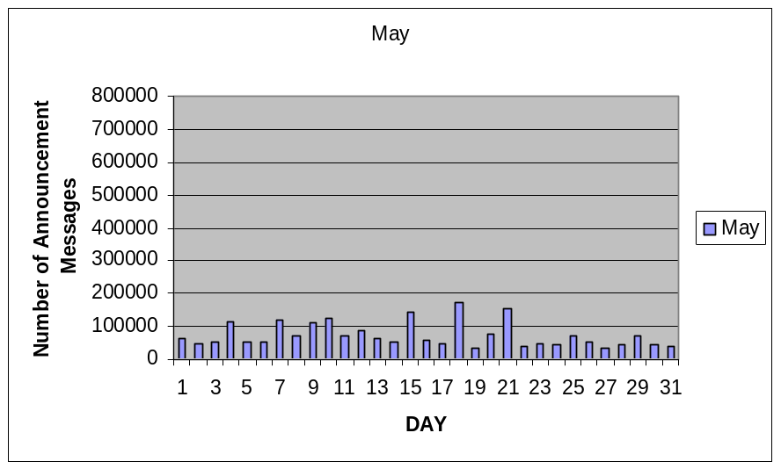
PB 1997
A
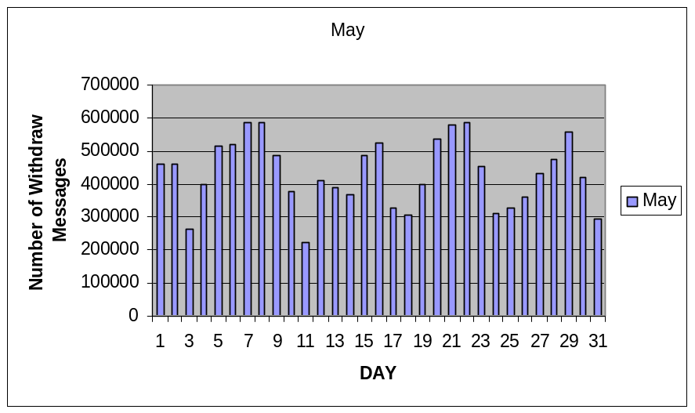
PB 1997
B

Figure 2: (A) shows the total daily number of Announcements in May 1997
(B) Shows the total daily number of Withdrawals in May 1997

From the graph, notice that the number of Withdrawals is much more than the number of Announcements this indicates there were more paths taken away than were added. There are two intuitive conclusions one could draw from this; one, the actually number of paths in the Internet is decreasing or alternatively duplicate withdrawals exist. Further investigation of the data suggests that the number of announcements and withdrawals for the years proceeding 1997 are nearly the same. We hypothesize therefore that the disproportionate number of Withdrawal message was due to router misconfiguration. This seems consistent with the work done Labovitz et al. [LRM97] Their findings led router vendors to improve the hardware of their routers and develop software updates to limit several problems.

The following graphs shows the average path length from 1997 to 2000 based on the data collected from three locations:
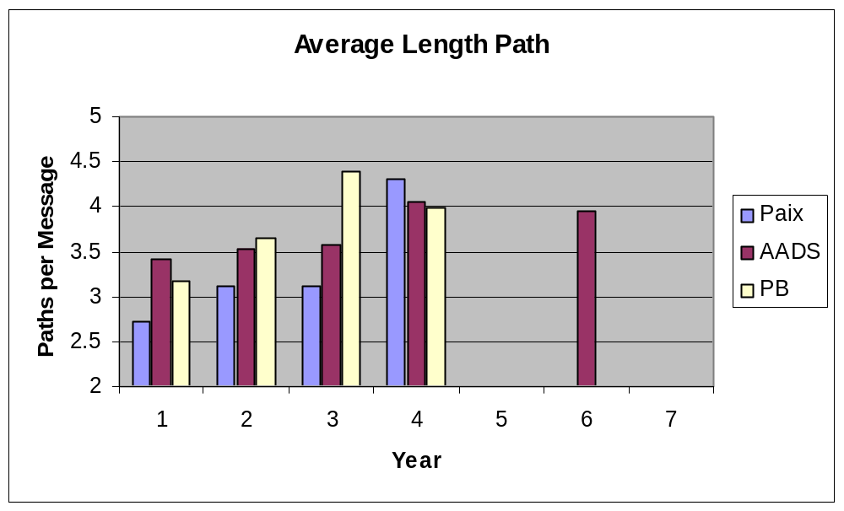
1997 1998 1999 2000 2001 2002 2003
Average Path Length
Figure 1: The above graph shows the average path length over the years in three locations

From the graph, we notice the average path length increases each year, from 1997 to 2000. To understand what this means, first we examine the meaning of average path length in more depth.
Average path length means the number of autonomous systems (ASes) that a packet will traverse when sent to its destination. In some sense the average path length of BGP paths is the average “width” of the Internet (i.e. how far is the average source from the average destination). For instance, how many states do you drive through when you go from city A to city B? This would say something like the “width” of a country.
What does average path length tell us? What does a small average length mean? Or what does an increasing average path length mean? Is this a good thing or a bad thing? Well, if in the extreme the average length was 1, then that would mean that most ASes are directly connected to each other. It might seem like this would be good but really a high degree of connectedness indicates a very low level of aggregation of BGP routes!! If all ASes are directly connected, then each AS must maintain a routing entry for all other ASes. Instead, we would like to see the average length larger, this indicates more aggregation. In another words, the router will find a specific path quicker and speed up the process of sending packets. Furthermore, the chance of losing packets decreases because time-out is less likely to occur.
However, the bigger the number of average path length, the longer journey a packet will have to go through. This is another problem since a packet can only last for 30 hops before it times-out. Therefore, having an appropriate size for average path length is important and we will continue to track the average path length as we are able to import more data.

8. Future Work

For the future work, we like to import more data from 2000 to present since we only have set of data from 1997 to 2000 in Paix, Aads, and PB. Analyze the possible changes in our current result in future and compare them. Further analysis will be continued after more raw data collect and it will provide a more detailed picture of the whole network traffic. Develop a web front end to the data and then issuing queries to analyze the data.

9. Conclusion

It is important to note all our remarks about the Internet instability are not to mean that to the Internet is poorly designed but see how we can make it better. If one think about how the internet has started and the level of development it has reached today and changed the way the information is distributed around the world one should even more be interested in making it more reliable. Although we are confident our result are accurate based on the large amount of data we have considered for our analysis; it is hard to predict how the network will behave since the movement within the internet itself, how the routers are configured and protocol implemented is difficult to control at least in short period of time
Our ambition is to be able to use our theoretical results and determine the real behavior of the Internet protocol and make it much more stable. Upon the completion of this project, we are sure that we have raised the attention of the reader of this paper to the internet instability and demonstrate that more work is need to be done to understand and solve the internet instability problem.

10. Acknowledgements

We would like to thank Dr. Jeanna Matthews for helping and teaching us through this project and graduate student Todd Deshane for guiding in our process to finish this project. We also would like to recognize the support of McNair Director Cathy Clark, Project Director Alan Rossner, Administrative Assistant Tammy Kunz, and Instructor Sara Morrison. Without their support, we might not be able to get this project this far.

References

[ISC03] “Internet Domain Survey,” Internet Software Consortium, http://www.isc.org/ds/WWW-200301/index.html, January 2003.

[RWL+95] Rekhter, Y., Watson Research Center, Li, T., Cisco Systems. “Border Gateway Protocol 4 (BGP-4),” Request for Comments, ftp://ftp.rfc-editor.org/in-notes/rfc1771.txt, March 1995.

[Pa96] Paxson, V. “End-to-End Routing Behavior in the Internet,” in Proceedings of the ACM SIGCOMM ’96, Stanford, C.A., August 1996.

[LRM97] Labovitz, C., Malan, G., Jahanian, F. “Internet Routing Instability,” in Proceedings of the ACM SIGCOMM ’97, Ann Arbor, MI, 1997.

[GW99] Griffin, T., Wilfong, G. “An Analysis of BGP Convergence Properties,” in Proceedings of the ACM SIGCOMM ’99, Murray Hill, NJ, 1999.

James Lu’s Masters Thesis.

[CC02] Chung, K., Cheng, S. “BGP Data Analysis.” 2002.

[FNC95] “Definition of ‘Internet’,” FNC Resolution, http://www.ccic.gov/fnc/Internet_res.html, October 1995.

NetSizer, www.netsizer.com.

MCI Center, http://www.mae.net/ATM/MAE_East.htm.

MCI Center, http://www.mae.net/ATM/MAE_West.htm.

AADS Filing Inc., http://www.aads-filing.com/index.htm.

SBC Internet Services, http://public.pacbell.net.

PAIX, http://www.academ.com/nanog/feb1998/paix.

Appendix A
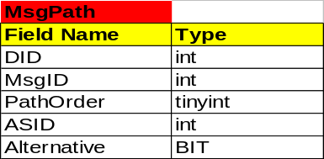
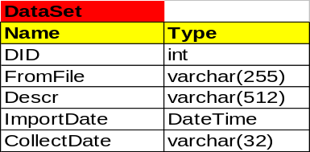
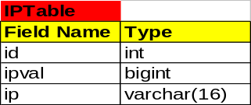
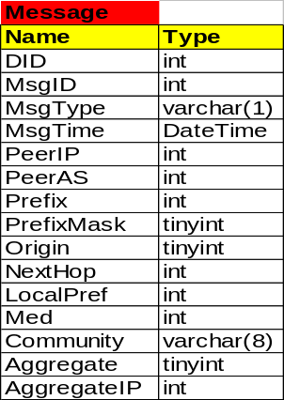
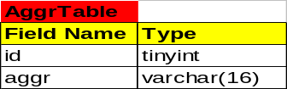
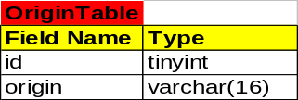

Fig B.1: The database designed by Kai-Wen Chung
San-Yiu Cheng (our modified version follows: Fig B.2)

  Message Table
  Field | Type
  MsgID | int(10)unsigned
  MsgType | char(1)
  MsgTime | Datetime
  MsgPathID | int(10)unsigned
  CommunityID | int(10)unsigned
  Med | int(10)unsigned
  DataSetID | int(11)
  PeerAS | Mediumint(8) unsigned
  AggregateIP | Mediumint(8) unsigned
  NextHopID | Mediumint(8) unsigned
  PeerIPID | Mediumint(8) unsigned
  PrefixID | Mediumint(8) unsigned
  PrefixMask | tinyint(3) unsigned
  BGPVersion | tinyint(4)
  AggregateID | tinyint(4)
  AggregateIPID | Mediumint(8) unsigned
  OriginID | tinyint(4)
  DataSet Table
  Field | Type
  id | int(10) unsigned
  FromFile | varchar(255)
  Desc | tinyblob
  ImportDate | datetime
  CollectDate | datetime
  CollectedFromID | tinyint(4)
  IPTable Table
  Field | Type
  id | int(10) unsigned
  ipval | bigint(20)
  ip | tinyint(4)
  Aggregate Table
  Field | Type
  id | tinyint(3) unsigned
  aggr | Char(3)
  BGPVersion Table
  Field | Type
  id | tinyint(3) unsigned
  aggr | varchar(5)
  CollectedFrom Table
  Field | Type
  Id | tinyint(3) unsigned
  CollectedFrom | varhar(16)
  Community Table
  Field | Type
  Id | int(10) unsigned
  CommunityID | int(10) unsigned
  PathOrder | tinyint(4)
  CommuniyAS | mediumint(8) unsigned
  LocalPref | mediumint(8) unsigned
  MsgPath Table
  Field | Type
  Id | int(10) unsigned
  MsgPathID | int(10) unsigned
  PathOrder | tinyint(4)
  ASN | mediumint(8) unsigned
  Altenative | tinyint(1)

Fig B.2: Our final table, which is an improved version of Fig B.1

