NAME: Aashish Raj

Reg no: 18BIT0113

Slot: A2/TA2



# DCCN DA-3

# REAL TIME CHATTING APPLICATION USING WEBSOCKETS

**BY**

# AASHISH RAJ (18BIT0113)

**ABSTRACT:**

Websockets allows the communication between client and server which is full duplex which helps in persisting the connection established between them.

The latency caused by websockets are negligible and it lives up to the standards and provides the accuracy and efficiency stream events.With websockets, overhead is removed and complexity is reduced.Handshaking is a procedure which guarantees synchronization among server and its customers. It's an essential idea of Web attachment convention.

Real-time communication is effortless and efficient with websockets.

So real-time chatting application with the websockets are very flaw less and very fast.

**INTRODUCTION:**

The web applications currently are based on HTTP and application layer protocol which is request response based. In HTTP the user initiates a request and TCP connection is enabled. After request is receives, server responds to the request. As mentioned above it doesn’t provide user with real time environment. Further long polling requires install plug-ins and cause heavy load on the server.

This is a web application for real-time chatting using websocket protocol which provides full duplex communication and very high speed data transfer. In this application NODE.JS is used as a server side language and Html and JavaScript as the client side language.

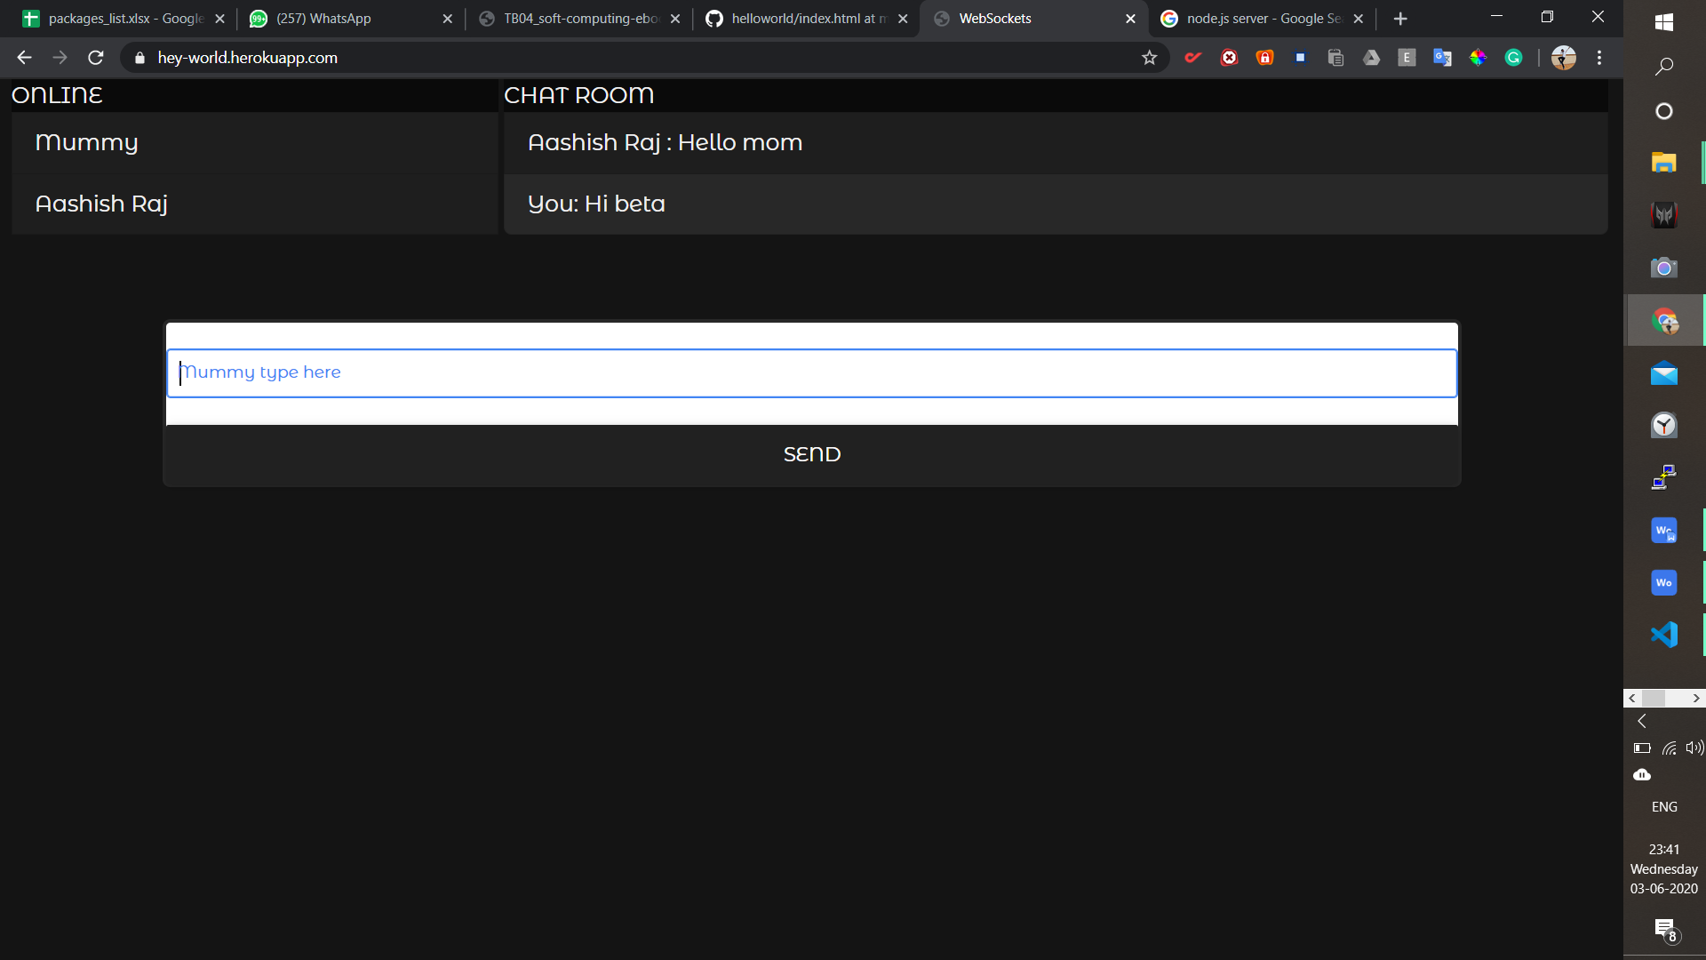

**LITERATURE REVIEW:-**

**Research of Web Real-Time Communication Based on Web Socket** Qigang Liu, Xiangyang Sun

The web applications currently are based on HTTP and application layer protocol which is request response based. In HTTP the user initiates a request and TCP connection is enabled. After request is receives, server responds to the request. As mentioned above it doesn’t provide user with real time environment. Further long polling requires install plug-ins and cause heavy load on the server.

Web sockets create a full duplex communication between client and server Ton HTTP and operates over a single socket. The advantage given a socket connection to internet with minimum overhead. It also is responsible for reduction of network traffic and latency compared various technologies such as AJAX, Comet. Sheer dominance is not shown by Web sockets as it requires HTTP standard ports (80 and 443) and is established during initial handshake. It is called proxy server. Apart from that it doesn’t require any further hardware support.

**Analysis**

An analysis performed by Peter Lubbers and Frank Greco compared the performance of Ajax polling and Web socket. The result concluded that performance of web sockets was highly dominating and much better compared to HTTP. The factors which distinguished them were network traffic and delay in concurrent systems.

**Conclusion**

Real time communication is bound to be the need of the hour for web based system. Web socket are considered to be future to Ajax and is bound to be the perfect solution in order to create concurrent system providing the user with real time environment. However the most popular browsers yet don’t support the web sockets but intelligent gateways are being developed in order to incorporate them within browsers.

**Introducing web Socket-Based Real-Time Monitoring System for Remote Intelligent Buildings-**

Kun Ma and Runyuan Sun

Wireless Sensor Networks are used in intelligent building management systems consist of different types of sensor nodes measuring parameters such as temperature, humidity, light, and asphyxiating smoke. Deficiencies of current monitoring systems include delay and concurrency.

**Networking Building Issues**

In the first place, how to use the rising web to consolidate the savvy object inside building and to create suite of intelligent interfaces. The duty of characterizing very much shaped conventions (AJAX and REST) particularly for condition checking. Second, how to help diverse heterogeneous system, (for example, ZigBee and 6LoWPAN is testing.

Today, WSN framework innovations experience the ill effects of no adaptability and exclusive arrangements. There are two well-known remote correspondence conventions received by IEEE 1451.5 standard ZigBee and 6LoWPAN. ZigBee has the benefit of intensity sparing and minimal effort, however juvenile contrasted and Internet Protocol (IP) which has been created in the course of the last 40 years.The principle disservices of ZigBee incorporate short range, low unpredictability, and low information speed. 6LoWPAN, an option to ZigBee, is an abbreviation of IPv6 over Low power Wireless Personal Area Networks.

**Monitoring Methods**

WSN’s can be monitored by HTTP long polling and has various disadvantages. Another way of monitoring is sockets in ActiveX provides easy development of applications that communicate using UDP or TCP. These have the advantage of working identically across the browsers with the appropriate plugin installed and need not rely on HTTP connections, but with the disadvantage of requiring the plugin to be installed. Besides, ActiveX runs from Windows Internet Explorer only, and embedding application in the browser would affect browser-side performance.

The third observing methodology is Flash Socket. Flash Socket transfers make utilization of the XMLSocket object in a solitary pixel Adobe Streak motion picture. The benefit of this methodology is that it acknowledges the regular read-compose asymmetry that is average of many web applications, and as an outcome, it offers high effectiveness.

There are numerous downsides of the above methodologies. Our examination investigated the Internet Attachment perfect server incorporated with WSNs to help each program. Regardless of whether Web Socket is chosen as the vehicle, Web Socket compatible server accomplishes more than Web Attachment itself, including pulses, timeouts, and detachment highlights. This systems administration has prompted a more prominent consciousness of the states of structures. The primary advantages of this are economies of scale picked up from continuous checking, quick stacking, low dormancy, and minimal effort.

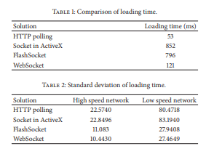

**CONCLUSION AND ANALYSIS**

A Web Socket-based ongoing checking framework for remote astute structures in electronic building has been proposed. By using the Web Socket, NoSQL, the Electronic checking framework can be executed to effortlessly control and screen the sensor action progressively. This exhibit delineated that it is conceivable to remotely control the electrical machines from this Internet UI of brilliant terminals. The open design of the idea considers simple and ceaseless updates and boundless expandability can be utilized to screen and gauge continuous information, for example, the temperature, light, moistness, and power utilization. Additionally, the test results demonstrate the productivity of the capacity of NoSQL information distribution center, particularly in a universe of huge information. The capacities offered by the sort of remote sensor framework exhibited in this paper are tremendous. They give the supervisors and proprietors of structures criticism on the vitality utilization of structures to help enhanced building control and occupant conduct change. Enhancements in the frameworks sensors could likewise be incorporated into the sort. A web attachment for WSN's tends give better stockpiling components, low idleness, quick stacking, lesser question time, storage room and excess rate.

**An Overview of Web Sockets: The future of Real-Time Communication**

Bhumij Gupta, Dr. M.P. Vani

A socket is defined as port through which data goes in and out of. Protocols are responsible for interpretation of data going to and going out. Such a protocol is HTTP. Over a HTTP connection, a request made by the client, subsequently the port is opened and server is responsible for sending the data on that particular port. Limitation associated with HTTP is latency, issues such as pull paradigm and port relaying. Web browsers need to poll the server for fresh information by echoing requests within a stipulated time recursively. With web socket protocol introduced that meant server’s stay open for the communication and data can be retrieved whenever required.

Polling-The client sends a request to the server. And as soon as the request is received, the server responds. A new message is subjected to availability. If there is one available, response is sent as message, else an empty response is sent. After a short time Δ, called the polling interval, the client polls the server again to see if any new messages are available. Various applications including chat, online games, and text messaging use HTTP polling.

Long Polling- Perhaps the disadvantage associated with polling is the number of unnecessary requests being made to the server and when there is now new data available, it creates load on the server and more importantly consumes bandwidth. Instead with long polling the request made by the client is held in server until a new message arrives or timeout expires. A drawback associated with long polling is to keep the connective alive and has to be saved locally which would add up on space complexity.

Handshaking is a process which ensures synchronization between server and its clients. It’s a basic concept of Web socket protocol. To Initiate a Web Socket communication, first a HTTP handshake needs to be done. Before a Web socket communication can start, a HTTP connection must be initiated. The browser sends an Upgrade header to the server to inform him he wants to start a Web Socket connection. Switching from the HTTP protocol to the Web Socket protocol is referred to as a handshake.

After the completion of the handshake the Web Socket connection is active and either the client or the server can send data. The data is contained in frames, each frame is pre-fixed with a 4-12 bytes to ensure the message can be reconstructed. Once the server and the browser have agreed on beginning a Web Socket communication. A first request is made to begin an Ethernet communication followed by a request to make a TCP / IP communication.

**ANALYSIS**

Aside from every one of these points of interest, web sockets isn't immaculate. It is as yet not perfect with versatile internet browsers. Web attachments are as yet defenseless to DOS assaults as malignant programming can make an extensive number of web attachment association to the server. It is additionally not good with different API calls it is likewise not perfect with REST API. We regularly require unique setup for load adjusting

Web sockets present another powerlessness called Cross-Site Web sockets Scripting (CRWS).

**CONCLUSION**

More or less, Web sockets is a progressive innovation. It is presently the best decision for executing continuous full duplex web applications. It lessens the inertness and HTTP header stack when contrasting with substitute innovation, and because of its similarity with other existing administrations its execution will continue rising. It can't be considered as a substitution to the current HTTP demonstrate yet a greater amount of as a move up to the model.

**HTML5 Web Sockets: A Quantum Leap in Scalability for the Web**

**By- Frank Greco and Peter Lubbers**

Lately there has been incremental demand advanced, real time and web driven applications. With streaming, the browser sends a complete request, but the server sends and maintains an open response that is continuously updated and kept open indefinitely the response is then updated whenever a message is ready to be sent, but the server never signals to complete the response, thus keeping the connection open to deliver future messages. However, since streaming is still encapsulated in HTTP, intervening firewalls and proxy servers may choose to buffer the response, increasing the latency of the message delivery.

Latency is introduced by methods like polling, long polling and streaming where in the response headers seek lot of space for transmission of data with various unnecessary variables.  To achieve a full-duplex communication requires two connections: one for the downstream and one for the upstream. The maintenance and coordination associated with connections bring in overhead in terms of resource requirements/allocation and adds onto complexity. HTTP is not designed for real-time full-duplex communication.

HTML5 Web Sockets represent the next evolution of web communications - a full-duplex, bidirectional communications channel that operates through a single socket over the Web. HTML5 Web Sockets provides a true standard that you can use to build scalable, real-time web applications.

Google's Chrome browser supports HTML5 Web Sockets.  However, Kaazing Web Socket Gateway provides complete Web Socket emulation for all the older browsers. Kaazing provides a Byte Socket library for binary communication and higher-level libraries for protocols like Stomp, AMQP, XMPP, IRC and more, built on top of Web Socket.

**CONCLUSION AND ANALYIS**

Web Sockets can give a 500:1 or - relying upon the span of the HTTP headers - even a 1000:1 decrease in superfluous HTTP header traffic and 3:1 decrease in inactivity. Kaazing web Socket Gateway gives give a stage setting up in full duplex correspondence in HTML5 by furnishing extra libraries to speak with back end administrations.

**METHODOLOGY:**

Here, In the real time chatting application, NODE.JS is used as a serer side languageand HTML and javascript as a clinent side language.

The client will send the message to the server in a json object with client name and message as its key. The server will take the message and forward to every websockets connected i.e client. Then the client will get the json object from the server having the message from other client and the name of the client sending the message. This is how the message transfer will take place.

**SOFTWARE/TOOLS/LANGUAGE:**

SOFTWARE: Virtual studio, heroku , npm

LANGUAGE: NODE.JS, HTML , CSS ,BOOTSTRAP , JavaScript

**RESULT & CONCLUSION:**

Website url : <https://hey-world.herokuapp.com/>

The website made for real-time chatting works very fast because of websockets. The full duplex communication provided by websocket protocol removes the latency to send data and allow both the sender and reciever to send the message at the same time.

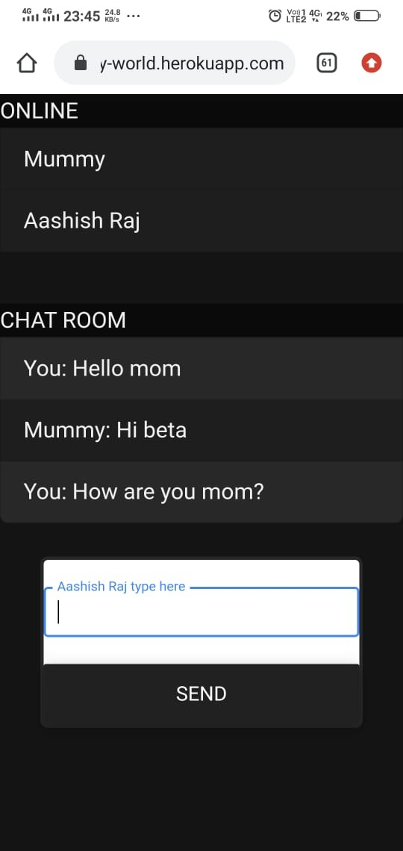

**REFERENCES:**

**Research of Web Real-Time Communication Based on Web Socket** Qigang Liu, Xiangyang Sun

**An Overview of Web Sockets: The future of Real-Time Communication** Bhumij Gupta, Dr. M.P. Vani

**HTML5 Web Sockets: A Quantum Leap in Scalability for the Web**

**By- Frank Greco and Peter Lubbers**

**Introducing web Socket-Based Real-Time Monitoring System for Remote Intelligent Buildings-** Kun Ma and Runyuan Sun