4.)

Table OrderTbl:

Foreign Key_1: CUSTNO

Foreign Key_2: EMPNO

Table OrderLine:

Foreign Key_1: ORDNO

Foreign Key_2: PRODNO

Table Employee:

Foreign Key: SUPEMPNO

Table Employee2:

Foreign Key: SUPEMPNO

There are 4 Relationships where parent and child tables are different:

* Parent: Customer Orders Child: OrderTbl
* Parent: Employee Accepts Child: OrderTbl
* Parent: OrderTbl details about the product Child: OrdLine
* Parent: Product Child: OrdLine

2 Relationships where parent and child tables are same: Employee, Employee2

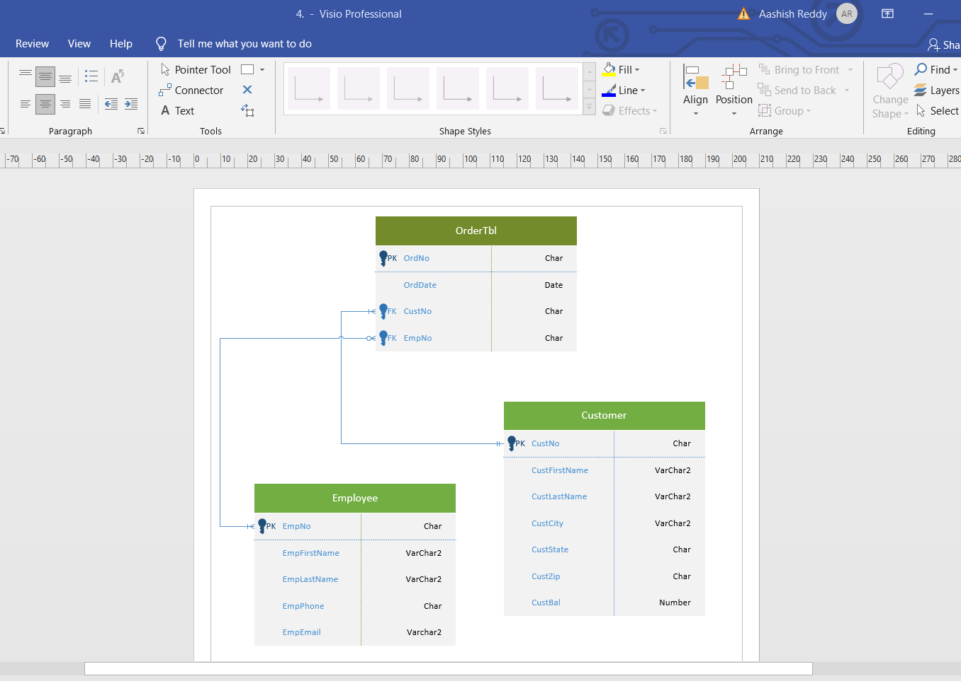

8.) select * from orderdb.OrderTbl where ORDDATE between '01-02-17' and '28-02-17';

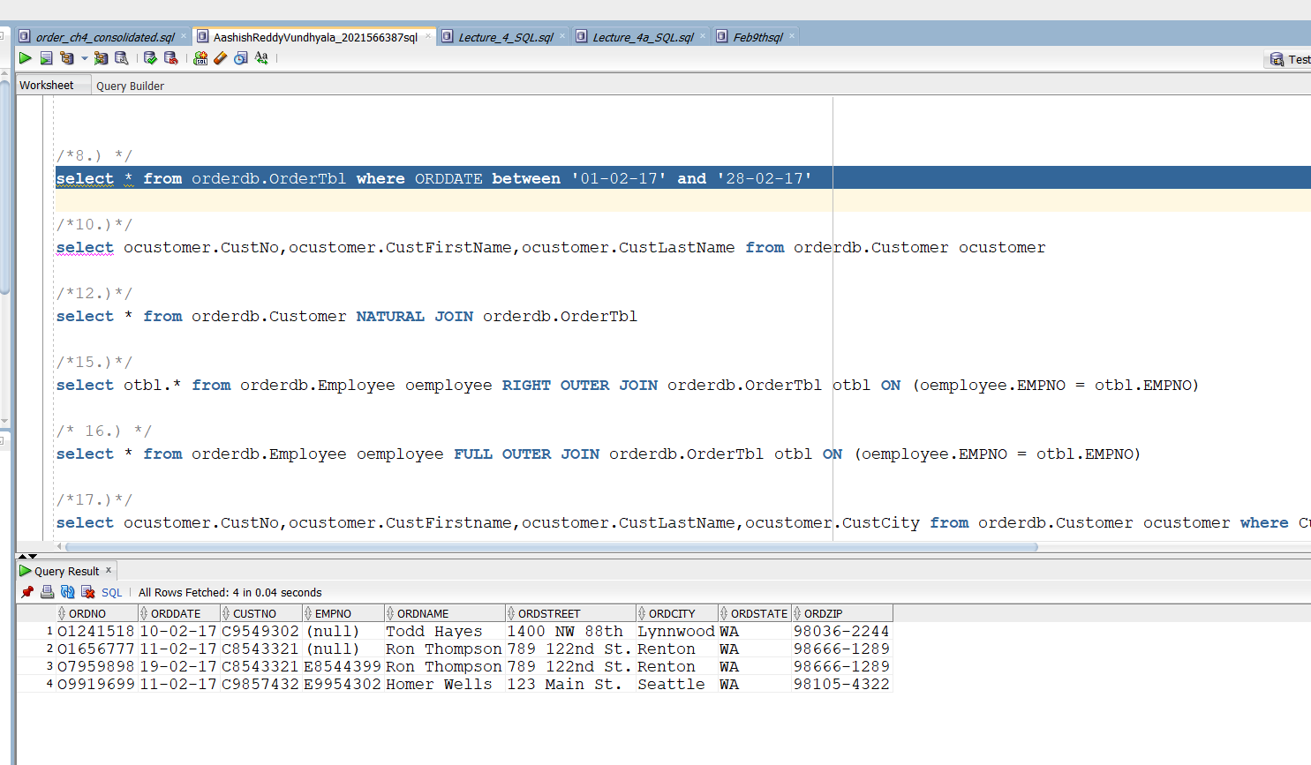

10.) select ocustomer.CustNo,ocustomer.CustFirstName,ocustomer.CustLastName from orderdb.Customer ocustomer;

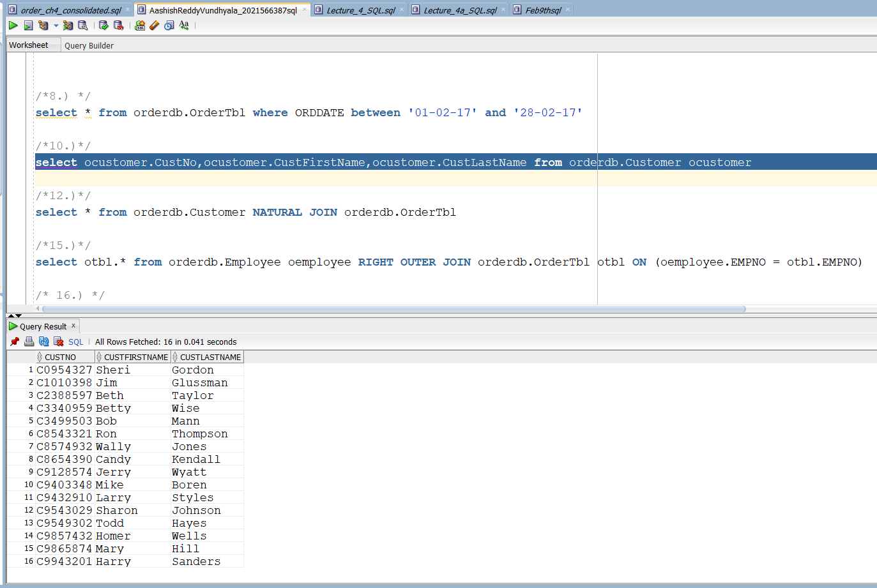

12.) select * from orderdb.Customer NATURAL JOIN orderdb.OrderTbl;

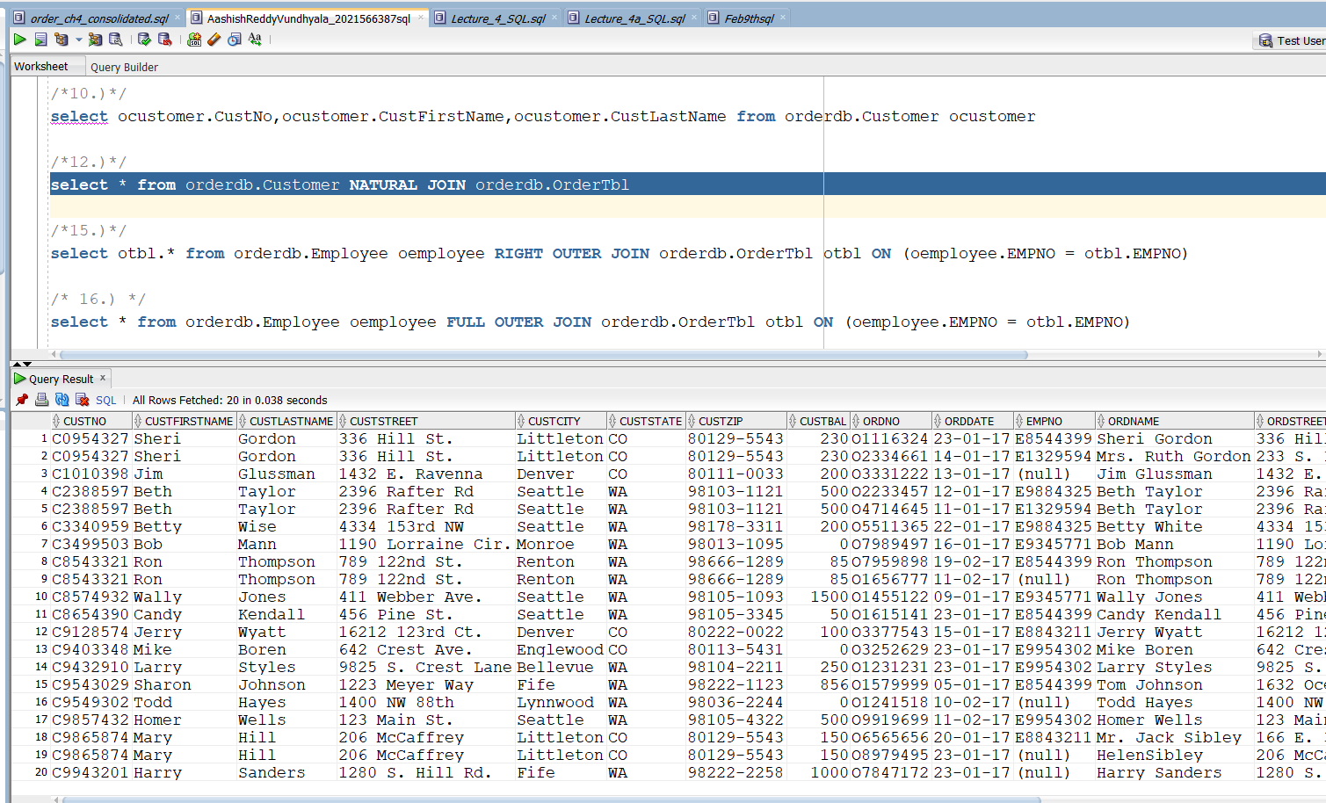

15.) select otbl.* from orderdb.Employee oemployee RIGHT OUTER JOIN orderdb.OrderTbl otbl ON (oemployee.EMPNO = otbl.EMPNO);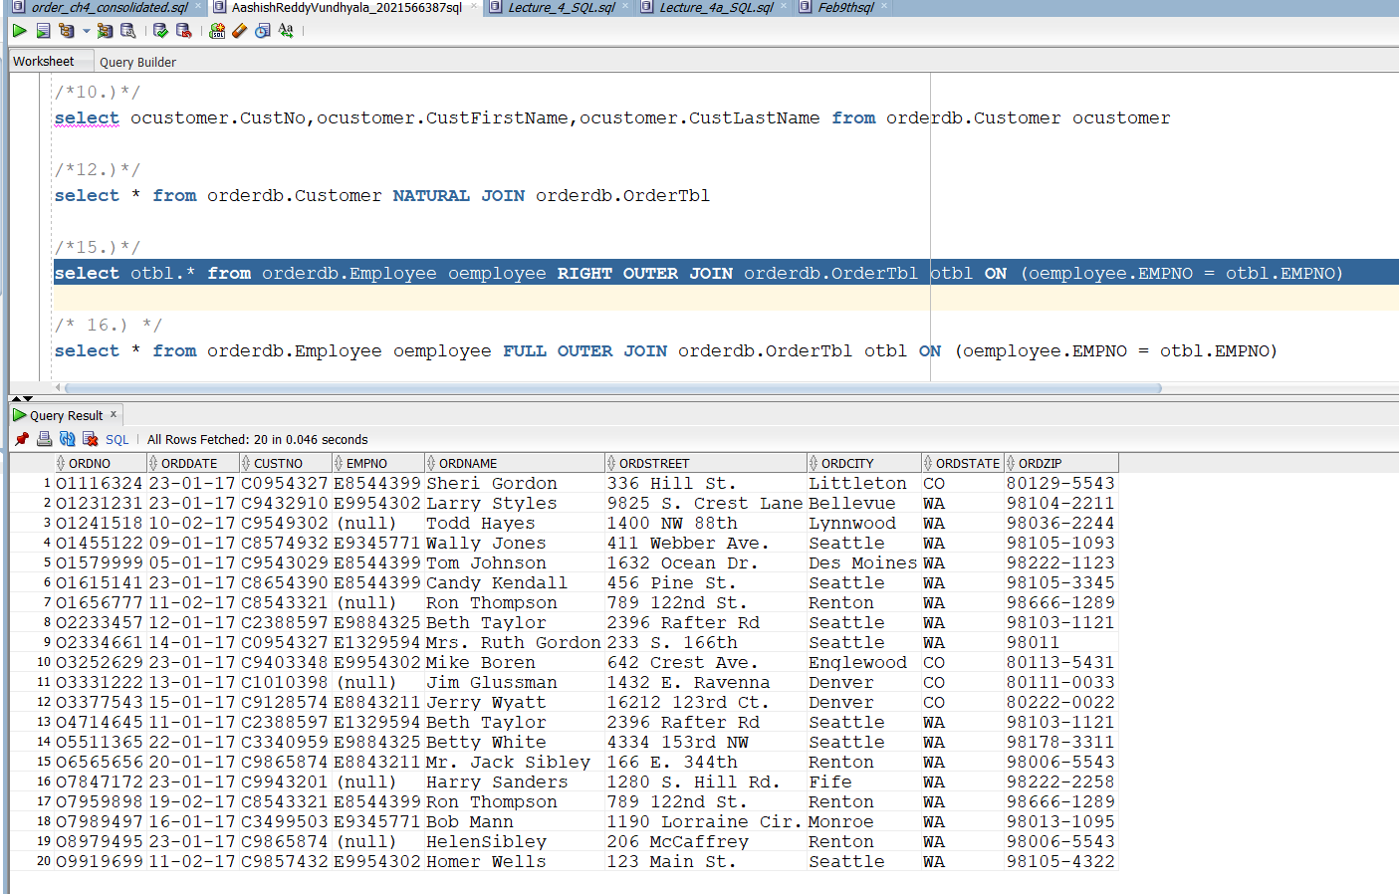

16.)

select * from orderdb.Employee oemployee

FULL OUTER JOIN orderdb.OrderTbl otbl

ON (oemployee.EMPNO = otbl.EMPNO);

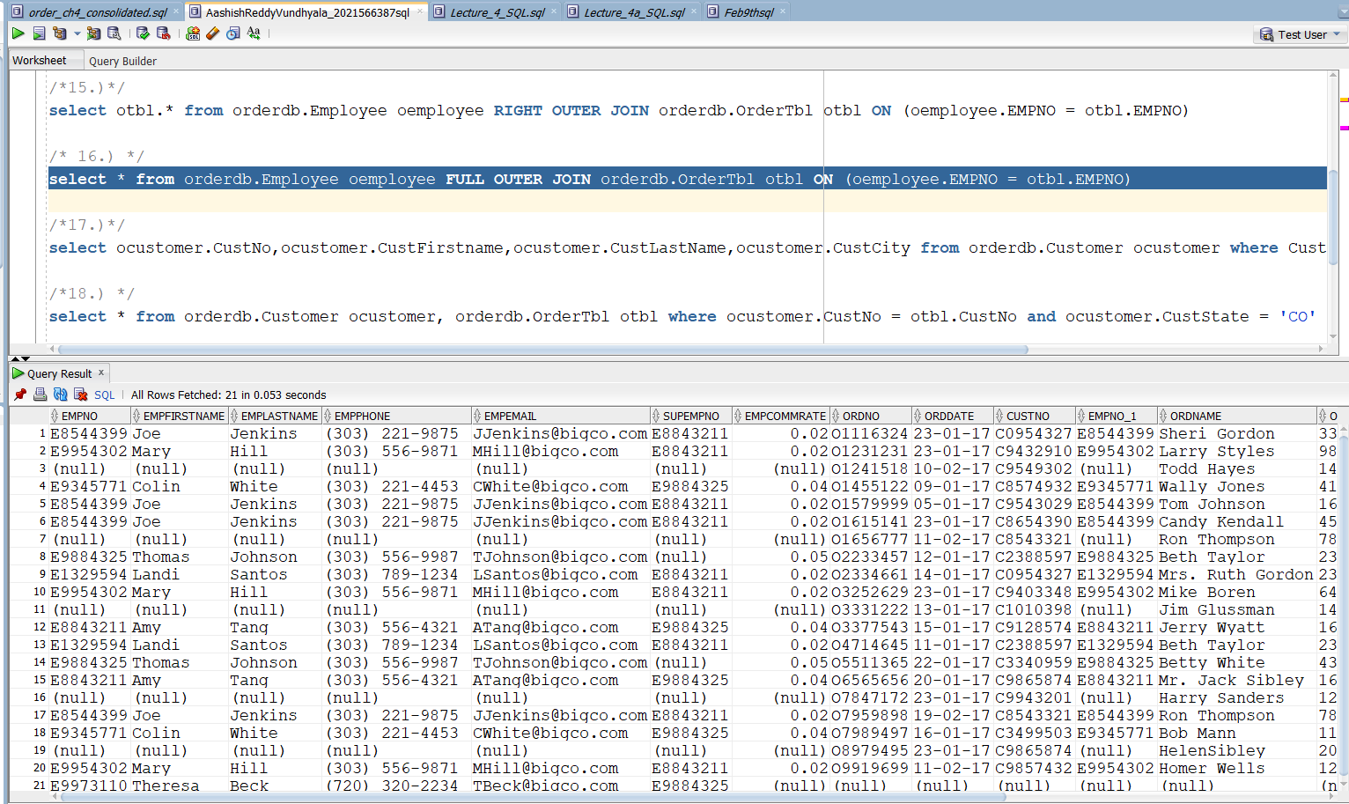

17.)

select ocustomer.CustNo,ocustomer.CustFirstname,ocustomer.CustLastName,ocustomer.CustCity

from orderdb.Customer ocustomer

where CustCity = 'Denver' or CustCity = 'Seattle';

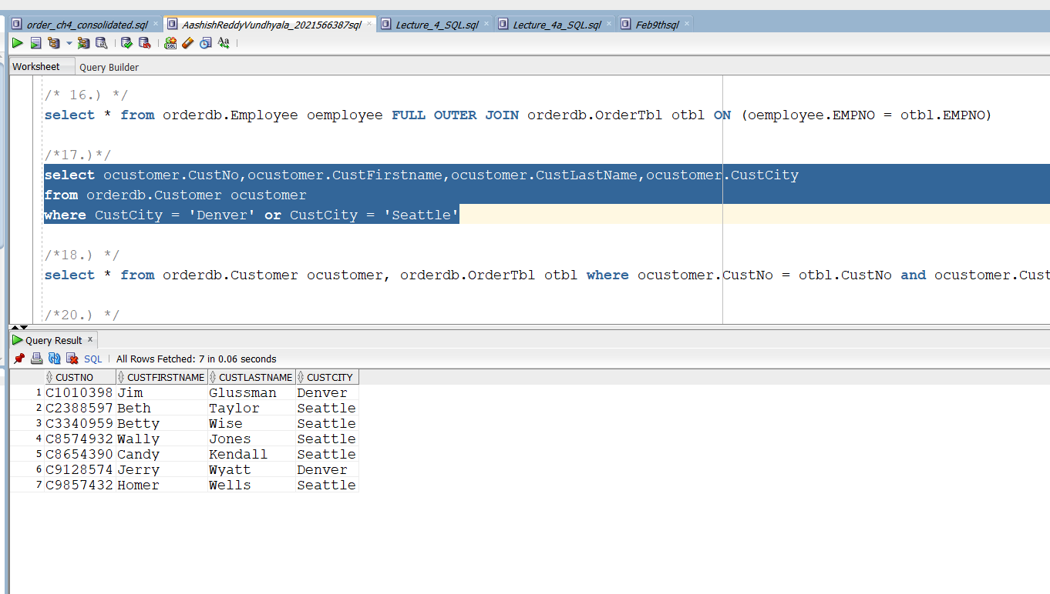

18.)

select * from orderdb.Customer ocustomer, orderdb.OrderTbl otbl

where ocustomer.CustNo = otbl.CustNo and ocustomer.CustState = 'CO';

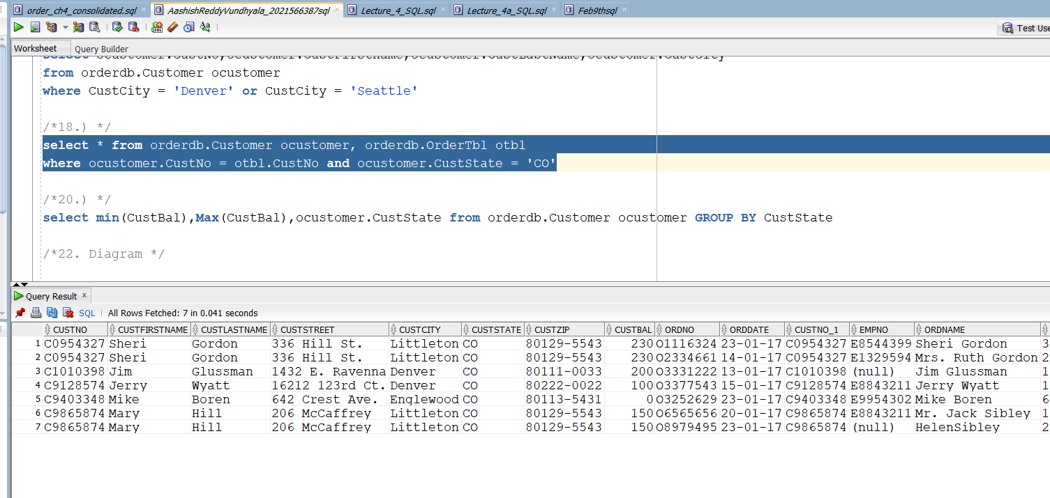

20.)

select min(CustBal),Max(CustBal),ocustomer.CustState from orderdb.Customer ocustomer

GROUP BY CustState;

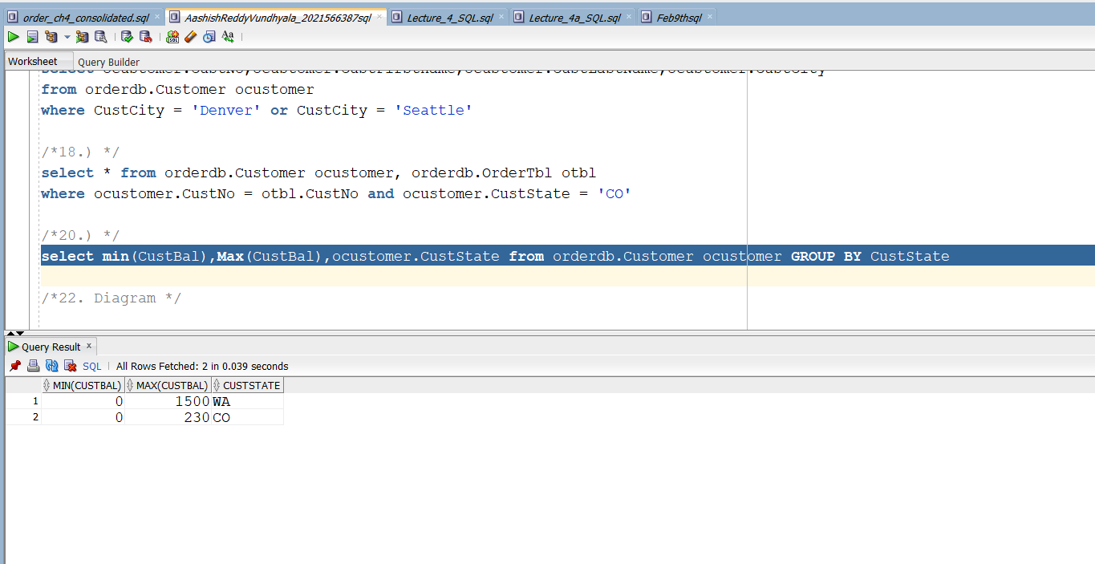

22.)

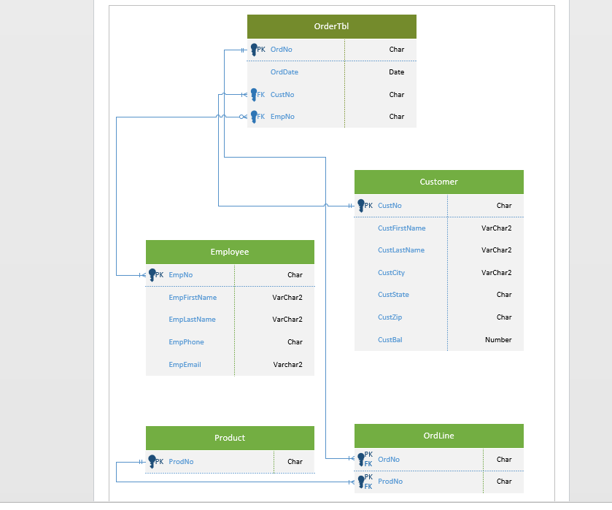

23.)

