1. )

UPDATE Student_tmp_asign3q1

set STDGPA= case

when (STDGPA*1.4) < 4 then STDGPA*1.4

when (STDGPA*1.4) >= 4 then 4

else STDGPA

end

where stdno in( select stdno from univdb.Student);

11 Records Updated.

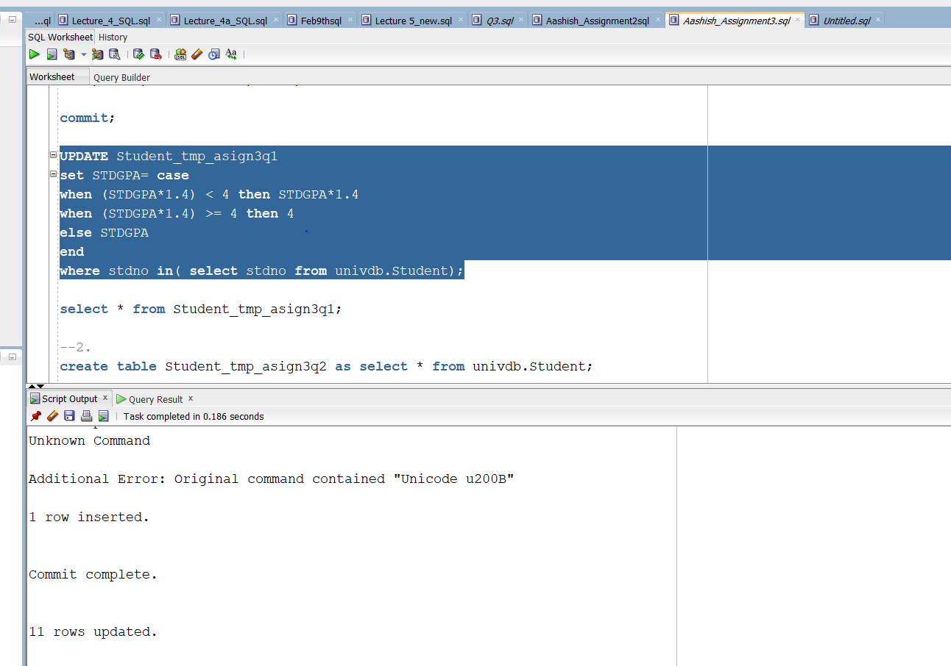

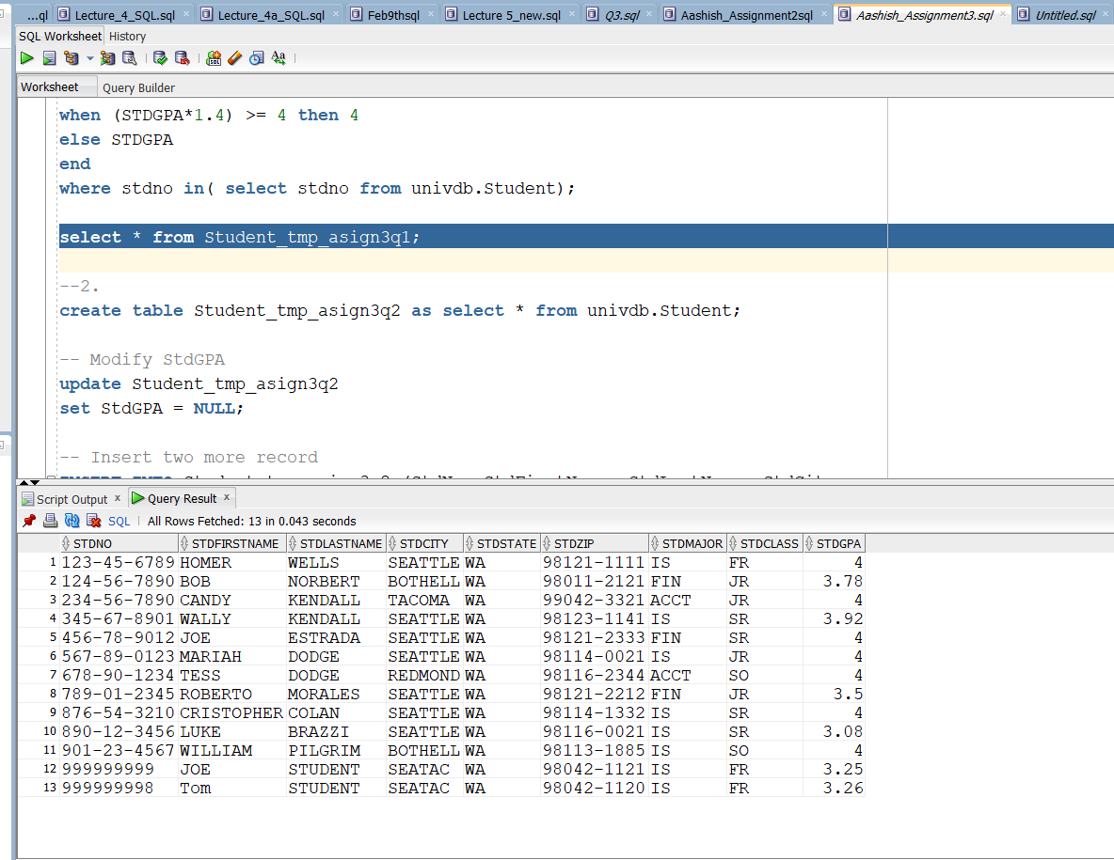

2.)

Update Student_tmp_asign3q2 s2

set stdgpa = (select avg(s.stdgpa) from univdb.student s

where s2.stdclass = s.stdclass

group by stdclass)

where stdno in (select stdno from univdb.student);

11 Rows Updated.

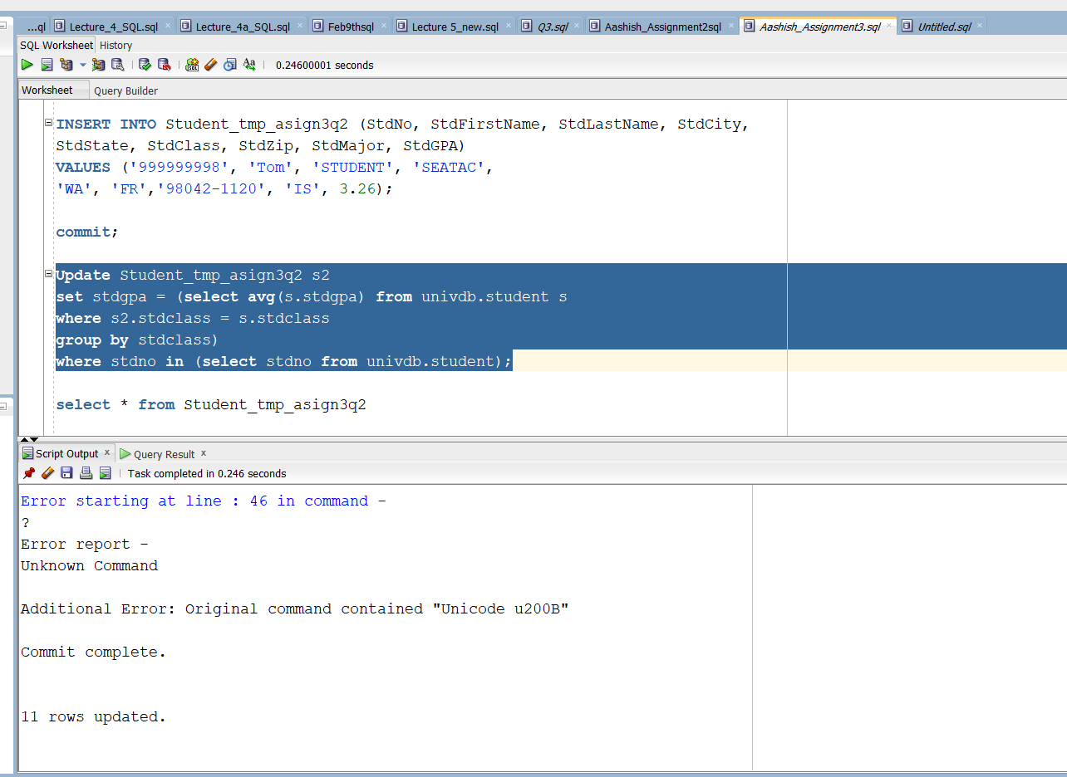

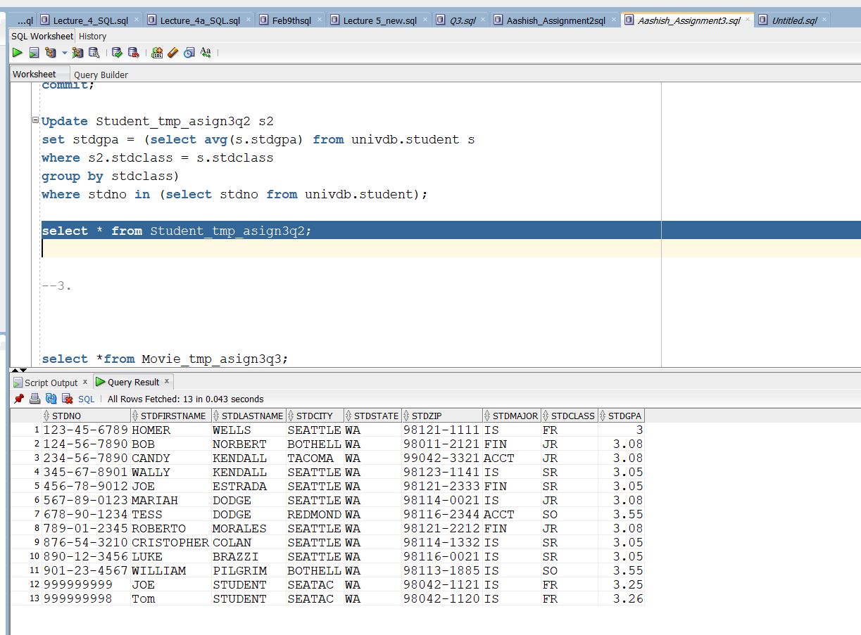

3.)

create table Movie_tmp_asign3q3(

movie_genre varchar(55),

year NUMBER,

rank_average float(100),

rank_stdev float(100);

INSERT INTO Movie_tmp_asign3q3 (movie_genre, year, rank_average, rank_stdev )

SELECT g.genre, m.year, AVG(m.rank), STDDEV(m.rank)

FROM

imdb.movies m,

imdb.movies_genres g

WHERE m.id = g.movie_id

AND m.rank IS NOT NULL

GROUP BY g.genre, m.year; 1869 rows inserted

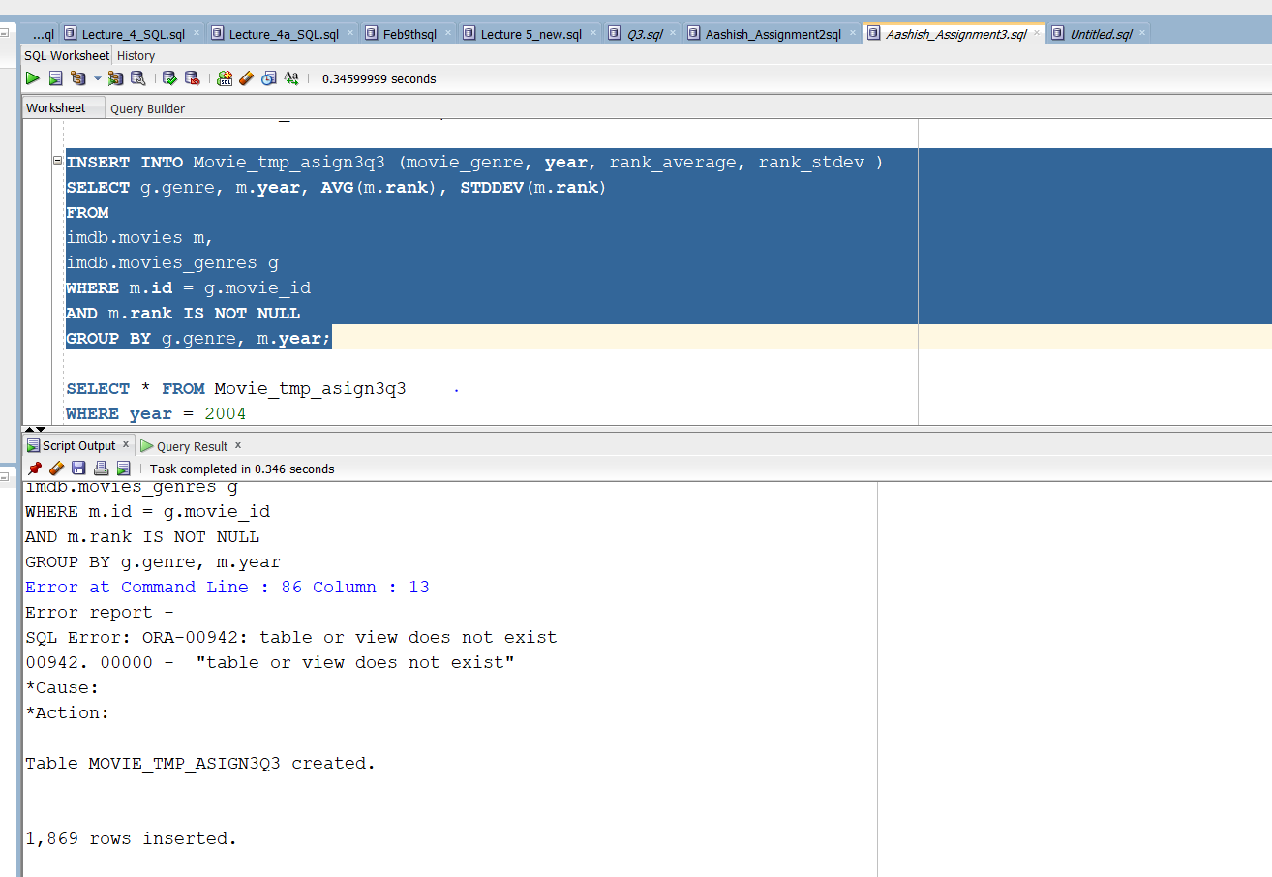

SELECT * FROM Movie_tmp_asign3q3

WHERE year = 2004

ORDER BY rank_average DESC;

