3.)

Primary Keys: A, B, D

All Functional Dependencies are violating 2NF,

because none of the non-key attributes are depending on the whole Primary keys (A, B, D).

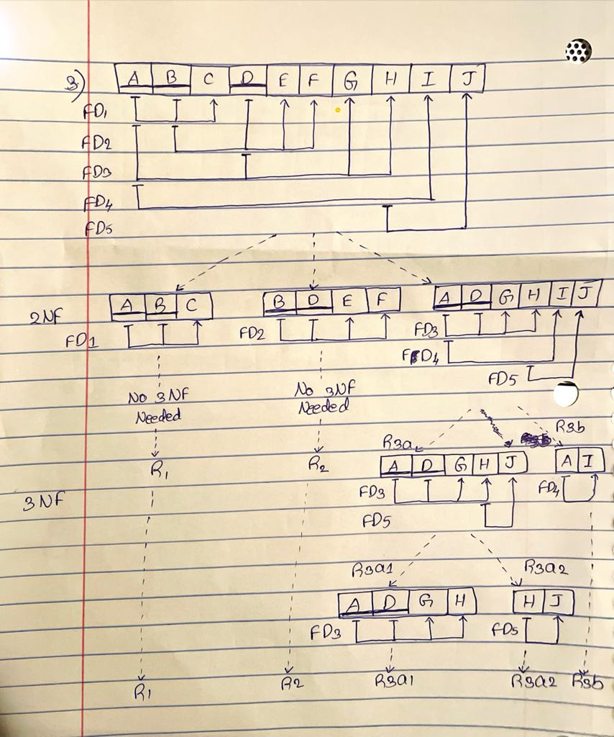

4.)

Primary Keys: E, F

FD2 is the only Full Functional Dependency.

