UTD ID: 2021566387

1.)

select store , total_sales, rank() over (order by total_sales desc) as RANK from

(select store, sum(weekly_sales) as total_sales

from (

select * from sales.sales

where department = 22

and EXTRACT(YEAR FROM sales_dt) = 2011

)

group by store

order by total_sales desc)

where rownum <11;

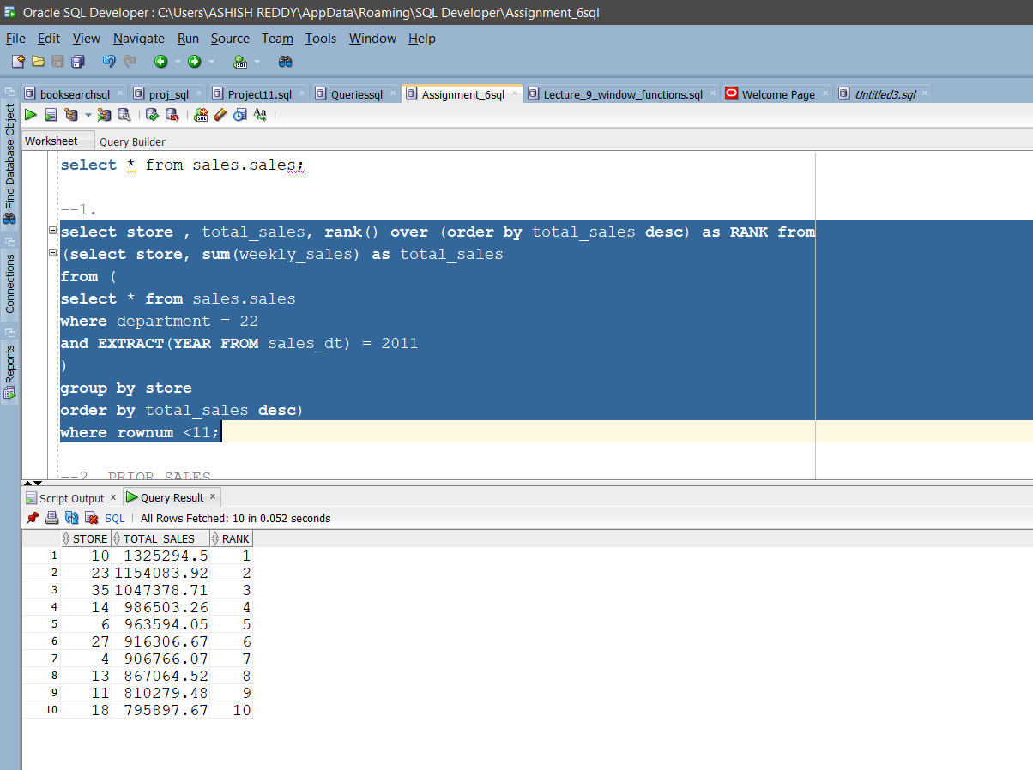

2.)

select store,sales_dt,weekly_sales,previous_week_sales, previous_year_sales

from

(select store,sales_dt,sum(weekly_sales) as weekly_sales,

LAG(sum(weekly_sales), 1) over

(partition by store order by sales_dt) as previous_week_sales,

LAG(sum(weekly_sales), 52) over

(partition by store order by sales_dt) as previous_year_sales

from sales.sales

group by store, sales_dt

order by store, sales_dt asc) x1

where EXTRACT(YEAR FROM sales_dt) = 2012

and EXTRACT(MONTH FROM sales_dt) = 04

and ROWNUM <= 12;

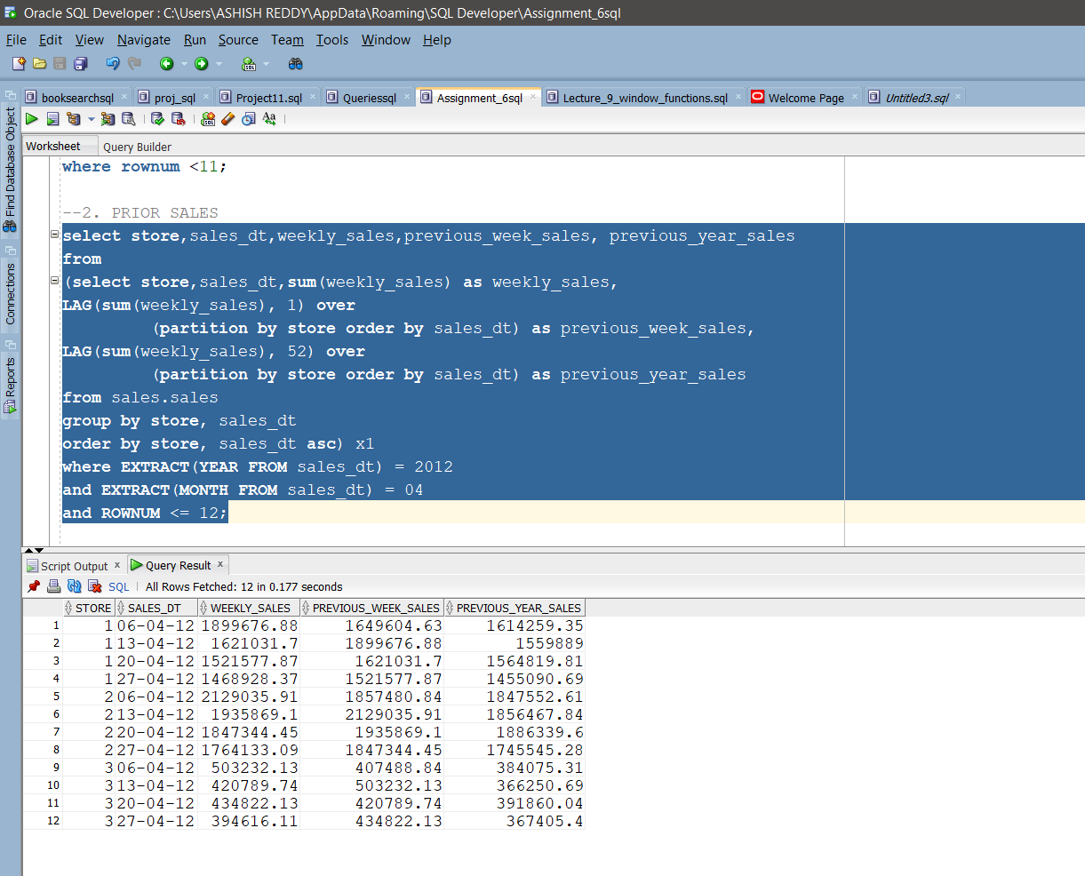

3.)

select store, sales_dt, DEP_1_SALES, DEP_2_SALES, DEP_3_SALES, DEP_4_SALES, DEP_5_SALES from

(select store, sales_dt,

sum(CASE WHEN department=1 THEN weekly_sales ELSE NULL END) AS DEP_1_SALES,

sum(CASE WHEN department=2 THEN weekly_sales ELSE NULL END) AS DEP_2_SALES,

sum(CASE WHEN department=3 THEN weekly_sales ELSE NULL END) AS DEP_3_SALES,

sum(CASE WHEN department=4 THEN weekly_sales ELSE NULL END) AS DEP_4_SALES,

sum(CASE WHEN department=5 THEN weekly_sales ELSE NULL END) AS DEP_5_SALES

from sales.sales

group by store, sales_dt

order by store, sales_dt asc) x1

where EXTRACT(YEAR FROM sales_dt) = 2012

and EXTRACT(MONTH FROM sales_dt) = 04

and rownum <= 12;

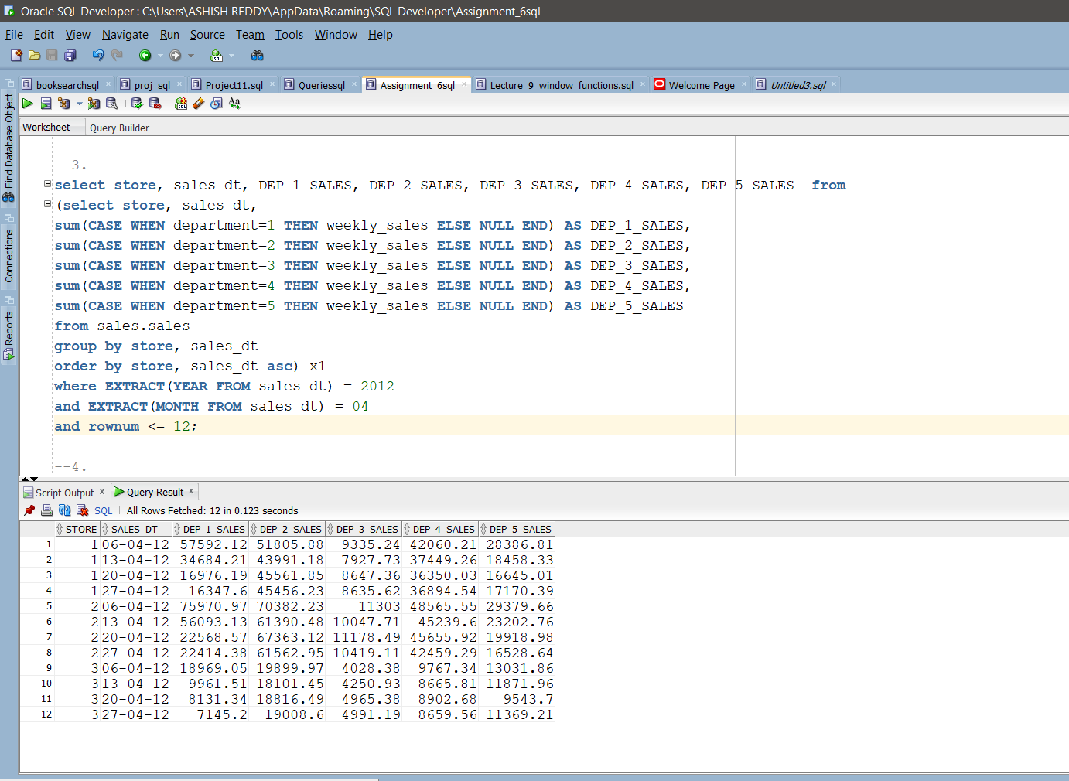

4.)

select ('Drop table Univdb.'||table_name||';') as Dropped_tables

from all_tables

where owner = 'UNIVDB'

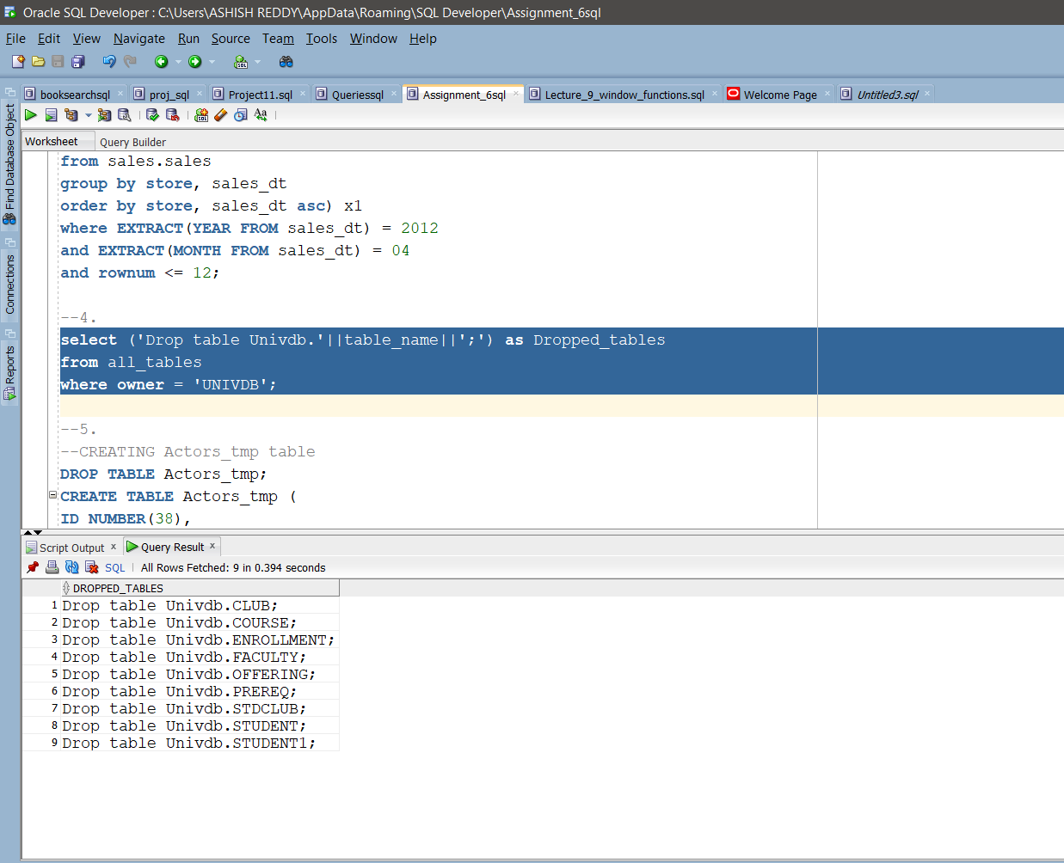

5.)

Create Table Actor_Tmp as Select * from Imdb.Actors;

commit;

Create Index Actor_Tmp_Fullname on actor_Tmp(Last_name, First_name);

Select * from actor_tmp Where Last_name = ‘Posse'

