UTD ID: 2021566387

Aashish Reddy Vundhyala

**Normalization**:

**CREATE AND INSERT STATEMENTS:**

Staff table:

create table staff(

staff_id varchar2(200)

);

alter table staff add constraint staff_id_pk primary key(staff_id);

insert into staff(staff_id) select distinct(staff_id) from Project2.Project2_data;

select * from staff;

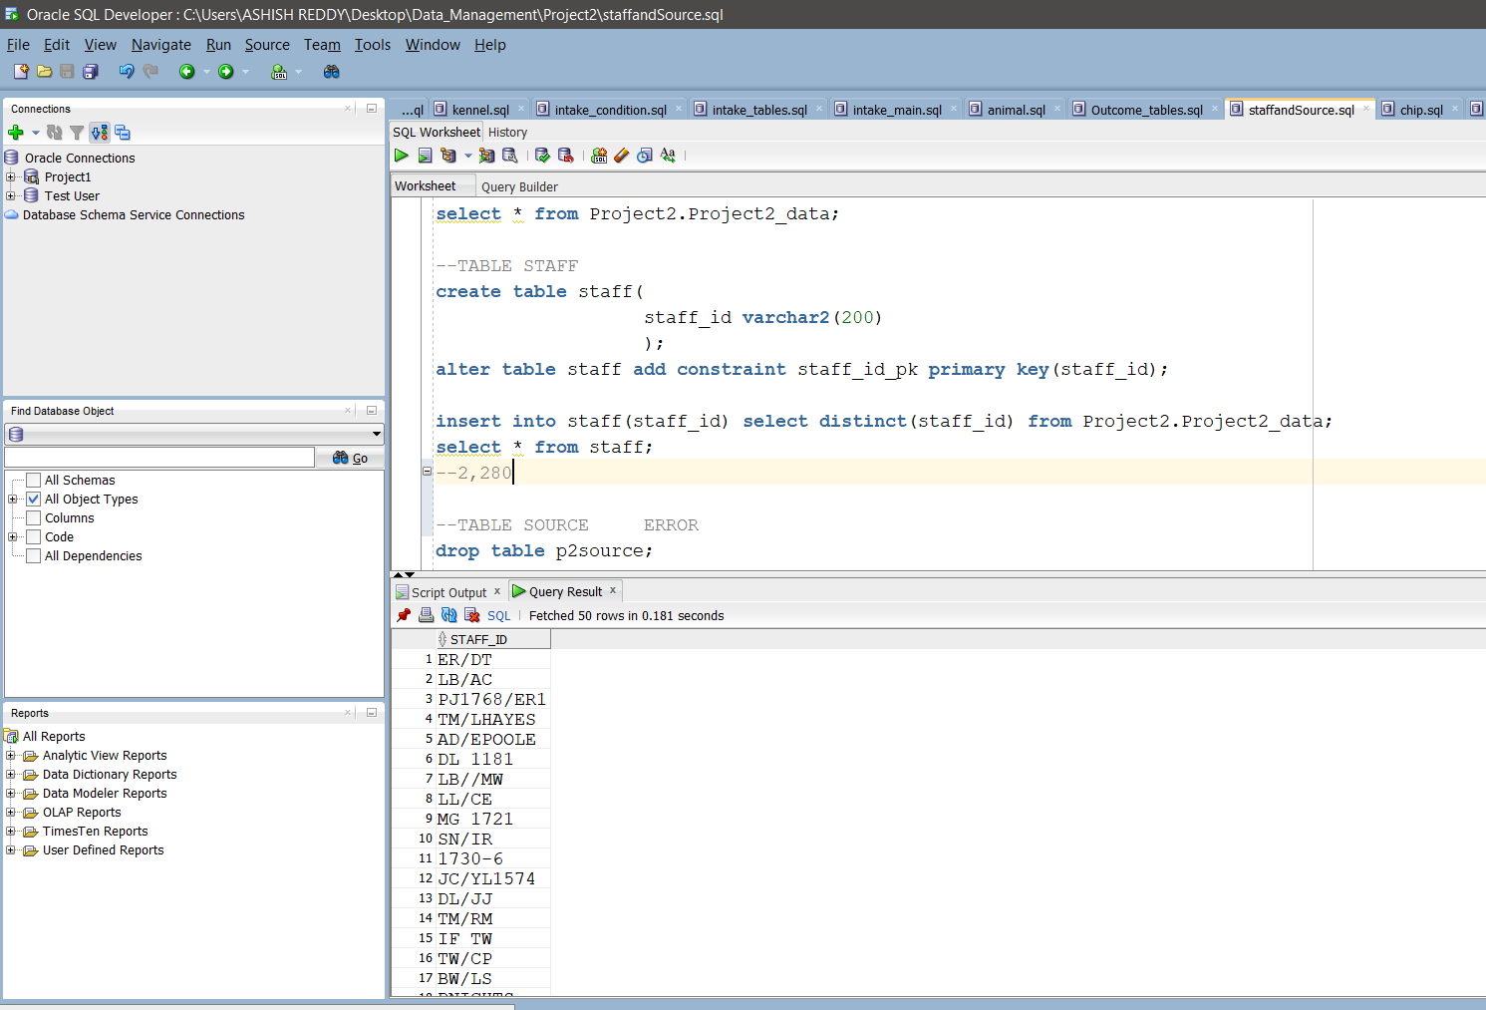

No.of Records: 2280

P2source:

drop table p2source;

create table p2source(

source_id varchar2(200)

);

alter table p2source add constraint source_id_pk primary key(source_id);

insert into p2source(source_id) select distinct source_id from Project2.Project2_data;

select * from p2source;

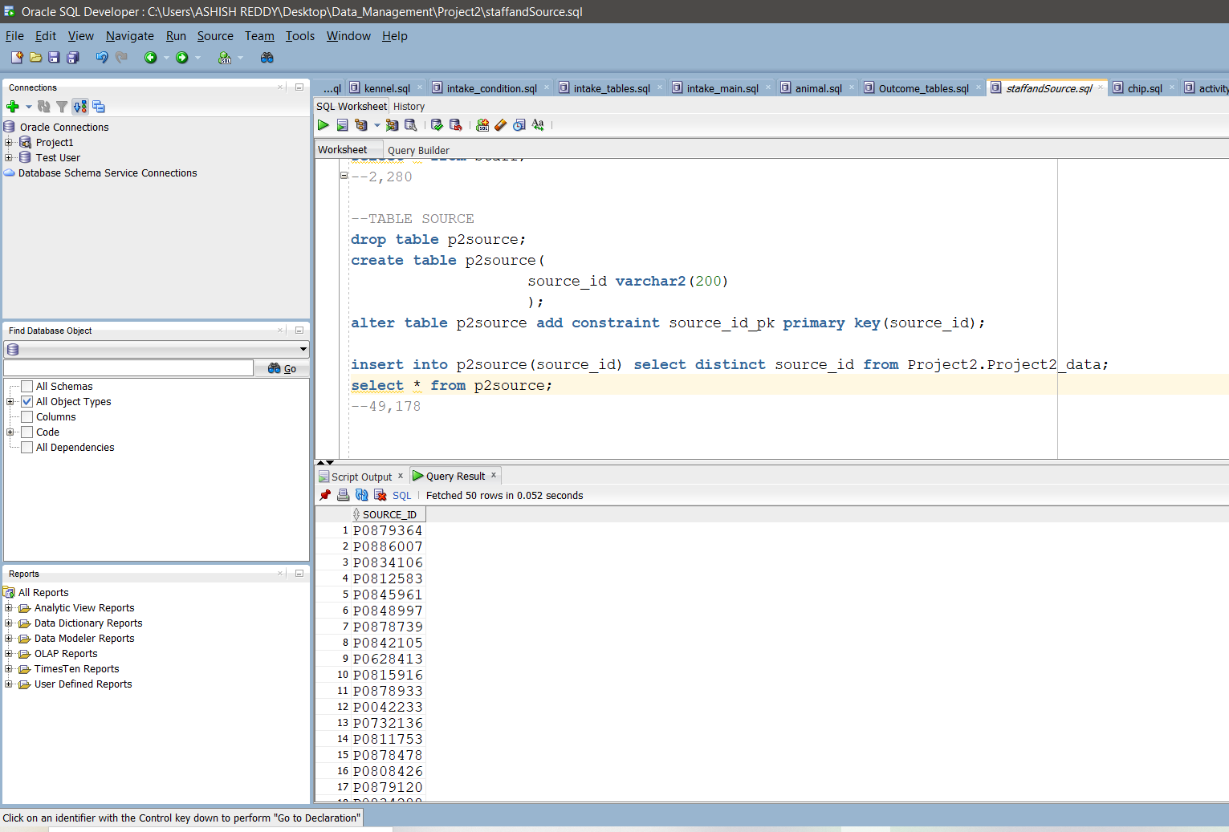

No.of Records:

49,178

chipStatus:

create table chipStatus(

chipstatus_id number generated by default on null as identity,

chip_status varchar2(200)

);

alter table chipStatus add constraint chipstatus_id_pk primary key(chipstatus_id);

insert into chipStatus(chip_status) select distinct chip_status from Project2.Project2_data;

select * from chipStatus;

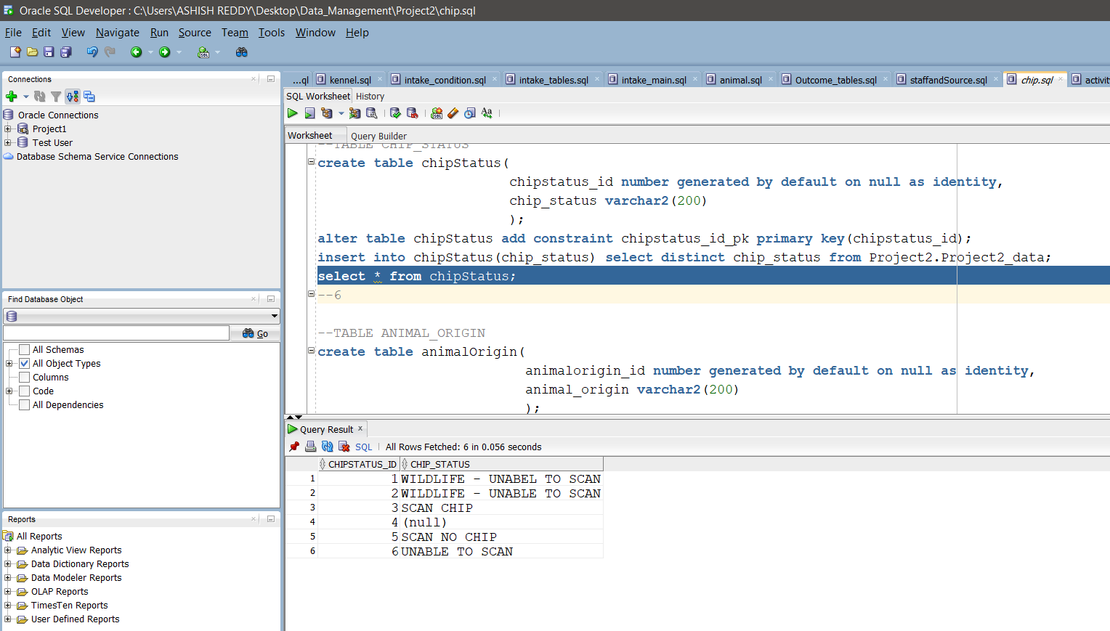

No.of Records: 6

animalOrigin:

create table animalOrigin(

animalorigin_id number generated by default on null as identity,

animal_origin varchar2(200)

);

alter table animalOrigin add constraint animalorigin_id_pk primary key(animalorigin_id);

insert into animalOrigin(animal_origin) select distinct animal_origin from Project2.Project2_data;

select * from animalOrigin;

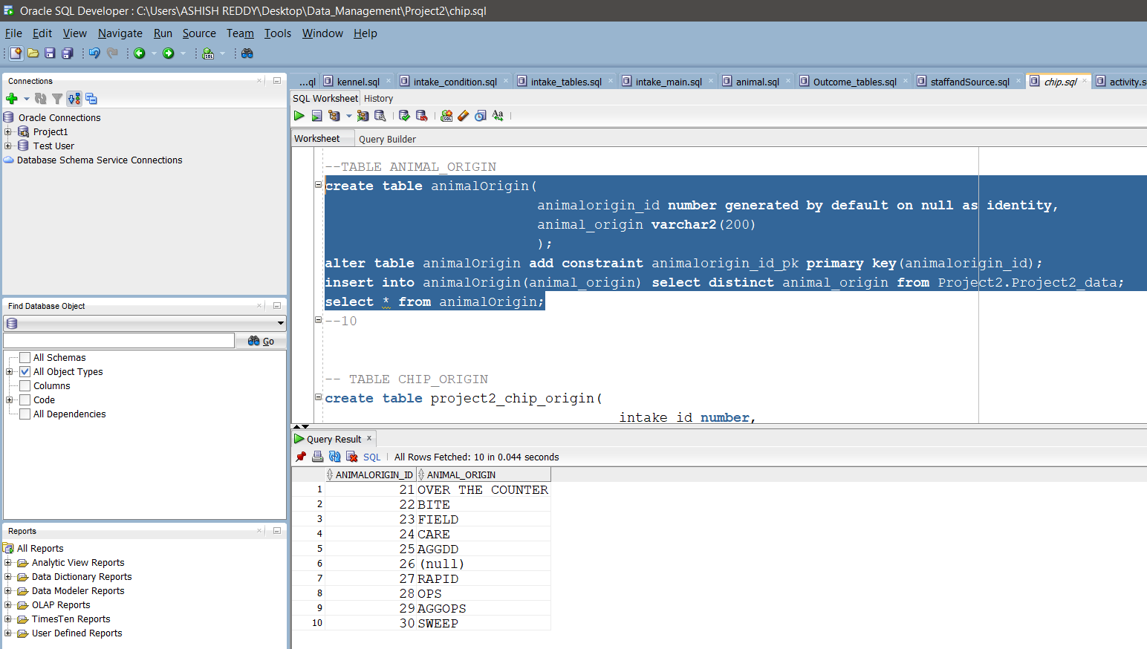

No.of Records: 10

Activity:

create table activity(

activity_id number generated by default on null as identity,

activity_number_beginning varchar2(200),

activity_number_end NUMBER

);

alter table activity add constraint activity_id_pk primary key(activity_id);

insert into activity(activity_number_beginning, activity_number_end)

select

SUBSTR(dl.activity_number, 1, INSTR(dl.activity_number,'-')-1) as activity_number_beginning,

SUBSTR(dl.activity_number, INSTR(dl.activity_number,'-')+1) as activity_number_end

from

Project2.Project2_data dl;

select * from activity;

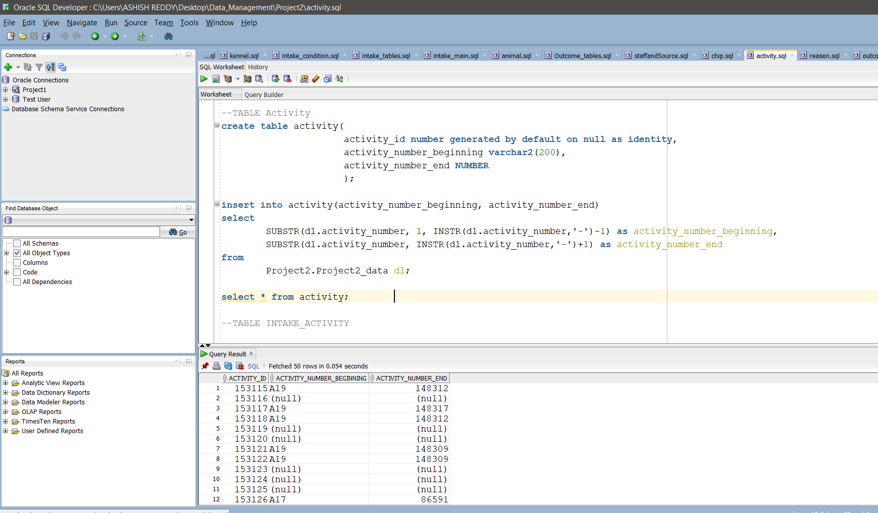

No.of Records: 135,234

P2Impound:

drop table p2impound;

create table p2impound(

impound_id number generated by default on null as identity,

impound_number_beginning varchar2(20),

impound_number_end varchar2(20)

);

alter table p2impound

add constraint impound_id_pk primary key(impound_id);

insert into p2impound(impound_number_beginning,impound_number_end)

select

SUBSTR(dl.impound_number, 1, INSTR(dl.impound_number,'-')-1) as impound_number_beginning,

SUBSTR(dl.impound_number, INSTR(dl.impound_number,'-')+1) as impound_number_end

from

Project2.Project2_data dl;

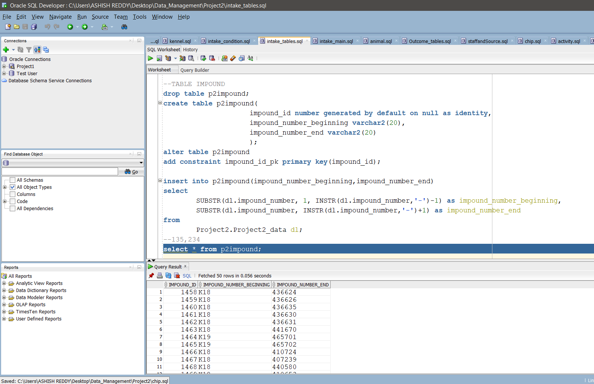

No.of Records: 135,234

Kennel:

drop table kennel;

create table kennel (

kennel_id number generated by default on null as identity,

kennel_number varchar2(150),

constraint kennel_id_pk primary key(kennel_id)

);

alter table kennel add constraint kennel_id_pk primary key(kennel_id);

insert into kennel(kennel_number) select distinct kennel_number from Project2.Project2_data;

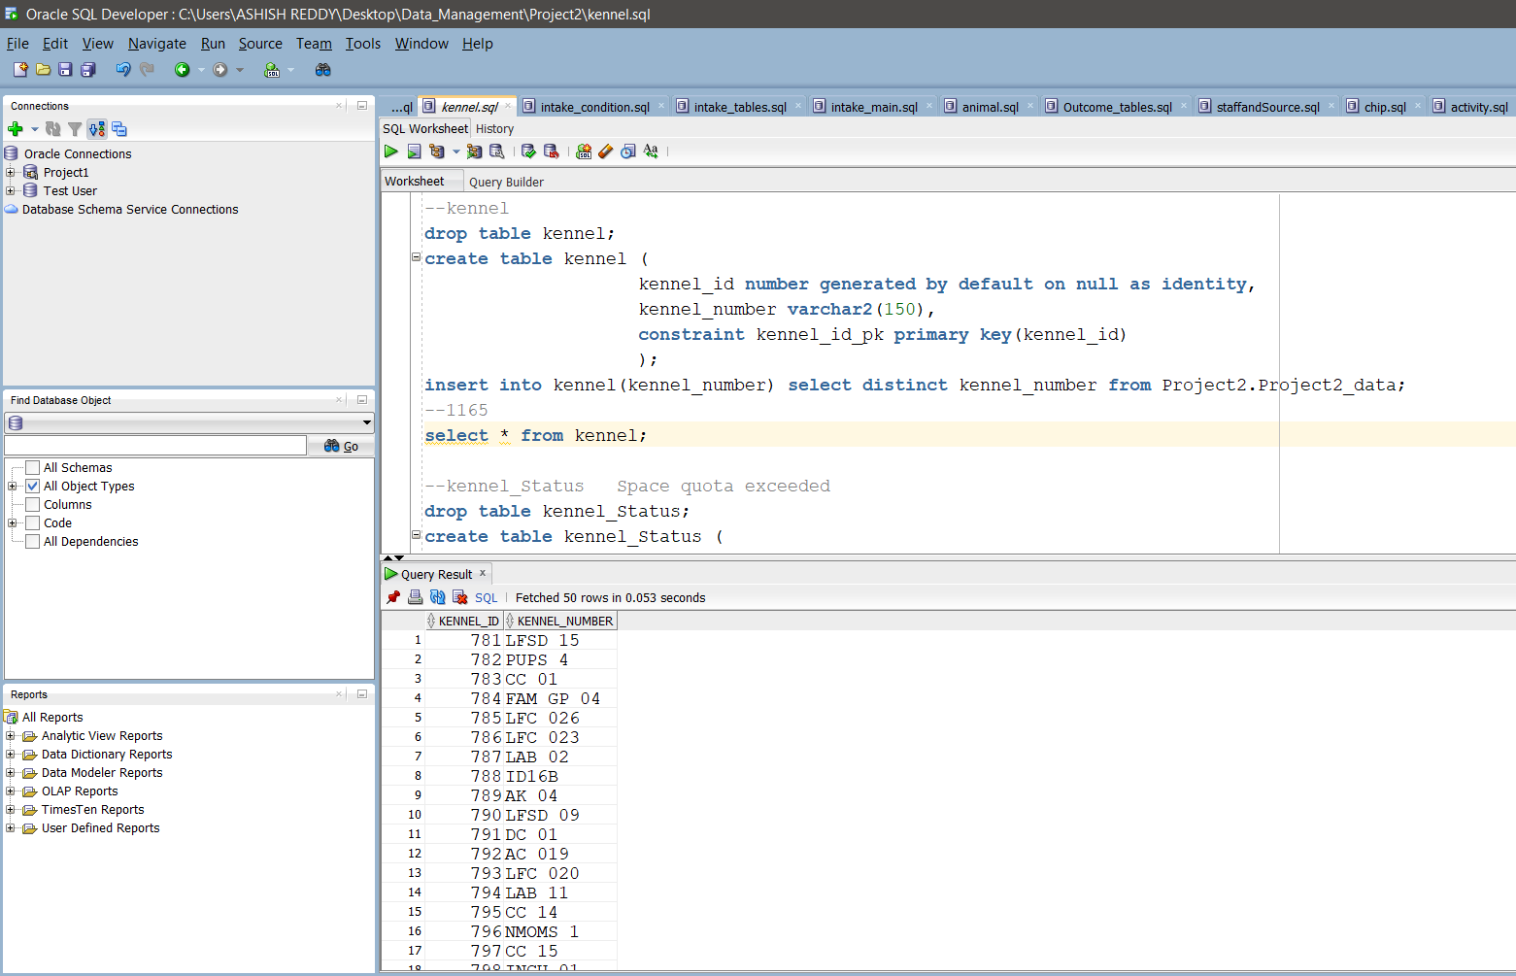

No.of Records: 1165

Kennel_Status:

drop table kennel_Status;

create table kennel_Status (

status_id number generated by default on null as identity,

kennel_status varchar(150),

constraint status_id_pk primary key(status_id)

);

alter table kennel_Status add constraint status_id_pk primary key(status_id);

insert into kennel_Status(kennel_status) select distinct kennel_status from Project2.Project2_data;

select * from kennel_Status;

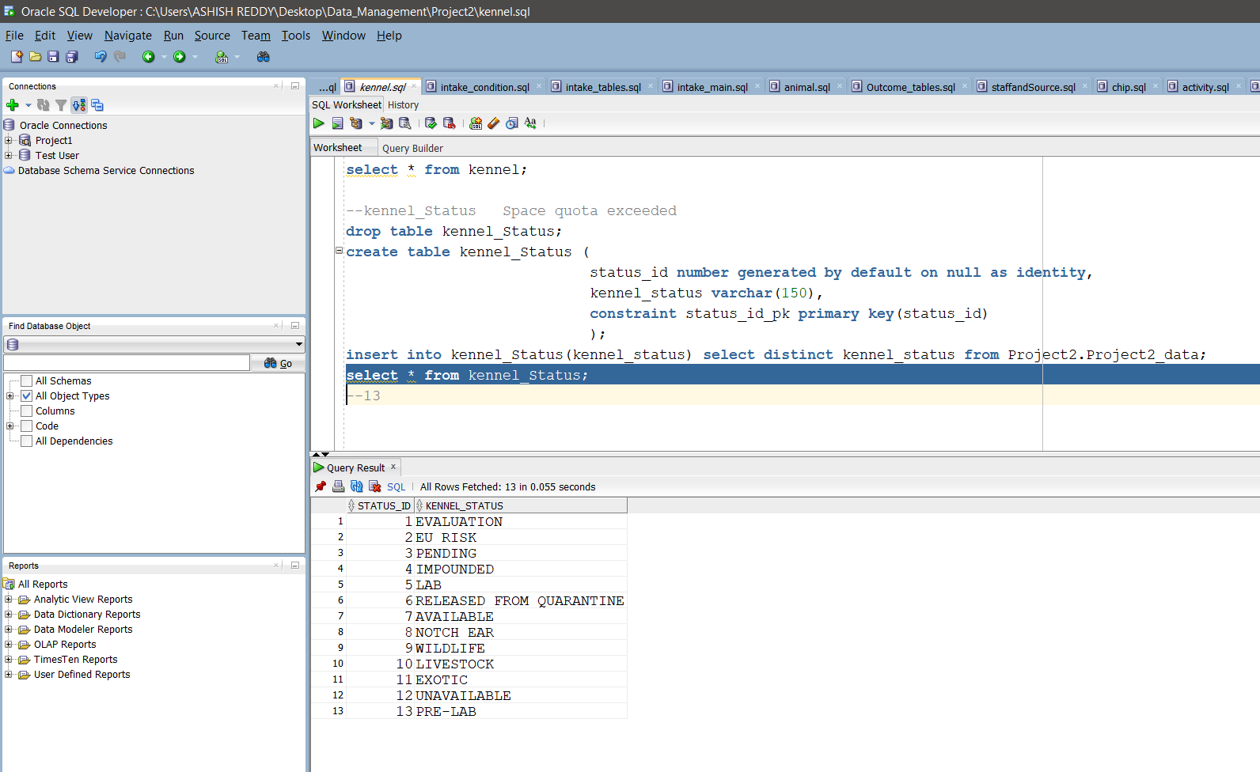

No.of Records: 13

intakeType:

create table intakeType(

intaketype_id number generated by default on null as identity,

intake_type varchar2(200)

);

alter table intakeType add constraint intaketype_id primary key(intaketype_id);

insert into intakeType(intake_type) select distinct intake_type from Project2.Project2_data;

select * from intakeType;

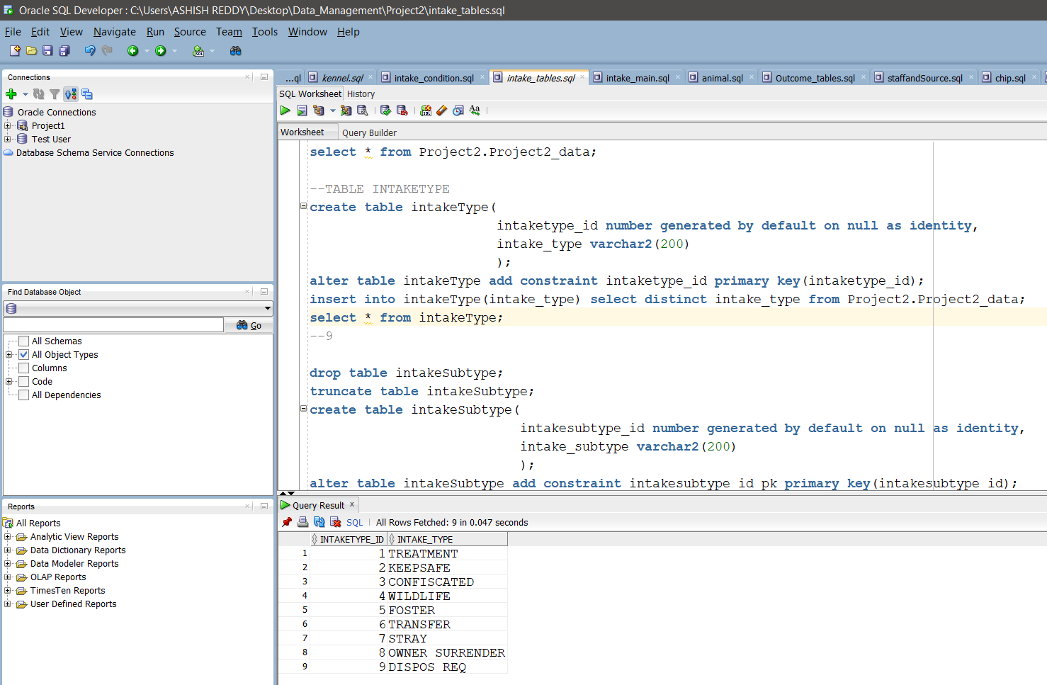

No.of Records: 9

intakeSubtype:

create table intakeSubtype(

intakesubtype_id number generated by default on null as identity,

intake_subtype varchar2(200)

);

alter table intakeSubtype add constraint intakesubtype_id_pk primary key(intakesubtype_id);

insert into intakeSubType(intake_subtype) select distinct intake_subtype from Project2.Project2_data;

select * from intakeSubtype;

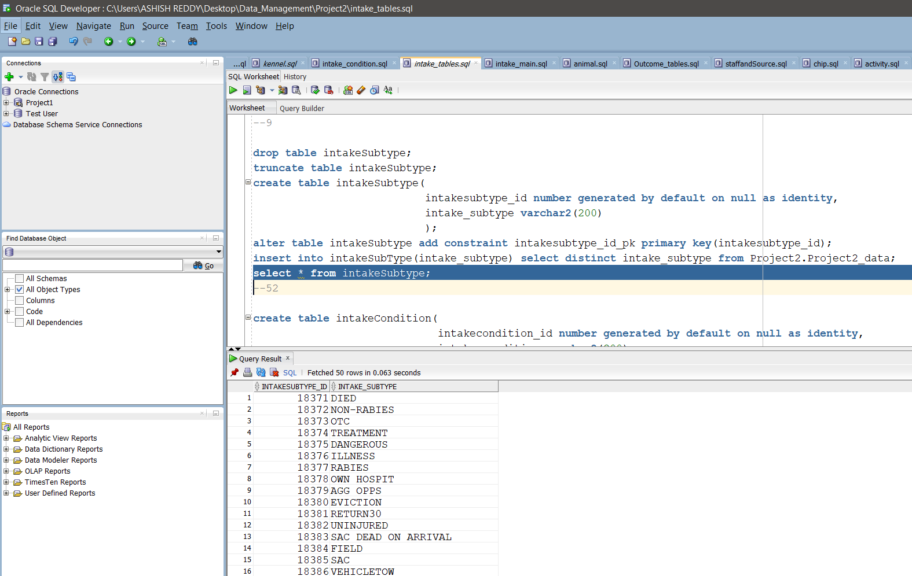

No.of Records: 52

intakeCondition:

create table intakeCondition(

intakecondition_id number generated by default on null as identity,

intake_condition varchar2(200)

);

alter table intakeCondition add constraint intakecondition_id_pk primary key(intakecondition_id);

insert into intakeCondition(intake_condition) select distinct intake_condition from Project2.Project2_data;

select * from intakeCondition;

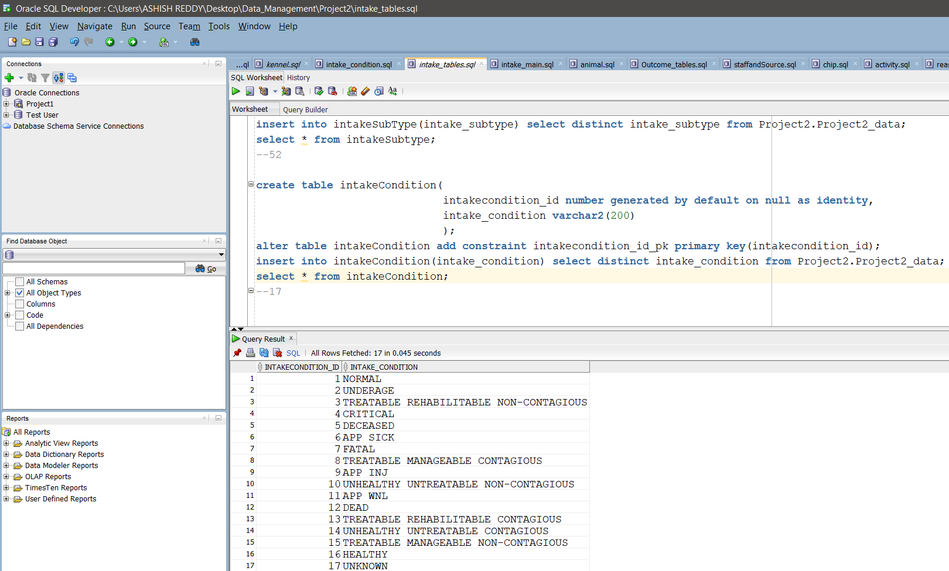

No.of Records: 17

animalType:

drop table animalType;

create table animalType (

animaltype_id number generated by default on null as identity,

animal_type varchar(20)

);

alter table animaltype add constraint animaltypeid_pk primary key(animaltype_id);

insert into animalType(animal_type) select distinct animal_type from Project2.Project2_data;

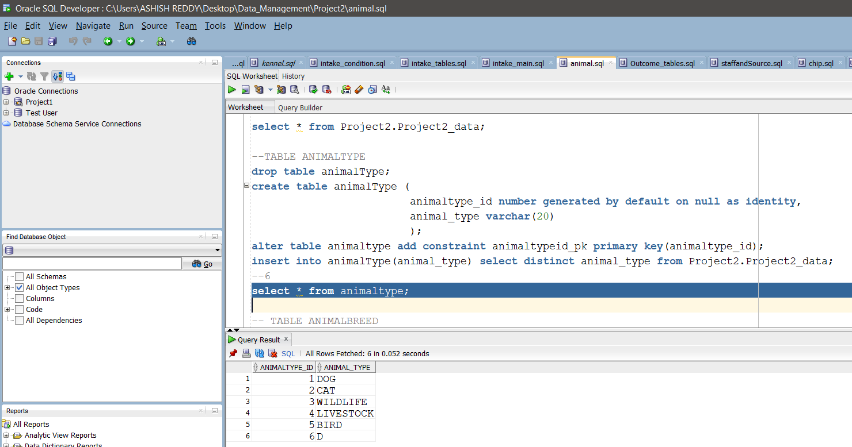

No.of Records: 6

animalBreed:

drop table animalBreed;

CREATE TABLE animalBreed(

breed_id number generated by default on null as identity,

animal_breed varchar2(200)

);

alter table animalBreed

add constraint breed_id_pk primary key(breed_id);

insert into animalBreed(animal_breed) select distinct animal_breed from Project2.Project2_data;

select * from animalBreed;

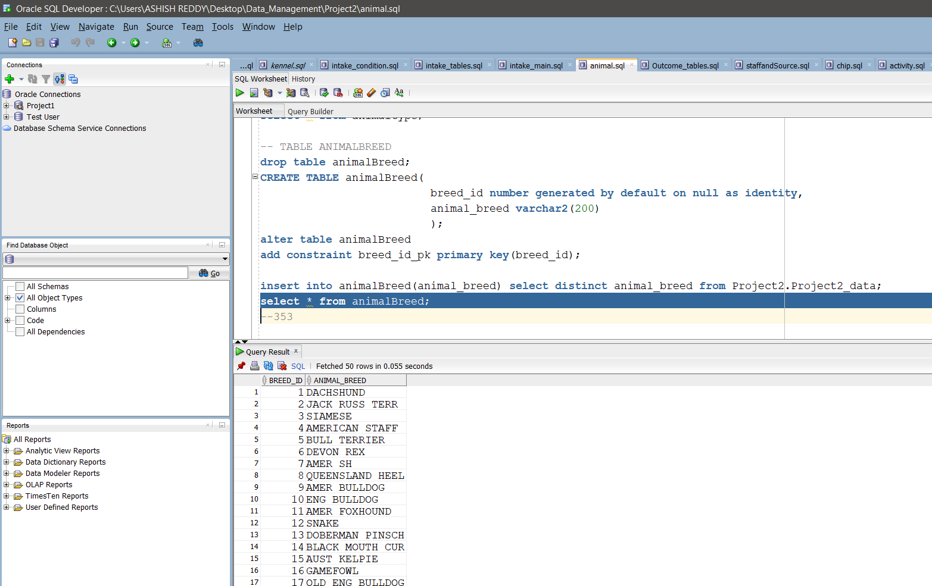

No.of Records: 353

animalOrigin:

create table animalOrigin(

animalorigin_id number generated by default on null as identity,

animal_origin varchar2(200)

);

alter table animalOrigin

add constraint animalorigin_id_pk primary key(animalorigin_id);

insert into animalOrigin(animal_origin) select distinct animal_origin from Project2.Project2_data;

select * from animalOrigin;

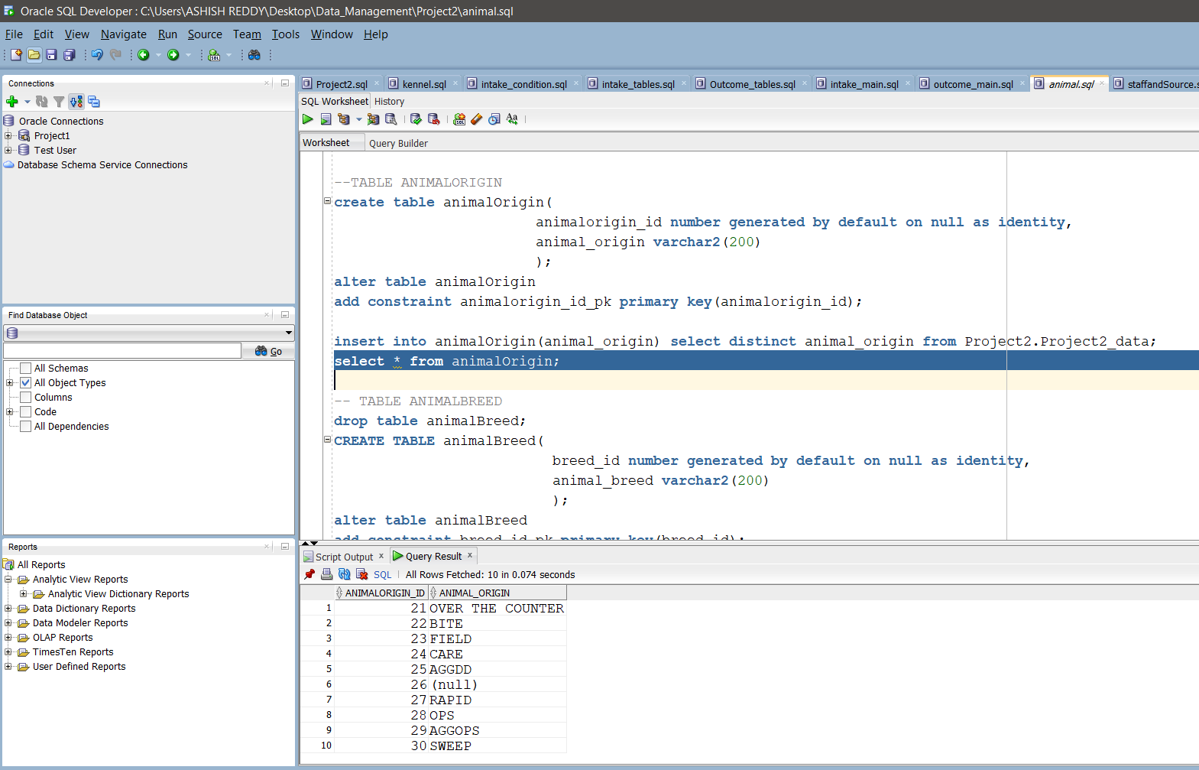

No.of Records: 10

animalCensus:

create table animalCensus(

animal_id varchar2(200),

census_tract varchar2(200),

council_district varchar2(200),

month varchar2(200),

year varchar2(200)

);

alter table animalCensus

add constraint animal_idd_pk primary key (animal_id);

alter table animalCensus

add constraint animal_idd_fk foreign key(animal_id) references animal(animal_id);

insert into animalCensus(animal_id,census_tract,council_district,month,year)

select d.animal_id,d.census_tract,d.council_district,d.month,d.year

from Project2.Project2_data d;

select * from animalCensus;

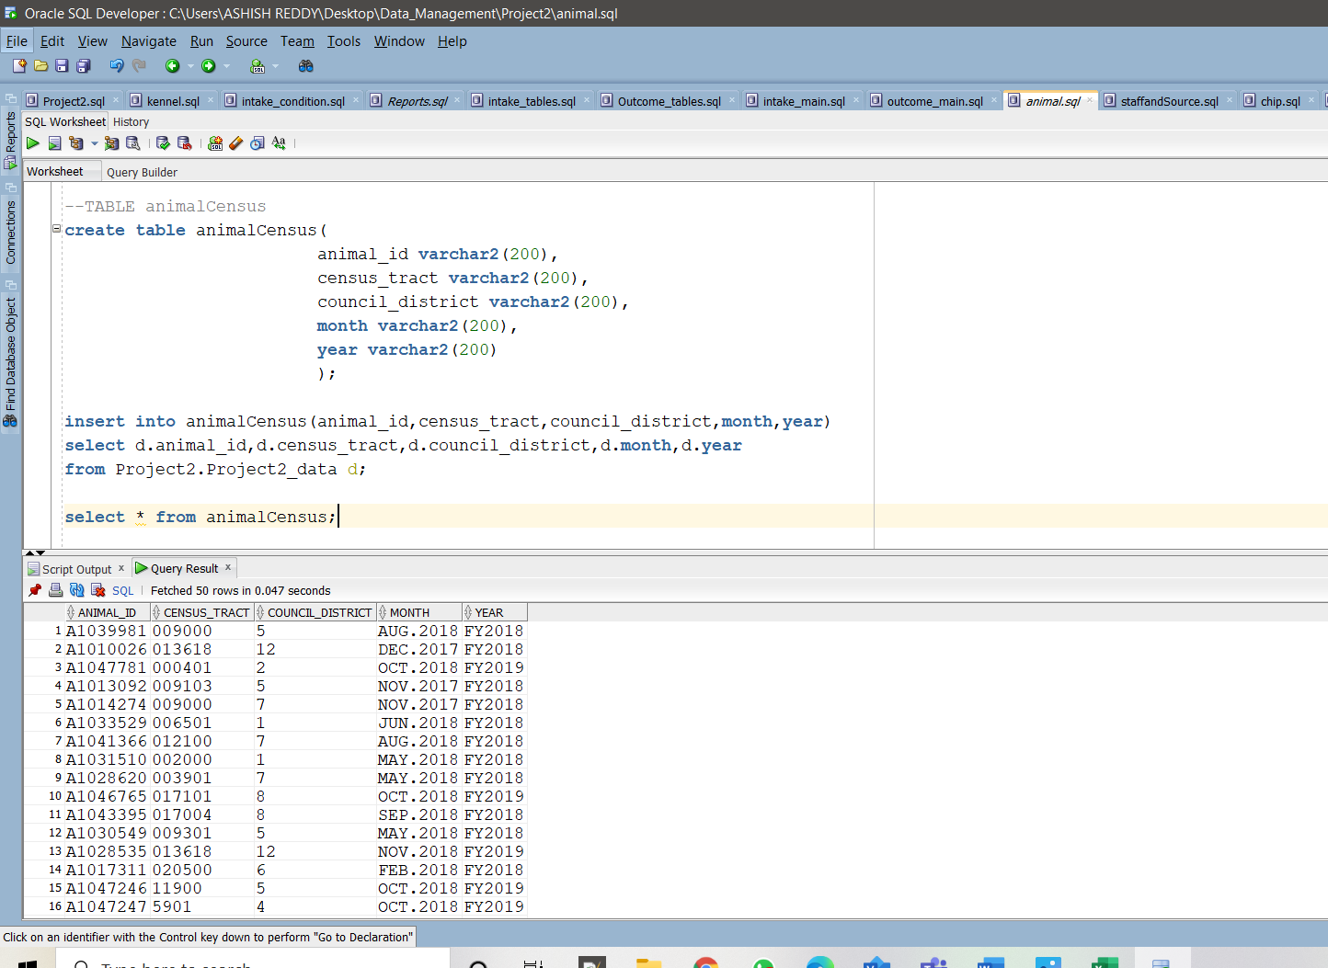

No.of Records: 135234

outcomeType:

create table outcomeType(

outcometype_id number generated by default on null as identity,

outcome_type varchar2(200)

);

alter table outcomeType add constraint outcometype_id_pk primary key(outcometype_id);

insert into outcomeType(outcome_type) select outcome_type from Project2.Project2_data;

select * from outcomeType;

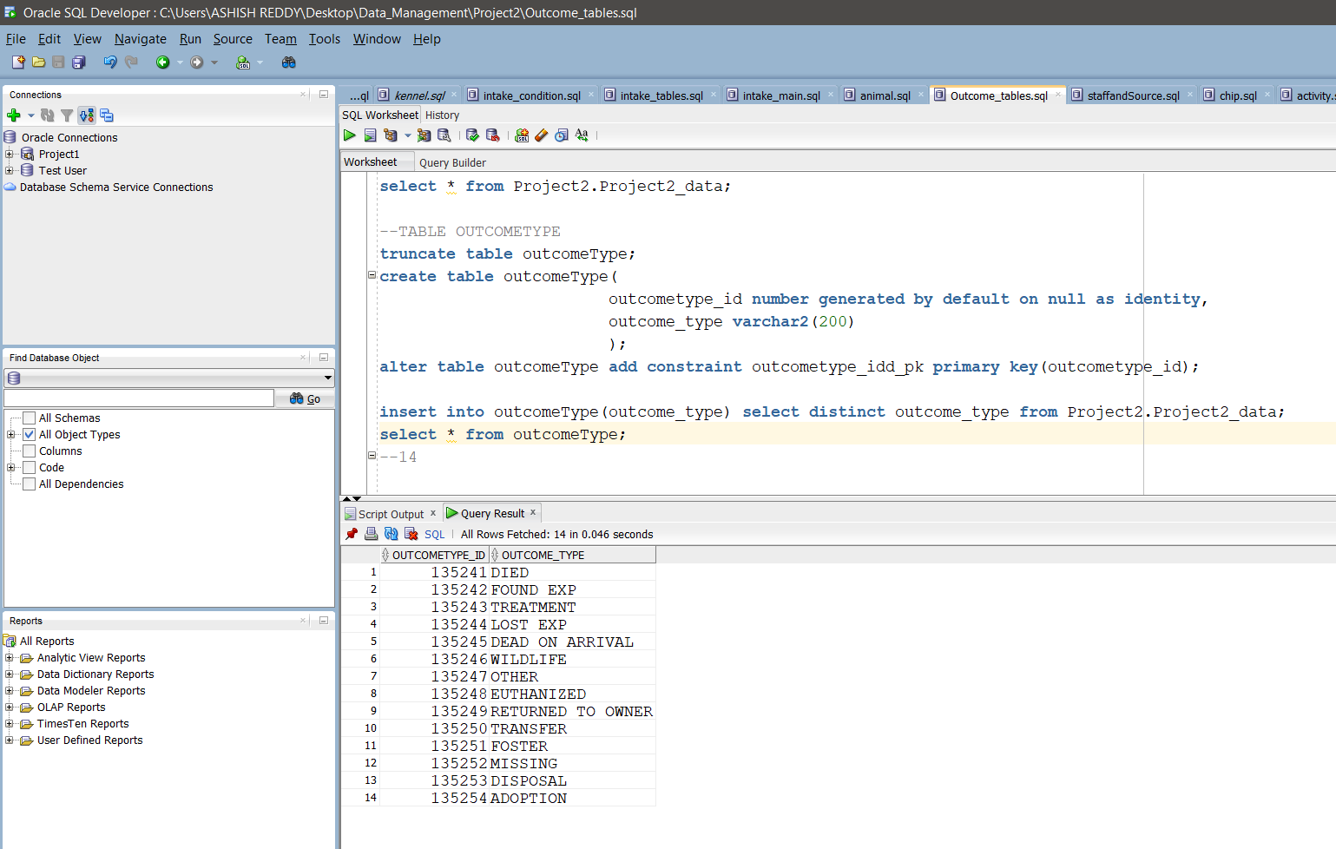

No.of Records: 14

outcomeSubtype:

create table outcomeSubtype(

outcomesubtype_id number generated by default on null as identity,

outcome_subtype varchar2(200)

);

alter table outcomeSubtype add constraint outcomesubtype_id_pk primary key(outcomesubtype_id);

insert into outcomeSubtype(outcome_subtype) select outcome_subtype from Project2.Project2_data;

select * from outcomeSubtype;

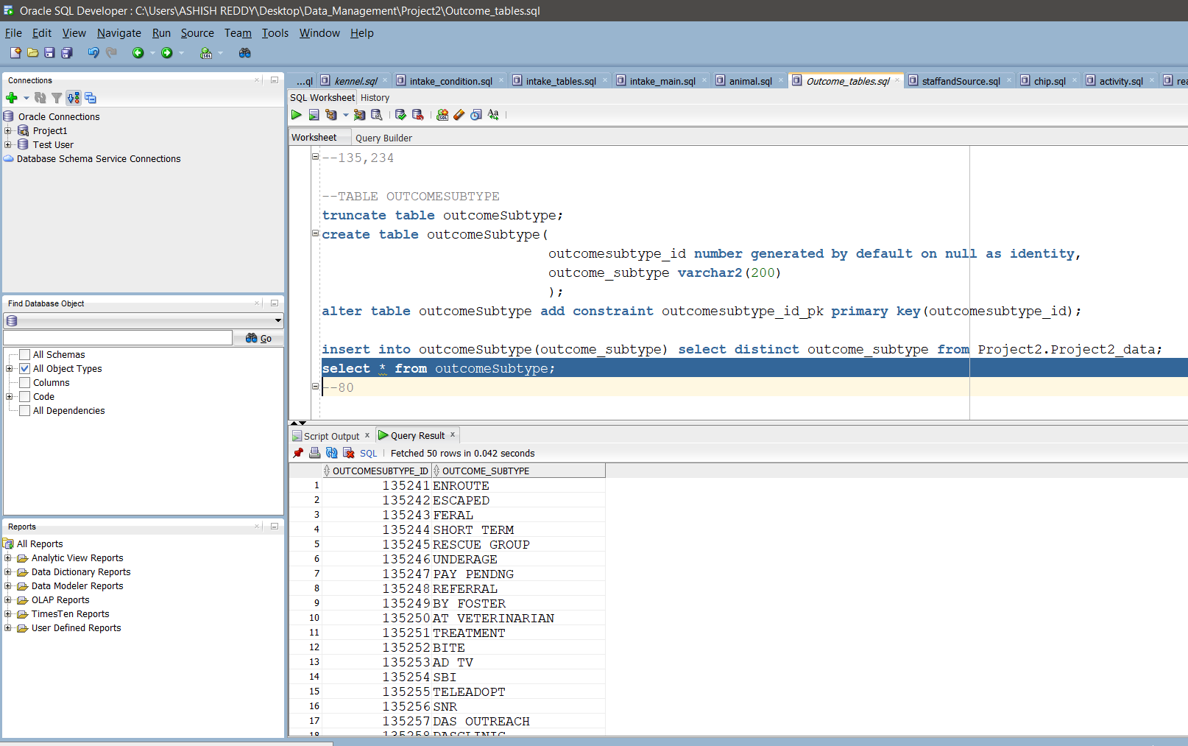

No.of Records: 80

outcomeCondition:

create table outcomeCondition(

outcomecondition_id number generated by default on null as identity,

outcome_condition varchar2(200)

);

alter table outcomeCondition add constraint outcomecondition_idd_pk primary key(outcomecondition_id);

insert into outcomeCondition(outcome_condition) select distinct outcome_condition from Project2.Project2_data;

select * from outcomeCondition; 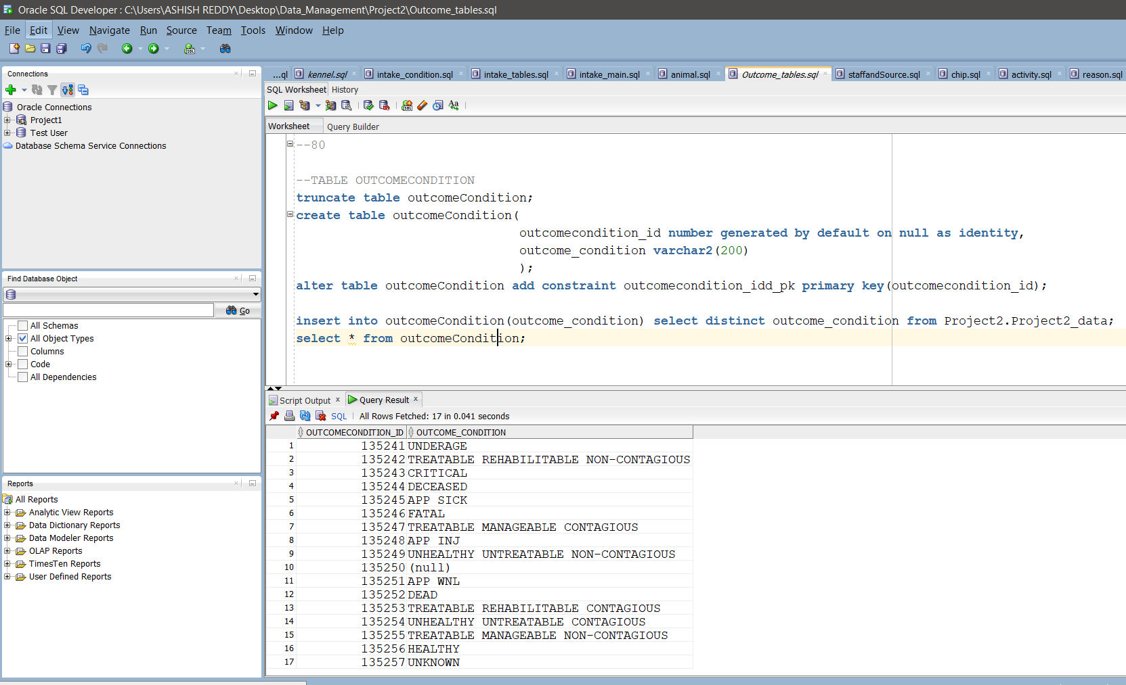

No.of Records: 17

Reason:

drop table reason;

create table reason(

reason_id number generated by default on null as identity,

reason varchar2(200)

);

alter table reason add constraint reason_id_pk primary key(reason_id);

insert into reason(reason) select distinct reason from Project2.Project2_data;

select * from reason;

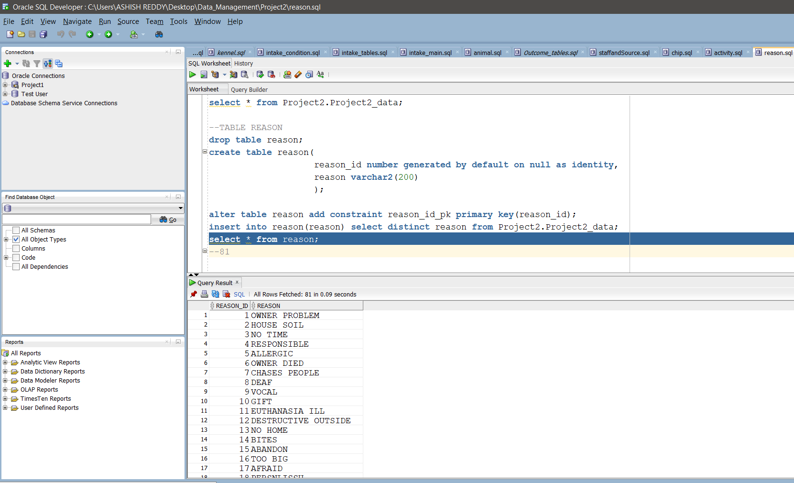

No.of Records: 81

Animal:

drop table animal;

create table animal(

animal_id varchar2(200),

breed_id number,

type_id number

);

alter table animal

add constraint animal_id_pk primary key(animal_id);

alter table animal

add constraint breed_id_fk foreign key(breed_id) references animalBreed(breed_id);

alter table animal

add constraint type_id_fkk foreign key(type_id) references animalType(animaltype_id);

select count(animal_id) from animal;

insert into animal(animal_id,type_id,breed_id)

select cc.animal_id,tt.animaltype_id,bb.breed_id

from

(select distinct aa.animal_id,aa.animal_type,bb.animal_breed

from

(

(select animal_id,animal_type,max(to_date(substr(intake_date,1,10),'MM-DD-YYYY')) as min_intake_date

from project2_data_load

group by animal_id,animal_type)aa

inner join

(select animal_id,animal_type,animal_breed,to_date(substr(intake_date,1,10),'MM-DD-YYYY') as intake_date

from project2_data_load)bb

on aa.animal_id = bb.animal_id

and aa.animal_type=bb.animal_type

and aa.min_intake_date=bb.intake_date)

)cc

left join animalType tt on cc.animal_type=tt.animal_type

left join animalBreed bb on cc.animal_breed=bb.animal_breed;

select * from animal;

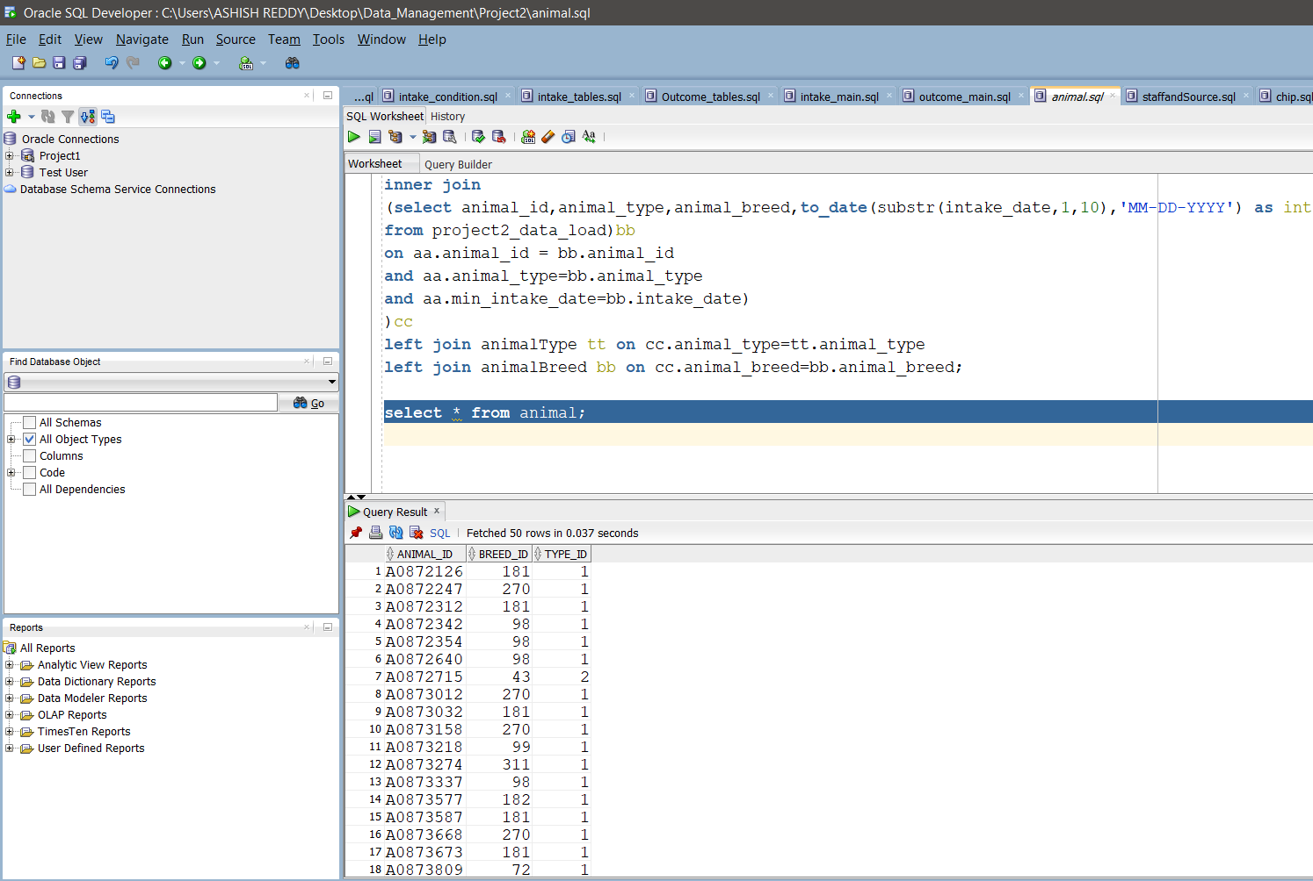

Intake:

truncate table intake;

create table intake(

intake_id number generated by default on null as identity,

intaketype_id number,

intakesubtype_id number,

impound_id number,

animal_id varchar2(200),

source_id varchar2(200),

staff_id varchar2(200),

intake_date varchar2(200),

intake_time varchar2(200)

);

alter table intake

add (

constraint intake_id primary key(intake_id),

constraint animal_id_fk foreign key(animal_id) references animal(animal_id),

constraint impound_id_fk foreign key(impound_id) references p2impound(impound_id),

constraint intaketype_id_fk foreign key(intaketype_id) references intakeType(intaketype_id),

constraint intakesubtype_id_fk foreign key(intakesubtype_id) references intakeSubtype(intakesubtype_id),

constraint source_id_fk foreign key(source_id) references p2source(source_id),

constraint staff_id_fk foreign key(staff_id) references staff(staff_id),

constraint condition_id_fk foreign key(condition_id) references p2intake_condition(condition_id)

);

insert into intake(animal_id, impound_id, intaketype_id, intakesubtype_id,source_id,

staff_id,intake_date, intake_time)

SELECT A.animal_id, im.impound_id, itt.intaketype_id, iss.intakesubtype_id,

S.source_id,s1.staff_id,TO_DATE(substr(intake_date, 1,10) ,'MM/DD/YYYY'),intake_time

FROM project2.project2_Data D

JOIN animal A ON D.animal_id = A.animal_id

JOIN p2impound im ON D.impound_number = im.impound_number_beginning||'-'||im.impound_number_end

JOIN intakeType itt ON D.intake_type = itt.intake_type

JOIN intakeSubtype iss ON D.intake_subtype = iss.intake_subtype

JOIN intakeCondition ic ON D.intake_condition = ic.intake_condition

JOIN p2source S ON D.source_id = S.source_id

JOIN staff s1 ON D.staff_id = s1.staff_id;

select * from intake;

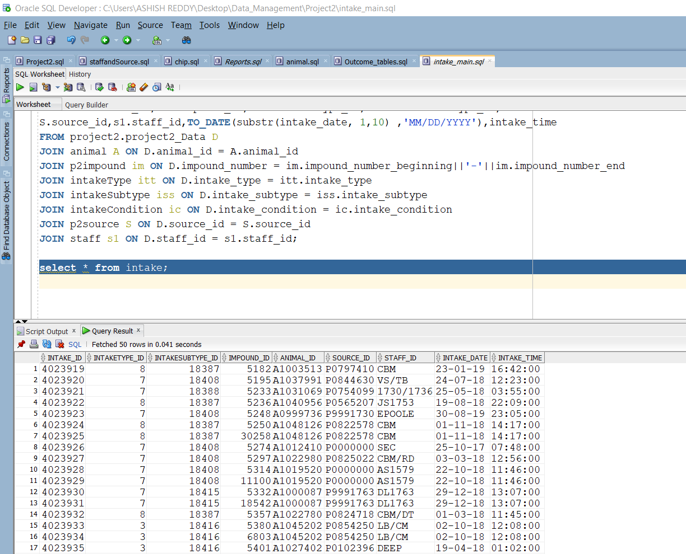

Outcome:

drop table outcome;

create table outcome(

outcome_id number generated by default on null as identity,

outcometype_id number,

outcomesubtype_id number,

outcomecondition_id number,

outcome_date date,

outcome_time varchar2(200),

intake_id number,

staff_id varchar2(200),

animal_id VARCHAR2(200)

);

alter table outcome

add constraint outcome_id_pk primary key(outcome_id);

alter table outcome

add constraint outcometype_id_fk foreign key(outcometype_id) references outcomeType(outcometype_id);

alter table outcome

add constraint outcomesubtype_id_fk foreign key(outcomesubtype_id) references outcomeSubtype(outcomesubtype_id);

alter table outcome

add constraint outcomecondition_id_fk foreign key(outcomecondition_id) references outcomeCondition(outcomecondition_id);

INSERT INTO outcome (INTAKE_ID, outcometype_id, outcomesubtype_id, outcomecondition_id, RECEIPT_NUMBER, OUTCOME_DATE, OUTCOME_TIME)

SELECT A.INTAKE_ID AS INTAKE_ID, T.outcometype_id AS TYPE_ID, S.outcomesubtype_id AS SUBTYPE_ID,

C.outcomecondition_id AS CONDITION_ID, D.RECEIPT_NUMBER,

CASE WHEN D.OUTCOME_DATE IS NOT NULL THEN TO_DATE(D.OUTCOME_DATE, 'MM/DD/YYYY HH:MI:SS AM') ELSE NULL END AS OUTCOME_DATE, D.OUTCOME_TIME

FROM Project2.Project2_data D,

outcomeType T,

outcomeSubtype S,

outcomeCondition C,

(SELECT I.intake_id AS INTAKE_ID, I.INTAKE_DATE, B.impound_number_beginning||'-'||B.impound_number_end AS IMPOUND_NUMBER

FROM intake I, p2impound B

WHERE B.impound_id = I.impound_id) A

WHERE T.OUTCOME_TYPE = D.OUTCOME_TYPE

AND S.OUTCOME_SUBTYPE = D.OUTCOME_SUBTYPE

AND C.OUTCOME_CONDITION = D.OUTCOME_CONDITION

AND A.IMPOUND_NUMBER = D.IMPOUND_NUMBER

AND A.INTAKE_DATE = TO_DATE(D.INTAKE_DATE, 'MM/DD/YYYY HH:MI:SS AM')

AND TO_DATE(D.OUTCOME_DATE, 'MM/DD/YYYY HH:MI:SS AM') IS NOT NULL;

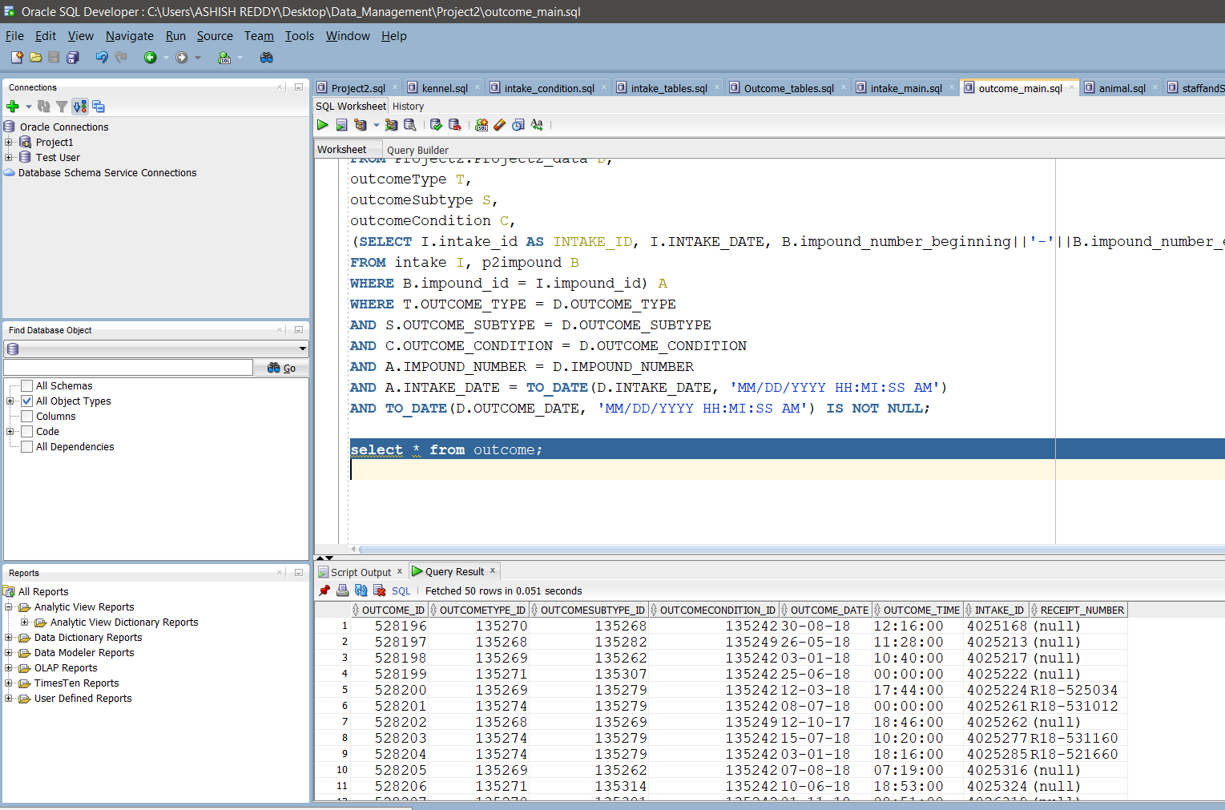

REPORTS:

1.)

What breed has best chance of survival for the years 2017, 2018,2019 and 2020 ?

SIBERIAN HUSKY

select * from(

select animaltype, animalbreed, max(total_count) as Best_breed from(

select a.animal_id as animalid,at.animal_type as animaltype, ab.animal_breed as animalbreed,count(a.animal_id) as total_count

from

outcome o, intake i, animal a, outcomeType ot, animalCensus ac, animalType at, animalBreed ab

where o.intake_id = i.intake_id and i.animal_id = a.animal_id

and o.outcometype_id = ot.outcometype_id

and ac.animal_id = a.animal_id

and a.type_id = at.animaltype_id

and ab.breed_id = a.breed_id

and ot.outcome_type not in ('DIED','EUTHANIZED')

and ac.year in('FY2017','FY2018','FY2019','FY2020')

and o.outcome_date > i.intake_date

group by at.animal_type, ab.animal_breed, a.animal_id

order by at.animal_type, ab.animal_breed, a.animal_id)temp

group by temp.animaltype, temp.animalbreed)

where Best_breed > 200

order by Best_breed desc;

--DIED and EUTHANIZED not included according to pdf

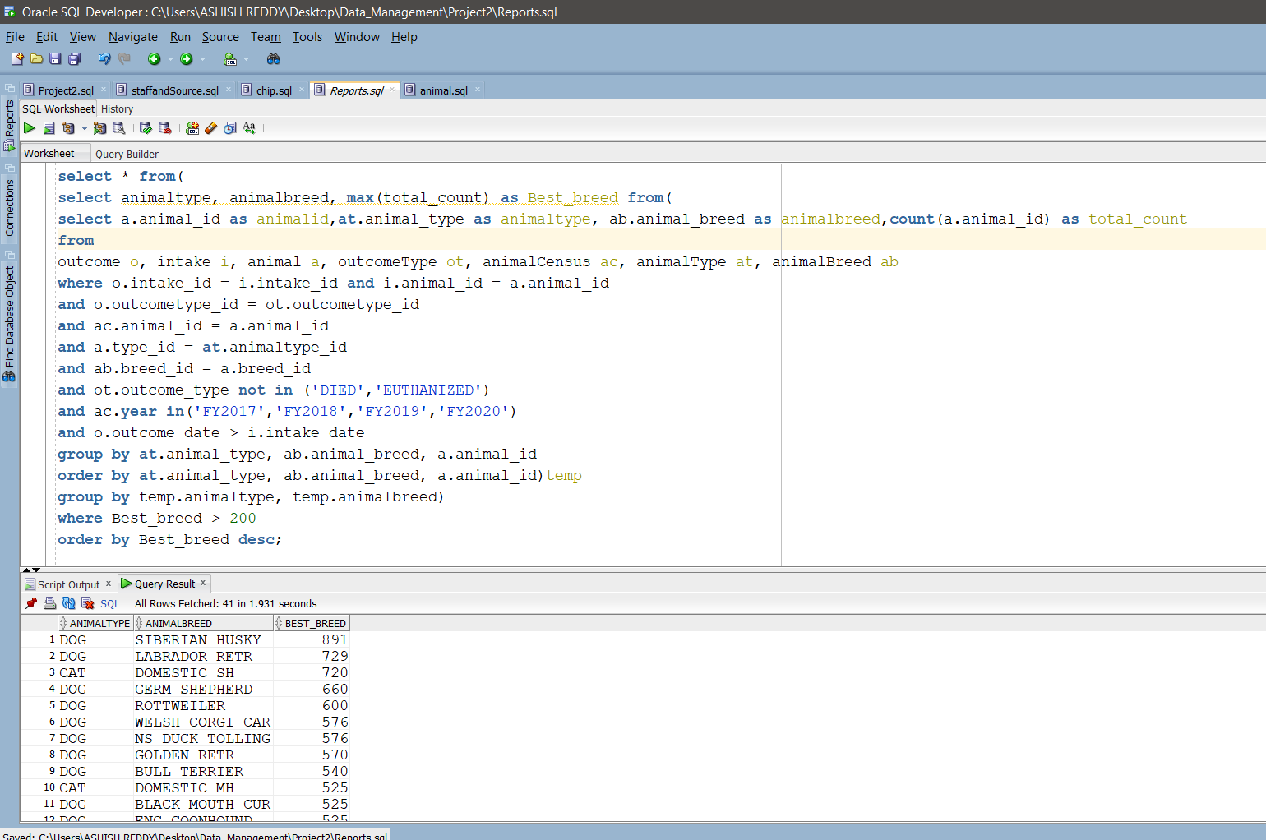

2.)

SELECT animal_type, Intake_Type, outcome_type, Animal_Count,

round(Animal_Count/(sum(Animal_Count) OVER (partition by

animal_type))*100,2)||''||'%' as Outcome_Total,

round(Animal_Count/(sum(Animal_Count)

OVER (partition by animal_type,intake_type ORDER by intake_type DESC))*100,2)||''||'%' as Intake_Percent,

round(Animal_Count/(sum(Animal_Count)

OVER (partition by animal_type,outcome_type ORDER by outcome_type DESC))*100,2)||''||'%' as Outcome_Percent

FROM

(SELECT at.animal_type, AIn.intake_type, AOut.outcome_type,count(a.animal_id) as Animal_Count

FROM

animal a, animalBreed B, animalType at,

intakeType AIn, intake i,

outcomeType AOut, outcome O

WHERE a.animal_id = i.animal_id

AND a.breed_id = B.breed_id

AND at.animaltype_id=a.Type_ID

AND at.animal_type IN ('WILDLIFE', 'BIRD')

AND O.intake_id = i.intake_id

AND AOut.outcometype_id = O.outcometype_id

AND AIn.intaketype_id = i.intaketype_id

GROUP BY at.animal_type, AOut.outcome_type, AIn.intake_type

ORDER BY at.animal_type, AOut.outcome_type, AIn.intake_type);

