Name: Aashish Reddy Vundhyala

UTD ID: 2021566387

All the tables are created in Project1 Database in my account.

1.) DESIGN AND DB ARCHITECTURE

1.) b.) Create statements

drop table project1_books;

drop table project1_authors;

drop table project1_book_authors;

drop table project1_library_branch;

drop table project1_fines;

drop table project1_book_loans;

drop table project1_borrowers;

drop table project1_book_copies;`

create table project1_books

(ISBN10 VARCHAR2(26) NOT NULL,

ISBN13 VARCHAR2(38),

Title VARCHAR2(256),

Author VARCHAR2(128),

Cover VARCHAR2(128),

Publisher VARCHAR2(128),

pages INTEGER,

CONSTRAINT isbn10_pk PRIMARY KEY(ISBN10) );

create table project1_authors

(Author_id NUMBER NOT NULL,

Name varchar2(500),

CONSTRAINT authorid_pk PRIMARY KEY(Author_id));



create table project1_book_authors

(Author_id NUMBER NOT NULL,

ISBN10 VARCHAR2(26) NOT NULL,

Author varchar2(128),

CONSTRAINT authorisbn_pk PRIMARY KEY(Author_id, ISBN10),

CONSTRAINT authorid_fk FOREIGN KEY(Author_id) REFERENCES project1_authors(Author_id),

CONSTRAINT isbn10_fk FOREIGN KEY(ISBN10) REFERENCES project1_books(ISBN10) );



create table project1_library_branch

(branch_id INTEGER NOT NULL,

branch_name VARCHAR2(100),

address VARCHAR2(500),

zip VARCHAR2(10),

CONSTRAINT branchid_pk PRIMARY KEY(branch_id));



create table project1_book_copies

(book_id VARCHAR2(26) NOT NULL,

branch_id INTEGER NOT NULL,

no_of_copies INTEGER,

ISBN10 VARCHAR2(26),

CONSTRAINT bookid_branchid_pk PRIMARY KEY(book_id),

CONSTRAINT branchid_fkk FOREIGN KEY(branch_id) REFERENCES project1_library_branch(branch_id),

CONSTRAINT isbn10_fkkk FOREIGN KEY(ISBN10) REFERENCES project1_books(ISBN10) );



create table project1_borrowers(

card_no VARCHAR2(26) NOT NULL,

ssn VARCHAR2(26),

first_name VARCHAR2(26),

last_name VARCHAR2(26),

email VARCHAR2(128),

address VARCHAR2(128),

city VARCHAR2(26),

state VARCHAR2(26),

phone varchar2(26),

CONSTRAINT cardno_pk PRIMARY KEY(card_no));



create table project1_book_loans(

loan_id NUMBER NOT NULL,

book_id VARCHAR2(26) NOT NULL,

card_no VARCHAR2(26) NOT NULL,

Date_out DATE,

Date_in DATE,

Due_date DATE,

branch_id INTEGER NOT NULL,

CONSTRAINT loanid_pk PRIMARY KEY(loan_id),

CONSTRAINT bookid_fk FOREIGN KEY(book_id) REFERENCES project1_book_copies(book_id),

CONSTRAINT cardno_fk FOREIGN KEY(card_no) REFERENCES project1_borrowers(card_no) );

ALTER TABLE project1_book_loans

ADD CONSTRAINT branch_id_fkk FOREIGN KEY(branch_id) REFERENCES project1_library_branch(branch_id);



create table project1_fines(

loan_id NUMBER NOT NULL,

fine_amt NUMBER,

paid VARCHAR2(20),

CONSTRAINT loanid_fk FOREIGN KEY(loan_id) REFERENCES project1_book_loans(loan_id));



2.) Data Load, Normalization and data generation

2.) 1.) Initial Load files to tables.

select * from project1_library_branch_load;

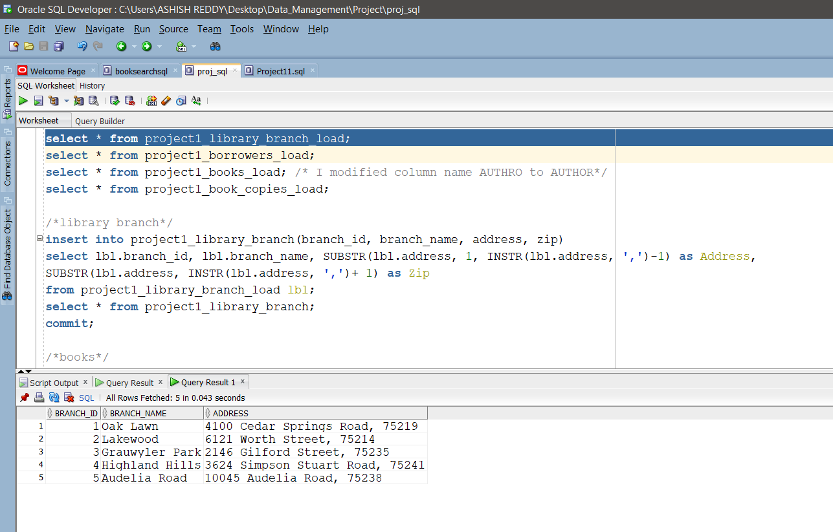

select * from project1_borrowers_load;

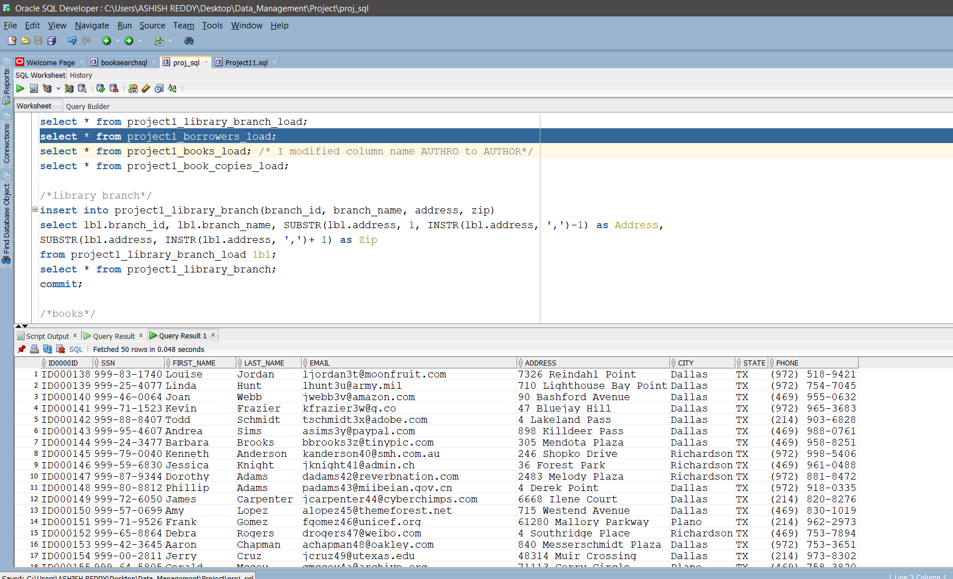

select * from project1_books_load;

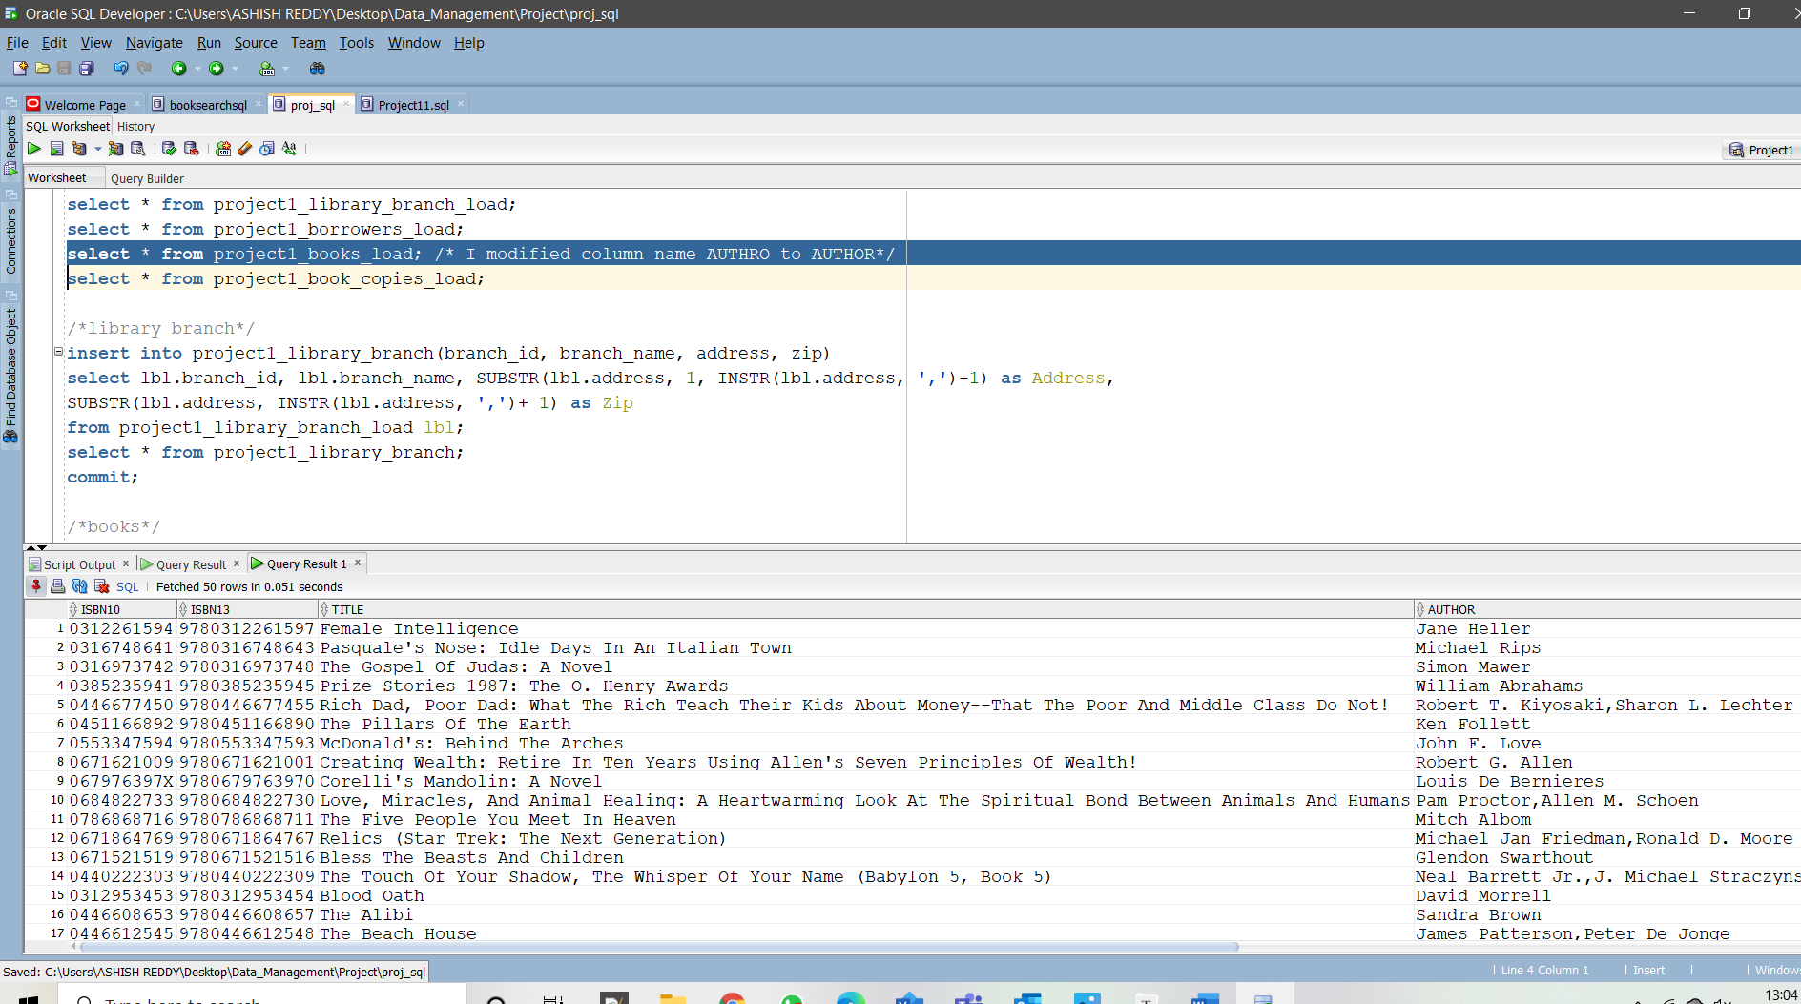

/*I modified column name AUTHRO to AUTHOR */

select * from project1_book_copies_load;

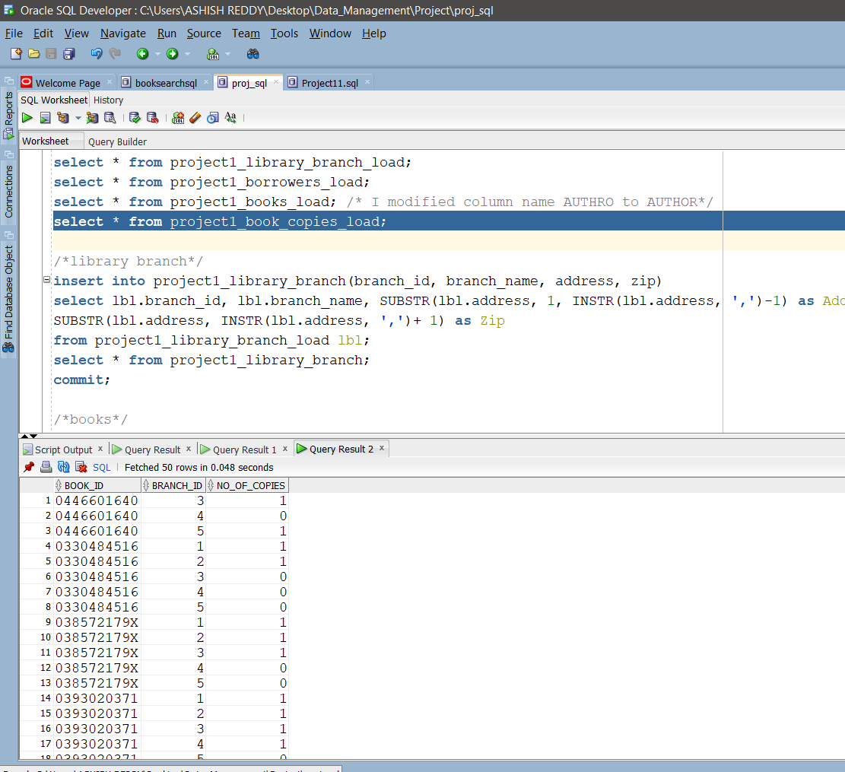

2.) 2.) SQL STATEMENTS ( Normalized tables)

/* library branch */

insert into project1_library_branch(branch_id, branch_name, address, zip)

select lbl.branch_id, lbl.branch_name,

SUBSTR(lbl.address, 1, INSTR(lbl.address, ',') -1) as Address,

SUBSTR(lbl.address, INSTR(lbl.address, ',')+ 1) as Zip from

project1_library_branch_load lbl;

select * from project1_library_branch;

commit;

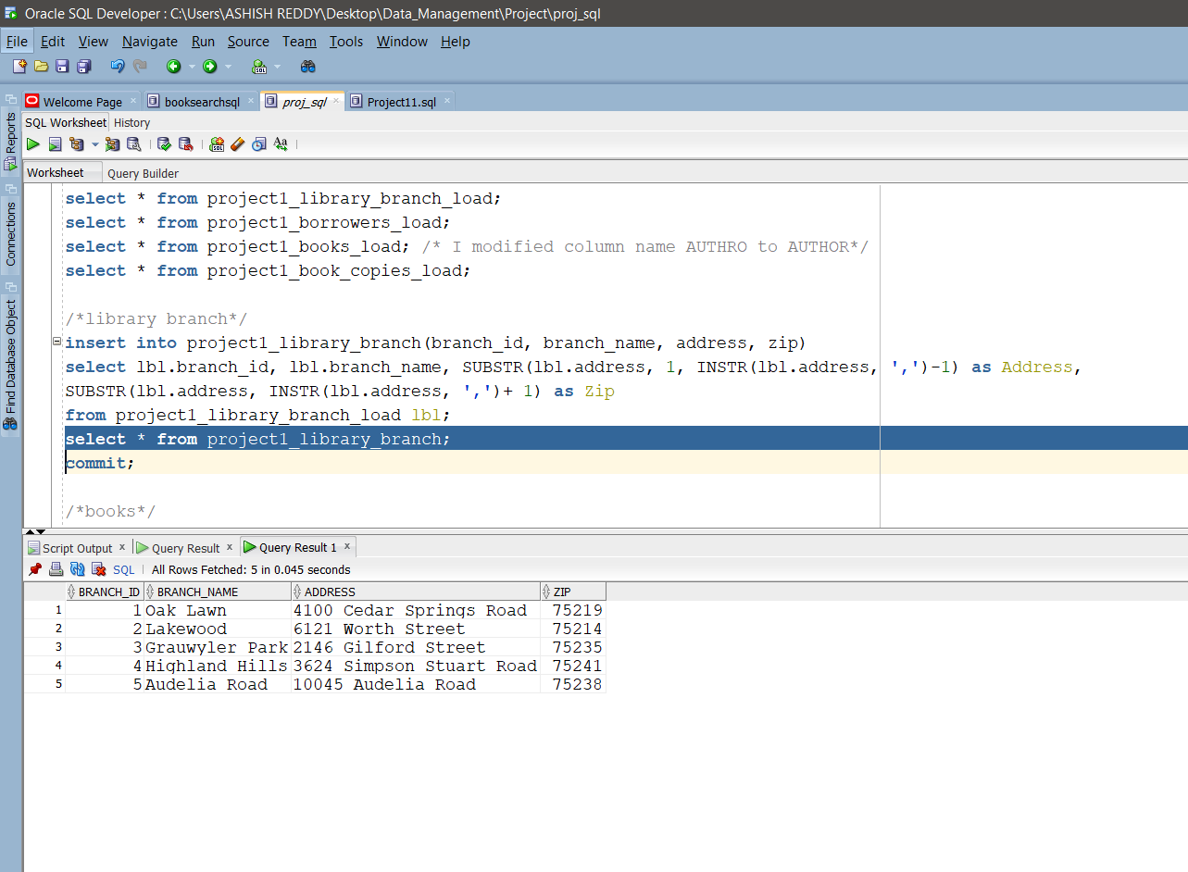

/* books */

insert into project1_books

select * from project1_books_load;

/* dropping Author column at the end*/

select * from project1_books;

commit;

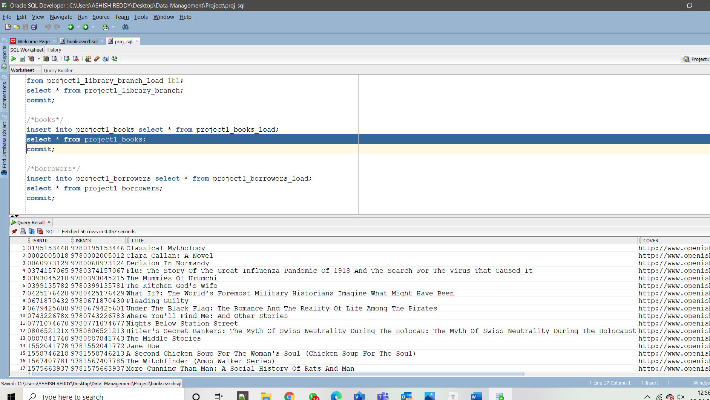

/*borrowers */

insert into project1_borrowers

select * from project1_borrowers_load;

select * from project1_borrowers;

commit;

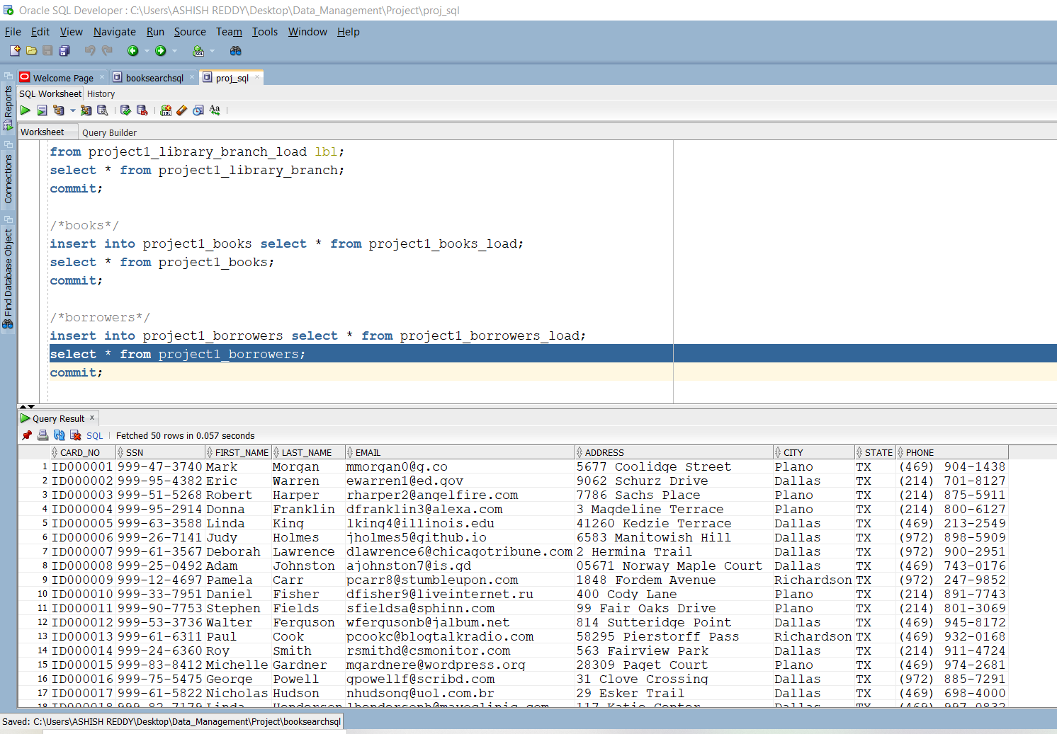

/*book_copies */

insert into project1_book_copies(book_id, branch_id, no_of_copies, ISBN10)

select bcl.book_id, bcl.branch_id, bcl.no_of_copies, pb.ISBN10

from project1_book_copies_load bcl, project1_books pb

where bcl.book_id = pb.ISBN10;

select * from project1_book_copies;

commit;

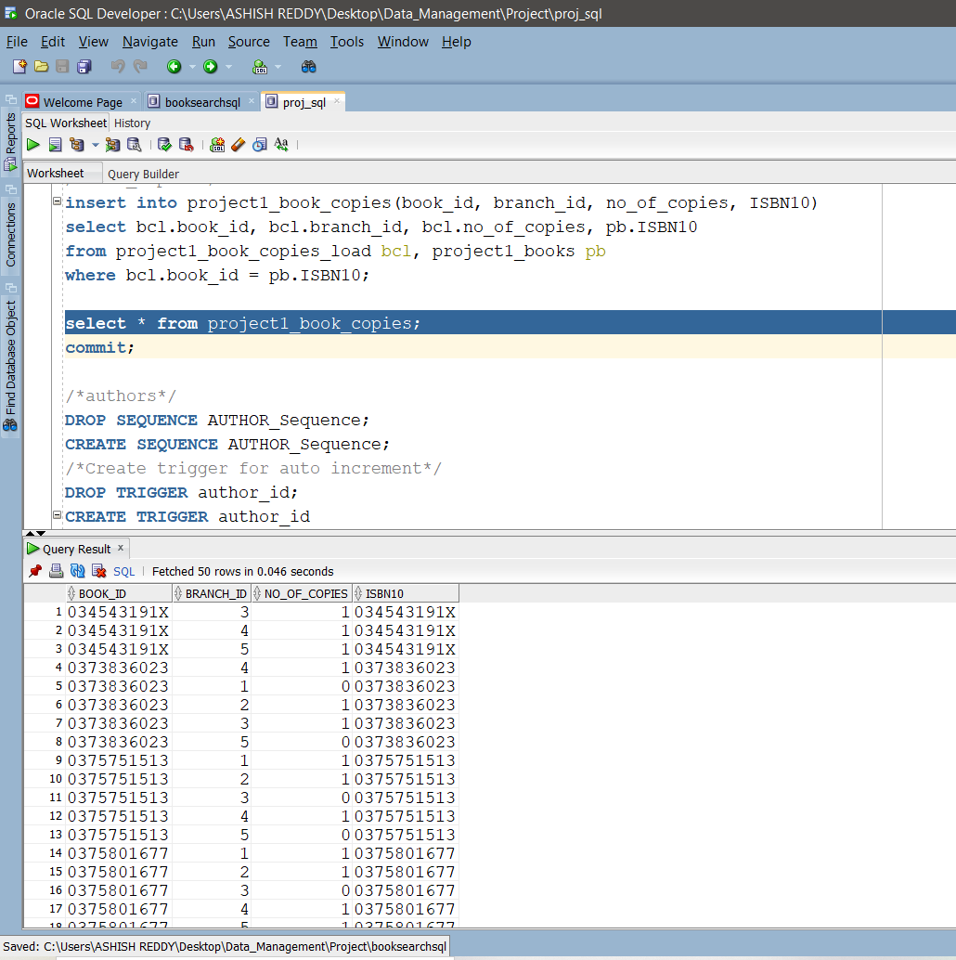

/*authors */

DROP SEQUENCE AUTHOR_Sequence;

CREATE SEQUENCE AUTHOR_Sequence;

/* AUTO INCREMENT */

DROP TRIGGER author_id;

CREATE TRIGGER author_id

BEFORE INSERT ON PROJECT1_AUTHORS

FOR EACH ROW

BEGIN

SELECT AUTHOR_Sequence.nextval

INTO :new.author_id FROM dual;

END;

insert into project1_authors(Name)

select distinct trim(regexp_substr(author,',+', 1, level)) author

from project1_books_load

where author is not null

connect by regexp_substr(author, ',+', 1, level) is not null

and PRIOR ISBN10 = ISBN10 and PRIOR SYS_GUID() is not null

order by author desc;

select * from project1_authors;

commit;

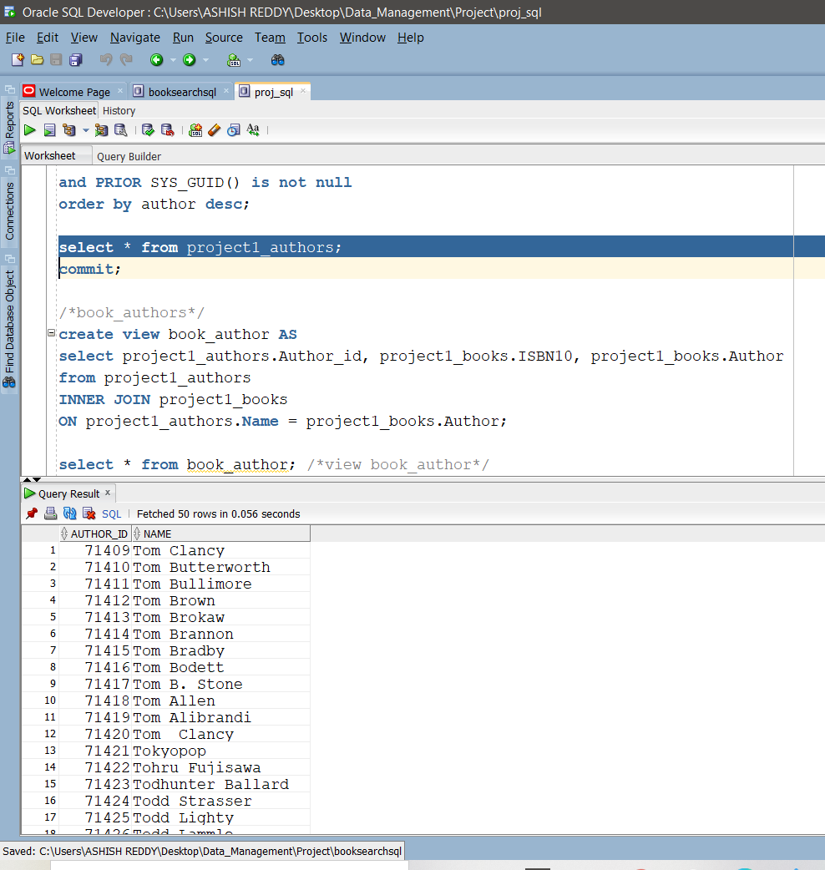

/*book_authors */

create view book_author AS

select project1_authors.Author_id, project1_books.ISBN10, project1_books.Author from project1_authors INNER JOIN project1_books ON

project1_authors.Name = project1_books.Author;

select * from book_author; /*VIEW */

insert into project1_book_authors select * from book_author;

select * from project1_book_authors;

commit;

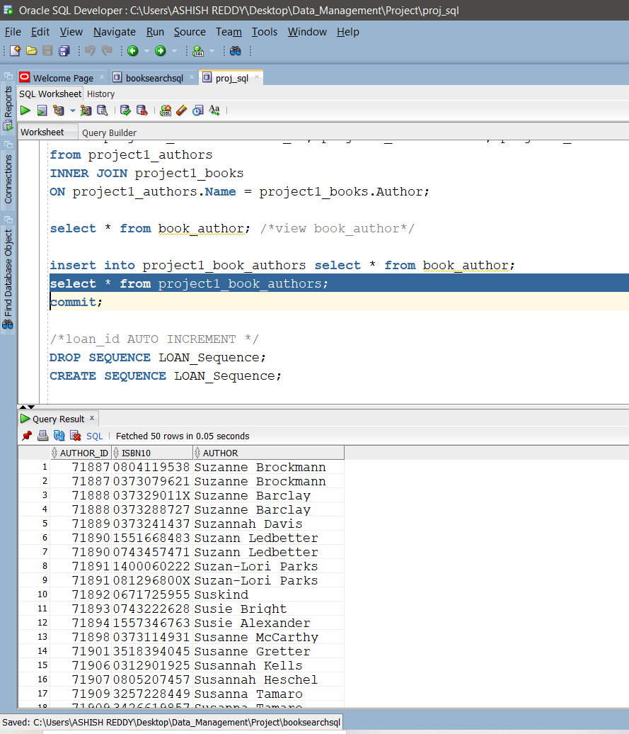

/* Dropping Author column in project1_books */

ALTER TABLE project1_books drop column Author;

2.) 3.)

1.) At least 500 books checkouts for at least 200 different borrowers and 100 different books.

DROP SEQUENCE LOAN_Sequence;

CREATE SEQUENCE LOAN_Sequence;

DROP TRIGGER loan_id; /* loan_id Auto increment */

CREATE TRIGGER loan_id

BEFORE INSERT ON PROJECT1_BOOK_LOANS

FOR EACH ROW BEGIN

SELECT LOAN_Sequence.nextval

INTO :new.loan_id FROM dual;

END;

insert into project1_book_loans(book_id, card_no, Date_out, Due_date, Date_in, branch_id)

select b.book_id, a.card_no, sysdate-20 as Date_out, sysdate-10 as Due_date,

sysdate - dbms_random.value(3,12) as Date_in, b.branch_id

from(select * from

(select a.card_no, a.ssn, a.first_name, a.last_name, a.email, a.phone

​ from project1_borrowers a

​ ORDER BY DBMS_RANDOM.RANDOM)where rownum<201) a,

(select * from (select b.book_id, b.ISBN10, b.branch_id

​ from project1_book_copies b

​ORDER BY DBMS_RANDOM.RANDOM)

where rownum<101)b

ORDER BY DBMS_RANDOM.RANDOM;

select * from project1_book_loans;

commit;

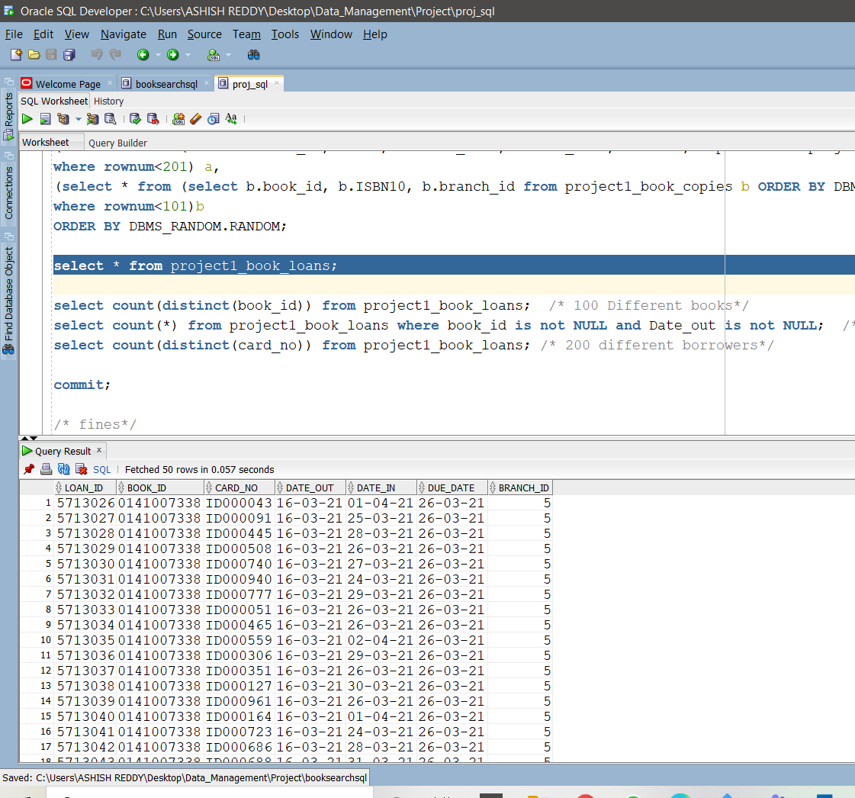

/* 100 Different books*/

select count(distinct(book_id)) from project1_book_loans;

/ * 20000 book checkouts*/

select count(*) from project1_book_loans where book_id is not NULL and Date_out is not NULL;

/* 200 different borrowers*/

select count(distinct(card_no)) from project1_book_loans;

2.) 3.)

2.) At least 50 fine records for 20 different borrowers.

insert into project1_fines(loan_id, fine_amt)

( select loan_id, floor(trunc(Date_in) - trunc(Due_date)) * 100

from project1_book_loans

where floor(trunc(Due_date) - trunc(Date_in)) < 0);

select * from project1_fines;

commit;

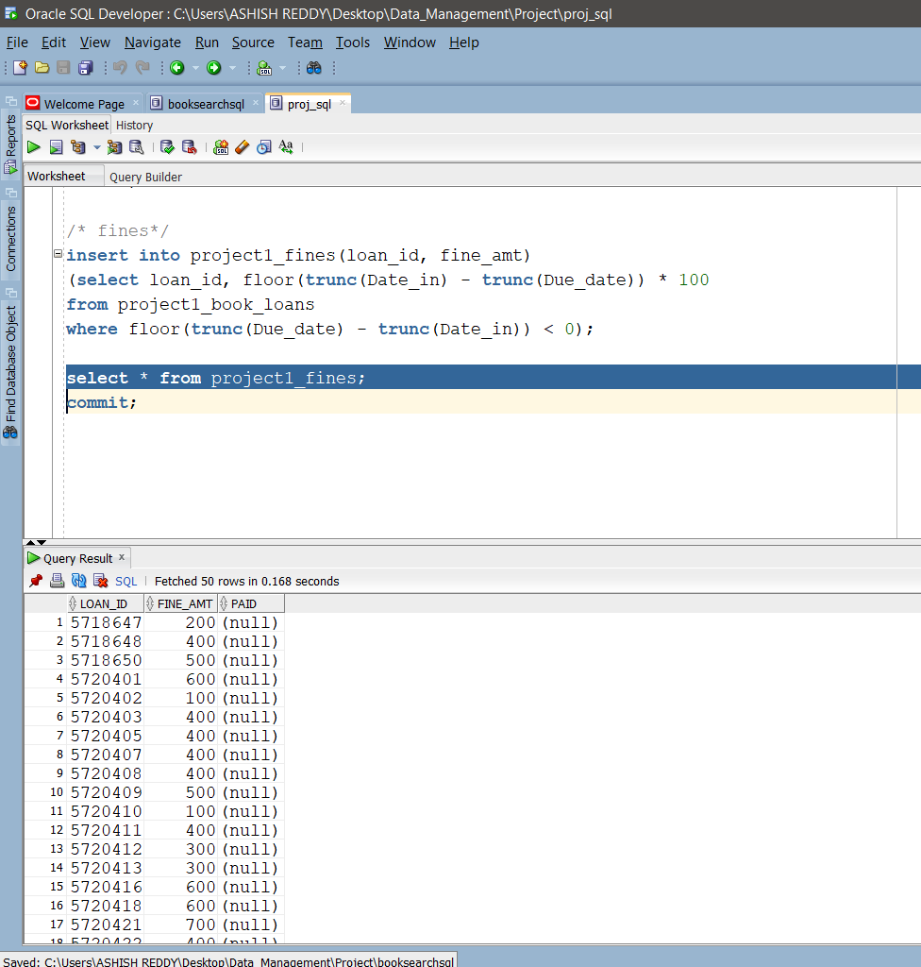

3.) Book Search and Availability

define string = 'lee';

select DISTINCT(b.ISBN10), b.title, (LISTAGG( a.NAME, ';' ) within group

(order by b.ISBN10) OVER (PARTITION BY b.ISBN10)) AS Author

from project1_books b, project1_Authors a, project1_book_authors bc

where bc.ISBN10 = b.ISBN10 and

bc.Author_id = a.Author_id and

( lower(b.title) like lower('%&string%')

or

lower(a.Name) like lower('%&string%')

);

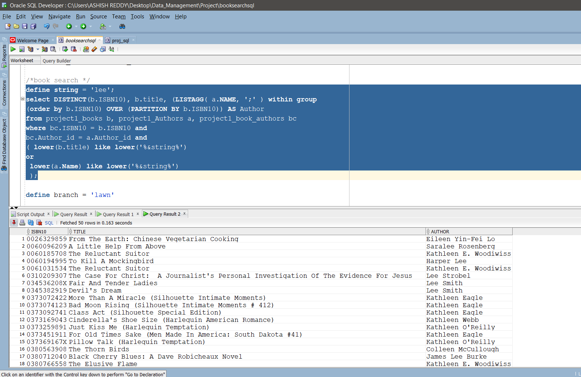

select distinct b.ISBN10, b.title, ba.AUTHOR, bc.no_of_copies, lb.branch_name, lb.address

from project1_library_branch lb, project1_book_copies bc, project1_books b, project1_book_authors ba

where b.ISBN10 = ba.ISBN10

and lb.branch_id = bc.branch_id

and b.ISBN10 = '0743457471' and

b.title like '%Lady Never%' and ba.AUTHOR like '%Suzann%';

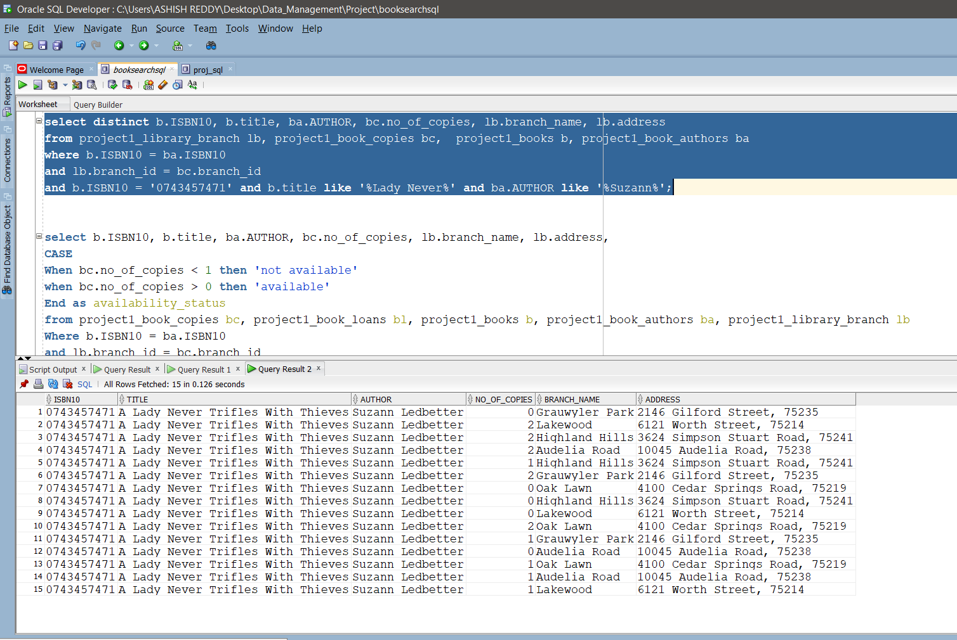

select b.ISBN10, b.title, ba.AUTHOR, bc.no_of_copies, lb.branch_name, lb.address,

CASE

When bc.no_of_copies < 1 then 'not available'

when bc.no_of_copies > 0 then 'available'

End as availability_status

from project1_book_copies bc, project1_book_loans bl, project1_books b, project1_book_authors ba, project1_library_branch lb

Where b.ISBN10 = ba.ISBN10

and lb.branch_id = bc.branch_id

and b.ISBN10 = '1853262439' and b.title like '%The Comedy Of Errors (Wordsworth Classics)%' and ba.AUTHOR like '%William Shakespeare%';

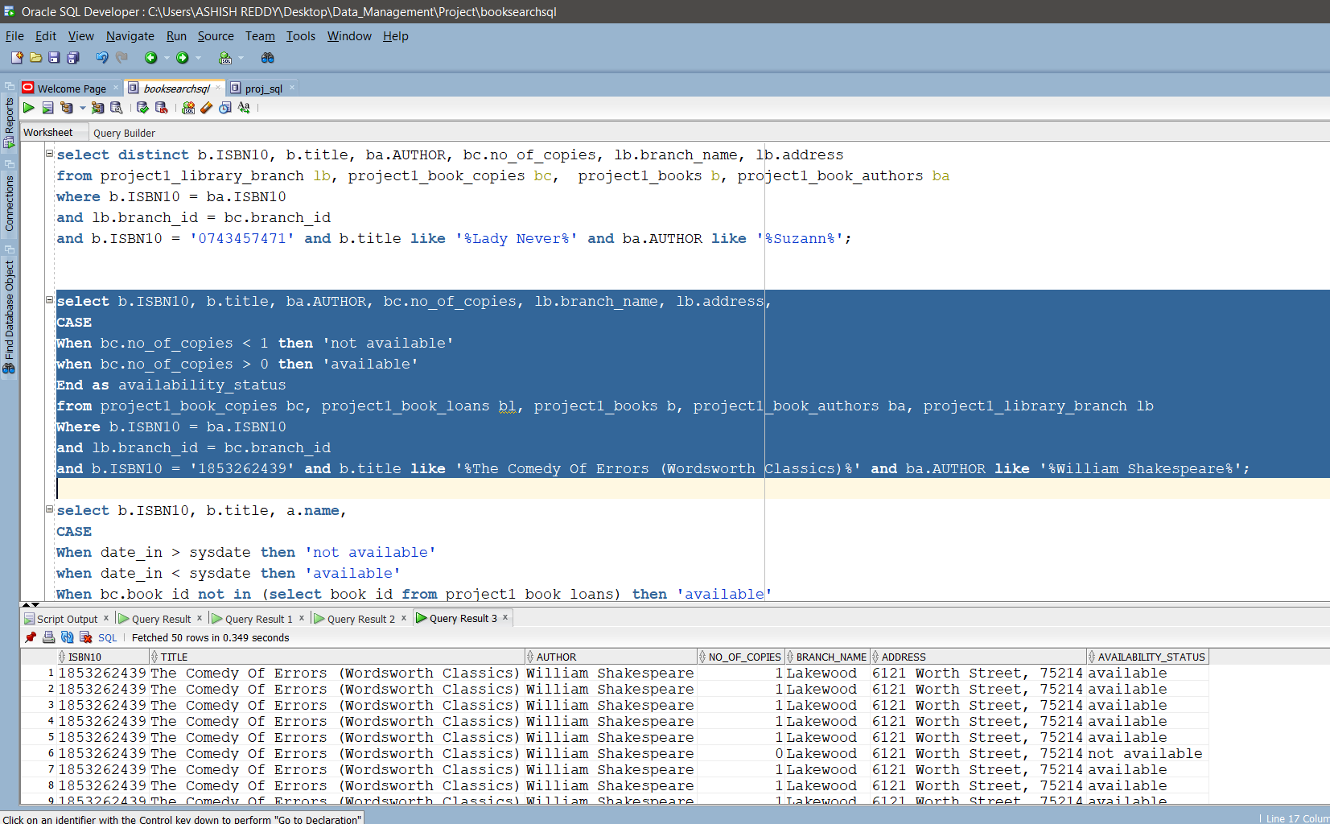

4.) Reports

/* Report 1: Author_id, Author Names whose book copies are exactly 6 */

select distinct ba.author_id, ba.author as author

from project1_book_authors ba join project1_book_copies bc

on ba.isbn10= bc.isbn10

where bc.book_id in

(select bookId from

(select bc.book_id as bookId, count(bc.branch_id) as

count_branch, sum(no_of_copies) as copies

from project1_book_copies bc join project1_books b

on b.isbn10= bc.isbn10 join project1_book_authors ba

on ba.isbn10= b.isbn10

group by bc.book_id

order by copies DESC) temp where temp.copies = 6);

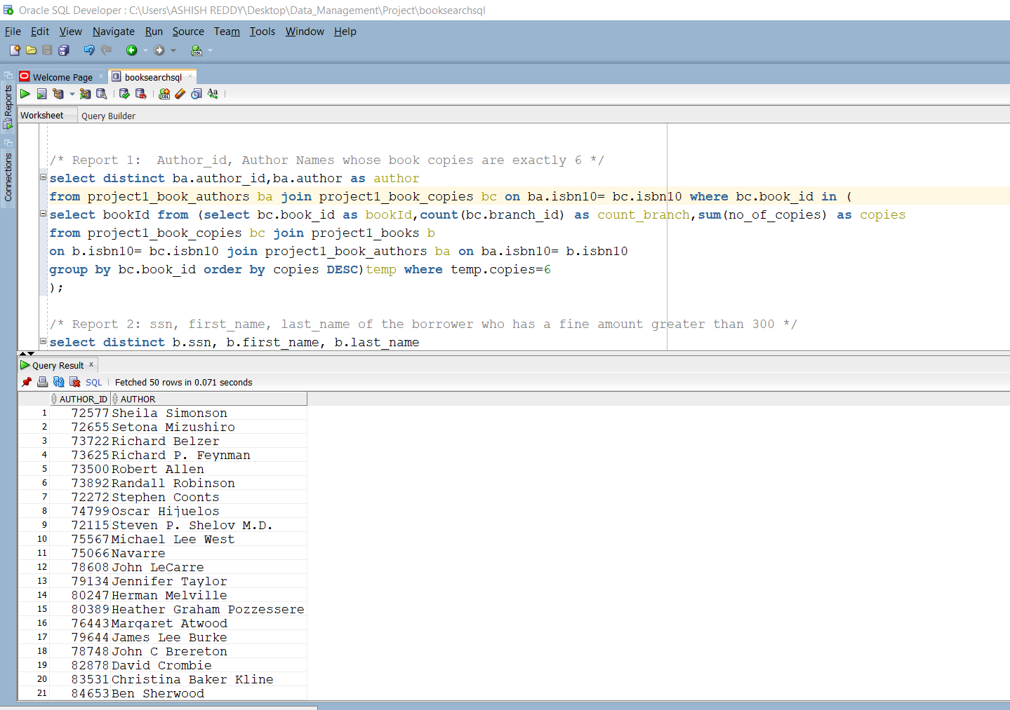

/* Report 2: ssn, first_name, last_name of the borrower who has a fine amount greater than 300 */

select distinct b.ssn, b.first_name, b.last_name

from project1_borrowers b, project1_book_loans bl, project1_fines f

where b.card_no = bl.card_no and bl.loan_id = f.loan_id

and f.fine_amt > 300;

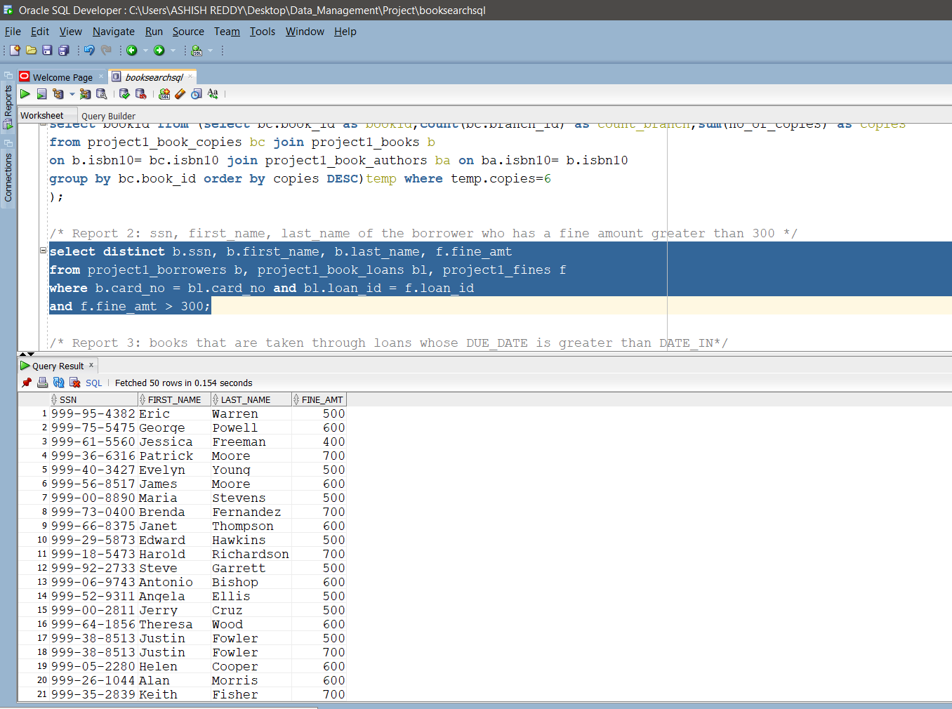

/* Report 3: books that are taken through loans whose DUE_DATE is greater than DATE_IN*/

select distinct b.title

from project1_books b, project1_book_copies bc, project1_book_loans bl

where b.ISBN10 = bc.ISBN10 and bc.book_id = bl.book_id

and bl.Due_date > bl.DATE_IN;

