**Exercise 2**

Question 3

***Aim:*** Create a user feedback page which asks questions about a software product. You are required to use checkbox, radio buttons, and drop-down, text area and various text input type for this. Structure the web page using HTML table.

***Code:***

**Feedback.html**

<!DOCTYPE html>

<html>

    <head>

        <title> Feedback form</title>

    </head>

    <body bgcolor="black">

        <table border=0 bgcolor="#e3dede" align="center">

            <form method = "post" action = "forms.html">

                <h3 align="center"><b><font color="white">Software feedback form</font></b></h3>

                <tr>

                    <td>

                        <label> Name </label>

                    </td>

                    <td>

                        <input type = "text" name = "Name" size=54 placeholder="Enter Your Name here" />

                    </td>

                </tr>

                <tr>

                    <td>

                        <label> Email </label>

                    </td>

                    <td>

                        <input type = "text" name = "email" size=54 placeholder="Enter Your Email here" />

                    </td>

                </tr>

                <tr>

                    <td>

                        <label> Gender  </label>

                    </td>

                    <td>

                        <input type = "radio" name = "gender" value ="male" /><label> Male </label>

                        <input type = "radio" name = "gender" value ="female" /><label> Female </label>

                    </td>

                </tr>

                <tr>

                    <td>

                        <label> What do you do? </label>

                    </td>

                    <td>

                        <select name = "class">

                            <option value = "Professional"> Student </option>

                            <option value = "Student"> Working Professional </option>

                        </select>

                    </td>

                </tr>

                <tr>

                    <td>

                        <label> How satisfied were<br> you with our product? </label>

                    </td>

                    <td>

                        <label for=min id=min> 0 </label>

                        <input type=range name="scale" min=0 max=10 />

                        <label for=max> 10</label>

                    </td>

                </tr>

                <tr>

                    <td>

                        <label> Remarks </label>

                    </td>

                    <td>

    <textarea name = "comment" rows=5 cols=50 placeholder="Remarks" ></textarea>

                    </td>

                </tr>

                <tr>

                    <td>

                        <label> How would you like<br> to receive updates? </label>

                    </td>

                    <td>

                        <input type="checkbox" id="email" name="email">

                        <label for="email"> Through Email</label><br>

                        <input type="checkbox" id="phone" name="phone">

                        <label for="phone"> Through Phone Number</label>

                    </td>

                </tr>

                <br>

                <tr>

                    <td colspan=2 align="center">

                        <input type = "reset" name = "reset" value= "reset" />

                        <input type = "submit" name = "submit" value = "submit" /><br>

                    </td>

                </tr>

            </form>

        </table>

    </body>

</html>

***Code:***

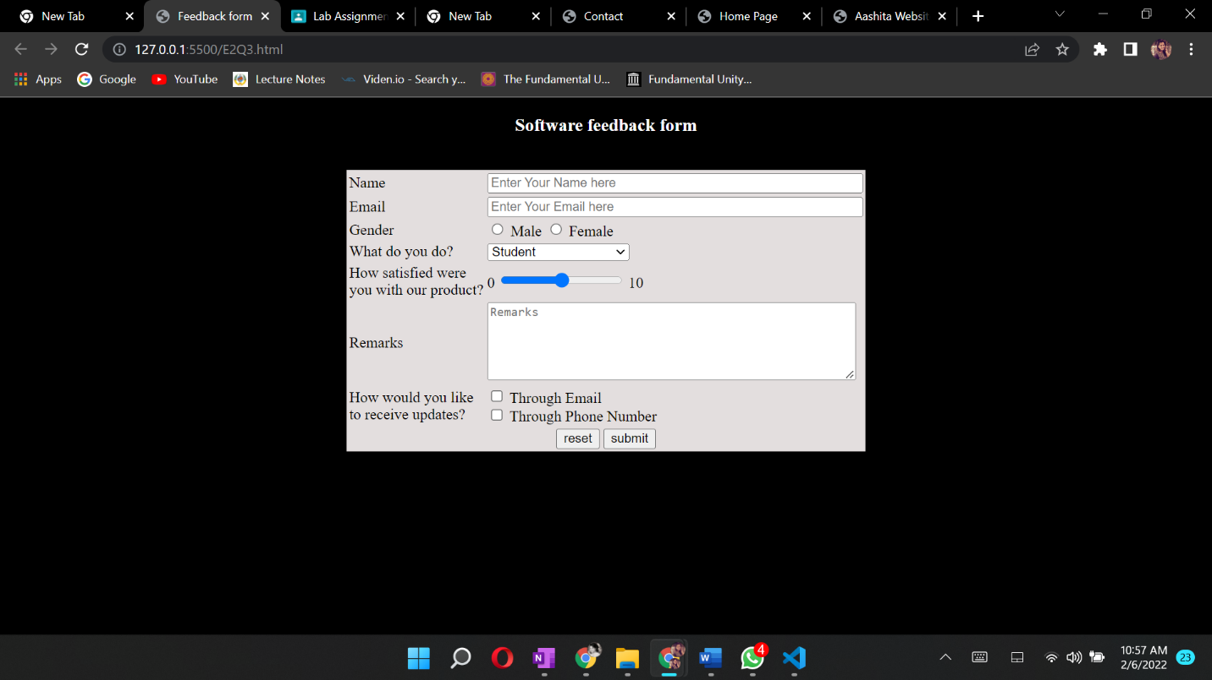

Question 4

***Aim:*** Create a home page for personal website with 4 sections Header, Navigation bar (menu bar), content and footer section. It should have a menu bar for “Bio-Data, Contact, Photo, Video, Notes etc.” For each menu option create a separate web page and link with home page. Structure the web page using HTML table.

***Code:***

**Home.html**

<html>

    <head>

        <title>Home Page</title>

    </head>

    <body bgcolor = "black" text="white">

        <header>

        <table  cellpadding = "8" >

        <tr colspan = 2>

            <nav position = "fixed" top = 0  >

            <td rowspan = 2><a  href = "BioData.html"><b>PersonalDetails</b></a></td>

            <td rowspan = 2><a href = "contact.html"><b>Contact</b></a></td>

            <td rowspan = 2><a href = "videos.html"><b>Videos</b></a></td>

            <td rowspan = 2><a href = "photos.html"><b>Photos</b></a></td>

            <td rowspan = 2><a href = "notes.html"><b>Notes</b></a></td>

            </nav>

            </tr>

            </table>

        </header>

    <div style = "font-size:18px">

    <p>Hello, I am Aashita Goyal</p>

    <p>This is my Introduction page with my basic details, Bio Data, Contact Details, some videos, some photos and some notes.</p>

    <p>In the personal details, I shared all the details you need to know about me.</p>

    <p>In contact section, I have provided all possible contact details.</p>

    <p>Videos section contains some fun videos :)</p>

    <p>In the image section, I have shown some beautiful scenic pictures.</p>

    <p>In the notes section, I have listed some of my basic understanding of web development.</p>

    </div>

    </body>

</html>

**BioData.html**

<html>

<head>

    <title>Personal Details</title>

</head>

<body>

    <header align = "centre">

        <h1>Basic Information</h1>

    <header>

    <hr>

    <table width = "800" border = "0" align = "centre" cellpadding = "5" style=font-size:20px >

    <tr>

    <td align = "right" font-size = 10px><b><label>Name : </label></b></td>

    <b><td >Aashita Goyal<td></b>

    </tr>

    <tr>

    <td align = "right"><b><label>Gender : </label></b></td>

    <b><td >Female<td></b>

    </tr>

    <tr>

    <td align = "right"><b><label>D.O.B : </label></b></td>

    <b><td >10 June 2001<td></b>

    </tr>

    <tr>

    <td align = "right"><b><label>Father's Name : </label></b></td>

    <b><td >Sumeet Goyal<td></b>

    </tr>

    <tr>

    <td align = "right"><b><label>Mother's Name : </label></b></td>

    <b><td >Rekha Goyal<td></b>

    </tr>

    <tr>

    <td align = "right"><b><label>Religion : </label></b></td>

    <b><td >Hindu<td></b>

    </tr>

    </table>

</body>

</html>

**contact.html**

<html>

<head>

    <title>Contact</title>

</head>

<body>

    <header align = "centre">

        <b><h1>Contact Details</h1></b>

    <header>

    <hr>

    <body>

    <table width = "800" cellpadding = "5" align = "centre" style=font-size:20px>

    <tr>

    <td align = "right" valign = "top"><b><label>Address : </label></b></td>

    <td>Sector 10<br>R K Puram<br>New Delhi<td>

    </tr>

    <tr>

    <td align = "right" valign = "top"><b><label>Phone no. : </label></b></td>

    <td>(+91)9464908884<br>(+91)9958379725<td>

    </tr>

    <tr>

    <td align = "right"><b><label>Email Address : </label></b></td>

    <td>aashitagoyal99@gmail.com<td>

    </tr>

    </table>

    </body>

    </html>

**photos.html**

<!DOCTYPE html>

<html>

<head>

    <title>Beautiful sights</title>

</head>

<body>

<header>

<h1>Beautiful sights</h1>

<hr>

</header>

    <TABLE>

        <tr>

        <img src = "8.jpg" alt = "beautiful pic" width = "1000px">

        </tr>

        <tr align = "right">

        <img src = "9.jpg" alt = "beautiful pic" width = "1000px">

        </tr>

        <tr>

        <img src = "10.jpg" alt = "beautiful pic" width = "1000px">

        </tr>

    </TABLE>

</body>

</html>

**videos.html**

<!DOCTYPE html>

<html>

<head>

    <title>Videos Page</title>

</head>

<body>

    <header>

        <h1>Videos</h1>

    <header>

    <table align = "centre">

    <tr >

    <video  height = 400 width = 800 controls>

    <source src = "first.mp4" type = "video/mp4">

    Browse doesn't support this video

    </video>

    </tr>

<br>

<tr>

    <video  height = 400 width = 800 controls>

    <source src = "second.mp4" type = "video/mp4">

    Browse doesn't support this video

    </video>

    </tr>

    <br>

    </table>

</body>

</html>

**notes.html**

<!DOCTYPE html>

<html>

<head>

    <title>Notes</title>

</head>

<body>

    <header align = "centre">

        <h1>Notes</h1>

    <header>

<p>DNS - Domain Name System

    Browser sends url text to DNS server

    DNS server converts the text into IP address

    This IP address is understood by the computer (application server)  and the specific browser window is opened

    The url text is entered by the user i.e. us</p>

<br>

<p>HTTPS - Hyper Text Transfer Protocol Secure

    Protocol - is an instruction. It instructs the specific HTML, CSS and JavaScript files that need to be accessed for the particular browser window

    Domain - is a unique identification or a license, provided to an application. It is bought.

    Sub Domain - is like a child of the main domain. It can be bought separately, or connected with the main domain

    Top Level Domain (TLD) is one of the categories that DNS uses to securely arrange the websites available in that domain

    .com .in .co are all TLD

    Path defines the HTML file address

    Anchor is used to display a particular content in HTML file

    Instead of reading the HTML file from beginning, anchor helps us access the part of the file that we want to.

    Web development - Planning, Deployment and uploading it on cloud is known as web development

    Static - The content of websites should not change

    Dynamic - The contents of websites change in dynamic

    How does the server read our HTML files?

    When a browser requests a server, the serve responds with the HTML, CSS and JavaScript files required.

        1. DOM - Document Object Model. It is hierarchial.

    It is not written one below the other.It is written in an hierarchial manner so that all parent and child tags can be accessed.

        2. CSSOM - Cascading Style Sheet Object Model. (similar to DOM, but this is for CSS where DOM is for HTML)

    Render Tree -  Combined DOM and CSSOM is known as render tree. It is responsible for showing our websites in our browser</p>

**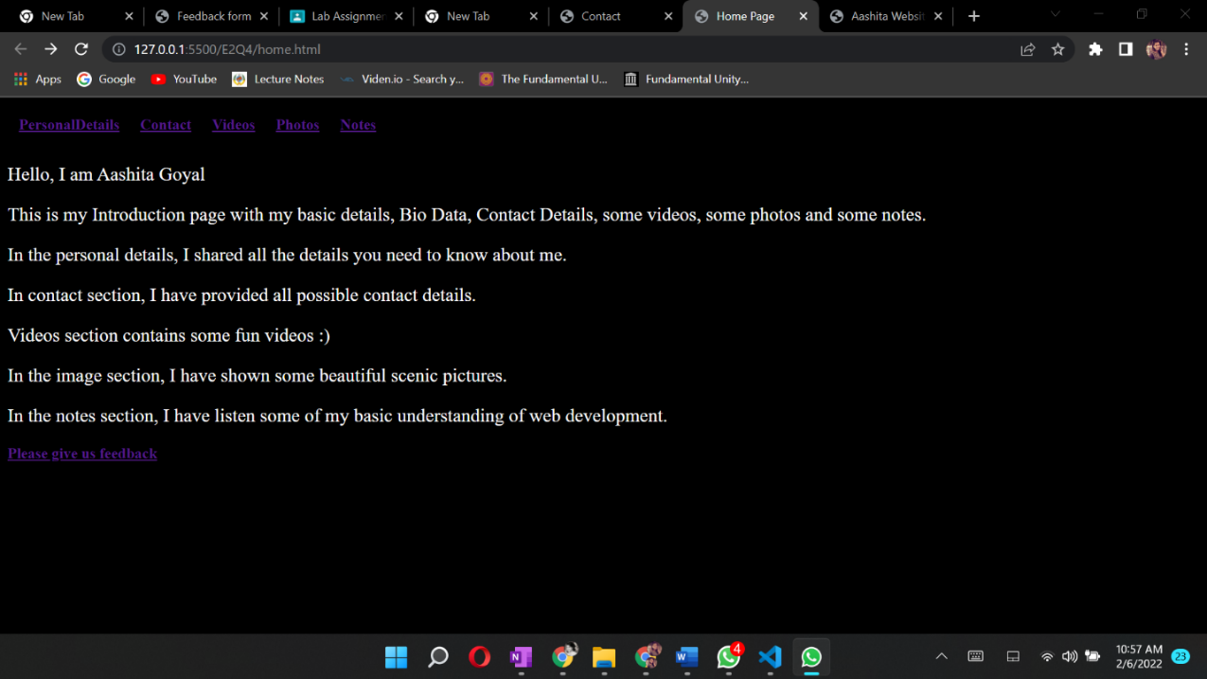*Output:***