**Exercise 4**

Question 7

***Aim:*** Implement a one-page personal website to present your resume. Design of the webpage should be like given example.

<https://sachagreif.com/>  
  
Your webpage should also have a navigation menu.

***Code:***

**Portfolio.html**

<!DOCTYPE html>

<html>

    <head>

        <title>Aashita Goyal (1913541) Exercise 4 Q1</title>

        <link rel="stylesheet" href="Portfolio.css">

        <link rel="shortcut icon" type="image/x-icon" href="https://iconape.com/wp-content/png_logo_vector/ag-2.png" class="tab-logo" />

    </head>

    <body>

        <nav class="navbar" style="background-color: #655d8a" id="grad">

            <div class="container">

                <img class="logo" src="https://iconape.com/wp-content/png_logo_vector/ag-2.png" >

                   <div class="nav-content">

                        <a href="#section1" class="btn">Bio</a>

                        <a href="#section2" class="btn">Code</a>

                        <a href="#section3" class="btn">Projects</a>

                        <a href="#section4" class="btn">Writing</a>

                        <a href="#section2" class="btn">Podcasts</a>

                        <a href="#section3" class="btn">Graveyard</a>

                    </div>

            <div class="nav-index">

                <ul class="nav-icon">

                    <li class="nav-item">

                      <a class="nav-link" href="">Profile

                      <img src="https://img.icons8.com/glyph-neue/64/000000/lifecycle.png" class="icons"/>

                      </a>

                    </li>

                    <li class="nav-item">

                      <a class="nav-link" href="">Logout

                      <img src="https://img.icons8.com/ios/100/000000/shutdown--v1.png" class="icons"/>

                      </a>

                    </li>

                </ul>

            </div>

        </div>

    </nav>

    <div style="background-color: #EB613D;" >

        <form id="form" style="border-left: 30px solid white; ">

            <img src="https://iconape.com/wp-content/png_logo_vector/ag-2.png"

                 style="width:100px; height:100px;" />

            <p>I'm <b>Aashita Goyal</b>, a developer, a student and an aspirant.

            I'm from New Delhi, India.

            <span style="color: red;">Say hello</span>, or keep scrolling.

            </p>

            <br><br>

        <div class="social-media-logo-container">

            <div><p>---------------------------------</p></div>

            <div >

            <a href="https://sachagreif.com/"><img src=" https://www.nicepng.com/png/detail/4-40303_see-here-new-2018-twitter-logo-black-and.png" class="social-media-logo"></a>

            <a href="https://sachagreif.com/"><img src="https://img.favpng.com/4/20/21/github-computer-icons-icon-design-png-favpng-KaDTwuHWgG8D1qn47QW2hK7Gj.jpg" class="social-media-logo"></a>

            <a href="https://sachagreif.com/"><img src=" https://i.pinimg.com/236x/79/b9/80/79b9802cd78648e7a6644f3710cd3375.jpg" class="social-media-logo"></a>

            <a href="https://sachagreif.com/"><img src=" https://toppng.com/uploads/preview/black-round-instagram-logo-11549531861xqjnpo2dom.png" class="social-media-logo"></a>

            </div>

            <div><p>---------------------------------</p></div>

        </div>

           </form>

           </div>

            <div id="section1" style="background-color: #A3D2DF;" >

            <form id="form" style="border-left: 30px solid #F0F0F0; ">

            <h1>Bio</h1>

            <h4>A little more about me. </h4><br>

            <table>

                <tr >

                    <td style="width:360px;"><p>I've always loved spending way too much time on the computer, and spent my teens tinkering  &nbspwith Photoshop and building crappy websites.

                        After coming back to France in 2007, I became a freelance UI designer, working with companies such as

                        <a href="#" style="color: red;">Hipmunk</a>, <a href="#" style="color: red;">Intercom</a>, and

                        <a href="#" style="color: red;">Le Monde</a>.

                    </td>

                    <td>A few years later, I decided what I really wanted was to create my own products, and set out to re-learn web programming. <brbr><brbr>

                        After moving to Japan in 2012 for my wife's studies, I now live in Kyoto and work part-time for

                        <a href="#" style="color: red;">Zens

                        </a> while also working on my own projects. </p>

                    </td>

                </tr>

                <tr>

                    <td>But after getting a computer science degree, I realized writing compilers wasn't for me and decided to switch majors completely and learn Mandarin instead. <br><br></td>

                    <td> <br><br>Yet as it turns out, my path would lead back to computers: after moving to China in 2006, I ended up quitting my language studies and getting a job in Beijing as a web designer. <br><br></td>

                </tr>

            </table>

            </form>

            </div>

            <div id="section2" style="background-color: #C6F0D5;">

            <form id="form" style="border-left: 30px solid #F0F0F0;" >

            <h1>Code</h1>

            <h4>The duct tape that keeps the world together. </h4><br>

            <table>

                <tr>

                    <td style="width:360px;">

                        <p><a href="#" style="color: red;">Vulcan.js</a><br><br>

                            An open-source full-stack app framework based on React, GraphQL, Meteor, and MongoDB. A.k.a. the “Rails for JavaScript”.<br><br><br>

                            <a href="#"style="color: red;">Discover Meteor</a><br><br>

                    </td>

                    <td><a href="#" style="color:red;">State Of JavaScript</a><br><br>I got tired of all this talk of “JavaScript fatigue”, so I created a survey to get more data about recent trends in the JavaScript community. <br><br><br>

                        </td>

                    </tr>

                        <tr>

                <td>I learned the Meteor JavaScript framework to build Telescope, and decided to reinvest the knowledge I had just acquired to co-author a book together with Tom Coleman. <br><br><br>

                    </td>

                    <td><a href="#" style="color:red;">State Of CSS</a><br><br>

                        The State of JS survey’s little sister, all about CSS and HTML. </p>

                    </td>

                </tr>

           </table>

            </form>

            </div>

            <div id="section3" style="background-color: #FFEEB2;">

            <form id="form" style="border-left: 30px solid #F0F0F0; ">

            <h1>Projects</h1>

            <h4>Get Idea; 2. Launch; 3. ???; 4. Profit.</h4><br>

            <table>

                <tr>

                    <td style="width:360px;"><p><a href="#" style="color:red;">Sidebar</a><br><br>

                        My daily newsletter of the five best design links, now with over 35000 subscribers.<br><br><br></td>

                    <td> <a href="#" style="color:red;">Community Building Guide</a><br><br>I wrote a free guide to help people build successful communities.<br><br><br>

                        </td>

                </tr>

                <tr>

                    <td> <a href="#" style="color:red;">Hacker News Kansai</a><br><br>

                        I co-organize the local Hacker News meetup here in Osaka.<br><br><br></td>

                    <td><a href="#" style="color:red;">Design Portfolio</a><br><br>

                        In a past life, I was a UI designer. You can find a collection of my client work here.</p></td>

                </tr>

            </table>

            </form>

            </div>

            <div id="section4" style="background-color: #E8C8ED;">

            <form id="form" style="border-left: 30px solid #F0F0F0; ">

            <h1>Writing</h1>

            <h4>Like coding, but with fewer bugs.</h4><br>

            <table>

                <tr>

                    <td style="width:360px;"><p><a href="#" style="color:red;">A Study Plan To Cure JavaScript Fatigue </span><span style="color:grey;">2016</a><br><br>

                        My ultra-popular guide to learning JavaScript.<br><br><br><br></td>

                    <td><a href="#" style="color:red;">The Spiderweb Strategy </a><span style="color:grey;">2014</span><br><br>

                        How to organize your products in a way that makes sense (and makes cents, too).

                        <br><br><br><br></td>

                </tr>

                <tr>

                    <td><a href="#" style="color:red;">What Kind Of Logo Do You Get For $5? </span><span style="color:grey;">&nbsp 2014</a><br><br>

                        I went on Fiver to see what kind of logo &nbspyou get for just $5. The results were surprising (or maybe not…).

                        <br><br><br><br></td>

                    <td><a href="#" style="color:red;">Flat Pixels </a><span style="color:grey;">2013</span><br><br>

                        A long-form essay about the never-ending battle between flat design and skeuomorphism.

                        <br><br><br><br></td>

                </tr>

                <tr>

                    <td><a href="#" style="color:red;">The Product Spectrum </a><span style="color:grey;">2014</span><br><br>

                        A blueprint for being an entrepreneur, from being a consultant to building consumer products.

                        <br><br><br><br></td>

                    <td><a href="#" style="color:red;">Step by Step UI design </a><span style="color:grey;">2012</span><br><br>

                        My first ebook, a surprise success that set me on the path of the solo entrepreneur.</p></td>

                </tr>

            </table>

            </form>

            </div><br>

            <div id="section5" style="background-color: #F9D8C4;">

            <form id="form" style="border-left: 30px solid #F0F0F0; ">

            <h1>Podcasts</h1>

            <h4>Now featuring 20% more French accent.</h4><br>

            <table>

                <tr>

                    <td style="width:360px;"><p><a href="#" style="color:red;">UI Breakfast Podcast </a><span style="color:grey;">2016</span><br><br>

                        Episode 40: Learning Through Projects<br><br><br></td>

                    <td><a href="#" style="color:red;">React Native Radio </a><span style="color:grey;">2016</span><br><br>

                        43 The State of JavaScript and React Native

                        <br><br><br></td>

                </tr>

                <tr>

                    <td><a href="#" style="color:red;">Discover Meteor Podcast </a><span style="color:grey;">2015</span><br><br>

                        5 episodes covering various aspects of Meteor

                        <br><br><br></td>

                    <td><a href="#" style="color:red;">Binpress Podcast </a><span style="color:grey;">2015</span><br><br>

                        Episode 39

                        <br><br><br></td>

                </tr>

                <tr>

                    <td> <a href="#" style="color:red;">Product People </a><span style="color:grey;">2014</span><br><br>

                        EP63: How things get popular

                        <br><br><br></td>

                    <td><a href="#" style="color:red;">The Changelog </a><span style="color:grey;">2013</span><br><br>

                        Discover Meteor.js

                        <br><br><br></td>

                </tr>

                <tr>

                    <td><a href="#" style="color:red;">Upfront Podcast </a><span style="color:grey;">2013</span><br><br>

                        Episode 12 - MeteorJS and Side Projects

                        <br><br><br></td>

                    <td><a href="#" style="color:red;">The Industry </a><span style="color:grey;">2012</span><br><br>

                        #10: Facebook IPO’d, The Toolbox launches, Parse for iOS and Android, and Say Hello to Octicons</p>

                        <br></td>

                </tr>

            </table>

            </form>

            </div>

            <div id="section6" style="background-color:#404448;">

            <form id="form" style="border-left: 30px solid #F0F0F0; ">

            <h1>Graveyard</h1>

            <h4>You gotta learn to let them go.</h4><br>

            <table>

                <tr>

                    <td style="width:360px;"><p><a href="#" style="color:red;">Screenings </a><span style="color:grey;">2015</span><br><br>

                        An attempt at building a directory of design talks. On life support due to a lack of updates.<br><br><br></td>

                    <td><a href="#" style="color:red;">BJJBot </a><span style="color:grey;">2015</span><br><br>

                        A directory of Brazilian Jiu-Jitsu videos that never quite took off.

                        <br><br><br></td>

                </tr>

                <tr>

                    <td><a href="#" style="color:red;">The Toolbox </a><span style="color:grey;">2012</span><br><br>

                        A directory of design resources. The domain expired, and then got a second life thanks to a new owner.

                        <br><br><br></td>

                    <td><a href="#" style="color:red;">SachaGreif.com </a><span style="color:grey;">2012</span><br><br>

                        The previous version of this site, a now-abandoned WordPress blog.

                        <br><br><br></td>

                </tr>

                <tr>

                    <td><a href="#" style="color:red;">Folyo </a><span style="color:grey;">2011</span><br><br>

                        My first “startup”. After many years trying (and failing) to make it work, sold the site to the talented Workshop crew.

                        <br><br><br></td>

                    <td><a href="#" style="color:red;">Patternify </a><span style="color:grey;">2011</span><br><br>

                        A simple pattern generation tool, and one of my first ever side projects. Still works!</p></td>

                </tr>

            </table>

            </form>

            </div>

        </div>

        <footer>

            <p>Made by Aashita Goyal with reference to Sacha Greif's website</p>

        </footer>

   </body>

</html>

**Portfolio.css**

* {

    margin: 0;

    padding: 0;

    box-sizing: border-box;

  }

  .tab-logo {

    background-color: wheat;

  }

  .container {

    display: flex;

    padding-bottom: 15px;

    margin-left: 15px;

  }

  .nav-index {

    margin-left: 30px;

  }

  .nav-icon {

    margin-left: 30px;

    display: flex;

    margin-top: 25px;

  }

  .nav-item {

    margin-left: 30px;

  }

  .nav-link {

    color: #000;

  }

  .nav-content {

    margin-left: 200px;

    padding-top: 28px;

  }

  .logo {

    height: 70px;

    width: 70px;

  }

  .navbar {

    width: 100%;

    background-color: #fff;

  }

  .nav a {

    color: #000;

  }

  .nav-item {

    padding-bottom: 10px;

    align-items: flex-end;

    justify-content: end;

  }

  .icons {

    height: 20px;

    width: 20px;

  }

  body {

    font-family: 'Lato', sans-serif;

  }

  .padLogo {

    padding-left: 5px;

    margin-left: 20px;

  }

  .social-media-logo-container{

      display: flex;

      margin-left: 30px;

  }

  .social-media-logo{

      height: 37px;

      width: 37px;

  }

  body {

    font-family:'Gill Sans', 'Gill Sans MT', Calibri, 'Trebuchet MS', sans-serif;

    font-size: larger;

  }

  form {

    background-color: #fff;

    max-width: 800px;

    margin: 50px auto;

    padding: 30px 20px;

    box-shadow: 2px 5px 10px rgba(0, 0, 0, 0.5);

  }

  .form-control {

    text-align: left;

    margin-bottom: 25px;

  }

  .form-control label {

    display: block;

    margin-bottom: 10px;

  }

  .form-control input,

  .form-control select,

  .form-control textarea {

    border: 1px solid #777;

    border-radius: 2px;

    font-family: inherit;

    padding: 10px;

    display: block;

    width: 95%;

  }

  .form-control input[type='radio'],

  .form-control input[type='checkbox'] {

    display: inline-block;

    width: auto;

  }

  button {

    background-color: #05c46b;

    border: 1px solid #777;

    border-radius: 2px;

    font-family: inherit;

    font-size: 21px;

    display: block;

    width: 100%;

    margin-top: 50px;

    margin-bottom: 20px;

  }

  .nav {

    color: white;

    text-align: center;

    display: flex;

    flex-direction: row;

    justify-content: space-around;

    place-items: center;

  }

  .btn {

    color: black;

    height: 30px;

    width: 80px;

    padding: 10px;

    margin: 10px;

    border: 2px solid black;

    text-decoration: none;

  }

  nav {

    display: flex;

    width: 100%;

  }

  footer {

    text-align: center;

    padding: 3px;

    background-color: black;

    color: white;

  }

  a:link {

    text-decoration: none;

  }

  a:hover {

    text-decoration: underline;

  }

***Output:***

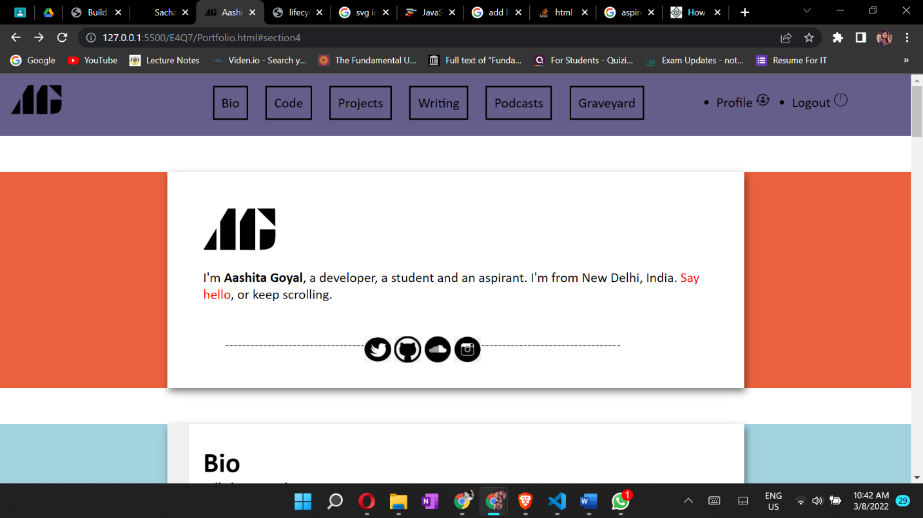

***Full Page Screenshot:***

