**Exercise 6**

Question 10

***Aim:*** Create a Web page that accept a value in a text box for temperature in one unit and convert it to another. It should accept input in kelvin, Celsius, Fahrenheit and Convert accordingly.

***Code:***

**Temp.html**

<!DOCTYPE html>

<html>

  <head>

    <title>Aashita Goyal (1913541) Exercise6-Q10</title>

    <link rel="stylesheet" href="./Temp.css">

  </head>

  <body>

    <div class="wrapper">

        <div class="card">

            <h1>Temperature Converter</h1>

            <p><strong>Enter temperature in any of the following units and obtain conversion of the same value into other two units.</strong> </p>

            <div class="temp-box">

                <div class="temp-fields">

                    <h3 class="spacing">Celsius</h3>

                    <input id="celsius" value="0"/>

                </div>

                <div class="temp-fields">

                    <h3 class="spacing">Fahrenheit</h3>

                    <input id="fahrenheit" value="0"/>

                </div>

                <div class="temp-fields">

                    <h3 class="spacing">Kelvin</h3>

                    <input id="kelvin" value="0"/>

                </div>

            </div>

            <div class="buttons">

                <button id="submit" class="spacing" type="submit" value="submit">Convert</button>

                <button id="reset" class="spacing" type="reset" value="reset">Reset</button>

            </div>

        </div>

    </div>

      <script src="./Temp.js"></script>

  </body>

</html>

**Temp.css**

* {

    margin: 0;

    padding: 0;

    box-sizing: border-box;

  }

  h1{

      color: firebrick;

      padding: 20px;

      text-align: center;

  }

  .temp-fields{

      text-align: center;

  }

  .buttons{

      margin-left: 580px;

      margin-top: 40px;

  }

  .temp-box{

      border-color: black;

      background-color: yellowgreen;

      width: 500px;

      margin-left: 380px;

      height: 280px;

  }

  .temp-fields{

      padding-top: 30px;

  }

  p{

      text-align: center;

      padding-bottom: 20px;

      background-color: silver;

      width: 800px;

      margin-left: 250px;

      padding-top: 15px;

      font-size: larger;

      margin-bottom: 30px;

  }

**Temp.js**

var lastEdited = "celsius";  // initialize the lastEdited flag to any of the three input fields.

//button listeners

document.getElementById("submit").onclick = convert;

document.getElementById("reset").onclick = reset;

//picks up on if and when an input field changes, then sets the lastEdited flag to the input field that was changed.

document.getElementById("celsius").onchange = function() {

  lastEdited = "celsius";

};

document.getElementById("fahrenheit").onchange = function() {

  lastEdited = "fahrenheit";

};

document.getElementById("kelvin").onchange = function() {

  lastEdited = "kelvin";

};

function convert(temp) {

  //initialize local variables

  var celsius = document.getElementById("celsius").value;

  celsius = parseFloat(celsius);

  var fahrenheit = document.getElementById("fahrenheit").value;

  fahrenheit = parseFloat(fahrenheit);

  var kelvin = document.getElementById("kelvin").value;

  kelvin = parseFloat(kelvin);

  //temp values

  var conversionC;

  var conversionF;

  var conversionK;

  //if the celsius field changes, convert the fahrenheit and kelvin values

  if (lastEdited === "celsius") {

    conversionF = celsius * 9 / 5 + 32;

    conversionK = celsius + 273;

    //round the converted fahrenheit and kelvin values

    document.getElementById("fahrenheit").value = Math.round(conversionF);

    document.getElementById("kelvin").value = Math.round(conversionK);

  }

    //if the fahrenheit field changes, convert the celsius and kelvin values

    else if (lastEdited === "fahrenheit") {

    conversionC = (fahrenheit - 32) * 5 / 9;

    conversionK = conversionC + 273;

    //round the converted celsius and kelvin values

    document.getElementById("celsius").value = Math.round(conversionC);

    document.getElementById("kelvin").value = Math.round(conversionK);

  }

    //if the kelvin field changes, convert the celsius and fahrenheit values

    else if (lastEdited === "kelvin") {

    conversionC = kelvin - 273;

    conversionF = conversionC * 9 / 5 + 32;

    //round the converted celsius and fahrenheit values

    document.getElementById("celsius").value = Math.round(conversionC);

    document.getElementById("fahrenheit").value = Math.round(conversionF);

  }

  //get the current conversion temp values and store them in the input fields

  document.getElementById("celsius").innerHTML = conversionC;

  document.getElementById("fahrenheit").innerHTML = conversionF;

  document.getElementById("kelvin").innerHTML = conversionK;

}

//reset function for the reset button to reset all current values

function reset() {

  document.getElementById("celsius").value = 0;

  document.getElementById("fahrenheit").value = 0;

  document.getElementById("kelvin").value = 0;

}

***Output:***

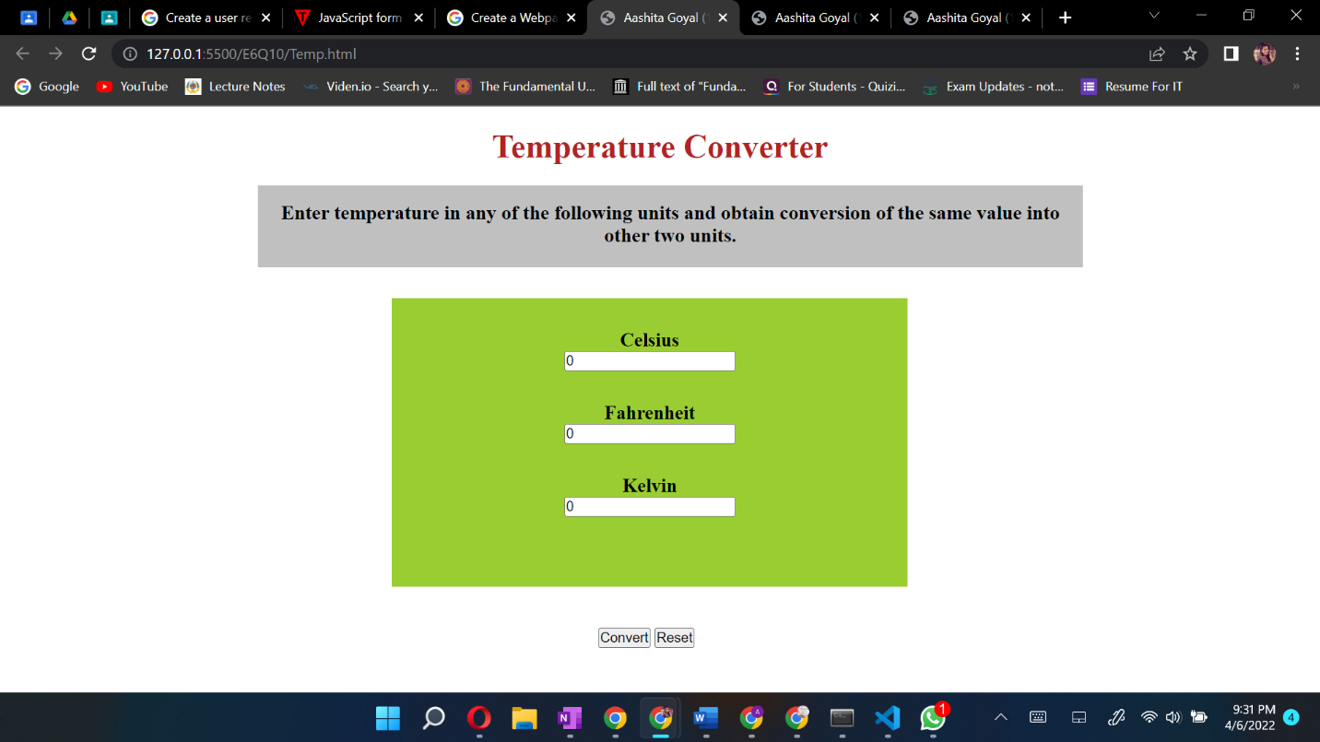

Question 11

***Aim:*** Create a Webpage with two buttons start and stop. When user click on start button a timer should start to count seconds. When a user click on stop button then it should stop.

***Code:***

**Timer.html**

<!DOCTYPE html>

<html>

  <head>

    <title>Aashita Goyal (1913541) Exercise6-Q11</title>

    <link rel="stylesheet" href="./Timer.css">

    <script src="https://ajax.googleapis.com/ajax/libs/jquery/3.2.1/jquery.min.js"></script>

  </head>

  <body>

    <center>

        <h1>TIMER</h1>

        <div id="timer">

          <span id="hours">00:</span>

          <span id="mins">00:</span>

          <span id="seconds">00</span>

        </div>

        <div id="controls">

        <button id="start">Start</button>

        <button id="stop">Stop</button>

        </div>

      </center>

    <script src="./Timer.js"></script>

  </body>

</html>

**Timer.css**

* {

    margin: 0;

    padding: 0;

    box-sizing: border-box;

  }

#timer {

    font-size:150px;

    margin:0 auto;

    width:800px;

    background-color: darkgrey;

    border-radius: 500px;

    margin-bottom: 50px;

  }

  #controls {

    margin:0 auto;

    width:600px;

  }

  #controls button {

    font-size:24px;

  }

**Timer.js**

var hours =0;

var mins =0;

var seconds =0;

$('#start').click(function(){

      startTimer();

});

$('#stop').click(function(){

      clearTimeout(timex);

});

$('#reset').click(function(){

      hours =0;      mins =0;      seconds =0;

  $('#hours','#mins').html('00');

  $('#seconds').html('00');

});

function startTimer(){

  timex = setTimeout(function(){

      seconds++;

    if(seconds >59){seconds=0;mins++;

       if(mins>59) {

       mins=0;hours++;

         if(hours <10) {$("#hours").text('0'+hours+':')} else $("#hours").text(hours+':');

        }

    if(mins<10){

      $("#mins").text('0'+mins+':');}

       else $("#mins").text(mins+':');

                   }

    if(seconds <10) {

      $("#seconds").text('0'+seconds);} else {

      $("#seconds").text(seconds);

      }

      startTimer();

  },1000);

}

***Output:***

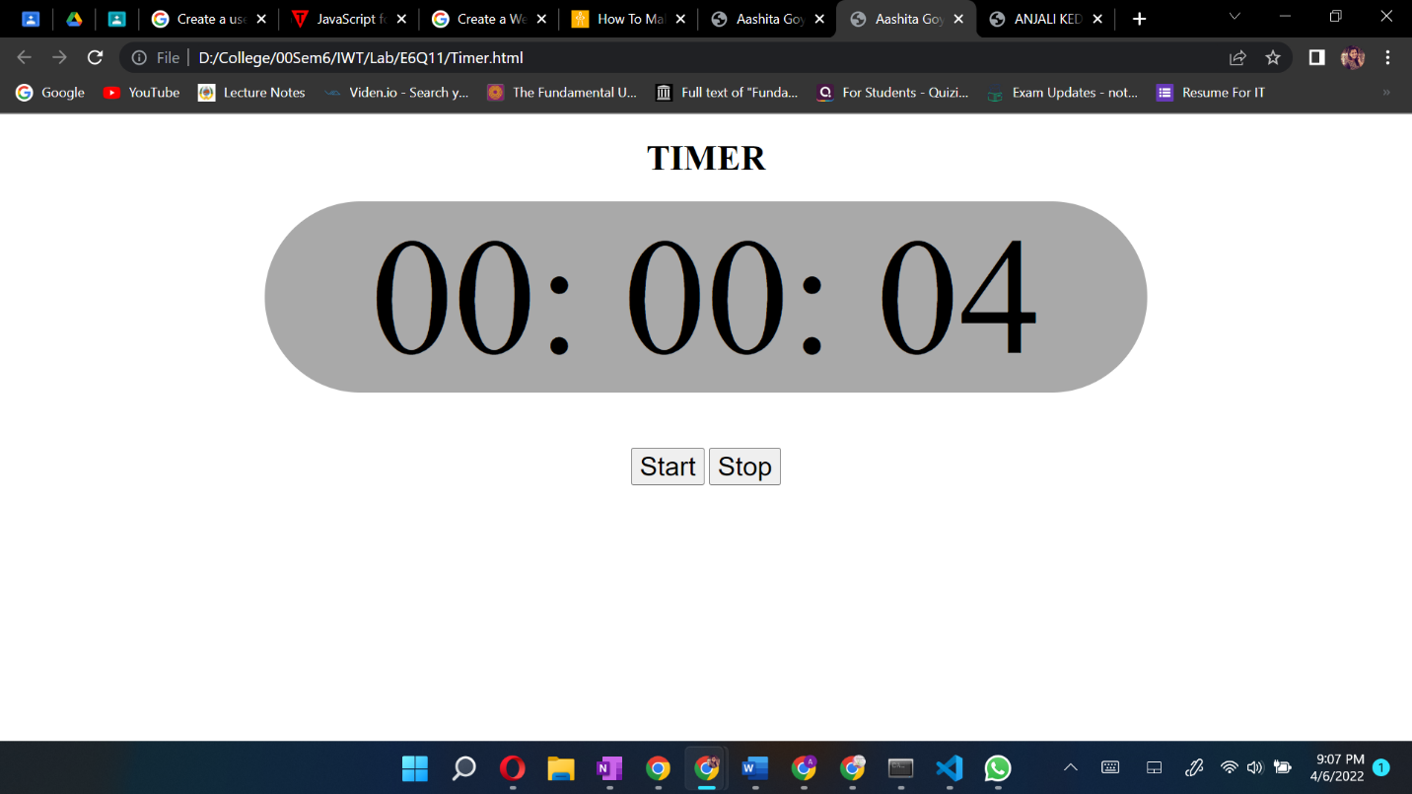

Question 12

***Aim:*** Create a Webpage to display digital clock that display updated time of your system without refreshing webpage.

***Code:***

**Clock.html**

<!DOCTYPE html>

<html>

  <head>

    <title>Aashita Goyal (1913541) Exercise6-Q</title>

    <link rel="stylesheet" href="./Clock.css">

  </head>

  <body>

    <h1>Digital Clock</h1>

    <div id="digClock"></div>

    <script src="./Clock.js"></script>

  </body>

</html>

**Clock.css**

* {

    margin: 0;

    padding: 0;

    box-sizing: border-box;

  }

  body{

      background-color: black;

  }

  #digClock {

    font-size: 90px;

    width: 400px;

    text-align: center;

    background-color: darkslategray;

    color: darkgray;

    margin-left: 450px;

    margin-top: 5px;

}

h1{

    margin-left: 490px;

    padding: 20px;

    font-size: 50px;

    margin-top: 150px;

    color: grey;

}

**Clock.js**

function showTime() {

    let time = new Date();

    let hour = time.getHours();

    let min = time.getMinutes();

    let sec = time.getSeconds();

    if (hour > 12) {

        hour -= 12;

    }

    if (hour == 0) {

        hr = 12;

    }

    hour = hour < 10 ? "0" + hour : hour;

    min = min < 10 ? "0" + min : min;

    sec = sec < 10 ? "0" + sec : sec;

    let currentTime = hour + ":"

        + min + ":" + sec;

    document.getElementById("digClock")

        .innerHTML = currentTime;

}

setInterval(showTime, 1000);

showTime();

***Output:***

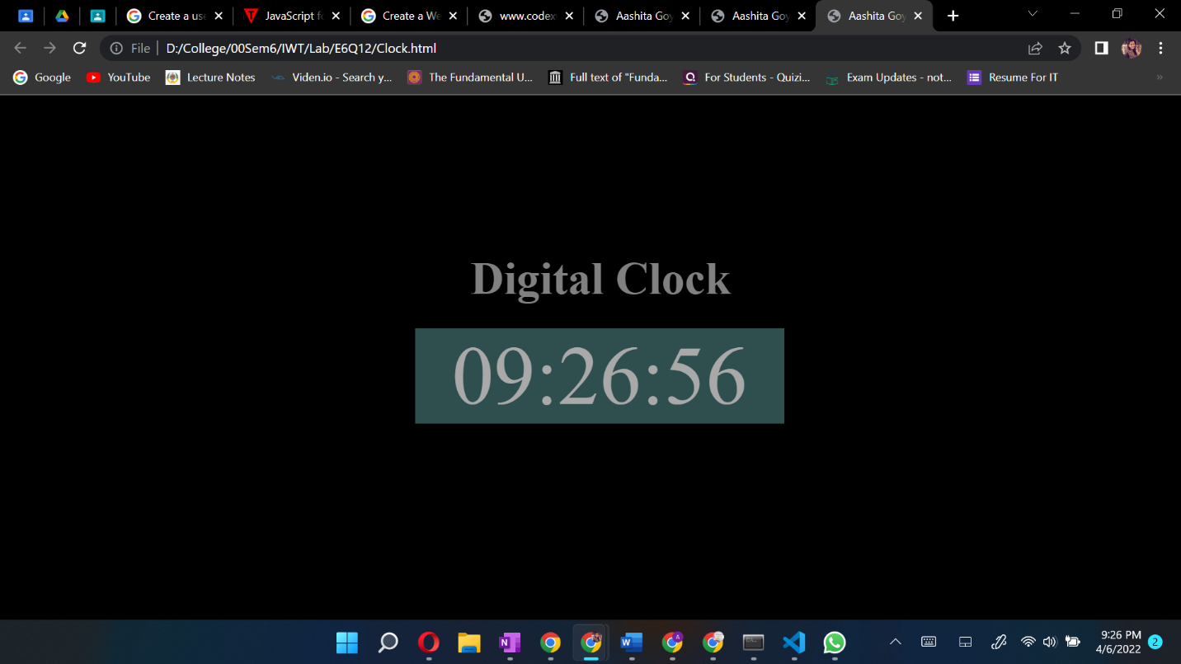

Question 13

***Aim:*** Write a JavaScript to display greeting message according to time with user name that is accessing the webpage. When user clicks on the greeting message it should hide.

***Code:***

**Greet.html**

<!DOCTYPE html>

<html>

  <head>

    <title>Aashita Goyal (1913541) Exercise6-Q13</title>

    <link rel="stylesheet" href="./Greet.css">

  </head>

  <body>

    <div class="box">

      <h1 id="para" onclick="greetings()"></h1>

      <div id="digClock"></div>

    </div>

      <script src="./Greet.js"></script>

  </body>

</html>

**Greet.css**

* {

    margin: 0;

    padding: 0;

    box-sizing: border-box;

  }

  body{

    background-color: darkolivegreen;

  }

  #para{

    text-align: center;

    padding: 20px;

    margin-top: 30px;

    font-size: 60px;

    color: darkkhaki;

  }

  #digClock{

    text-align: center;

    padding: 10px;

    font-size: 30px;

    color: darkkhaki;

  }

  .box{

    background-color: black;

    width: 500px;

    margin-left: 410px;

  }

**Greet.js**

let fname = window.prompt("Enter your full name");

var now = new Date();

var hour = now.getHours();

greet = document.getElementById('para');

greet.addEventListener('click',function run()

{

    greet.style.display='none';

})

if(hour >= 6 && hour < 12)

{

    greet.innerHTML = "Good Morning "+fname +"The time is: ";

}

else if(hour == 12)

{

    greet.innerHTML = "Good Noon "+fname;

}

else if(hour >= 12 && hour <= 17)

{

    greet.innerHTML = "Good Afternoon "+fname;

}

else if (hour >= 18 && hour <= 21) {

    greet.innerHTML = "Good Evening "+fname;

}

else

{

    greet.innerHTML = "Good Night "+fname;

}

function showTime() {

    let time = new Date();

    let hour = time.getHours();

    let min = time.getMinutes();

    let sec = time.getSeconds();

    if (hour > 12) {

        hour -= 12;

    }

    if (hour == 0) {

        hr = 12;

    }

    hour = hour < 10 ? "0" + hour : hour;

    min = min < 10 ? "0" + min : min;

    sec = sec < 10 ? "0" + sec : sec;

    let currentTime = hour + ":"

        + min + ":" + sec;

    document.getElementById("digClock")

        .innerHTML = "The time is "+currentTime;

}

setInterval(showTime, 1000);

showTime();

***Output:***

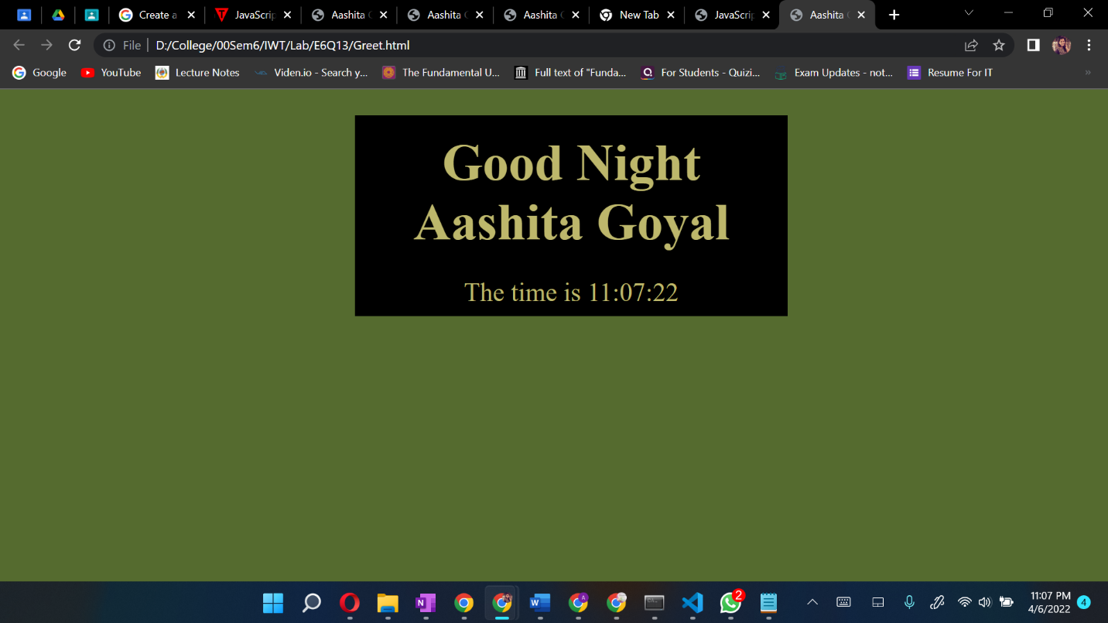

Question 14

***Aim:*** Create a user registration form which accepts first name, last name, user ID, password, confirm password, Address, Email ID, Contact number. Apply appropriate client side validations using JavaScript for all fields of html form. Also format this form using a CSS

***Code:***

**Form_Validation.html**

<!DOCTYPE html>

<html>

  <head>

    <title>Aashita Goyal (1913541) Exercise6-Q14</title>

    <link rel="stylesheet" href="./Form_Validation.css">

  </head>

    <body onload="document.registration.userid.focus();">

      <h1>Registration Form</h1>

      <div class="box">

      <form name='registration' onSubmit="return formValidation();">

      <ul>

          <li><label for="userid">First Name:</label></li>

      <li><input type="text" name="userid" size="12" /></li>

      <li><label for="userid">Last Name:</label></li>

      <li><input type="text" name="userid" size="12" /></li>

      <li><label for="passid">Password:</label></li>

      <li><input type="password" name="passid" size="12" /></li>

      <li><label for="passid" id="label_length">Confirm Password:</label></li>

      <li><input type="password" name="passid" size="12" /></li>

      <li><label for="address">Address:</label></li>

      <li><input type="text" name="address" size="50" /></li>

      <li><label for="email">Email:</label></li>

      <li><input type="email" name="email" size="50" /></li>

      <li><label for="phone">Contact No:</label></li>

      <li><input type="text" name="number" /></li>

      <li><input type="submit" name="submit" value="Submit" /></li>

      </ul>

      </form>

    </div>

      <script src="./Form_Validation.js"></script>

  </body>

</html>

<

**Form_Validation.css**

* {

    margin: 0;

    padding: 0;

    box-sizing: border-box;

  }

  body{

    background-color: darkgray;

  }

  form{

    text-align: center;

    font-size: 30px;

  }

  label{

    width: 100px;

  }

  #label_length{

  width: fit-content;

  }

  .box{

    margin-left: 500px;

    padding-top: 30px;

  }

  h1 {

    margin-left: 70px;

    text-align: center;

    padding: 10px;

    margin-top: 20px;

    }

    form li {

    list-style: none;

    margin-bottom: 5px;

    margin: 10px;

    }

    form ul li label{

    float: left;

    clear: left;

    width: 100px;

    text-align: right;

    margin-right: 10px;

    font-family:Verdana, Arial, Helvetica, sans-serif;

    font-size:14px;

    }

    form ul li input, select, span {

    float: left;

    margin-bottom: 10px;

    }

    form textarea {

    float: left;

    width: 350px;

    height: 150px;

    }

    [type="submit"] {

    clear: left;

    margin: 20px 0 0 230px;

    font-size:18px

    }

    p {

    margin-left: 70px;

    font-weight: bold;

    }

**Form_Validation.js**

function formValidation()

{

var uid = document.registration.userid;

var passid = document.registration.passid;

var uname = document.registration.username;

var uadd = document.registration.address;

var uphone = document.registration.phone;

var uemail = document.registration.email;

var fname = document.reg_form.fname;

var lname = document.reg_form.lname;

if(userid_validation(uid,5,12))

{

if(passid_validation(passid,7,12))

{

if(allLetter(uname))

{

if(alphanumeric(uadd))

{

if(allnumeric(uphone))

{

if(ValidateEmail(uemail))

{

}

}

}

}

}

}

return false;

}

function userid_validation(uid,mx,my)

{

var uid_len = uid.value.length;

if (uid_len == 0 || uid_len >= my || uid_len < mx)

{

alert("User Id should not be empty / length be between "+mx+" to "+my);

uid.focus();

return false;

}

return true;

}

function passid_validation(passid,mx,my)

{

var passid_len = passid.value.length;

if (passid_len == 0 ||passid_len >= my || passid_len < mx)

{

alert("Password should not be empty / length be between "+mx+" to "+my);

passid.focus();

return false;

}

return true;

}

function allLetter(uname)

{

var letters = /^[A-Za-z]+$/;

if(uname.value.match(letters))

{

return true;

}

else

{

alert('Username must have alphabet characters only');

uname.focus();

return false;

}

}

function alphanumeric(uadd)

{

var letters = /^[0-9a-zA-Z]+$/;

if(uadd.value.match(letters))

{

return true;

}

else

{

alert('User address must have alphanumeric characters only');

uadd.focus();

return false;

}

}

function allnumeric(uphone)

{

var numbers = /^[0-9]+$/;

if(uphone.value.match(numbers))

{

return true;

}

else

{

alert('phone code must have numeric characters only');

uzip.focus();

return false;

}

}

function ValidateEmail(uemail)

{

var mailformat = /^\w+([\.-]?\w+)@\w+([\.-]?\w+)(\.\w{2,3})+$/;

if(uemail.value.match(mailformat))

{

return true;

}

else

{

alert("You have entered an invalid email address!");

uemail.focus();

return false;

}

if (fname.value.length <= 0) {

 alert("Name is required");

 fname.focus();

 return false;

 }

 if (lname.value.length <= 0) {

 alert("Last Name is required");

 lname.focus();

 return false;

 }

else

{

alert('Form Succesfully Submitted');

window.location.reload()

return true;

}

}

***Output:***

