**Exercise 1**

Question 1

***Aim:*** Create a web page having 9 images arranged in 3*3 matrixes. When a user clicks on any image, it should open in a new tab.

***Code:***

**Images.html**

<!DOCTYPE html>

<html>

    <head>

        <title>Aashita Goyal (1913541) Exercise Q1</title>

    </head>

    <body>

        <table>

            <tr>

                <td><a href="images/1.jpg" target = _blank ><img src="images/1.jpg" alt = "Image 1" height=170 width=275 border="6" /></a></td>

                <td><a href="images/3.jpg" target = _blank ><img src="images/3.jpg" alt = "Image 3" height=170 width=275 border="6" /></a></td>

                <td><a href="images/5.jpg" target = _blank ><img src="images/5.jpg" alt = "Image 5" height=170 width=275 border="6" /></a></td>

            </tr>

            <tr>

                <td><a href="images/7.jpg" target = _blank ><img src="images/7.jpg" alt = "Image 7" height=170 width=275 border="6" /></a></td>

                <td><a href="images/9.jpg" target = _blank ><img src="images/9.jpg" alt = "Image 9" height=170 width=275 border="6" /></a></td>

                <td><a href="images/11.jpg" target = _blank ><img src="images/11.jpg" alt = "Image 11" height=170 width=275 border="6" /></a></td>

            </tr>

            <tr>

                <td><a href="images/13.jpg" target = _blank ><img src="images/13.jpg" alt = "Image 13" height=170 width=275 border="6" /></a></td>

                <td><a href="images/15.jpg" target = _blank ><img src="images/15.jpg" alt = "Image 15" height=170 width=275 border="6" /></a></td>

                <td><a href="images/17.jpg" target = _blank ><img src="images/17.jpg" alt = "Image 17" height=170 width=275 border="6" /></a></td>

            </tr>

        </table>

    </body>

</html>

***Output:***

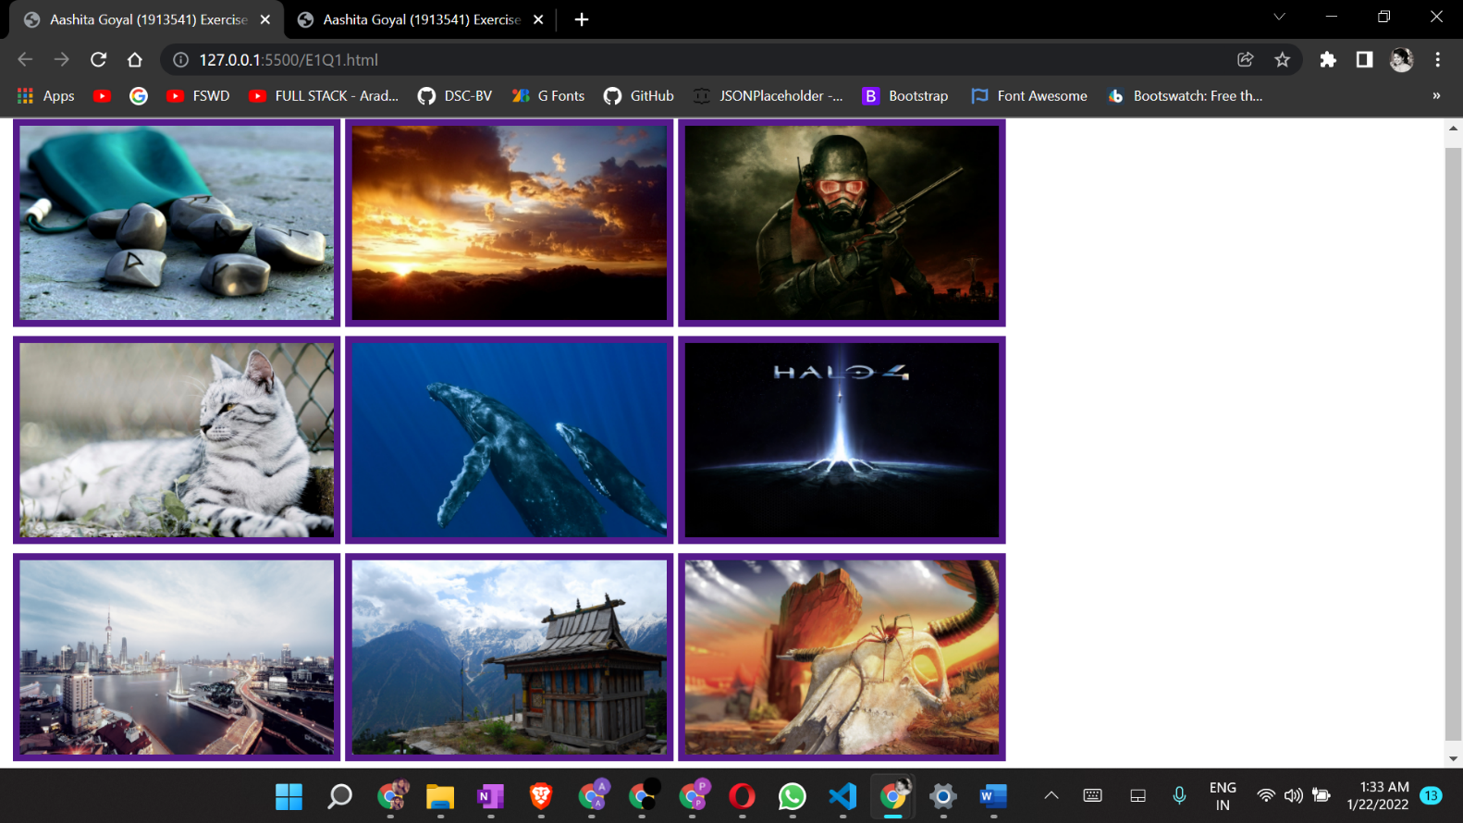

Question 2

***Aim:*** Create a web page that displays image thumbnails of 4 images. Also arrange all these images in one after another in same webpage covering 100% width of webpage. When a user clicks on thumbnail it should display corresponding image to user. (You have to create only one page).

***Code:***

**Thumbnails.html**

<!DOCTYPE html>

<html>

    <head>

        <title>Aashita Goyal (1913541) Exercise Q2</title>

    </head>

    <body bgcolor="black" >

        <a href="#2"><img src = "images/2.jpg"  alt= "Image 2" height="80" ></a>

        <a href="#4"><img src = "images/4.jpg"  alt= "Image 4" height="80" ></a>

        <a href="#6"><img src = "images/6.jpg"  alt= "Image 6" height="80" ></a>

        <a href="#8"><img src = "images/8.jpg"  alt= "Image 8" height="80" ></a>

        <br><br><hr>

        <img id="2" src = "images/2.jpg"  alt= "Image 2" height=550 width=100% >

        <hr>

        <img id="4" src = "images/4.jpg"  alt= "Image 4" height=550 width=100% >

        <hr>

        <img id="6" src = "images/6.jpg"  alt= "Image 6" height=550 width=100% >

        <hr>

        <img id="8" src = "images/8.jpg"  alt= "Image 8" height=550 width=100% >

        <hr>

    </body>

</html>

***Output:***

