**Aashita Goyal**

**1913541**

**BTBTI19113**

**BTech**

**Information Technology**

**Internal Lab Assessment**

Question 1

***Aim:*** Create a web page that display an image with two buttons “hide” and “seek” to hide

and show the image. Write an external JavaScript to add function on hide and seek

buttons.

***Code:***

**q1.html**

<!DOCTYPE html>

<html>

    <head>

        <title>Aashita Goyal (1913541) Lab Internals Q1</title>

        <link rel="stylesheet" href="q1.css" />

    </head>

    <body>

    <div class="container">

        <div id="third"><img src="../Lab/images/quote.jpg" alt="image-hide" width=400px height=400px/></div>

        <div class="buttons">

        <button id="hide_button">Hide Image</button>

        <button id="display_button">Display Image</button>

        </div>

    </div>

        <script src="./q1.js"></script>

    </body>

</html>

**q1.css**

* {

    margin: 0;

    padding: 0;

    box-sizing: border-box;

  }

  .container{

      margin-left: 470px;

      margin-top: 50px;

  }

  .buttons{

      margin-left: 130px;

  }

  button{

      margin: 5px;

  }

**q1.js**

const targetDiv = document.getElementById("third");

const hideBtn = document.getElementById("hide_button");

const displayBtn = document.getElementById("display_button");

hideBtn.onclick = function () {

  if (targetDiv.style.display !== "none") {

    targetDiv.style.display = "none";

  }

};

displayBtn.onclick = function () {

if(targetDiv.style.display == "none"){

    targetDiv.style.display = "block";

  }

};

***Output:***

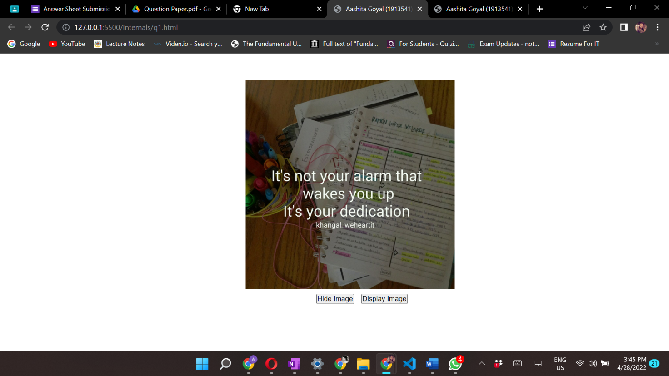

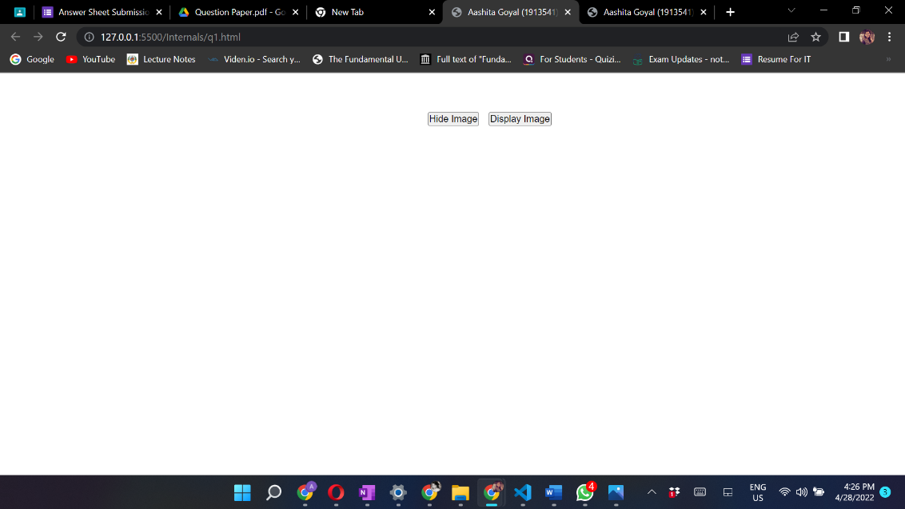

Question 2

***Aim:*** Create an animation using JavaScript in which rectangle should move from one corner

of outer rectangle to another corner when user clicks on it.

***Code:***

**q2.html**

<!DOCTYPE html>

<html>

    <head>

        <title>Aashita Goyal (1913541) Lab Internals Q2</title>

        <link rel="stylesheet" href="q2.css" />

    </head>

    <body>

        <div class="container">

        <div id="outerRectangle">

            <div class="rectangle" id="innerRectangle"></div>

        </div>

        <div id="rectangle">

        </div>

       </div>

        <script src="./q2.js"></script>

    </body>

</html>

**q2.css**

* {

    margin: 0;

    padding: 0;

    box-sizing: border-box;

  }

  .container{

      margin: 100px;

      margin-left: 350px;

  }

  #outerRectangle {

    width: 800px;

    height: 300px;

    background-color: purple;

    position: relative;

  }

  #innerRectangle {

    width: 200px;

    height: 100px;

    background-color: yellow;

    position: absolute;

  }

  #rectangle{

    background-color: purple;

    margin: 500px;

    width: 800px;

    height: 600px;

  }

**q2.js**

const container = document.getElementById('outerRectangle');

const box = document.getElementById('innerRectangle');

box.onclick = function (){

let t = setInterval(move, 0.5);

let pos = 1;

let run = true;

maxRight = '200px';

function move() {

  box.style.left = pos + '1.5px';

  box.style.top = pos + '1px';

  if (run)

    pos++; /* move down */

  else

    pos--; /* move up */

  /* update the direction when you reach the top or bottom limit*/

  if (pos = 60)

    run = false ;

 else if (pos <= 0)

    run = true;

}

};

***Output:***

