Project

1. What data structures are you using?

The data structures used in the project are arrays and lists. Lists are used for storing the data and saving it into a file. The data is then moved into arrays so the data can be sorted and then stored back into the lists. Arrays are also used for the purpose of searching the songs.

1. Where are you using hashing techniques?

The hashing technique used to encrypt the user password is SHA256. It is a hashing technique the is one-way hashing, which means once the user passwords are encrypted, they can’t be decrypted which makes them more secure and protected.

1. What sorting algorithm are you using how this is different from selection and bubble sort?

The sorting algorithm used in the project is merge sort. Merge Sort is a sort algorithm that splits an array into two sub arrays and recursively sorts each sub array before merging them back into one giant sorted array. Merge Sort is preferred for huge data sets because it compares all the elements present in the array, whereas Insertion Sort is preferred for fewer elements as it becomes fast when data is already sorted or nearly sorted because it skips the sorted values.

1. What search technique are you using?

The search technique used in this project is binary search. Binary search searches a sorted array by repeatedly dividing the search interval in half. Binary search works on a sorted array. The value is compared with the middle element of the array. If equality is not found, then the half part is eliminated in which the value is not there. In the same way, the other half part is searched.

1. What third party libraries are you using?

The third-party library used in this project is called csvhelper. It is a library for reading and writing CSV files. Extremely fast, flexible, and easy to use. Supports reading and writing of custom class objects.

1. Where can I find the documentation for this?

In the word doc named Project.

1. A mock-up of the GUI.

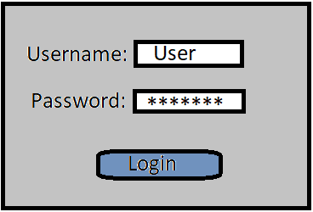

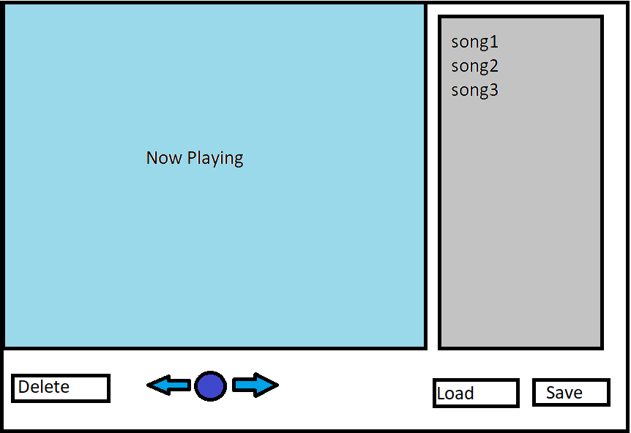

1. What source control are you using?

The Source control used for this project is GitHub. To use GitHub, create a private repository will be hosted on GitHub, all the members will be able to join. Based on their jobs, the work will be divided, and each can work on their own branch. When finished with their branches, it is tested and reviewed before merging it together into the master branch.

1. What are your coding standards you are enforcing?

In this project, the naming standards is camel case. In this standard, the first letter of the word always in small letter and after that each word starts with a capital letter.

Commenting conventions:

//30010080

//Aashiyandeep Singh

//to store temp song information

//to store song information

//first letter of title for sorting

//playing music through list

//sorting method

//mergesort from searchandsort class

//this method encrypt password

//this method encrypt password

//Hash data

1. What tests are you going to run?

For this project, we will be testing the new functionality of our application and how it well performs to the general user. To achieve this, the testing methods employed will be the system testing. A form of black box testing where the tester will go through the application as a whole and test the various functionalities presented in the application. The tester does not know the implementation, to simulate an end user trying the application for the first time. For this project, a test table will be used to record the actual result of each test case.