# UML

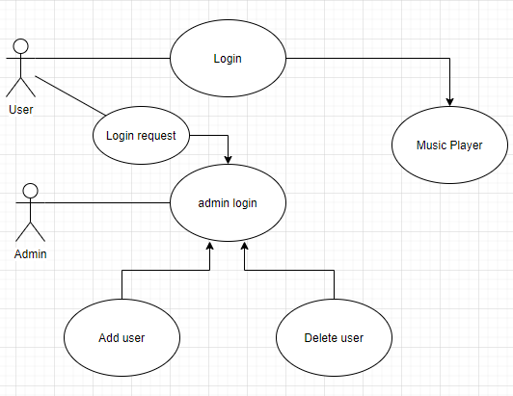

# Test Tables

## Login-in Page

|  |  |  |  |
| --- | --- | --- | --- |
| Subject | Expected | Actual | Reference |
| Ran the program | Login page appears | Meets expectation | TestEvidence/1.1 |
| Login as admin with correct credentials | Opens the admin page | Meets expectation | TestEvidence/1.2 |
| Login without entering any data | Gives error message | Meets expectation | TestEvidence/1.3 |
| Login with wrong credentials | Gives error message | Meets expectation | TestEvidence/1.4 |
| Login as user with correct credentials | Opens the music player. | Meets expectation | TestEvidence/1.5 |

## Music player Page

|  |  |  |  |
| --- | --- | --- | --- |
| Subject | Expected | Actual | Reference |
| Clicked load songs | Opens the file selector | Meets expectation | TestEvidence/2.1 |
| Selected a song and pressed play | Plays the song | Meets expectation | TestEvidence/2.2 |
| Pressed next song button | Plays the next song in queue | Meets expectation | TestEvidence/2.3 |
| Pressed previous song button | Plays the previous song in the playlist | Meets expectation | TestEvidence/2.4 |
| Pressed stop button | Stops the playing song | Meets expectation | TestEvidence/2.5 |
| Pressed the delete button | Deletes the selected song from the list | Meets expectation | TestEvidence/2.6 |
| Searched for a song | Shows the songs with that name | Meets expectation | TestEvidence/2.7 |
| Pressed the sort button | Sorts the list depending on the button you clicked | Meets expectation | TestEvidence/2.8 |
| Pressed the save button | Saves the list to a csv file | Meets expectation | TestEvidence/2.9 |
| Pressed the load playlist button | Loads the saved playlist | Meets expectation | TestEvidence/2.10 |
| Pressed Logged button | Saves the songs and Logs out of user account | Meets expectation | TestEvidence/2.11 |

## Admin Page

|  |  |  |  |
| --- | --- | --- | --- |
| Subject | Expected | Actual | Reference |
| Added user | Adds the user and displays tit in list | Meets expectation | Test Evidence/3.1 |
| Clicked logout | Logs out | Meets expectation |  |