Music Player
Product Design Specification
Version 1.0
15/06/20

VERSION HISTORY

Version  # | Implemented  By | Revision  Date | Approved  By | Approval  Date | Reason
1.0 | Aashiyandeep Singh | 15/06/20 |  |  | Initial Design Definition draft

TABLE OF CONTENTS
1 Introduction 4
1.1 Purpose of The Product Design Specification Document 4
2 General Overview and Design Guidelines/Approach 4
2.1 Assumptions / Constraints / Standards 4
3 Architecture Design 4
3.1 Hardware Architecture 4
3.2 Software Architecture 4
3.3 Security Architecture 5
3.4 Performance 5
4 System Design 5
4.1 Use-Cases 5
4.2 User Interface Design 5
5 Product Design Specification Approval 6

Introduction

Purpose of The Product Design Specification Document
The Product Design Specification document documents and tracks the necessary information required to effectively define architecture and system design in order to give the development team guidance on architecture of the system to be developed. The Product Design Specification document is created during the Planning Phase of the project. Its intended audience is the project manager, project team, and development team. Some portions of this document such as the user interface (UI) may on occasion be shared with the client/user, and other stakeholder whose input/approval into the UI is needed.

General Overview and Design Guidelines/Approach
This section describes the principles and strategies to be used as guidelines when designing and implementing the system.

Assumptions / Constraints / Standards
To design the Music Player, we will be using Java NetBeans to provide the client with the expected GUI requirements. It will have a sign in feature that the users will need to log into the music player. The project will be using merge sort for sorting songs, binary search to search the songs, csvhelper as a third-party library to store the passwords etc.

Architecture Design
This section outlines the system and hardware architecture design of the system that is being built.
The Music Player, we will be using Java NetBeans to provide the client with the expected GUI requirements. It will have a sign in feature that the users will need to log into the music player. The project will be using merge sort for sorting songs, binary search to search the songs, csvhelper as a third-party library to store the passwords etc.

Hardware Architecture
For the hardware, the software will be created on an i7- 3770K 3.50GHz, 16gb DDR3 Ram with GTX 1070 and on windows.

Software Architecture
For the software part, we will be using NetBeans to provide the client with the expected GUI requirements. It will have a sign in feature that the users will need to log into the music player. It will also have an admin login to see all the users and options to remove or add any users. The passwords will be protected with a hashing technique.

Security Architecture
For the security part, there will be a login feature to access the music player itself. You must have a valid username and password to access the music player. To create an account, you must contact admin and he will create you a login. The admin can remove or add new users but the user passwords that will be created, will be hidden by a hashing technique.

Performance
After the software is complete, we will be testing the software’s performance on system with i7- 3770K 3.50GHz, 16gb DDR3 Ram with GTX 1070. Everything will be tested on how well they perform like how long it takes to search a song, song loading times and all the other components.

System Design

Use-Cases

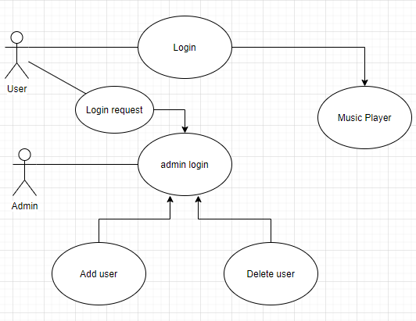

User Interface Design
The user interface design for this software will be familiar to most clients which will make it more user friendly. The users will be greeted with a login screen when they login and they can enter their username and passwords given to them by the admin. Once they have logged in, they will be able to access the music player and everything will be easy to navigate from playing the music to loading your playlist with just a click of a button.

Product Design Specification Approval
The undersigned acknowledge they have reviewed the Music Player Product Design Specification document and agree with the approach it presents. Any changes to this Requirements Definition will be coordinated with and approved by the undersigned or their designated representatives.

Signature: |  | Date:
Print Name:
Title:
Role:

Signature: |  | Date:
Print Name:
Title:
Role:

