# System Requirements Specification:

* Platforms: Created using Java Swing and AWT so the game is effectively platform independent, can be played on any post-2000s version of popular operating systems such as Windows, MacOS and Linux. Since AWT elements are used, performance and look may vary between different operating systems. However, because the installation method uses a .bat file, it is recommended that the user be on a Windows machine.
* Processor: Any modern processor from Intel or AMD is more than sufficient.
* Memory: The modern benchmark of 4GB RAM is the recommended minimum, but any older machine with over 1GB of RAM is enough.
* Graphics: Modern graphics cards, including those built-in are capable of handling the game. Any manufactured by AMD or Nvidia are preferred.
* Sound: Not required as the game does not contain any sounds.

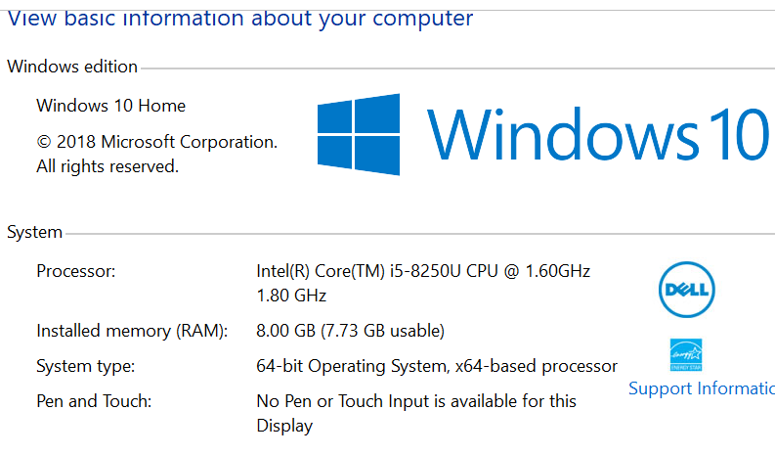  
-- This computer meets the system requirements.

# Installation Requirements:

* Disk Space Required: 1MB (Minimum) recommended
* File Size: 405KB
* Must have installed the JRE (Java Runtime Environment):  
  ( <https://www.java.com/en/download/> )
* Method of Installation: Executable JAR

# Security Concerns:

The main security concern is malicious software bundled in the installation, which could be used for the purposes of extracting user’s personal details, altering or damaging personal files and other malware functionality.

In terms of preventing bundling of malicious software, the user must make sure to download the program from a reputable source, in this case, on GitHub, which has strict policies against its users uploading malware for the purposes of inflicting malicious software on to unsuspecting targets. It is also assumed the user is competent enough to have installed software to scan and protect against malicious software on their own machine.

As for the program itself, since it has no networking capability, and is meant to be played by the user on his local machine, there is no security risk involving the user manually entering personal information into the program even if it had phishing functionalities built in.

In conclusion, while the program itself has not been built with security in mind, given the method of distribution and the basic nature of the game, it should not be considered a security risk to download and play.

# Installation Plan:

* Pre-requisites:  
  - Jave Runtime Environment installed:  
  ( <https://www.java.com/en/download/> )

1. To download, go to: <https://github.com/hboiled/tetrisSD> and click “Clone or download” then navigate to “Download ZIP”:  
   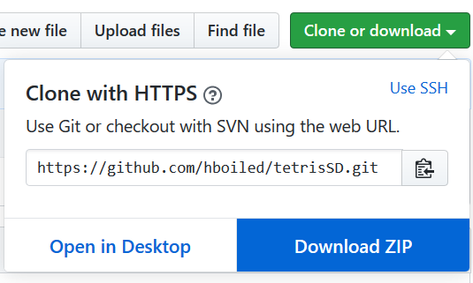
2. Extract the file to your desired location:  
   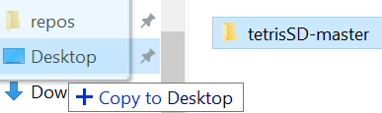
3. Navigate to the following directory:  
   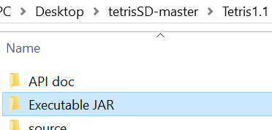
4. Double-click on the batch file “Run this to create an executable JAR” and it will create an executable JAR file of the game in the same directory as so:  
   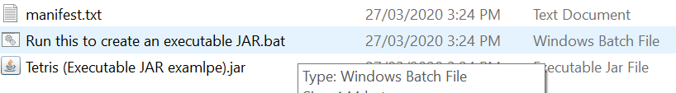
5. The game can now be played by double-clicking the JAR file.  
   