A PROJECT REPORT

on

“COMPARISION OF DEEP LEARNING MODELS FOR STOCK PRICE PREDICTIONS”

Submitted to

KIIT Deemed to be University

In Partial Fulfillment of the Requirement for the Award of

BACHELOR’S DEGREE IN

COMPUTER SCIENCE ENGINEERING

BY

AASHMIT SHRESTHA
AAYUSH RATNA STHAPIT
BISHAL PANDEY
NARESH KHATIWADA

20051712
20051713
20051723
20051737

UNDER THE GUIDANCE OF

Mr. Ajay Anand



SCHOOL OF COMPUTER ENGINEERING

KALINGA INSTITUTE OF INDUSTRIAL TECHNOLOGY

BHUBANESWAR, ODISHA - 751024

May 2023

A PROJECT REPORT

on

“COMPARISION OF DEEP LEARNING MODELS FOR STOCK PRICE PREDICTIONS”

Submitted to

KIIT Deemed to be University

In Partial Fulfillment of the Requirement for the Award of

BACHELOR’S DEGREE IN
COMPUTER SCIENCE ENGINEERING

BY

AASHMIT SHRESTHA
AAYUSH RATNA STHAPIT
BISHAL PANDEY
NARESH KHATIWADA

20051712
20051713
20051723
20051737

UNDER THE GUIDANCE OF

Mr. Ajay Anand

/

SCHOOL OF COMPUTER ENGINEERING

KALINGA INSTITUTE OF INDUSTRIAL TECHNOLOGY

BHUBANESWAR, ODISHA -751024

May 2023

KIIT Deemed to be University

School of Computer Engineering
Bhubaneswar, ODISHA 751024

CERTIFICATE

This is certify that the project entitled

“COMPARISION OF DEEP LEARNING MODELS FOR STOCK PRICE PREDICTIONS”

submitted by

AASHMIT SHRESTHA
AAYUSH RATNA STHAPIT
BISHAL PANDEY
NARESH KHATIWADA

20051712
20051713
20051723
20051737

is a record of bonafide work carried out by them, in the partial fulfillment of the requirement for the award of Degree of Bachelor of Engineering (Computer Science & Engineering ) at KIIT Deemed to be university, Bhubaneswar. This work is done during year 2022-2023, under our guidance.

Date: / /

(Ajay Anand)
Project Guide

Acknowledgments

We are profoundly grateful to AJAY ANAND sir of the School of Computer Science Department for his expert guidance and continuous encouragement throughout to see that this project rights its target since its commencement to its completion.

We would like to express our sincere gratitude to all the individuals who have contributed to the successful completion of this minor project.

Lastly, we would like to thank our families and friends who have been a constant source of motivation and encouragement throughout our academic journey.

AASHMIT SHRESTHA
AAYUSH RATNA STHAPIT
BISHAL PANDEY
NARESH KHATIWADA

ABSTRACT

Owing to its volatility and its dependence on numerous factors predicting the future course of the stock market is difficult. Forecasts are frequently made using technical indicators and historical data to address this issue. A few examples of Deep Learning RNNs that may be utilized to take advantage of various properties to improve the prediction accuracy include LSTM and GRU.

This project aims to compare the prediction accuracy proposed the deep learning models for stock prices .Historical data as well as technical indicators such as the Moving Average make the input data. The framework proposed in this study uses GRU to identify long-term trends and make predictions.

Keywords: LSTM, GRU, Technical Indicators, Stock Prediction, RNN

Contents

1 | Introduction |  | 1
2 | Basic Concepts |  | 2
 | 2.1 | Deep Learning | 2
 | 2.2 | Recurrent Neural Networks (RNN) | 3
 | 2.3 | Long Short Term Memory(LSTM) | 3
 | 2.4 | Gated Recurrent Unit (GRU) | 3
3 | Problem Statement |  | 6
 | 3.1 | Software Requirement Specification | 7
 | 3.2 | Project Planning
 | 3.3 | System Architecture
4 | Implementation |  | 4
 | 4.1 | Methodology | 4
 | 4.2 | Testing | 4
 | 4.3 | Result Analysis | 4
 | 4.4 | Quality Assurance | 4
5 | Standard Adopted |  | 5
 | 5.1 | Design Standards . . . . . . . . . . . . . . . | 5
 | 5.2 | Coding Standards . . . . . . . . . . . . . . | 5
 | 5.3 | Testing Standards . . . . . . . . . . . . . . . | 5
6 | Conclusion and Future Scope |  | 6
 | 6.1 | Conclusion ……………………….. | 6
 | 6.2 | Future Scope ………………………. | 6
References |  |  | 7
Individual Contribution |  |  | 8
Plagiarism Report |  |  | 9

List of Figures

- LSTM Architecture 4
- GRU Architecture 5
COMPARISION OF DEEP LEARNING MODELS FOR STOCK PRICE PREDICTIONS

Chapter 1

Introduction

The dataset used in this study is the historical stock price data of a selected company, including features like closing price,high price,opening price, low price and volumes. The dataset was preprocessed by normalizing the values and splitting them into testing and training sets.
The training set was used to train the LSTM and GRU models, while the testing set was used to evaluate them. These models are categories of Recurrent Neural Networks (RNN). They posses the ability to capture long-term dependencies in sequential data. The LSTM model has memory units that can retain significant information for a longer period of time. The GRU model has lesser parameters in comparison to the LSTM model, making it faster to train and execute.

School of Computer Engineering, KIIT, BBSR 1

COMPARISION OF DEEP LEARNING MODELS FOR STOCK PRICE PREDICTIONS

Chapter 2

Basic Concepts

2.1 Deep Learning

Deep Learning is a subfield of machine learning that uses neural networks with multiple layers to learn complex representations of data. The term "deep" refers to the multiple layers that make up these neural networks, which allow them to model hierarchical relationships between different features of the data.

Deep learning has shown remarkable success in a wide range of applications, including computer vision, natural language processing, speech recognition, and game playing, among others. One of the main advantages of deep learning is its ability to automatically learn features from raw data, without the need for manual feature engineering.

Deep learning models can be trained using a variety of optimization techniques, such as stochastic gradient descent (SGD), which iteratively adjusts the weights of the network to minimize a loss function. Additionally, deep learning architectures can be customized for specific tasks and data types, with different layers and activation functions used to achieve optimal performance. The availability of large amounts of labeled data and powerful hardware, such as graphics processing units (GPUs), has contributed to the rapid progress and widespread adoption of deep learning in recent years.

2.2 Recurrent Neural Networks (RNN)

Recurrent Neural Networks (RNNs) are a type of neural network designed for sequential data processing, where the output of each step is fed back into the network as input for the next step.

School of Computer Engineering, KIIT, BBSR 2

COMPARISION OF DEEP LEARNING MODELS FOR STOCK PRICE PREDICTIONS

This feedback loop allows RNNs to maintain an internal memory or state that can be used to process sequential data, such as time series data, natural language text, or audio signals.

In an RNN, the input at each time step is processed by a set of interconnected neurons, which also receive input from the previous time step's output. This allows the network to capture temporal dependencies between the input data, as well as to learn patterns and relationships that extend across time.

One of the key features of RNNs is their ability to handle input sequences of variable length, as the network can be unrolled for as many time steps as needed to process the entire sequence. RNNs can be trained using various learning algorithms, such as backpropagation through time (BPTT), which adjusts the network's weights based on the errors in the predicted output compared to the desired output.

Recurrent Neural Networks (RNNs) are a type of deep learning. RNNs are neural networks with multiple layers that are designed to handle sequential data, such as time series data or natural language text. The multiple layers in RNNs allow them to learn hierarchical representations of the sequential data, and the feedback loops in the network allow them to maintain an internal memory of past inputs, making them particularly useful for processing sequences of variable length.

As RNNs have multiple layers and can learn complex representations of sequential data, they are considered a type of deep learning. In fact, many recent advances in natural language processing and speech recognition have been driven by the development of deep RNN architectures such as Long Short-Term Memory (LSTM) and Gated Recurrent Unit (GRU) networks, which can handle long-term dependencies in sequential data.

2.3 Long Short Term Memory (LSTM)

For time series prediction applications, the LSTM (Long Short-Term Memory) Recurrent Neural Network architecture is frequently used. Being able to choose recall or ignore previous information, this style of architecture is very successful when processing time-series data with long-term dependencies. A series of past prices and other pertinent variables, such as trade volume, market indices, and sentiment towards the news, are commonly represented as the input data in a stock price prediction model using LSTM. Following this series of inputs processing, the LSTM model produces an output that reflects the forecasted stock price at a specific timestep.
The LSTM architecture consists of three main components:

School of Computer Engineering, KIIT, BBSR 3

COMPARISION OF DEEP LEARNING MODELS FOR STOCK PRICE PREDICTIONS

- Forget gate: In an LSTM neural network cell, the first step is to determine whether we should retain or discard information from the previous time step.
The forget gate equation is as follows:
ft =σ (Wxf ∗ Xt +Whf ∗ht−1 +Wcf ∗ct−1 + b_{f})
(1)
- Input gate: The input gate measures the weight of any fresh information that is being brought in.
This is the input gate equation:
ιt=σ (Wxi ∗ Xt +Whi ∗ht−1 +Wci∗ct−1 + b_{i})
(2)
- Output gate: These gates regulate information flow through the network and decide whether to recall or forget previous information. LSTM also has a memory cell that stores information over time, enabling the network to capture long-term dependencies in data. The output gate equation is as follows:
Οt =σ (Wx_{Ο} ∗ Xt +Wh_{O} ∗ht−1 +Wc_{O}∗ct + b_{O})
(3)
The hidden state is calculated using the following equation:
ht = ot tanh(ct)
(4)
Utilising the forget gate's f_{t} activation, the cell state is multiplied. The updated cell is multiplied by o_{t} after being processed by the tan h function.
ct = ftct−1 + it tanh (WxcXt +Whcht−1 + bc)
(5)
An LSTM model is often optimised using a loss function that gauges the difference between the projected and real stock prices in order to train it to forecast stock prices. The model can be trained using a variety of techniques, including back-propagation through time (BPTT) and gradient descent optimization.
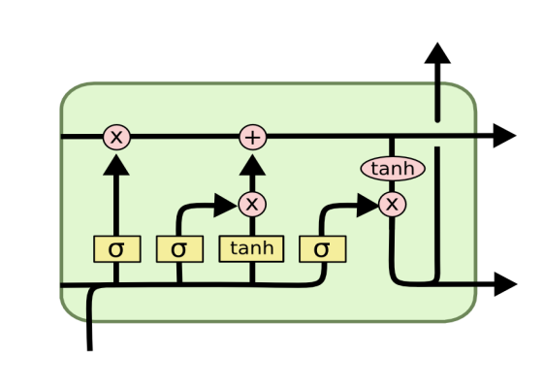
Figure 1: LSTM Architecture

School of Computer Engineering, KIIT, BBSR 4

COMPARISION OF DEEP LEARNING MODELS FOR STOCK PRICE PREDICTIONS

2.3 Gated Recurrent Unit (GRU)

Similar to an LSTM is a Recurrent Neural Network (RNN) architecture called a Gated Recurrent Unit (GRU). The GRU was introduced as a compressed version of the LSTM that can identify long-term associations in time-series data and is computationally less expensive and easier to train.
GRU features gating mechanisms that control the information flow through the network similarly to LSTM, allowing them to select whether data from previous time steps to keep or reject. The GRU, however, has fewer gating mechanisms than the LSTM, having just two gates.
- Gate update:How much of the previous data should be kept and forwarded to subsequent stages is decided by the update gate. Calculating the time step's z_{t} requires:
z_{t=} σ(W^{(z)}x_{t}+U^{(z)}h_{t-1})
(9)
ii) Reset gate: The amount of previous information to be forgotten is decided by the reset gate.
r_{t=} σ(W^{(r)}x_{t}+U^{(r)}h_{t-1})
(9)
The reset gate is used to compute the memory content, which stores pertinent data from earlier phases.
h́́_{t} =tanh(Wx_{t}+r_{t}+‌⊙ Uh_{t-1})
(10)
The network uses the update gate to decide which data to collect from the previous phase h́́_{t-1} in order to generate the h́́_{t} vector for the current unit and which data to gather from the current memory contents.
h_{t} =z_{t}‌⊙ h_{t-1}+(1-z_{t})‌⊙ h́́_{t}

(11)
The framework for Gated Recurrent Unit (GRU) is given in figure 4:

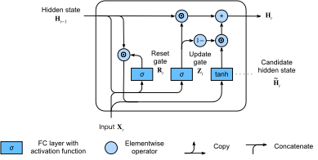
Figure 2: Gated Recurrent Unit(GRU) Architecture

School of Computer Engineering, KIIT, BBSR 5

COMPARISION OF DEEP LEARNING MODELS FOR STOCK PRICE PREDICTIONS

Chapter 3

Problem Statement :

Predicting stock prices is an essential component of financial decision-making for traders, investors, and companies. With the development of big data and machine learning technology, Deep Learning Models have become a viable option for more accurate and reliable stock price predictions.

Deep Learning models are used to anticipate stock prices with the primary goal of analysing vast amounts of historical data to find patterns and trends that can be used to forecast future stock values. Deep Learning Models make forecasts by using sophisticated algorithms to examine a variety of data sources, such as stock prices, trade volumes, news, social media sentiments, and other market indicators.
The Long Short-Term Memory (LSTM) network is a sort of recurrent neural network (RNN) that can analyse and predict sequences of data, making it well-suited for analysing time-series data, such as stock prices. It is one of the most often used Deep Learning Models for stock price prediction. Like the LSTM network, the GRU can process and predict sequences of data, which makes it well-suited for analyzing time-series data such as stock prices. The GRU network uses a gating mechanism to selectively update and forget information in the hidden state.
The Deep Learning Model must be trained on vast amounts of historical data in order to recognise patterns and trends in the market in order to produce an accurate and trustworthy stock price prediction model. In order for the model to remain accurate and be able to adjust to market changes, it should also be periodically updated with fresh data.
By giving traders and investors precise and trustworthy forecasts of future stock prices, stock price prediction using deep learning models ultimately aims to assist them in making wise investment decisions. This can aid them in minimising trading-related risks and maximising their return on investment.

School of Computer Engineering, KIIT, BBSR 6

COMPARISION OF DEEP LEARNING MODELS FOR STOCK PRICE PREDICTIONS

3.1 Software Requirement Specification (SRS):

Introduction:
The purpose of this Software Requirement Specification (SRS) document is to describe the requirements for a software system that predicts stock prices using deep learning models. The system will analyze historical data, such as stock prices, trading volumes, news, and social media sentiments to make future predictions on stock prices. This document will outline the functional and non-functional requirements of the system.

Functional Requirements:

- Data Collection: The system should be able to collect a large volume of historical data from various sources, including stock prices, trading volumes, news, and social media sentiments.
2) Data Preprocessing: The system should be able to preprocess the collected data to remove noise and inconsistencies.
3.)Deep Learning Model: The system should use deep learning models,Long Short-Term Memory (LSTM) and Gated Recurrent Unit (GRU), to analyze the preprocessed data and make predictions on future stock prices.
4)Training the Model: The system should be able to train the deep learning model using the preprocessed historical data.
5)Prediction: The system should be able to use the trained model to predict future stock prices based on the input data.
6) Data Visualization: The system should be able to properly visualize the produced data.
7)User Interface: The system should have a user-friendly interface that allows users to input data and view predictions.

Non-Functional Requirements:

- Performance: The system should be able to process large volumes of data and make accurate predictions in a timely manner.

2)Security: The system should be secure and protect the privacy of users' data.
3)Reliability: The system should be reliable and provide accurate predictions consistently.
4)Scalability: The system should be able to handle an increasing volume of data as the user base grows.
5)Compatibility: The system should be compatible with various operating systems and web browsers.

School of Computer Engineering, KIIT, BBSR 7
COMPARISION OF DEEP LEARNING MODELS FOR STOCK PRICE PREDICTIONS

Assumptions and Constraints:
- The accuracy of the stock price prediction depends on the quality of the input data and the performance of the deep learning model.
- The system will only be as accurate as the quality of the data being used for predictions.
- The system will not provide investment advice or recommendations.

Conclusion:

This Software Requirement Specification document has described the functional and non-functional requirements of a software system that predicts stock prices using deep learning models. The system should be able to collect, preprocess, and analyze large volumes of historical data to make accurate predictions on future stock prices. The system should also have a user-friendly interface and be secure, reliable, and scalable. The accuracy of the stock price prediction depends on the quality of the input data and the performance of the deep learning model.

3.2 System Architecture:

The following diagram shows the framework for our given model:
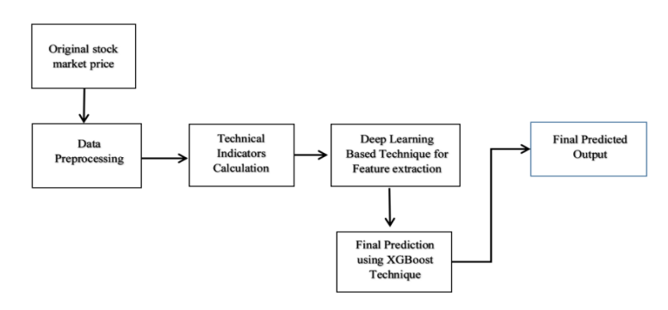

The original data is imported from the Yahoo finance website and the data is preprocessed.
Yahoo Finance was used to gather Apple stock data for 10 years, or from January 2013 to January 1, 2023. The Close, High, Low, and Opening Prices are included in the statistics. Before further training, these data were preprocessed and scaled between 0 and 1. The deep learning techniques were used to perform Day Ahead Prediction.

School of Computer Engineering, KIIT, BBSR 8
COMPARISION OF DEEP LEARNING MODELS FOR STOCK PRICE PREDICTIONS

Chapter 4

Implementation :

The experiment was performed with an Intel Core i7 (1.30 GHz) processor and 16GB RAM. The proposed model was built in Python on the Visual Studio Code IDE using TensorFlow. The required graphs were plotted using the matplotlib library. A Moving Average Technical Indicator was considered for this study. Figure 5 shows the original closing price for apples over 10 years, and Figure 6 shows the relationship between the Moving Average of closing prices over 200 and 100 days with respect to the closing price.

4.1 Methodology:

As mentioned previously ,LSTM and GRU algorithms are used. The models were created using Keras supported by Tensorflow.
The data visualization was done using using Matplotlib library and for developing the web application , the streamlit library was used.

- Keras
Keras is a deep learning API written in Python, running on top of the machine learning platform TensorFlow. It was developed with a focus on enabling fast experimentation and providing a delightful developer experience.
Keras is the high-level API of TensorFlow 2: an approachable, highly-productive interface for solving machine learning problems, with a focus on modern deep learning. It provides essential abstractions and building blocks for developing and shipping machine learning solutions with high iteration velocity.

The purpose of Keras is to give an unfair advantage to any developer looking to ship ML-powered apps.

- Matplotlib:
Matplotlib is an amazing visualization library in Python for 2D plots of arrays. Matplotlib is a multi-platform data visualization library built on NumPy arrays and designed to work with the broader SciPy stack. It was introduced by John Hunter in the year 2002. One of the greatest benefits of visualization is that it allows us visual access to huge amounts of data in easily digestible visuals. Matplotlib consists of several plots like line, bar, scatter, histogram etc.

School of Computer Engineering, KIIT, BBSR 9

COMPARISION OF DEEP LEARNING MODELS FOR STOCK PRICE PREDICTIONS

- Streamlit:
Streamlit is a free and open-source framework to rapidly build and share beautiful machine learning and data science web apps. It is a Python-based library specifically designed for machine learning engineers.Streamlit lets you turn data scripts into shareable web apps in minutes, not weeks.

- LSTM model:
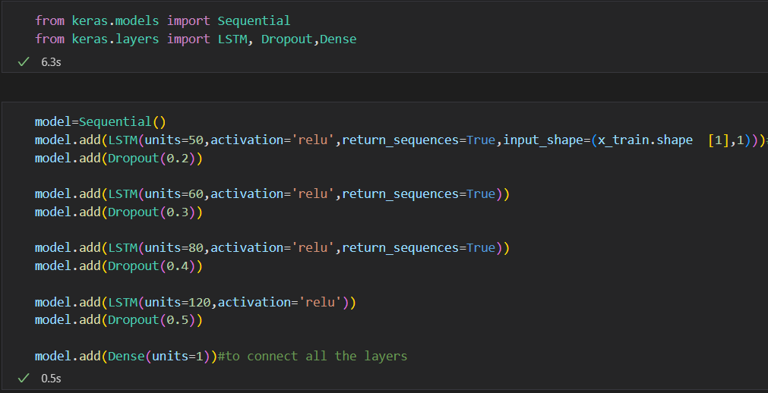
Code snippet for the creation of the LSTM model.
Our LSTM model has 4 preceding layers, with 0.2,0.3,0.4 and 0.5 dropout;50,60,80 and 120 nodes respectively,with a rectified linear unit (ReLU) as an activation function and a Dense layer.
- The trained model for the Dropout machine learning model is prone to over-fitting if the model's parameters are too numerous and the training samples are insufficient. Fitting is a common issue we run across while training neural networks. The following are signs of overfitting: On training data, the model's loss function is smaller, and prediction accuracy is higher; however, on test data, the loss function is comparatively larger, and prediction accuracy is lower.
- A rectified linear unit (ReLU) is an activation function that introduces the property of non-linearity to a deep learning model and solves the vanishing gradients issue. "It interprets the positive part of its argument.
- In any neural network, a dense layer is a layer that is deeply connected with its preceding layer which means the neurons of the layer are connected to every neuron of its preceding layer.

School of Computer Engineering, KIIT, BBSR 8

COMPARISION OF DEEP LEARNING MODELS FOR STOCK PRICE PREDICTIONS

Model summary:
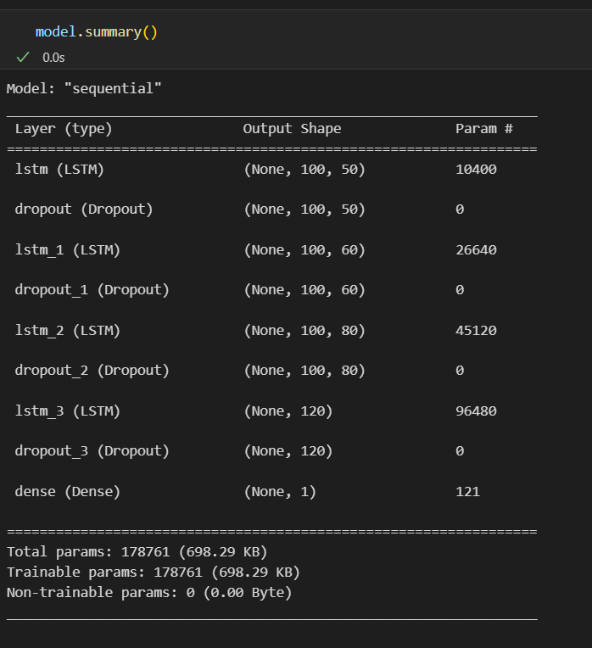
- GRU Model:
Code snippet for the creation of the GRU model:
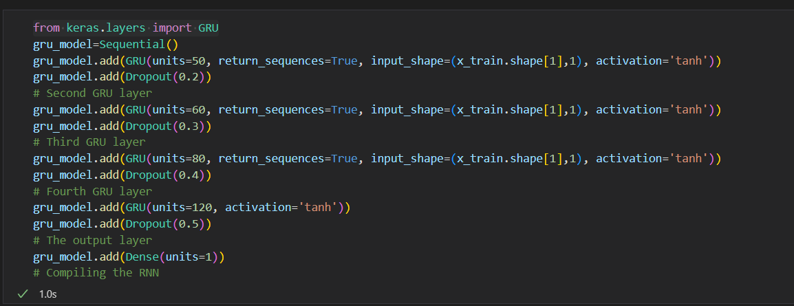
The dropout and the number of nodes is the same as that of the LSTM model with the only difference being the activation function. In this case we use the tanh activation function.
The tanh function produces a zero-centered output, thereby supporting the backpropagation process and is commonly used in recurrent neural networks.
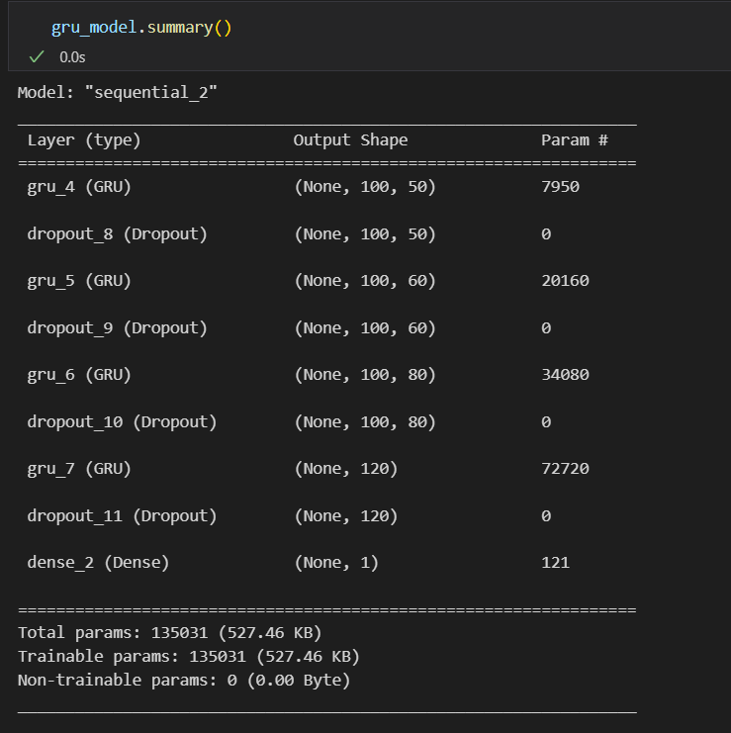

School of Computer Engineering, KIIT, BBSR 4
COMPARISION OF DEEP LEARNING MODELS FOR STOCK PRICE PREDICTIONS

4.2 Testing:

The proposed model was built in Python on the Visual Studio Code IDE using TensorFlow. The required graphs were plotted using the matplotlib library.
A Moving Average Technical Indicator was considered for this project. Figure 5 shows the original closing price for apples over 10 years, and Figure 6 shows the relationship between the Moving Average of closing prices over 200 and 100 days with respect to the closing price.

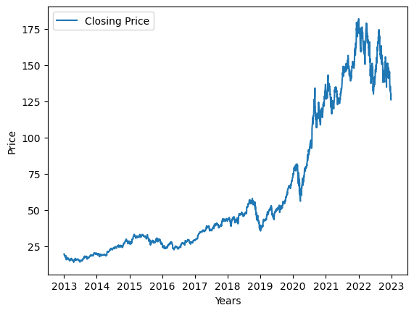
Figure 5: Closing Price of Apple (2013-2023)
The graph is non linear and has several highs and lows and thus requires a good technique for prediction.
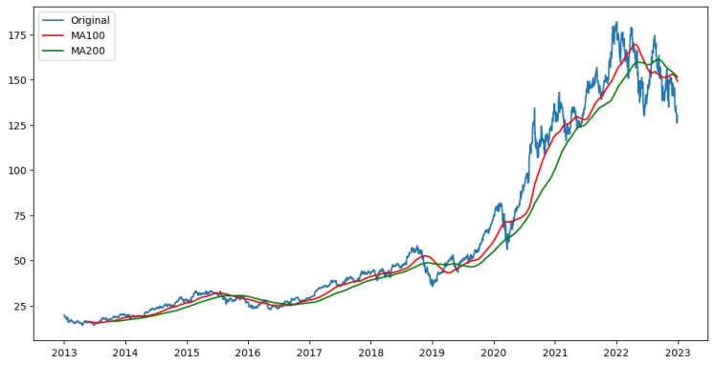
Figure:Moving Average(100 days) and Moving Average (200 days) with respect to the Original closing price.
The moving average for 100 days moves closely with the closing price of the stock, and was hence considered for this Project.

School of Computer Engineering, KIIT, BBSR 4

COMPARISION OF DEEP LEARNING MODELS FOR STOCK PRICE PREDICTIONS

The dataset was split into training and testing set. 70% of the data was used for training and 30% was used for validation/testing.
The final 100 days data was used to compare the predicted results with the actual results.

4.3 Result Analysis:

School of Computer Engineering, KIIT, BBSR 4

SAMPLE INDIVIDUAL CONTRIBUTION REPORT:

<TITLE OF THE PROJECT IN FONT SIZE 14, FONT STYLE TIMES NEW ROMAN, BOLD AND CENTERED>

<Student Name (in capital letters in font size 12, Times New Roman and centered>
<Student Roll number (font size 12, Times New Roman and centered>

Abstract: A short description of the aim and objective of the project work carried out in 3-4 lines. This part should be common to all students in the group. The font size and style will remain same from this point onwards. The font size will be 12 and font style will be Times New Roman. The line spacing will be 1.5.
This report should be prepared in A4 page format with ‘default’ option under ‘Margin’ of the ‘Page Layout’ tab in Microsoft Word. Word limit for this section is 80.

Individual contribution and findings: The student should clearly indicate his/her role in the project group and the contribution in implementing the project work. The student should also outline his /her planning involved in implementing his/her part in the work. This contribution report should be different for every student in the group. The student would also write his./her technical findings and experience while implementing the corresponding part of the project. The overall contribution report should not be less than 1 page for each student. The Student should provide both the soft copy and signed hard copy to the project supervisor.

Individual contribution to project report preparation: Student should mention his/her role in preparing the group project report indicating which chapter and portions contributed.

Individual contribution for project presentation and demonstration: Student should mention his/her role in preparing presentations and part of the project demonstrated.

Full Signature of Supervisor: Full signature of the student:
……………………………. ……………………………..

School of Computer Engineering, KIIT, BBSR 8

TURNITIN PLAGIARISM REPORT
(This report is mandatory for all the projects and plagiarism
must be below 25%)

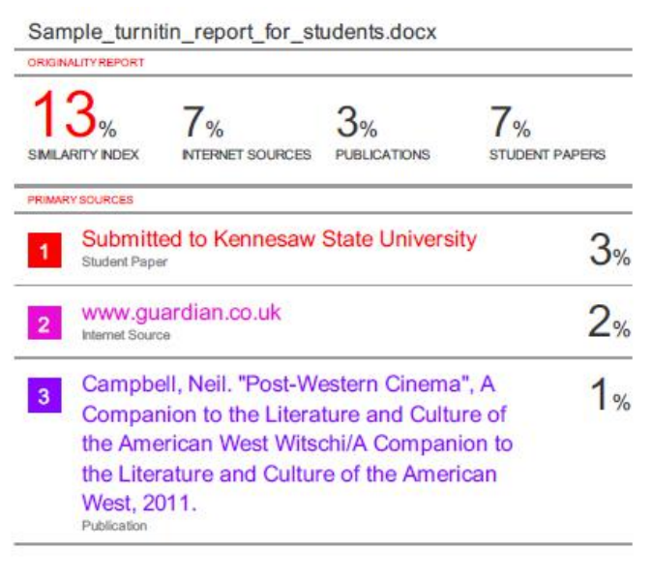

School of Computer Engineering, KIIT, BBSR 9

