Game Design Document

Fill up the Following document

1. Write the title of your project.
2. What is the goal of the game?

The goal of the game is to defeat all the enemies.

1. Write a brief story of your game?

The enemies have invaded the player’s homeland. The players must try to fight all the enemies to save their home from being destroyed.

1. Which are the playing characters of this game?

* Playing characters are the ones which respond to the user based on the input from the user
* Cars, monkeys, dinos, wizards etc, are the playing characters in the game.

|  |  |  |
| --- | --- | --- |
| Number | Character Name | What can this character do? |
| 1 | Player 1 | Jump, go right and left and also attack |
| 2 | Player 2 | Jump, go right and left and also attack |
| 3 |  |  |
| 4 |  |  |
| 5 |  |  |
| 6 |  |  |
| 7 |  |  |
| 8 |  |  |

1. Which are the Non Playing Characters of this game?

* Non Playing characters are the ones which don't have an action or a behaviour when the user interacts with the game.
* Hurdles, stones, bananas, coins, etc are non playing characters in the game.

|  |  |  |
| --- | --- | --- |
| Number | Character Name | What can this character do? |
| 1 | Ground | Moves across screen |
| 2 | Power-up | Allows the player to be invincible for a certain period of time |
| 3 | Clouds | Moves across the screen |
| 4 | Enemy | Attacks player |
| 5 | Hearts | When the player is hurt, they will lose one heart. |
| 6 |  |  |
| 7 |  |  |
| 8 |  |  |

Draw your imagination of this game. What does this game look like?

* Draw the game either on your computer or on paper,
* Add images of scenes of the game to show each of the playing and non-playing characters at least once.

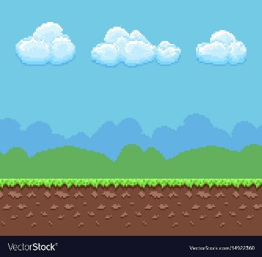

How do you plan to make your game engaging?

I plan to make my game engaging by making the enemies have more lives, making the player hit the enemies more and making it harder.