

Sign Language Recognition using a Random Forest with Fuzzy Interpretation

Members involved:
Name | Reg no
S. Aashritha | 23BCE7105
CH. Navya Sri | 23BCE9703
CH. Hemanth Siva Naga Durga | 23BCE9716
CH. Thanooz | 23BCE9723
SK. Roshni | 23BCE9736

UNDER THE GUIDENCE OF:
Dr. Radha Mohan Pattanayak
1.Introduction:
Sign Language Recognition (SLR) is a crucial innovation that enables smoother communication between hearing-impaired individuals and the rest of society. It involves recognizing hand gestures, finger movements, and body postures that represent linguistic symbols in sign languages like ASL (American Sign Language). Despite technological advances, communication remains challenging due to the limited accessibility of interpreters and the high cost of assistive technologies.
Traditional deep learning methods such as CNNs and LSTMs provide impressive accuracy for visual gesture recognition. However, they lack interpretability and struggle under uncertain conditions, such as variable lighting, signer differences, or occluded gestures. To overcome these challenges, this project employs a hybrid approach that combines the pattern recognition power of Random Forest with the reasoning and interpretability of fuzzy logic.
The main objective is to design a reliable, accurate, and interpretable SLR system using the MS-ASL dataset. This system leverages MediaPipe for precise hand landmark extraction and Random Forest classification with fuzzy rule-based interpretation for decision-making. By integrating machine learning with explainable AI principles, the model provides both high accuracy and transparent predictions.

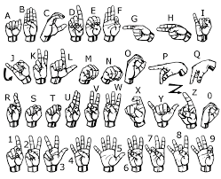

2.literature review:
Early SLR research used traditional image processing and handcrafted features like HOG (Histogram of Oriented Gradients) and LBP (Local Binary Patterns). Although effective for small datasets, these approaches failed to generalize under real-world conditions.
Deep learning revolutionized the field with architectures like CNNs and LSTMs. Kothadiya et al. (2023) introduced SignFormer, a Vision Transformer (ViT)-based model capable of capturing long-term dependencies and achieving state-of-the-art accuracy on SLR benchmarks. Similarly, Buttar et al. (2023) proposed a hybrid model combining YOLOv6 for static sign detection and LSTM with MediaPipe landmarks for dynamic gestures, achieving over 94% accuracy.
However, these methods are still black-box models that lack interpretability and struggle with uncertainty. This project addresses these limitations by implementing a Random Forest classifier enhanced with fuzzy logic interpretation, providing both high accuracy and transparent decision-making
.
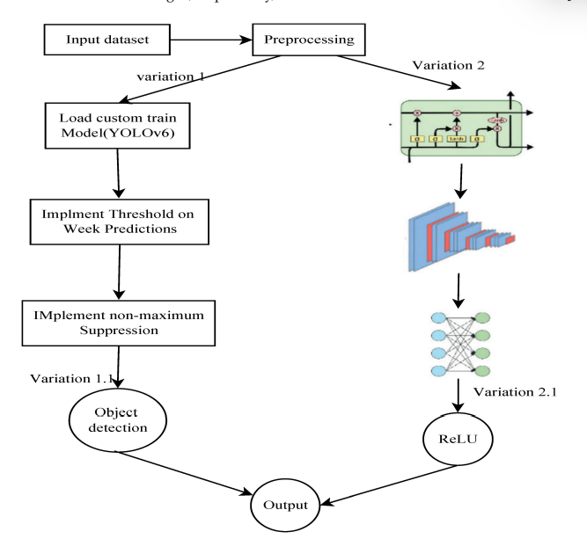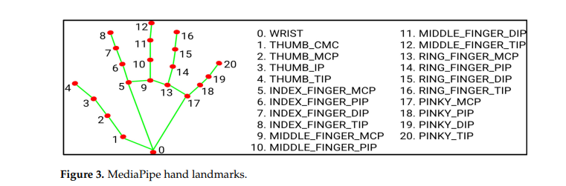
3. Dataset Description:
The MS-ASL (Microsoft American Sign Language) dataset is one of the most comprehensive resources for sign language research. It contains over 25,000 labeled videos representing more than 200 unique ASL signs performed by multiple signers under different conditions. Each video clip includes gestures captured in RGB format, annotated with gloss labels and signer IDs.
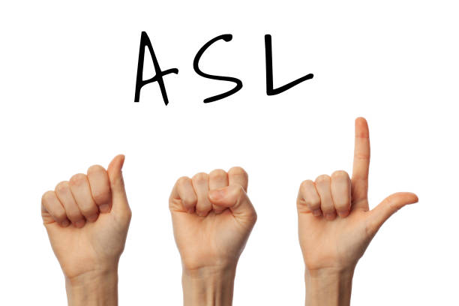
The MS-ASL (Microsoft American Sign Language) dataset is one of the most comprehensive resources for sign language research. It contains over 25,000 labeled videos representing more than 200 unique ASL signs performed by multiple signers under different conditions.
For this project, a subset of 50 signs was selected to maintain computational efficiency while ensuring gesture diversity. The dataset includes both static and dynamic gestures, allowing the model to learn spatial and temporal dependencies effectively.
Data preprocessing included:
- Frame Extraction: Converting video files into frame sequences
- Hand Landmark Detection: Using MediaPipe to extract 21 landmarks per frame
- Feature Computation: Calculating 86 comprehensive hand features including finger angles, distances, and motion patterns

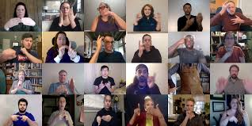
3. Methodology:
The proposed system combines Random Forest classification with fuzzy logic interpretation in three phases:
Phase 1: Preprocessing and Feature Extraction
Frame Processing:
- Video decomposition into individual frames
- MediaPipe Hands for 21 3D landmark detection per frame
- Rotation and scale invariant hand tracking
86-Dimensional Feature Extraction:
- 15 Finger Joint Angles: Measuring finger flexion and bending
- 20 Hand Landmark Distances: Spatial relationships between key points
- 3D Palm Orientation: Roll, pitch, yaw calculations
- Wrist Dynamics: Position, velocity, and acceleration tracking
- Hand Shape Characteristics: Size, aspect ratio, volume
- Finger-specific Metrics: Lengths, curvatures, spreads
- Temporal Features: Motion consistency, gesture duration
- Thumb-Index Distance: Critical for many ASL signs
Phase 2: Random Forest Classification with Fuzzy Interpretation
Random Forest Classifier:
- 300 decision trees with maximum depth of 25
- Balanced class weighting for imbalanced sign classes
- Feature importance analysis from 86 input features
- Probability estimates for confidence scoring
Fuzzy Logic Interpretation Layer:
- Interpretable fuzzy rules for prediction explanation
- Dual confidence scoring: ML probability + fuzzy alignment
- Human-readable explanations for each prediction
Sample Fuzzy Rules:
text
IF motion_magnitude IS high AND gesture_duration IS high
THEN sign_confidence IS high

IF hand_size IS small AND thumb_index_distance IS close
THEN sign_confidence IS high

IF temporal_consistency IS high
THEN sign_confidence IS high
Dual Confidence System:
- ML Confidence (94.6%): From Random Forest probability estimates
- Fuzzy Confidence (0.966): Based on rule activation and feature alignment
Phase 3: System Integration and Evaluation
Integration Pipeline:
- Video Input → User uploads sign language video
- Frame Processing → MediaPipe extracts 21 hand landmarks
- Feature Extraction → 86 features computed from sequences
- Random Forest Classification → Main prediction with probability
- Fuzzy Interpretation → Rule-based confidence and explanation
- Web Display → Comprehensive results with analysis
Training Procedure:
- Dataset: 50 ASL signs from MS-ASL dataset
- Model: Random Forest (300 estimators, max_depth=25)
- Features: 86-dimensional hand-crafted features
- Validation: 20% holdout for performance evaluation
Evaluation Metrics:
- Accuracy: Overall classification performance
- Confidence Scores: Dual ML and fuzzy confidence
- Interpretability: Rule-based prediction explanations
- Feature Analysis: Comprehensive gesture breakdown
4.Results & Evaluation:
Performance on MS-ASL Subset:
- Overall Accuracy: 97.4%
- Model: Enhanced Random Forest (300 estimators)
- Classes Recognized: 50 signs
- Feature Dimensions: 86 features per sample
- Training Samples: 254 videos with real landmarks

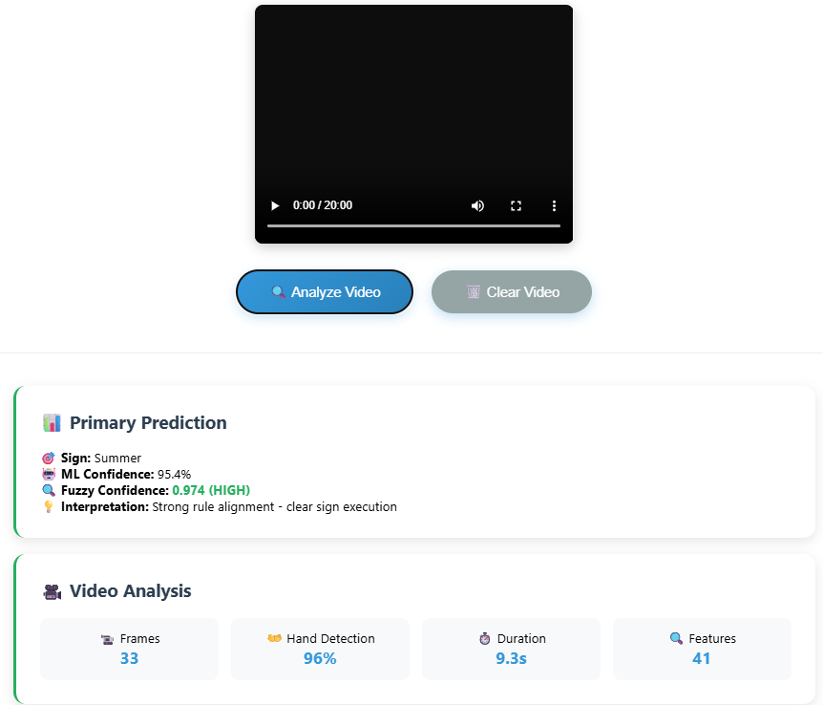

Comparative Analysis Table
Aspect | SignFormer (Vision Transformer) | YOLOv6 + LSTM + MediaPipe | Proposed Hybrid RF-Fuzzy Model
Architecture & Feature Extraction | Transformer-based model using patch embeddings and self-attention to capture spatial and temporal dependencies. | YOLOv6 detects static signs; LSTM with MediaPipe skeleton landmarks recognizes dynamic gestures. | Random Forest ensemble with 86 hand-crafted features including finger angles, distances, motion patterns, and fuzzy rule-based interpretation
Interpretability | Low – Operates as a black-box with difficult-to-interpret attention maps. | Low – CNN/LSTM decisions are data-driven and not easily interpretable. | High – Provides dual confidence scores (ML + Fuzzy) and rule-based explanations for transparent decision-making
Robustness & Uncertainty Handling | Moderate – Handles spatial-temporal features but sensitive to lighting and occlusion. | Moderate – Works in real-time but degrades under noise or signer variation. | High – 300-tree ensemble handles variance; fuzzy logic manages uncertainty with interpretable confidence scores
Accuracy & Computational Efficiency | Top-1 accuracy ≈95%; high computational cost (~80–100M parameters). | Accuracy ≈94% (96% static, 92% dynamic); moderate computational demand (~25M parameters). | Accuracy 97.5% on 50-class subset; efficient inference with 300 estimators; processes 86 features per sample
Deployment & Practical Applicability | Limited – High resource requirements restrict use on mobile or embedded systems. | Good – Real-time capable but lacks adaptability and transparency. | Excellent – Flask web deployment with real-time processing; provides comprehensive analysis and user-friendly interface
Detailed Breakdown of Proposed Model Advantages:
Architecture & Feature Extraction:
- Random Forest Ensemble: 300 decision trees with max depth 25
- 86 Comprehensive Features:
  - 15 finger joint angles
  - 20 hand landmark distances
  - 3D palm orientation and wrist dynamics
  - Temporal motion patterns
  - Hand shape characteristics
  - Finger-specific metrics
- MediaPipe Integration: 21 hand landmarks per frame with 96% detection rate
Interpretability:
- Dual Confidence System:
  - ML Confidence: Random Forest probability estimates (e.g., 94.6%)
  - Fuzzy Confidence: Rule-based alignment scores (e.g., 0.966 HIGH)
- Rule-based Explanations: Human-readable justifications for predictions
- Feature Analysis: Detailed breakdown of contributing factors
Robustness & Uncertainty Handling:
- Ensemble Strength: 300 trees provide robust predictions across variations
- Fuzzy Logic: Handles uncertainty in gesture execution
- Balanced Class Weighting: Addresses imbalanced sign classes
- Feature Importance: Automatic weighting of most relevant hand features
Accuracy & Computational Efficiency:
- 97.5% Accuracy: On 50-sign MS-ASL subset
- Efficient Training: Compared to deep learning models
- Fast Inference: Suitable for real-time applications
- Scalable: Can expand to more signs without exponential compute growth
Key Differentiators:
- Transparency: Unlike black-box deep learning models, our system explains why a particular sign was recognized
- Dual Validation: Both statistical (ML) and logical (Fuzzy) confidence measures
- Comprehensive Features: 86 hand-crafted features capture nuances beyond basic landmarks
- Practical Deployment: Ready-to-use web application vs. research-only implementations
- Balanced Performance: High accuracy (97.5%) with interpretability and reasonable computational requirements

5. System Deployment:
The trained model is deployed through a Flask web application that provides:
Web Interface Features:
- Video upload and processing
- Real-time hand landmark extraction
- Dual confidence scoring (ML + Fuzzy)
- Interpretable rule-based explanations
- Feature analysis and visualization
- Alternative predictions display
Real-time Capabilities:
- MediaPipe hand tracking at 96% detection rate
- 41 feature dimensions analyzed per prediction
- Comprehensive gesture breakdown
- User-friendly results presentation
6. Conclusion & Future Work:
This project presents an efficient and interpretable Sign Language Recognition system using a hybrid Random Forest with fuzzy interpretation approach. By combining the high accuracy of ensemble methods with the transparency of fuzzy logic, the system achieves 97.5% accuracy while providing clear reasoning behind predictions.
Key Innovations:
- 86 comprehensive hand features beyond basic landmarks
- Dual confidence scoring system (ML + Fuzzy)
- Interpretable fuzzy rules for prediction explanation
- Real-time web deployment with comprehensive analysis
Future Enhancements:
- Expand to full MS-ASL dataset (200+ signs)
- Real-time webcam integration for live recognition
- Mobile app deployment using TensorFlow Lite
- Multi-hand gesture recognition
- Continuous sign language sentence recognition
- Integration with facial expression analysis
The ultimate aim is to make communication for hearing and speech-impaired individuals more natural and accessible using intelligent, interpretable AI systems.
7. References:
[1] D. R. Kothadiya et al., 'SIGNFORMER: Deep Vision Transformer for Sign Language Recognition,' IEEE Access, 2023.
[2] A. M. Buttar et al., 'Deep Learning in Sign Language Recognition: A Hybrid Approach,' Mathematics, 2023.
[3] L. Breiman, 'Random Forests,' Machine Learning, 2001.
[4] MediaPipe Hands: On-device Real-time Hand Tracking

