DOCKING_ANALYSIS

- Title

PC(Phosphorylcholine) docked with human gene OLR1(Oxidised low density lipoprotein receptor 1).

- Materials & Methods

  - Selection of Protein and ligand

The structure of PC(Phosphorylcholine) was extracted from PubChem with CID 135437, and the structure of OLR1 gene was obtained from PDB database with PDB ID 1YPQ.

  - Preparation of Protein and ligand for docking

The preparation of final structure of PC for docking was done using Autodock tools/ MGL tools which was initiated with removing water molecules from the structure, addition of polar hydrogen bonds to the structure, and finally adding Kollman charges to the structure, making it completely ready for further studies. The structure was saved in PDBQT format.

  - Docking

Once the final structure is prepared, we take both the structures and generate a grid-box for docking to be done. After this we will be making a config file, where all the information about docking will be present. Like the name of protein and ligand structure file generated, dimensions of the grid-box where the docking will be done, size of the grid box, energy range between the models, and the exhaustiveness of docking. Then we added the prompt for docking in AutoDock Vina by adding the path where the docking results will be predicted and from where the structures file will be taken.

- Results & Discussions

The water molecules were removed from the structure to prevent the interference in the electroststic forces while docking, and the polar hydrogens were added for more precise structure for docking. The Kollman charges were selected to calculate electrostatic interactions, accurately predict binding affinities, and leads to more reliable and meaningful simulation results. The grid-box was generated with spacing 0.375, dimensions as 58 56 56 as X, Y, and Z-axis respectively, and the centre of the box has co-ordinates as 11.434 3.915 19.020 as X, Y, and Z-co-ordinates respectively in unit Å (Fig. 1). The config file has information about the file of protein and ligand structure, dimensions and size of the grid-box generated, energy range was 4 which is basically the default for difference between the best docked structure and the predicted model, then the exhaustiveness was selected as 8 which is basically how many time the exhaustive docking has to be done (Fig.2). The docking result predicted the best docked structure has the binding affinity of -4.2 kcal/mol with RMSD lower bound as 0.00 and RMSD upper bound as 0.00 Å from the rest (Fig.3). The RMSD should be <2Å for the best docked structure.

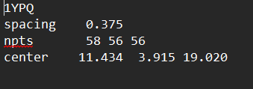

Fig.1

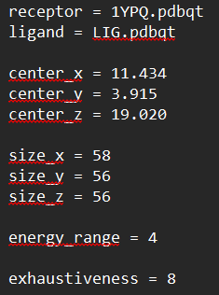

Fig.2

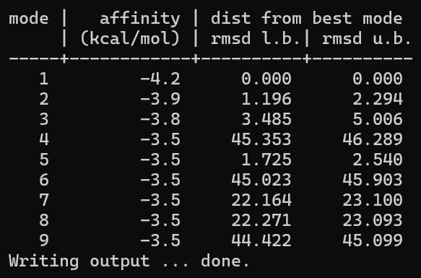

Fig.3

