AlgoSmiths
Technical Report
PRISM
A Persistent, Local Context Layer for AI Coding Agents
System architecture, test environment and measured token consumption on Claude Code, Codex and Antigravity, with a comparison against four other tools
Document reference | PRISM-TR-2026-01
Software | PRISM, package prism-ctx, version 0.1.0 (main branch)
Prepared by | AlgoSmiths
Date of issue | 12 October 2026
Period covered | 27 September to 11 October 2026
Status | Issued for review

Document Control
Table 1. Revision history
Version | Date | Author | Description
1.0 | 12 October 2026 | AlgoSmiths | First issue

This report describes the design of PRISM and records the methods and results of the measurements made to evaluate it. Quantities are reported as measured, together with the conditions under which they were obtained. Where a result is not statistically distinguishable from zero, it is stated as such. Statements about third-party tools describe only the versions and configurations listed in Section 3.1 and are not general assessments of those products.
The document should be read with the limitations in Section 6. In particular, the live agent measurements were carried out on a single repository with four tasks and by the authors of the software.

Contents
Abstract 6
1. Introduction 7
1.1 Background 7
1.2 Objectives 7
1.3 Scope 7
1.4 Structure of the report 7
2. System description 7
2.1 Design principles 7
2.2 Architecture overview 8
2.3 Indexing pipeline 9
2.4 Incremental update and freshness 9
2.5 Query processing 10
2.6 Delivery interfaces 10
2.7 Agent integrations 11
2.8 Consent and security 11
2.9 Implementation profile 11
3. Test environment and methodology 12
3.1 Test platform 12
3.2 Subjects and tasks 12
3.3 Experimental conditions 12
3.4 Measures and statistical treatment 13
3.5 Offline harness 13
4. Results 13
4.1 Offline orientation harness 13
4.2 Earlier edit benchmark 14
4.3 Latency 15
4.4 Token consumption on three agent platforms 15
4.5 Comparison with Graphify, TokenSave, RTK and AgentMemory 17
4.6 Local embedding comparison 19
5. Discussion 19
6. Limitations and validity 20
6.1 Limitations of the evidence 20
6.2 Defect identified during testing 20
6.3 Other operational observations 21
7. Conclusions and recommendations 21
7.1 Conclusions 21
7.2 Recommendations 21
References 21
Appendix A. Reproduction of the measurements 22
Appendix B. Abbreviations and terms 22
Appendix C. Data sources 22

List of Tables and Figures
Table 1. Revision history 2
Table 2. Design commitments 7
Figure 1. Overview of the PRISM system and its delivery interfaces 8
Table 3. Functional components 8
Figure 2. The ten-stage indexing pipeline 9
Table 4. Pipeline stages and outputs 9
Figure 3. Request flow with the prompt hook 10
Table 5. Delivery interfaces 10
Table 6. Files and hooks installed per agent 11
Table 7. Size and composition of the code base 11
Table 8. Hardware and software of the test platform 12
Table 9. Tasks used in the live campaigns 12
Table 10. Orientation tokens by subject 13
Figure 4. Tokens read to orient, with and without PRISM (logarithmic scale) 14
Figure 5. Mean tokens per task on the web application, by step 14
Table 11. Retrieval quality in the same runs 14
Figure 6. Median end-to-end time per operation, fresh process and prepared warm daemon 15
Figure 7. Change in total input tokens relative to no PRISM, by platform and condition, with 95% intervals 16
Table 12. Codex, gpt-6-luna, 100 sessions 16
Table 13. Claude Code, Claude Haiku 5.5, 60 sessions 17
Table 14. Antigravity, Gemini 3.8 Flash (medium), 60 sessions 17
Table 15. Tools compared and the configuration tested 17
Table 16. Comparison of seven conditions, Claude Code, Claude Haiku 5.5, 20 sessions each 18
Figure 8. Change in total input relative to no tool, with 95% intervals 18
Figure 9. Mean total input relative to no tool, by task 18
Figure 10. Tokens per solved task and number of sessions solved, by condition 19
Table 17. Limitations and their effect on the conclusions 20
Table 18. Commands for reproducing the measurements 22
Table 19. Abbreviations and terms 22

Abstract
AI coding agents spend a large share of each session locating the code that a request concerns, and repeat this work in every new session. PRISM is a local software component that indexes a repository by deterministic static analysis, keeps the index current as files change, and answers a request with a bounded packet containing the relevant code, exact string matches, callers, tests and an impact estimate. It does not invoke a language model, does not require an API key, and does not transmit data off the machine.
This report describes the architecture of PRISM and the test environment used to evaluate it, and presents measurements of token consumption. A scripted harness, which counts the tokens an agent would read, gave reductions of 92% on a 305-file web application and 73% on PRISM's own source, and an increase of 181% on a 12-file fixture. In live campaigns on one repository, in which agents solved four tasks verified by hidden tests, total input tokens fell by 50% on Codex, by 52% on Claude Code and by 79% on Antigravity under the best configuration of each. The Antigravity figure was obtained without the prompt hook being delivered and is not directly comparable with the others. In a separate comparison of seven setups on Claude Code, PRISM reduced total input by 33% to 35%, whereas three of the four other tools evaluated showed a higher total input than no tool, significantly so for two of them.
The measurements support a reduction in token use for multi-file changes on repositories of moderate size, provided the answer is delivered to the agent automatically. They do not establish the magnitude of the effect on other repositories, and they do not measure monetary cost.

1. Introduction

1.1 Background
A coding agent that begins a session without prior knowledge of a repository normally lists directories, searches for identifiers and opens complete files before it can make a change. When the change affects a function with many callers, it must also read those callers and the associated tests. Each additional tool call causes the accumulated conversation to be processed again by the model. The cost of this orientation is therefore paid in tokens, in elapsed time and, where usage is metered, in money, and it recurs in each session because the agent retains nothing between sessions.
PRISM addresses this by maintaining a persistent index of the repository next to the code. The agent's context window then holds a small working set retrieved on demand, instead of the results of an exploratory search. The governing principle of the design is that PRISM performs deterministic analysis and bookkeeping, while all reasoning remains with the coding agent already in use.

1.2 Objectives
The objectives of this report are: (a) to describe the architecture and implementation of PRISM; (b) to document the environment, procedure and statistics used to evaluate it; (c) to report the measured change in token consumption on three agent platforms; (d) to compare PRISM with Graphify, TokenSave, RTK and AgentMemory under a common procedure; and (e) to state the limits within which the results hold.

1.3 Scope
The evaluation is confined to token volume and task success on the repositories and tasks described in Section 3. Monetary cost, long-term effects over repeated sessions, and behaviour on repositories other than those listed were not measured. Latency was measured on one workstation running Windows.

1.4 Structure of the report
Section 2 describes the system. Section 3 describes the test environment and method. Section 4 presents the results. Sections 5 and 6 discuss the findings and the limits of their validity, and Section 7 gives conclusions and recommendations. Appendices list the commands needed to reproduce the measurements, abbreviations, and the data sources.

2. System description

2.1 Design principles
The design follows five commitments, summarised in Table 2. They are enforced in the project's contribution rules and, where practical, by automated tests.
Table 2. Design commitments
Principle | Description
Local operation | No network calls, API keys or telemetry. Optional semantic search uses a model stored on disk.
Determinism | Identical source yields identical .aicontext/ output: sorted JSON, PageRank with fixed summation order, and timestamps confined to the manifest.
Opt-in use | Installation changes nothing until a user runs prism init. Each user enables a repository individually, and use can be paused or disabled.
Agent independence | Output is plain JSON and Markdown, exposed through a command-line interface, an MCP server, hooks and skills, with integrations for six agents.
Non-interference | Hooks always exit with status zero, write nothing to the agent on error, and do nothing if PRISM is absent, disabled or paused.

2.2 Architecture overview
The system consists of an indexing core, a navigator that answers queries from the index, bookkeeping components for the project brief and audits, and several delivery interfaces (Figure 1). Source files are processed into the .aicontext/ directory. Queries are served from a read-only SQLite cache derived from those artifacts. The command-line interface, the MCP server and the viewer call the same library functions and contain no logic of their own.
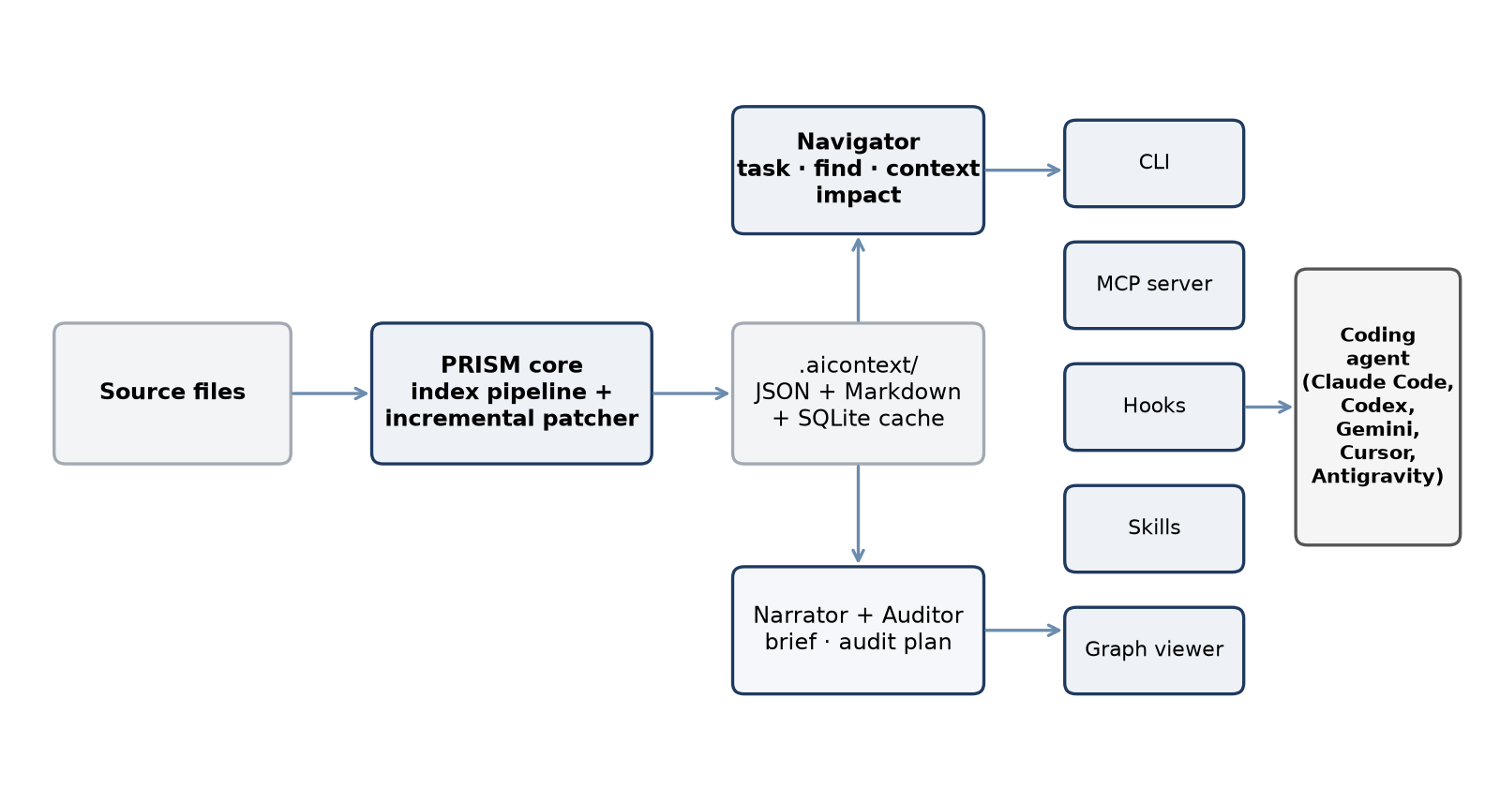
Figure 1. Overview of the PRISM system and its delivery interfaces
The five functional components are listed in Table 3.
Table 3. Functional components
Component | Function | Performed by
Index | Symbols, import and call graphs, PageRank importance, routes, models, configuration keys, test map, health indicators and git history | PRISM
Navigator | Budgeted context packs: location, callers, callees, tests, blast radius and a list of ranges to read | PRISM
Narrator | Project brief (AGENTS.md) and module summaries; facts supplied by PRISM, prose written by the agent | PRISM and agent
Auditor | Prioritised audit plan, finding store and reports that can be compared between audits | PRISM and agent
Visualizer | Offline interactive graph with live display of agent activity | PRISM

2.3 Indexing pipeline
A scan comprises ten sequential stages (Figure 2). Each stage is independently testable, exchanges data through typed dataclasses, and does not import from any later stage. Python sources are parsed with the standard library module ast. JavaScript, TypeScript, Go and Java are parsed with tree-sitter when the optional extra is installed, and Dart, Kotlin and Swift with a dependency-free declaration scanner.
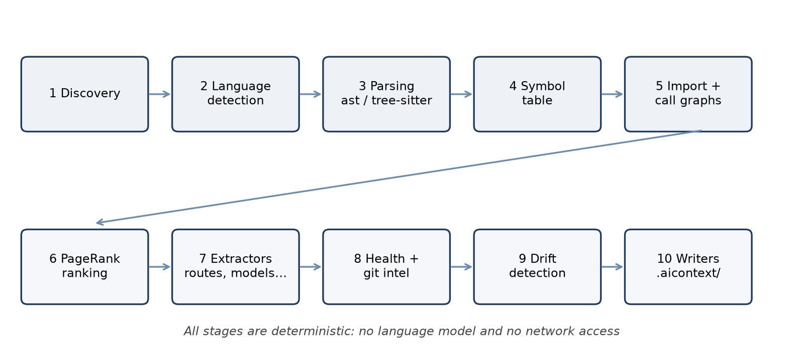
Figure 2. The ten-stage indexing pipeline
Table 4. Pipeline stages and outputs
Stage | Name | Output
1–2 | Discovery and language detection | Sorted file list that honours .gitignore, .prismignore, size limits and binary or minified files
3–4 | Parsing and symbol table | Qualified symbol identifiers, signatures, line ranges, first docstring line and visibility
5 | Graph construction | Module import graph and static call graph; each call edge carries a resolution confidence of high, medium or low
6 | Ranking | PageRank scores, used to order results and to allocate budgets
7 | Extractors | Routes, ORM models, configuration keys, entry points, test map, dead-code candidates, blast radius and toolchain commands
8 | Health and git analysis | Cyclomatic complexity, churn, ownership, co-change, coverage where available, and a combined risk score
9 | Drift detection | Structural difference from the previous run and a weighted staleness score for each brief section
10 | Writers | Byte-stable JSON, brief, module summaries and a manifest holding a SHA-256 digest per file

2.4 Incremental update and freshness
An update re-parses only the files that changed. Hashes and parsed results of unchanged files are reused, and PageRank is recomputed in full only when more than the larger of ten edges or two per cent of all edges changed; otherwise earlier scores are retained and marked approximate. Artifacts whose content digest is unchanged are not rewritten. A scan from scratch must produce the same output as a scan followed by any number of updates, and this equivalence is the principal correctness test of the suite.
Freshness does not depend on hooks. Before answering, every query compares the working tree with the manifest and, for an enabled user, updates up to 300 changed files under a cross-process lock. The post-edit hook returns in approximately 0.2 s and completes the update in a detached process within a time box of 0.9 s. Files are written atomically and the manifest is written last, so an interrupted update cannot leave a corrupt index.

2.5 Query processing
The principal query, prism task, combines three kinds of evidence. First, literals in the request (quoted strings, code names, numbers with units and phrases) are located through a postings index of the sources and verified by exact match, so that the result is a complete list of occurrences and not a ranking. Second, candidate files, selected by BM25 over bodies and paths, are scanned line by line for the less common words of the request, with related terms from a small synonym table given half weight. Third, matching lines are grouped into blocks; blocks that call one another reinforce each other, and the highest-scoring symbols are supplemented with callers, mentioning tests and an impact count. Confidence is derived from the presence of exact evidence, the margin between the best and next block, and the share of request weight covered.
The packet may also contain a checked, byte-exact patch for an explicit old-to-new change at every exhaustive site, a list of functions defined in several files, the exact test command, and a statement of the completion condition. Figure 3 shows the request flow when the prompt hook is installed.
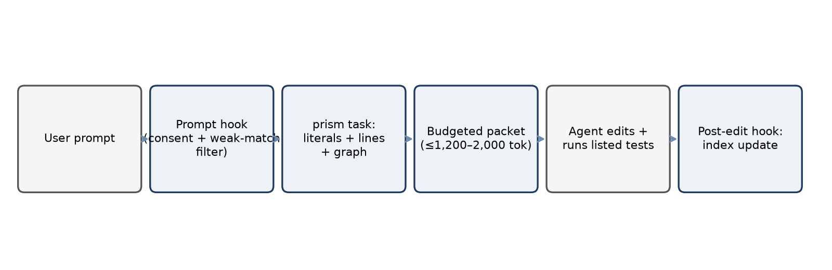
Figure 3. Request flow with the prompt hook

2.6 Delivery interfaces
Table 5. Delivery interfaces
Interface | Description
Command line | task, find, context, impact, search, locate, module, trace, diff, filter, doctor and view, among others. Output is Markdown by default and JSON on request.
MCP server (stdio) | The default profile exposes prism_task only. A standard profile adds status, context and impact; a full profile adds audit, refresh and decision tools. Five tools write, and only within .aicontext/.
Hooks | session-start (brief), user-prompt (adds the packet to the prompt), post-edit (index update), stop (finish-time check) and an optional deny-only read de-duplication.
Skills | prism-context (installed by default), prism-refresh, prism-audit and prism-decisions.
Viewer and exports | Offline browser graph; export to HTML, Obsidian vault, Mermaid, DOT, GraphML and JSON.

2.7 Agent integrations
The command prism init installs, for each detected agent, an instruction block, an MCP entry and hooks where the agent supports them (Table 6). Installers merge into existing files, back up every file they modify, mark owned content as prism-managed, are idempotent and are reversed in full by prism uninstall-integration.
Table 6. Files and hooks installed per agent
Agent | Instructions | MCP configuration | Hooks
Claude Code | CLAUDE.md block | .mcp.json | SessionStart, UserPromptSubmit, PostToolUse, Stop
Codex | AGENTS.md block | .codex/config.toml | SessionStart, UserPromptSubmit, PostToolUse, Stop; project must be trusted
Gemini CLI | GEMINI.md block | .gemini/settings.json | SessionStart, BeforeAgent, AfterTool
Cursor | .cursor/rules/prism.mdc | .cursor/mcp.json | sessionStart, afterFileEdit; a prompt hook is not possible
Antigravity (experimental) | .agent/rules/prism.md | Entry printed for the user-level file | Stop only; no prompt hook is documented
Other agents | AGENTS.md block | Manual | Optional git hooks (post-commit, post-merge, post-checkout)

2.8 Consent and security
PRISM operates in a repository only after the user has enabled it. The flag is stored in ~/.config/prism/repos.toml, keyed by repository path and identifier, and is never committed. A teammate's committed index can be read but is not updated until that user runs prism enable. The MCP server has no network listener, the viewer binds to 127.0.0.1, and no tool edits source code or runs shell commands. The shipped instructions direct agents not to run init, scan, enable or install --global unless the user requests it.

2.9 Implementation profile
Table 7. Size and composition of the code base
Item | Value
Language and runtime | Python 3.10 or later (developed on 3.14); dependencies typer, rich, pathspec, jsonschema and mcp
Library | 156 Python modules, approximately 26,600 lines
Automated tests | 90 files, approximately 10,800 lines (unit, integration, golden-file and skill tests); recorded run: 707 passed, 6 skipped
Benchmark harness | 26 files, approximately 5,600 lines
Fixture repositories | Five: small, layered, seeded (known defects), polyglot (Go, Java, TypeScript) and mobile (Dart, Kotlin, Swift)
Artifact schemas | 14 JSON schemas
Architecture decision records | 7
Development period | 183 commits between 27 September and 11 October 2026
Optional extras | treesitter, dart, kotlin, swift, semantic, semantic-full

3. Test environment and methodology

3.1 Test platform
All measurements were made on one laptop workstation. Agent sessions were driven non-interactively by harness scripts. Third-party tools were installed at the versions given in Table 8 and run in isolated sessions.
Table 8. Hardware and software of the test platform
Component | Specification
Processor | Intel Core i5-12450H, 8 cores, 12 threads
Memory | 15.7 GB
Graphics | NVIDIA GeForce RTX 3050 Laptop GPU, 6 GB (used for one embedding comparison only)
Operating system | Windows 11 Home, build 10.0.26200
Runtimes | Python 3.14.4; Node.js 24.14.1; Git 2.53.0
Agents and models | Claude Code with Claude Haiku 5.5; Codex CLI with gpt-6-luna (host version 0.162.1); Antigravity with Gemini 3.8 Flash (medium)
Compared tools | TokenSave 7.15.0; Graphify 0.9.85; RTK 0.51.0; AgentMemory 0.9.30 with iii 0.22.1

3.2 Subjects and tasks
The live campaigns used a multi-stack application, ArogyaTrack, comprising a Django backend, a Next.js frontend and a Flutter mobile application. A frozen snapshot was copied into a fresh sandbox for every session, each session had its own private agent home and an isolated consent registry, and the source repository was never initialised or modified. Four tasks were common to all conditions (Table 9), and success was decided by hidden tests that the agent could not read. The offline harness used three further subjects: the PRISM repository itself, a 305-file Django and React application, and a 12-file seeded fixture.
Table 9. Tasks used in the live campaigns
Task | Description | Success criterion
t0_orient | Describe the architecture of the repository | The answer names all five required components: django, next, flutter, anonymizer and validators
t1_age | Change a minimum-age rule wherever it applies | Hidden tests pass across approximately ten modified files
t2_webp | Add WEBP support to the image validators | Both the accounts and the patients validators are changed and hidden tests pass
t3_severity | Change a severity classification | Hidden tests pass

3.3 Experimental conditions
Five conditions were used for the platform measurements: no PRISM (baseline); CLI, in which the index and instruction block are installed and the agent may run prism task; MCP, in which the agent may call the prism_task tool; CLI with hook; and MCP with hook, in which the prompt hook additionally places the packet in the prompt before the model's first turn. The comparison with other tools used seven conditions on Claude Code: no tool; PRISM CLI with hook; PRISM MCP with hook; RTK through its native hook; TokenSave through MCP and hooks; Graphify with local code-only extraction and its official project hooks; and AgentMemory with its full 54-tool runtime and plugin, using fresh, isolated memory and no embeddings.

3.4 Measures and statistical treatment
Total input is the sum of fresh input, cache-creation tokens and cache-read tokens. Fresh input excludes cache reads. Output tokens are reported separately. Tokens per solved task is the total token count of all sessions in a condition divided by the number of sessions solved, so that unsuccessful sessions add to the cost. The measure pass^k is the number of tasks solved in every repetition.
Differences from the baseline are reported with 95% percentile bootstrap intervals (4,000 resamples, seed 7), in which repetitions are resampled within the four fixed tasks. An interval that contains zero is reported as not distinguishable from noise. Index build time, setup time and login pre-flight calls are recorded separately and excluded from task totals. Cost figures produced by the agent clients are estimates and are not used in this report. Whether the prompt hook delivered content was recorded for each session.

3.5 Offline harness
The script tests/benchmarks/tokens.py replays bug-fix requests, each paired with the symbol that a correct fix must change, and counts the tokens read under two strategies, estimating tokens as characters divided by four. The baseline strategy reads the file list, searches for the function name and reads the defining file, the caller files and the related test files in full. It assumes that the agent already knows the function name and is therefore favourable to the baseline. A best-case baseline that reads only the defining file is also reported. The PRISM strategy reads the brief, a search result, a context pack and the listed line ranges.

4. Results

4.1 Offline orientation harness
Table 10 and Figure 4 give the tokens read to orient on each subject. On the web application the reduction was 92% against the baseline and 75% against the best-case baseline. On PRISM's own source the corresponding values were 73% and 15%. On the 12-file fixture PRISM consumed more tokens than reading the code directly, because its fixed overhead of approximately 1,300 tokens (brief, search and pack) exceeds the size of the code.
Table 10. Orientation tokens by subject
Subject | Tasks | Without PRISM | With PRISM | Change | vs. best case
Django and React/TypeScript application (305 files) | 12 | 356,657 | 28,202 | −92% | −75%
PRISM source (140 files) | 10 | 105,846 | 28,981 | −73% | −15%
Seeded fixture (12 files) | 5 | 1,115 | 3,136 | +181% | +223%

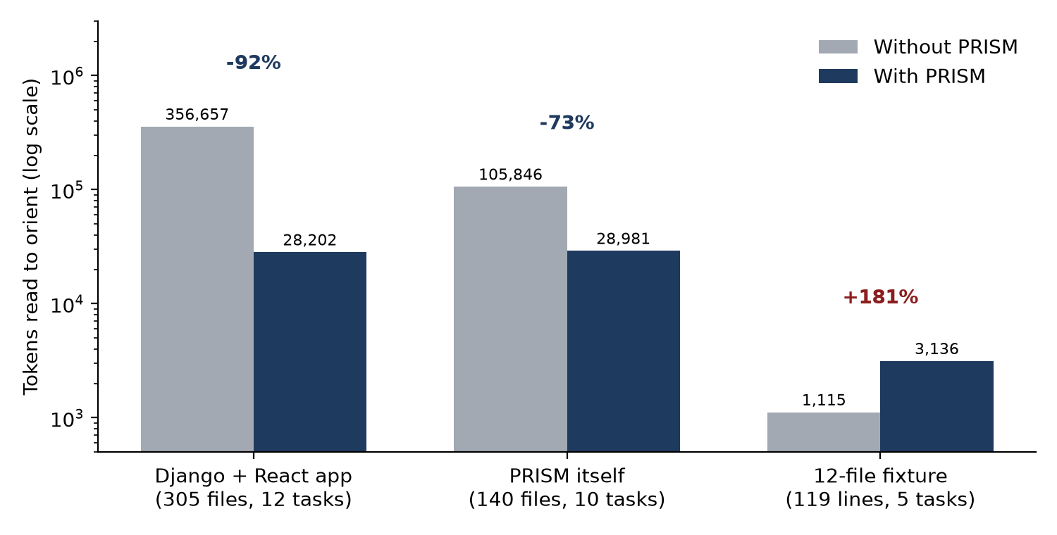
Figure 4. Tokens read to orient, with and without PRISM (logarithmic scale)
Figure 5 shows where the tokens are consumed on the web application. In the baseline, caller files account for 18,307 of the 29,224 tokens per task. With PRISM the per-task total is 2,125 tokens, and a pre-edit impact check adds 186. Project orientation, paid once per session, costs 5,978 tokens without PRISM and 472 with the brief.
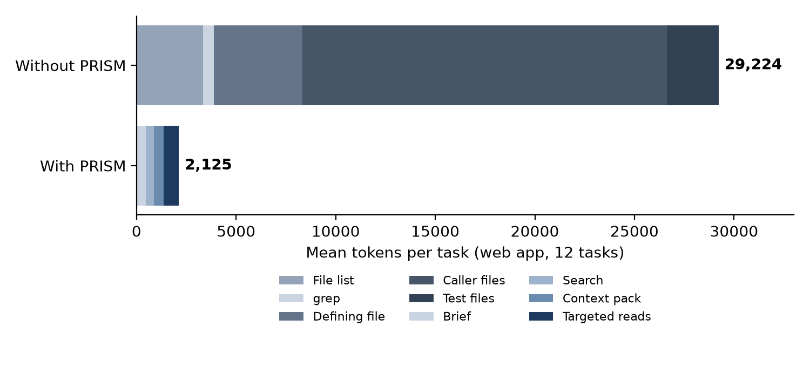
Figure 5. Mean tokens per task on the web application, by step
Table 11. Retrieval quality in the same runs
Check | Web application | PRISM source
Context pack lists every caller file | 12 of 12 tasks | 9 of 10 tasks
Correct file among top three search results | 9 of 12 | 10 of 10
Correct function among top three search results | 6 of 12 | 6 of 10
Function found at its new lines after an edit | 12 of 12 | 10 of 10

Savings increased with the number of callers of the changed code; a hook used by 22 components gave a reduction of 96%. Search on plain-English bug reports located the correct file among the top three results in most cases but the exact function in only about half.

4.2 Earlier edit benchmark
On 7 October 2026 fifteen fresh agents each made five real changes with and without PRISM, with every edit checked by executable tests. With the prompt hook, PRISM reduced total input by 34%, billable-equivalent input by 15%, turns by 30%, tool output by 89% and elapsed time by 26%, with identical correctness. For a one-method change that is easy to locate by text search, no saving was observed. These figures are taken from the project's benchmark documentation.

4.3 Latency
Figure 6 gives median wall-clock times for each operation, measured as fresh processes on Windows without flushing file-system caches. Internal query time was 1 to 3 ms (95th percentile) on a 50,000-line repository against a target of 200 ms on 100,000 lines. A full scan of that repository took 2.8 s, a one-file update about 0.4 s in process and about 1 s through the hook including process start, and loading of the viewer graph about 0.2 s for 4,000 symbols. End-to-end times are dominated by process start-up and lie between 0.2 s and 1.0 s.
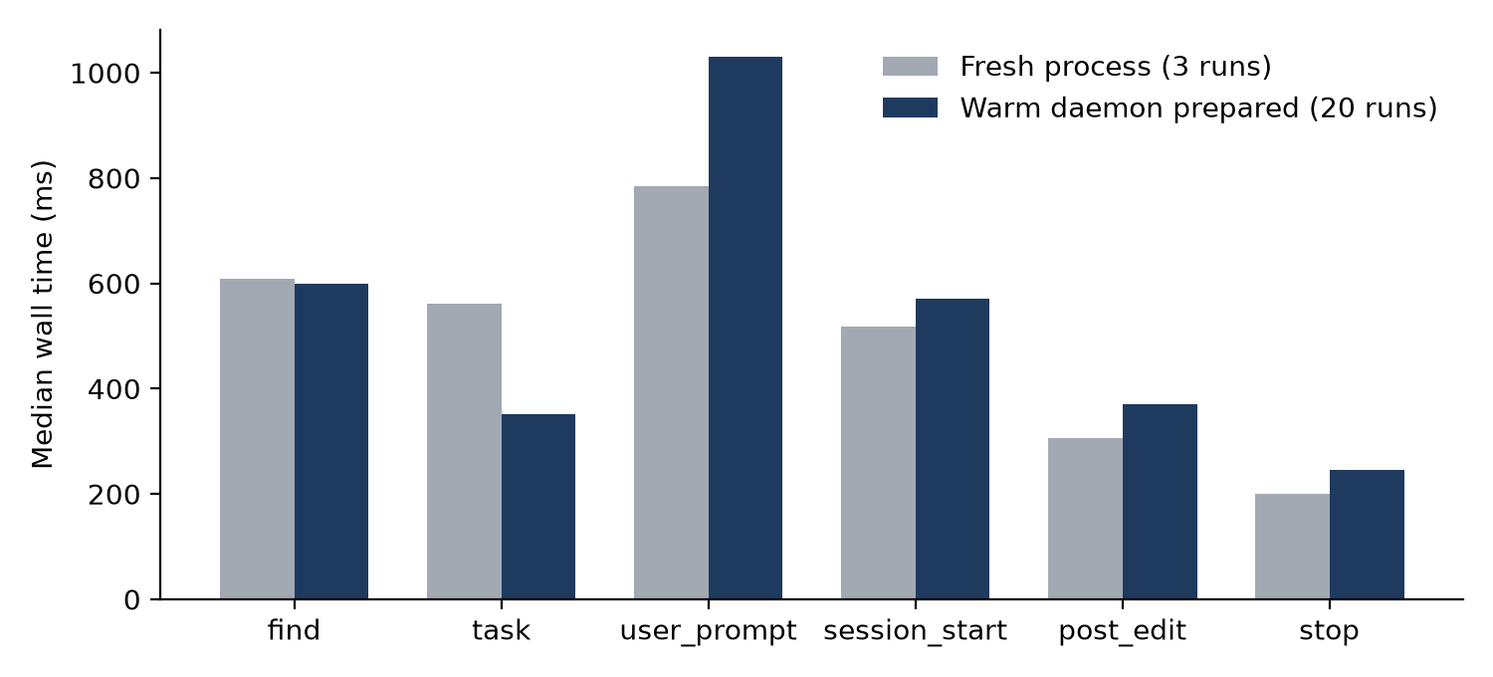
Figure 6. Median end-to-end time per operation, fresh process and prepared warm daemon
The warm daemon reduced the median time of prism task from 562 ms to 351 ms but did not reduce all operations; in the sampled run user_prompt took longer (784 ms to 1,030 ms). The fresh-process figures rest on three runs per operation, and the values should be read as orders of magnitude.

4.4 Token consumption on three agent platforms
The four tasks of Table 9 were run on three agents, each with a different model. Results are expressed as the change in total input tokens relative to the same agent without PRISM (Figure 7). Because the models differ in caching behaviour, percentages should not be compared in magnitude across platforms.
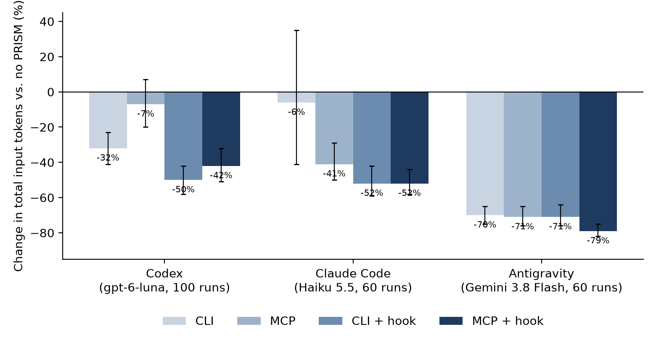
Figure 7. Change in total input tokens relative to no PRISM, by platform and condition, with 95% intervals

4.4.1 Codex
The Codex campaign comprised 100 sessions (five repetitions of four tasks under five conditions), all of which completed. Results are given in Table 12. Delivery of the packet through the hook gave the largest reduction in total input (50%) and the highest number of tasks solved (20 of 20). The MCP condition without the hook did not differ measurably from the baseline. By task, the hook condition reduced mean input by 73% on the cross-cutting age change (from 302,139 to 80,605 tokens), by 50% on the WEBP change and by 41% on the severity change. On the architecture task the reduction was 10% with the CLI hook, and the MCP conditions used 8% to 14% more input than the baseline.
Table 12. Codex, gpt-6-luna, 100 sessions
Condition | Fresh input vs. none | Total input vs. none | Tokens per solved task | Solved | Hook delivered
No PRISM | n/a | n/a | 203,746 | 18/20 | n/a
CLI | −15% (n.s.) | −32% (−41 to −23) | 130,428 | 19/20 | n/a
MCP | −11% (n.s.) | −7% (n.s.) | 200,151 | 17/20 | n/a
CLI with hook | −28% (−40 to −15) | −50% (−58 to −42) | 91,109 | 20/20 | 20/20
MCP with hook | −39% (−48 to −29) | −42% (−51 to −32) | 111,973 | 19/20 | 20/20

n.s.: interval includes zero. Intervals are 95% bootstrap ranges. This run was made after the correction described in Section 6.2.

4.4.2 Claude Code
The first Claude Code campaign comprised 60 sessions (three repetitions) with Claude Haiku 5.5 (Table 13). The MCP and hook conditions reduced total input by between 41% and 52%, and every PRISM condition solved all twelve sessions, against nine of twelve for the baseline. The CLI condition alone did not differ measurably from the baseline. Because the baseline solved fewer sessions, its tokens per solved task is inflated; the five-repetition measurement in Section 4.5 gives a more conservative estimate of 33% to 35%.
Table 13. Claude Code, Claude Haiku 5.5, 60 sessions
Condition | Fresh input vs. none | Total input vs. none | Tokens per solved task | Solved | Hook delivered
No PRISM | n/a | n/a | 422,940 | 9/12 | n/a
CLI | −12% (n.s.) | −6% (n.s.) | 296,888 | 12/12 | n/a
MCP | −45% (−50 to −40) | −41% (−50 to −29) | 186,626 | 12/12 | n/a
CLI with hook | −32% (−37 to −28) | −52% (−59 to −42) | 153,584 | 12/12 | 12/12
MCP with hook | −49% (−52 to −45) | −52% (−58 to −44) | 152,248 | 12/12 | 12/12

4.4.3 Antigravity
The Antigravity campaign comprised 60 sessions (three repetitions) with Gemini 3.8 Flash at medium setting (Table 14). Total input fell by 70% to 79% in every PRISM condition. Three qualifications apply. First, the baseline consumed approximately 3.5 million tokens per solved task, an order of magnitude more than on the other platforms, so that the run is dominated by repeated reading of cached context. Second, the prompt hook was delivered in none of the 24 sessions in the two hook conditions, because no prompt hook is documented for this agent; those conditions therefore differ from the CLI and MCP conditions only by installed rules and chance. Third, the campaign was run on 10 October 2026, before the correction described in Section 6.2, and was not repeated. A pilot of six sessions on a different task set showed total input rising by 25% to 45% under PRISM; that sample is too small to weigh against the 60-session run, but it indicates that the result depends on configuration.
Table 14. Antigravity, Gemini 3.8 Flash (medium), 60 sessions
Condition | Fresh input vs. none | Total input vs. none | Tokens per solved task | Solved | Hook delivered
No PRISM | n/a | n/a | 3,513,035 | 12/12 | n/a
CLI | −39% (−46 to −32) | −70% (−75 to −65) | 1,143,179 | 11/12 | n/a
MCP | −45% (−51 to −39) | −71% (−76 to −65) | 1,028,209 | 12/12 | n/a
CLI with hook | −44% (−51 to −34) | −71% (−76 to −64) | 1,125,954 | 11/12 | 0/12
MCP with hook | −54% (−59 to −47) | −79% (−82 to −75) | 749,070 | 12/12 | 0/12

4.5 Comparison with Graphify, TokenSave, RTK and AgentMemory
Seven conditions were run on Claude Code with Claude Haiku 5.5 on the four tasks of Table 9, with five repetitions each, giving 140 sessions. The tools and their configurations are summarised in Table 15. The same hidden tests scored all conditions.
Table 15. Tools compared and the configuration tested
Tool | Principle of operation | Configuration tested
PRISM | Deterministic index; compact packet delivered by prompt hook, CLI or MCP | CLI with hook; MCP with hook
Graphify | Builds a graph of the codebase for the agent to query | Local code-only extraction with official project hooks. Semantic document indexing and the cloud service were not tested
TokenSave | Code graph exposed through MCP | MCP and hooks, version 7.15.0
RTK | Compresses command output before it reaches the model | Native hook, version 0.51.0
AgentMemory | Persistent memory across sessions | Full 54-tool runtime and plugin; fresh, isolated memory. Measures cold start only, not benefit from accumulated history

Results are given in Table 16 and Figures 8 to 10. PRISM was the only condition with a reduction whose interval excluded zero. The reduction was 33% to 35% in total input and 26% to 27% in fresh input, with 19 and 18 of 20 sessions solved against 16 of 20 for no tool. The RTK condition did not differ measurably from the baseline. AgentMemory increased fresh input by 13% and did not differ measurably in total input. Graphify increased total input by 28%, and TokenSave by 48%.
Table 16. Comparison of seven conditions, Claude Code, Claude Haiku 5.5, 20 sessions each
Condition | Fresh input vs. none | Total input vs. none | Tokens per solved task | Solved
No tool | n/a | n/a | 306,161 | 16/20
PRISM CLI with hook | −26% (−33 to −18) | −35% (−46 to −21) | 168,494 | 19/20
PRISM MCP with hook | −27% (−32 to −21) | −33% (−43 to −21) | 182,048 | 18/20
RTK native hook | −4% (n.s.) | −8% (n.s.) | 264,481 | 17/20
AgentMemory, cold | +13% (+5 to +21) | +11% (n.s.) | 340,154 | 16/20
Graphify, code-only | +12% (n.s.) | +28% (+4 to +56) | 392,256 | 16/20
TokenSave MCP and hooks | +5% (n.s.) | +48% (+32 to +67) | 382,039 | 19/20

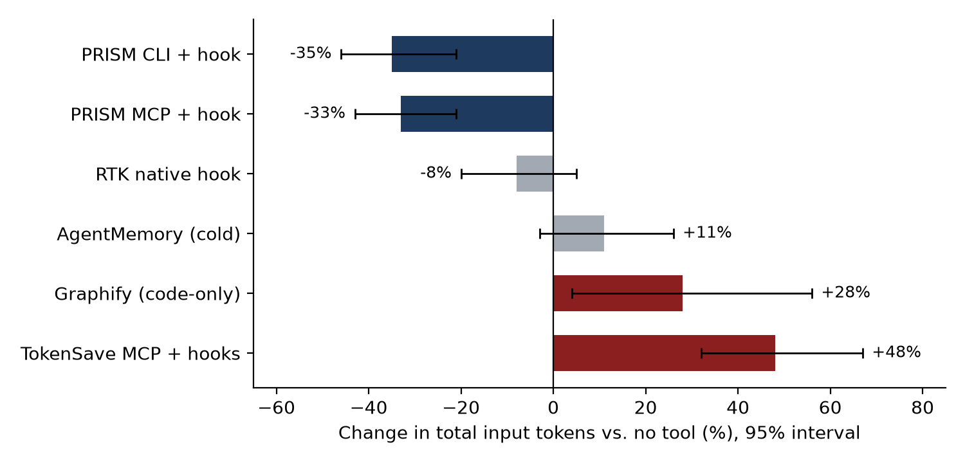
Figure 8. Change in total input relative to no tool, with 95% intervals
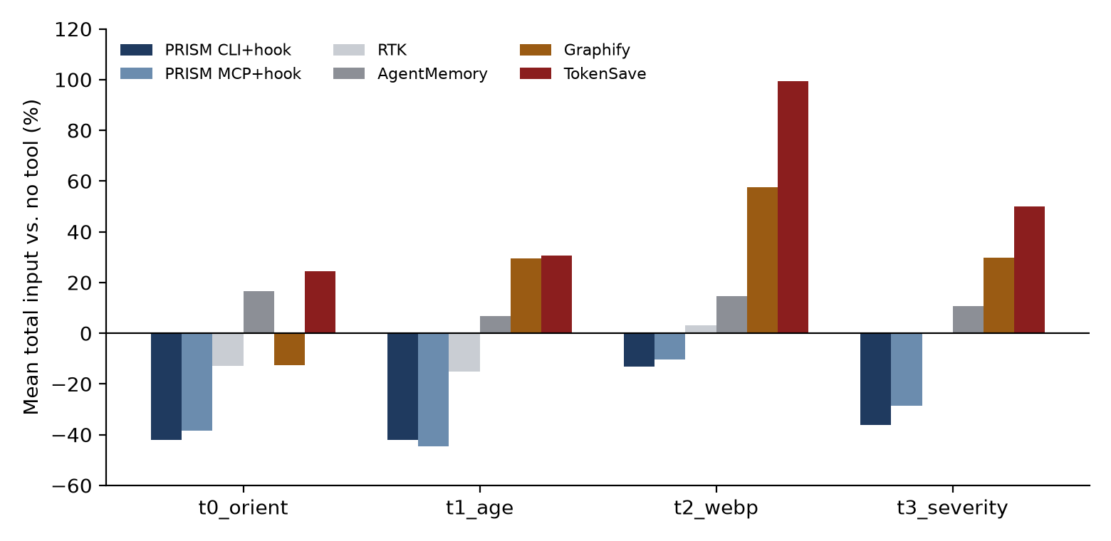
Figure 9. Mean total input relative to no tool, by task
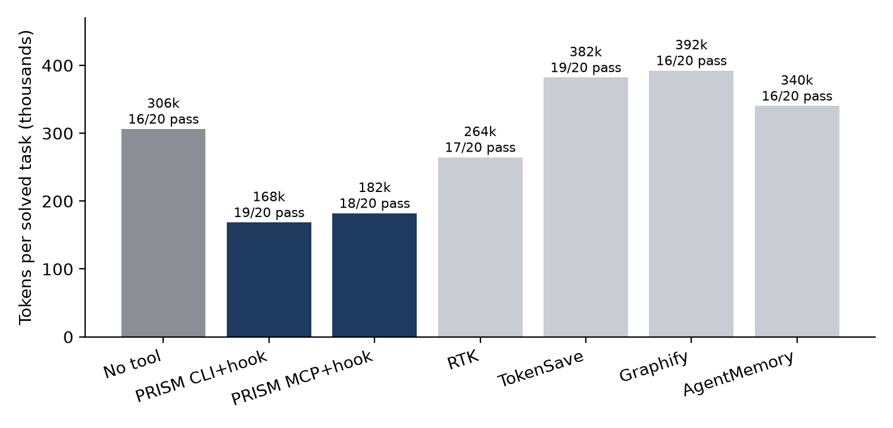
Figure 10. Tokens per solved task and number of sessions solved, by condition
By task, PRISM gave lower mean input than no tool on all four tasks, with reductions of 38% to 42% on the orientation task, 42% to 44% on the age change, 10% to 13% on the WEBP change and 29% to 36% on the severity change. TokenSave used more input than no tool on all four tasks, and Graphify on three of the four. Graphify reduced input by 13% on the orientation task. On the WEBP task TokenSave approximately doubled input (+99%). Unsuccessful WEBP sessions occurred in every condition including the baseline and were in most cases due to a change to only one of the two required validators.
The provenance of the PRISM rows should be noted. A first full run of this comparison was invalidated by an out-of-memory failure. In the repeated run, seven PRISM sessions failed at setup because the hook timed out while the query caches were still being built; these were recovered by a recovery script and merged with the other results to give 140 of 140 sessions. The summary was regenerated from the merged data using the campaign's report script. Without the recovered sessions the PRISM conditions comprise 16 and 17 of 20 sessions.

4.6 Local embedding comparison
The optional semantic search blends a local embedding model into ranking. On 11 October 2026, MiniLM-L6 and CodeRankEmbed were compared on 61 file targets taken from 40 historical repository states and on 16 code-to-code targets. File recall at five was 29.5% for CodeRankEmbed and 23.0% for MiniLM-L6, and recall at ten was equal at 31.1%. CodeRankEmbed required 64.6 s to load and a working set of about 1.5 GB, against 0.25 s and 0.9 GB for MiniLM-L6, and the two ran on different hardware paths (GPU and CPU). MiniLM-L6 was retained as the optional default. A third model was excluded because its licence (CC-BY-NC-4.0) does not permit unrestricted use. Inference is local and no API calls were made. The data sets are small and no confidence intervals were computed.

5. Discussion
The results show a consistent pattern. On Codex the same index produced a reduction of 50% when its answer was inserted into the prompt by the hook, 32% when the agent was told to use the command line, and no measurable reduction when the answer was available through MCP only. A likely explanation is that an optional tool yields no saving unless the agent chooses to call it, whereas the hook makes the answer available before the first model turn. The data are consistent with this but do not isolate it from other differences between the conditions.
The reduction in tokens accompanies a reduction in the number of model steps, for example from 8.2 to 2.4 on the age change under Codex. Because each step causes the accumulated context to be processed again, fewer steps reduce total input more than they reduce the information read. The exhaustive literal lists contribute to this on requests that change a value wherever it appears, since they remove the need for repeated searching.
The results also identify conditions in which PRISM is of little or no benefit: very small repositories, where the fixed overhead exceeds the code; changes confined to one easily located method; and tasks that ask for explanation only, where on Codex the architecture task showed a reduction of 10% with the hook and an increase of 14% with MCP and hook. Agents that provide no prompt hook depend on the agent choosing to call the tool.
The comparison with other tools indicates that, under this metric and configuration, tools that give the agent a structure to explore (Graphify, TokenSave) increased total input, probably because tool definitions, graph output and additional exchanges add context that is re-read on each turn. This does not imply that they are ineffective for other purposes. RTK targets command output, which these tasks produce little of. AgentMemory is intended to pay off across repeated sessions and was measured cold. The tools may be complementary to PRISM, but combinations were not tested.

6. Limitations and validity

6.1 Limitations of the evidence
Table 17. Limitations and their effect on the conclusions
Limitation | Effect
One repository and four tasks | The results do not establish effects on other repositories or task types. Intervals resample repetitions within the fixed tasks only.
Measurements made by the authors | Hidden tests, fixed arms and seeds, and retention of failed sessions limit bias, but the study is not independent.
Small samples | Conditions contain 12 to 20 sessions; several intervals include zero.
Tokens rather than cost | Provider pricing, cache discounts and subscriptions vary; no statement is made about monetary cost.
Different models on each platform | Caching behaviour differs; percentages cannot be compared in magnitude across platforms.
Different software builds | The Antigravity and 60-session Claude Code runs (10 October) were not repeated after the correction of 11 October; the Codex and comparison runs used the later build.
Tool configurations | Graphify was used in code-only mode and AgentMemory with empty memory; other modes may give different results.
Token estimate in the offline harness | Characters divided by four rather than a model tokenizer; the harness models strategies and does not record a real agent.

6.2 Defect identified during testing
An earlier Codex campaign on 11 October 2026 was cancelled after 44 sessions. Analysis showed that every explicit PRISM retrieval had failed: all 14 command-line queries raised a SQLite IntegrityError (UNIQUE constraint on docs.kind and docs.ref), and all 5 MCP calls returned failed results. A change made to the index cache required document identity to be unique on kind and reference, but route documents were identified by HTTP method and path only. Distinct Django routes, for example two handlers for ANY /invoices/ in different modules, therefore shared one identity. The unit tests did not include duplicate route identities. Because the lookups failed, agents ran additional broad searches, and in that campaign the PRISM conditions consumed 11% to 22% more total input than the baseline. The defect was corrected and the campaign repeated in full; the Codex results in this report are from the corrected build.

6.3 Other operational observations
In some sessions the hook ran but returned nothing while the query caches were still being built, as happens on a fresh clone. PRISM now builds the caches in the background and remains silent once; benchmark procedures should warm the caches beforehand. A parallel session setup once failed because of a file-permission conflict on a shared launcher; one session was repeated and no scored failure was repeated. Codex loads project hooks only for trusted projects and locates MCP tools on demand, which makes the hook the dependable delivery route on that agent.

7. Conclusions and recommendations

7.1 Conclusions
- In the scripted harness PRISM reduced orientation tokens by 73% to 92% on repositories of 140 to 305 files and increased them on a 12-file fixture.
- In live campaigns on one repository, total input fell by 33% to 52% on Claude Code and by 42% to 50% on Codex under the CLI-with-hook and MCP-with-hook conditions, while the number of tasks solved was equal to or greater than the baseline.
- The reduction depended on automatic delivery of the packet. Tool availability alone gave inconsistent results.
- Of the five tools compared on Claude Code, only PRISM showed a reduction whose interval excluded zero under the metric and configurations used.
- The Antigravity result is large but was obtained without the hook and is not comparable in magnitude with the others.

7.2 Recommendations
- Repeat the measurements on at least three further repositories of different size and language mix, with tasks fixed in advance and preferably by an independent party.
- Repeat the Antigravity measurements on the current build and establish a delivery route for the packet on that agent.
- Add a regression test for duplicate route identities, and a benchmark pre-flight that fails when explicit retrieval returns errors.
- Measure cost in provider units, the effect over repeated sessions of tools that retain memory, and the combination of PRISM with RTK.
- Improve ranking of the exact function for plain-English bug reports, where the correct function currently appears among the top three results in about half of the cases.

References
[1] AlgoSmiths. PRISM README. Project repository, README.md.
[2] AlgoSmiths. PRISM Architecture. docs/architecture.md.
[3] AlgoSmiths. PRISM Agent Integrations. docs/agents.md.
[4] AlgoSmiths. PRISM Local Context Engine. docs/context-engine.md.
[5] AlgoSmiths. PRISM Benchmarks. docs/benchmarks.md.
[6] AlgoSmiths. T42 Local Embedding Comparison, 11 October 2026. docs/benchmarks/embedding-2026-10-11/README.md.
[7] AlgoSmiths. Codex campaign report, gpt-6-luna, run arogya-luna-fixed-20261011194955.
[8] AlgoSmiths. Claude Code campaign report (report_cc_r4) and Antigravity campaign analysis (analysis_r3), 10 October 2026.
[9] AlgoSmiths. Peer comparison, Claude Haiku 5.5, run peer-haiku-full-20261011214725, with recovered rows.
[10] AlgoSmiths. Token investigation, run arogya-luna-20261011131719.
[11] AlgoSmiths. Windows latency measurements, windows-latency-after.json.

Appendix A. Reproduction of the measurements
Table 18. Commands for reproducing the measurements
Purpose | Command
Offline token measurement | python -m tests.benchmarks.tokens (options --repo, --tasks and --json for other repositories)
Latency on a generated repository | python -m tests.benchmarks.run --packages 20 (add --enforce on a dedicated runner)
Retrieval scoring | python -m tests.benchmarks.retrieval_eval
Embedding comparison | python -m tests.benchmarks.embedding_bakeoff --help
Agent campaigns | tests/benchmarks/campaign_run.py, campaign_preflight.py, campaign_analysis.py and the agent_* scripts
Installation | pip install "git+https://github.com/Aashutosh-Mahajan/prism"; prism init; prism task "request"

Appendix B. Abbreviations and terms
Table 19. Abbreviations and terms
Term | Meaning
BM25 | Ranking function for text retrieval
Cache read | Input tokens served from the provider's prompt cache
Context pack, packet | The bounded answer built by PRISM for a request
Fresh input | Input tokens not served from cache
MCP | Model Context Protocol, a standard interface for exposing tools to agents
n.s. | Not significant: the 95% interval includes zero
PageRank | Graph importance score used to rank symbols
pass^k | Number of tasks solved in every repetition
Prompt hook | Agent hook that runs on each user prompt and adds the packet before the model's first turn

Appendix C. Data sources
The figures in this report were taken from the project documentation and from the campaign result files named in the references. The Codex, Claude Code and Antigravity tables reproduce the campaigns' own reports. The seven-condition comparison was regenerated from the merged session records with the campaign's report script (Section 4.5). The latency figures were computed from the median of the recorded timings.

