AlgoSmiths | Technical Report | PRISM-TR-2026-01 | 12 October 2026
PRISM: A Persistent, Local Context Layer for AI Coding Agents
Architecture, test environment and measured token consumption on Claude Code, Codex and Antigravity, with a comparison against Graphify, TokenSave, RTK and AgentMemory

Abstract
AI coding agents spend much of each session locating the code a request concerns, and repeat this in every session. PRISM is a local component that indexes a repository by deterministic static analysis, keeps the index current, and answers a request with a bounded packet of relevant code, exact string matches, callers, tests and impact. It calls no language model, needs no API key and sends no data off the machine. This report summarises its design, the test environment, and the measured change in token consumption. A scripted harness gave reductions of 92% (305-file web application) and 73% (PRISM source), and an increase of 181% on a 12-file fixture. In live campaigns on one repository, total input tokens fell by 50% on Codex, 52% on Claude Code and 79% on Antigravity under the best configuration of each; the Antigravity hook was not delivered, so that figure is not comparable with the others. In a seven-condition comparison on Claude Code, PRISM reduced total input by 33% to 35%, while three of the four other tools showed higher input than no tool. The results come from one repository and four tasks, were obtained by the authors, and concern token volume, not cost.

1. System description
PRISM follows the principle that it performs deterministic analysis and bookkeeping while the agent performs all reasoning. It operates locally and offline, produces byte-identical output for identical source, is enabled per user, and its hooks never interfere with a session (they exit with status zero and are silent on error). Figure 1 summarises the pipeline.
A scan runs ten stages: discovery, language detection, parsing (Python through ast; JavaScript, TypeScript, Go and Java through tree-sitter; Dart, Kotlin and Swift through a declaration scanner), symbol table, import and call graphs with edge confidence, PageRank, extractors (routes, models, configuration, tests, blast radius), health and git analysis, drift detection, and writers that produce the .aicontext/ artifacts and a hashed manifest. Updates re-parse only changed files, and every query first reconciles the working tree with the manifest, so freshness does not depend on hooks. Queries are served from a read-only SQLite cache.
The principal query, prism task, combines exact literal matches (a complete list of occurrences), line-level scoring of candidate files by BM25, and the call graph, and returns a budgeted packet that may include callers with the calling line, tests, the exact test command, a checked patch for explicit value changes, and a completion condition. The packet reaches the agent through the command line, an MCP tool, or a prompt hook that inserts it before the model's first turn. Integrations are provided for Claude Code, Codex, Gemini CLI, Cursor and Antigravity (experimental); Antigravity has no documented prompt hook. The implementation comprises 156 Python modules (about 26,600 lines), 90 test files (about 10,800 lines; 707 passed, 6 skipped in the recorded run) and a 26-file benchmark harness.
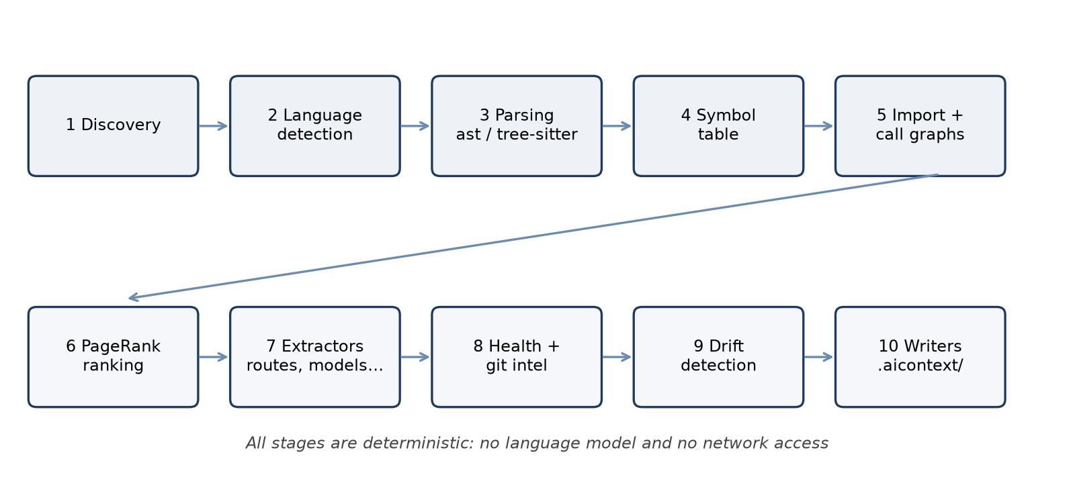
Figure 1. The ten-stage indexing pipeline

2. Test environment and methodology
Table 1. Test platform and subjects
Item | Specification
Hardware | Intel Core i5-12450H (8 cores, 12 threads), 15.7 GB memory, NVIDIA RTX 3050 Laptop GPU 6 GB (one embedding comparison only)
Software | Windows 11 Home 10.0.26200; Python 3.14.4; Node.js 24.14.1; Git 2.53.0
Agents and models | Claude Code with Claude Haiku 5.5; Codex CLI (0.162.1) with gpt-6-luna; Antigravity with Gemini 3.8 Flash (medium); sessions driven non-interactively
Compared tools | TokenSave 7.15.0, Graphify 0.9.85 (local code-only mode), RTK 0.51.0, AgentMemory 0.9.30 (full 54-tool runtime, empty memory)
Subject | ArogyaTrack (Django, Next.js and Flutter); frozen snapshot copied to a fresh sandbox per session with a private agent home and isolated consent registry
Tasks | t0_orient (name five architecture components); t1_age (change a minimum-age rule in about ten files); t2_webp (add WEBP to two validators); t3_severity (change a severity classification). Success decided by hidden tests
Offline harness | PRISM source, a 305-file Django and React application, a 12-file seeded fixture; tokens estimated as characters divided by four

Platform measurements used five conditions: no PRISM, CLI, MCP, CLI with hook and MCP with hook, with three or five repetitions of each task. The comparison with other tools used seven conditions on Claude Code with five repetitions (140 sessions). Total input is fresh input plus cache creation and cache reads; fresh input excludes cache reads; output is reported separately. Tokens per solved task is the total of all sessions divided by the number solved. Differences use 95% percentile bootstrap intervals (4,000 resamples, seed 7, repetitions resampled within the four tasks); an interval including zero is marked n.s. Setup time and login calls are excluded, and no monetary cost is reported.

3. Results

3.1 Offline orientation harness
On the web application PRISM reduced orientation tokens by 92% against the baseline (356,657 to 28,202) and by 75% against a best-case baseline that reads only the defining file. On PRISM's own source the reductions were 73% and 15%. On the 12-file fixture it used 181% more tokens, because its fixed overhead of about 1,300 tokens exceeds the size of the code. On the web application, caller files account for 18,307 of the 29,224 baseline tokens per task, against 2,125 with PRISM. The pack listed every caller file in 12 of 12 tasks (9 of 10 on PRISM), and the correct file was among the top three search results in 9 of 12 (10 of 10), but the exact function in only 6 of 12 (6 of 10).
Table 2. Orientation tokens by subject
Subject | Tasks | Without PRISM | With PRISM | Change | vs. best case
Django and React application (305 files) | 12 | 356,657 | 28,202 | −92% | −75%
PRISM source (140 files) | 10 | 105,846 | 28,981 | −73% | −15%
Seeded fixture (12 files) | 5 | 1,115 | 3,136 | +181% | +223%

An earlier edit benchmark (7 October 2026; fifteen agents, five real changes, executable tests) gave, with the prompt hook, 34% less total input, 15% less billable-equivalent input, 30% fewer turns, 89% less tool output and 26% less time at identical correctness; a one-method change that is easy to find by search showed no saving. Internal query time was 1 to 3 ms (95th percentile) on a 50,000-line repository; a full scan took 2.8 s and a one-file update about 0.4 s in process (about 1 s through the hook). End-to-end calls on Windows took 0.2 s to 1.0 s, dominated by process start-up; a prepared warm daemon reduced the median of prism task from 562 ms to 351 ms but did not reduce every operation.
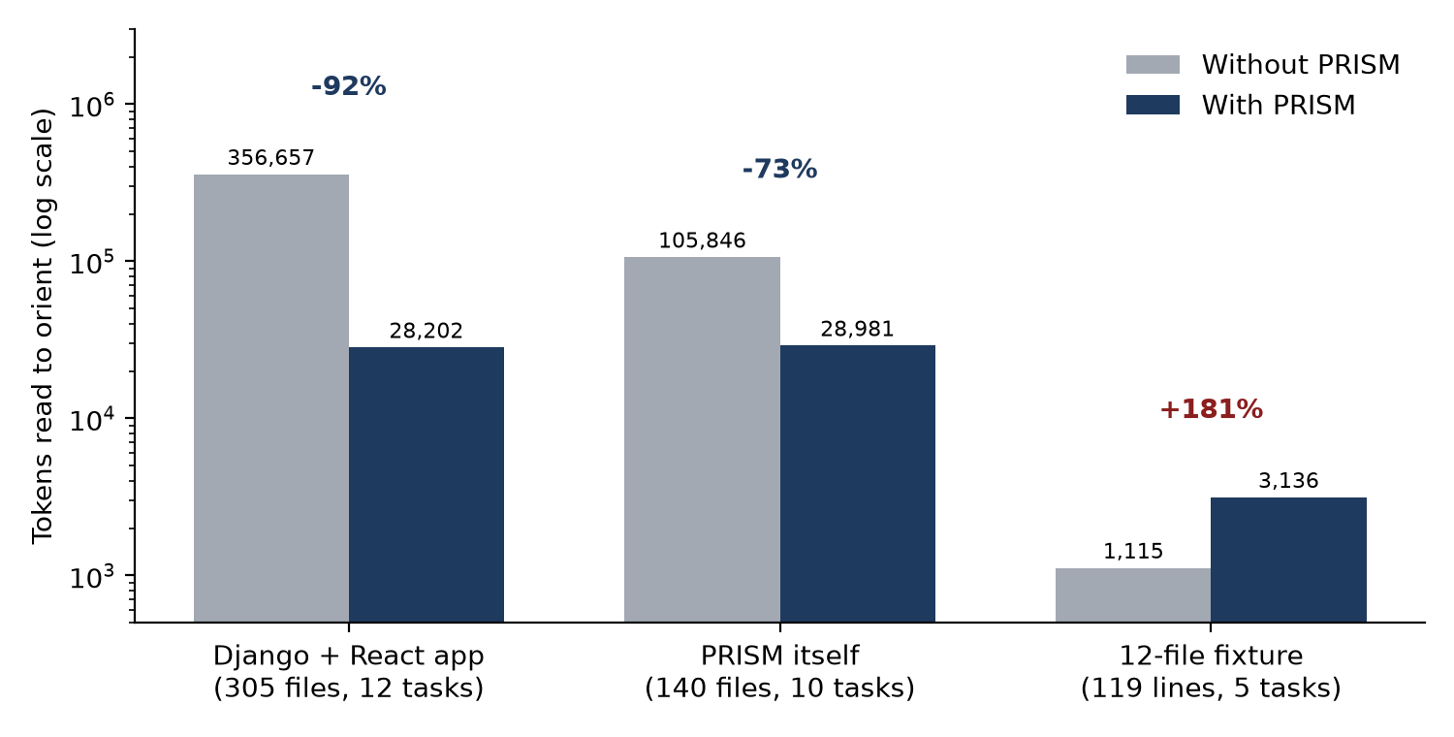
Figure 2. Tokens read to orient, with and without PRISM (logarithmic scale)

3.2 Token consumption on three agent platforms
Table 3 and Figure 3 give the change in total input relative to the same agent without PRISM. Models differ in caching behaviour, so percentages should not be compared in magnitude across platforms. Codex comprised 100 sessions (five repetitions), Claude Code 60 (three) and Antigravity 60 (three).
Table 3. Change in total input versus no PRISM, number solved, and hook delivery
Platform | Condition | Total input | Fresh input | Tokens / solved | Solved | Hook
Codex | No PRISM | n/a | n/a | 203,746 | 18/20 | n/a
 | CLI | −32% (−41 to −23) | −15% (n.s.) | 130,428 | 19/20 | n/a
 | MCP | −7% (n.s.) | −11% (n.s.) | 200,151 | 17/20 | n/a
 | CLI with hook | −50% (−58 to −42) | −28% (−40 to −15) | 91,109 | 20/20 | 20/20
 | MCP with hook | −42% (−51 to −32) | −39% (−48 to −29) | 111,973 | 19/20 | 20/20
Claude Code | No PRISM | n/a | n/a | 422,940 | 9/12 | n/a
 | CLI | −6% (n.s.) | −12% (n.s.) | 296,888 | 12/12 | n/a
 | MCP | −41% (−50 to −29) | −45% (−50 to −40) | 186,626 | 12/12 | n/a
 | CLI with hook | −52% (−59 to −42) | −32% (−37 to −28) | 153,584 | 12/12 | 12/12
 | MCP with hook | −52% (−58 to −44) | −49% (−52 to −45) | 152,248 | 12/12 | 12/12
Antigravity | No PRISM | n/a | n/a | 3,513,035 | 12/12 | n/a
 | CLI | −70% (−75 to −65) | −39% (−46 to −32) | 1,143,179 | 11/12 | n/a
 | MCP | −71% (−76 to −65) | −45% (−51 to −39) | 1,028,209 | 12/12 | n/a
 | CLI with hook | −71% (−76 to −64) | −44% (−51 to −34) | 1,125,954 | 11/12 | 0/12
 | MCP with hook | −79% (−82 to −75) | −54% (−59 to −47) | 749,070 | 12/12 | 0/12

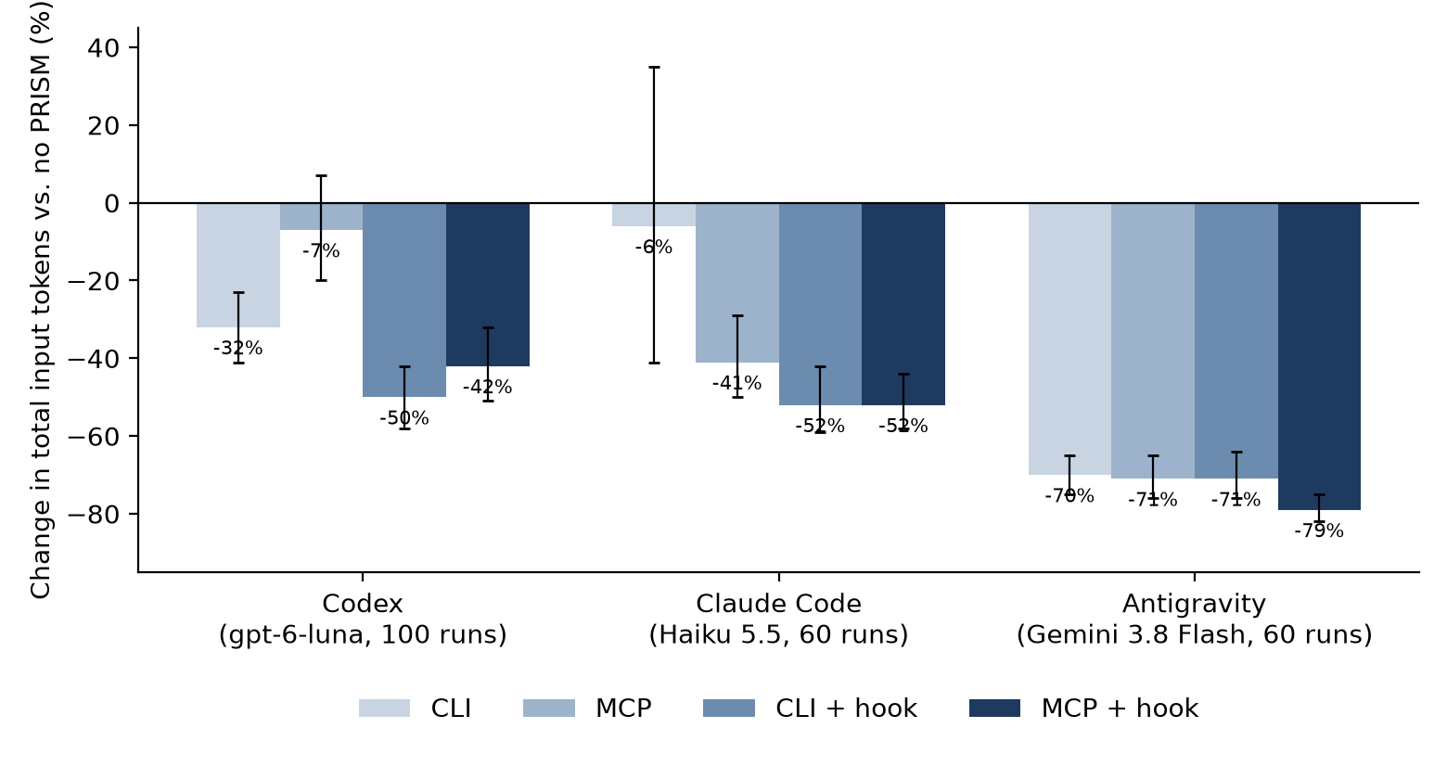
Figure 3. Change in total input relative to no PRISM, by platform and condition, with 95% intervals
On Codex the hook condition gave the largest reduction and the most tasks solved, while MCP alone did not differ measurably from the baseline. Per task, the CLI hook reduced input by 73% on the age change (302,139 to 80,605 tokens), 50% on WEBP and 41% on severity, but only 10% on the architecture task, where the MCP conditions used 8% to 14% more input. On Claude Code the baseline solved nine of twelve sessions, which inflates its tokens per solved task; the five-repetition comparison below gives a more conservative 33% to 35%. On Antigravity the baseline consumed about 3.5 million tokens per solved task, an order of magnitude more than the other platforms, so the run is dominated by cached-context rereads; the prompt hook was delivered in none of the 24 hook-condition sessions, so those rows differ from the CLI and MCP rows only by installed rules and chance; and the run (10 October) was not repeated after the correction described in Section 4. A six-session pilot on a different task set showed total input rising by 25% to 45%.

3.3 Comparison with Graphify, TokenSave, RTK and AgentMemory
Seven conditions were run on Claude Code with Claude Haiku 5.5, five repetitions of four tasks each (140 sessions). PRISM was the only condition with a reduction whose interval excluded zero: 33% to 35% in total input and 26% to 27% in fresh input, with 19 and 18 of 20 sessions solved against 16 of 20 for no tool. RTK, which compresses command output, did not differ measurably from the baseline. AgentMemory, measured with empty memory, raised fresh input by 13% and did not differ in total input. Graphify (code graph, local code-only extraction with its official hooks) raised total input by 28% and TokenSave (code graph over MCP) by 48%. By task, PRISM used less input than no tool on all four: 38% to 42% less on orientation, 42% to 44% on the age change, 10% to 13% on WEBP and 29% to 36% on severity. TokenSave used more input on all four tasks and Graphify on three; Graphify reduced input by 13% on the orientation task. The higher input of the graph tools is probably due to tool definitions, graph output and extra exchanges being re-read on each turn; the data are consistent with this but do not isolate it. Unsuccessful WEBP sessions occurred in every condition and were mostly due to changing only one of the two required validators.
Table 4. Seven conditions on Claude Code (Claude Haiku 5.5), 20 sessions each
Condition | Total input | Fresh input | Tokens / solved | Solved
No tool | n/a | n/a | 306,161 | 16/20
PRISM CLI with hook | −35% (−46 to −21) | −26% (−33 to −18) | 168,494 | 19/20
PRISM MCP with hook | −33% (−43 to −21) | −27% (−32 to −21) | 182,048 | 18/20
RTK native hook | −8% (n.s.) | −4% (n.s.) | 264,481 | 17/20
AgentMemory, cold | +11% (n.s.) | +13% (+5 to +21) | 340,154 | 16/20
Graphify, code-only | +28% (+4 to +56) | +12% (n.s.) | 392,256 | 16/20
TokenSave MCP and hooks | +48% (+32 to +67) | +5% (n.s.) | 382,039 | 19/20

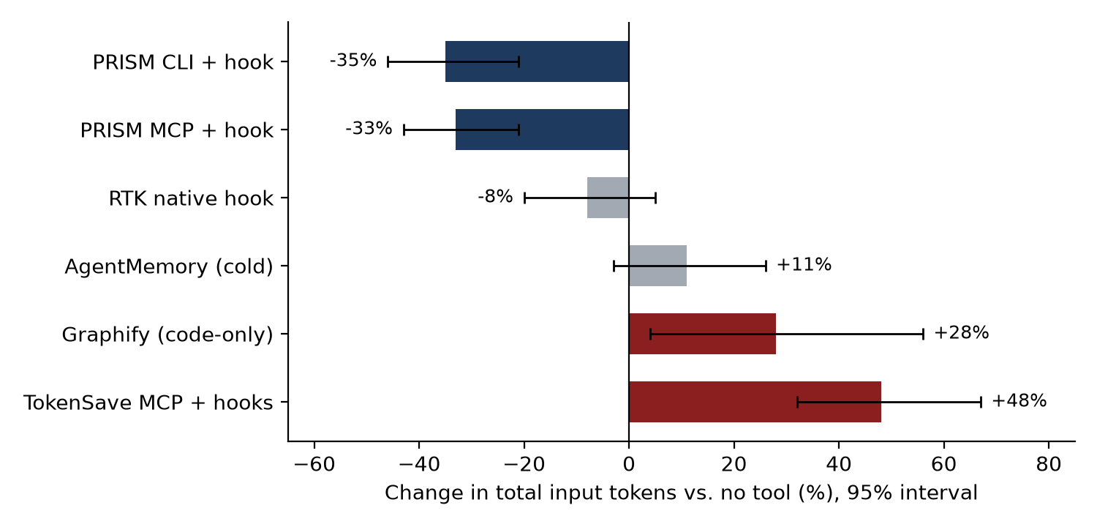
Figure 4. Change in total input relative to no tool, with 95% intervals
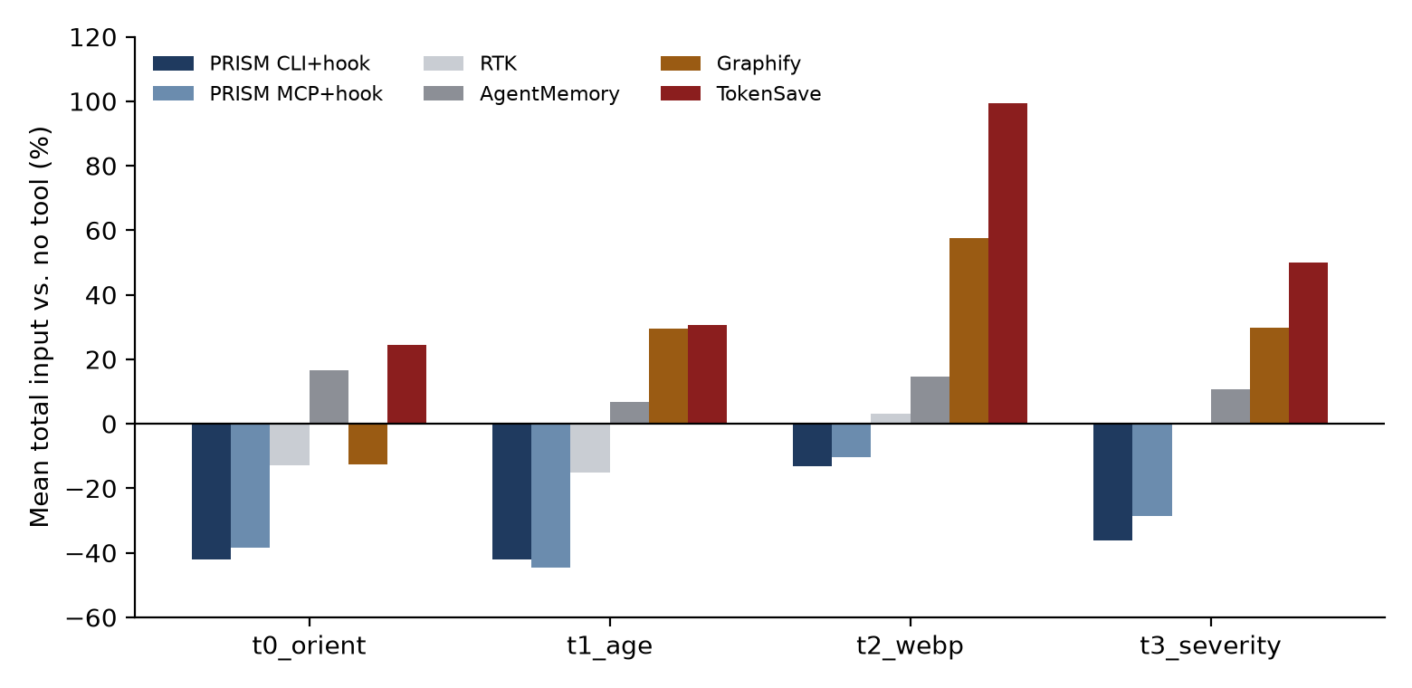
Figure 5. Mean total input relative to no tool, by task
Provenance: a first full run was invalidated by an out-of-memory failure. In the repeated run seven PRISM sessions failed at setup because the hook timed out while query caches were being built; they were recovered by a script and merged to give 140 of 140 sessions, and the summary was regenerated with the campaign's report script. Without them, the PRISM conditions comprise 16 and 17 of 20 sessions.
In a local embedding comparison (11 October 2026; 61 file targets and 16 code-to-code targets), CodeRankEmbed reached file recall at five of 29.5% against 23.0% for MiniLM-L6, but needed 64.6 s to load and about 1.5 GB of memory against 0.25 s and 0.9 GB, on different hardware paths; MiniLM-L6 was kept as the optional default.

4. Limitations and defect found
The live measurements used one repository and four tasks, with 12 to 20 sessions per condition, so several intervals include zero and the results do not establish effects on other repositories. The measurements were made by the authors, with hidden tests, fixed seeds and retained failures limiting bias but not providing independence. Tokens, not cost, were measured; the three agents use different models with different caching; Graphify was used in code-only mode and AgentMemory with empty memory; the Antigravity and 60-session Claude Code runs predate the correction below; and the offline harness estimates tokens as characters divided by four and models strategies rather than recording an agent.
An earlier Codex campaign (11 October 2026) was cancelled after 44 sessions because every explicit PRISM retrieval had failed: all 14 command-line queries raised a SQLite IntegrityError (UNIQUE constraint on docs.kind and docs.ref), and all 5 MCP calls failed. A cache change had made document identity unique on kind and reference, but route documents were identified by method and path only, so distinct Django routes (for example two ANY /invoices/ handlers) shared one identity. The unit tests did not cover duplicate route identities. The failures caused extra broad searches, and PRISM conditions then used 11% to 22% more input than the baseline. The defect was corrected and the campaign repeated in full; the Codex results above are from the corrected build.

5. Conclusions and recommendations
In the scripted harness PRISM reduced orientation tokens by 73% to 92% on repositories of 140 to 305 files and increased them on a 12-file fixture. In live campaigns on one repository, total input fell by 33% to 52% on Claude Code and by 42% to 50% on Codex with the hook conditions, with task success equal to or above the baseline. The reduction depended on automatic delivery of the packet; tool availability alone gave inconsistent results. Of the five tools compared, only PRISM showed a reduction whose interval excluded zero under the metric and configurations used.
Recommended next steps are to repeat the measurements on at least three further repositories, preferably by an independent party; to repeat Antigravity on the current build with a delivery route for the packet; to add a regression test for duplicate route identities and a benchmark pre-flight that fails on retrieval errors; and to measure cost in provider units, the effect of memory tools over repeated sessions, and PRISM combined with RTK. Commands to reproduce the offline measurements are python -m tests.benchmarks.tokens and python -m tests.benchmarks.run; campaign scripts are in tests/benchmarks/. Source data are the campaign reports and result files in the project's benchmark folders and docs/benchmarks.md.

