Objective: Configure and test basic firewall rules
1. Check if UFW is installed and enabled
sudo ufw status
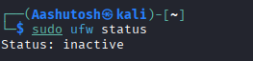
Enable the firewall:
sudo ufw enable
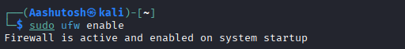
2. List current firewall rules
sudo ufw status numbered
This will show existing rules with numbers (for easy removal later).
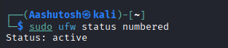
3. Block inbound traffic on a specific port (e.g., Telnet - port 23)
sudo ufw deny 23
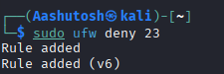
✅ Explanation: This blocks any incoming connection on port 23 (Telnet).

4. Test the rule
Try connecting locally:
telnet localhost 23
Getting “Connection refused” message — meaning the rule is working.
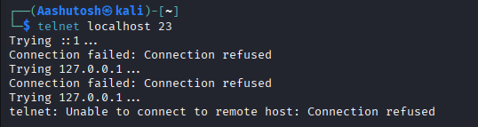
5. Allow SSH (port 22)
sudo ufw allow 22
✅ This ensures you don’t lose SSH access while testing firewall rules.
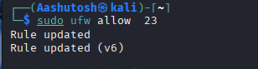
6. Remove the test block rule
After testing, remove the Telnet block rule:
sudo ufw delete deny 23
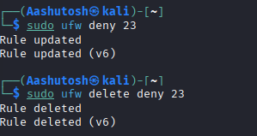

7. List rules again to confirm
sudo ufw status
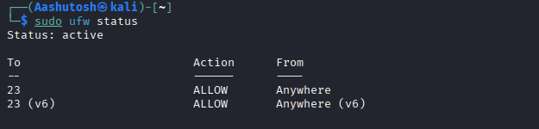
8. Summary: How firewall filters traffic
A firewall works as a network security filter that controls incoming and outgoing traffic based on defined rules.
- Inbound filtering: Decides which external connections can access your system.
- Outbound filtering: Controls what your system can connect to outside.
- UFW acts as a frontend for iptables, simplifying rule management.
For example:
- allow 22 → lets SSH traffic pass
- deny 23 → blocks Telnet connections
The firewall checks packets against these rules and allows or denies them accordingly.

