Real World Scanning using nmap and Wireshark

1. ping testfire.net -> To know About IP Address of testfire.net
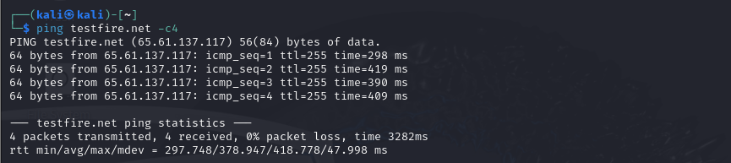
2. nmap 65.61.137.117 -> To know port number
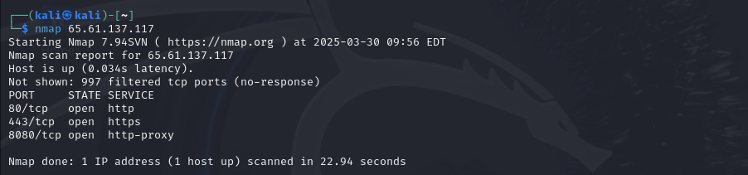
3. sudo nmap -PR -sn 65.61.137.117
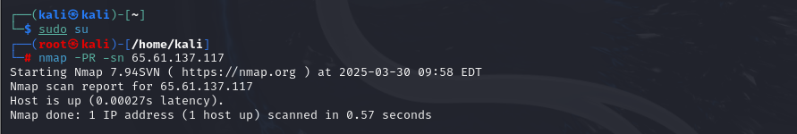
4. wireshark &
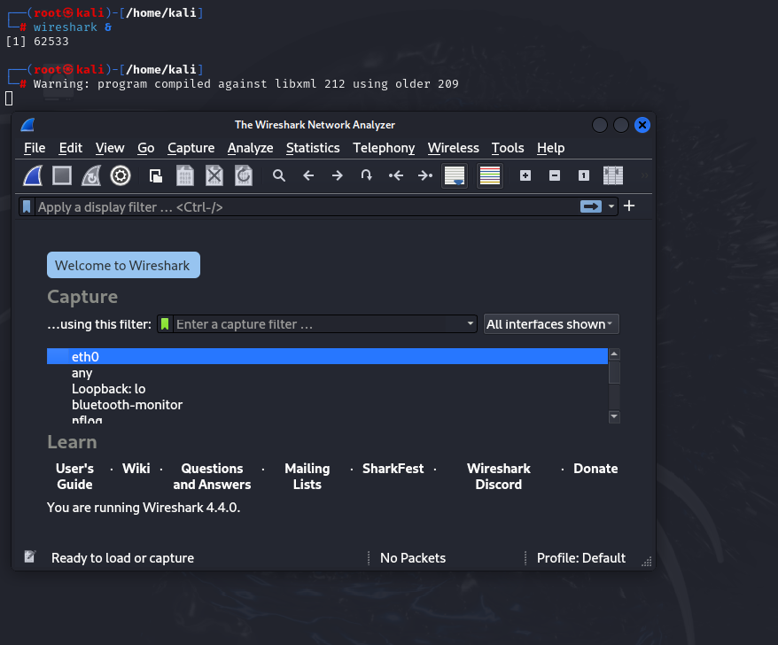
5. nmap -sT -p23 65.61.137.117
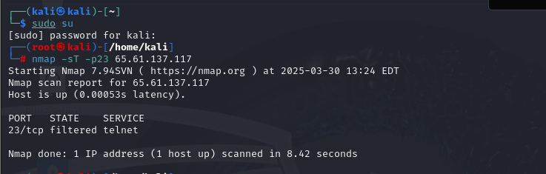

6. wireshark view
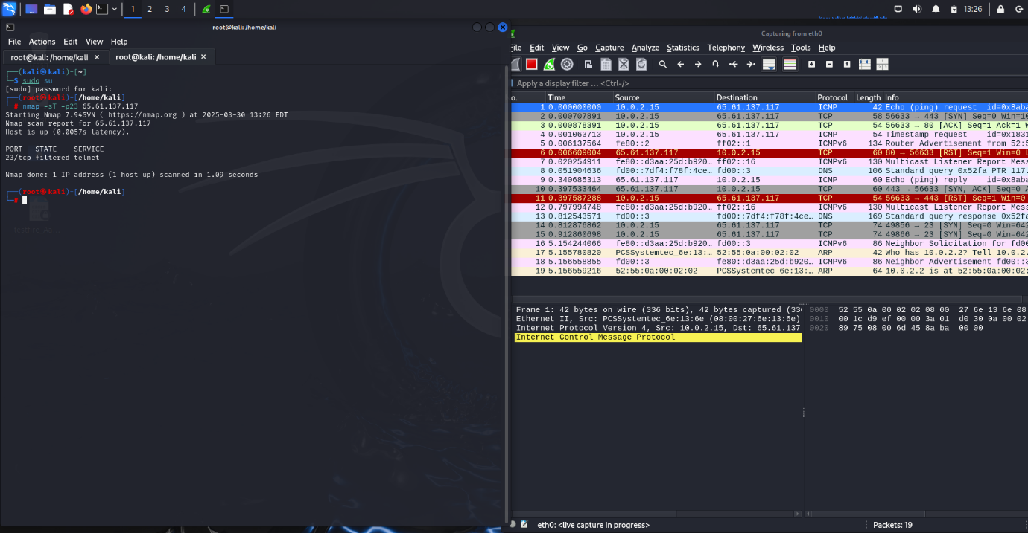

7. Enter the password in testfire.net
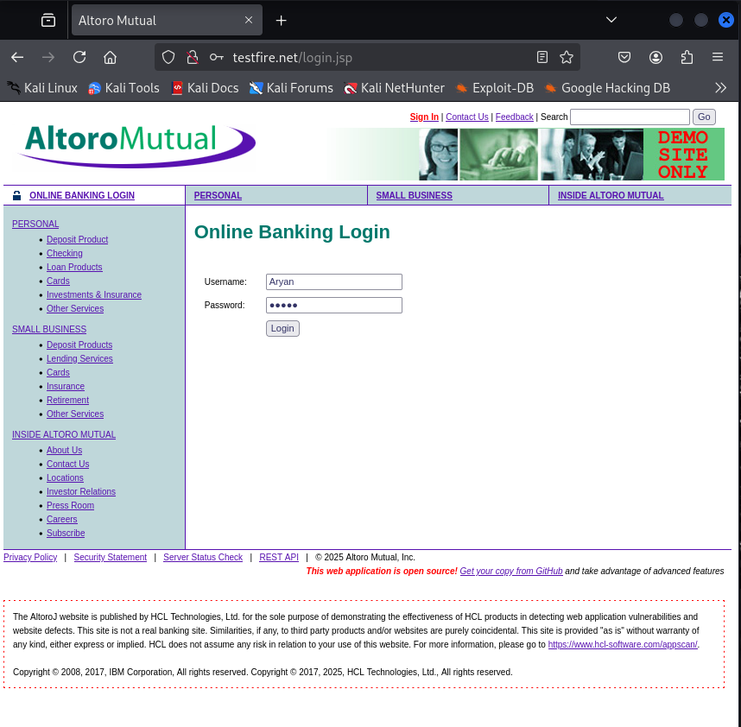

8. Captured login id and password using wireshark
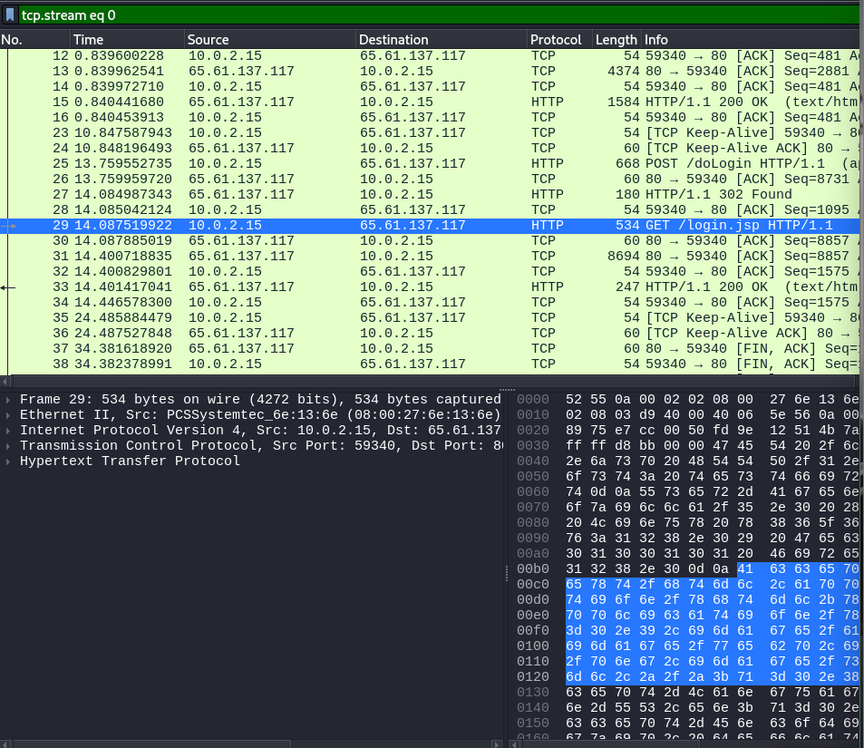

9. Found password and userid by follow up the login.jsp
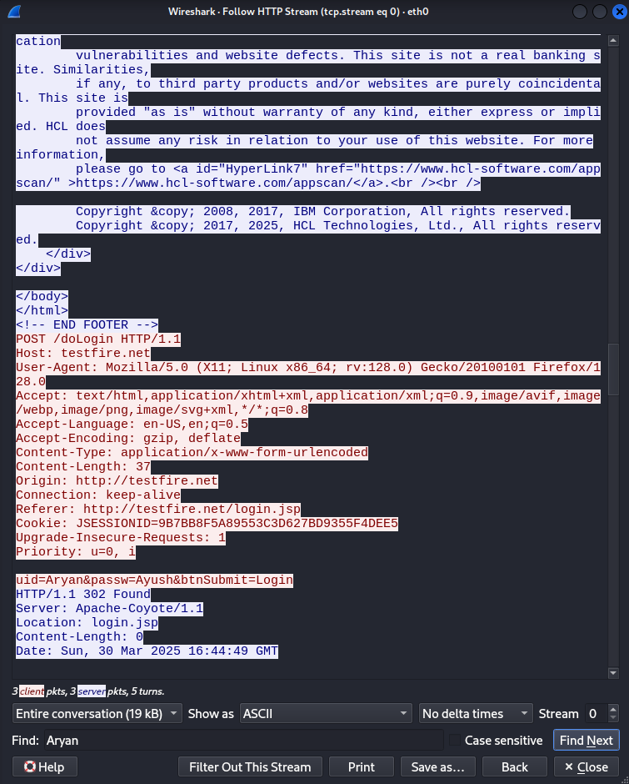

Graphical Report of the pcap file in apackets
1. Overall Data view
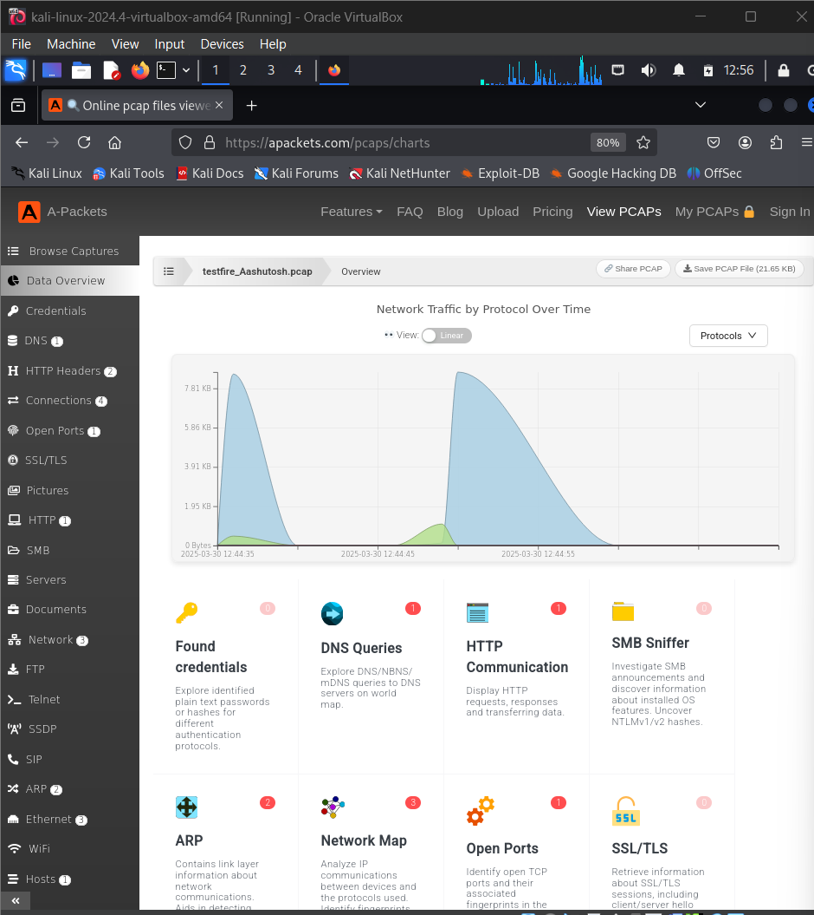

2. Dns
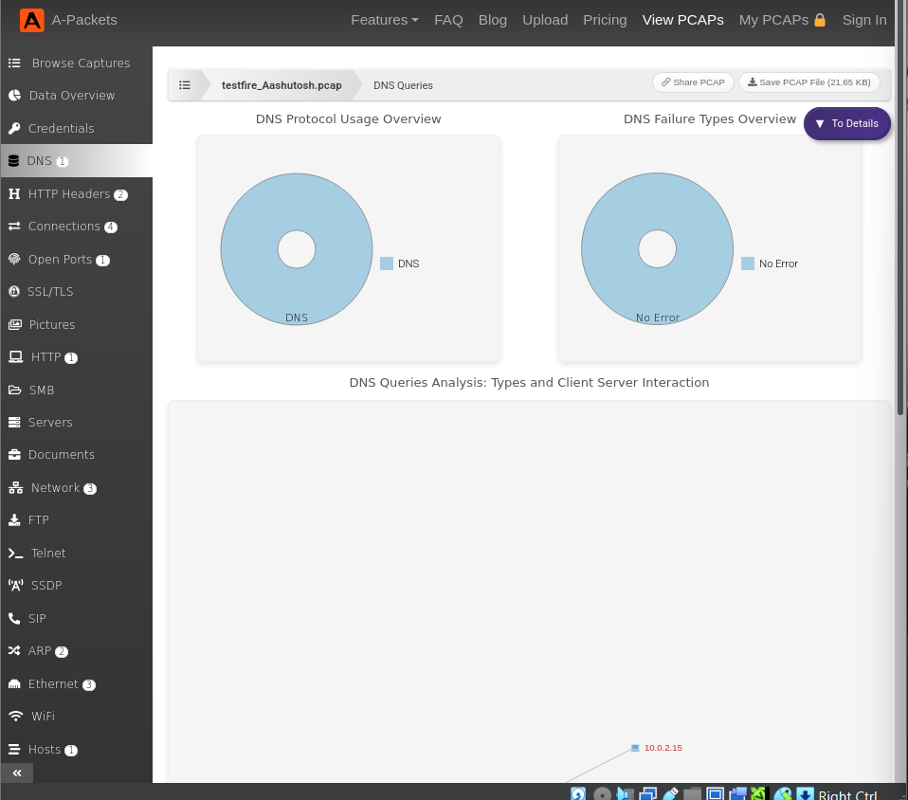

3. HTTP Headers
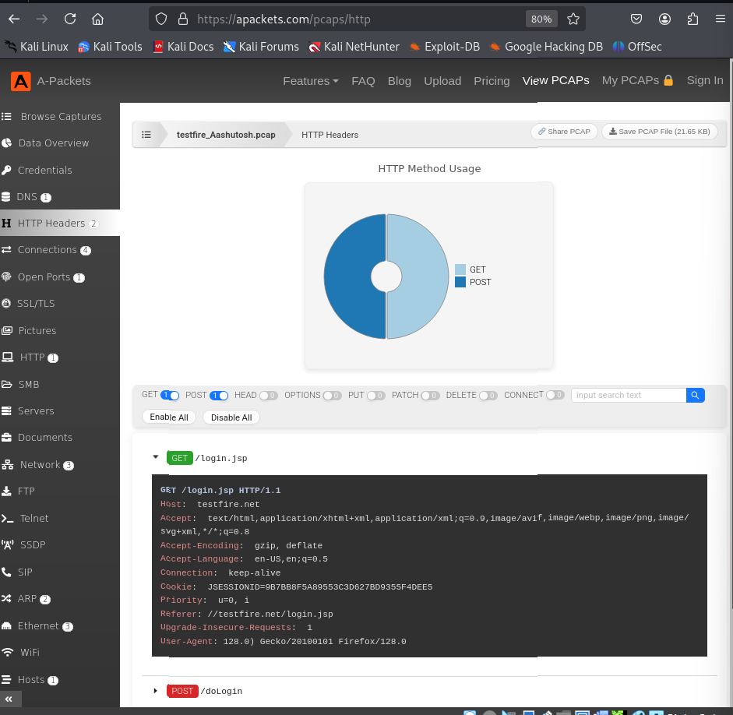

4. Connections from the world
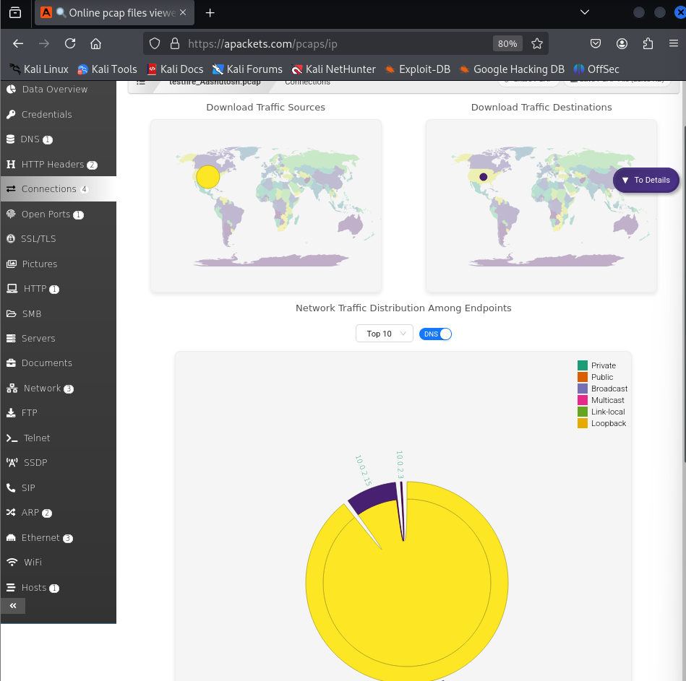

5. Network
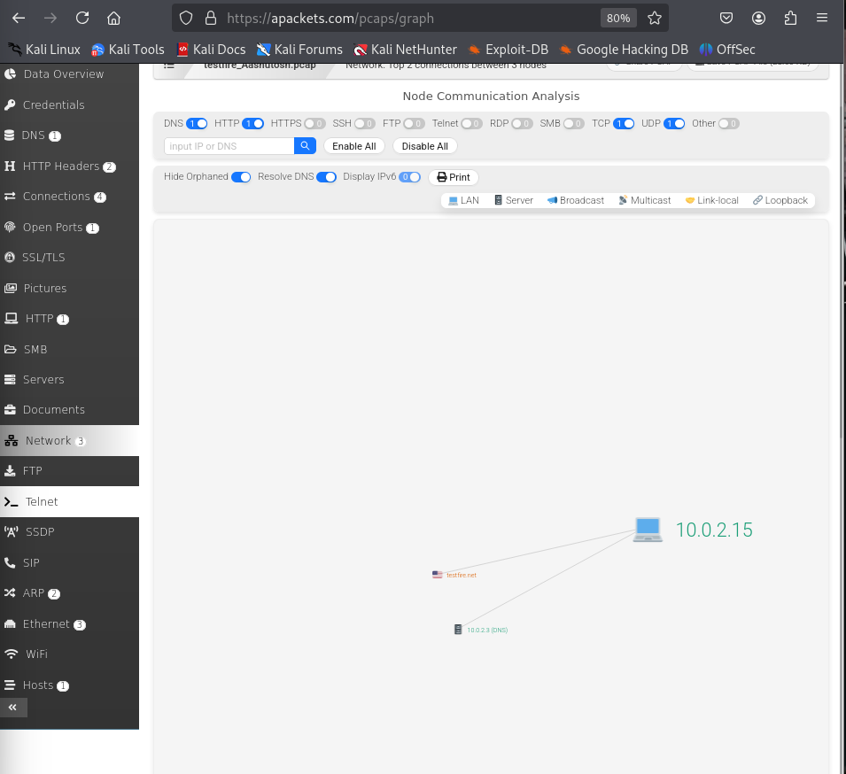

6. Host Details
