### VISVESVARAYA TECHNOLOGICAL UNIVERSITY

**BELGAVI**



**COMPUTER GRAPHICS MINI-PROJECT REPORT**

**ON**

**3 WAY HANDSHAKING**

Submitted By

**ASHUTOSH ASHAR NAWAB**

**1AT17CS011 1AT17CS040**

Submitted in partial fulfilment of the requirement for the Degree of Bachelor of Engineering

In

Computer Science & Engineering

Under the Guidance of

**Mrs. Pallavi T P**

Asst. Professor

Computer Science and Engineering Department

Atria Institute of Technology

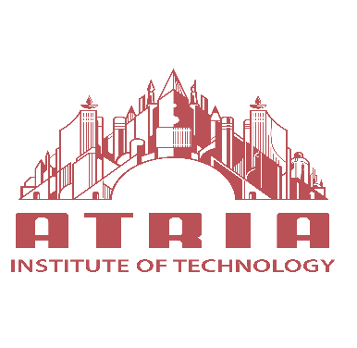

**Atria Institute of Technology**

CERTIFICATE

This is to certify that the project entitled 3 WAY HANDSHAKING has been successfully completed by

**ASHUTOSH ASHAR NAWAB**

**1AT17CS011 1AT17CS040**

In partial fulfilment for the Computer Graphics mini-project report [17CS62] - VI semester, B.E. Computer Science during 2019-2020.

Signature of the Guide Signature of HOD

Mrs. Pallavi T P Dr.Aishwarya P

**DECLARATION**

### We, ASHUTOSH and ASHAR NAWAB, Students of 6th Semester B.E. in Computer Science and Engineering at Atria Institute of Technology, hereby declare that the project work entitled “3 WAY HANDSHAKING” has been carried out by us under the supervision of Mrs. Pallavi T P, Dept. of CS&E, Atria Institute of Technology and submitted in partial fulfillment of the course requirements for the award of degree in B.E. in Computer Science and Engineering of Visvesvaraya Technological University Belgavi during the year 2019-2020. We further declare that the report has not been submitted to any other university for the award of any other degree.

Place: Bangalore ASHUTOSH(1AT17CS011)

Date: ASHAR NAWAB (1AT17CS040)

Technical Report · June 2020

Department of Computer Science

Report on

3 WAY HANDSHAKING

By

ASHUTOSH -1AT17CS011

AND

ASHAR NAWAB-1AT17CS040

Contents

1. System requirements
2. Visualization of Three Way Handshake Mechanism of TCP/IP
3. Introduction
4. DESIGN
5. EXISTING SYSTEM
6. PROPOSED SYSTEM
7. TRANMISSION CONTROL PROTOCOL
8. BRIEF HISTORY OF OPENGL
9. OBJECTIVES OF THE PROJECT
10. WOKING OF THREE WAY HANDSHAKE
11. Conclusion
12. REFERENCES
13. RESULTS AND SCREENSHOTS

**SOFTWARE AND HARDWARE SPECIFICATIONS**

**HARDWARE REQUIREMENTS:**

|  |  |  |
| --- | --- | --- |
| Processor | : | Intel P-IV based system and above |
| Processor Speed | : | 2.0. GHz and above |
| RAM | : | 2GB and above |
| Hard Disk | : | 40GB and above |

Visualization of Three Way Handshake Mechanism of TCP/IP

Abstract: The three way hand shake in transmission control protocol (also called the three message hand shake) is the method used to establish and tear down network connections. These hand shaking technique is referred to as the three way hand shake or as “SYN-SYN-ACK”(or more accurately SYN,SYN-ACK,ACK).The Transmission Control Protocol(TCP) hand shaking mechanism is designed so that two computers attempting to communicate can negotiate the parameters of the network connection before beginning communication. This process is also designed so that both ends can initiate and negotiate separate connections at the same time. This three way handshake is implemented in Computer Graphics using OpenGL by using Microsoft Visual Studio 2008. Keywords: Three Way Handshake, Transmission control protocols, computer networks, OpenGL, Microsoft Visual Studio 2008

**INTRODUCTION**

A three-way-handshake is a method used in a TCP/IP network to create a connection between a local host/client and server. It is a three-step method that requires both the client and server to exchange SYN and ACK (acknowledgment) packets before actual data communication begin. A three-way-handshake is also known as a TCP handshake. To begin communicating, connection-oriented TCP uses what is known as the three-way handshake. When Host A wants to connect to Host B to transfer data, it has to let Host B know that it wants to connect. Host A does this by sending a packet to Host B with the SYN (or synchronization) flag set, meaning, "I want to start a new conversation." If Host B can and wants to converse back to Host A, it returns a packet with the SYN and ACK (or acknowledgment) flags set, meaning, "I want to start a conversation with you too and I am acknowledging that I will be a part of your conversation." Finally, Host A returns the third part of the handshake, a packet with just the ACK flag set, meaning, "I will also take part in your conversation, so let's start talking!" With that, data begins transferring. In a simplified view, the two hosts are simply exchanging SYN flagged packets to say they want to start a conversation and ACK flagged packets to say They acknowledge the receipt of the SYN. The second host simply "piggybacks" its acknowledgment onto the same packet that contains its initiating SYN. Till now three way handshake have been demonstrated using the socket programming, Java Virtual Machine and macromedia flash player and also implemented in distributed computing to achieve good speed which can be provided by three way handshake than four handshake and it is also used for key exchange in IEEE 802.11i. Here we are visualizing the working of three way handshake using OpenGL in computer graphics. In this one can easily understand how the three way handshake works. It is different from available survey because we demonstrated the working of three way handshake using OpenGL that is a software interface for graphics hardware using Microsoft Visual C++ 2008 software. This project gives the more realistic visualization of three way handshake.

### OBJECTIVES OF THE PROJECT

• To implement the concepts of computer graphics.

• To design an interactive demo of working of client-server model.

• Simulation of data transmission between client and server using TCP.

• Simulation of data transmission between client and server using UDP.

• Simulation of data transmission from one client to another using server as a centralized system.

**EXISTING SYSTEM**

A. Authentication and key exchange is a challenging area in wireless networks. The authentication process of IEEE 802.11i is using the standards of IEEE 802.1X for authentication; and for key management and distribution, 4-way handshake protocol is used. Due to various design flaws, 4-way handshake is incapable in providing the security and performance. In this paper they have proposed a new technique for key exchange which is able to provide an enhance security in comparison with 4-way handshake protocol. This enhanced technique called, 3-way handshake, is able to provide security against DOS attacks, dictionary attacks, replay attacks and passive attacks.

B. Distributed computing has a special role in computer world, especially when we want to do massive process. The special advantage of distributed computing is its speed and unfortunately sometimes this speed due to lack of agents or algorithmic mistakes decrease. In this paper they have introduced a new method for preventing of speed decreasing by using three way handshaking, and results compared to each other before and after using this technique. Finally, some suggestions are presented. From this paper we got the advantage of three way handshake in the prevention of reduction in speed in distributed computing.

C. Animation of Working of Three Way Handshake using Java Virtual Machine and Macromedia Flash Player This animation again highlights the connection setup process. Unlike the previous animation which showed packets flowing between hosts, this animation builds a signal sequence diagram showing the timing of packet transmissions during connection setup. Often the reliable connection setup process used by TCP is called the "Three Way Handshake" due to the fact that a three stage process is employed (the animation shows this process well).We referred this paper for implementation purpose.

D. Communication Networks Fundamental Concepts and Key Architecture, Alberto Leon Garcia and Indra Widjaja, 2nd Edition, Tata McGraw-Hill, India. We have referred this book to get the information about the working of three way handshake.

E. Edward Angel Interactive Computer Graphics-A Top-Down Approach with OpenGL.5th Edition, Pearson Education, and 2008.We have referred this book to get the information about the OpenGL functions for implementation.

**PROPOSED SYSTEM**

We have implemented the visualization of working of three way handshake of TCP/IP in OpenGL using Microsoft Visual C++ 2008.It visualizes the real time working of three way handshake. Here we have shown all the conditions of three way handshake during connection establishment like safe sending, packet crashing and timeout.

**TRANMISSION CONTROL PROTOCOL**

TCP/IP (Transmission Control Protocol/Internet Protocol) is the basic communication language or protocol of the Internet. It can also be used as a communications protocol in a private network (either an intranet or an extranet). When you are set up with direct access to the Internet, your computer is provided with a copy of the TCP/IP program just as every other computer that you may send messages to or get information from also has a copy of TCP/IP. TCP/IP is a two-layer program. The higher layer, Transmission Control Protocol, manages the assembling of a message or file into smaller packets that are transmitted over the Internet and received by a TCP layer that reassembles the packets into the original message. The lower layer, Internet Protocol, handles the address part of each packet so that it gets to the right destination. TCP/IP uses the client/server model of communication in which a computer user (a client) requests and is provided a service (such as sending a Web page) by another computer (a server) in the network. TCP/IP communication is primarily point-to-point, meaning each communication is from one point (or host computer) in the network to another point or host computer. TCP/IP and the higherlevel applications that use it are collectively said to be "stateless" because each client request is considered a new request unrelated to any previous one.

**BRIEF HISTORY OF OPENGL**

OpenGL was developed by Silicon Graphics and is popular in the video games industry where it competes with Direct3D on Microsoft Windows IrisGL, a proprietary graphics API, is the precursor of OpenGL. It is developed by Silicon Graphics Inc. (SGI). IrisGL was used as the starting point of an open standard for computer graphics that would save time porting applications by avoiding direct hardware access. After SGI cleaned up IrisGL and opened up the standard to other companies, OpenGL was born. In 1992 the OpenGL Architectural Review Board (OpenGL ARB) was established. The OpenGL ARB is a group of companies that maintain and update the OpenGL standard. In 2003 the first OpenGL (Exchange Specification) ES specification was released. OpenGL ES is a subset of OpenGL designed for mobile phones, embedded devices and video game systems. In 2004 the OpenGL 2.0 specification was released, including the GLSL (OpenGL Shading Language) specification. In August 2008, the OpenGL 3.0 specification was released.

**DESIGN**

The entire project is itself designed in C++ using Visual Studio. The simulation is performed by considering 1 server in the center and 4 clients around it. The server is centralized i.e. all the communications among the clients has to be done through the server itself.

Client 1 makes use of TCP to transmit data to the server. Similar to HTTP, the client first sends a client request to the server and the server responds with the server response. The Client, after receiving the server response can again transmit the data (if any) to the server and similarly, the server also can transmit the data to the client. Client request and response are demonstrated using animating lines.  
Client 2 makes use of UDP to transmit data to the server. In this case, there is no need of handshaking. Instead, the data is directly pushed towards the server and vice versa. In UDP, there is no method to detect packet loss. In this case datagram packet transmission is shown using animating lines.  
Client 3 and Client 4 demonstrate how data is transmitted among these 2 clients through the central server. First one client (say client 3) uploads some data to the server (that is not present in the server). If the same data is required by another client (say client 4), they download it from the server itself. Notice that client to client data transmission is not possible without the influence of server.

**WOKING OF THREE WAY HANDSHAKE**

Before any host can send data a connection must be established. TCP establishes the connection using a three way hand shake procedure. Client sends a connection request to server by setting the SYN bit. Client also register its initial sequence number to use (seq_no=x).Server acknowledges the request by setting the ACK bit and indicating next data byte to receive (ACK_no=x+1).The “plus one” is needed because the SYN bit consumes one sequence number. At the same time, server also sends a request by setting the SYN bit and registering its initial sequence number to use (seq_no=y).Client acknowledges the request from server by setting the ACK bit and confirming the next data byte to receive (ACK_no=y+1).Note that the sequence number is set to x+1.On receipt at server the connection is established. If during a connection establishment phase one of the host decides to refuse connection request, it will send a reset segment by setting the RST bit. Each SYN message can specify options such as maximum segment size, window scaling and time stamps. In this project the communication between the sender and receiver has been demonstrated where the sender is acting as client and the receiver is acting as server. In safe sending condition the sequence no. of SYN and ACK bit are unique so the connection is safe the frames will reach the correct destination. In packet crashing since the sequence no. of SYN and ACK is same and according to three way handshake the connection must be in the form of SYN,SYN-ACK,ACK form but here in packet crashing the last form ACK is acting as SYN_ACK form so the frame will be lost and no acknowledgement will be received so next frames won't get the proper acknowledgement from the receiver so the packet crashing will occur. In time out condition the frames will not reach the destination in proper time so the packets will be duplicated and discarded.

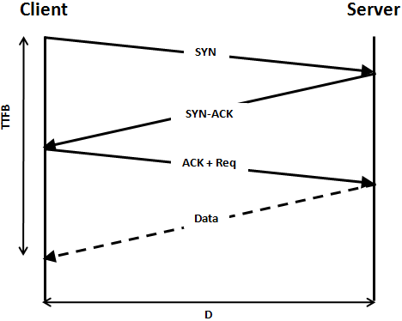

The above snapshot shows the condition of packet crashing. In packet crashing the traffic between the connection and transmission of packets has shown, it is because the sequence numbers are same not unique. 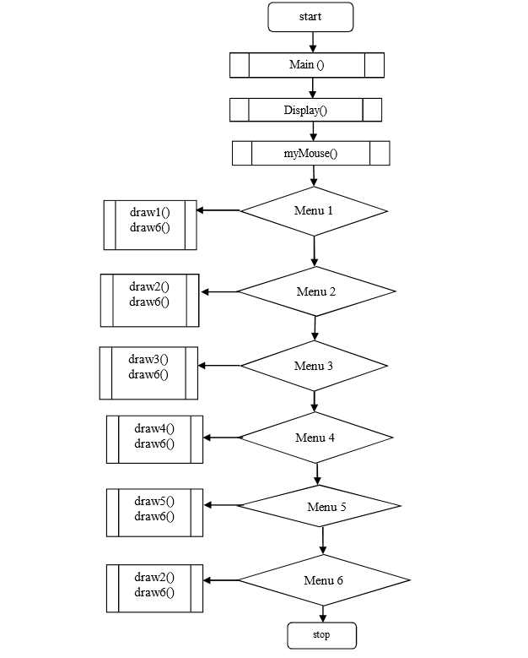

The above flow chart shows the user interfaces used in the project. In this the user interfaces are keyboard and mouse. The mouse interface is to select the window from the menu screen and the keyboard is used to ensure whether to continue with the current window or not for that we have used Y/N letters Y to be in the current window N to exit from the current window.

**CONCLUSION**

This project deals with the Demonstration of three way handshake. All the things from successful sending to packet loss as well as the Ack sending and the loss is well demonstrated. There is also timer show to make the project look more realistic. The project is wholly represented the flow of packets in a network and the various aspect that challenges to it. Usages: Welcome screen open and which remain for few seconds and the second page where you will find different menu to view the different demos.

Select the menu and see what you want to view.

SEND WINDOW: View the sender window

RECEIVE WINDOW: View the receiver window

SAFE SENDING: Demonstrates the sending of packet from source to destination

PACKET CRASHING: The loss and crashing of packet is demonstrated.

TIME OUT: Demonstrates the packets those which didn't reach at the proper time.

EXIT: Close the program.

**REFERENCES**

[1] Behrouz A. Forouzan: Data Communication and Networking, 4th Edition Tata McGraw-Hill 2006.

[2] Fundamentals Concepts and Key Architecture –Alberto Leon Gracia and Indra Widjaja, 2nd Edition Tata McGraw –Hill.

[3] Edward Angel: Interactive Computer Graphics-A Top-Down Approach with OpenGL 5th Edition, Pearson Education, 2008.

[4] Davis Chapman, Sam’s Teach yourself Visual C++ 6.0 in 21 days,SAMS, 1998,ISBN 0-672-31240-9 Behrouz A .Foruzan,Data Communication and Networking,4th edition Tta McGraw-Hill,2006.

[5] James D. Foley, Andres Van Dam, Steven K. Feiner, John F. Hughes, Computer Graphics, Addison-Wesley, 1997.

[6] Woo, Neider, Davis, Shreiner, OpenGL Programming Guide, Addison Wesley, 3rd edition, ISBN 0-201- 60458-2.

[7] Richard S.Wright, Jr., Michael Sweet, OpenGL Super Bible, Waite Group press, 2nd edition, ISBN 1-57169-164-2.

**RESULTS AND SCREENSHOTS**

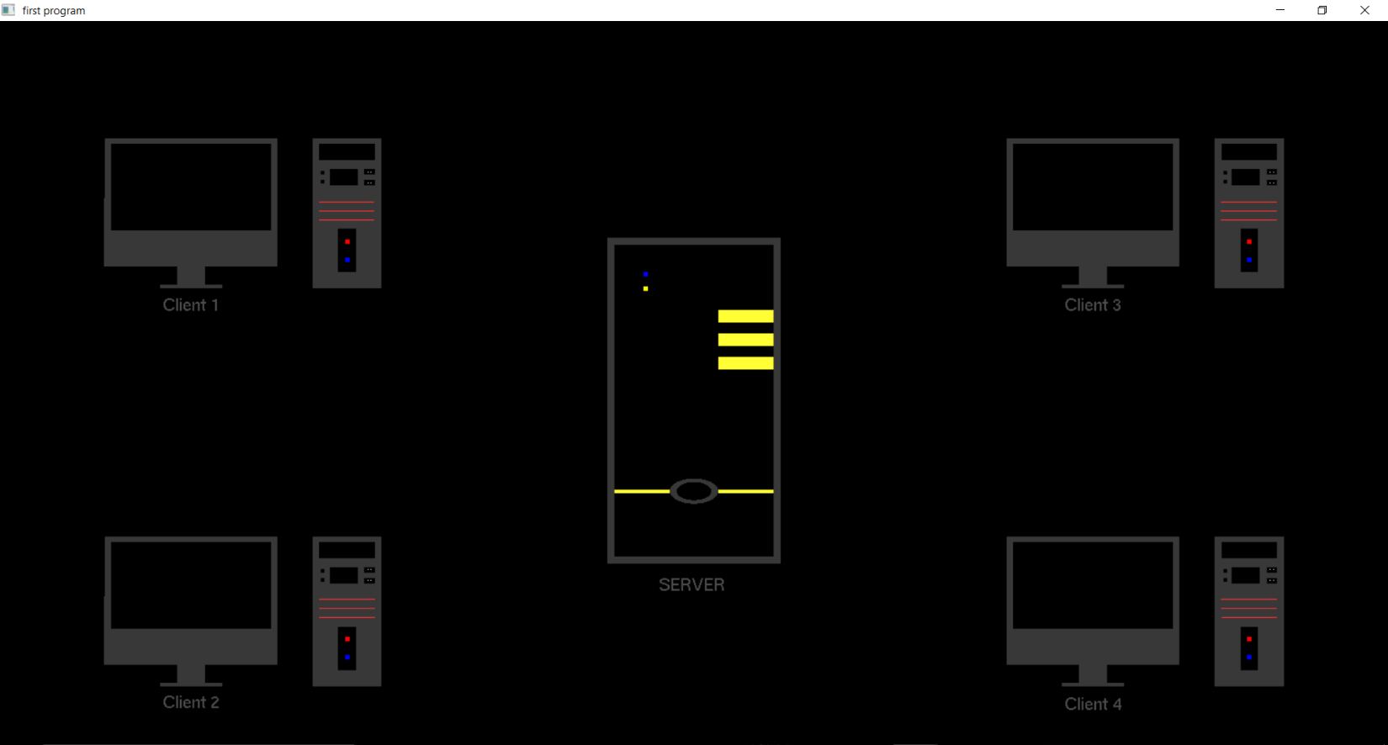**Design**

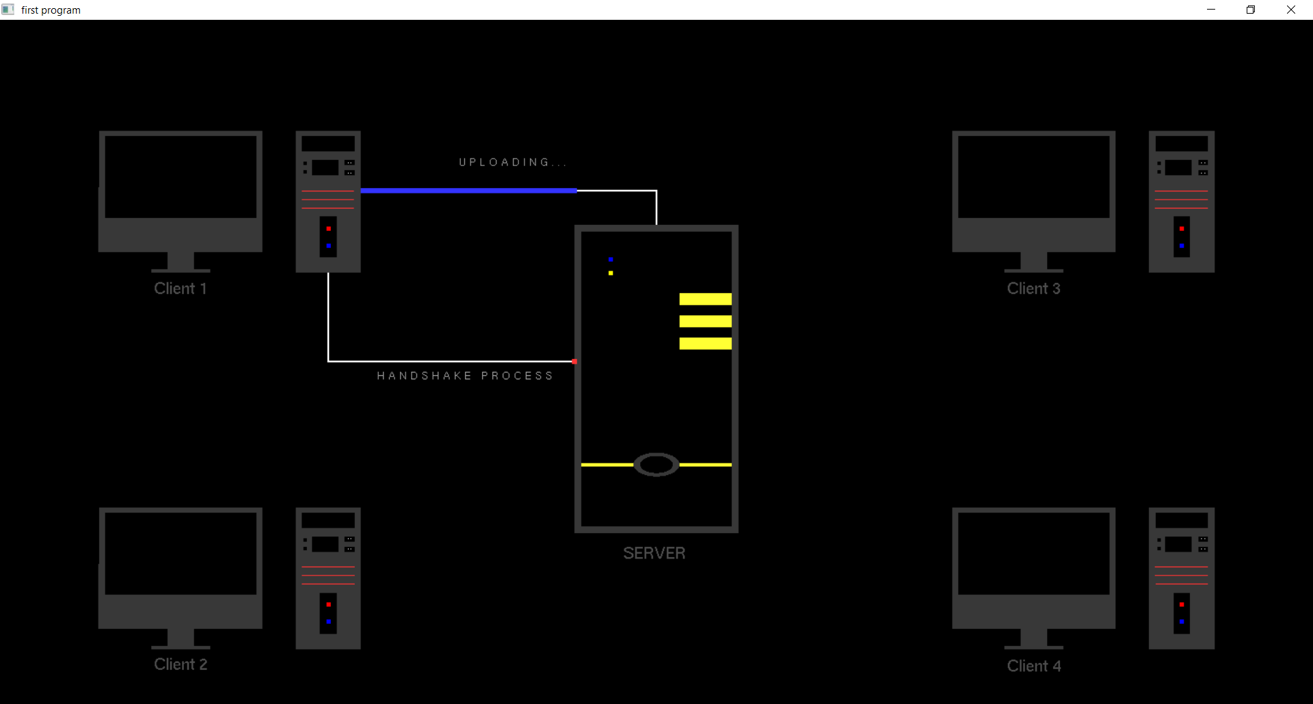

**Client Upload**

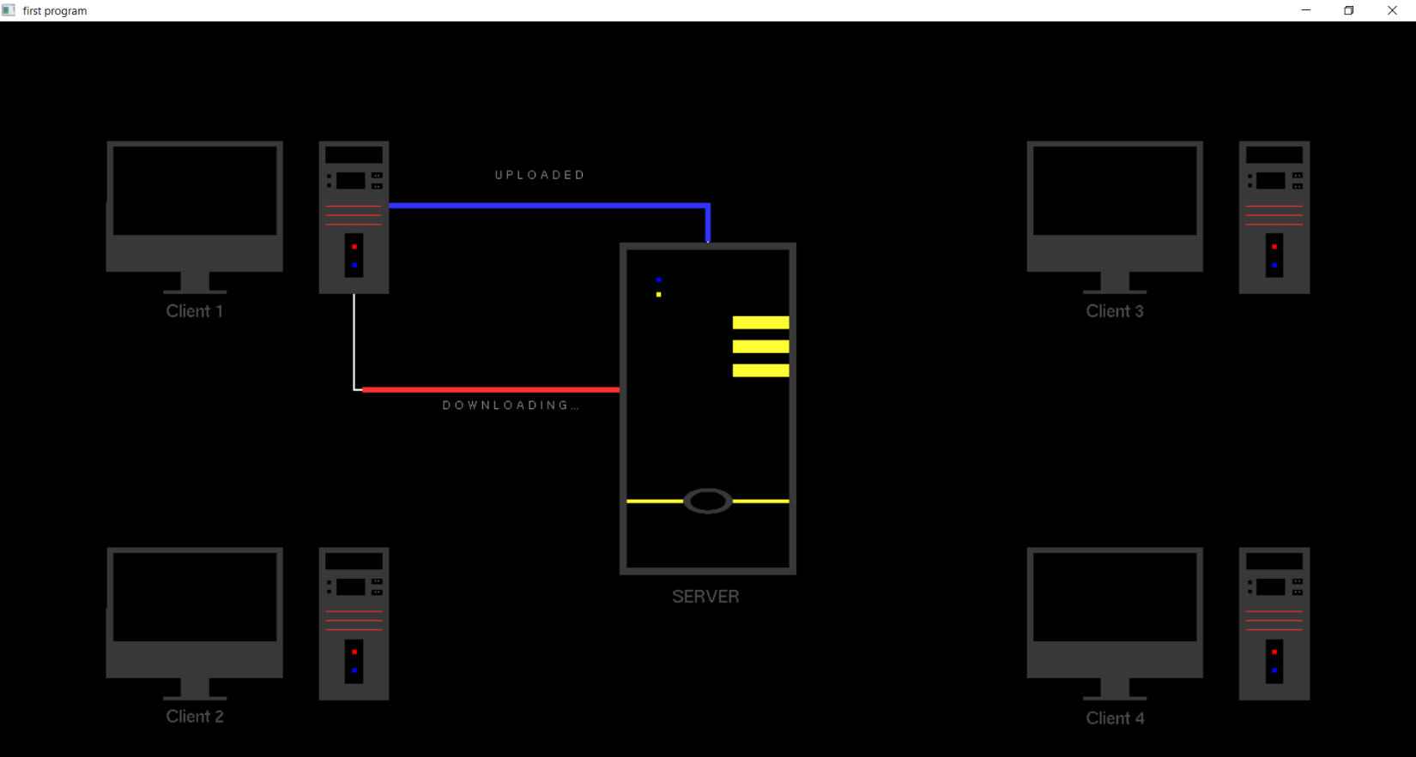

**Client Download**

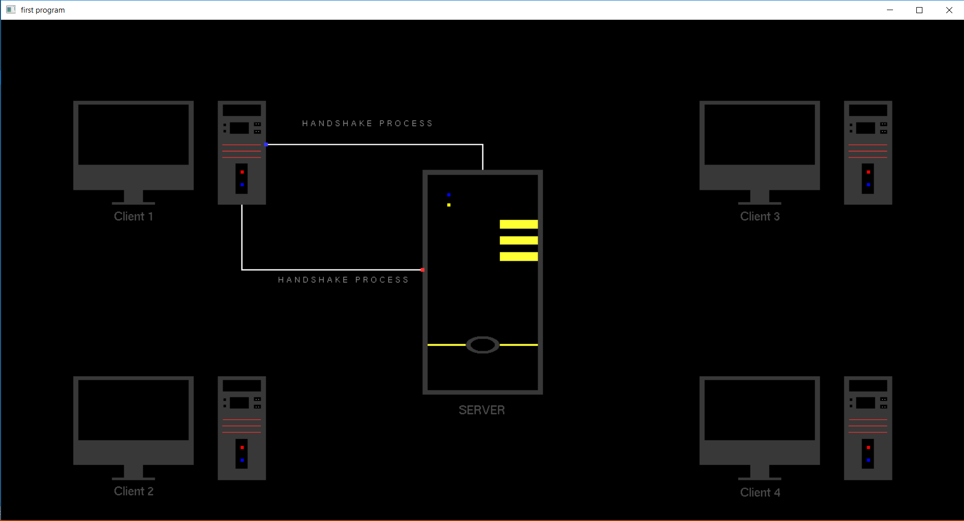

**HANDSHAKING**

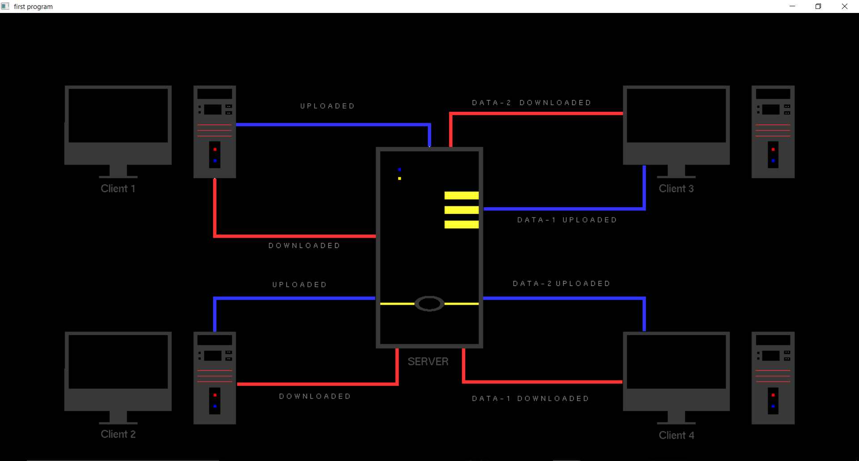

**FINAL Handshaking of between Client & Server**