Contents

1. User Management 3

1.1. SRS 3

1.2. Activity Diagram 4

1.3. Sequence Diagram 5

1.4. Entity Relationship Diagram 6

1.5. Use case Diagram 7

1.6. Wireframes 8

2. Appointment Management 12

2.1. SRS 12

2.2. Activity Diagram 13

2.3. Sequence Diagram 14

2.4. Entity Relationship Diagram 15

2.5. Use Case Diagram 16

2.6. Wireframe 17

3. Email Reminders 19

3.1. SRS 19

3.2. Activity Diagram 20

3.3. Sequence Diagram 21

3.4. Entity 22

3.5. Use case Diagram 23

3.6. WireFrame 24

4. Report Sharing 25

4.1. SRS 25

4.2. Activity Diagram 26

4.3. Sequence Diagram 27

4.4. Entity Relationship Diagram 28

4.5. User case Diagram 29

4.6. Wireframe 30

5. Prescription management 31

5.1. SRS 31

5.2. Activity Diagram 32

5.3. Sequence Diagram 33

5.4. Entity Relationship Diagram 34

5.5. Use case Diagram 35

5.6. Wireframe 36

6. Payment System 37

6.1. SRS 37

6.2. Activity Diagram 38

6.3. Sequence Diagram 39

6.4. Entity Relationship Diagram 40

6.5. Use case diagram 41

7. Testing 42

7.1. User Management 42

Register 42

Login 42

7.2. Email Reminder 42

# User Management

## SRS

|  |  |
| --- | --- |
| Requirements | Type |
| Users can register with a unique username, email, and password | Functional Requirement |
| Users can log in and log out securely. | Functional Requirement |
| Users can update their profile information (e.g., name, contact details). | Functional Requirement |
| Admins can create, read, update, and delete user accounts. | Functional Requirement |
| System should support different authentication methods (e.g., OAuth, social login) | Functional Requirement |
| User data must be encrypted both in transit and at rest | Non-Functional Requirement |
| - User interface should be user-friendly and accessible. | Non-Functional Requirement |

## Activity Diagram

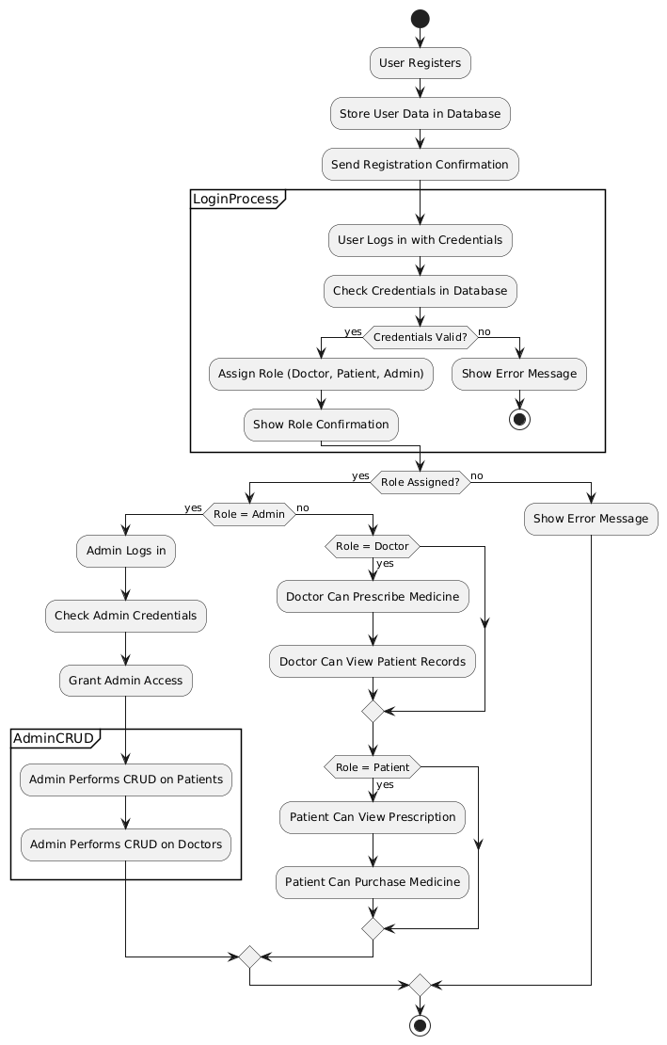

## Sequence Diagram

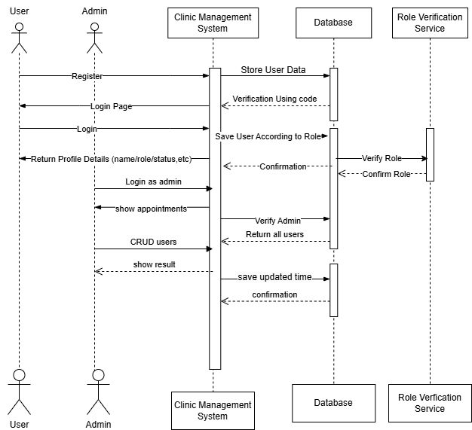

## Entity Relationship Diagram

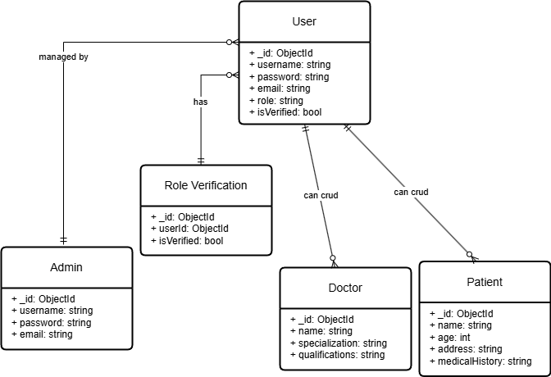

## Use case Diagram

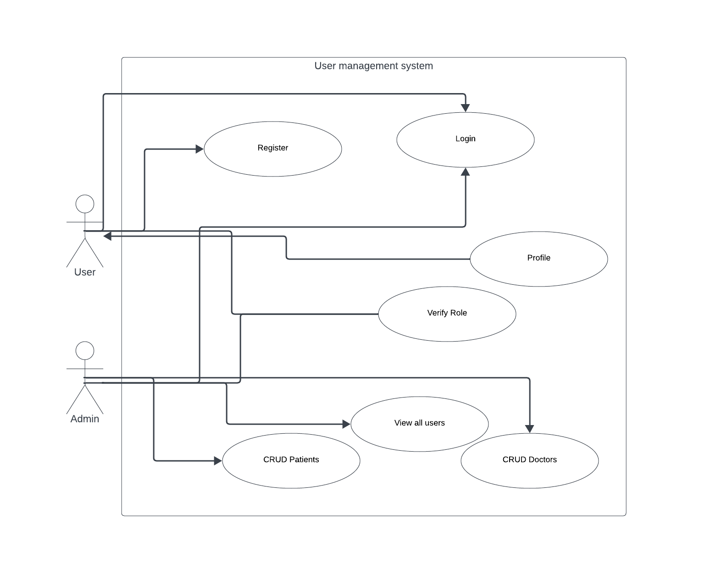

## Wireframes

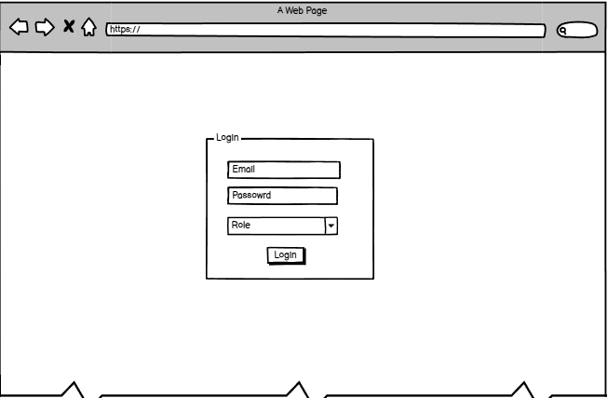

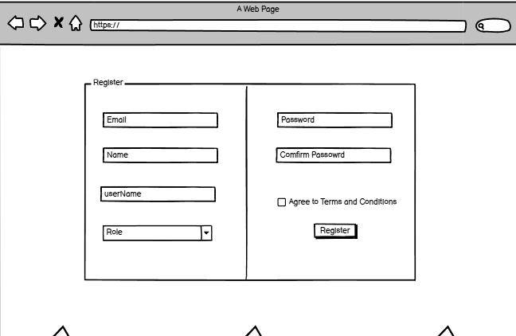

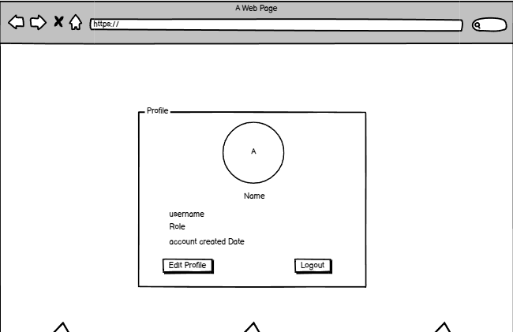

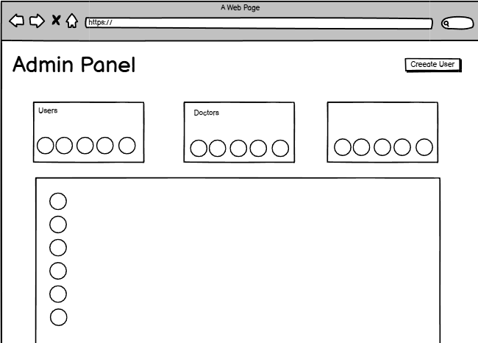

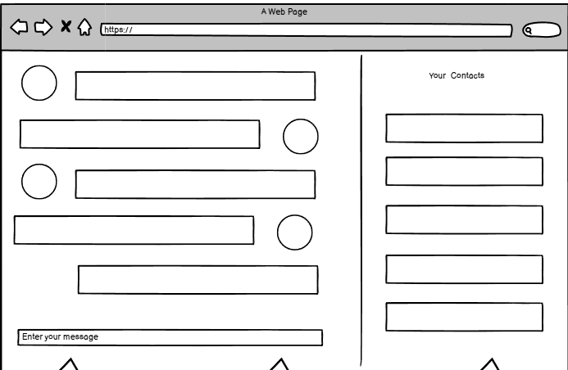

# Appointment Management

## SRS

|  |  |
| --- | --- |
| Requirements | Type |
| Patients can book, reschedule, and cancel appointments | Functional Requirement |
| Doctors can manage their availability and appointments. | Functional Requirement |
| Admins can oversee and resolve scheduling conflicts. | Functional Requirement |
| Email for upcoming appointments. | Functional Requirement |
| Must provide real-time appointment updates. | Non-Functional Requirement |
| Must be accessible across devices (mobile & desktop) | Non-Functional Requirement |

## Activity Diagram

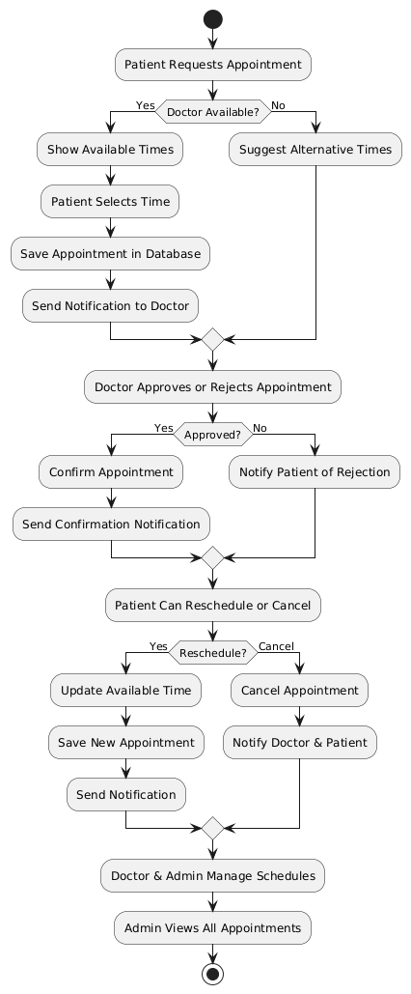

## Sequence Diagram

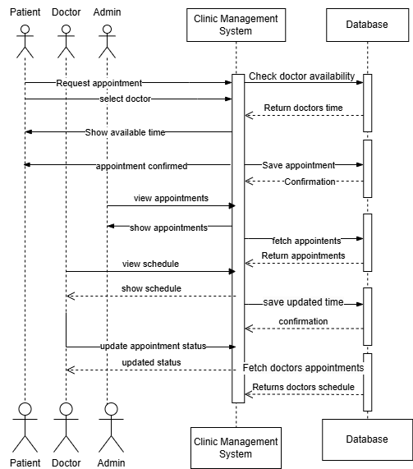

## Entity Relationship Diagram

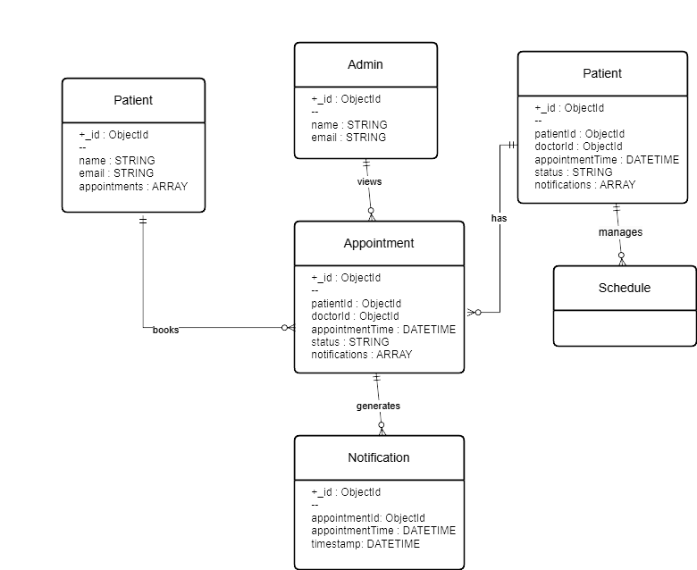

## Use Case Diagram

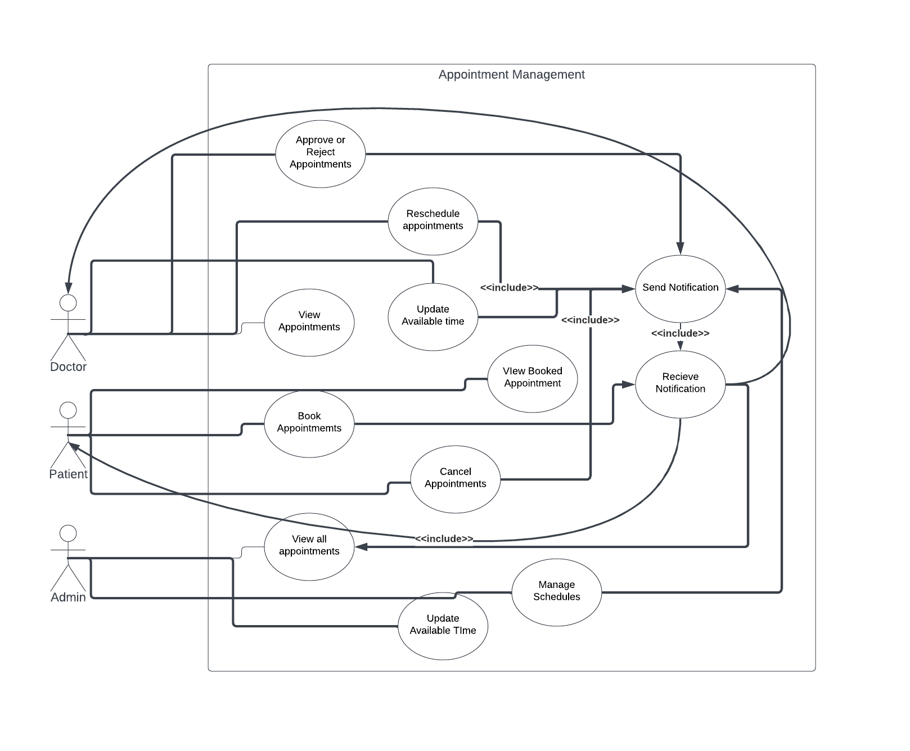

## Wireframe

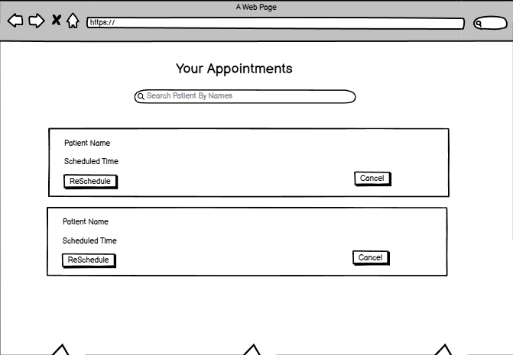

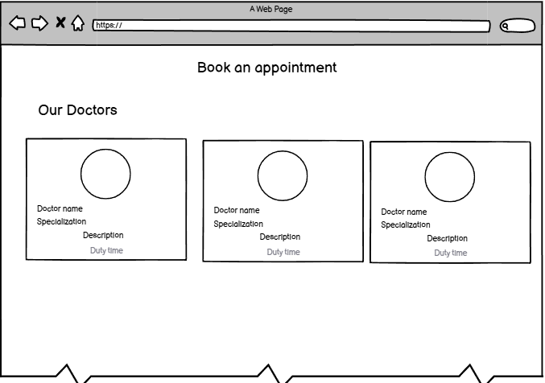

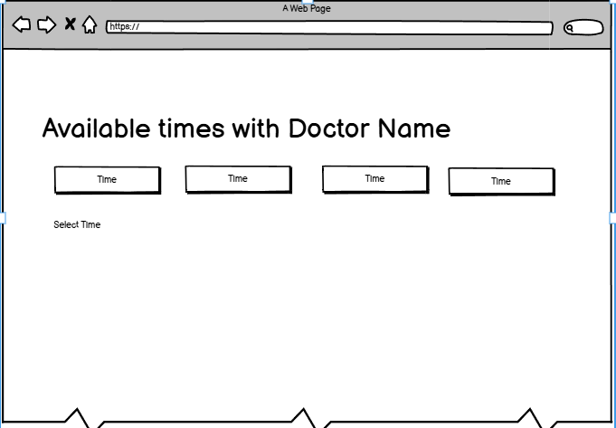

# Email Reminders

## SRS

|  |  |
| --- | --- |
| Requirements | Type |
| System sends automated email reminders before appointments | Functional Requirement |
| Users can enable or disable reminders | Functional Requirement |
| Reminders are sent at configurable intervals | Functional Requirement |
| Emails should comply with spam regulations (CAN-SPAM, GDPR) | Non-Functional Requirement |
| High availability with 99.9% uptime for email service | Non-Functional Requirement |

## Activity Diagram

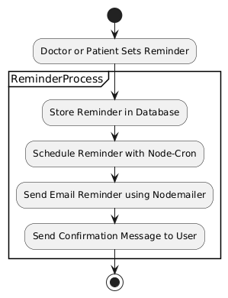

## Sequence Diagram

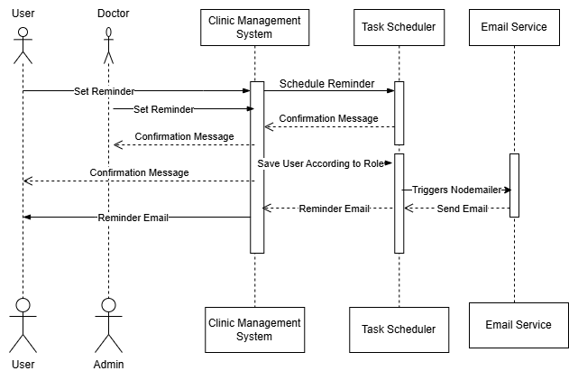

## Entity

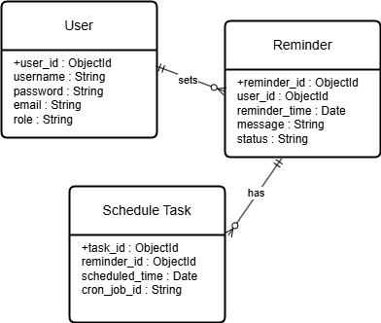

## Use case Diagram

## WireFrame

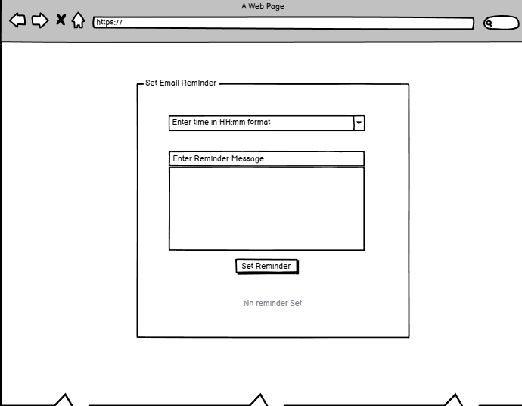

# Report Sharing

## SRS

|  |  |
| --- | --- |
| Requirements | Type |
| Doctors can share reports with patients via email. | Functional Requirement |
| Patients receive secure, downloadable report links | Functional Requirement |
| Reports should be accessible only to authorized users | Functional Requirement |
| Must comply with HIPAA and data privacy laws | Non-Functional Requirement |
| Email delivery must have at least 95% success rate | Non-Functional Requirement |

## Activity Diagram

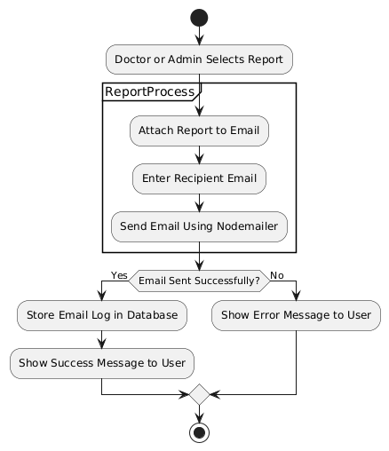

## Sequence Diagram

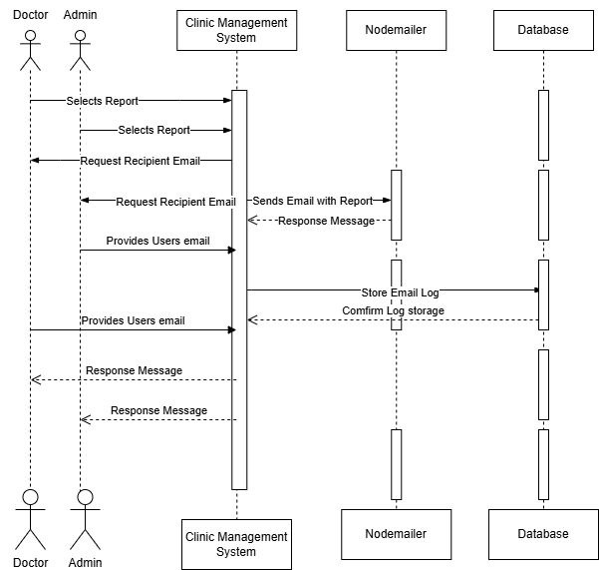

## Entity Relationship Diagram

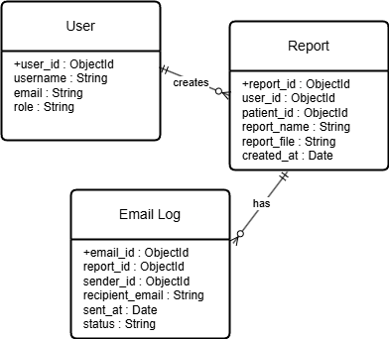

## User case Diagram

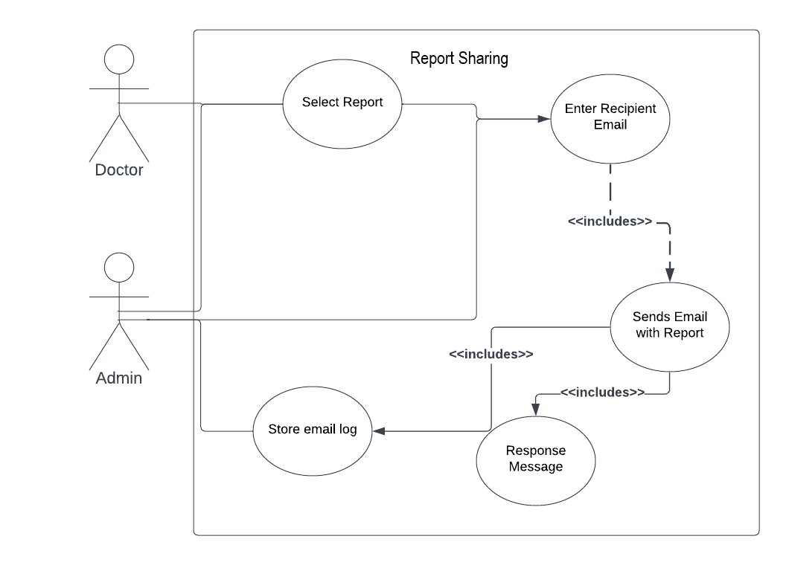

## Wireframe



# Prescription management

## SRS

|  |  |
| --- | --- |
| Requirements | Type |
| Doctors can create, edit, and delete prescriptions | Functional Requirement |
| Patients can view and download their prescriptions | Functional Requirement |
| System integrates with a medicine inventory API. | Functional Requirement |
| Secure access control to prevent unauthorized access | Non-Functional Requirement |
| Prescriptions should be stored for required time | Non-Functional Requirement |

## Activity Diagram

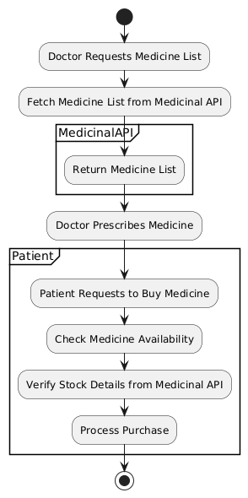

## Sequence Diagram

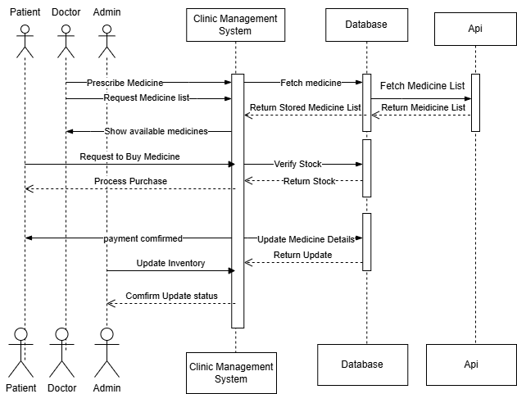

## Entity Relationship Diagram

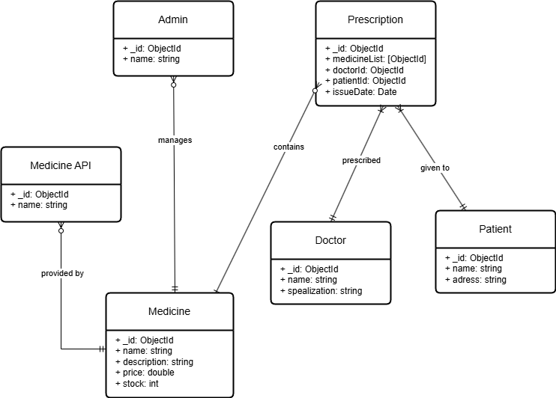

## Use case Diagram

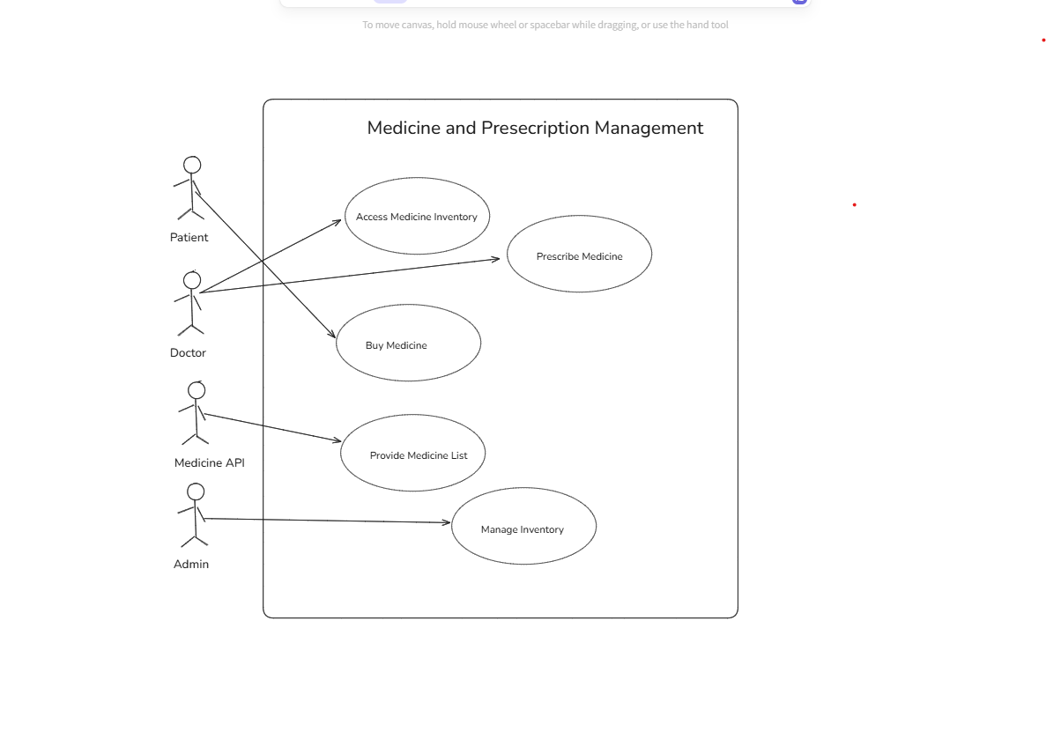

## Wireframe

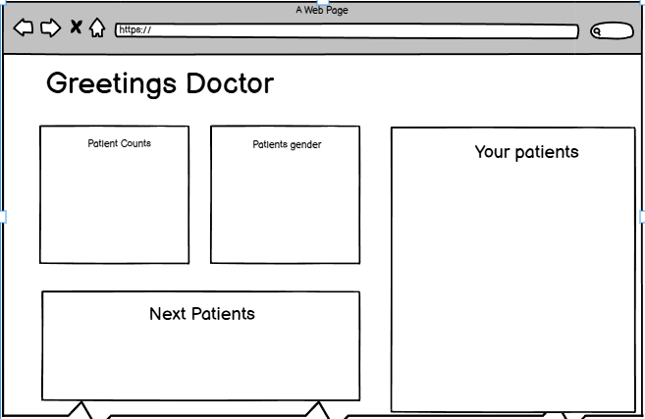

# Payment System

## SRS

|  |  |
| --- | --- |
| Requirements | Type |
| Patients can pay via multiple payment gateways (Stripe, PayPal, Esewa, Khalti). | Functional Requirement |
| Payment status updates should be logged | Functional Requirement |
| Transactions must be encrypted end-to-end | Non-Functional Requirement |
| System should handle peak loads without downtime | Non-Functional Requirement |

## Activity Diagram

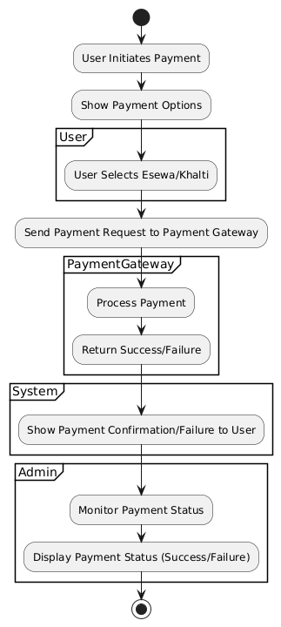

## Sequence Diagram

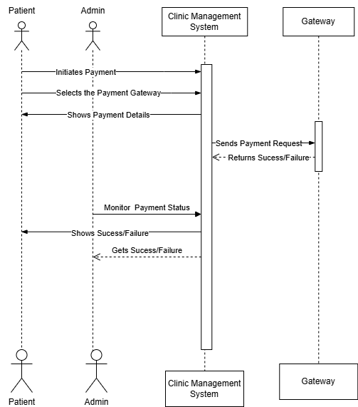

## Entity Relationship Diagram

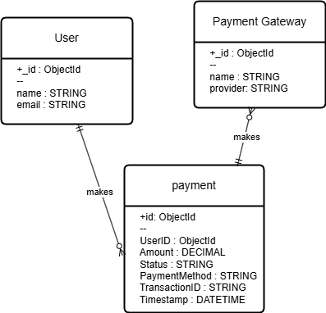

## Use case diagram

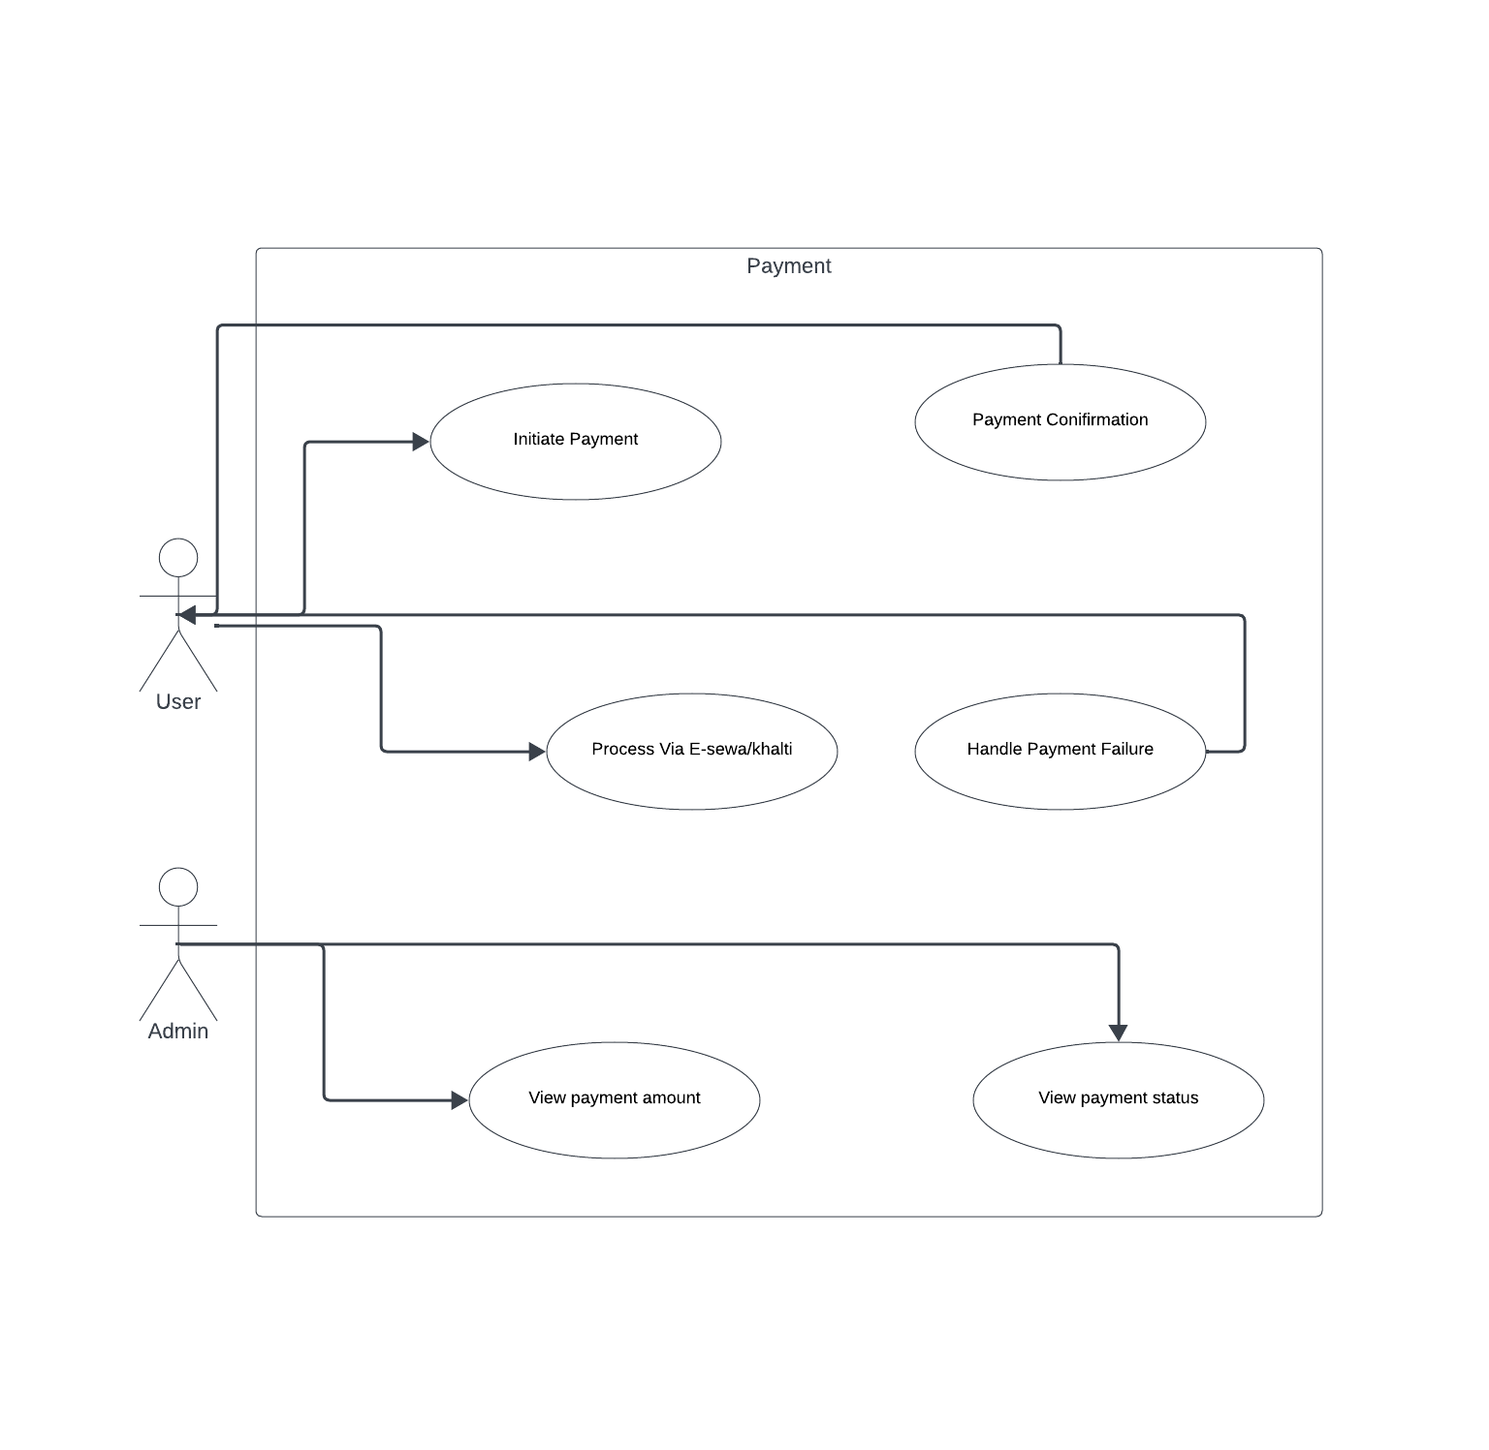

# Testing

## User Management

### Register

Successful Registration

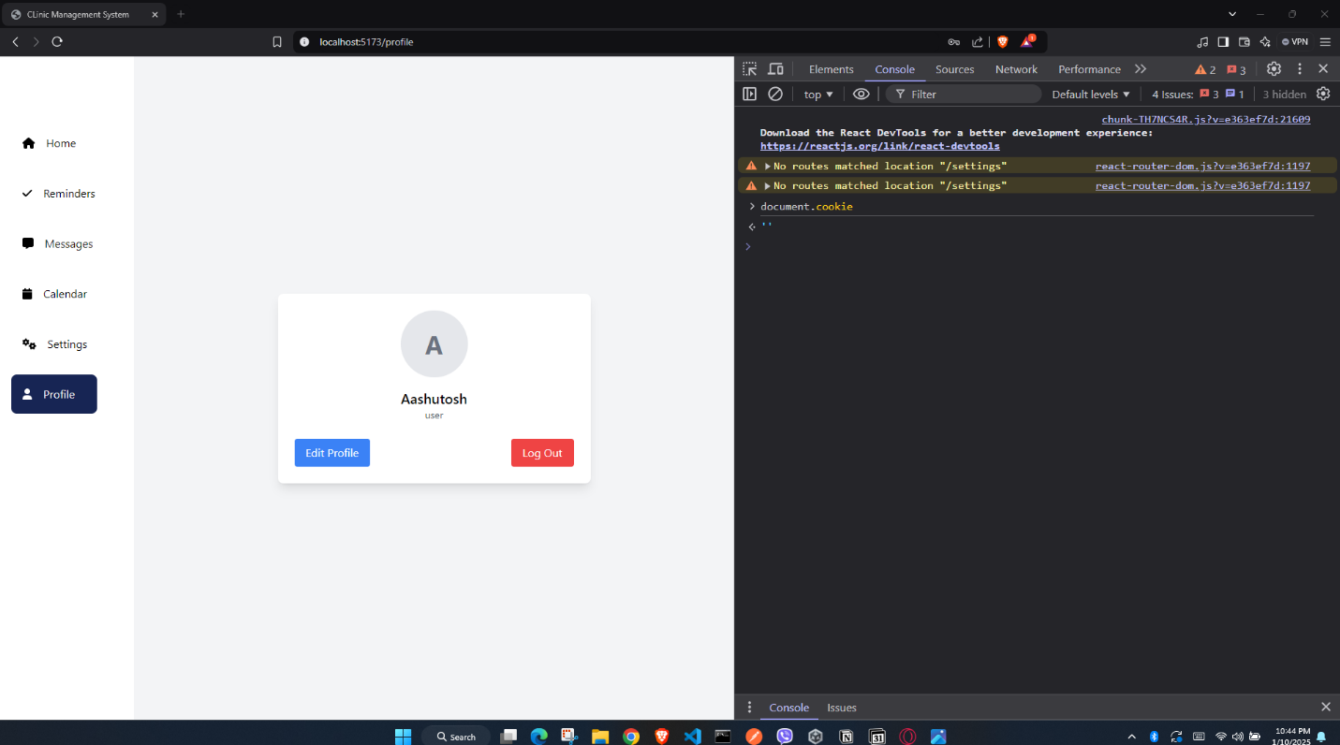

Invalid Email

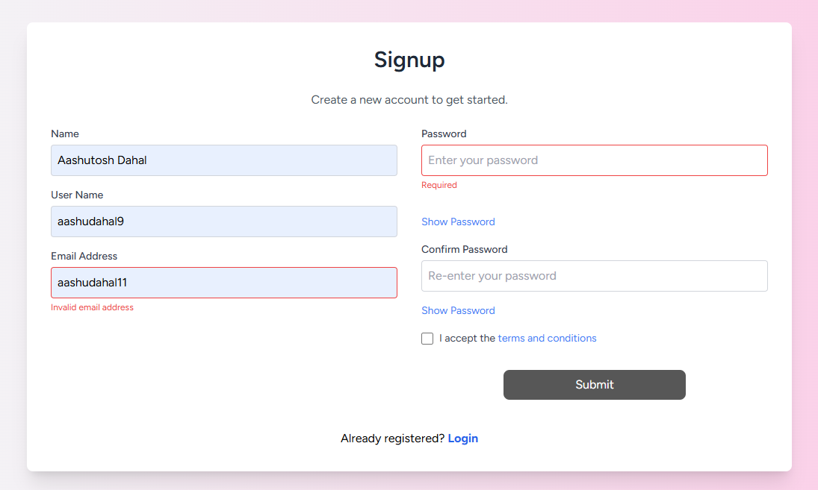

Incorrect passwords

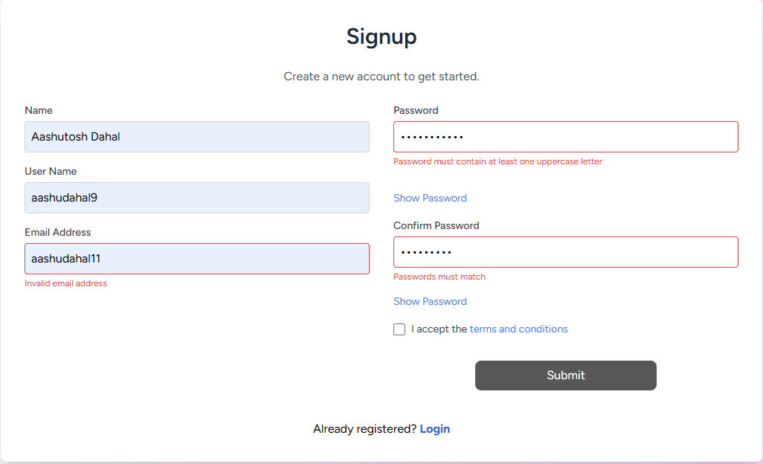

Empty Fields

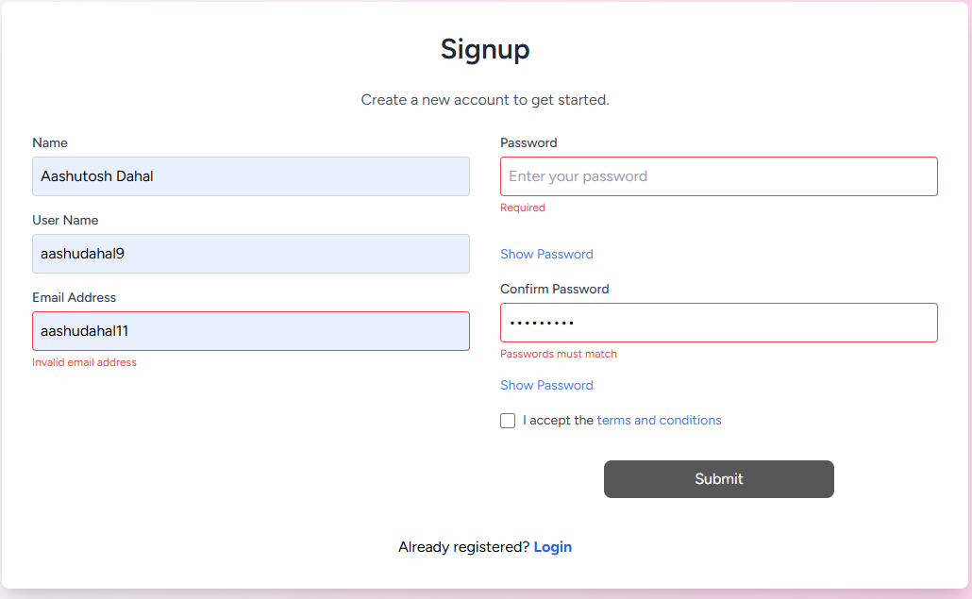

### Login

Invalid Email

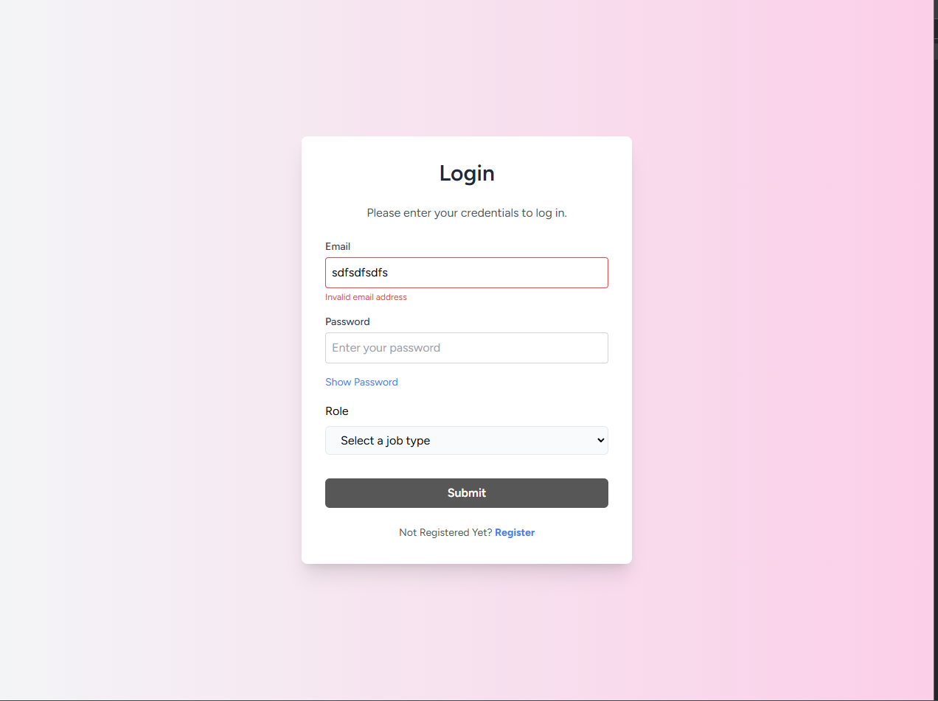

Invalid Password

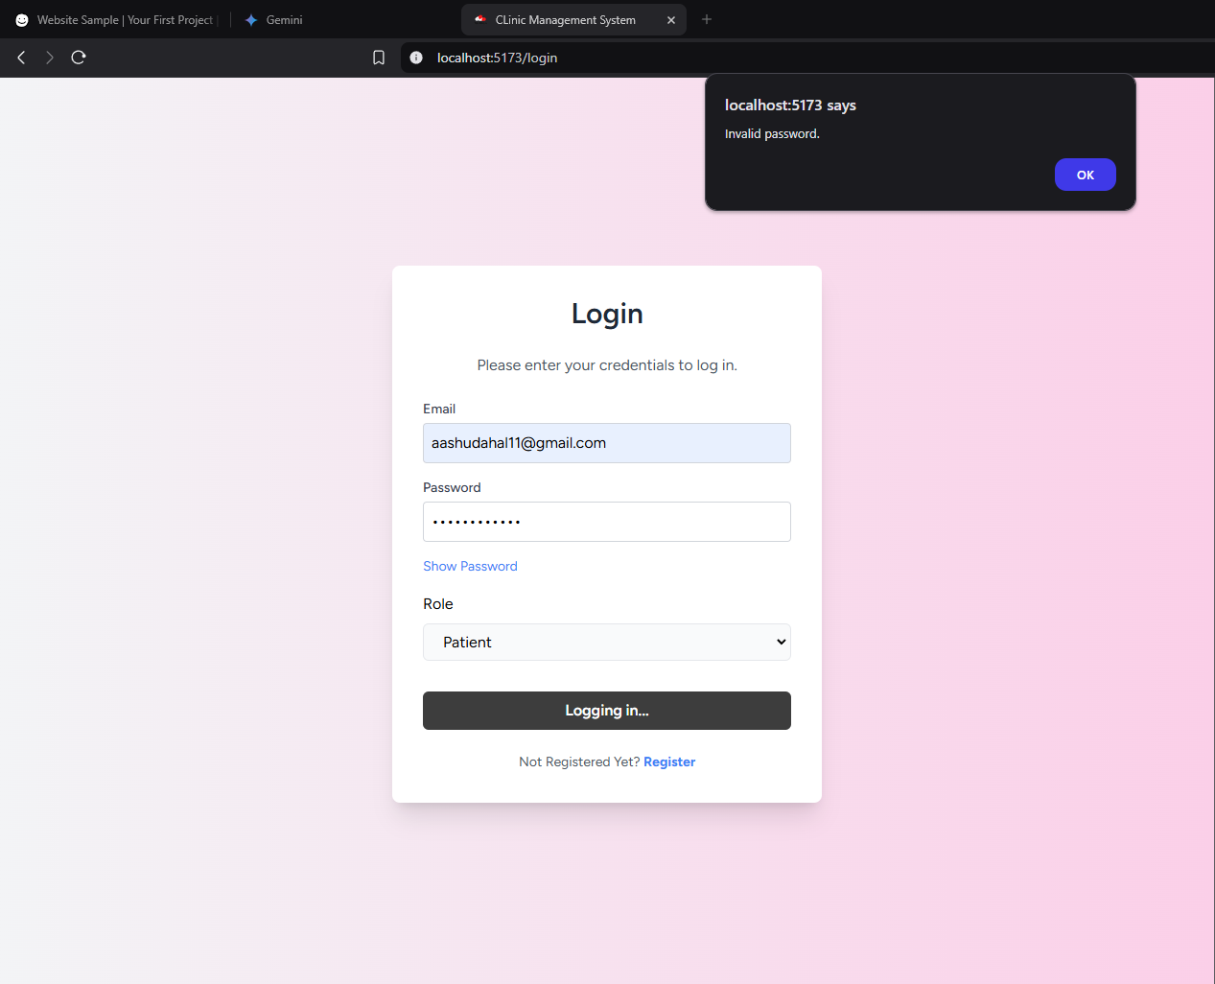

Successful Login

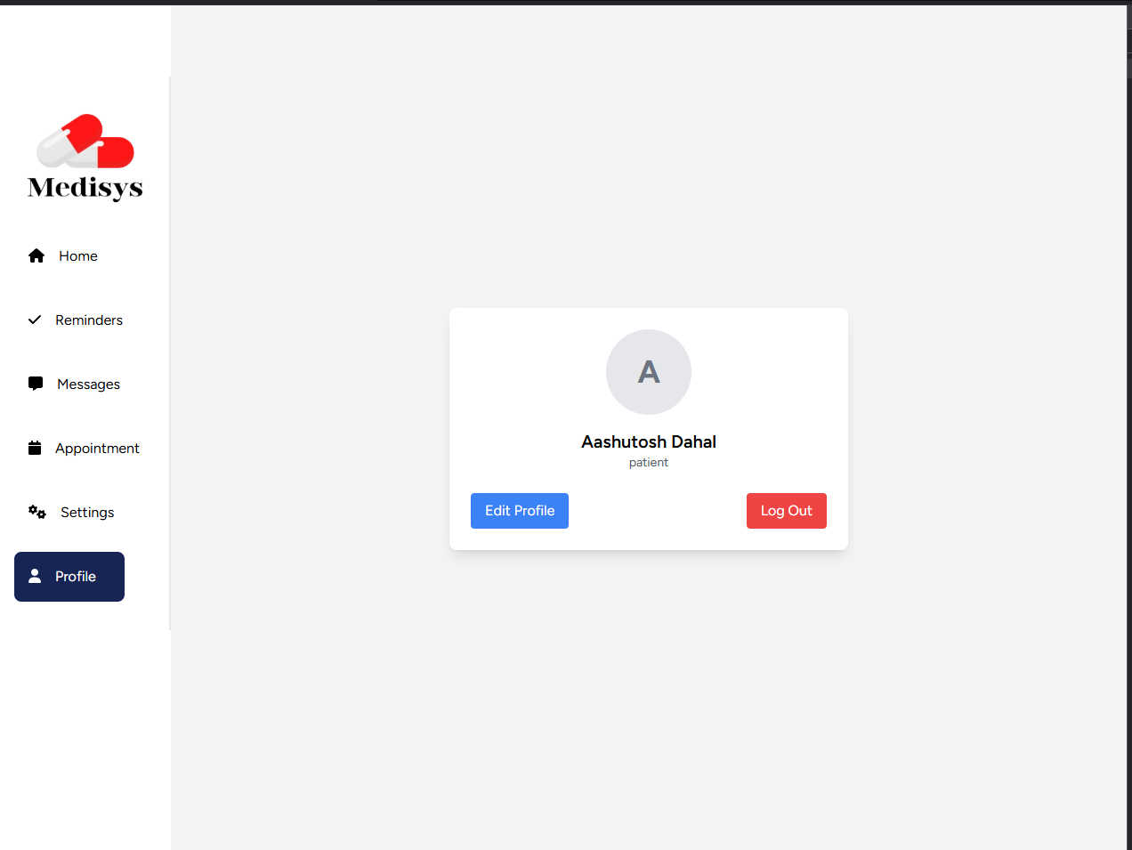

## Email Reminder

Invalid reminder setting

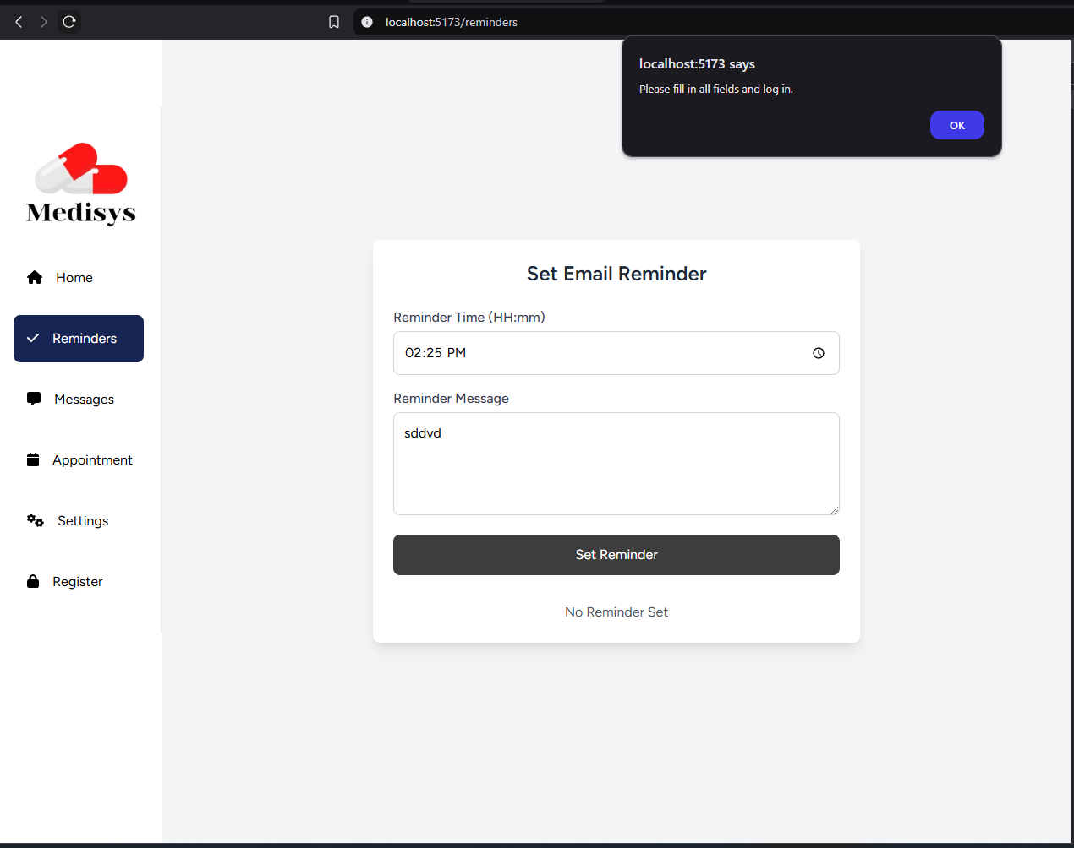

Empty Message box

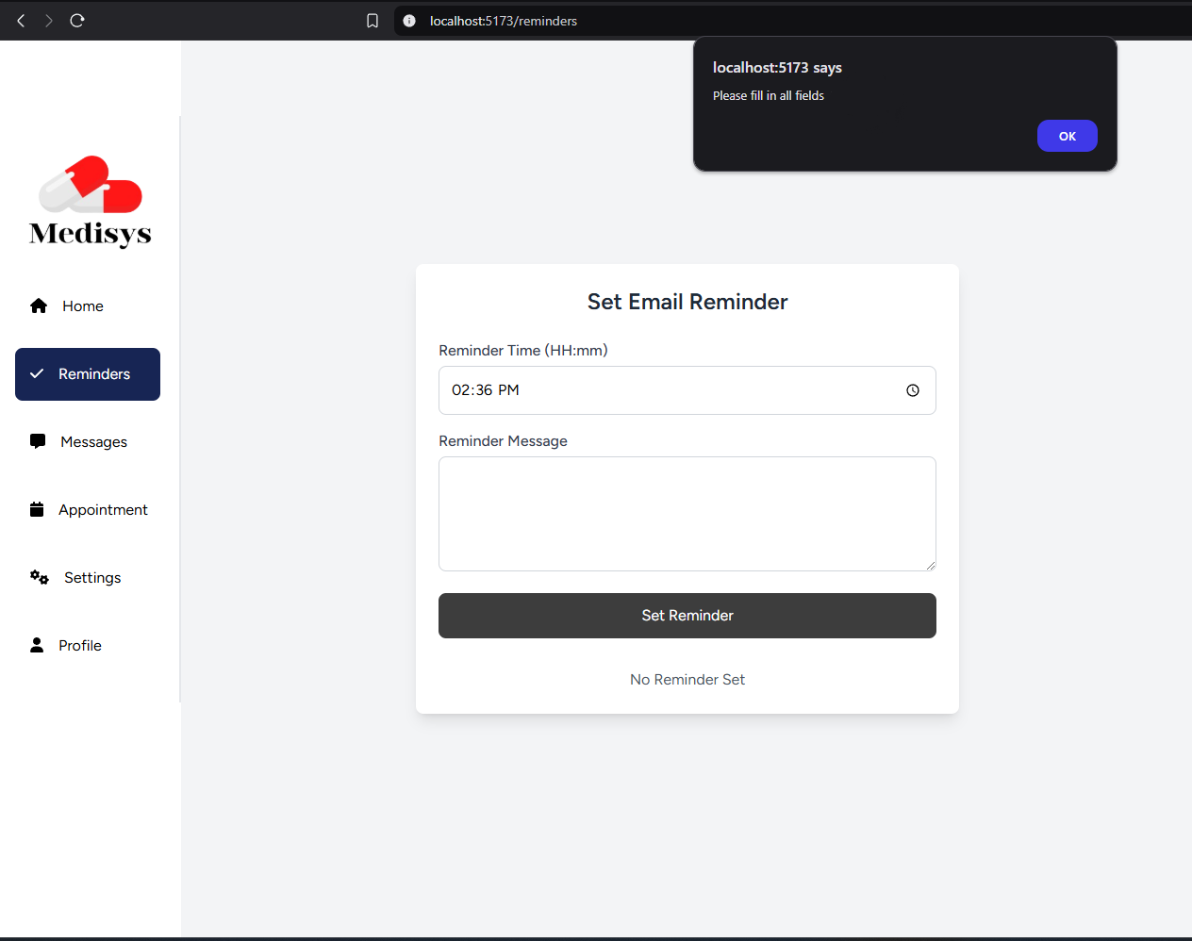

Successful reminder

