1. Title: Medisys
2. Academic Questions

How can modern health tracking systems and data analytics be leveraged to monitor individual and family health, manage clinical operations, and provide data analytics to patients based on patients’ health data?

1. Aims
   1. To provide real-time health monitoring and data insights for individuals and their families
   2. To encourage healthy lifestyle through personalized reminders
   3. To improve accessibility for all users
   4. To save time and effective communication via the application
   5. To encourage timely medicine intake for better results
   6. To provide an easy way to manage prescriptions
   7. To provide a centralized place for all clinic visited
   8. To provide emergency support in case of emergencies
   9. To prescribe medicines to patients effectively and quickly
   10. To manage all doctors and nurses for effective workflow
   11. Better management of appointments
   12. Monitoring the users to analyze the effectiveness of the clinic
2. Objectives
   1. Designing and building user-friendly clean and simple interface for all users to track their health status like heart rate, blood pressure, sugar level, etc.
   2. Developing a notification and reminder that alerts users about their daily habits.
   3. Integrating voice guidance for elderly individuals and for people with low digital awareness.
   4. Having secure and centralized place for all medical records for effective user for the future including hospital visited, medicines intake, etc.
   5. Testing the application with diverse groups of individuals for effectiveness and proper usage
   6. Implementing proper security for the data and strict usage of medical data inside the application
   7. Integrating 15 days re-login feature for better security.
   8. Implementing an emergency feature for extreme cases
   9. Proper user (doctors, nurses) management for the clinic admin
   10. Data analysis regarding the health of the individuals/patient to calculate the success rate of the clinic
   11. Safe buying and selling of the medicines using online payment like (E-sewa, Khalti, Paypal, Stripe)
3. PROJECT PROPOSAL
   1. Introduction

Medisys is a comprehensive healthcare application designed to empower individuals and families to effectively manage and track their health status and well-being. It also focuses on effectively managing clinics, appointment booking and communication between clinics and users.

Whether you're managing your own health or assisting a family member or another individual who might not be able to handle their health information independently, Medisys simplifies the process with user-friendly features and effective technologies.

Medisys is filled with features and functionality which can profoundly help an individual or a clinic some of which are: -

* Timely Medicine Reminders
* Health Status Management
* Clinic Management
* Records and Logs of Health Records

As we have faced in different Hospitals and Clincs, we have to keep record of every prescription and manage it using the cards given by the hospital or clinic but when we have to visit multiple hospitals or clinic it can be difficult to maintain and log the data and even for the clinic it can be a hassle to manage the patients and the clinic itself.

Hence Medisys can be the ultimate and the effective solution to solve the problem and be the bridge towards digitalizing the health status and logs of an individual and also effectively manage the clinic as a whole.

1. Initial Research into sources of information
   1. Similar Systems

There is many healthcare applications developed which focuses on healthcare tracking, mental health, appointment bookings, medical transactions. Although they provide an excellent service and functionality through their features which mainly focuses on one major functionality but Medisys provides a middle ground and provide both the clinic management and provide healthcare tracking whether it be individual or of family members.

Some of the applications are: -

* + 1. **MyChart**

As we can observe MyChart provides many of the functionality similar to Medisys but fails to provide Payment Integration and Accessibility Feature but Medisys being a common ground has the features.

* + 1. **ZocDoc**

Similarly, ZocDoc mainly focuses on Appointment Management and Prescriptions handling but lacks on personal and family health management. It lacks many features that Medisys can provide.

* + 1. **HealthMate**

Although this application provides personal health tracking appointment management, medicine management, accessibility, communication tools. It lacks on family health management, payment integration, patient record management which doesn’t fit our needs properly.

* + 1. **Doctor on Demand**

As the name suggests itself, this application mainly is about management of doctors, appointment and prescriptions and lacks the aspects of personalized health tracking and family health tracking which hinders the health management aspects of our requirements for the application.

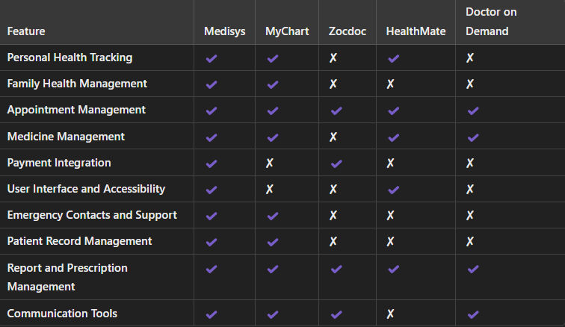

From the chart above we can observe that each of the individual application lack on one feature and excel on the other, some provide effective staff management while some provide effective healthcare tracking, similarly some provide effective appointment booking system. Therefore, Medisys provides functionalities to enable clinics to easily track their patients and manage their medicine, prescriptions and medical reports, while an individual can manage their health data and their families. It also helps the users to effectively store their health data for long term use and have easy access to communication with the medical personnels and fullfill their medical needs.

1. User Interface Design: Effect of Color in Medical Spaces

A Research was conducted by The Uiversity of Southern Mississippi which focused on the effects of color in Medical Environments. The Research which was conducted amongst 55 participants ranging from ages of 18-55 in which they were given a survey with 20 questions to gather data on how color can influence their mood in medical environments. They analyzed the results data and the findings suggested that the colors such as BLUES and GREENS promote calmness whereas colors also affect a person’s perception of comfort and cleanliness. The research showed that when asked about what the color of clean was, 55% of people chose the color WHITE, similarly over 64% of people chose the color YELLOW as the color of happiness. Moreover, BLUE promotes a comforting atmosphere for healing. This research also suggests us to include a balance between the calm color palette which can enhance the mood and bring out comfort and calmness.

This research then finally concludes that color and well-placed furniture can influence an individual’s mood and enhance their comfort.

Hence using the color themes which consists of different shades of white, blue, yellow and green can effectively enhance the mood and give a comfort feeling when engaging with our web application. (Mississippi, 2013)

1. Artefact
   1. Personal and Family Health Management

* Health Status Tracking
  1. Family health management
* Appointment Management
  1. Appointment Handling
* Billing or payment
* Prescription Based Purchases
  1. Clinic Management
* Medicine and Prescription management
* Report Sharing
  1. Remote Communication
* Chat System
  1. Medical History Maintenance
* Data logs
  1. Profile code sharing
* Data Security and Encryption
  1. Data protection
* Data Visualization
  1. Visualize patients’ data for clinics growth
* Medicine Reminders
  1. Timely placed Reminders

1. Plan/Schedule
   1. Gantt Chart

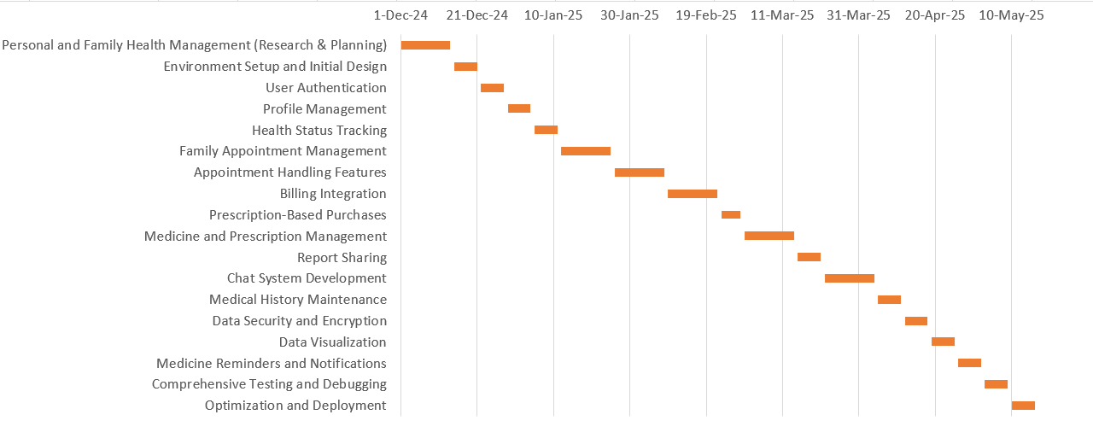

* 1. Work Breakdown Structure
     1. Planning
        1. Defining project objectives
        2. Task list
        3. Setting project timelines and milestones
        4. Tools and technologies
     2. Design
        1. Sketch wireframes
        2. Designing User Interfaces
     3. Development
        1. Backend Development
           1. Setting up project structure and Database
           2. Writing backend logics and APIs
        2. Frontend Development
           1. Developing Frontend Components
           2. Calling api and fetching data
     4. Testing
        1. Unit testing
        2. Code block testing
        3. Usability testing
     5. Deployment
        1. Choosing deployment platform
        2. Setting up domain name
  2. Methodology

This project we use Agile development approach which will ensure its progress and adaptability towards the changes in the development cycle. This project is divided into multiple phases, each encompassing specific sprints to focus on distinct features and deliverables. Each sprint involves tasks and uses tools like Node js, Express and React to create and develop robust web application. Emphasis on secure, well handled and simple yet effective design which ensures maintainability and extensibility.

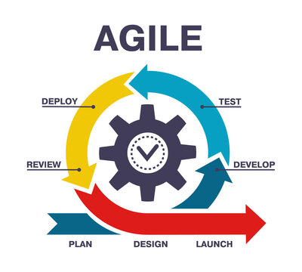

Phase 1: Research & Setup (Weeks 1-3)

Sprint 1: Project Research and Planning (Weeks 1-2)

* Features to Address:
  + Personal and Family Health Management
* Tasks:
  + Research:
    - Identify and evaluate APIs for medicine data.
    - Finalize technology stack: React (frontend), Node.js/Express (backend), MongoDB/MySQL (database).
    - Investigate security protocols for data protection and encryption.
  + Design:
    - Develop comprehensive wireframes for all major features.
    - Define user journeys for authentication, health tracking, appointment management, etc.
  + Setup:
    - Initialize project repository with GitHub.
    - Set up project structure for frontend and backend.
* Deliverables:
  + Detailed wireframes and user journey maps.
  + Initialized GitHub repository with project skeleton.

Sprint 2: Environment Setup and Initial Design (Week 3)

* Features to Address:
  + Personal and Family Health Management
* Tasks:
  + Setup:
    - Configure development environments for React and Node.js.
    - Set up MongoDB/MySQL database connections.
  + Design:
    - Create high-fidelity UI mockups for authentication and profile pages.
    - Define database schemas for users, health logs, appointments, etc.
  + Integration:
    - Establish basic routing in React.
    - Set up Express server with initial routes.
* Deliverables:
  + Functional development environments.
  + High-fidelity mockups for key interfaces.
  + Basic frontend and backend routing established.

Phase 2: Authentication and Profile Management (Weeks 4-5)

Sprint 3: User Authentication (Week 4)

* Features to Address:
  + User c
  + Data Security and Encryption
* Tasks:
  + Authentication:
    - Implement signup, login, and logout functionalities using JWT or OAuth.
    - Set up role-based access control for patients and medical professionals.
  + Security:
    - Integrate encryption for sensitive data transmission and storage.
  + Design:
    - Develop UI components for authentication forms with validation.
* Deliverables:
  + Secure authentication system with role-based access.
  + Encrypted data handling mechanisms.
  + User-friendly authentication interfaces.

Sprint 4: Profile Management (Week 5)

* Features to Address:
  + Profile Code Sharing
* Tasks:
  + Profile Management:
    - Create user profile pages with editable fields.
    - Implement functionality for profile code sharing with encryption.
  + Design:
    - Enhance UI/UX for profile management features.
  + Integration:
    - Connect frontend profile components with backend APIs.
* Deliverables:
  + Fully functional user profiles with secure data sharing capabilities.
  + Integrated frontend and backend profile management.

Phase 3: Personal and Family Health Management (Weeks 6-8)

Sprint 5: Health Status Tracking (Week 6)

* Features to Address:
  + Personal and Family Health Management
* Tasks:
  + Development:
    - Build interfaces for users to log and view personal health status.
    - Enable tracking of family members' health statuses.
  + Integration:
    - Connect health tracking features to the backend database.
  + Design:
    - Design intuitive UI for health logs and status displays.
* Deliverables:
  + Functional health status tracking for users and their families.
  + Integrated health data storage and retrieval.

Sprint 6: Family Appointment Management (Weeks 7-8)

* Features to Address:
  + Family Health Management
* Tasks:
  + Development:
    - Create interfaces to book, manage, and track family appointments.
    - Implement calendar views and scheduling functionalities.
  + Integration:
    - Link appointment management with user profiles and health data.
  + Design:
    - Develop user-friendly appointment booking and management screens.
* Deliverables:
  + Comprehensive appointment management system for families.
  + Seamless integration with health tracking and user profiles.

Phase 4: Appointment Handling (Weeks 9-10)

Sprint 7: Appointment Handling Features (Weeks 9-10)

* Features to Address:
  + Appointment Management
* Tasks:
  + Development:
    - Enhance appointment booking with reminders and notifications.
    - Implement cancellation and rescheduling functionalities.
  + Integration:
    - Integrate appointment data with calendar APIs if necessary.
  + Design:
    - Refine UI for appointment lists and detailed views.
* Deliverables:
  + Advanced appointment handling with robust scheduling features.
  + Improved user interface for managing appointments.

Phase 5: Billing & Prescription Purchases (Weeks 11-13)

Sprint 8: Billing Integration (Weeks 11-12)

* Features to Address:
  + Billing or Payment
* Tasks:
  + Development:
    - Integrate a secure payment gateway (e.g., Stripe, Khalti, E-Sewa).
    - Implement billing features for appointments and services.
  + Security:
    - Ensure PCI compliance and secure transaction handling.
  + Design:
    - Create user interfaces for payment processing and billing history.
* Deliverables:
  + Secure billing system with integrated payment processing.
  + User-friendly billing interfaces.

Sprint 9: Prescription-Based Purchases (Week 13)

* Features to Address:
  + Prescription Based Purchases
* Tasks:
  + Development:
    - Enable users to purchase medications based on prescriptions.
    - Link prescriptions to available medicines via APIs.
  + Integration:
    - Connect prescription data with billing and inventory systems.
  + Design:
    - Develop interfaces for viewing and purchasing prescribed medicines.
* Deliverables:
  + Functional prescription-based purchasing system.
  + Integrated purchase flow from prescription to payment.

Phase 6: Clinic Management (Weeks 14-16)

Sprint 10: Medicine and Prescription Management (Weeks 14-15)

* Features to Address:
  + Medicine and Prescription Management
* Tasks:
  + Development:
    - Build features for managing medicine inventories and prescriptions.
    - Implement CRUD operations for medicines and prescriptions.
  + Integration:
    - Link medicine data with external APIs for up-to-date information.
  + Design:
    - Create admin interfaces for clinic staff to manage medicines and prescriptions.
* Deliverables:
  + Robust medicine and prescription management system.
  + Admin-friendly interfaces for clinic management.

Sprint 11: Report Sharing (Week 16)

* Features to Address:
  + Report Sharing
* Tasks:
  + Development:
    - Enable users and clinic staff to generate and share health reports.
    - Implement secure sharing mechanisms (e.g., encrypted links, permissions).
  + Integration:
    - Connect report generation with user data and medical history.
  + Design:
    - Develop intuitive UI for creating, viewing, and sharing reports.
* Deliverables:
  + Secure report sharing functionality.
  + User and admin interfaces for managing reports.

Phase 7: Remote Communication (Weeks 17-18)

Sprint 12: Chat System Development (Weeks 17-18)

* Features to Address:
  + Chat System
* Tasks:
  + Development:
    - Build a real-time chat interface for patient-doctor communication using libraries like Socket.io.
    - Implement chat features such as message history, typing indicators, and notifications.
  + Integration:
    - Connect chat system with user profiles and authentication.
  + Design:
    - Create user-friendly chat interfaces with clear UX/UI.
* Deliverables:
  + Fully functional real-time chat system.
  + Integrated communication features within the application.

Phase 8: Medical History Maintenance (Week 19)

Sprint 13: Medical History Data Logs (Week 19)

* Features to Address:
  + Medical History Maintenance
* Tasks:
  + Development:
    - Develop a system to log and display comprehensive medical histories for users.
    - Implement search and filter functionalities for easy access to medical records.
  + Integration:
    - Link medical history logs with health tracking and appointment data.
  + Design:
    - Design intuitive interfaces for viewing and managing medical histories.
* Deliverables:
  + Comprehensive medical history maintenance system.
  + User-friendly interfaces for accessing medical records.

Phase 9: Data Protection & Visualization (Weeks 20-21)

Sprint 14: Data Security and Encryption (Week 20)

* Features to Address:
  + Data Security and Encryption
  + Data Protection
* Tasks:
  + Security:
    - Implement advanced encryption techniques for data at rest and in transit.
    - Conduct security audits and vulnerability assessments.
  + Compliance:
    - Ensure compliance with data protection regulations (e.g., HIPAA, GDPR).
  + Design:
    - Enhance UI to reflect secure data handling practices.
* Deliverables:
  + Enhanced data security measures.
  + Compliance documentation and secure data handling processes.

Sprint 15: Data Visualization (Weeks 21)

* Features to Address:
  + Data Visualization
  + Visualize Patients’ Data for Clinic Growth
* Tasks:
  + Development:
    - Implement data visualization dashboards using libraries like Chart.js or D3.js.
    - Create visualizations for patient health trends, appointment statistics, and clinic growth metrics.
  + Integration:
    - Connect visualization tools with backend data sources.
  + Design:
    - Develop interactive and user-friendly visualization interfaces.
* Deliverables:
  + Interactive data visualization dashboards.
  + Insightful visual representations of key metrics for users and clinic administrators.

Phase 10: Reminders (Week 22)

Sprint 16: Medicine Reminders and Notifications (Week 22)

* Features to Address:
  + Medicine Reminders
  + Timely Placed Reminders
* Tasks:
  + Development:
    - Build a reminder system allowing users to set, manage, and receive medicine reminders.
    - Integrate notification services (e.g., email, SMS, in-app notifications) for timely reminders.
  + Integration:
    - Link reminders with user profiles and appointment data.
  + Design:
    - Create intuitive interfaces for setting and viewing reminders.
* Deliverables:
  + Fully functional medicine reminder system with reliable notifications.
  + User-friendly reminder management interfaces.

Phase 11: Testing & Deployment (Weeks 23-24)

Sprint 17: Comprehensive Testing and Debugging (Weeks 23)

* Features to Address:
  + All Features
* Tasks:
  + Testing:
    - Conduct unit testing for frontend and backend components using tools like Jest and Mocha.
    - Perform integration testing to ensure seamless interaction between modules.
    - Execute end-to-end testing to validate user flows and feature interactions.
  + Debugging:
    - Identify and resolve bugs and performance issues.
    - Optimize codebase for efficiency and scalability.
  + Security Testing:
    - Perform security testing to ensure data protection measures are effective.
* Deliverables:
  + A stable and bug-free application with comprehensive test coverage.
  + Documentation of testing procedures and results.

Sprint 18: Optimization and Deployment (Weeks 24)

* Features to Address:
  + All Features
* Tasks:
  + Optimization:
    - Optimize application performance (e.g., load times, responsiveness).
    - Refine UI/UX based on testing feedback and user experience best practices.
  + Deployment:
    - Prepare deployment environment on platforms like AWS, Heroku, or Azure.
    - Deploy the application, ensuring proper configuration and scalability.
    - Set up monitoring and analytics tools for post-deployment performance tracking.
  + Documentation:
    - Finalize user manuals and technical documentation.
    - Provide training materials if necessary.
* Deliverables:
  + Deployed, optimized, and fully functional application accessible to users.
  + Comprehensive documentation and monitoring setup.