**6CS007: PROJECT AND PROFESSIONALISM**

**Title: Clinic Management System**

**Student Id:** 2332267

**Student Name:** Aashutosh Dahal

**Group :** <L6CG10>

**Supervisor:** Mr. Bhanu Aryal

**Reader:** Mr. Subash Bista

**Word Count :** 2441

**Submitted on:** <12-1-2024>

Acknowledgement

I would like to thank Herald College Kathmandu and The University of Wolverhampton for giving us a wonderful opportunity to work on a solo project and learn and understand all aspects of project and professionalism. I would also like to express my humble gratitude towards Mr. Bhanu Aryal our project supervisor for guiding and also our Reader Mr. Subash Bista for reviewing our work and providing us necessary feedbacks and suggestions.

Contents

1. STATEMENT OF PROJECT DETAILS 1

1.1 Title: Clinic Management System 1

1.2 Academic Questions 1

1.3 Aims 1

1.4. Objectives 2

1.5 Artefact 3

2. PROJECT PROPOSAL 4

2.1 Introduction 4

2.2. Initial Research 5

2.2.1 Similar Systems 5

2.2.2 User Interface Design: Effect of Color on Different Surroundings 7

2.2.3. Medicine Reminders 8

2.3. Artefact 9

Present Aspects 9

Future Enhancements 10

2.4. Plan/Schedule 11

2.4.1. Gantt Chart 11

2.4.2. Work Breakdown Structure 12

2.4.3 Functional Decomposition Diagram 14

2.4.4. Methodology 15

Phase 1: Research & Setup (Weeks 1-4) 17

Phase 2: Authentication and Profile Management (Weeks 5-8) 18

Phase 3: Appointment Handling (Weeks 9-12) 19

Phase 4: Billing & Prescription Management (Weeks 13-16) 20

Phase 5: Report Sharing and Communication (Weeks 17-20) 21

Phase 6: Data Visualization & Protection (Weeks 21-24) 22

2.5. References 23

3. ADDITIONAL INFORMATION 24

3.1 Resources 24

3.2 Client 24

Table of Figures

Figure 1: Comparison Chart of Similar Systems 6

Figure 2: Gantt Chart 11

Figure 3: Functional Decomposition Diagram 14

Figure 4: Agile Workflow 15

Figure 5: Sprint Breakdown 16

# 1. STATEMENT OF PROJECT DETAILS

## 1.1 Title: Clinic Management System

## 1.2 Academic Questions

How can clinic management system and data analytics be leveraged to monitor individual and family health, manage clinical operations, and help a clinic track its patients?

## 1.3 Aims

* To provide health reports for individuals and their families
* To improve accessibility for all users
* To save time and effective communication via the application
* To encourage timely medicine intake for better results
* To provide an easy way to manage prescriptions
* To provide a centralized place for all clinic visited
* To provide emergency support in case of emergencies
* To prescribe medicines to patients effectively and quickly
* To manage all doctors and nurses for effective workflow
* Better management of appointments
* Monitoring the users to analyze the effectiveness of the clinic

## 1.4. Objectives

* Data analysis regarding the health of the individuals/patient to calculate the success rate of the clinic
* Developing a notification and reminder for medicine intake.
* Having secure and centralized place for all medical records for effective user for the future including clinics visited, medicines intake, etc.
* Implementing proper security for the data and strict usage of medical data inside the application.
* Integrating 15 days re-login feature for better security.
* Implementing an emergency feature for extreme cases
* Proper user (doctors, nurses) management for the clinic admin
* Safe buying and selling of the medicines using online payment like (E-sewa, Khalti, PayPal, Stripe)

## 1.5 Artefact

The proposed Clinic Management System is designed to automate the various tasks to create a smooth flow of the clinic. The system will be providing an integrated platform for managing patients’ records, appointment scheduling, billing, inventory prescription and interaction or communication between patients and clinics. It also will be providing effective data visualization which can help to track progress of client or the clinic.

Tech stack like MERN will be used in the development of the web application which will ensure that the application is robust, scalable and secure. It also developer friendly with different packages and library available which can also help in the development process and also develop a secure and robust application.

Since MERN also provides real time data sync and easy integrations with web sockets it can help in many of the features such as easy secure report sharing along with secure application using the JWT and Auth0, also the support of node mailer ensures an effective and fast mailing system.

# 2. PROJECT PROPOSAL

## 2.1 Introduction

Clinic Management System is a comprehensive healthcare application designed to manage clinics, appointment booking and communication between clinics and users and effective report sharing.

It can be pretty hard to manage clinic and send reports to the users on a daily or a weekly basis and also managing your own health or a family member or another individual who might not be able to handle their health information independently, Medisys simplifies the process with user-friendly features and effective technologies.

Medisys is filled with features and functionality which can profoundly help an individual or a clinic some of which are: -

* Appointment Management
* Report and Prescription Management
* Reminders
* Clinic and Staff Management
* Records and Logs of Health Records

As we have faced in different Hospitals and Clincs, we have to keep record of every prescription and manage it using the cards given by the hospital or clinic but when we have to visit multiple hospitals or clinic it can be difficult to maintain and log the data and even for the clinic it can be a hassle to manage the patients and the clinic itself.

Hence Medisys can be the ultimate and the effective solution to solve the problem and be the bridge towards digitalizing the health status and logs of an individual and also effectively manage the clinic as a whole.

## 2.2. Initial Research

### 2.2.1 Similar Systems

There is many healthcare applications developed which focuses on healthcare tracking, mental health, appointment bookings, medical transactions. Although they provide an excellent service and functionality through their features which mainly focuses on one major functionality but Medisys provides an effective ground for clinic management and share medical reports and medical prescriptions effectively whether it be individual or of family members.

Some of the applications are: -

1. Smart hospital Management
   1. Workflow from appointments to patient registration and payment handling
   2. Electronic medical records
   3. Inventory, payroll and financial administration
2. DeltaTech Hospital Management system
   1. Digital patient records
   2. Appointment scheduling and real time updates
   3. Reporting tools for operational and financial insights
3. Techware hospital management system
   1. Extensive EMR for patient records
   2. Appointment and queue management
   3. Integrated pharmacy and inventory systems
   4. Analytics and reporting for hospital management

**Missing features in these systems**

Interactive data visualization:

Real time charts graphs about patients progress for effectiveness of the clinic

Seamless Report sharing:

Sharing reports across primary and secondary user i.e. n elder member of the family which can be beneficial and time saving

Secure communication: Direct and secure communication with medical personnels

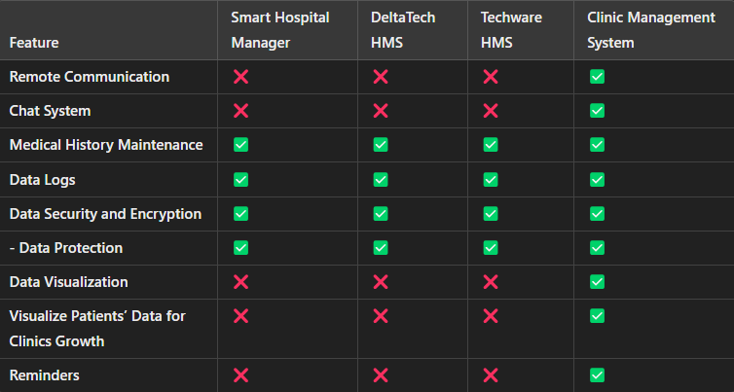

Figure : Comparison Chart of Similar Systems

From the chart above we can observe that all of the clinic management system pretty much lacks to provide effective communication between the patients and the medical personnels but my system provides a platform for that in the form of chat system also lacks to provide data visualization which can be beneficial to the patients as well as the clinics to see or track their progress. Many people due to their busy lives may tend to forget about their appointments or something important but our system will send effective reminders to make sure they don’t lack behind.

### 2.2.2 User Interface Design: Effect of Color on Different Surroundings

A Research was conducted by The University of Southern Mississippi which focused on the effects of color in Medical Environments. The Research which was conducted amongst 55 participants ranging from ages of 18-55 in which they were given a survey with 20 questions to gather data on how color can influence their mood in medical environments. They analyzed the results data and the findings suggested that the colors such as BLUES and GREENS promote calmness whereas colors also affect a person’s perception of comfort and cleanliness. The research showed that when asked about what the color of clean was, 55% of people chose the color WHITE, similarly over 64% of people chose the color YELLOW as the color of happiness. Moreover, BLUE promotes a comforting atmosphere for healing. This research also suggests us to include a balance between the calm color palette which can enhance the mood and bring out comfort and calmness.

Sevinc Kurt and Kelechi Kingsley Osueke's study explores the psychological impacts of color on a university campus's student union complex. The study emphasizes how cold hues like blue and green encourage serenity, relaxation, and intellectual productivity, whereas warm hues like red and yellow arouse and excite. It was discovered that the student union's color schemes improved emotional reactions, blue and green were preferred for their relaxing qualities, while too much white in other places, such as the Lake View cafeteria, was thought to be boring. Additionally, respondents said that the colors improved their communication, memory recall, and sense of belonging. These results are consistent with the University of Southern Mississippi's study, which highlights those hues like blue and green create calming atmospheres and promote healing, while white signifies cleanliness and yellow represents happiness. (Publications, 2014)

Hence these researches finally conclude that color and well-placed furniture can influence an individual’s mood and enhance their comfort. Therefore, using the color themes which consists of different shades of white, blue, yellow and green can effectively enhance the mood and give a comfort feeling when engaging with our web application. (Mississippi, 2013)

### 2.2.3. Medicine Reminders

The effectiveness and the working mechanism of the medicines highly depends on the natural cycle of the body like natural rhythms, body absorptions, duration of actions, and different side effects. Similarly, the body’s biological processes also vary throughout the day which can be essential can be in the working of the medicines, and how medicines and metabolized. As we know that cholesterol peaks at night, making evening or early night can be best time for statins. On the contradictory, fast-acting drugs require specific timing based on symptoms, while slow-release formulations, ensure slow effects with low doses. Similarly, according to the research managing the medicine cycle and timing can help us reduce the side effects comparatively less than having medicines at a random interval of time. Research, such as the TIME trial, highlights that flexibility in timing can work for some medications, allowing patients to choose convenient schedules. Adherence to prescribed instructions, maintaining consistent timing, and using reminders or pill organizers help ensure medications are taken correctly, optimizing their benefits and minimizing risks. (Tang, n.d.)

Studies show that adjusting drug regimens to a patient's chronotype, or circadian rhythms, can improve treatment results. Antihypertensive drugs, for example, work better for those with early chronotypes when taken in the morning, whereas late chronotypes benefit more from evening dosages. Timing must be consistent, though, as variations might reduce the effectiveness of medications and raise the possibility of side effects. In managing chronic diseases, non-adherence—which is frequently brought on by forgetfulness or conflicting schedules—remains a major obstacle. (Grannell, 2019)

Hence, using the medicine reminders according to the chronotype, circadian rhythms, body absorptions and duration of medicines can help the effectiveness of the medicine which can solve the problem and cure the patient or self on time.

## 2.3. Artefact

### Present Aspects

* Appointment Management
  + Users can book, reschedule and even cancel appointments according to their needs after seeing the appointments calendar
  + Doctors can edit the appointment calendar and include their appointment time
    - Using tools which provide calendar to hold and edit events
* Payment
  + Users can use integrated payment system to buy drugs or other medicinal items
    - Using payment methods like (e-Sewa, Khalti, or Stripe) to process the transactions
* Medicine and Prescription management
  + Making an inventory of the medicines which can be access by the doctors or the nurses to prescribe to the patients
  + Users or patients can buy those medicines from the inventory
    - Using medicinal Api which can provide the list of medicines which can be fetched and used accordingly
* Report Sharing
  + Clinic can share report to patients and the family members simultaneously
    - Using multer to share images and reports
* Data Security and Encryption
  + Encrypted data can ensure better securing amongst the user and ensures the data is safe against any potential breach
    - Using tools or process which encrypt the data
* Reminders
  + For effective reminders of appointments or report alerts
    - Using desktop notification or email notifications

### Future Enhancements

* Patients Medical History Maintenance
  + Ensures the patient a safe place for all their medical history including their medicines taken, the treatment to the clinics visited
* Healthcare vitals tracking
  + Users can track their necessary vitals to track their overall health which can be beneficial in case of any mishappening
* Automatic Report Summary
  + Using NLP based models to generate a summary of the medical report
* Data Visualization
  + Users can visualize their progress or their health and take necessary measures
    - Using data visualization tools like chart js which can ensure a diagrammatical view which can be monitored to track a patient’s health or the progress of the clinic.
* Chat System
  + Users can chat with the medical personnels ensuring direct communication
  + Doctors can consult a patient directly via the web app in minor case or emergency
    - Using WebSocket to establish a connection for chatting or communication

## 2.4. Plan/Schedule

### 2.4.1. Gantt Chart

A Gantt chart, commonly used in project management, is one of the most popular and useful ways of showing activities (tasks or events) displayed against time. (gantt.com, n.d.)

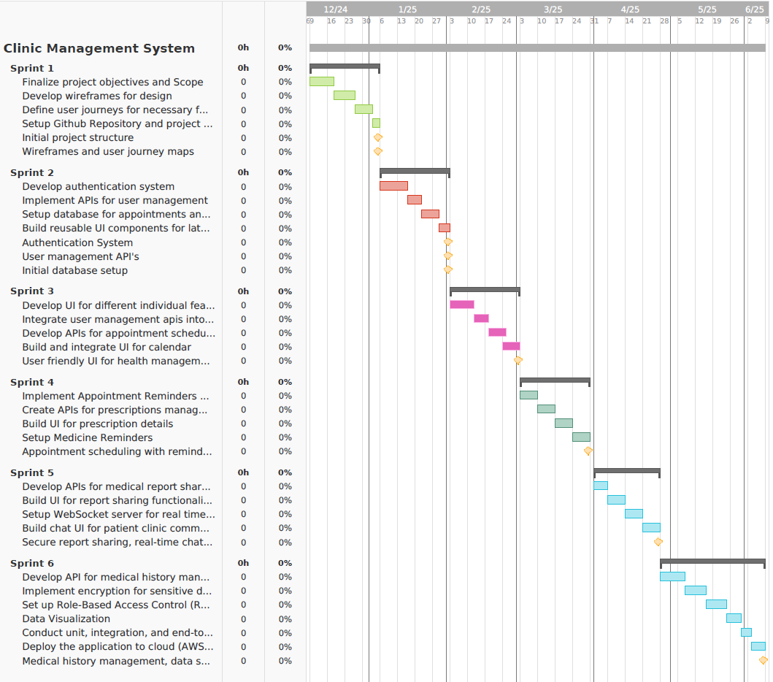

Figure : Gantt Chart

### 2.4.2. Work Breakdown Structure

* Planning
  + Defining project objectives
    - Developing healthcare web application for clinics and report sharing for primary user
  + Task list
    - Working on completion of key features
* Setting project timelines and milestones
  + Tools and technologies
    - Frontend: React
    - Backend: Express Node
    - Database: MongoDB
    - Notifications: Desktop Notification and Email Reminders
  + Design
    - Sketch wireframes
      * Creating simple and rough wireframes to structure the frontend of the applications
    - Designing User Interfaces
      * Creating proper high fidelity UI designs according to the wireframes ensuring consistency and readability
* Development
  + Backend Development
    - Setting up project structure and Database
    - Writing backend logics and APIs
      * Implementing apis for different features such as
        + User management
        + Medicine Reminders
        + Health Status updates
        + Appointment managements
        + Clinic management
  + Frontend Development
    - Developing Frontend Components
      * Creating different UI for different features
    - Calling Api and fetching data
      * Calling and fetching data from backend APIs
* Testing
  + Unit testing
    - Testing Individual Features
  + Integration testing
    - Testing the interactions between frontend and backend APIs
  + Usability testing
    - Conduct usability testing with user and clinics
* Deployment
  + Choosing deployment platform
    - Using cloud services to deploy the platform for public use

### 2.4.3 Functional Decomposition Diagram

Functional decomposition is a method of analysis that dissects a complex process in order to examine its individual elements.

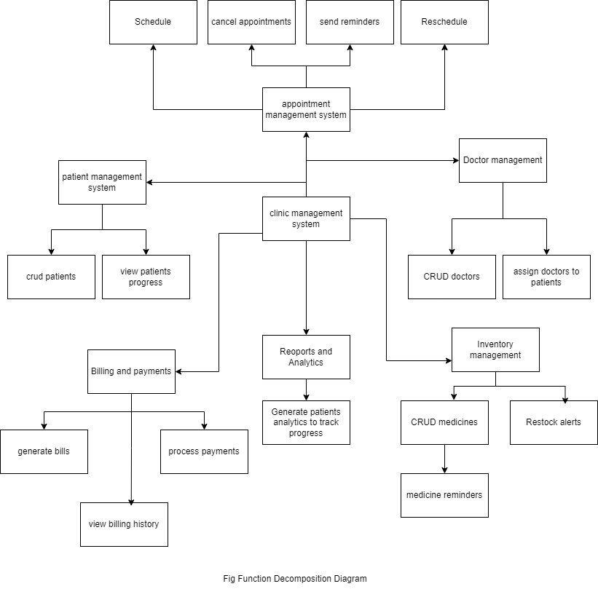

Figure : Functional Decomposition Diagram

### 2.4.4. Methodology

This project we use Agile development approach which will ensure its progress and adaptability towards the changes in the development cycle. This project is divided into multiple phases, each encompassing specific sprints to focus on distinct features and deliverables. Each sprint involves tasks and uses tools like Node js, Express and React to create and develop robust web application. Emphasis on secure, well-handled and simple yet effective design which ensures maintainability and extensibility.

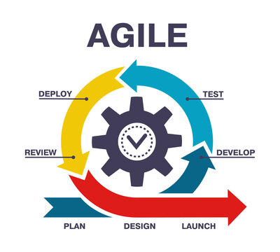

Figure : Agile Workflow

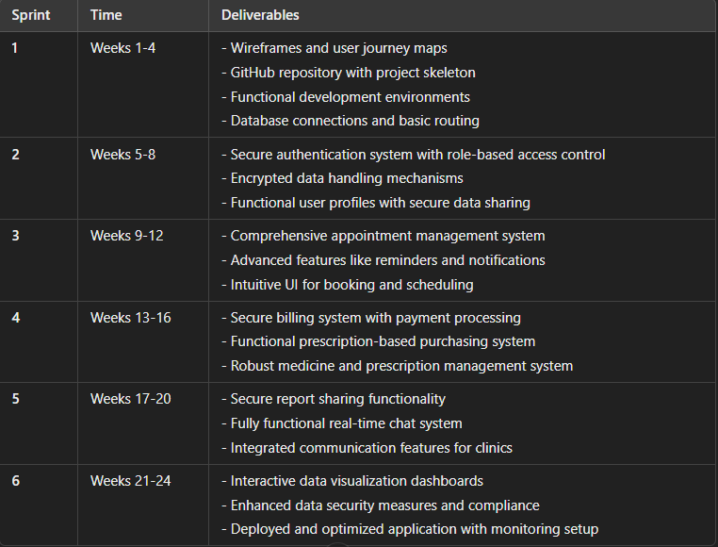

Figure : Sprint Breakdown

### Phase 1: Research & Setup (Weeks 1-4)

**Sprint 1: Project Research and Planning (Weeks 1-4)**  
**Tasks:**

* Research APIs for managing appointments and medicine data.
* Finalize technology stack (React, Node.js/Express, MongoDB/MySQL).
* Investigate security protocols for sensitive data protection.
* Develop wireframes for clinic management features.
* Define user journeys for authentication, appointment management, and report sharing.
* Initialize GitHub repository and project structure.

**Deliverables:**

* Wireframes and user journey maps.
* GitHub repository with project skeleton.

### Phase 2: Authentication and Profile Management (Weeks 5-8)

**Sprint 2: Authentication and Profile Management (Weeks 5-8)**  
**Tasks:**

* + Implement secure authentication system with JWT or OAuth.
  + Set up role-based access control for clinic staff and patients.
  + Encrypt sensitive data transmission and storage.
  + Create UI components for authentication forms with validation.
  + Develop user profile pages with editable fields.
  + Implement secure profile data sharing capabilities.

**Deliverables:**

* + Secure authentication system with role-based access control.
  + Encrypted data handling mechanisms.
  + Functional user profiles with secure data sharing.

### Phase 3: Appointment Handling (Weeks 9-12)

**Sprint 3: Appointment Management (Weeks 9-12)**  
**Tasks:**

* + Build interfaces for booking, managing, and tracking appointments.
  + Implement calendar views and scheduling functionalities.
  + Link appointments with user profiles and clinic data.
  + Design intuitive appointment booking and management screens.

**Deliverables:**

* + Comprehensive appointment management system.
  + User-friendly appointment booking interfaces.

### Phase 4: Billing & Prescription Management (Weeks 13-16)

**Sprint 4: Billing and Prescription Management (Weeks 13-16)**  
**Tasks:**

* + Integrate a secure payment gateway (e.g., Stripe, Khalti, E-Sewa).
  + Implement billing features for appointments and services.
  + Ensure PCI compliance and secure transaction handling.
  + Develop interfaces for payment processing and billing history.
  + Enable prescription-based medication purchases.
  + Link prescriptions with medicine data via APIs.

**Deliverables:**

* + Secure billing system with payment processing.
  + Functional prescription-based purchasing system.

### Phase 5: Report Sharing and Communication (Weeks 17-20)

**Sprint 5: Report Sharing and Chat System (Weeks 17-20)**  
**Tasks:**

* + Enable users and staff to generate and share health reports.
  + Implement secure sharing mechanisms (encrypted links, permissions).
  + Develop interfaces for creating, viewing, and sharing reports.
  + Build real-time chat interface for patient-clinic communication using Socket.io.
  + Implement features like message history, typing indicators, and notifications.

**Deliverables:**

* + Secure report sharing functionality.
  + Fully functional real-time chat system.

### Phase 6: Data Visualization & Protection (Weeks 21-24)

**Sprint 6: Data Visualization, Security, and Finalization (Weeks 21-24)**  
**Tasks:**

* + Create dashboards to visualize appointment trends and clinic metrics.
  + Use libraries like Chart.js or D3.js for interactive charts.
  + Implement encryption for data at rest and in transit.
  + Conduct security audits and vulnerability assessments.
  + Ensure compliance with data protection regulations (HIPAA, GDPR).
  + Conduct unit, integration, and end-to-end testing.
  + Optimize performance for responsiveness and scalability.
  + Deploy the application on platforms like AWS or Azure.

**Deliverables:**

* + Interactive data visualization dashboards.
  + Enhanced data security measures.
  + Deployed, optimized application with full functionality.
  + Comprehensive documentation and monitoring setup.

## 2.5. References

Grannell, L., 2019. *When should I take my medicines?.* [Online]   
Available at: https://australianprescriber.tg.org.au/assets/p86-Grannell.pdf  
[Accessed 27 11 2024].

Mississippi, T. U. o. S., 2013. *Color Theory: The Effects of Color in Medical Environment.* [Online]   
Available at: https://aquila.usm.edu/cgi/viewcontent.cgi?article=1173&context=honors_theses  
[Accessed 27 11 24].

Publications, S., 2014. *The Effects of Color on the Moods of College Students.* [Online]   
Available at: https://journals.sagepub.com/doi/epub/10.1177/2158244014525423  
[Accessed 27 11 2024].

Tang, A., n.d. *British Heart Foundation.* [Online]   
Available at: https://www.bhf.org.uk/informationsupport/heart-matters-magazine/research/timing-of-medications  
[Accessed 27 11 2024].

# 3. ADDITIONAL INFORMATION

## 3.1 Resources

For Clinic Management System to be successfully run and deployed following requirements are needed: -

* A standard computer or laptop with more than 4GB of ram and dual processor to handle development and testing environment.
* Software tools and code editors like Vs-Code, Postman and MongoDB to server different purposes.
* Frameworks like MERN to ensure smooth development and deployment.
* Cloud hosting platform to make the system public for other users.

Other Resources

* Sample patient data will be created and imported to simulate the environment

## 3.2 Client

For this project, my university supervisor, Mr. Bhanu Aryal will be representing as the client and will be providing necessary feedbacks, requirements to ensure successful delivery of the project i.e. Clinic Management System.