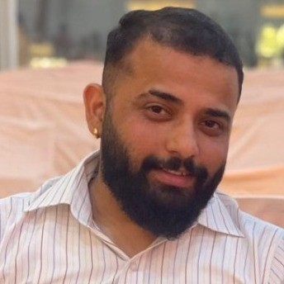MR.AASHUTOSH RAJ

Front End Developer at CS Soft Solutions Pvt. Ltd.

# PERSONAL DETAILS

Chandigarh, [aashiiraj01@gmail.com](mailto:aashiiraj01@gmail.com), 8627952432 Gender: Male

LinkedIn: [linkedin.com/in/mr-aashutosh-raj-b4394a108](https://www.linkedin.com/in/mr-aashutosh-raj-b4394a108/)

# PROFILE

Hi, I'm an experienced UI Developer with over 5+ years of professional experience. During my career, I have developed a strong skillset in Front End and have worked on various projects ranging from small business websites. My expertise lies in creating user-centered designs that are both aesthetically pleasing and functional. I am passionate about staying up-to-date with the latest design trends and technologies, and I am always looking for new challenges to push my skills further.

# EDUCATION

BCA Jul 2010 - Jul 2014

Sikkim Manipal University - Distance Education

# EMPLOYMENT

Web Designer Oct 2020 - Present

CS Soft Solutions (India) Pvt Ltd, Mohali district, India · On-site

**Responsibility:**

I have been with the company for four years, initially working as a Web Designer. Over the past year, I transitioned to a Front-End Developer role. My current responsibilities include reviewing UX files to build a design system aligned with UX guidelines, creating reusable components, and converting UX designs into JSX code

Web Designer Jun 2020 - Sep 2020

Jaw Dropping Marketing Pvt Ltd., Chandigarh, India

Web Designer Jan 2019 - Jun 2020

Mechlin Software Technology Pvt. Ltd., Mohali, Punjab, India

Web Designer Feb 2018 - Jan 2019

Horizon e-SOLUTIONS, Mohali, Punjab, India

Data Processor Dec 2016 - Jan 2018

OCREX, Mohali, Punjab, India

Junior Web Developer Jun 2014 - Oct 2014

Indisolutions, Solan, Himachal Pradesh, India

# SKILLS

React.js

HTML5

Web Design

Cascading Style Sheets (CSS) Bootstrap 4

LESS (Stylesheet Language) GSAP

SASS

Bootstrap

Adobe Photoshop Tailwind

# LANGUAGES

Hindi English

# COURSES

React JS Dec 2023

I have completed an industrial internship in React JS at A2IT Mohali, which took place in August 2023. Now, I am eager to transition my career into React development.

# PROJECTS

MUAU - https://muau.ch/

ELMAG - https:[//www](http://www.elmag.at/de/).[elmag](http://www.elmag.at/de/).[at/de/](http://www.elmag.at/de/)

GARHAMMER - https:[//www](http://www.garhammer.de/).[garhammer](http://www.garhammer.de/).[de/](http://www.garhammer.de/) ADDLLY - https://addlly.ai/