**Game Design Document**

1. Write the title of your project.

**Alladin The Prince of Baghdad**

1. What is the goal of the game?

**Help Alladin to escape the prison & reach the castle**

1. Write a brief story of your game.

**Alladin the prince of Baghdad has been imprisoned in Central Prison Of Baghdad. He asks for your help. Help Alladin to escape the prison and reach the castle of princess Jasmine.**

**Are you ready for an adventurous journey ?**

1. Which are the playing characters of this game?

* Playing characters are the ones who respond to the user based on the input from the user.
* Cars, monkeys, dinos, wizards, etc., are the playing characters in the game.

|  |  |  |
| --- | --- | --- |
| Number | Character Name | What can this character do? |
| 1 | Alladin | Escapes the prison by fighting against his enemies (obstacles) to reach the castle of princess Jasmine. |
| 2 | ------ |  |
| 3 | ------- |  |
| 4 | ------ |  |
| 5 | ------ |  |
| 6 | ------ |  |
| 7 | ------ |  |
| 8 | ------ |  |

1. Which are the Non-Playing Characters of this game?

* Non-Playing characters are the ones that don't have an action or behavior when the user interacts with the game.
* Hurdles, stones, bananas, coins, etc., are non-playing characters in the game.

|  |  |  |
| --- | --- | --- |
| Number | Character Name | What can this character do? |
| 1 | Magical portion (lamp) | Can revive the character if it dies while running |
| 2 | Crates | Can act as an obstacle. If character bangs to it for the first time half heart of the full is gone.  If bangs for the second time chracter dies |
| 3 | Cactus | If character bangs to it half heart of the full is gone. |
| 4 | GGinie | Gets activated for 10 seconds when Alladin gets the lamp  Fights againsts obstacles that come in Alladin’s way by destroying them |
| 5 | BGinie | Gets activated when Alladin survives 180 seconds of the game |
| 6 | ------ |  |
| 7 | ------ |  |
| 8 | ------ |  |

Draw your imagination of this game. What does this game look like?

* Draw the game either on your computer or on paper.
* Add images of the game scenes to show each of the playing and non-playing characters at least once.

 

***Alladin Magical***

***[PC] Portion***

***[NPC]***

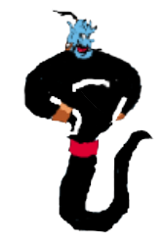 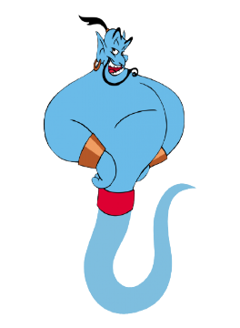

***BGinie GGinie***

***[NPC] [NPC]***

  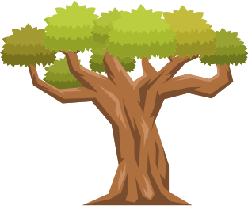 

***Cactus Crate Tree Alladin with***

***[NPC] [NPC] [NPC] Jamine***

How do you plan to make your game engaging?

1. **SOUND** **THEME**

I plan to makes my game engaging by adding the Arabic theme song in the

background and specific sound when he jumps over obstacles or acivates

the magical portion.

1. **VISUAL** **THEME**

I would like to add good animations for all the playing and non-playing characters so that it gives a a good visual effect and can attract more players.