**STUDENT MANAGEMENT**

**Student Data Tracking Web Application**

Student Management, created by InfoCentroid Software Solutions is an online student data tracking application, empowers all faculty members to not only keep track of each student's progress, but also take immediate action to course-correct or provide assistance as needed. It manages the entire campus operations administration. It provides an interactive platform for all faculty members like training co-ordinators, trainers, counselor, accountant and placement officer in a personalized way.

Application Highlights:

* Multiple campus management through single application.
* Integrated solution to manage academic, administrative and business processes.
* Convenience
* Instant access to the information required.
* Complete automation of all operations.
* User-friendly interface.

Student management make faculty jobs more accessible by giving them an easy place to find and sort information.

**Trainer Dashboard**

* 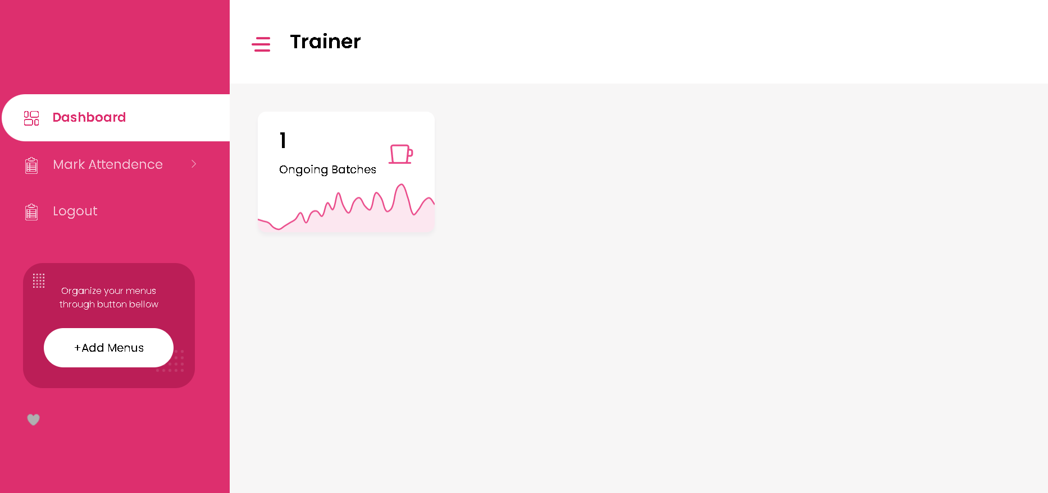**Dashboard -** The Trainer dashboard will show the number of batches here.
* 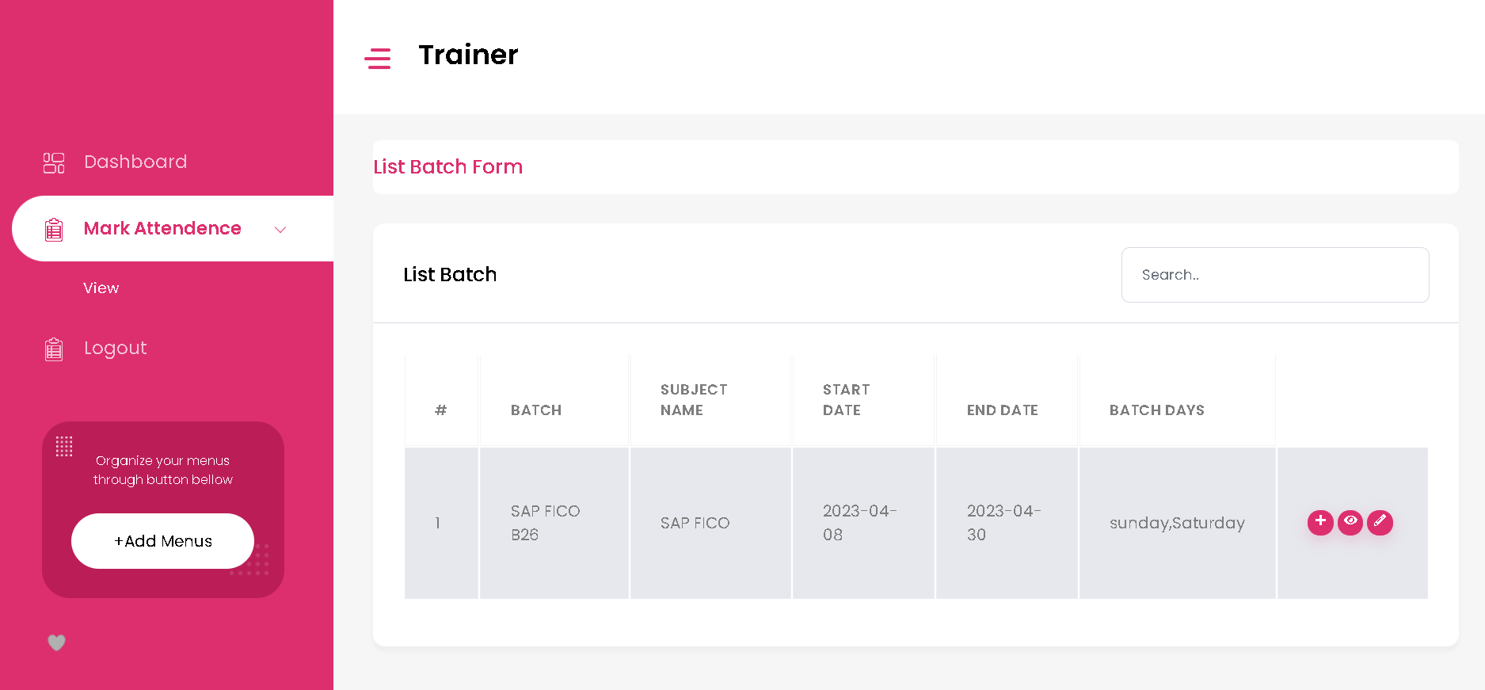**Mark Attendence Page -** Batch details will be visible here. Trainer can view and edit the attendance of students here.

1. 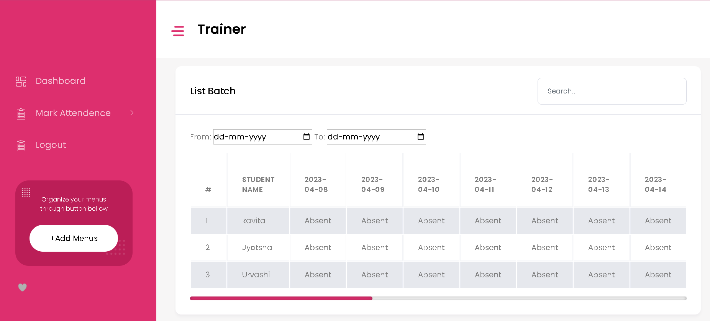Trainer can view the attendance details here.
2. 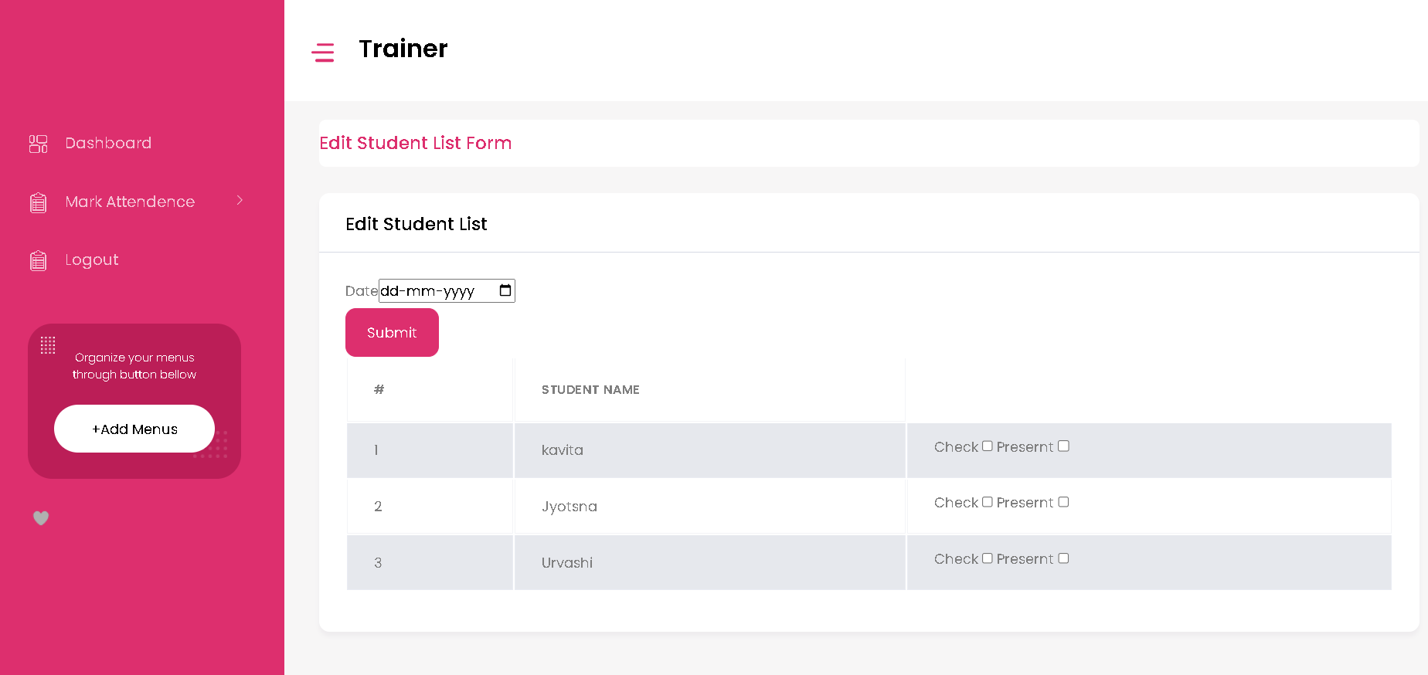 Trainer can edit the attendance datewise here.

* 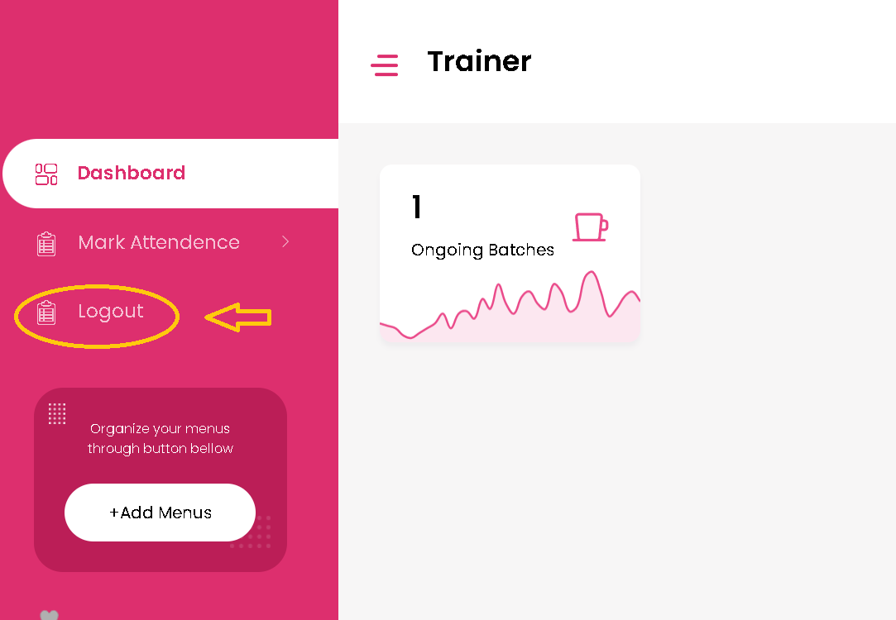 **Logout -** Trainer can Logout fom here.

**Training Co-ordinator Dashboard**

* 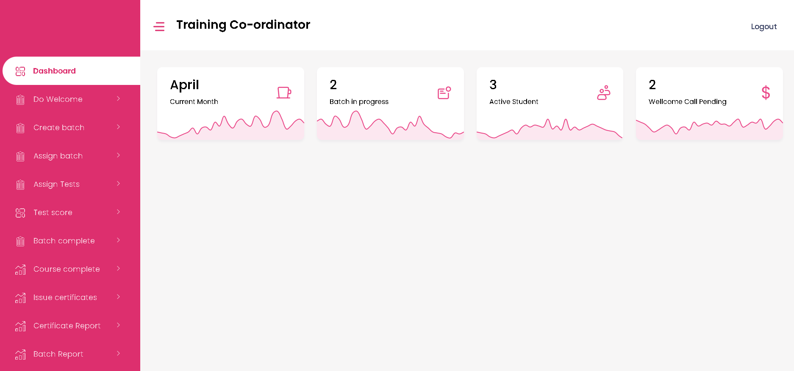 **Dashboard -** The Training Co-ordinator dashboard will show the number of batches, number of active students and number of welcome calls pending.
* **Do Welcome Page - 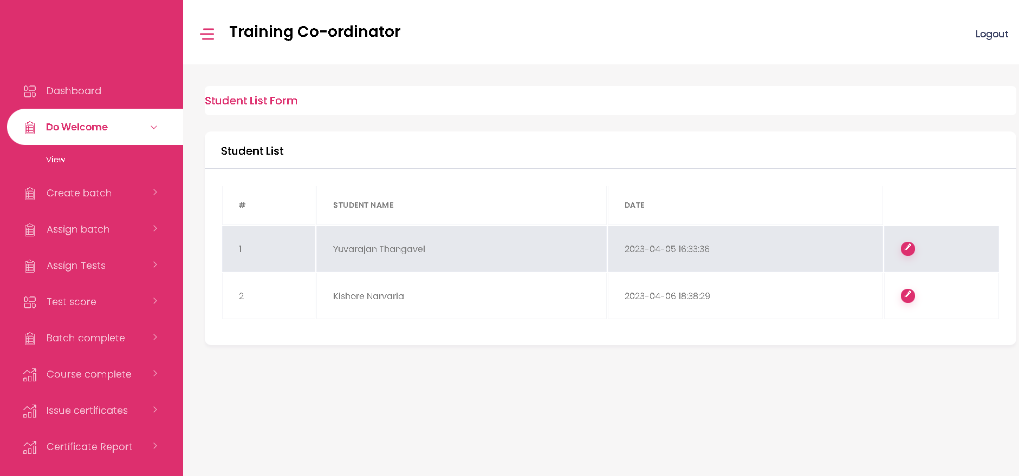**Student’s details will be as shown below. Training Coordinator can view & edit the student’s details here.

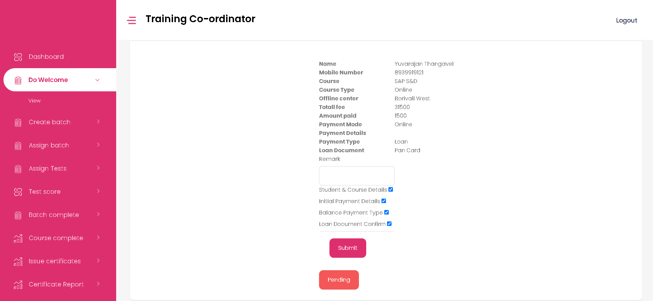

* **Create batch Page**

1. 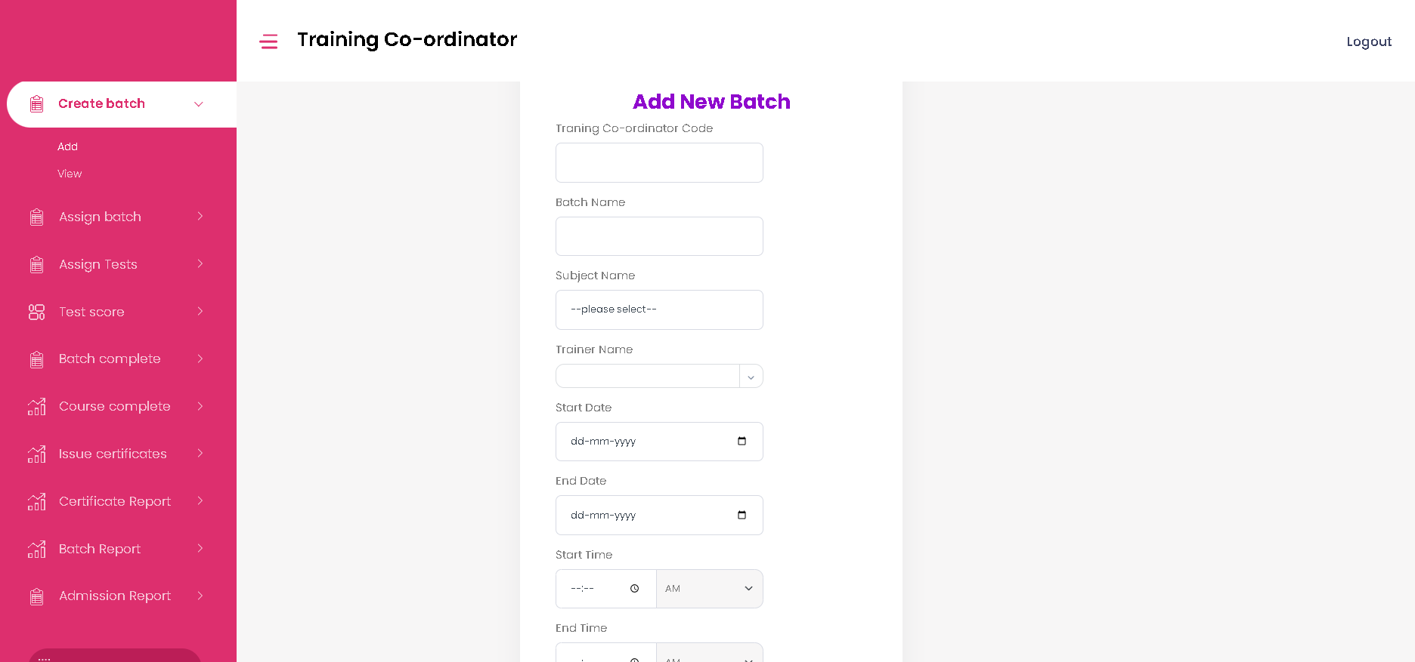Add- Traning Co-ordinator can add new batch details here.
2. View- Traning Co-ordinator can view and edit batch details here.

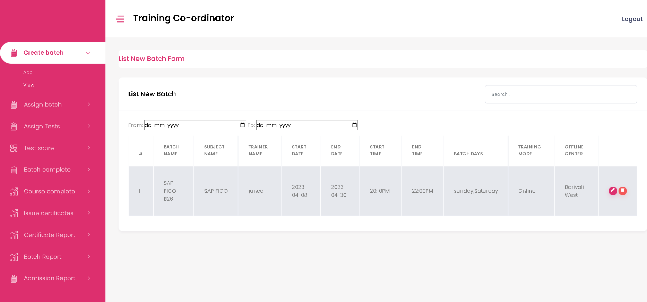

* **Assign batch Page 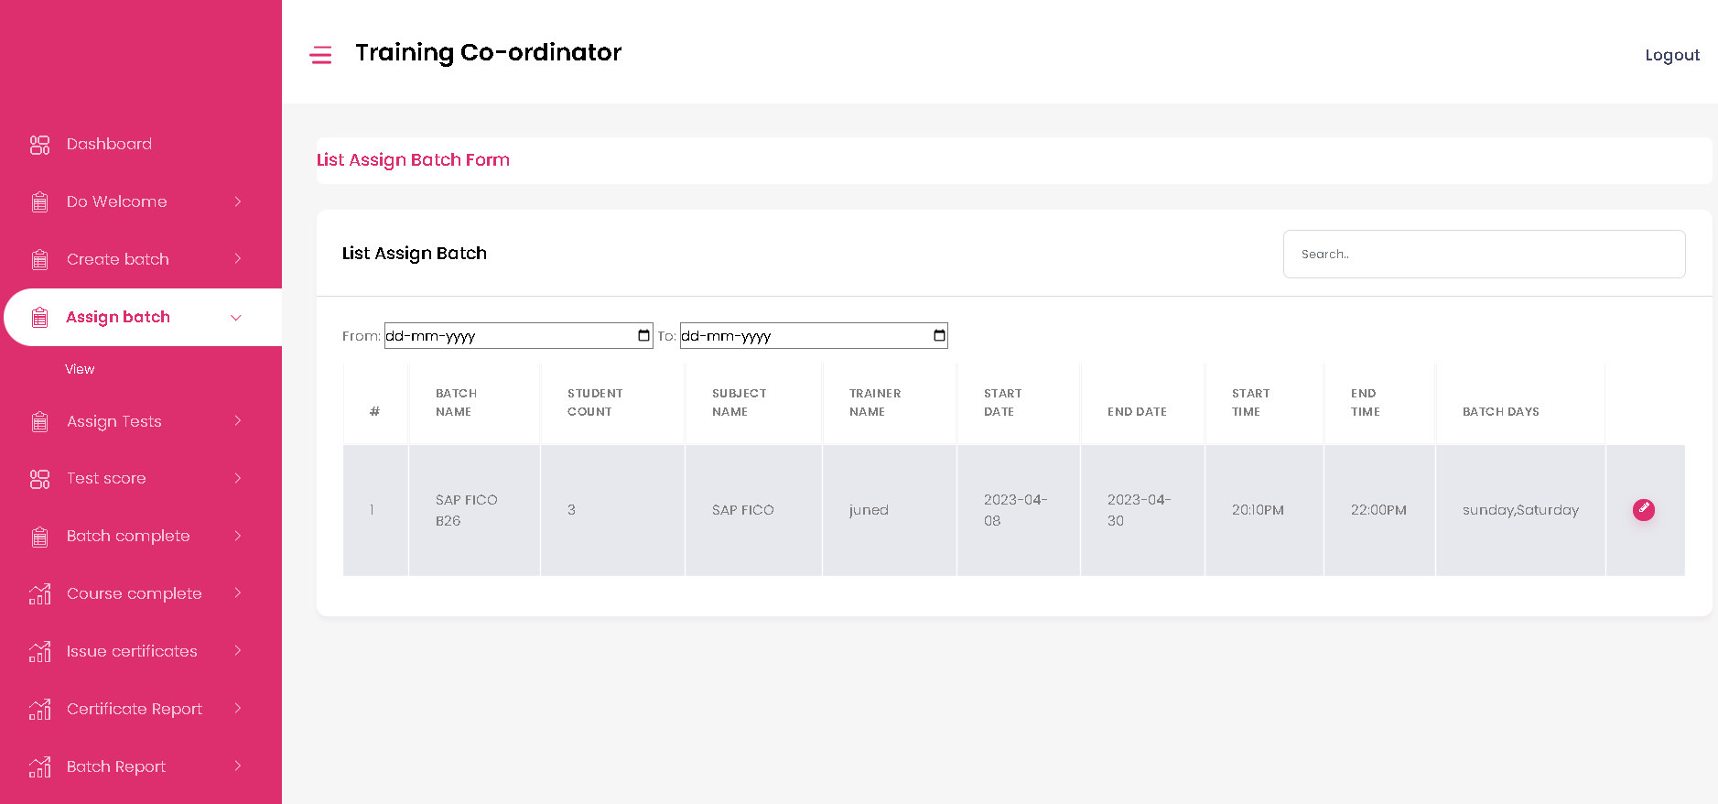-** Assign batch page with batch details will be shown here.Training co-ordinator can view and edit the details.
* **Assign Tests Page**

1. 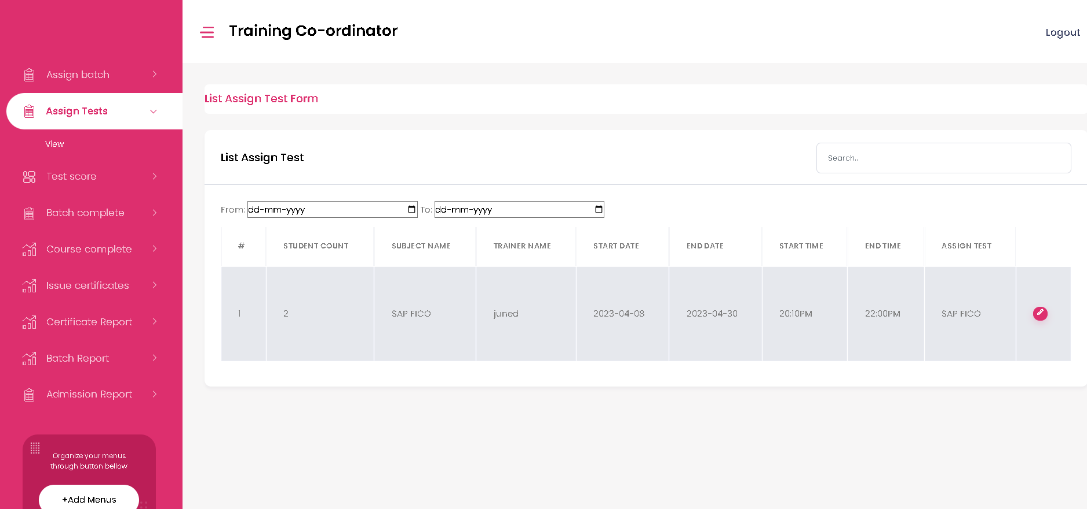Traning Co-ordinator can view the details of assigned tests to the batch here.
2. Traning Co-ordinator can edit the tests here.

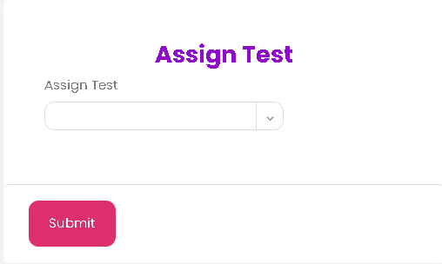

* 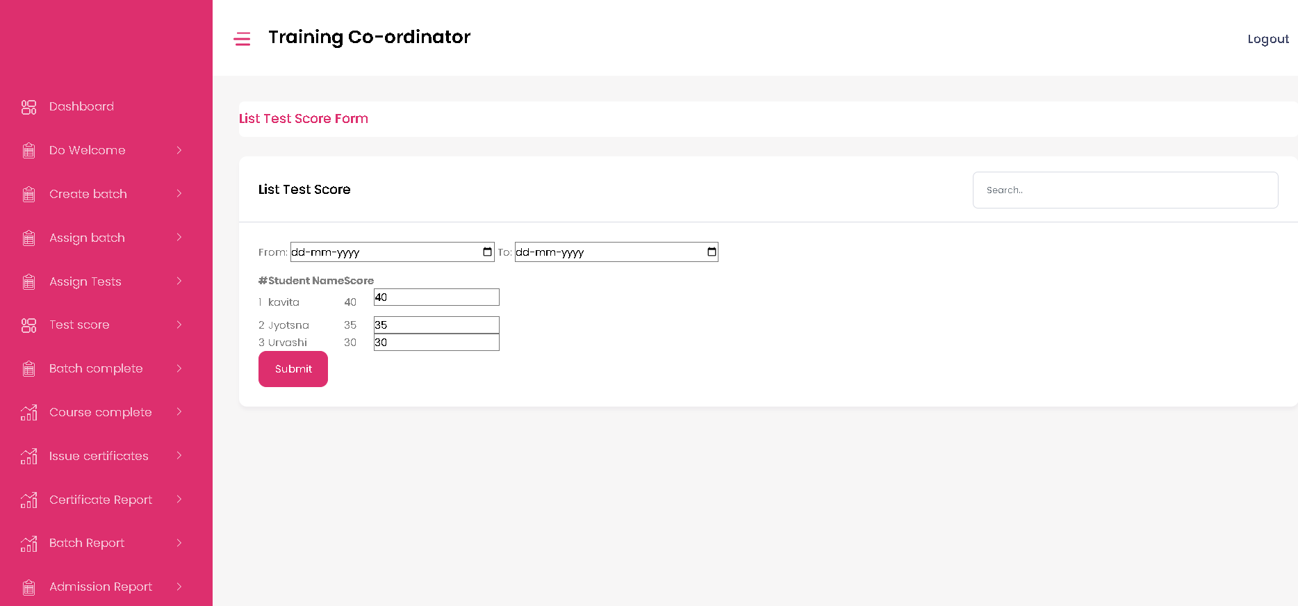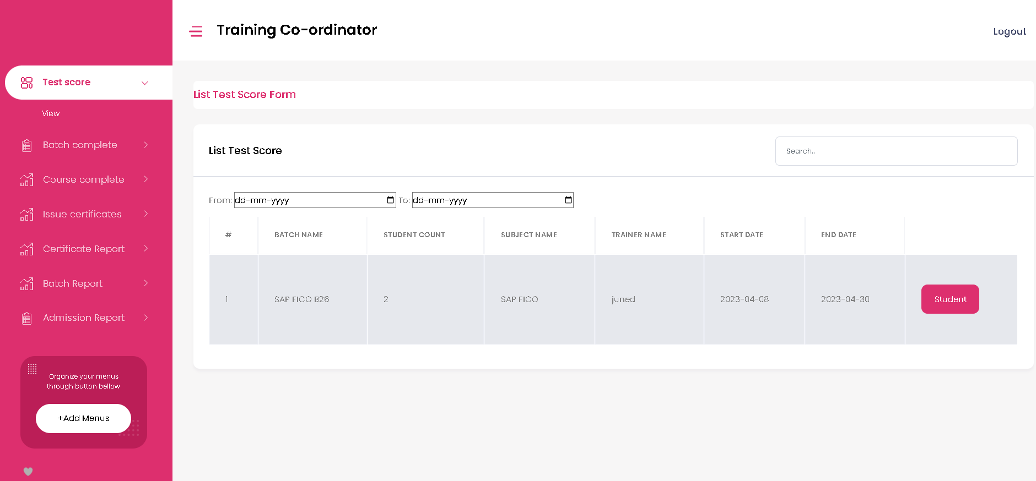**Test Score Page –** Traning Co-ordinator can view and edit the Test scores here.
* 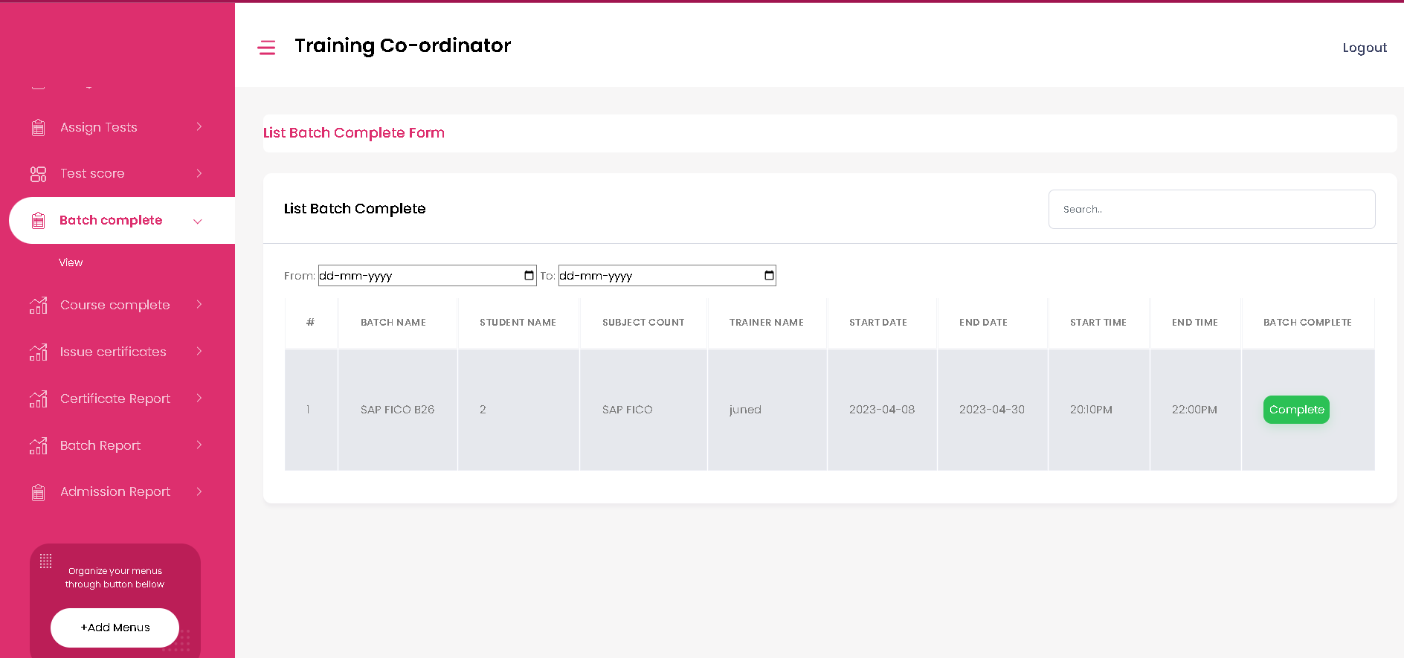**Batch complete Page –** Traning Co-ordinator can view and edit the completion status of batch here.
* 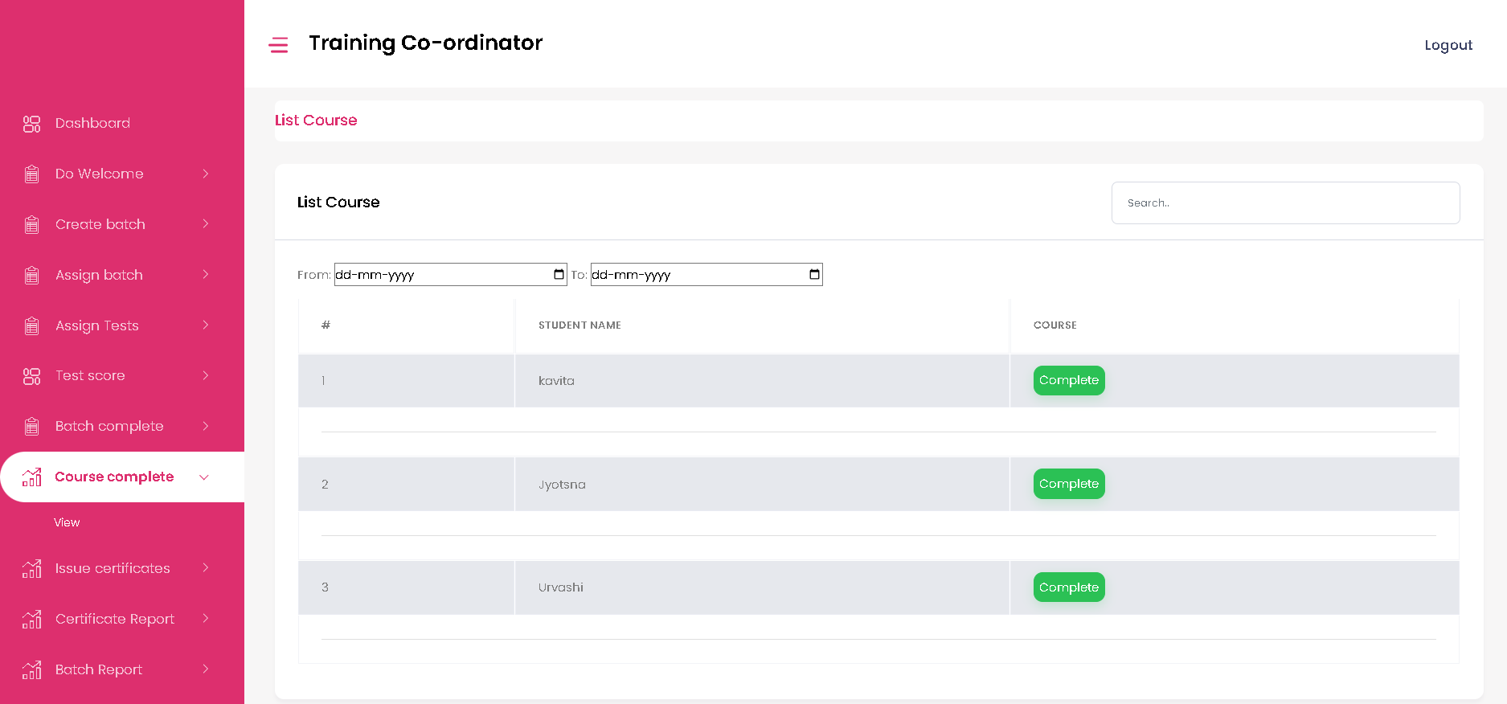**Course complete Page –** Traning Co-ordinator can view and edit the completion status of course here.
* 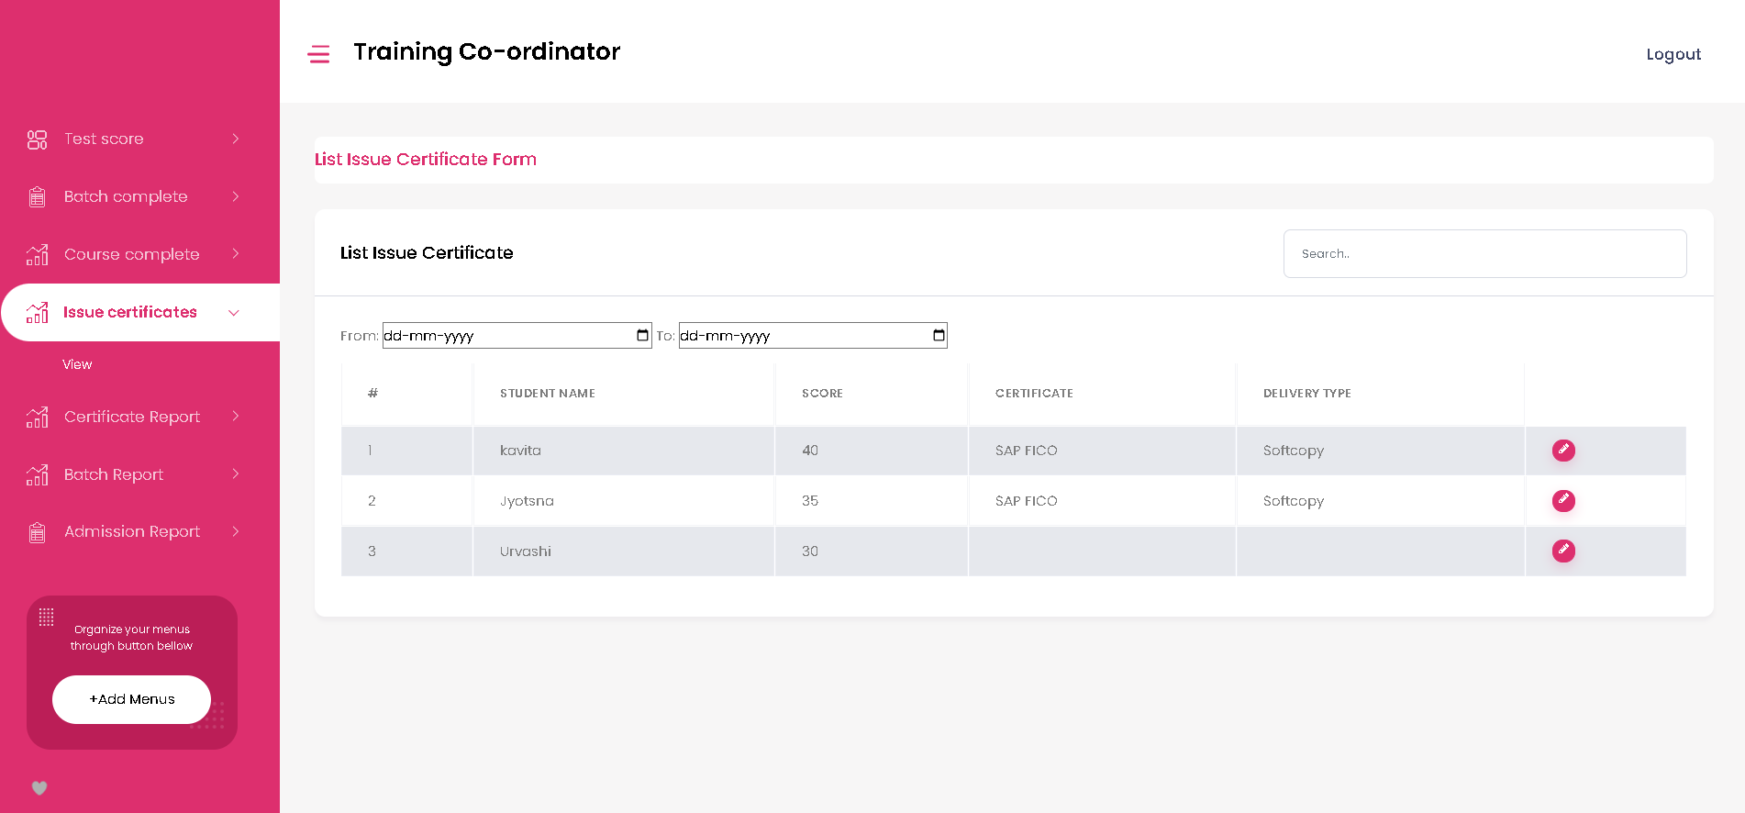**Issue certificates Page –** Traning Co-ordinator can view and issue the certificates here.

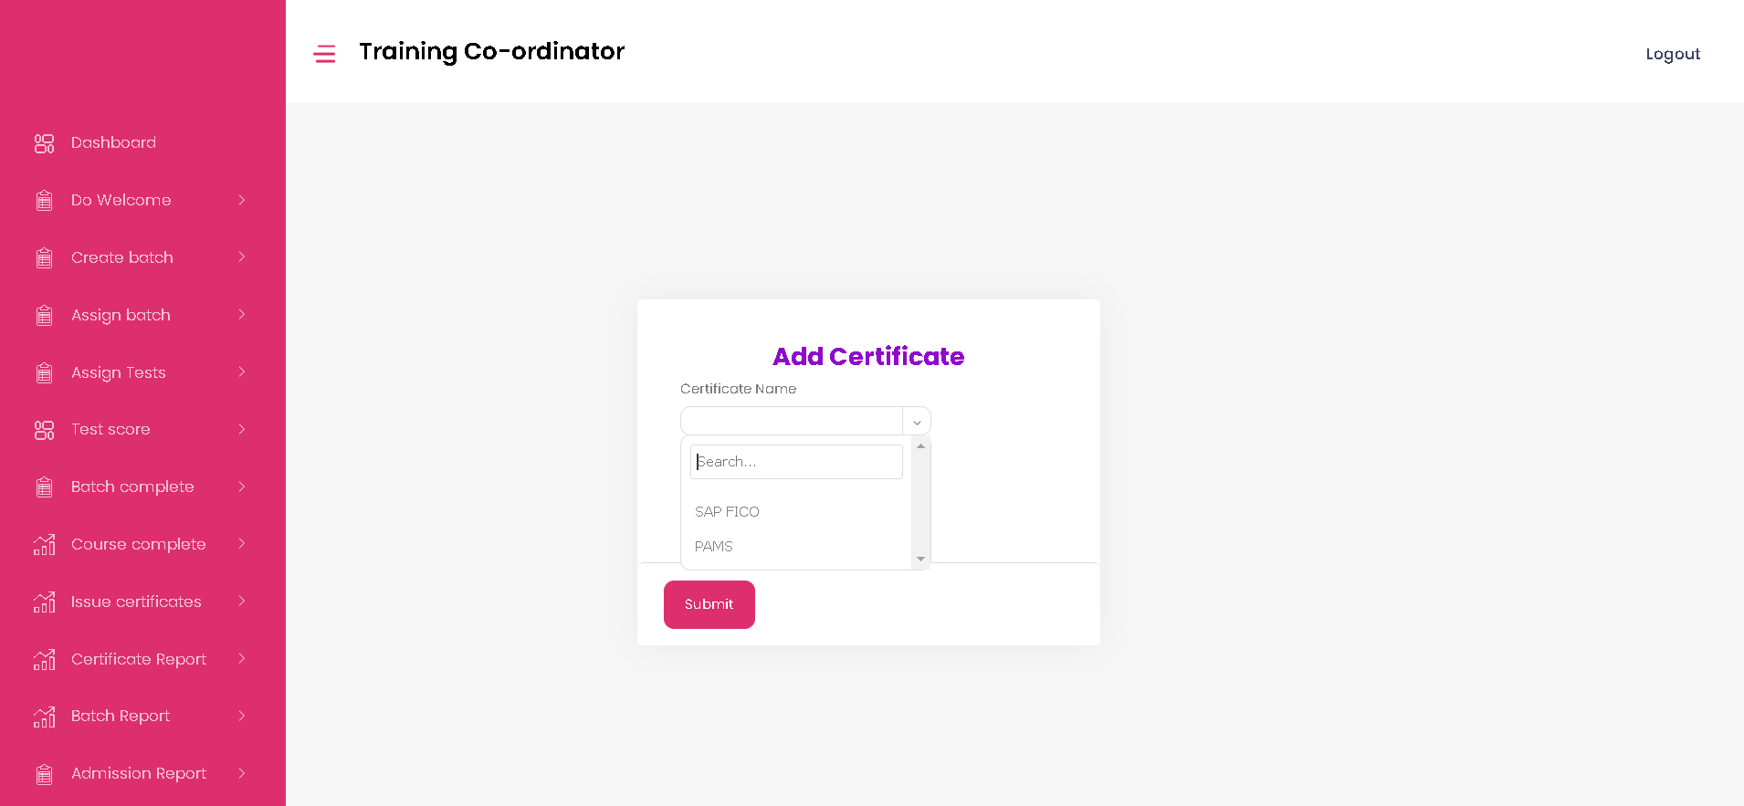

* 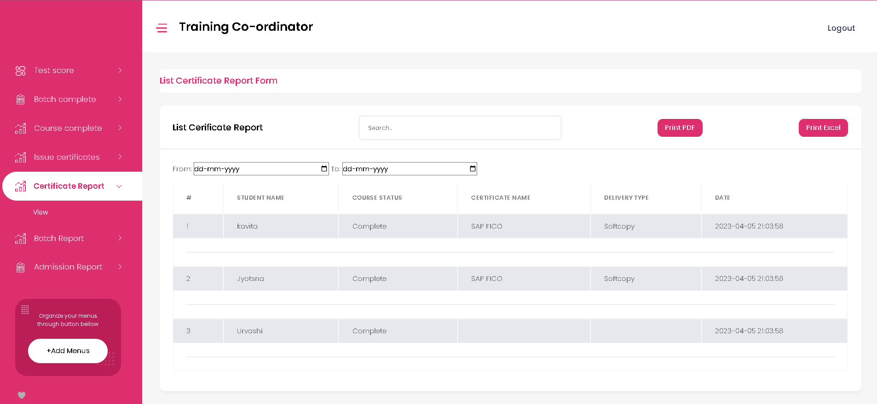**Certificate Report Page -** Traning Co-ordinator can view and print certificates report here.
* 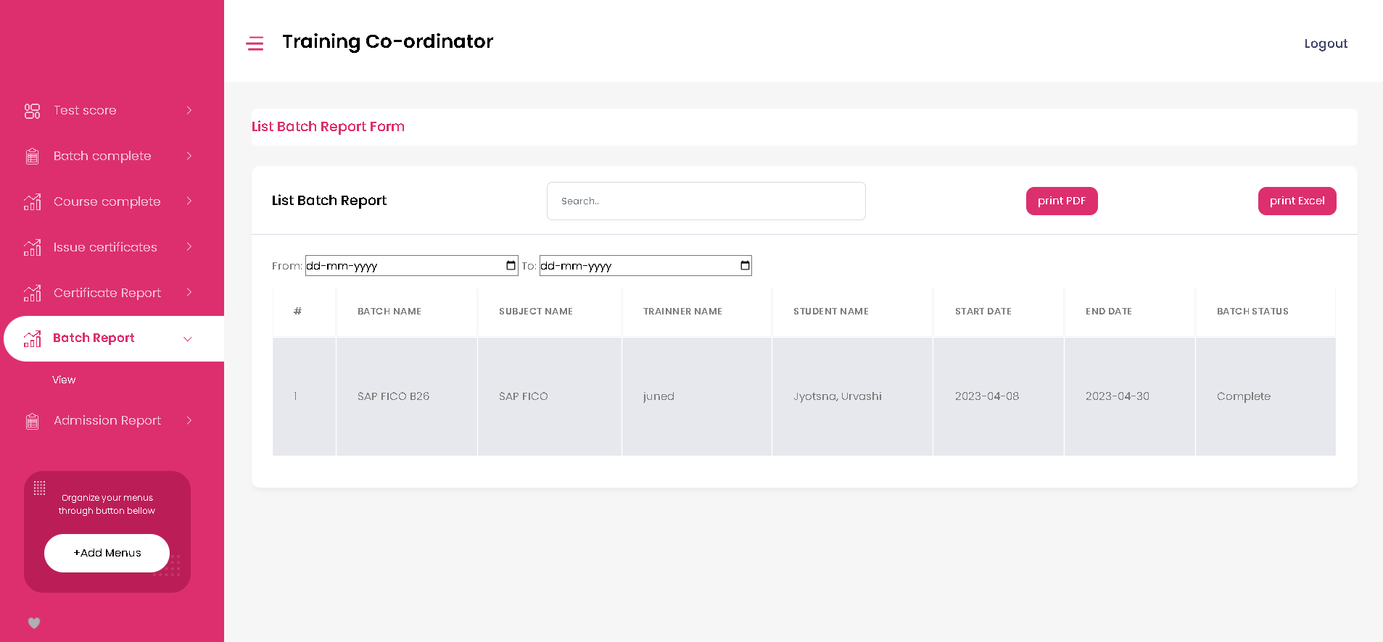**Batch Report Page -** Traning Co-ordinator can view batch report here.
* 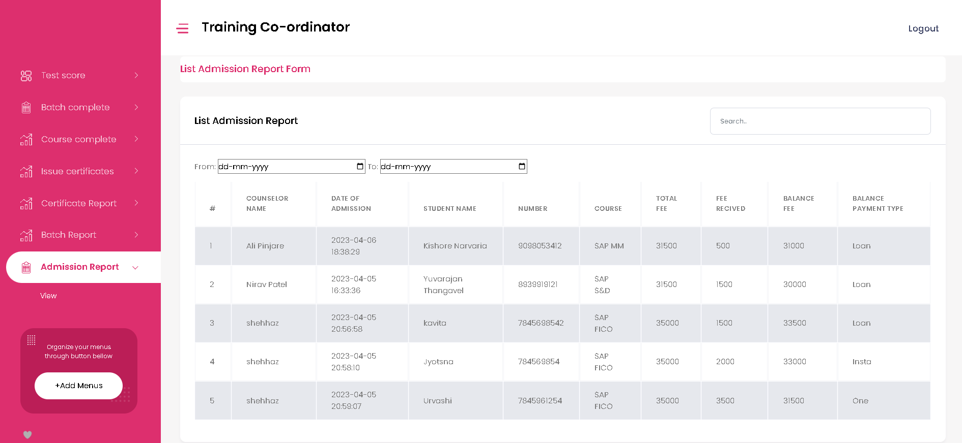**Admission Report Page -** Traning Co-ordinator can view Admission report here.
* 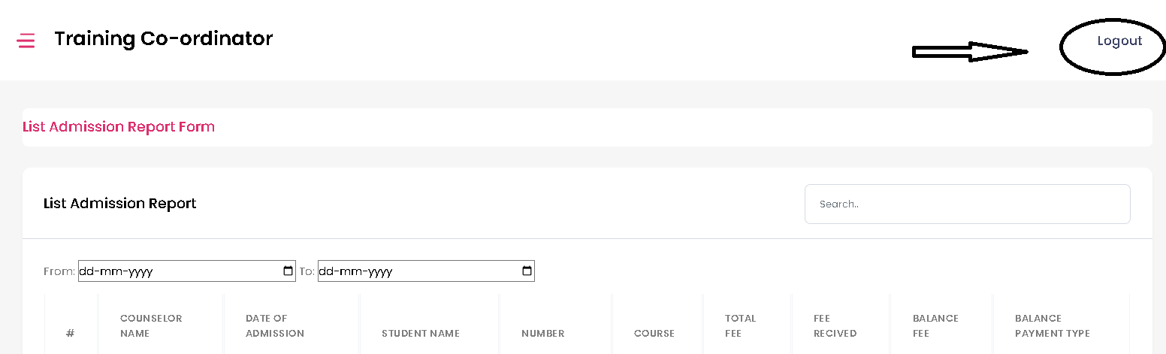**Logout -** Traning Co-ordinator can Logout from here.

**Counselor Dashboard**

* 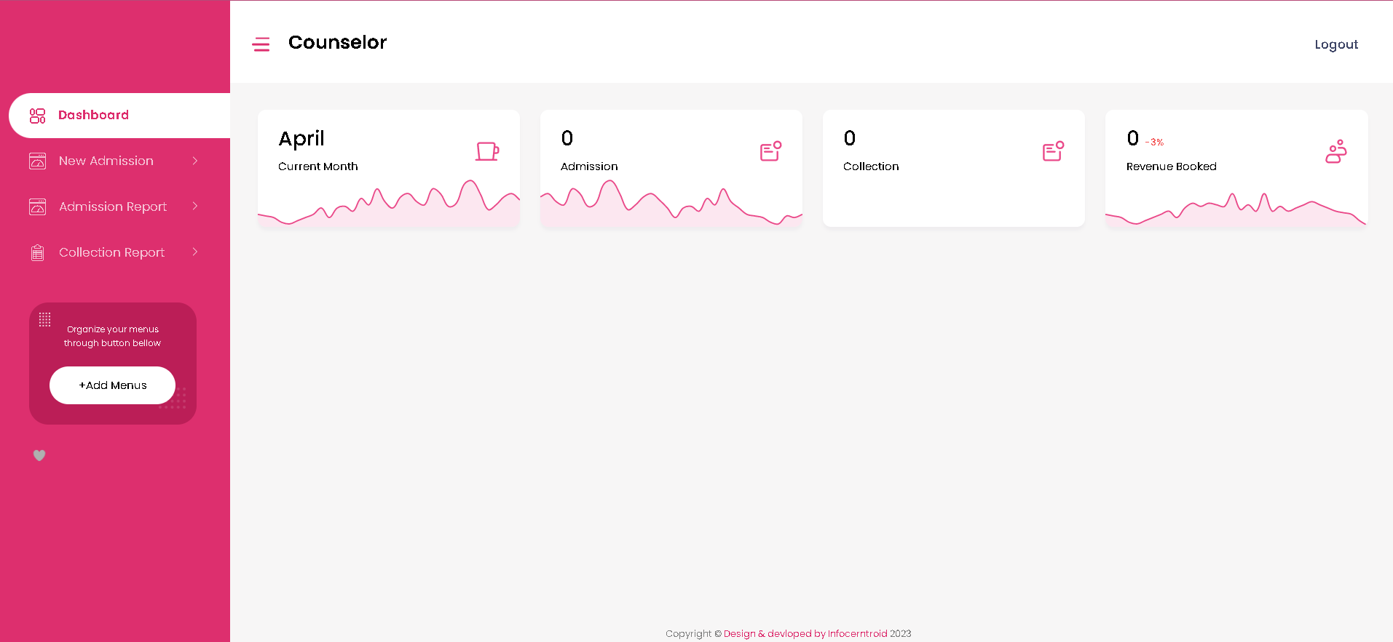**Dashboard** - The Counselor can view following details here.
* **New Admission Page**

1. 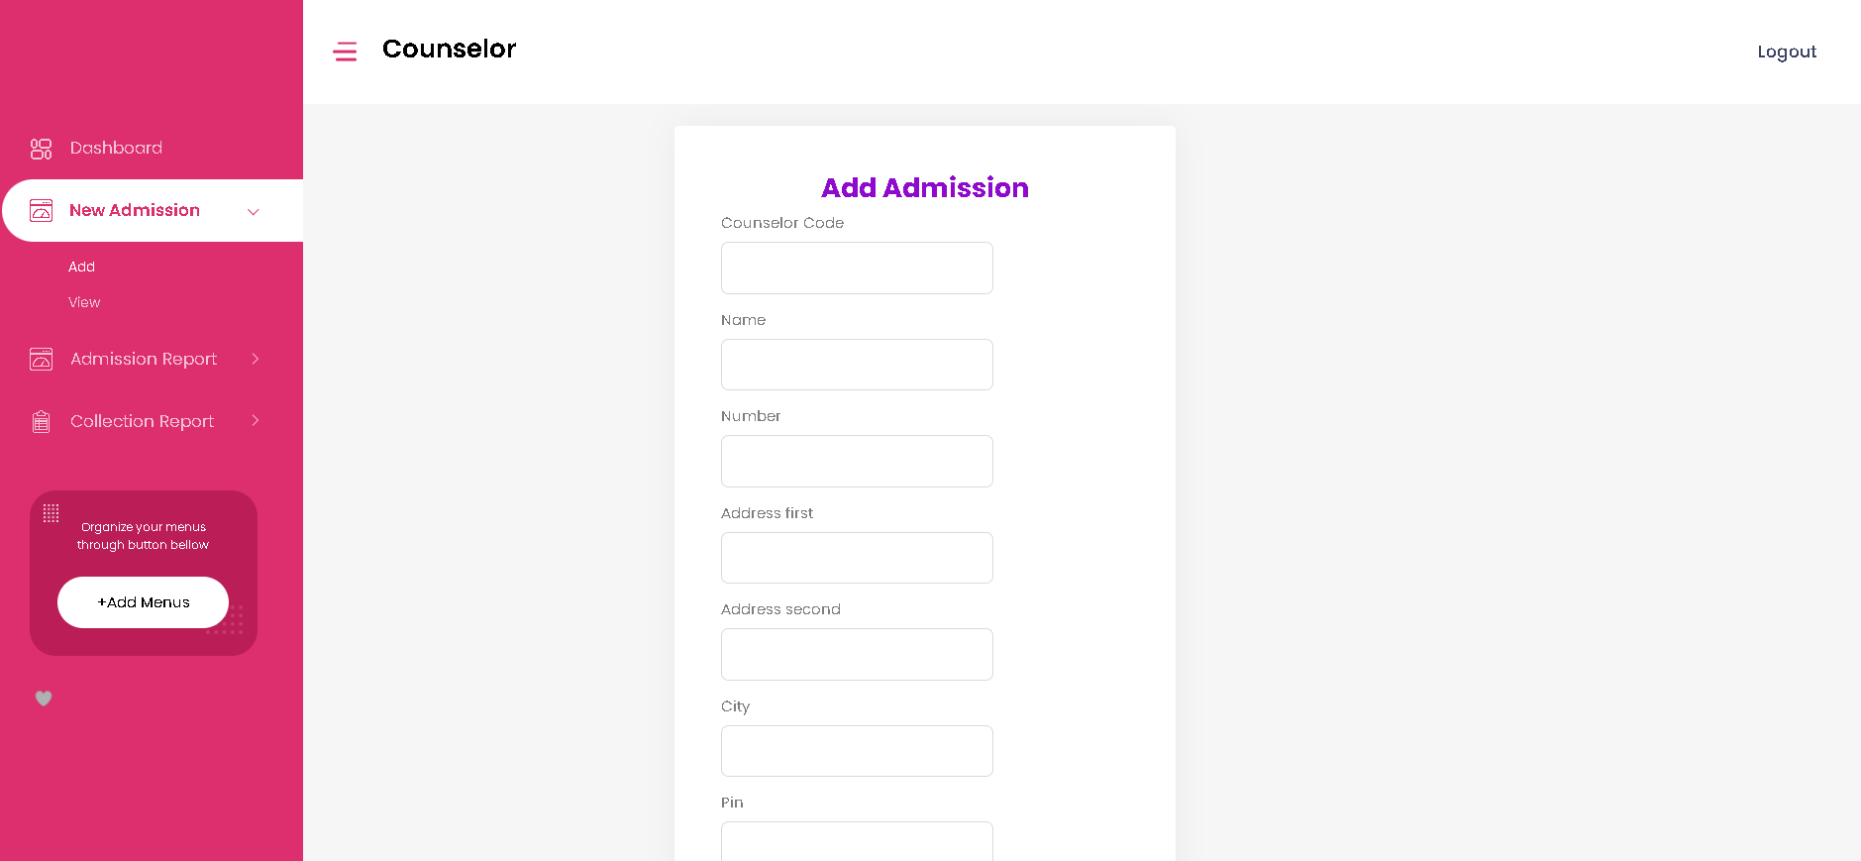**Add** - Counselor can add new admission details here.
2. **View –** Counselor can view admissions here.

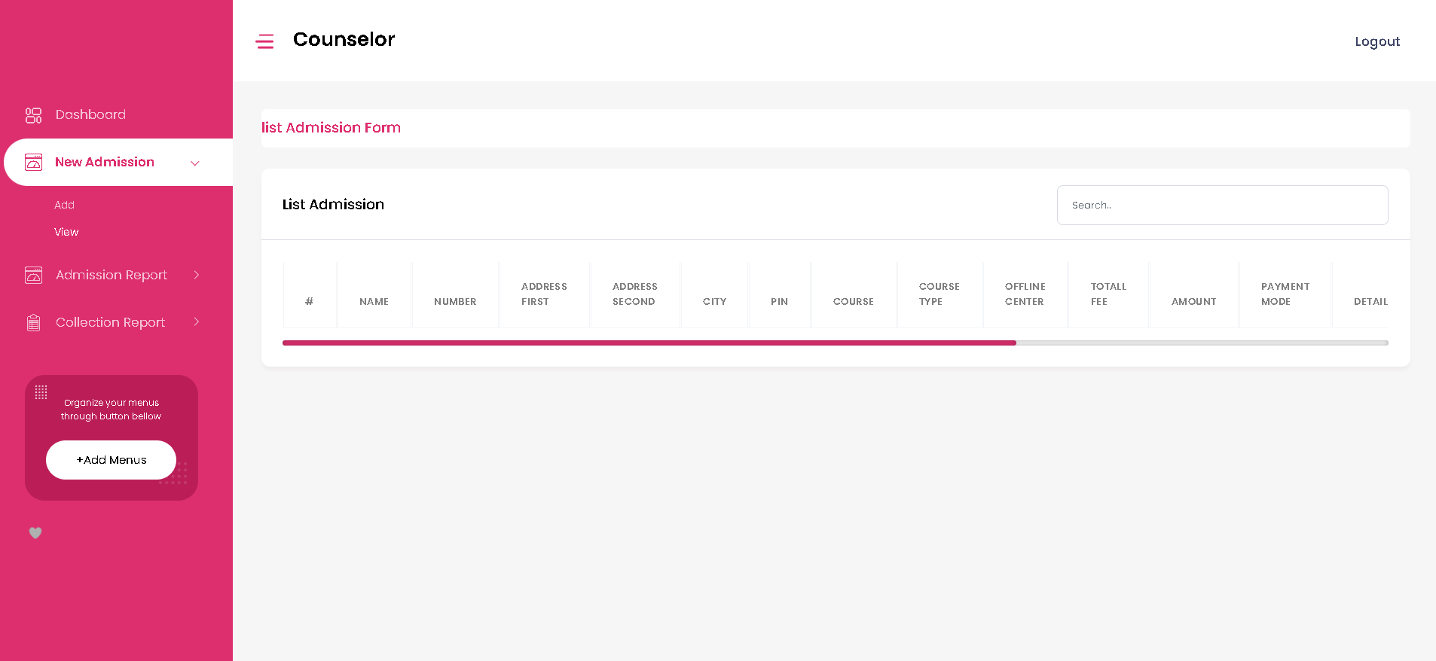

* **Admission Report Page –** Counselor can view Admission report here**.**

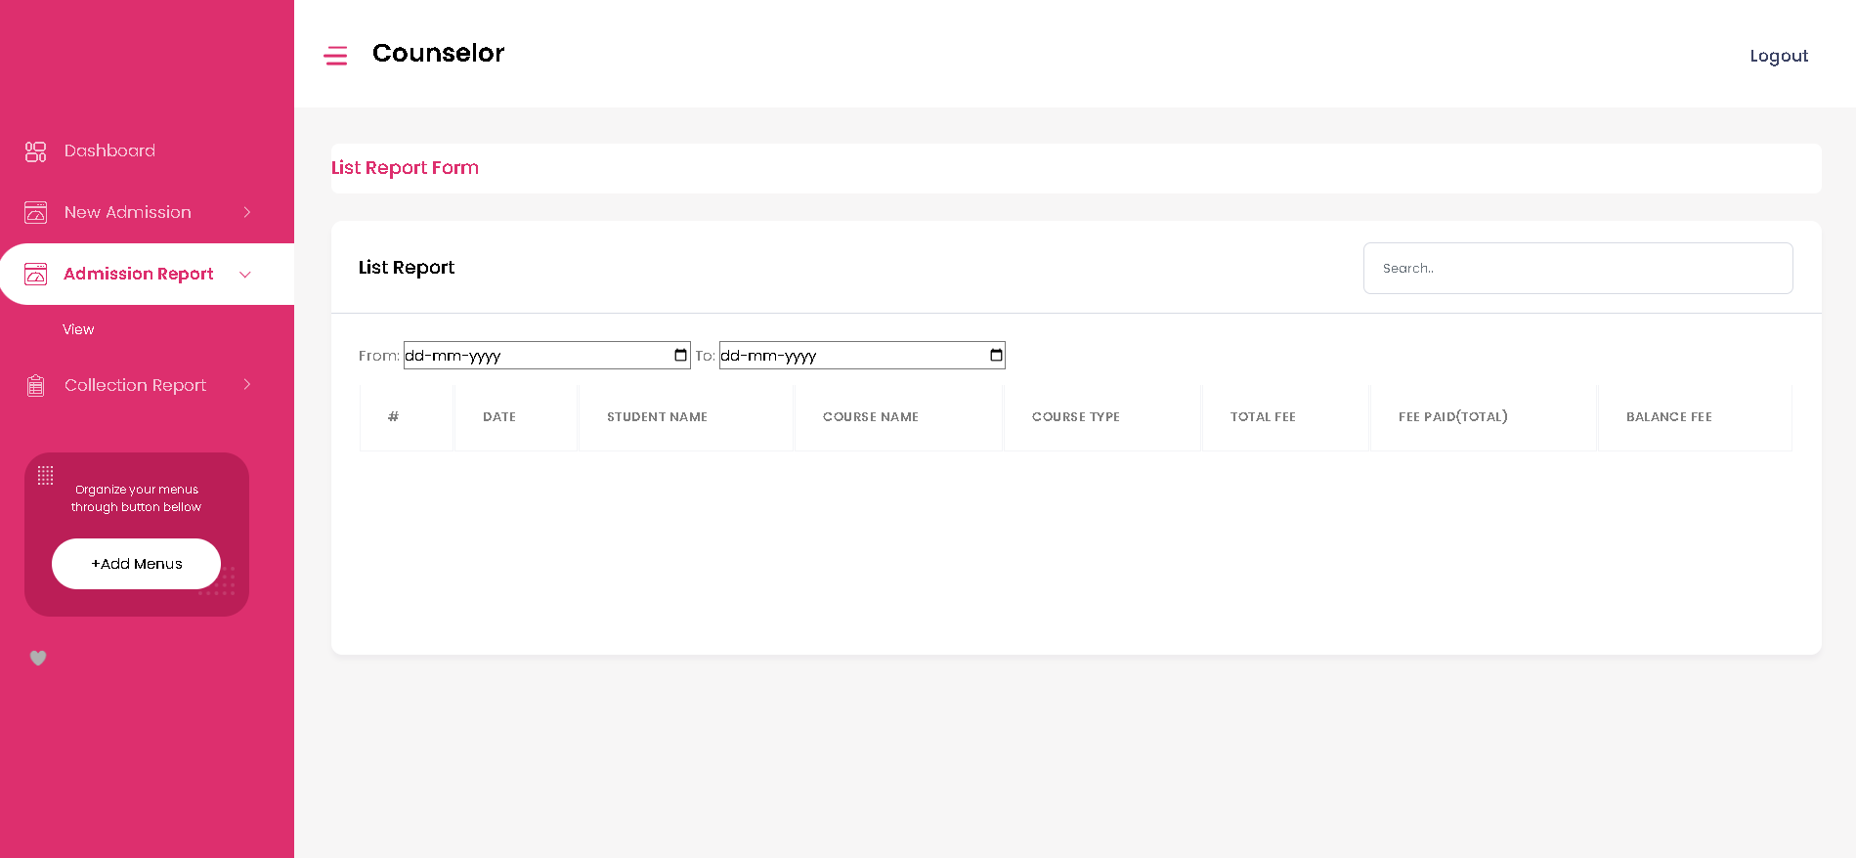

* **Collection Report Page –** Counselor can view collection report here**.**

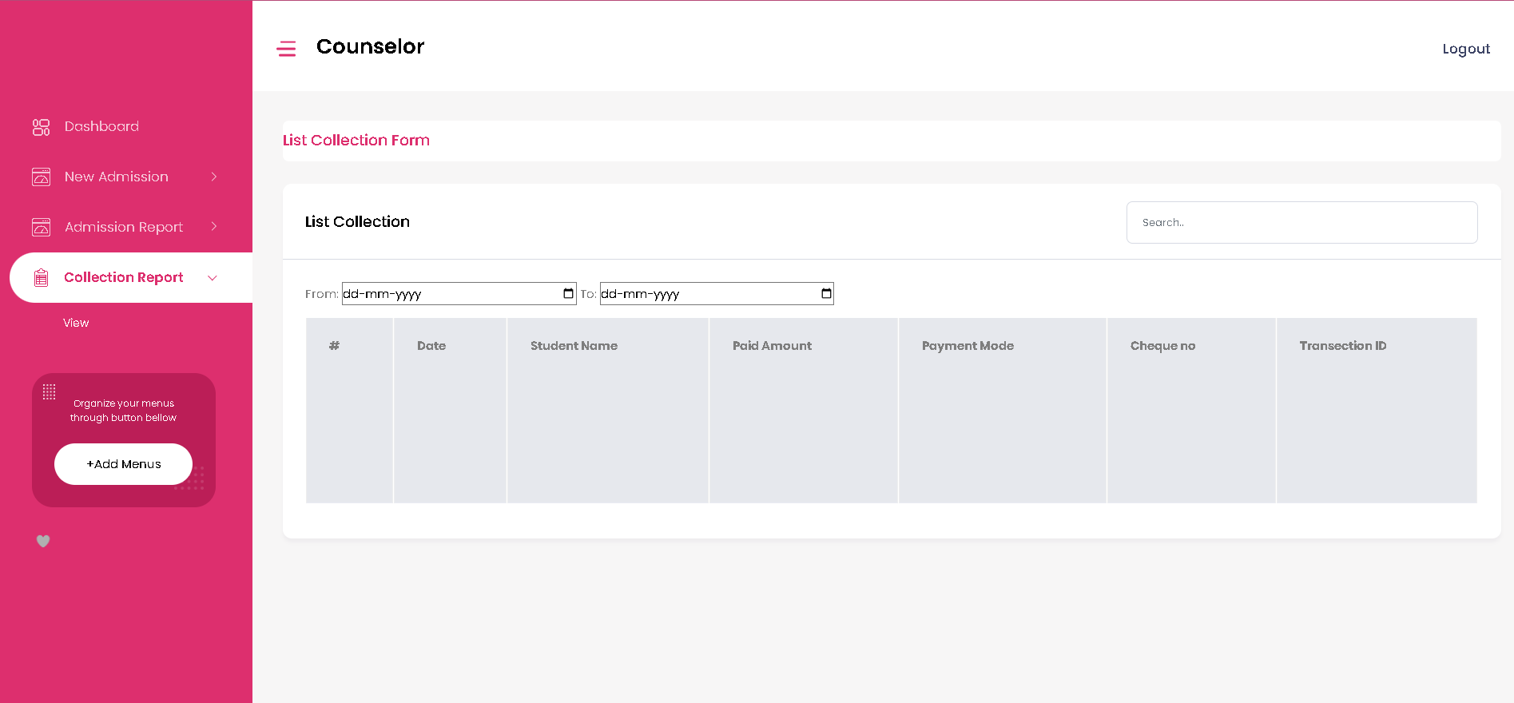

* **Logout –** Counselor can Logout from here**.**

**Accountant Dashboard**

* **Dashboard Page**- The accountant can view following details here.

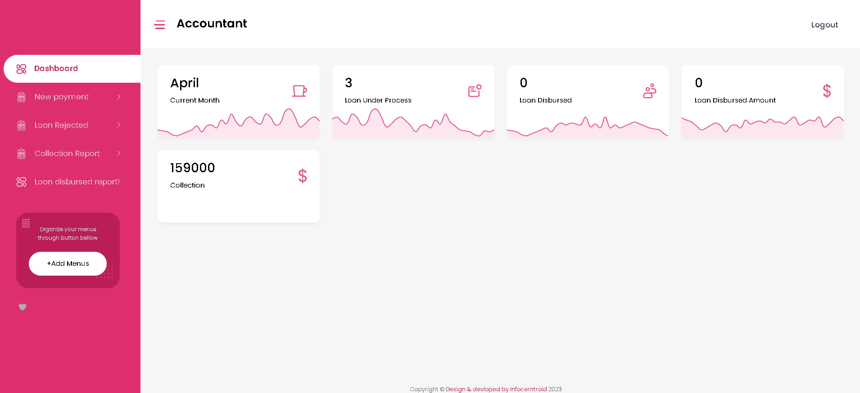

* **New Payment Page**

1. **View** 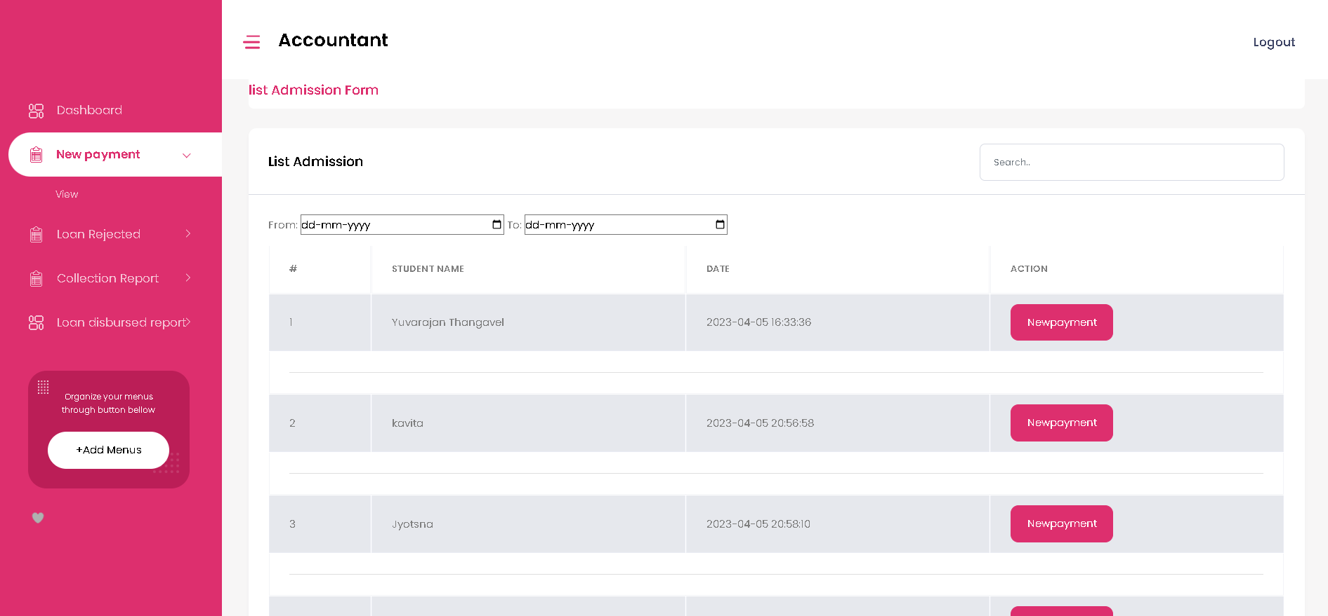 - The accountant can view payment details here.
2. **Add -** 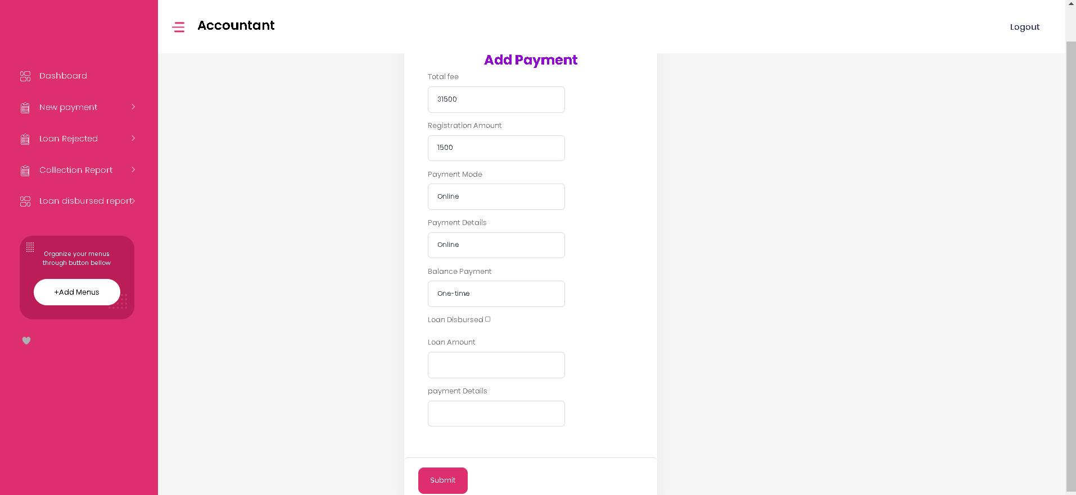The accountant can add payment details here.

* **Loan Rejected Page**

1. **View –** The accountant can view loan rejection details here.

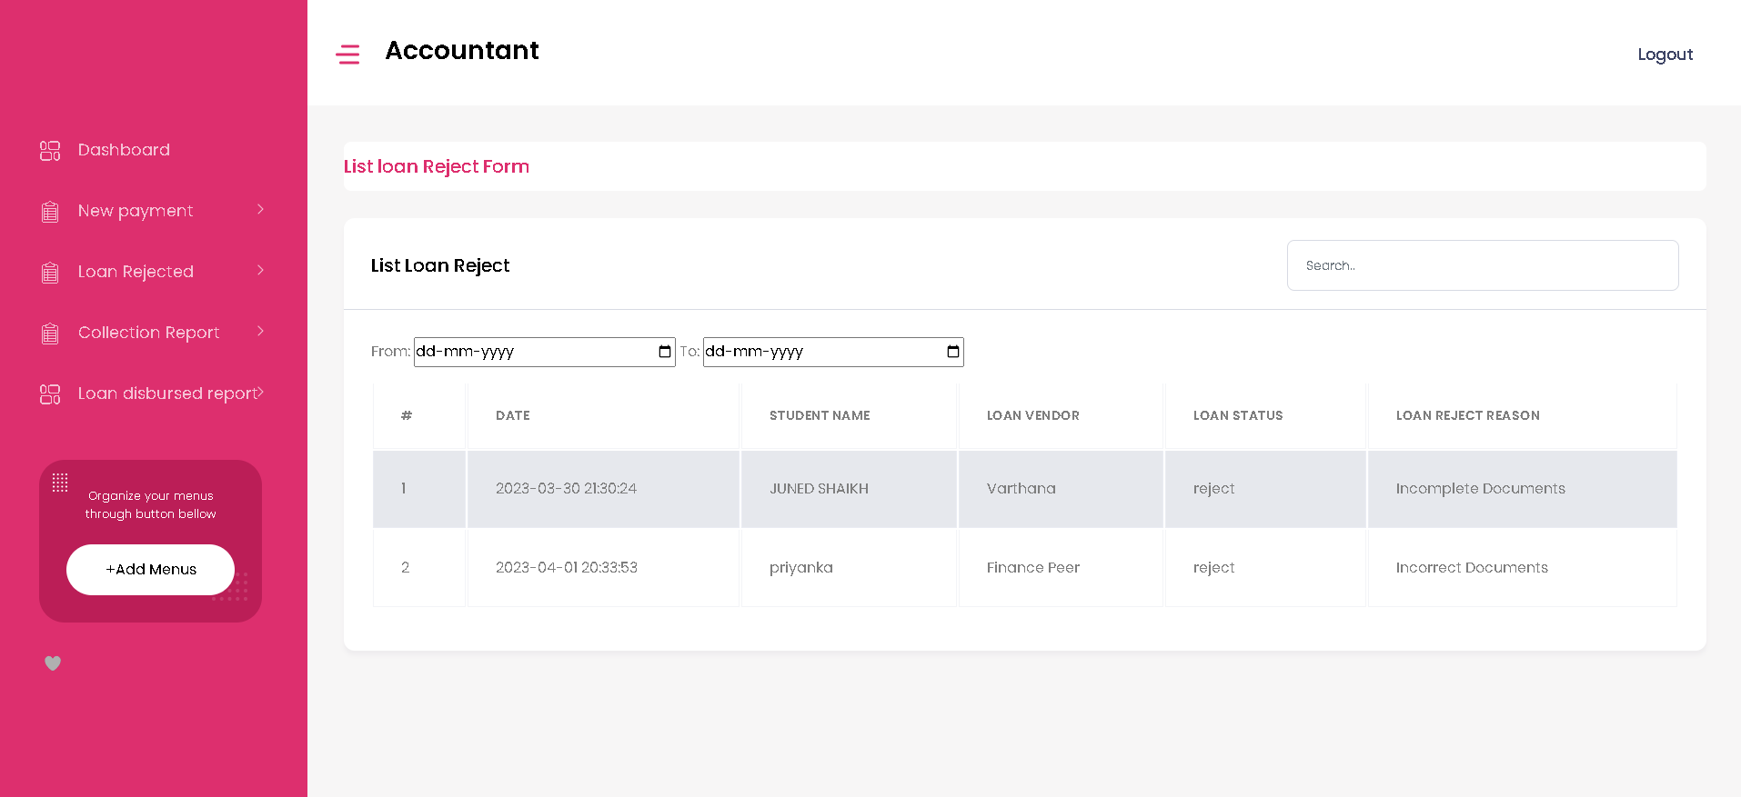

1. **Add –** The accountant can add loan details here and can accept or reject the loan.

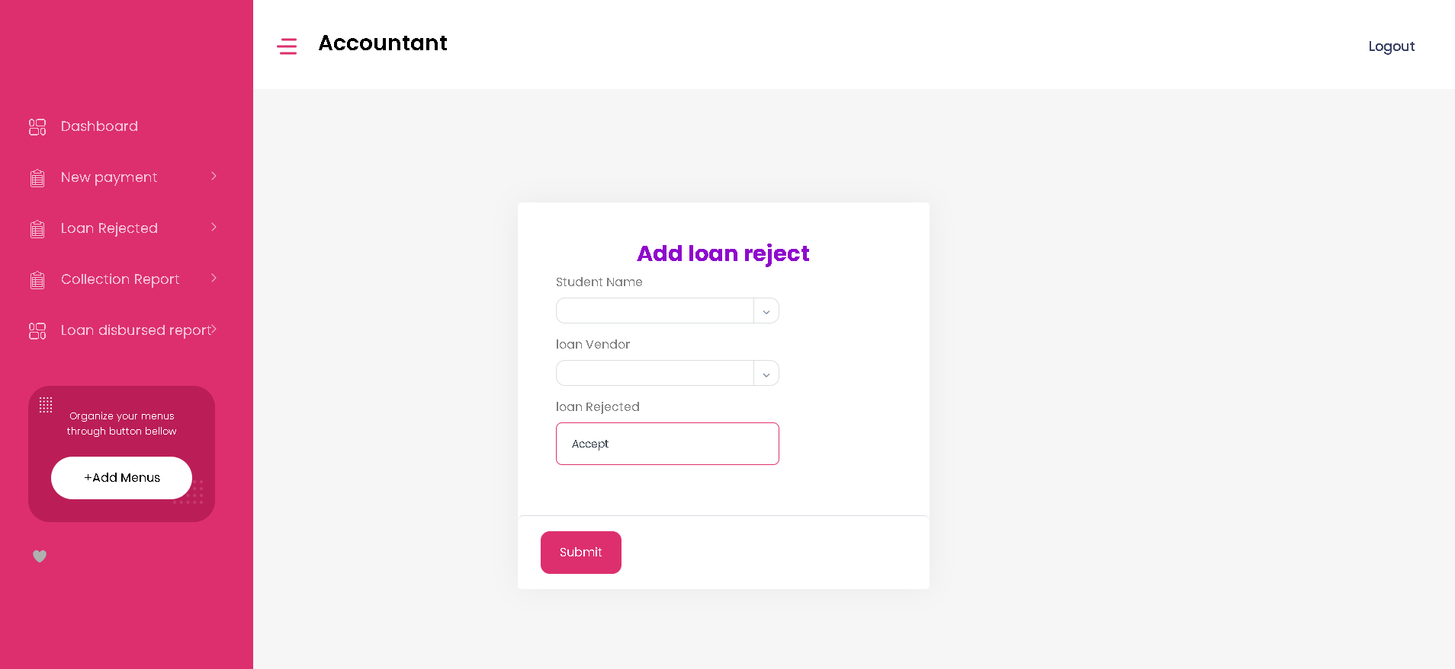

* **Collection Report Page**

1. **View –** The accountant can view collection report here.

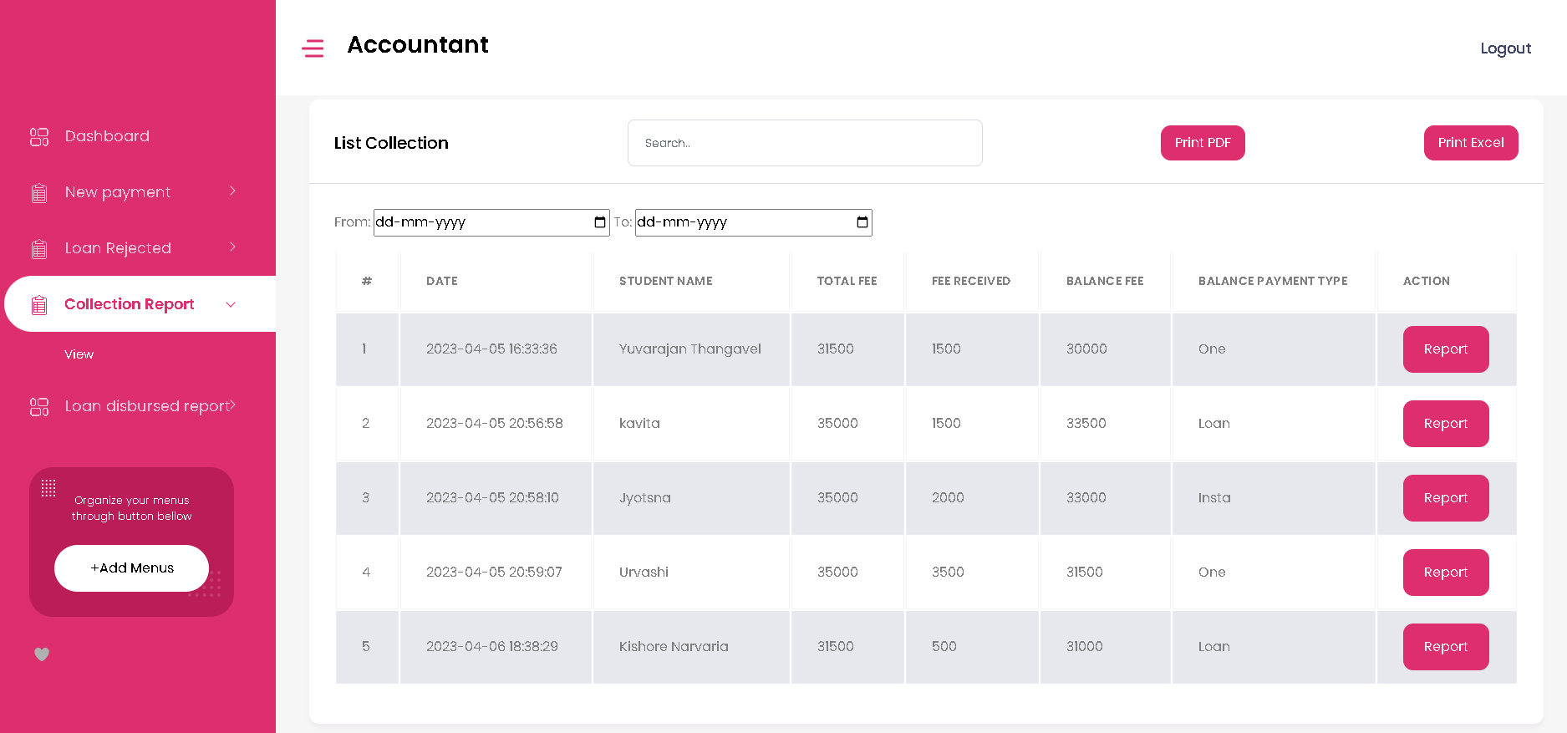

1. 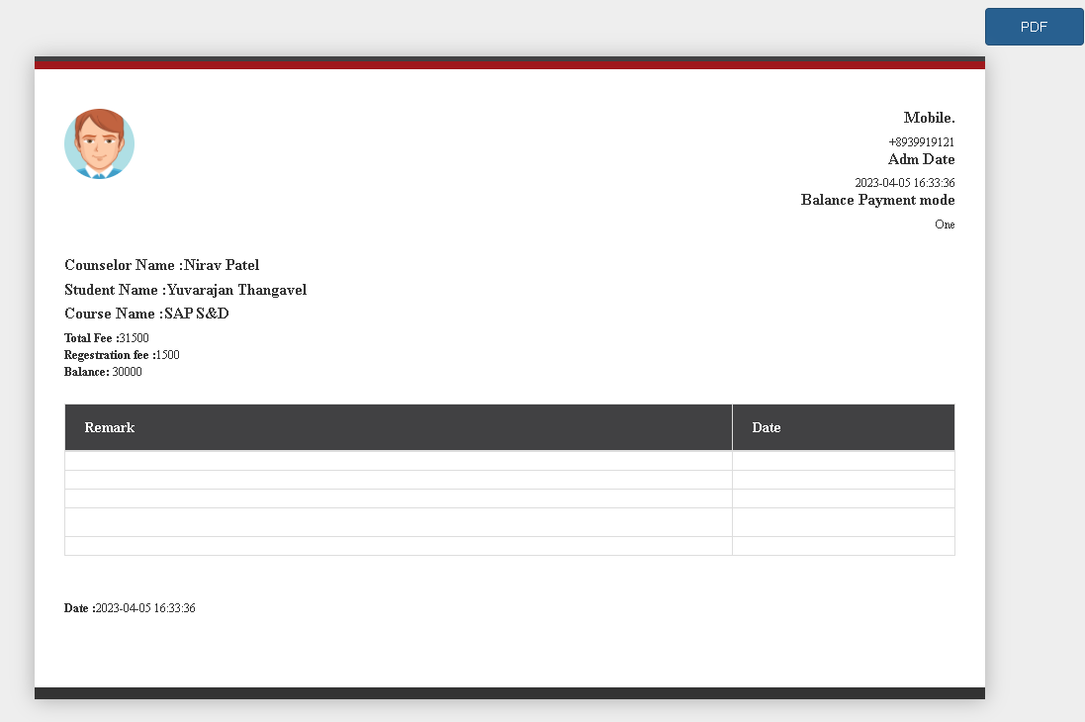**Print –** The accountant can print collection report here.

* 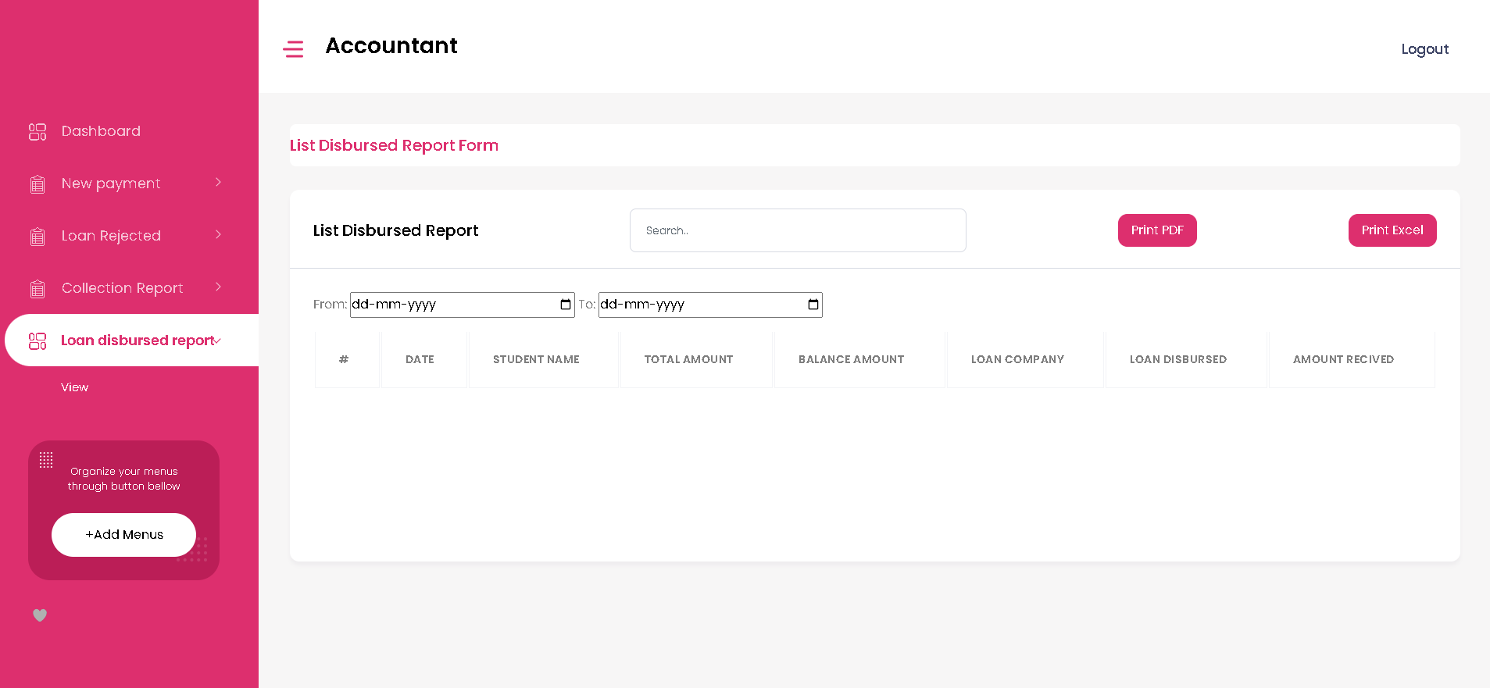**Loan disbursed report Page –** The accountant can view loan disbursed report here.
* **Logout –** The accountant can Logout from here.

**Placement Officer Dashboard**

* 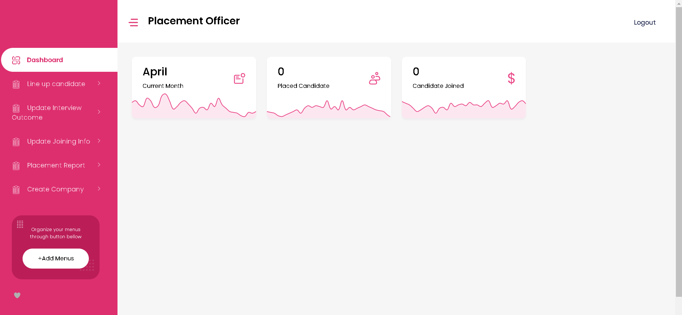**Dashboard Page**- The placement officer can view following details here.
* **Line up candidate Page**

1. 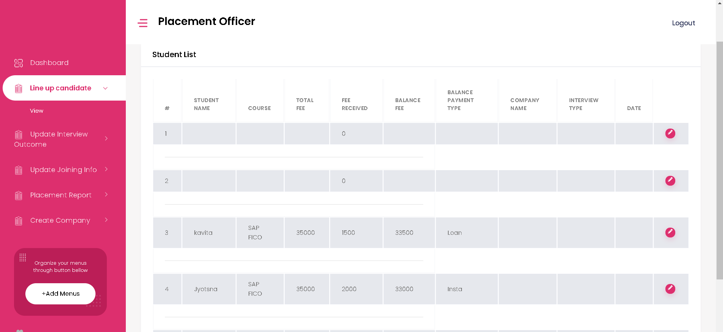**View –** The placement officer can view the list of lined up candidates for interview.
2. 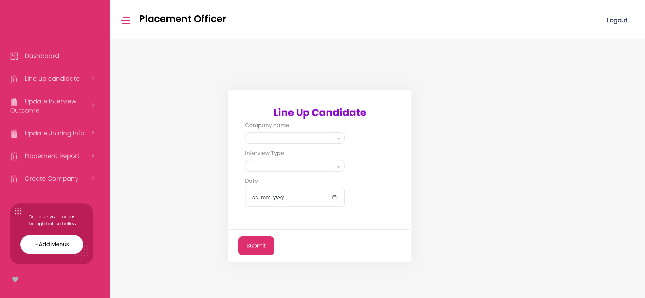**Add** – The placement officer can add the details on line up candidates page here.

* **Update Interview Outcome Page –**

1. 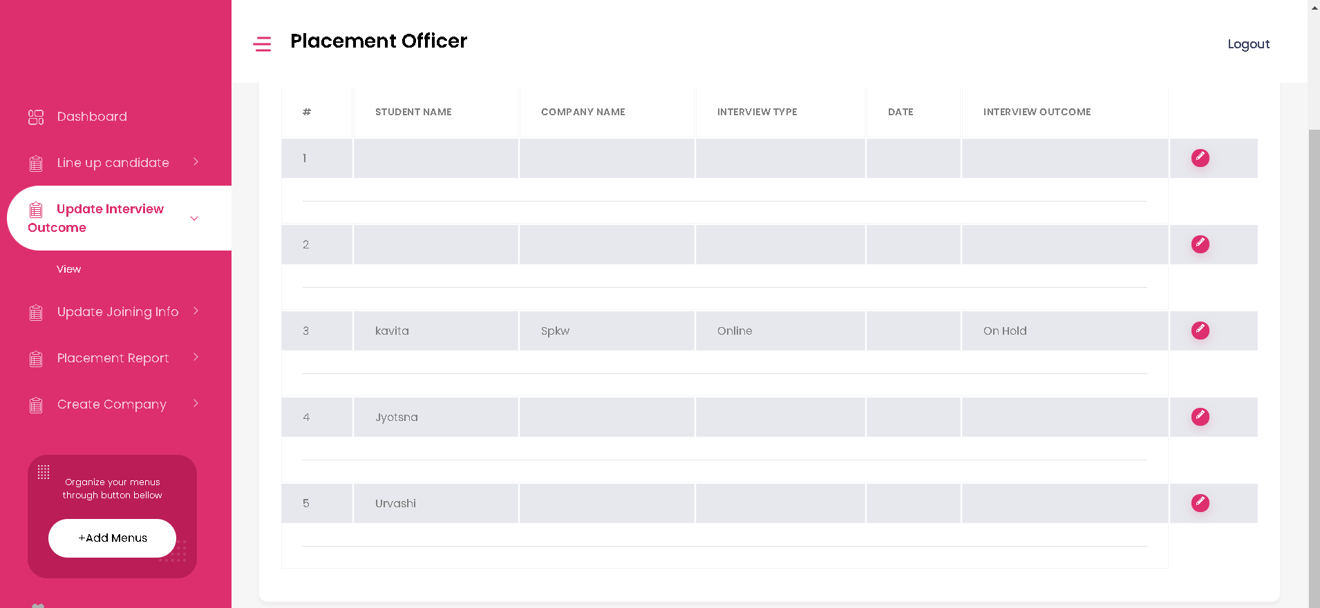**View-** The placement officer can view the list of Interview outcome of candidates here.
2. 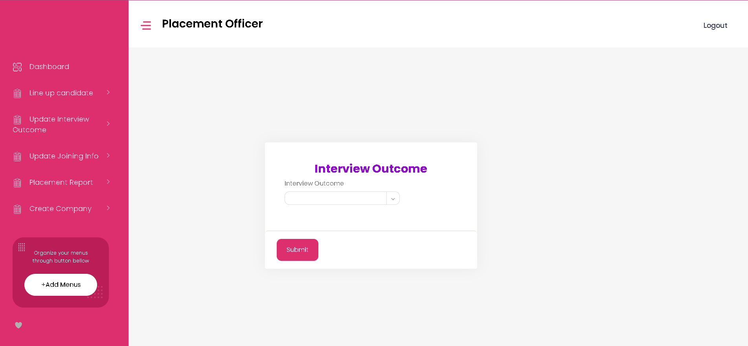**Add** – The placement officer can add the interview outcome here.

* 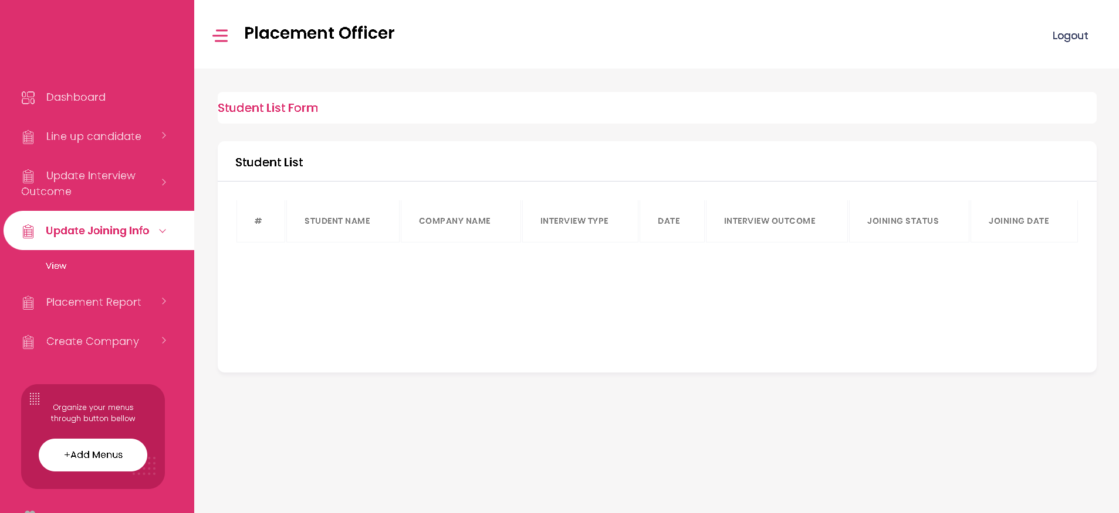**Update Joining Info Page –** The placement officer can view the joining information of all candidates here.
* **Placement Report Page-** The placement officer can view and print the placement report here.

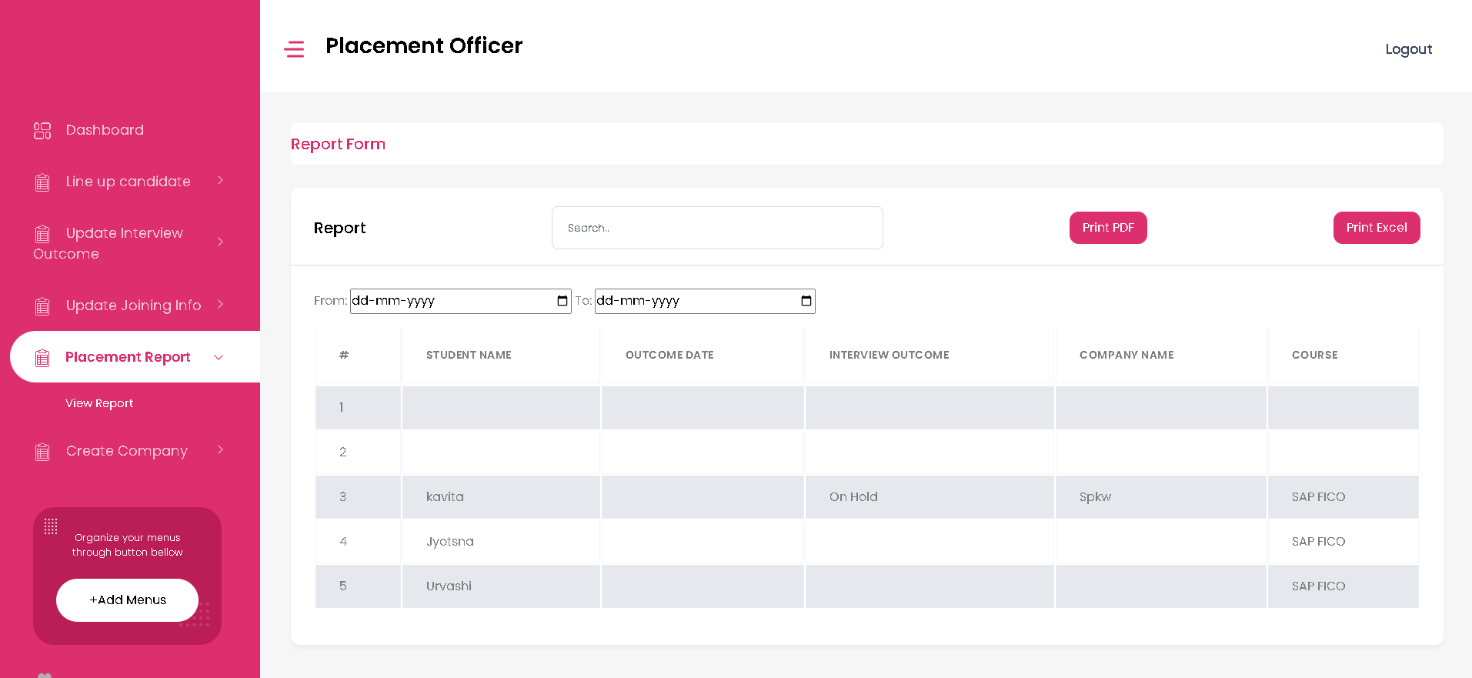

* **Create Company Page**

1. 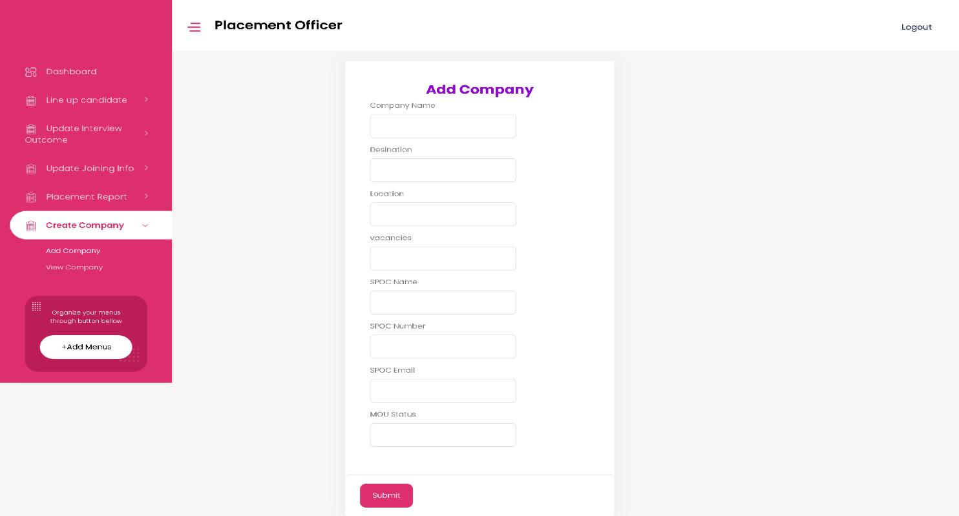**Add Company** – The placement officer can add company details here.
2. 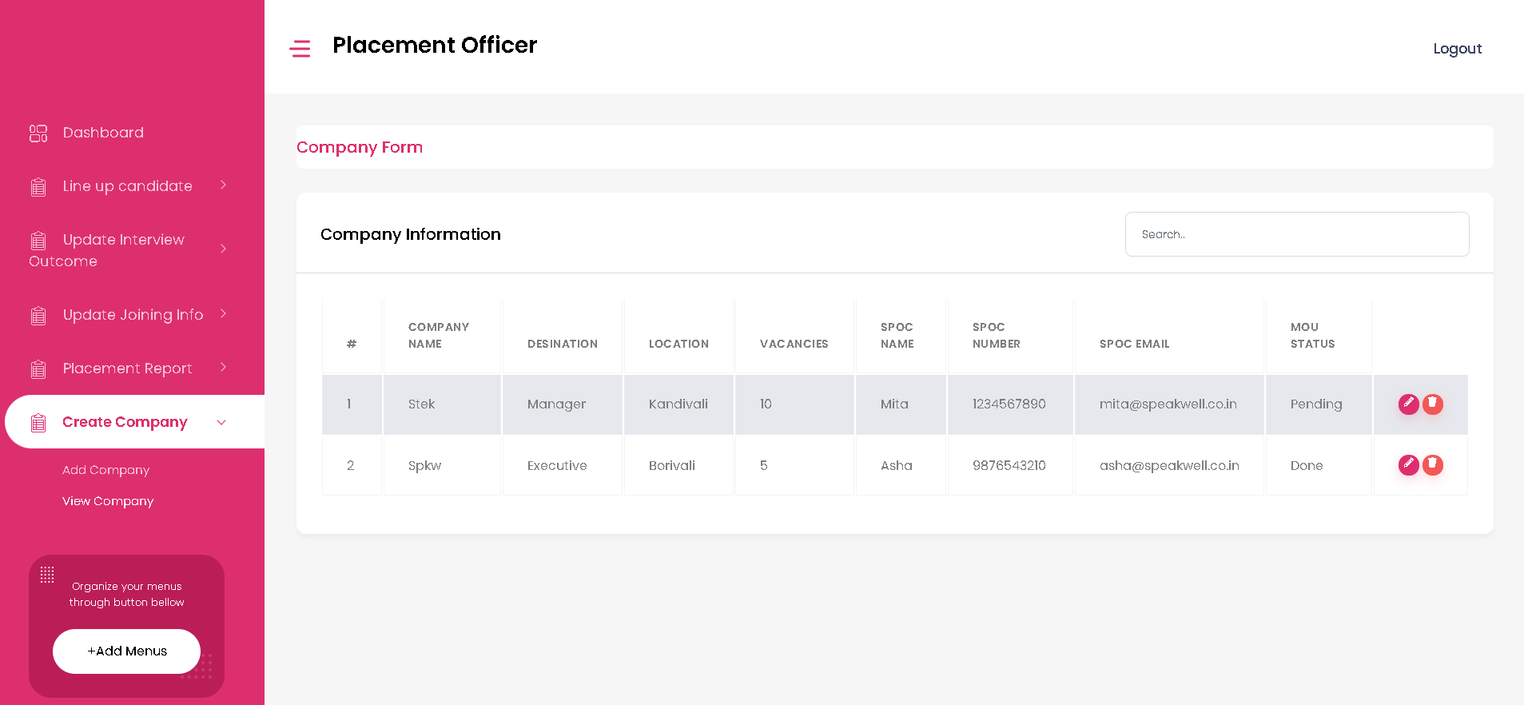**View Company** – The placement officer can view company details here.

* **Logout –** The placement officer can Logout from here.

**Admin Dashboard**

* **User Menu Page**

1. 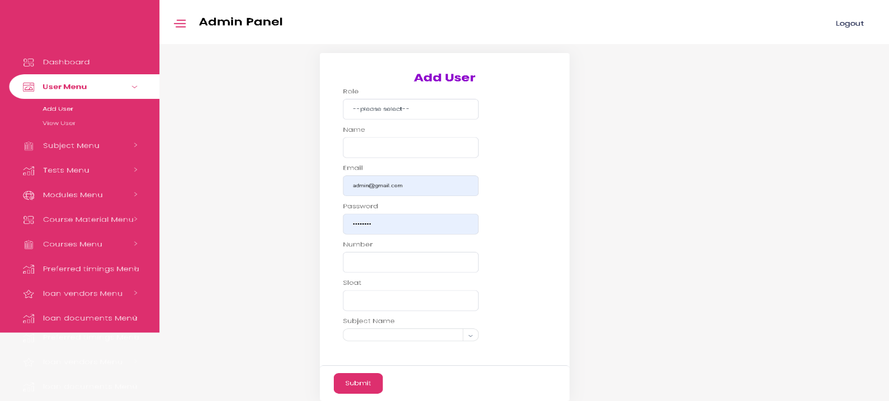**Add User -** The admin can add user details here.
2. 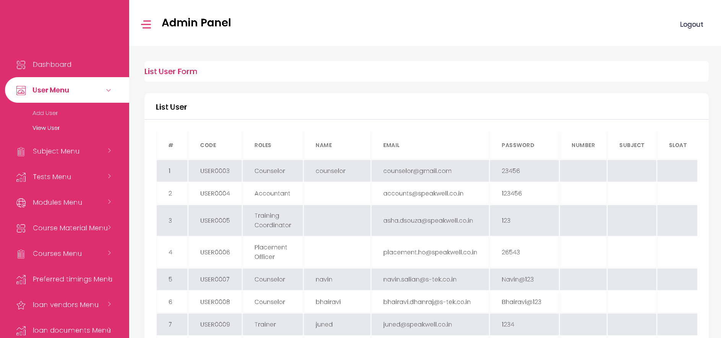**View User -** The admin can view user details here.

* **Subject Menu Page**

1. **Add Subject -** The admin can add subject details here.

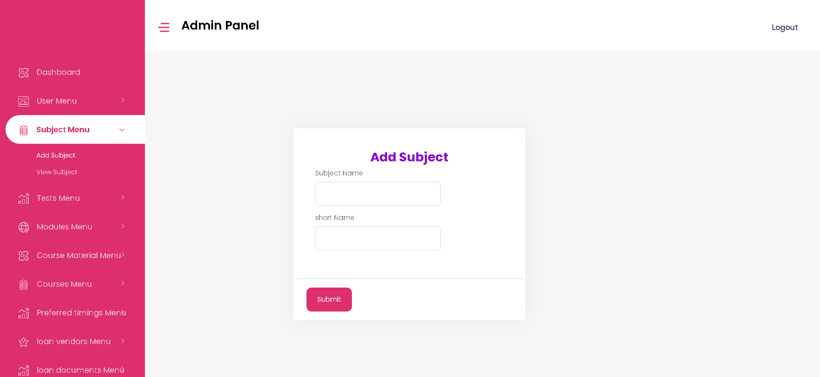

1. 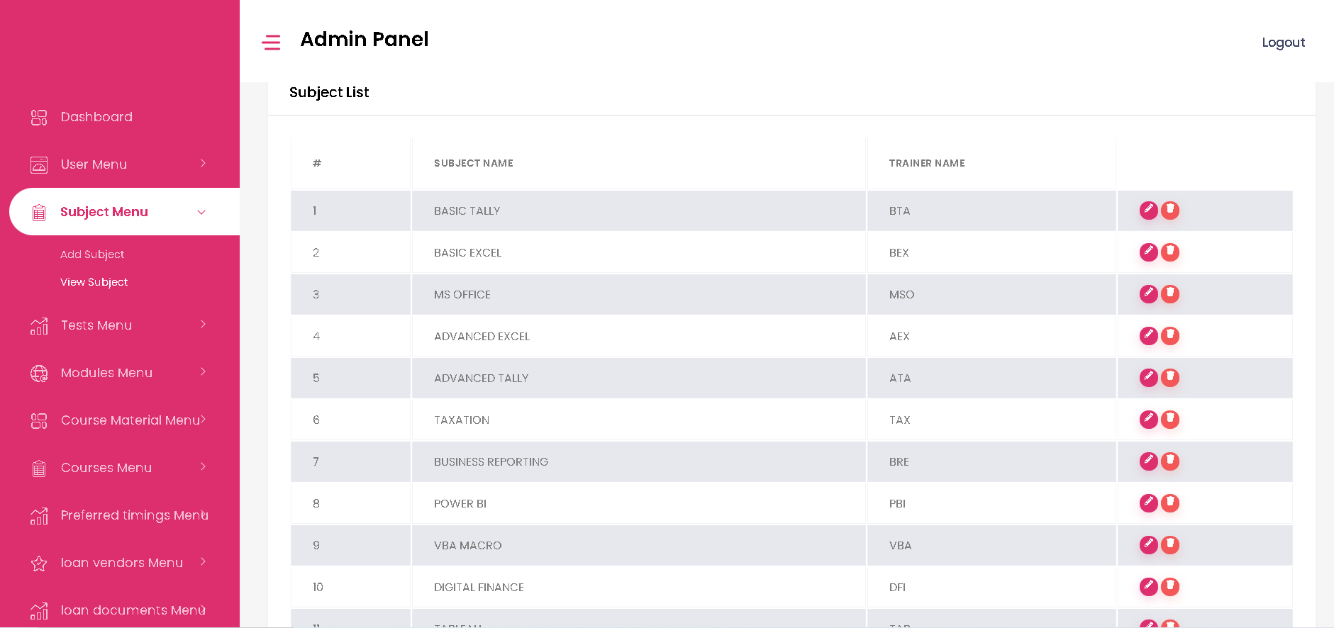**View Subject -** The admin can view subject details here and can edit and delete the details.

* **Tests Menu Page**

1. **Add Tests -** The admin can add test details here.

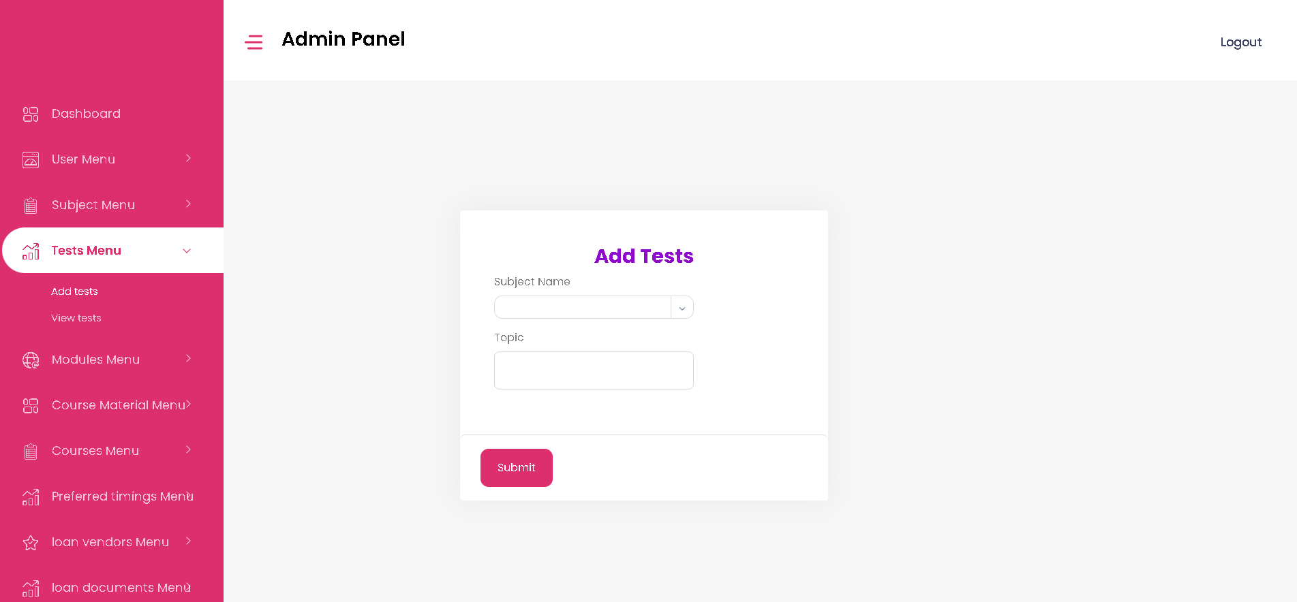

1. 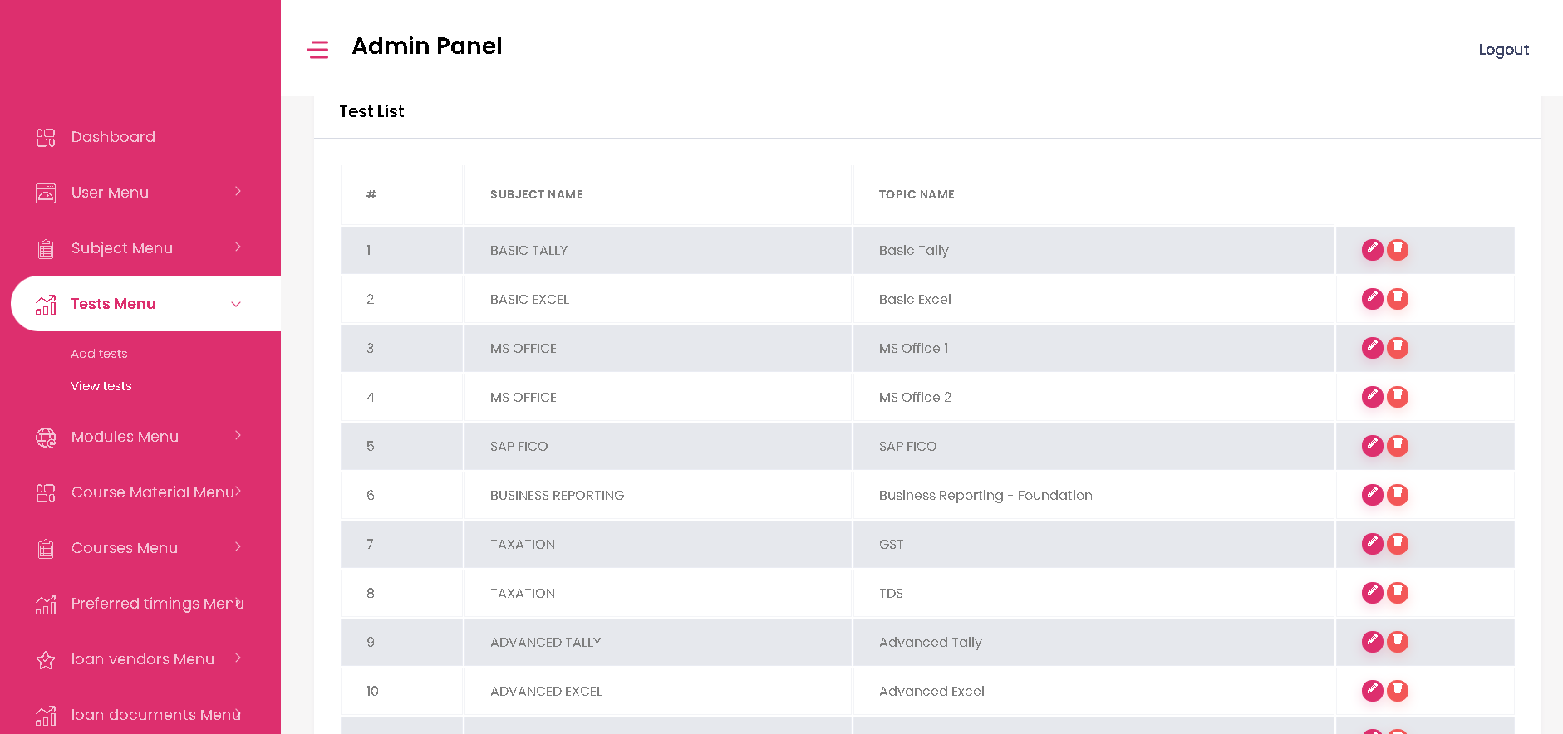**View Tests -** The admin can view test details here and can edit or delete the details.

* **Modules Menu Page**

1. **Add Modules -** The admin can add modules details here.

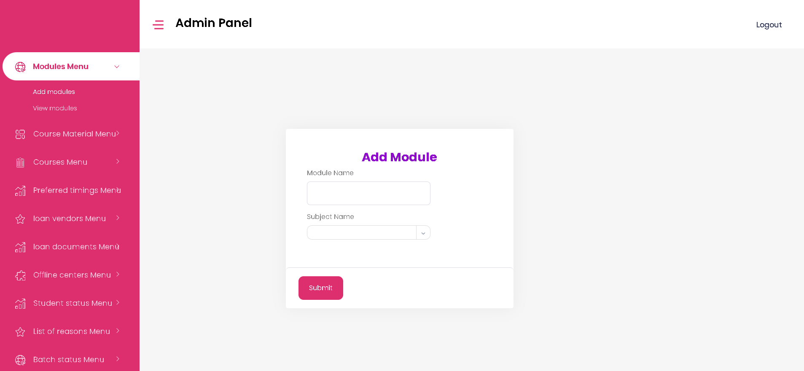

1. 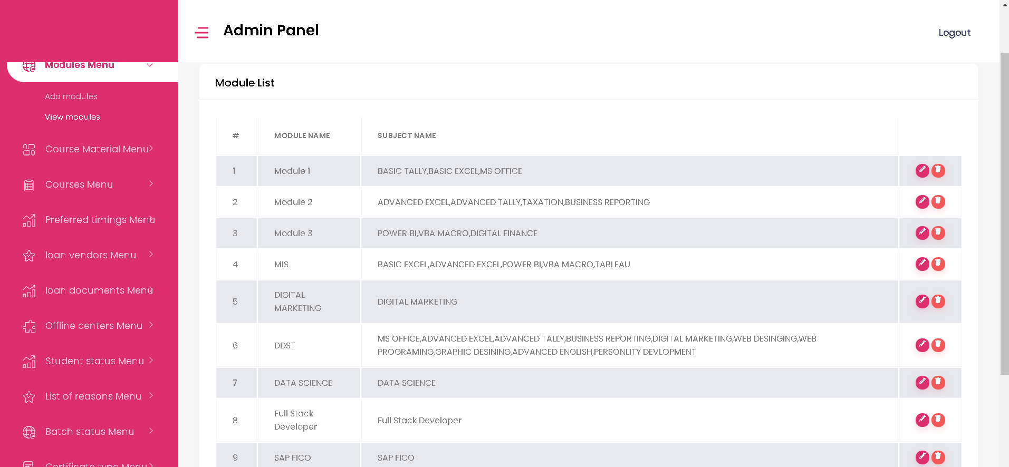 **View Modules -** The admin can view modules details and can edit or delete the details too.

* **Course Material Menu Page**

1. **Add Course Material -** The admin can add material name here.

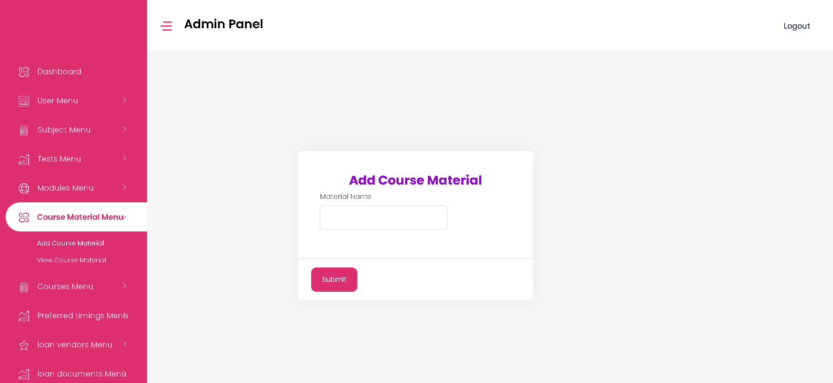

1. 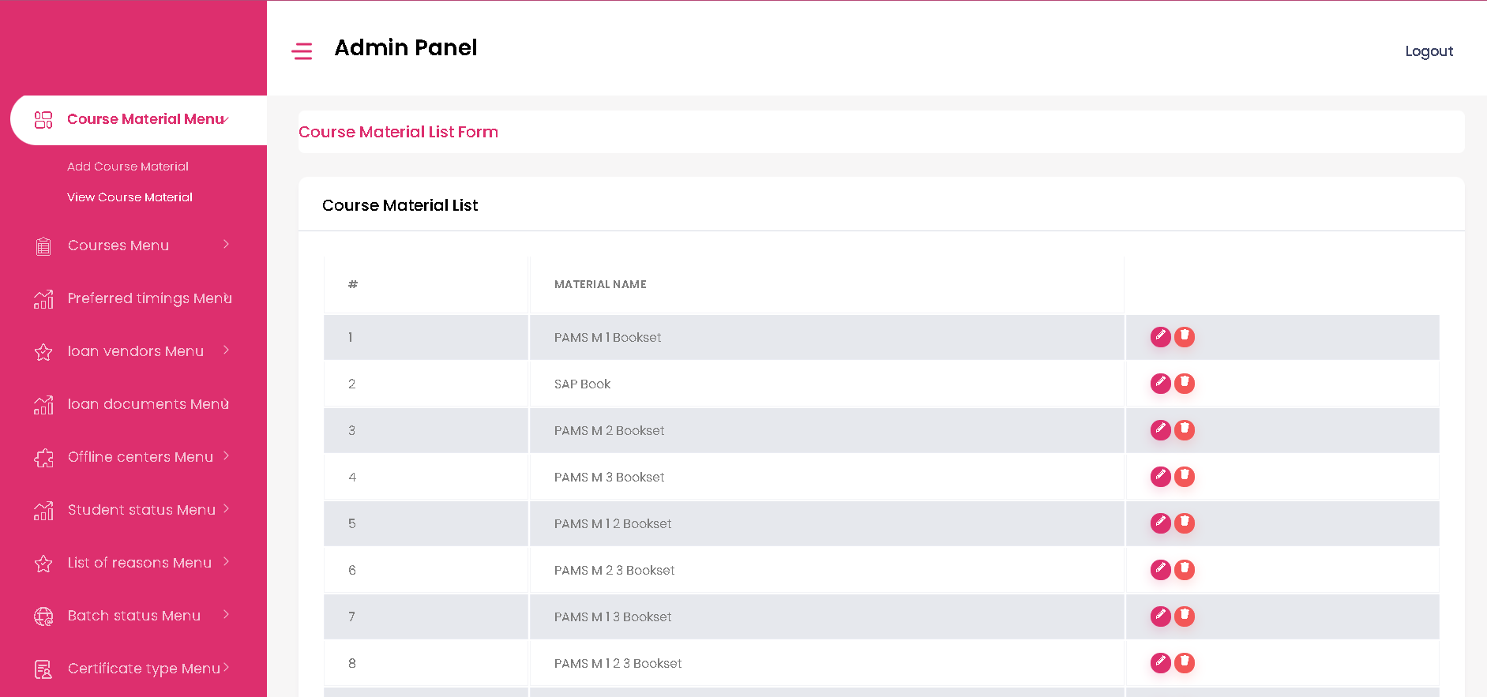**View Course Material -** The admin can view details of course material and can edit or delete the details too.

* **Courses Menu Page**

1. **Add Courses -** The admin can add course details here.

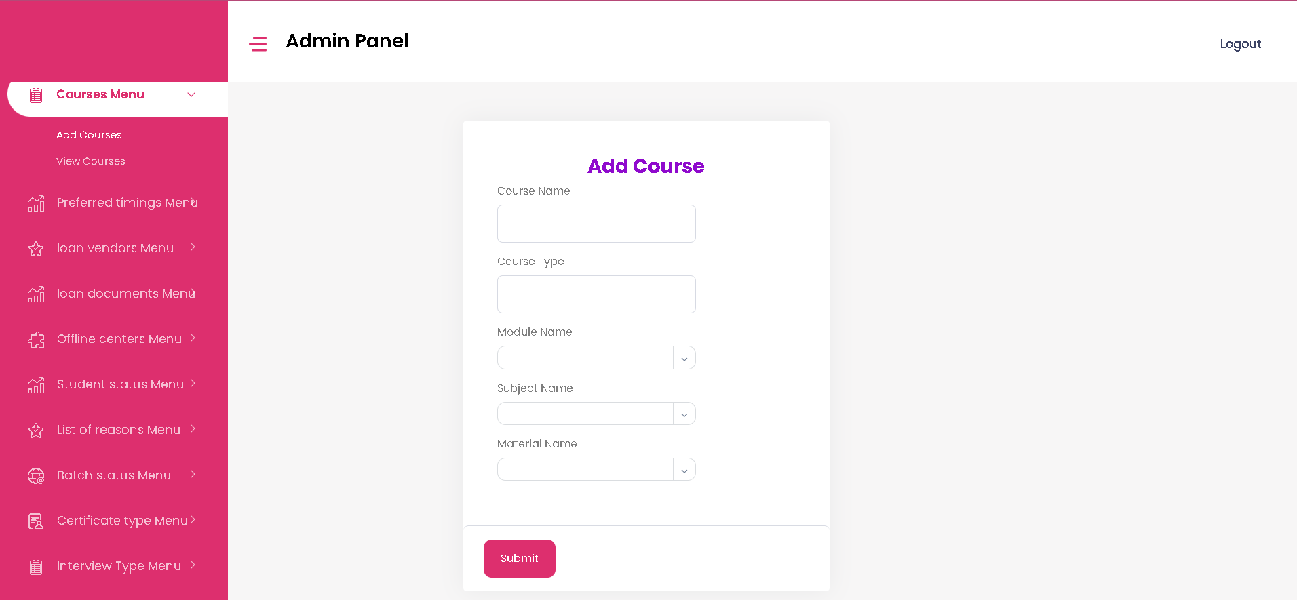

1. **View Courses -** The admin can view course details here and can edit or delete the details too.

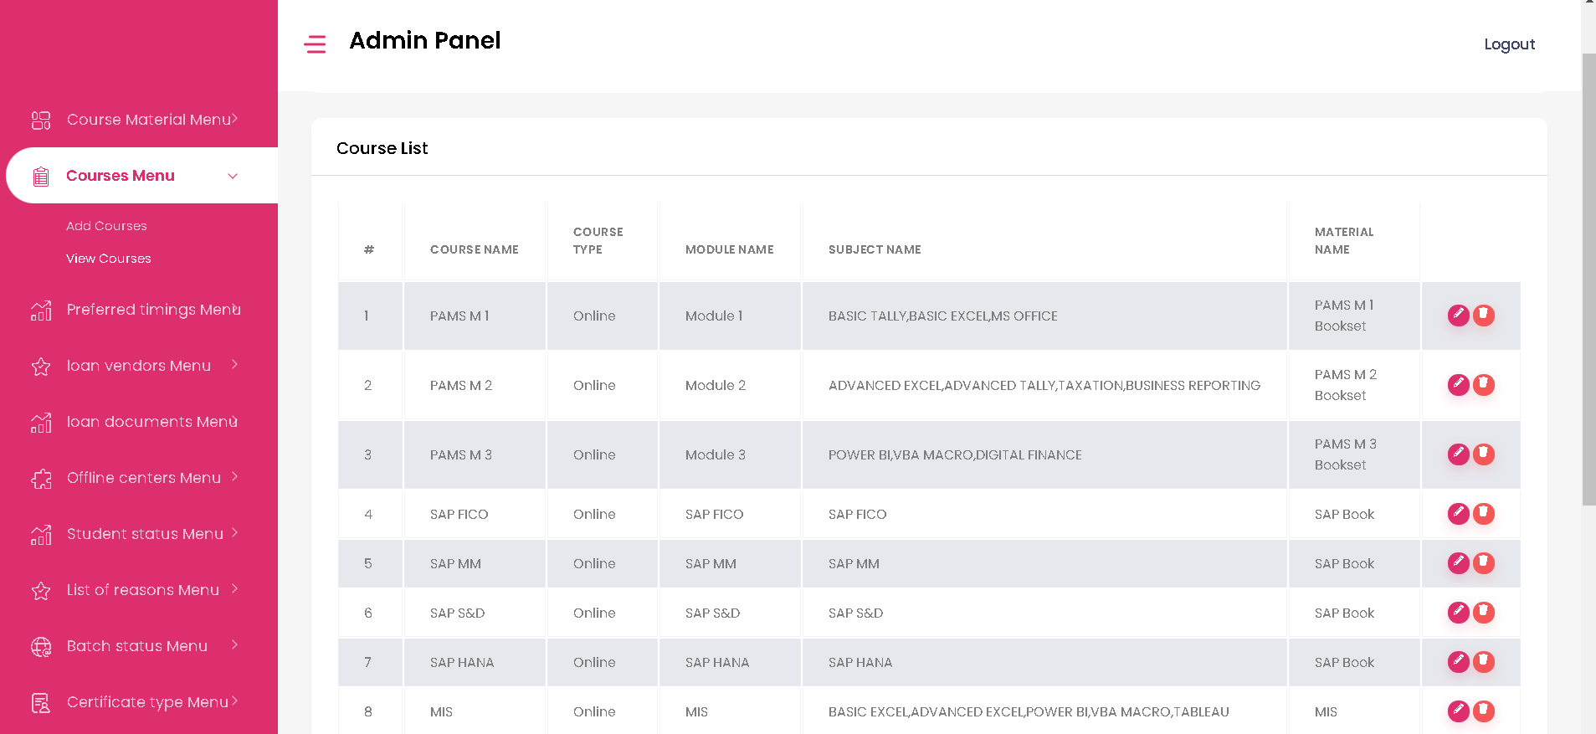

* **Preferred Timings Menu Page**

1. 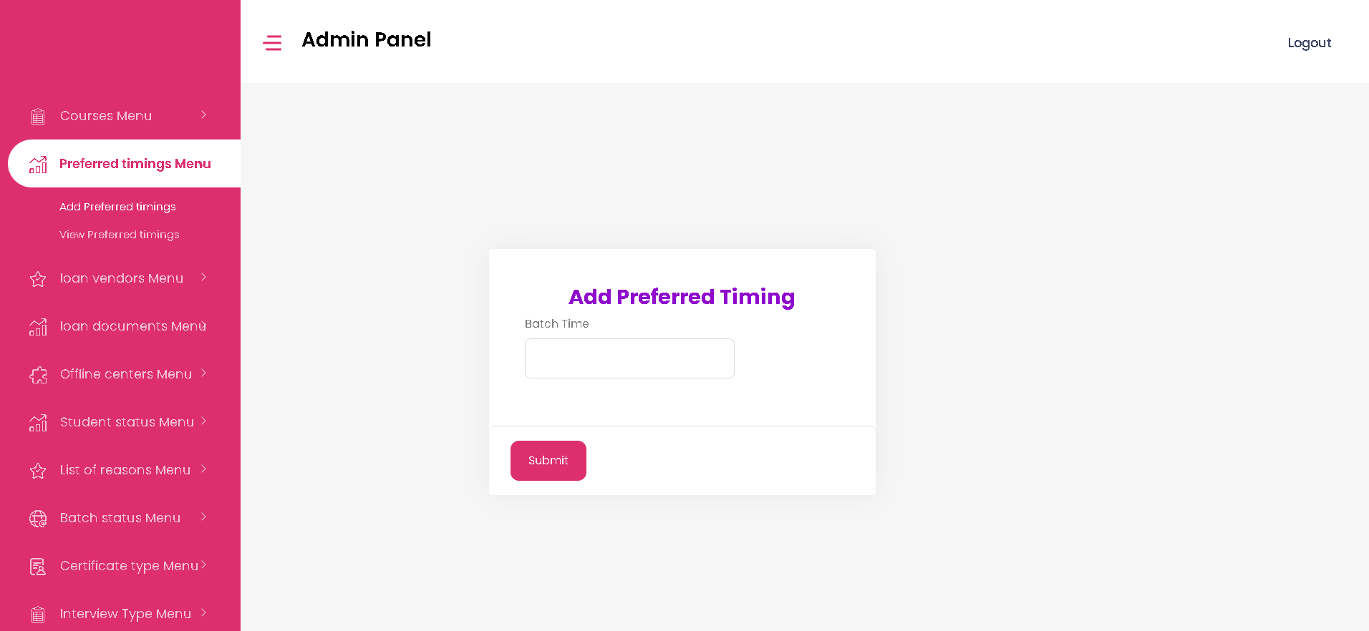**Add Preferred Timings -** The admin can add preferred batch timings here.
2. 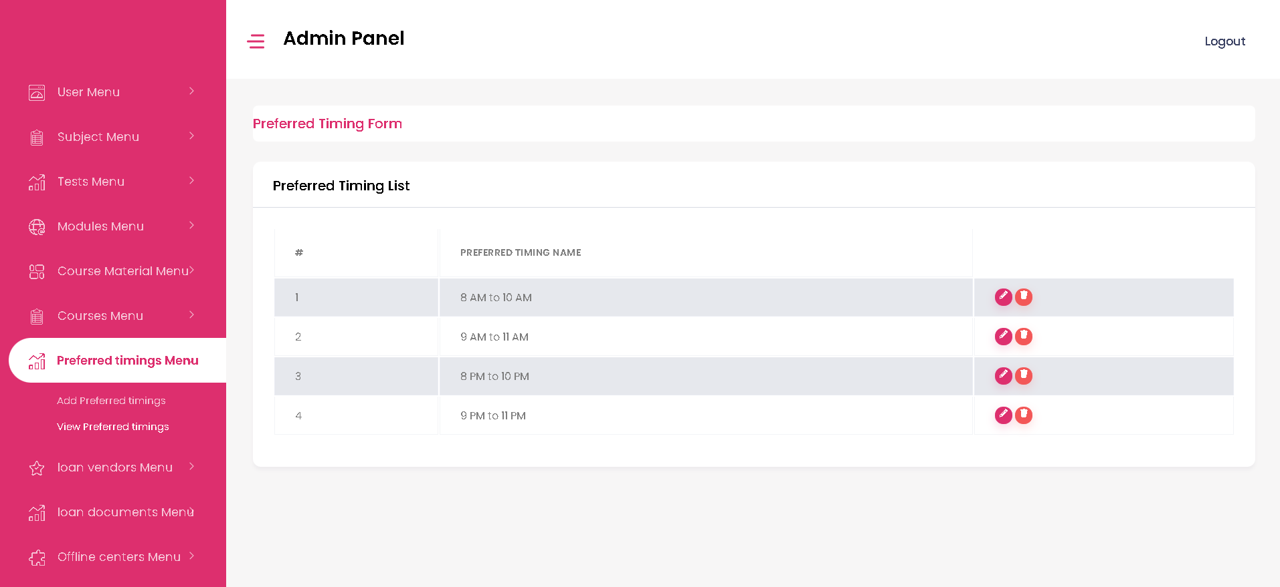**View Preferred Timings -** The admin can view preferred timings list and can edit or delete the details here.

* **Loan Vendors Menu Page**

1. 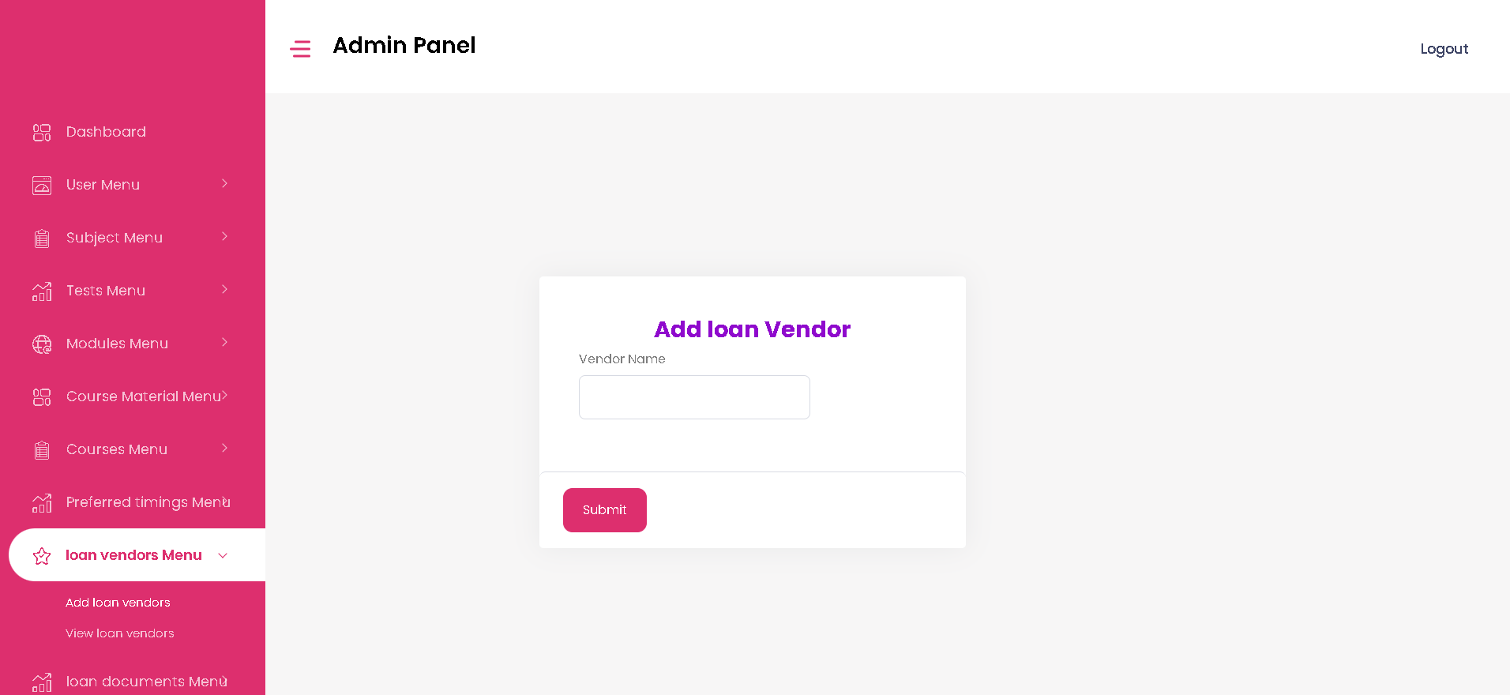**Add loan vendors -** The admin can add loan vendors details here.
2. **View loan vendors -** The admin can view loan vendors details here.

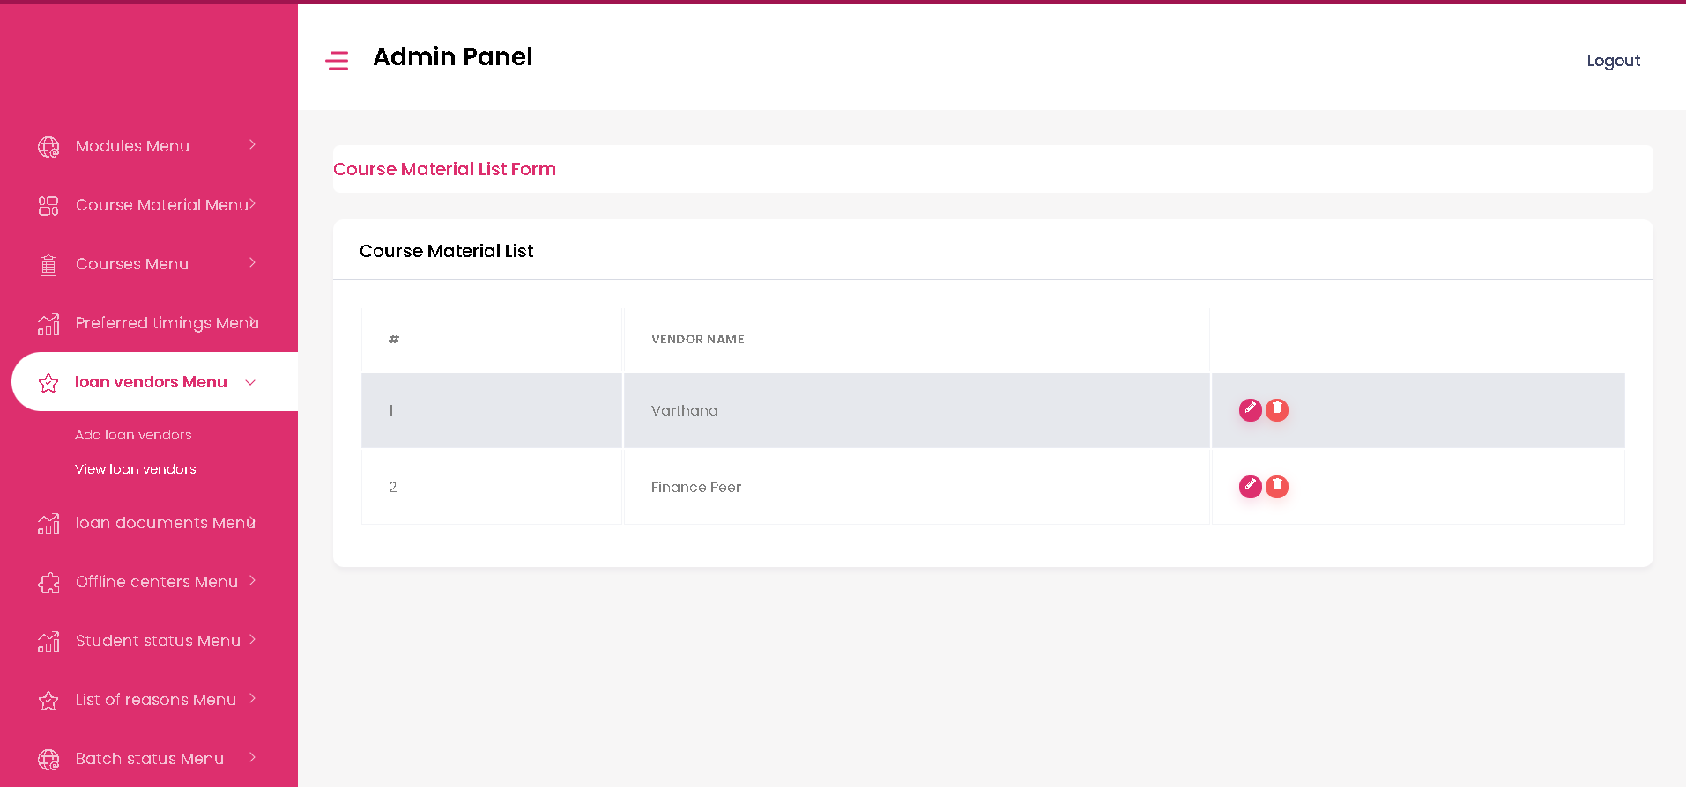

* **Loan Documents Menu Page**

1. **Add loan documents-** The admin can add loan document details here.

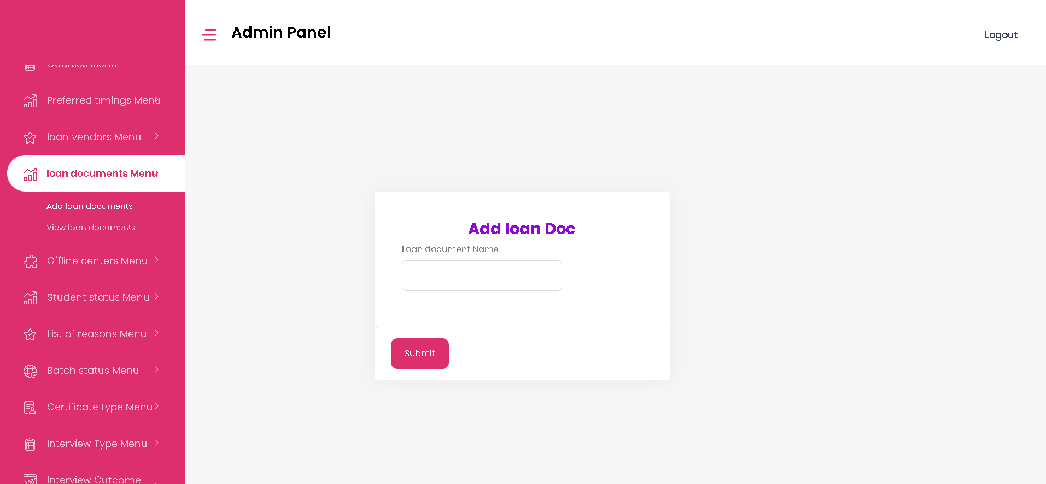

1. **View loan documents-** The admin can view loan document details here and can edit or delete the details too.

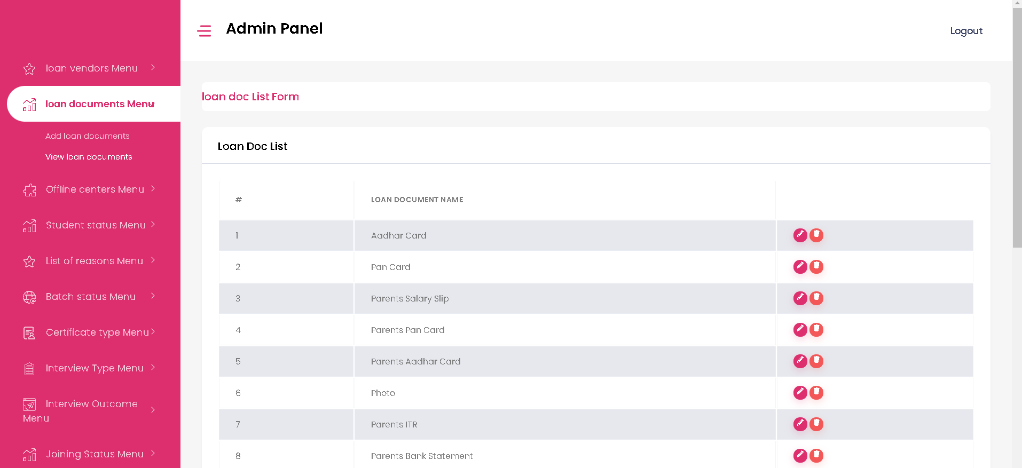

* **Offline Centers Menu Page**

1. 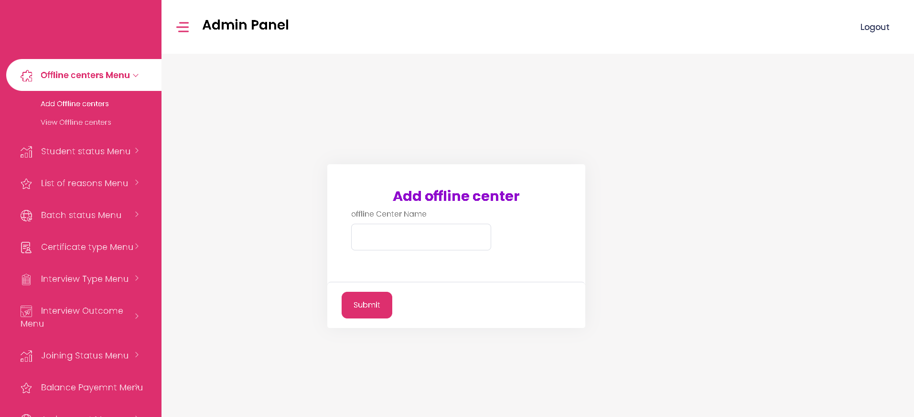**Add Offline Centers-** The admin can add offline center’s name here.
2. **View Offline Centers-** The admin can view ofline center’s details and can edit or delete the details here.

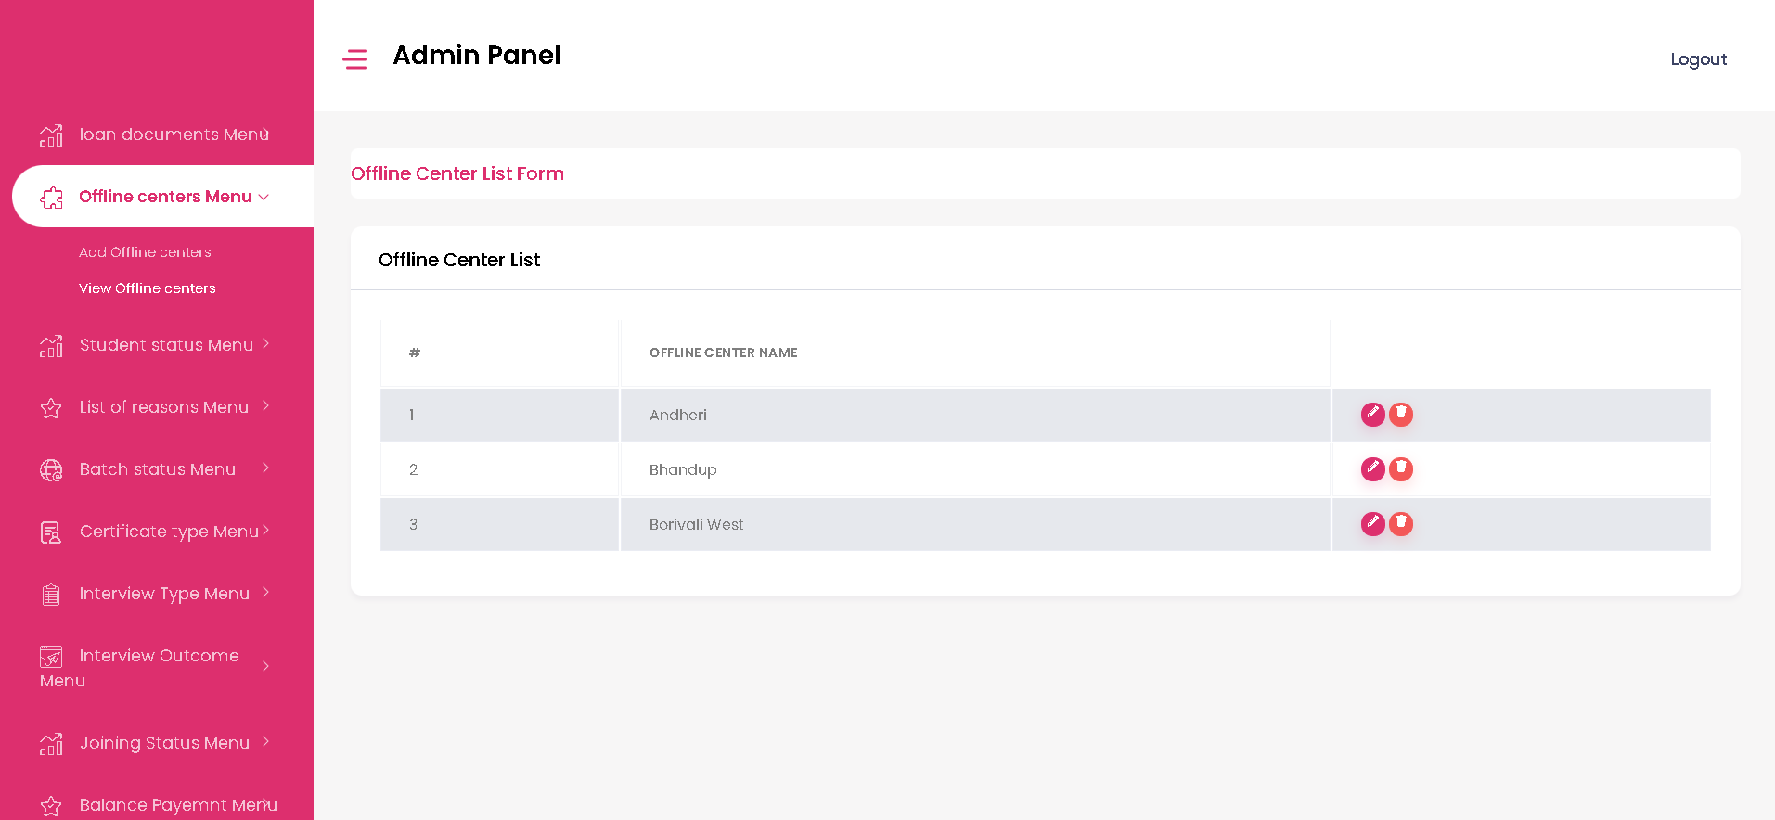

* **Student Status Menu Page**

1. 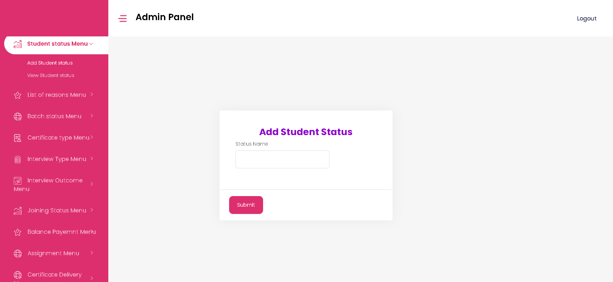**Add Student Status-** The admin can add student’s status here.
2. 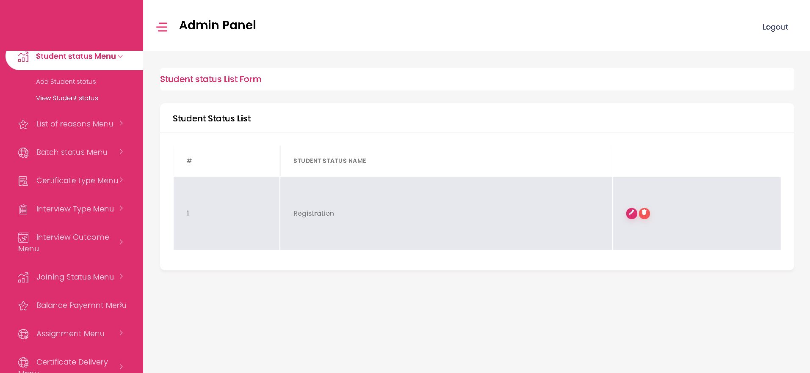**View Student Status-** The admin can view student’s status here.

* **List of Reasons Menu Page**

1. 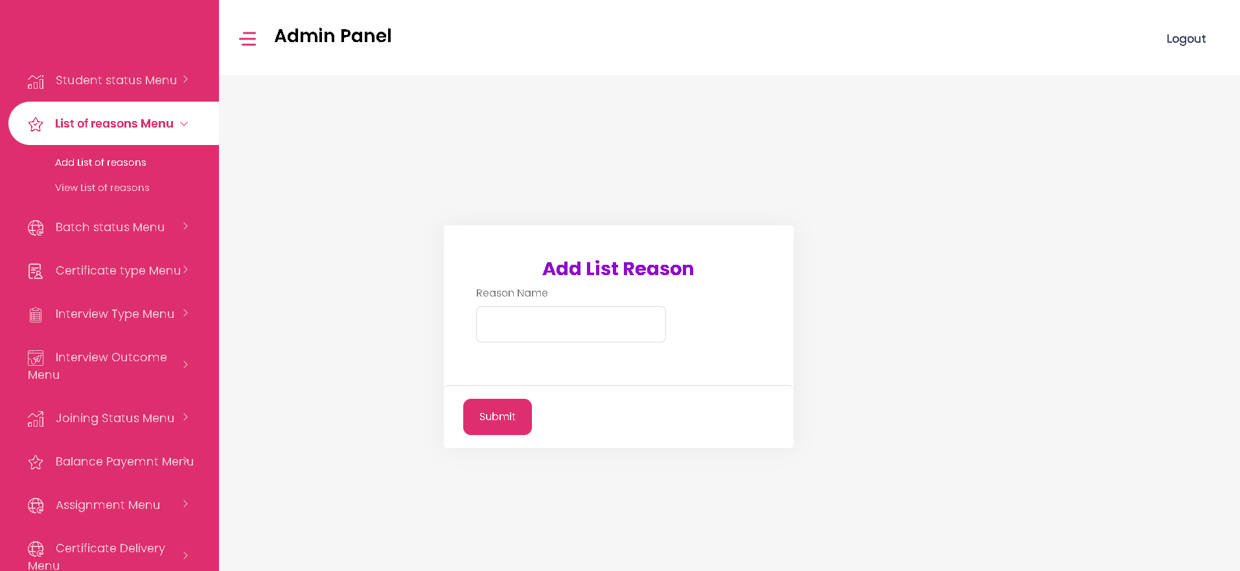**Add List of Reasons-** The admin can add reason name here.
2. **View List of Reasons-** The admin can view list of reasons here and can edit or delete the details.

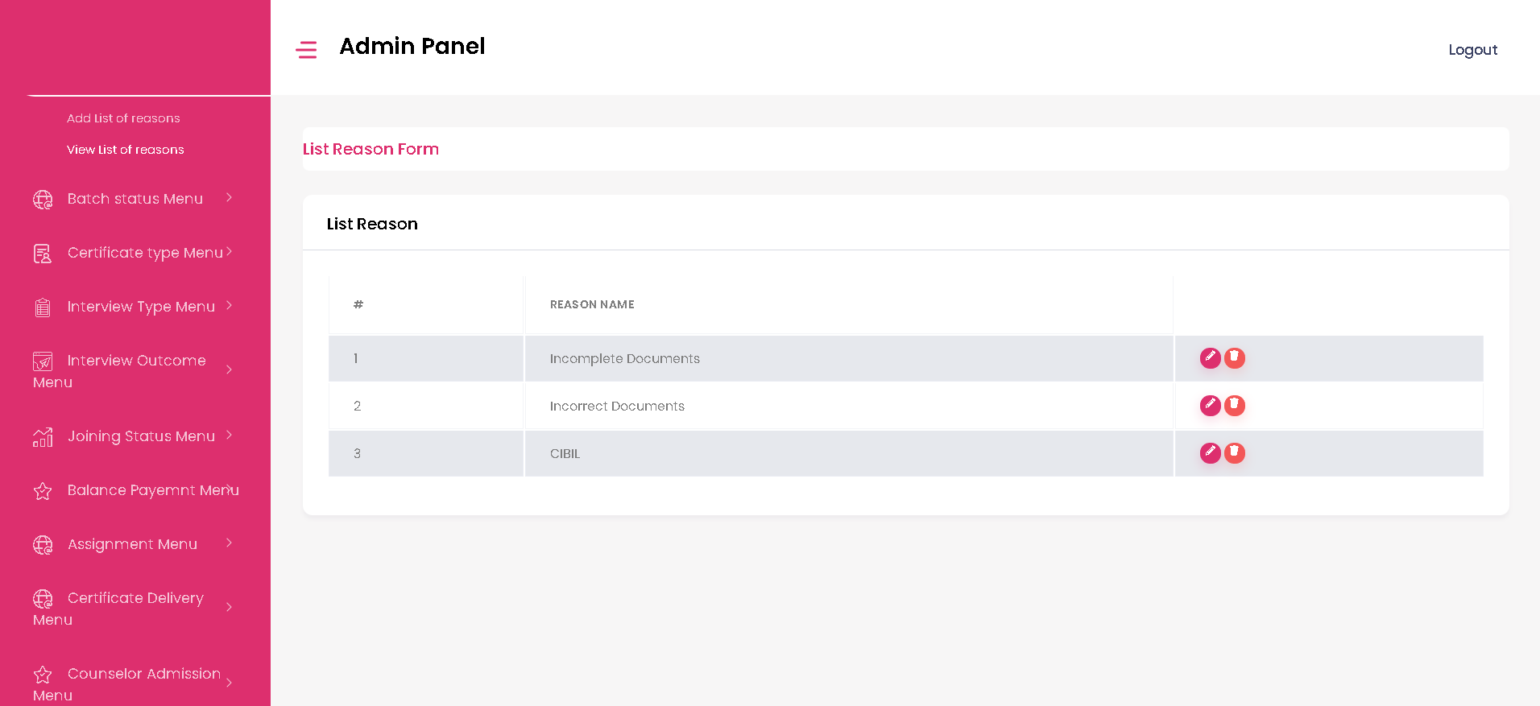

* **Batch Status Menu Page**

1. 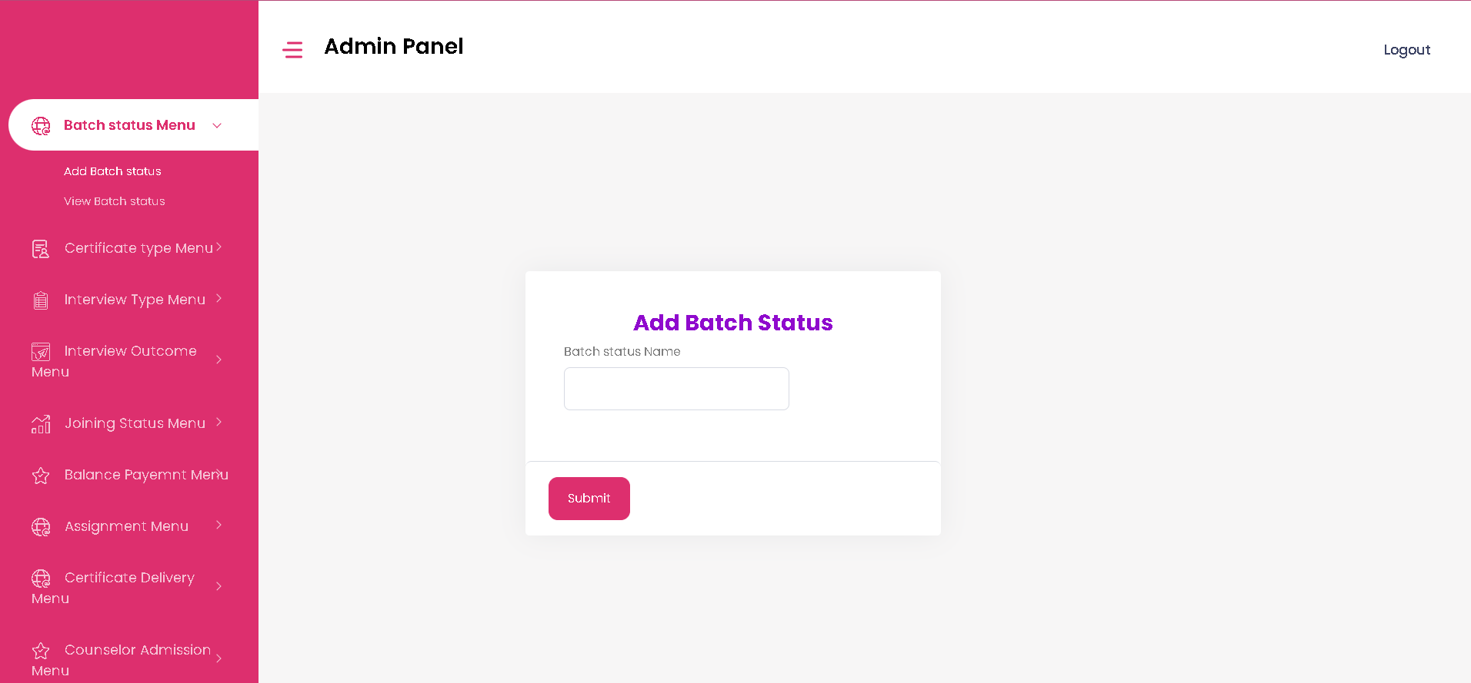**Add Batch Status-** The admin can add batch status here.
2. **View Batch Status-** The admin can view batch status and can edit or delete the details here.

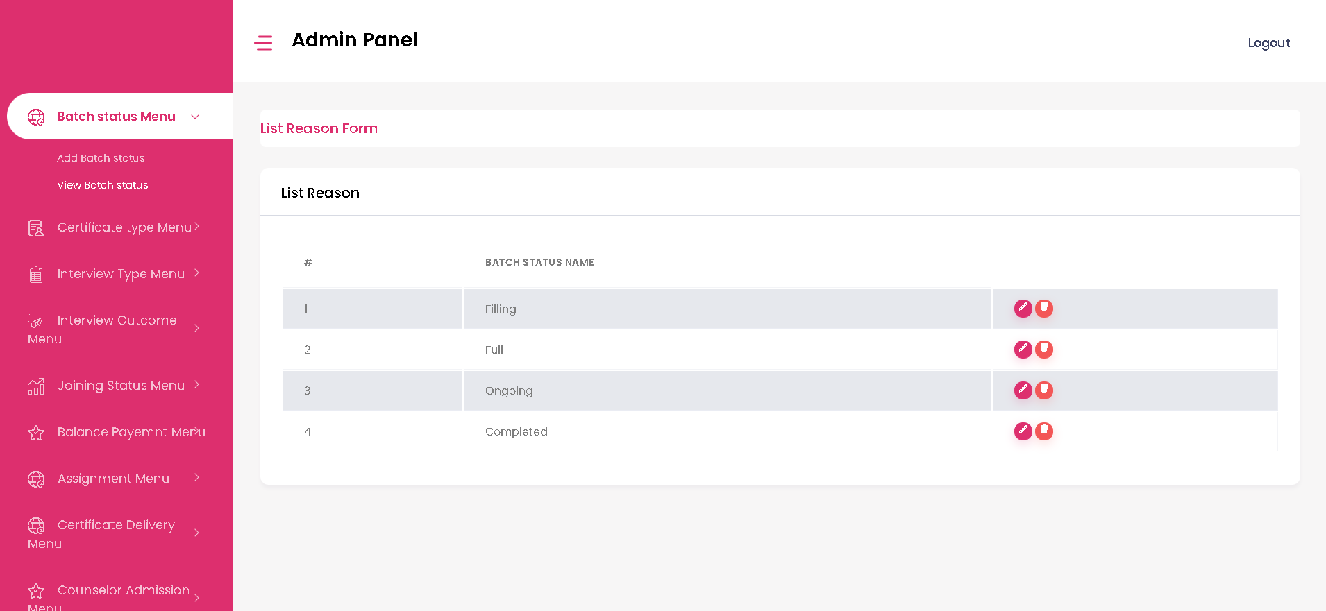

* **Certificate Type Menu Page**

1. 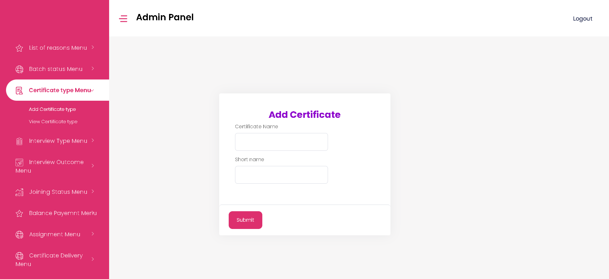**Add Certificate Type -** The admin can add certificate details here.
2. 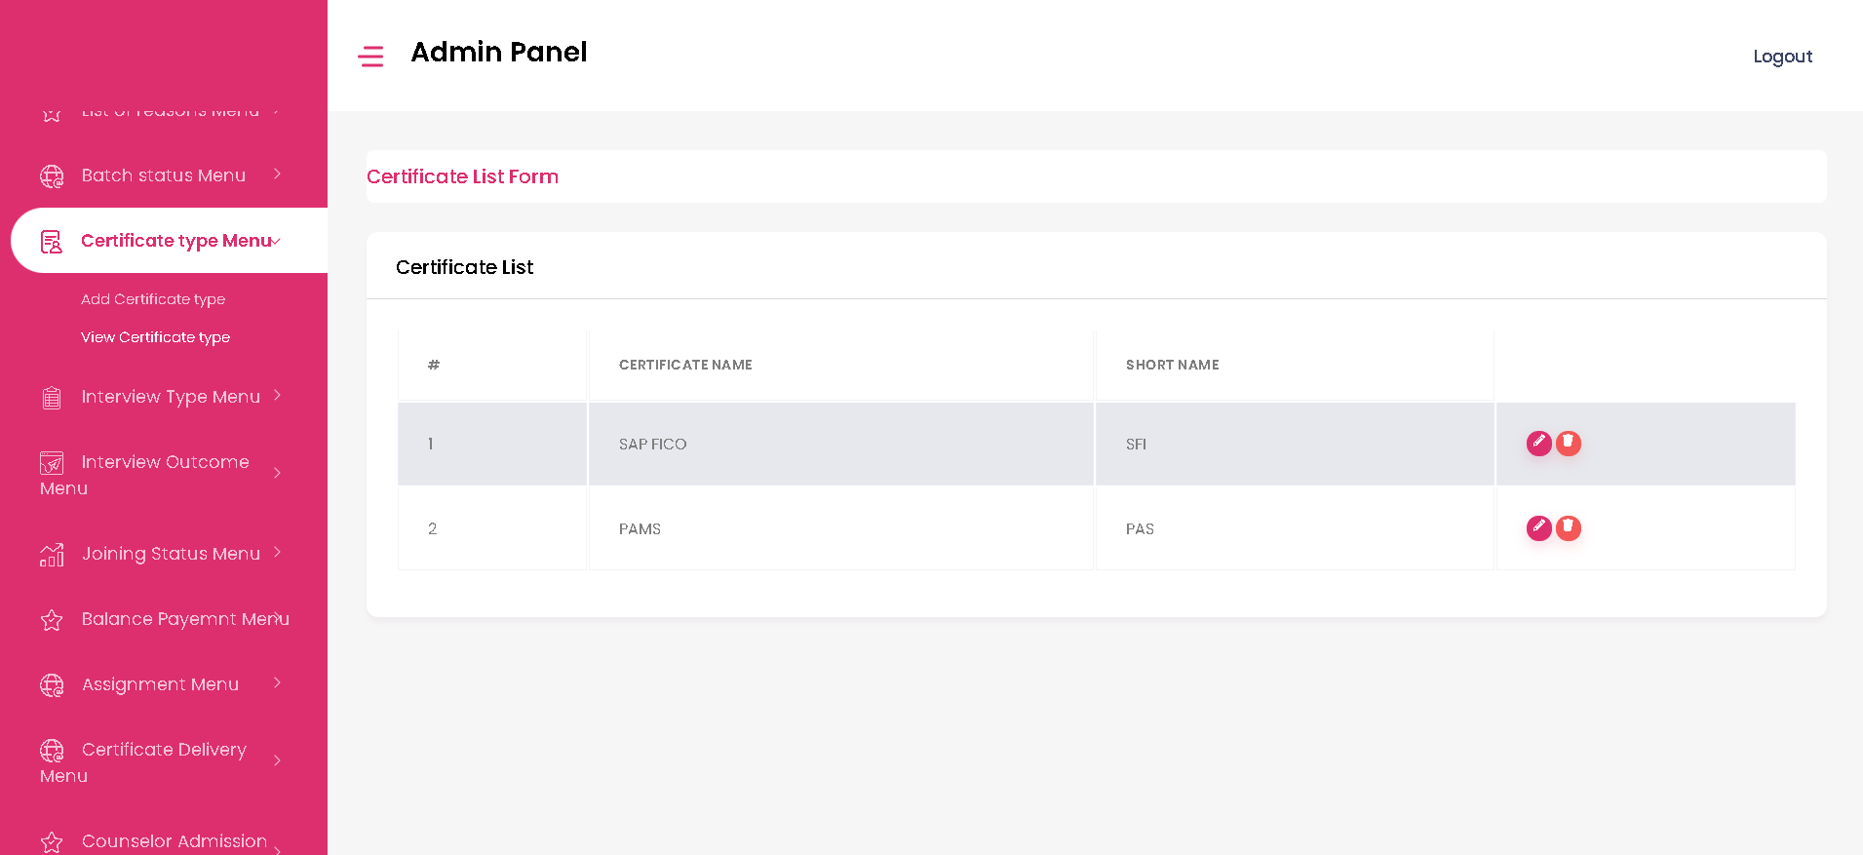**View Certificate Type -** The admin can view certificate details and can edit or delete the details here.

* **Interview Type Menu Page**

1. **Add Interview Type -** The admin can add interview type here.

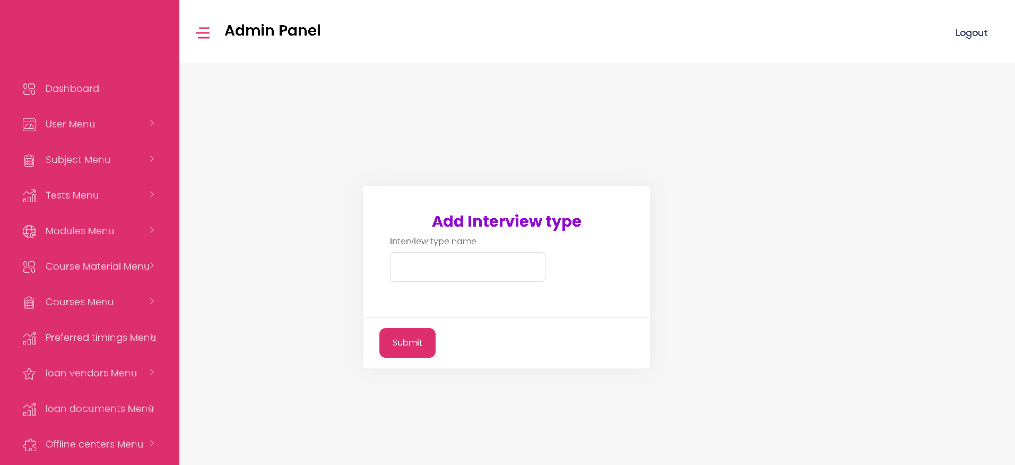

1. 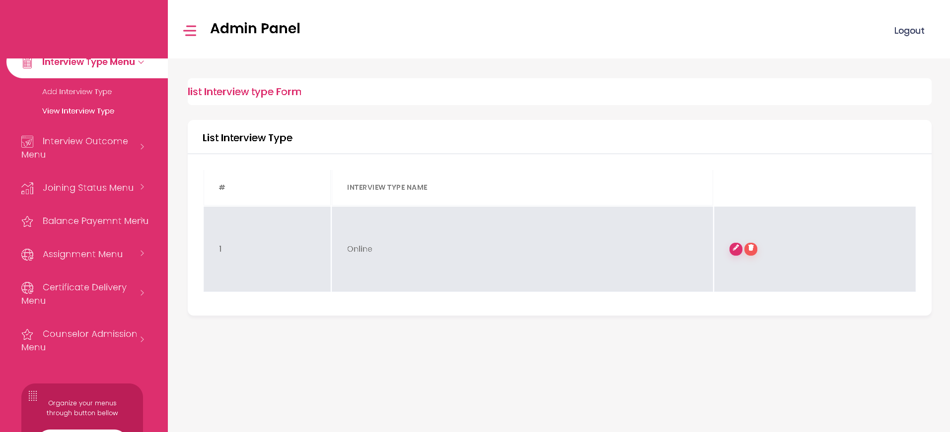**View Interview Type -** The admin can view and edit/delete the interview type details here.

* **Interview Outcome Menu Page**

1. 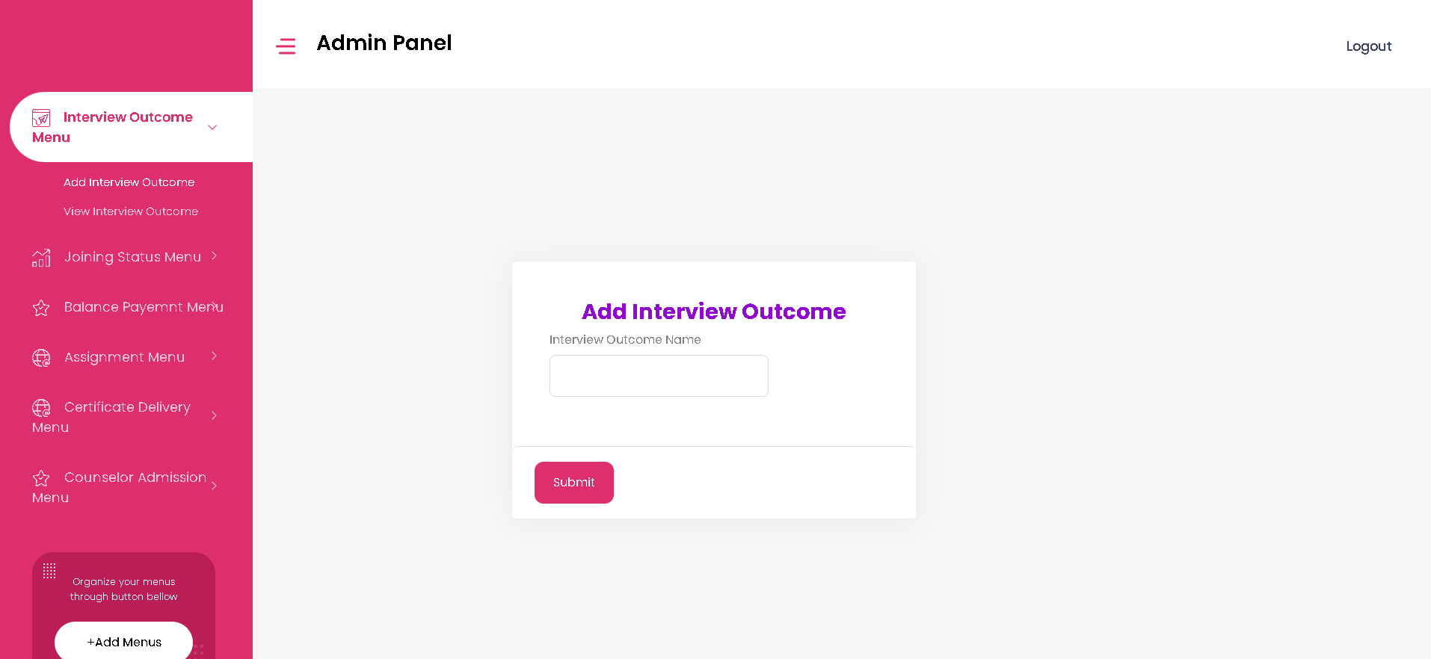**Add Interview Outcome -** The admin can add interview outcome here.
2. **View Interview Outcome -** The admin can view interview outcome here and can edit or delete the details.

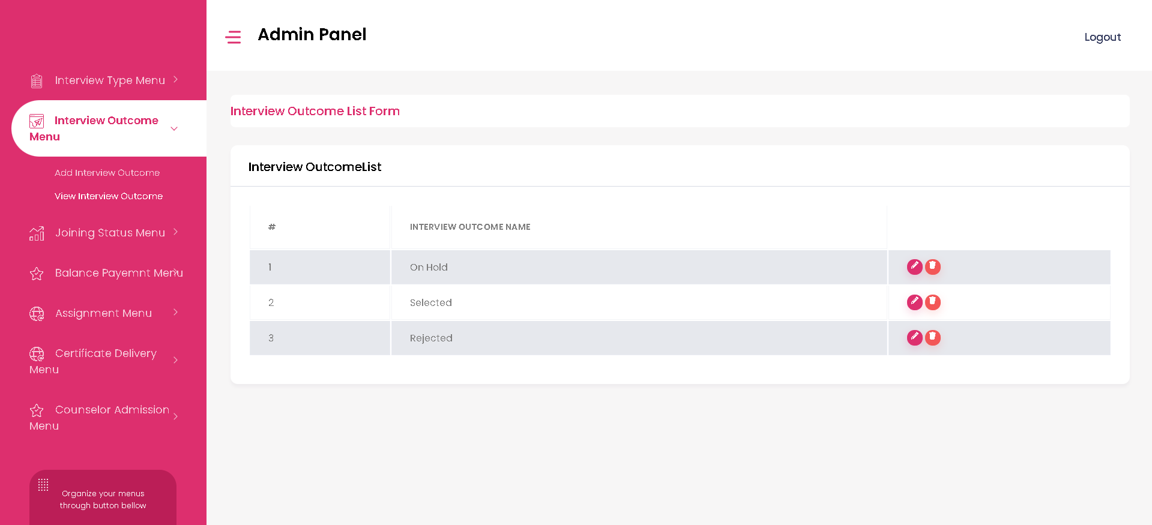

* **Joining Status Menu Page**

1. **Add Joining Status-** The admin can add joining status here.

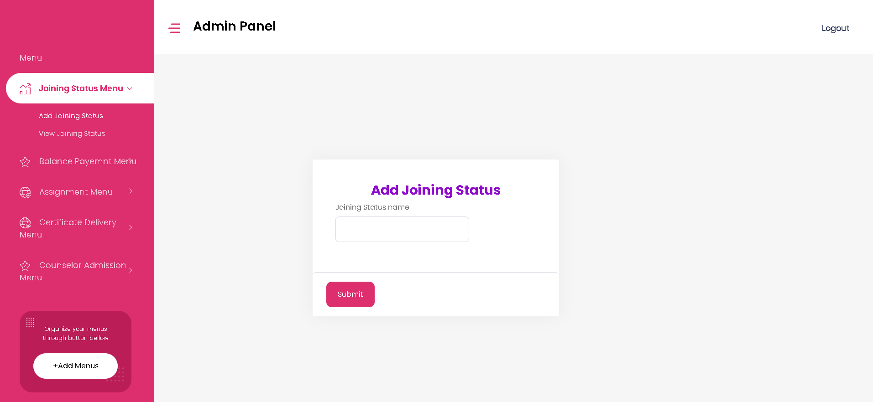

1. **View Joining Status-** The admin can view joining status and can edit or delete the details here.

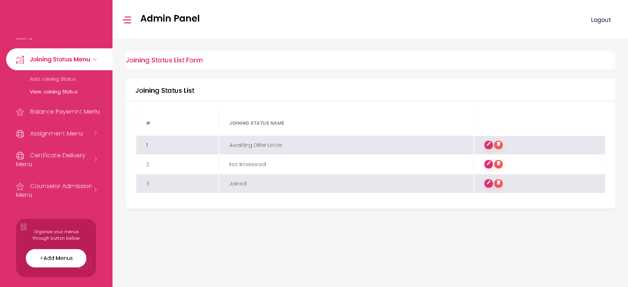

* **Balance Payment Menu Page**

1. 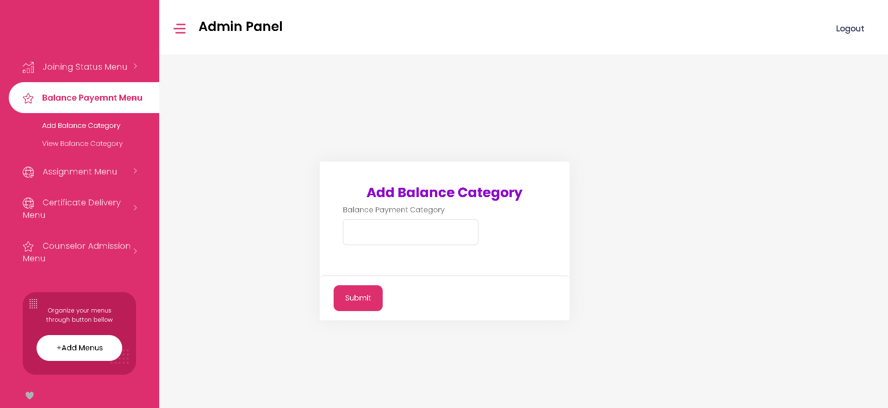**Add Balance Category-** The admin can add balance category here.
2. **View Balance Category-** The admin can view balance categories here and can edit or delete the details.

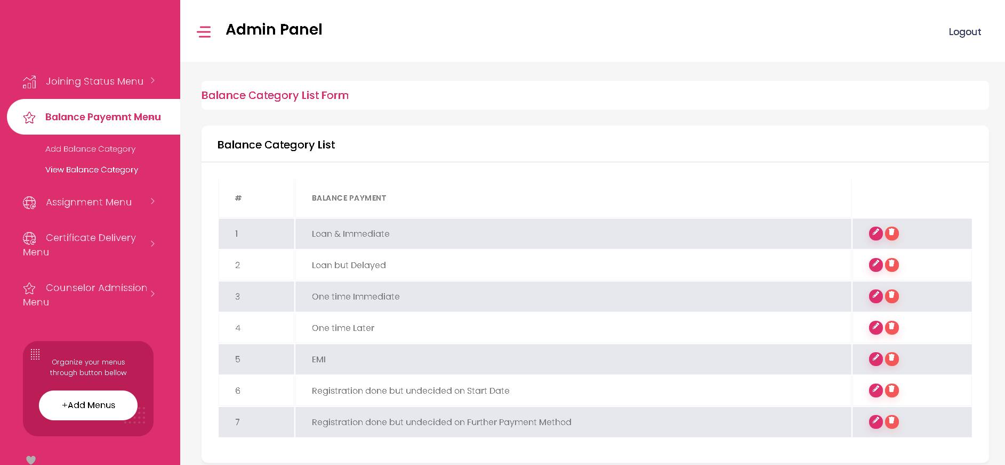

* **Assignment Menu Page**

1. 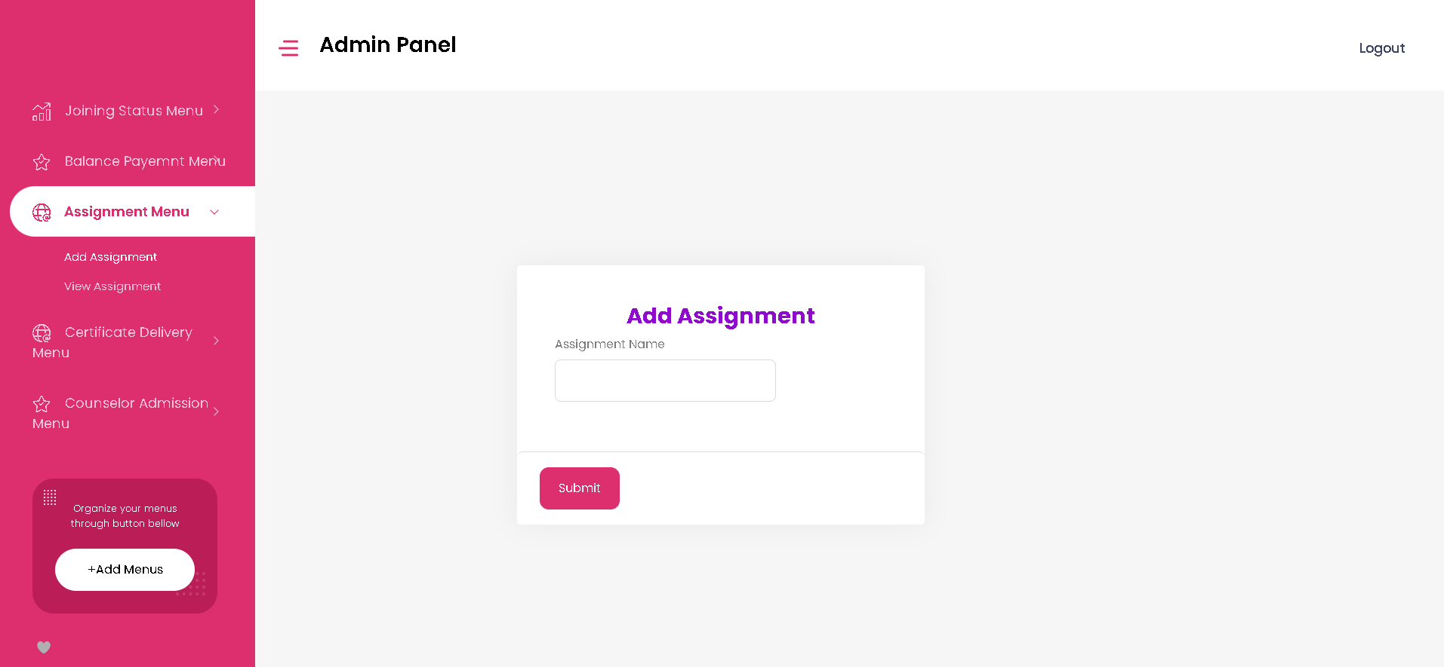**Add Assignment-** The admin can add assignment details here.
2. 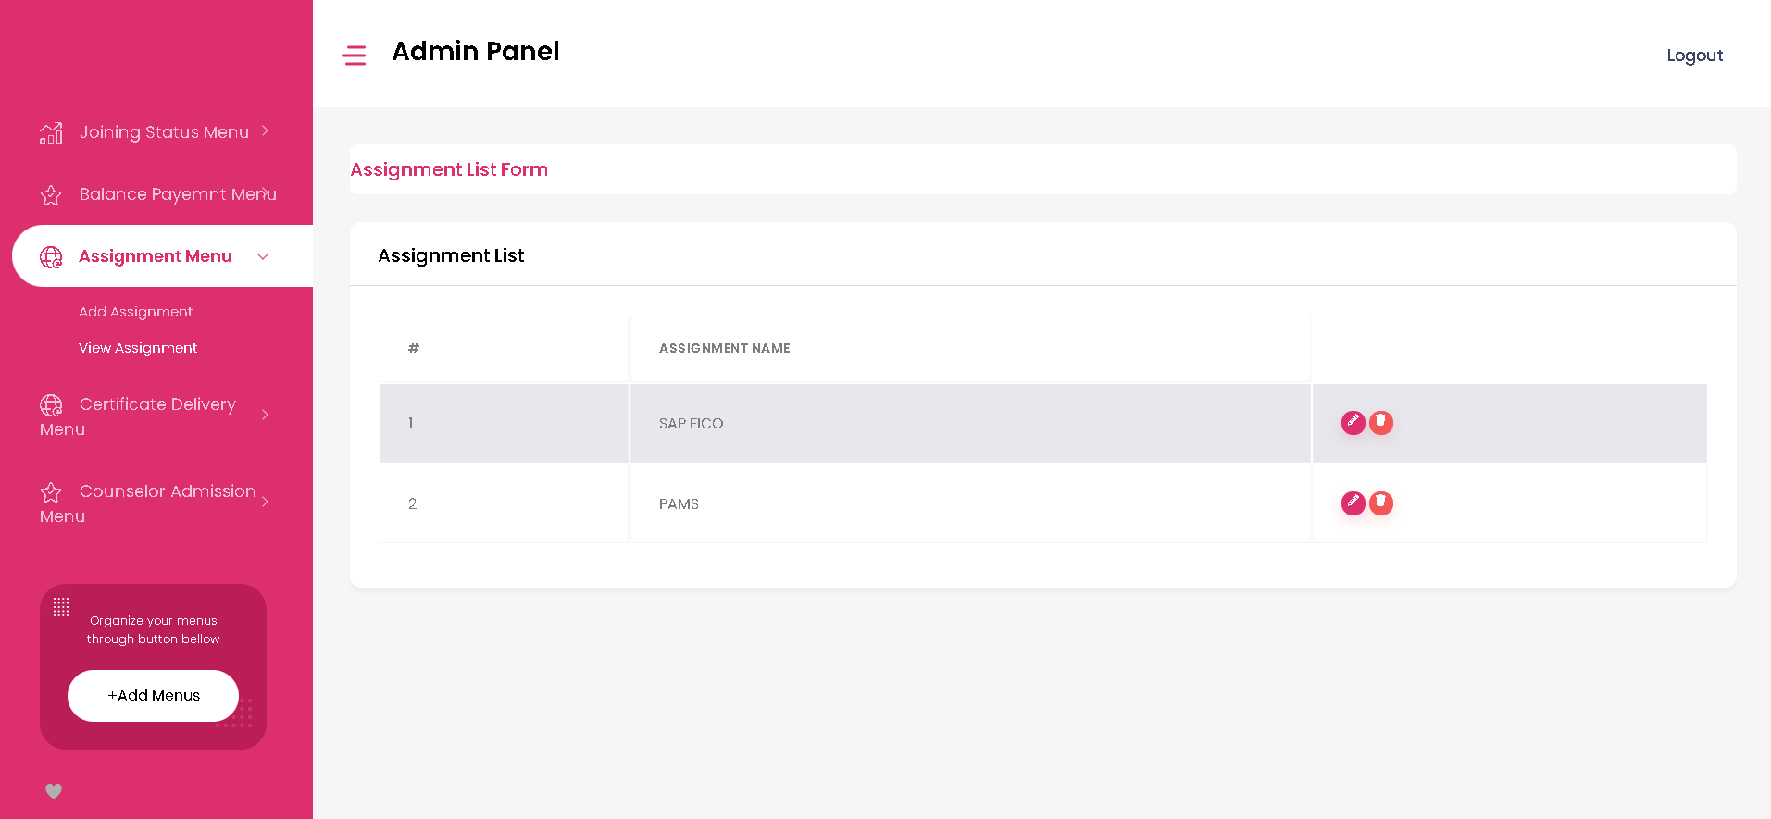**View Assignment-** The admin can view assignment details and can edit or delete the details here.

* **Certificate Delivery Menu Page**

1. **Add delivery-** The admin can add certificate delivery type here.

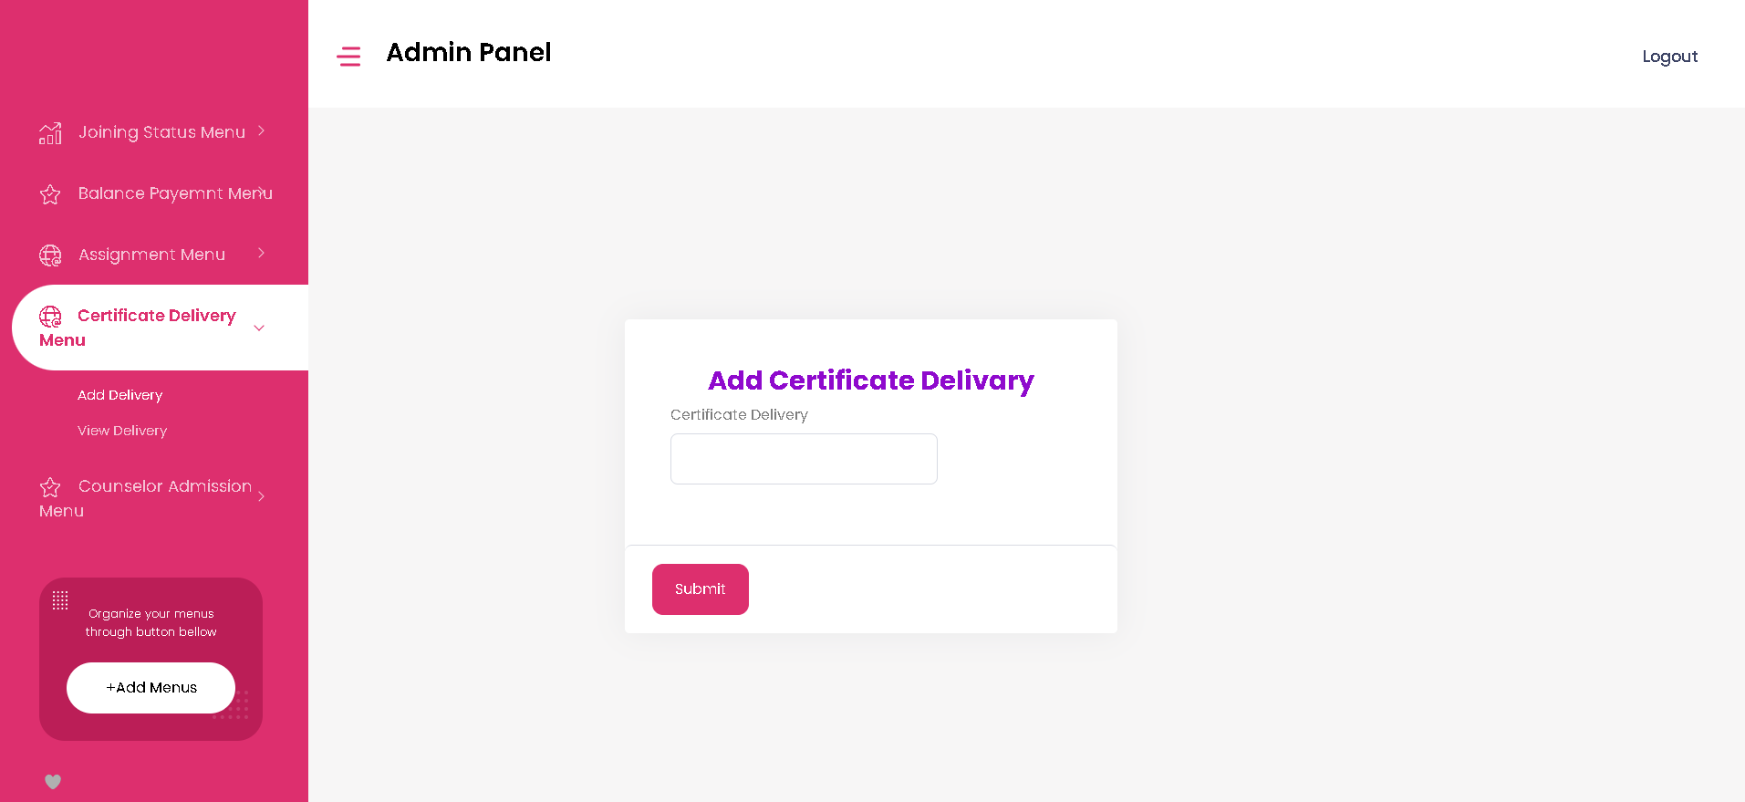

1. 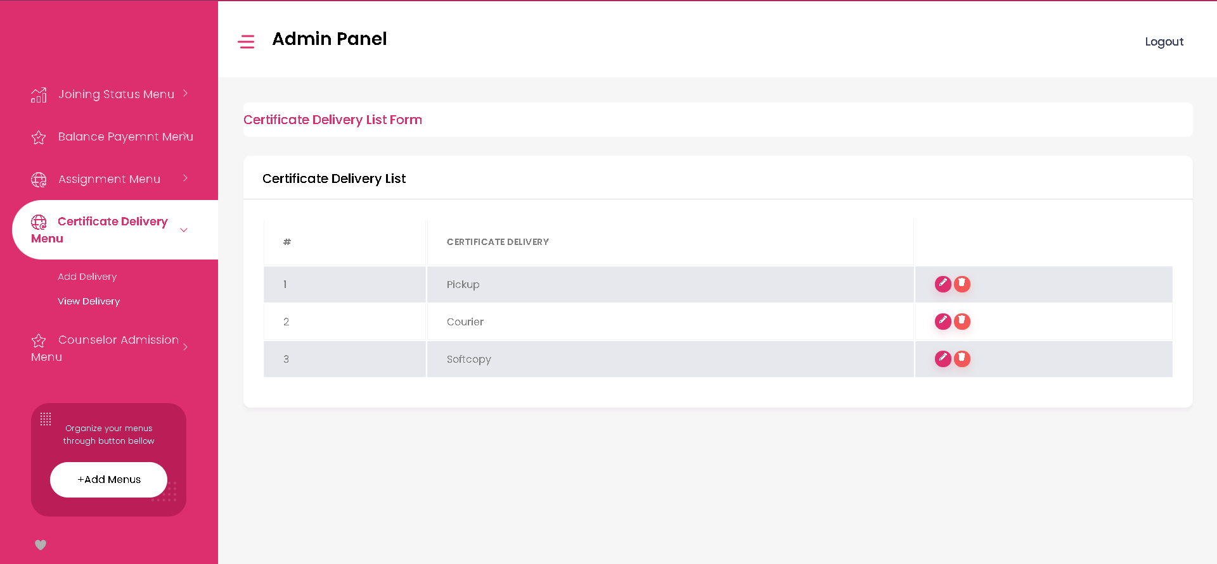**View delivery-** The admin can view certificate delivery and can edit or delete the details here.

* 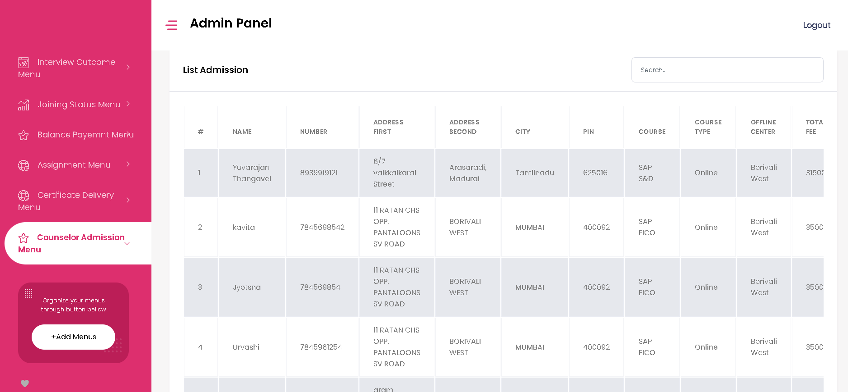**Counselor Admission Menu Page -** The admin can view admission details and can edit or delete the details here.
* **Logout –** The admin can Logout from here.



* **Student Management**

**Online Data Tracking Web Application**

1. Application link for Admin with Login Credentials

<https://admissionmanagement.celebritybytes.com/admin_login>

1. Username- admin@gmail.com
2. Password-12345678
3. Application Link for Training Co-ordinator

<https://admissionmanagement.celebritybytes.com/TrainingCoo_login>

1. Application Link for Counselor

<https://admissionmanagement.celebritybytes.com/Conselor_login>

1. Application Link for Accountant

<https://admissionmanagement.celebritybytes.com/Accounts_login>

1. Application Link for Placement Officer

<https://admissionmanagement.celebritybytes.com/Placementofficer_login>

1. Application Link for Trainer

<https://admissionmanagement.celebritybytes.com/Trainer_login>