System Health Snapshot
A lightweight shell script that prints a quick health summary for Operations:
- CPU usage
- Memory usage
- Top processes (snapshot, not interactive) by using top -bn1
- Disk usage (df -h, human-readable)
- Active network connections using ss – tuna

Files
- health_snapshot.sh — main script that prints the system snapshot and appends to log.txt
- log.txt — log file (created automatically)

Execution Instructions
# 1) Make script executable
chmod +x health_snapshot.sh

# 2) Run it
./health_snapshot.sh

Steps involved to create this script
Step 1 -> Created the healthscript.sh file to identify the cpu, memory, disk usage, top processes and active network connections and appends it to the log.txt

Step 2 -> Added the permission to execute using chmod +x healthcheck.sh
Step 3 -> Then finally executed it using the bash healthcheck.sh

Example Script (health_snapshot.sh)
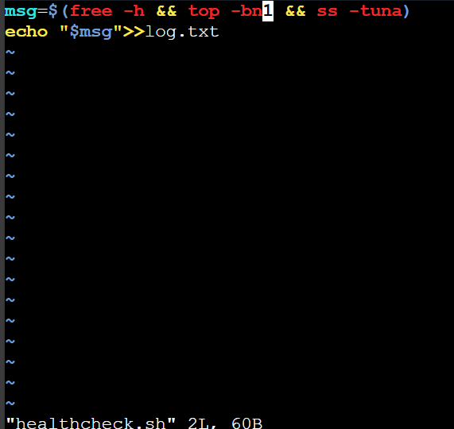

Sample Console Output
