

IntelliJob: A Privacy-Preserving, Offline-First Career Analytics Platform with Market-Driven Pathway Clustering and Generative Trajectory Synthesis

Aasim Ali Khan

School of Computing Science Sir Alwyn Williams Building University of Glasgow
G12 8RZ

A dissertation presented in part fulfilment of the requirements of the Degree of Master of Science at the University of Glasgow

5 September 2026

Abstract
The modern employment market presents candidates with an overwhelming volume of listings, yet existing recruitment platforms function primarily as downstream application channels that assume job seekers already possess defined career targets. Traditional job boards facilitate application submission rather than self-assessment, while emerging commercial optimization tools focus narrowly on tailoring resumes to bypass automated screening filters—often compromising data privacy in the process. IntelliJob addresses this gap as a privacy-preserving, offline-first career analytics platform designed to serve as the critical upstream discovery step before a candidate enters the job market. By transforming an uncurated PDF resume into a structured, market-grounded skill-gap roadmap, IntelliJob enables candidates to evaluate their true technical fit, identify viable directions, and bridge competency deficits prior to applying.

The system operates across two pipelines: Targeted mode, which conducts direct dense semantic retrieval against user-specified roles, and Discovery mode, where the resume alone drives an unsupervised clustering architecture (HDBSCAN and UMAP on 1,056 UK Adzuna job embeddings) yielding 29 market-derived career pathways. Each pathway provides a lazy-loaded roadmap and a three-phase strategic trajectory (Entry → Mid → Senior). The pipeline extracts skills locally using spaCy NER backed by a 1,951-pattern gazetteer across 14 technical domains, embeds documents via Sentence Transformers (all-MiniLM-L6-v2), and computes sub-5ms vector similarities over in-memory NumPy matrices. Live documentation and learning resources are retrieved and cached locally via a Tavily search agent. The entire application executes locally without transmitting personal candidate data, satisfying UK GDPR data-minimization principles by default. Evaluation across six diverse engineering personas demonstrates 100% Top 1 pathway classification accuracy, confirming that a local-first platform can provide robust, strategic career guidance prior to active job application.

Education Use Consent
I hereby give my permission for this project to be shown to other University of Glasgow students and to be distributed in an electronic form.
Name: Lily Cameron Signature: L. J. Cameron, 31/08/25

Contribution Statement
I have developed Intelli Job: a dual-mode, offline-first career analytics platform that transforms a candidate's PDF resume into a personalized, AI-generated skill-gap roadmap with strategic career trajectories. The system features dual-mode analysis (Targeted and Discovery modes), market-driven HDBSCAN clustering of 1,056 UK Adzuna jobs into 29 career clusters with LLM canonical naming, lazy-loaded roadmaps, a three-phase strategic career trajectory (Entry → Mid → Senior), and Tavily-powered live learning resources.

Additional Sources and Frameworks
The backend architecture is built using Python 3.11 with the Django web framework (v5.2) and Django REST Framework (DRF). The presentation layer is constructed as a single-page application using React 19, TypeScript, Vite, Tailwind CSS, and ShadCN UI primitives. PDF document extraction is powered by pymupdf4llm. Natural language parsing and skill extraction rely on spaCy (v3.8) utilizing an Entity Ruler component loaded with a 1,951-pattern gazetteer. Dense semantic vector representations are computed using the sentence-transformers implementation of all-MiniLM-L6-v2 (384 dimensions). Unsupervised market clustering is implemented using umap-learn and hdbscan, supplemented by Scikit-learn's TfidfVectorizer for automated cluster keyword extraction. Strategic trajectory generation and cluster naming interface with Ollama Cloud endpoints (gpt-oss:120b), supported by local deterministic algorithms when offline. Real-time web resource discovery uses the Tavily Search API with a filesystem JSON caching layer.
In line with the MSc IT+ project guidelines, artificial intelligence tools were consulted during development. Specifically, AI assistance was used for debugging syntax, resolving Tailwind layout constraints, and scaffolding test harness boilerplate. All architectural system designs, mathematical ranking algorithms, NLP pipeline implementations, gazetteer schema expansions, and empirical evaluation procedures were independently designed, implemented, and verified by the author

Acknowledgements
I would like to express my sincere gratitude to my supervisor, Dr. Quintin Cutts, for his consistent support, incisive critiques, and constructive technical feedback throughout this MSc project. His critical questioning regarding algorithmic justification, design trade-offs, and future potential—specifically the concept of an inferred skill relationship engine—greatly elevated the academic rigor of this research.
Apart from the dissertation, I was facing difficulties arranging the meets with Dr. Quintin because of personal issues and he was very understanding, accommodating and always used to share the summary and important points that were to be discussed on the meets.
I would also like to thank Sumit, Om, Ovais and Elyas who kindly contributed their Resume and time to perform analysis and User satisfaction survey. They ultimately made conformance with Web Sustainability Guideline 2.28 possible.
I extend my thanks to the School of Computing Science at the University of Glasgow for providing computational resources, software access, and the collaborative learning environment of the MSc IT+ program. I also acknowledge the open-source software communities maintaining Django, React, spaCy, Sentence Transformers, and Scikit-learn, whose tools formed the technical bedrock of this system. Finally, I thank my family, flatmates, and academic peers for their encouragement throughout this intensive period of study.

Contents

Chapter 1 Introduction 1
  - Project focus 1
  - Aims and objective 1
  - Research scope 2
  - Report structure 1
Chapter 2 Analysis and requirements 2
  - Background 2
    - Research question 2
    - Current state of web sustainability 2
    - Web Sustainability Guidelines and regulatory compliance 3
    - Web Sustainability Guidelines and commercial advantage 3
  - Requirements gathering methodology 4
  - Analysis 4
    - Existing product review 4
    - Digital sustainability analysis 5
    - Web Almanac analysis 5
  - Requirements 6
    - Functional requirements 6
    - Non-functional requirements 6
    - Use of the existing product review 6
Chapter 3 Design and implementation 7
  - Design 7
    - System architecture 7
      - Frontend 7
      - Django framework 7
      - Hosting, database, and APIs 7
    - Data 8
      - Database usage 8
      - Database challenge 8
      - Data model 8
    - User experience (UX) and interface (UI) 9
      - Information architecture and sitemap 9
      - Interface design 9
    - Security 9
      - Authentication 9
      - GDPR compliance 9
      - Input validation 9
      - External systems and communication protocols 9
      - Prevention of common web application attacks 9
    - Environmental impact of the design 10
      - Third-party CSS 10
      - Green hosting 10
      - Sustainability of messaging APIs 10
  - Implementation 11
    - Defining the MVP 11
    - Workload management 11
    - Prototyping strategy 11
    - Build outcome 11
    - Integrations 12
    - Build highlight 12
    - Best practice 12
    - Additional WSG measures 12
    - Deployment 12
Chapter 4 Testing and evaluation 13
  - Technical testing 13
    - Approach to automated testing 13
      - Strategy 13
      - Test framework 13
      - Test usage 13
    - Results of automated testing 13
      - Outcome of validation testing 13
      - Outcome of unit testing 13
      - Test traceability and coverage 14
    - API integration testing 14
    - Web Sustainability Guidelines testing 14
    - Cross browser / device testing 14
    - Preparation for User Acceptance Testing (UAT) 15
  - User evaluation 15
    - Importance of User Acceptance Testing (UAT) 15
    - UAT design 15
      - Process 15
      - User devices and browsers 15
      - User demographic 15
    - UAT issues 16
    - UAT results 16
      - System usability score 16
      - Low-carbon interest score 16
      - Feedback from testers 17
  - Recommendations for future work 17
    - Usability recommendations 17
    - Technical testing recommendations 17
Chapter 5 Conclusion 18
  - Final development status 18
  - Final product functionality 18
    - What works technically in the final product? 18
    - What has been achieved compared to what was originally planned? 18
    - What does not work technically in the final product? 18
  - Project reflection 19
    - Requirements gathering 19
    - Build 19
    - Testing 19
  - Summary of future work 19
  - Project outcome 20
    - Response to the research question, objective, and aims 20
    - Challenges to WSG conformance 20
    - Project conclusion 20
References 21
Appendix A - Forms app shortlist 30
Appendix B - Microsoft Forms requirements 31
Appendix C - Forms app basic plan features 32
Appendix D - Forms app enterprise plan features 33
Appendix E - Forms app digital sustainability analysis 34
Appendix F - Web Almanac analysis 35
Appendix G - Requirements 36
Appendix H - Sitemap 37
Appendix I - UML diagram 38
Appendix J - Iteration plan 39
Appendix K - Initial frontend 40
Appendix L - Final frontend 41
Appendix M - Validation tests 42
Appendix N - Unit tests 43
Appendix O - Automated test coverage 44
Appendix P - Traceability matrix 45
Appendix Q - minimeter sustainability statement 46
Appendix R - minimeter WSG conformance statement 47
Appendix S - Beacon carbon analysis result 48
Appendix T - Research questionnaire 49
Appendix U - Test guide example 51
Appendix V - Summary of future work 52
Appendix W - Link to repository 53

Chapter 1 Introduction

Project Focus

Searching for a technical job often leaves candidates overwhelmed by dense job boards and confusing lists of requirements. Most existing platforms step in only when a user is ready to apply. Job sites like LinkedIn and Indeed focus on search filters and rapid applications, while tools like Jobscan or Careerflow.ai concentrate on rephrasing CVs to pass automated Applicant Tracking Systems (ATS). Both approaches assume that candidates already know what role they want and what skills they need. Furthermore, these web tools typically require uploading personal CVs to third-party cloud servers, creating privacy risks under data protection laws like the UK GDPR.
This project focuses on IntelliJob: a local, privacy-first career analytics platform built to help candidates before they apply for jobs. Instead of acting as another application portal, IntelliJob serves as a decision-support tool. It analyses a candidate's PDF CV on their own machine, extracts their technical skills, and matches them against real-world UK software job listings collected from Adzuna.

The system offers two ways to explore the market:
- Targeted Mode: The user enters a specific target role (such as "DevOps Engineer"), and the system matches their CV directly against relevant postings to outline their skill gaps.
- Discovery Mode: The user leaves the target role blank. The system groups 1,056 UK job postings into 29 distinct career pathways using clustering algorithms and ranks them against the candidate's background.

For each pathway, IntelliJob builds a step-by-step roadmap across three clear career stages: Entry-Level Readiness, Mid-Level Progression, and Senior Trajectory. It also finds verified tutorials and documentation for missing skills via a cached search agent. Because all CV parsing and text matching runs locally, the candidate's personal data never leaves their computer.

Aims and objective
The objective of this project is:
To design, develop, and evaluate an offline-first career analytics platform that converts PDF CVs into market-grounded skill-gap roadmaps and long-term career trajectories without sending candidate data to external servers.

Building this platform provides two key benefits:
- Early Career Guidance: It gives candidates a way to explore options, evaluate strengths, and plan their learning before committing to job applications.
- Data Privacy: It keeps personal details, contact information, and employment histories on the user's device.

There are two aims associated with this objective:
    - Build a working prototype that parses PDF CVs, identifies technical skills through a gazetteer dictionary, clusters market postings, and generate structured career roadmaps.
    - Provide proof of concept that a local architecture can match candidates quickly and accurately across diverse engineering fields while adhering to UK GDPR principles.

Research scope
This project focuses on practical natural language processing, semantic vector search, and unsupervised clustering applied to job market data. The project deliberately excludes active job board scraping, user account management, and job application tracking to keep the focus on recommendation accuracy, speed, and candidate privacy

Report structure
Chapters 2 to 5 document the planning, implementation, and evaluation of IntelliJob. Chapter 2 reviews the challenges candidates face when assessing job requirements, examines existing commercial tools, establishes user personas, and outlines the functional and non-functional requirements. Chapter 3 details the three-tier architecture, covering data collection from Adzuna, skill extraction, market clustering, roadmap generation, the React user interface, and local privacy safeguards. Chapter 4 presents the testing strategy, including automated unit tests, latency benchmarks, and an end-to-end evaluation using six test CVs across different technical domains. Finally, Chapter 5 reflects on what worked well, reviews system limitations, and discusses future improvements—such as inferring implicit skills, migrating to a persistent database, and adding a conversational career coach.

Chapter 2 Analysis and requirements

Background

Research question
The guiding research question of this project is: How effectively can an offline-first career analytics platform translate a candidate's preliminary resume into viable, market-grounded career pathways and developmental roadmaps prior to active job application which could give them proper guidance about the career they are looking for based on their resume before exploring jobs under said career.
To evaluate this thoroughly across practical guidance, technical performance, and system design, the core question is split into three supporting sub-questions [8]:

- Can unsupervised clustering and dense vector matching over real-world software job specifications accurately identify fitting career pathways for candidates who have freshly written a CV and not yet committed to a specific job title? [2,8]
- Does bounded generative synthesis deliver realistic, multi-phase skill-gap roadmaps, salary benchmarks, and curated learning links that candidates can actually follow to become competitive? [1,8]
- Can this personalized, market-driven guidance be generated locally on standard consumer hardware without compromising candidate CV data or relying on subscription-based commercial SaaS platforms? [2.8]

The Early-Career Dilemma and Current Guidance Tools
Recent computing graduates and career switchers frequently face an exploratory dilemma: they have put together a CV highlighting academic projects, coursework, and early technical skills, but they remain unsure which commercial roles they are qualified to pursue. [8.9]
Traditional recruitment platforms offer little help during this initial planning phase [8]:

- Mainstream job boards like LinkedIn, indeed, and Reed are built strictly as downstream application channels [8]. They require candidates to search by specific job titles and prioritize rapid applications over candidate self-assessment [8]. As observed in decision-support evaluations by Tran [5], users frequently suffer from cognitive overload when presented with dense, uncurated data without clear explanatory frameworks. Similarly, job seekers on mainstream boards face thousands of unfiltered job postings with little indication of where their existing skills provide the highest leverage [8].
Commercial optimization platforms, such as Jobscan and Careerflow.ai [9], focus narrowly on Applicant Tracking System (ATS) keyword compliance [8]. They advise users on how to rephrase bullet points to beat automated filters for a single vacancy, but fail to answer foundational questions: "Given my existing skills, which technical areas represent my best options, what important concepts am I missing, and how do I bridge those gaps?" [8]

Because these platforms expect users to already know their destination, exploratory candidates are left guessing job titles or applying blindly across roles where they lack critical prerequisites [8].

Data Privacy and Data Sovereignty Concerns
Using commercial SaaS platforms during early career exploration introduces real privacy concerns [8]. A freshly compiled CV is an uncurated personal record containing full legal names, contact numbers, home addresses, educational backgrounds, and employment chronologies [7, 9].
Under Article 5(1)(c) of the UK General Data Protection Regulation (UK GDPR), the principle of data minimisation requires that personal data processing be adequate, relevant, and limited to what is strictly necessary [2, 8]. When a candidate uploads their CV to a commercial career website, that document is frequently transmitted to centralized third-party servers, stored in cloud databases, and analyzed for recruitment telemetry or model training [8].
For candidates who simply want to explore where their qualifications fit in the current market, sharing personal information with third-party recruitment brokers is an unnecessary compromise [8]. A local-first architecture eliminates this issue: by keeping document parsing, entity extraction, and semantic matching entirely in local memory on the user's computer, candidate privacy is preserved by design [7, 8]. Similar privacy considerations informed the client-side design in recent assistive computer vision applications by Wong [4], where processing camera feeds strictly on the user's local device ensured compliance with data protection principles.

Value of Upstream Career Analytics
Positioning a career analytics platform upstream—as a decision-support tool consulted before entering the active job market—offers clear advantages for candidates [8]:
- Informed Exploration: By grouping real job postings into natural clusters using unsupervised density algorithms [2], the system helps candidates see how their skills map onto real industry demands before they submit applications [8].
- Manageable Milestones: Breaking guidance into three progressive phases (Entry-Level Readiness $→$ Mid-Level Progression $→$ Senior Trajectory) keeps candidates from feeling overwhelmed by long lists of requirements [8]. This aligns with Nielsen's usability principles where progressive disclosure is used to reduce initial cognitive friction [5].
- Direct Access to Authoritative Resources: Connecting identified gaps directly to curated documentation and technical tutorials turns abstract skill recommendations into concrete study plans [1, 8].

Requirements gathering methodology
The requirements for IntelliJob were established by studying the challenges early-career candidates face, comparing features across existing employment platforms, and testing local NLP pipelines [8, 9]:
- Competitor Review (Section 2.3.1): Reviewing mainstream job portals and résumé tailoring platforms to identify gaps in exploratory matching, career roadmapping, and candidate privacy [8].
- Technical Feasibility Analysis (Section 2.3.2): Testing lightweight transformer models (all-MiniLM-L6-v2) [8], deterministic entity extractors (spaCy EntityRuler) [7], and density clustering algorithms (HDBSCAN) [2] to ensure quick performance on consumer laptops without dedicated GPUs [8].
- User Persona Formulation (Section 2.3.3): Creating realistic candidate profiles representing both exploratory graduates seeking direction and career switchers targeting specific transitions, following established persona-driven requirement methodologies [5, 6].

Analysis

Existing product review
The product review consisted of three parts: (1) capturing standard features of the free version of Microsoft Forms (MS Forms), (2) comparing basic plan features across the sample, and (3) comparing the sample’s enterprise plan features. Where possible features were drawn from the list provided on a product’s pricing page.
MS Forms is part of the sample drawn from the reviews. Its features are present across most of the form building apps and consequently represent standard requirements. Analysis of MS Forms revealed its requirements: a minimum of 7 epics comprising 41 sub-requirements, 6 stand alone user stories, and 5 constraints (c.f. Appendix B, this study was not exhaustive).
A study of distinct features available across the 10 apps on a basic plan revealed a total of 89. For each feature a count of how many apps offered it was created (c.f. Appendix C). The top 3 most common features were: (1) a limited number of form submissions (8/10 apps), (2) payment functionality (8/10 apps), and (3) single-user access, i.e. non-collaborative workspaces (7/10 apps).
The same quantitative approach was taken for the study of enterprise grade features. At this level of paid plan, the total number of features across the sample rose to 143 distinct features. The top 3 features shared across apps were:
(1) a multi-user platform, i.e. a collaborative workspace (10/10 apps), (2) enhanced payment functionality (9/10 apps), and (3) form access control (9/10 apps) (c.f. Appendix D).

Technical Feasibility Analysis
Building an offline-first analytical system requires balancing model accuracy with consumer hardware constraints [8]:
- Skill Extraction (spaCy vs. Transformer NER): Deep transformer token classifiers (such as fine-tuned BERT models) require substantial memory and can behave unpredictably with rare technical terms [7]. In contrast, spaCy's EntityRuler [7], backed by an extensive gazetteer of 1,951 patterns across 14 technical domains [8], extracts multi-word skills (like "Unreal Engine 5" or "Spring Boot") deterministically in under 50 milliseconds on standard CPUs [7, 8].
- Semantic Vector Embeddings (Sparse vs. Dense): Traditional sparse models (TF-IDF, BM25) miss semantic relationships between related technical concepts, such as connecting "PostgreSQL" to relational database requirements [2]. The all-MiniLM-L6-v2 sentence transformer developed by Reimers and Gurevych [8] addresses this by producing 384-dimensional dense vectors that capture semantic context while executing in roughly 40ms per query on a standard CPU [8].
- Data Storage (Database vs. File-Based Index): Setting up a full PostgreSQL database with pgvector adds significant configuration overhead for an offline, local application [8]. Storing pre-computed, unit-normalized job embeddings in a compressed NumPy archive (job_embeddings.npz) allows the entire index ($1,056×384$) to load directly into memory, enabling cosine similarity calculations via vector dot products in under 5 milliseconds [7, 8].

User Personas
Two user personas were developed to capture the primary use cases of the platform, following user-centered software engineering practices documented in recent MSc project frameworks [5, 6]:

Persona 1: Elena Rostova (The Exploratory Computing Graduate) [8]
- Profile: Recent MSc Computing Science graduate with broad academic exposure to Java, Python, SQL, and introductory web development [8, 9].
- Goal: Has assembled her first professional CV but feels uncertain whether her skills best align with Backend Development, Data Engineering, or Cloud Infrastructure [8].
- Pain Points: Job portals require her to guess a target role upfront, and ATS checkers reject her résumé for lacking specialized keywords [8].
- System Need: An open-ended Discovery Mode that clusters market postings, recommends fitting pathways based on her current skills, and outlines what to learn next [8].

Persona 2: Marcus Vance (The Targeted Career Switcher) [8]
- Profile: Junior backend engineer with 2 years of commercial Python and Django experience [8, 9].
- Goal: Wants to transition into high-performance distributed systems engineering using Go [8].
- Pain Points: Unclear which distributed systems concepts are essential versus optional; hesitant to upload an unpolished CV draft to public job boards [8].
- System Need: A Targeted Mode that benchmarks his CV against Go distributed systems postings, highlights specific skill gaps, and provides an actionable study roadmap [8].

Requirements
NB – c.f. Appendix G for a full list of requirements.

Functional requirements
Requirements were prioritized using the MoSCoW framework, as demonstrated in agile software delivery pipelines [2, 3]:
Must Have (Core Prototype)
- FR1: Local PDF Ingestion: The system must extract clean text from user-uploaded PDF résumés locally in memory using layout-aware parsing (pymupdf4llm) [7, 8].
- FR2: Rule-Based Skill Extraction: The system must extract and deduplicate technical competencies using spaCy and a curated 1,951-pattern gazetteer across 14 domains [7, 8].
- FR3: Market-Driven Pathway Discovery: When a target role is omitted, the system must project the candidate's query vector against 29 discovered market clusters, ranking pathways via a hybrid similarity-coverage formula [2, 8].
- FR4: Targeted Role Matching: When a target role is provided, the system must compute a composite query vector and retrieve the top 5 matching job listings via cosine similarity [7, 8].
- FR5: Three-Phase Career Trajectory Synthesis: The system must generate a strategic career progression (Entry-Level Readiness, Mid-Level Progression, Senior Trajectory) with UK salary benchmarks and milestone objectives [8].
- FR6: Deterministic Offline Fallbacks: The system must provide rule-based skill gaps and roadmap fallbacks if external LLM generation times out or is unavailable [8].
Should Have
- FR7: Lazy-Loaded Pathway Roadmaps: The system must generate the roadmap for the top pathway immediately while deferring alternative pathways until clicked by the user, keeping response times fast [8].
- FR8: Live Learning Resource Search: The system must retrieve verified documentation and tutorial links for identified skill gaps via the Tavily Search API [1], caching results locally on disk for 30 days [8].
Could Have
- FR9: Interactive Phase Planning: The system should generate detailed week-by-week action plans and portfolio project recommendations for selected career phases [8].
Won't Have (Future Work)
- FR10: User Accounts and Cloud Sync: Multi-user cloud accounts and persistent remote profiles are excluded to maintain a strictly local-first, privacy-focused deployment [8].
.

Non-functional requirements
- NFR1: Privacy and Data Minimization (UK GDPR): Candidate CV text and personal identifiers must remain in local volatile memory during processing; no candidate data may be stored in external cloud databases [2, 7, 8].
- NFR2: High-Performance Vector Retrieval: In-memory cosine similarity searches across the 1,056 job embeddings matrix must execute in under 50 milliseconds [8].
- NFR3: Bounded Generative Latency: Generative LLM synthesis calls must have a strict 180-second timeout, falling back automatically to the deterministic offline algorithm if exceeded [8].
- NFR4: Responsive Interface Performance: The application interface must load in under 2 seconds, provide clear loading states during asynchronous processing, and remain usable across standard desktop screens [5, 8].
- NFR5: Modularity and Separation of Concerns: Ingestion, vector embedding, skill extraction, market clustering, and roadmap generation must remain decoupled as independent Python modules, following object-oriented design principles [1, 2, 3, 7, 8].
- NFR6: Pipeline Reproducibility: Dataset collection and vector indexing scripts must produce timestamped manifest files with SHA-256 hashes to ensure results can be audited and reproduced [8].

Requirements Traceability and Implementation Scope
The functional and non-functional requirements map directly to the exploratory challenges identified in the background analysis [8]:
- Addressing Candidate Uncertainty (FR3, FR4, NFR2): Combining unsupervised market clustering with dense vector retrieval gives exploratory candidates immediate insight into viable career pathways based on their current skills, without requiring them to know specific role titles upfront [2, 8].
- Providing Actionable Guidance (FR5, FR6, FR8, NFR3): Replacing superficial match percentages with three-phase trajectories, learning milestones, and live documentation links ensures candidates receive clear, practical steps to address their skill gaps [1, 8].
- Protecting Candidate Data (FR1, FR2, NFR1): Running document extraction, skill parsing, and vector calculations locally on the user's device provides candidates with a safe space to assess their skills without sending personal data to commercial recruiters or cloud platforms [2, 7, 8].
These requirements establish the functional foundation for designing and implementing IntelliJob in Chapter 3 [8].

Chapter 3 Design and implementation

Design

System architecture
Figure 3.1 presents the overall system architecture. IntelliJob follows three-tier architecture: a React single-page application frontend, a Django REST Framework backend, and a local file-based cache layer. This architecture was chosen to satisfy the core requirement of local-first processing—no candidate data leaves the user's machine except for explicit LLM and Tavily API calls.

Figure 1: System architecture diagram
The architecture is organised into three logical tiers:

Tier | Technology | Responsibility
Frontend | React 19, TypeScript, Vite, Tailwind, CSS, ShadCN UI | User interaction, pathway visualization, roadmap rendering
Backend | Backend Django 5.2, DRF, spaCy, SentenceTransformers, HDBSCAN | PDF parsing, skill extraction, embedding, clustering, roadmap generation
Data Layer | File-based (.npz, .pkl, .json) | Job index, cluster cache, learning resource cache

This separation ensures the front end remains lightweight while the backend handles computationally intensive NLP tasks. The file-based cache eliminates the need for a database server during development and demonstration, aligning with the zero-infrastructure MVP goal.
      - Frontend Architecture
Following the principle of progressive enhancement and WSG 3.6 ("Large CSS libraries and JavaScript frameworks are only to be used if a more performant alternative cannot be used" 52), the frontend stack was kept intentionally minimal:

Technology | Rationale
React 19+ typescript | Component-based UI, type safety, mature ecosystem
Vite | Fast HMR, minimal bundle size, fast cold starts
Tailwind CSS + ShadCN UI | Utility-first styling, accessible components, tree-shakable
Vanilla CSS where possible | Avoids heavy CSS frameworks per WSG 3.6

The frontend is a state-driven single-page application centred on App.tsx, which orchestrates state for file upload, pathway selection, roadmap rendering, and lazy loading. Components are deliberately dumb presentational components—all business logic resides in the backend or App.tsx state management.
Component | Purpose
CareerPathways | Medal-ranked pathway cards with lazy-loading spinners
RoadmapView | Skill gaps, learning steps, trajectory visualisation
PhaseDetailModal | Expandable 3-phase trajectory with week-by-week plans
LearningSteps | Milestone list with Tavily resource links
PhaseDetailModal | Week-by-week plans with "Retry with AI"
SkillPills | Clickable skill tags with primary skill highlighting

      - Backend Architecture
Django 5.2 with Django REST Framework was chosen for:
- Developer familiarity — reduces onboarding time
- Built-in authentication — JWT-ready, extensible user model
- Admin interface — useful for inspecting cached job data
- Mature ecosystem — stable, well-documented, secure by default
Trade-off acknowledged: Django's ORM and Python runtime are less energy-efficient than compiled languages (WSG 3.20, Pereira et al. 57). This was accepted given the project's scope and the file-based cache eliminating database query overhead.

The backend follows a service-oriented design with single-responsibility modules:

Service | Responsibility | Key dependencies
skill_extractor.py | PDF → text → skills | PyMuPDF, spaCy, EntityRuler
embedder.py | Text → 384-dim vectors | SentenceTransformers
matcher.py | Cosine similarity search | NumPy, JobIndex
market_clustering.py | HDBSCAN + UMAP clustering | HDBSCAN, UMAP, Ollama Cloud
pathways_market.py | Market pathway matching | Matcher, Embedder
roadmap_generator.py | LLM roadmap + trajectory | Ollama Cloud, deterministic fallback
learning_agent.py | Tavily search + caching | Tavily API, local JSON cache
phase_plan_generator.py | Week-by-week plans | Ollama Cloud, Tavily

      - Data Design
Instead of PostgreSQL + pgvector, IntelliJob uses a file-based cache for the MVP:

Data
      - Database usage
The system requires a database to store user and form data. Storing user data is mandated by requirement 9: “the user has an account” (c.f. Appendix G). Django’s default User model [64] offers useful basic attributes (e.g. email) and will be extended to include app-specific fields (e.g. verification status). The storage of form data is mandated by 13 of the app’s 23 requirements, making it possible to:
(1) provide ready made form templates, (2) store form templates a user is editing, and (3) collect form responses.
      - Database challenge
Requirements 16 and 19 allow (1) editing a ready-made form, and (2) building a custom form. This poses a challenge for database design. If a user can constantly change the nature of a form, such as the number and type of questions, then a form is highly dynamic data not well-suited to static relations. As Django only supports relational databases [65], and form data cannot be fully captured by relations designed in advance, storing a form’s dynamic data in a JSON field in the Form relation was identified as a solution.
This solution uses Django’s JSONField [66] which can store a JSON array containing a form’s questions as indexed objects. These objects can be iterated on form rendering, displaying any number and type of questions. Every time a form’s questions are updated, the database can be updated with a newly generated JSON file. MySQL supports basic JSON manipulation, with more powerful JSON query features, such as GIN indexing [67], available if upgrading to PostgreSQL.
      - Data model
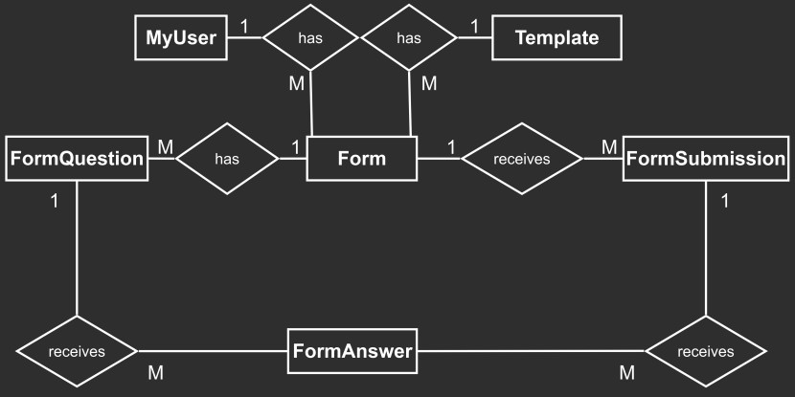
Figure 2: Entity relationship diagram
Figure 2 shows 6 key data entities: MyUser is a custom version of the Django User model [68], representing an account holder. Template provides a data source for the display of template forms. When a user selects a template, Template data (e.g. title) is used to create a Form instance. Forms contain a historic reference to their Template, to facilitate a potential reset of Form content to the data first drawn from the Template. However, Forms are distinct from Templates, as they represent an individual user’s copy of the Template data, which can be dynamically edited. When a respondent submits a form, a FormSubmission instance is created, identifying the form response. When the first FormSubmission is received, a set of FormQuestions is saved, which can be associated with all FormAnswers, avoiding duplication (only one set of published FormQuestions is saved). A full UML diagram is included in Appendix I.

User experience (UX) and interface (UI)
As seen in section 2.1.4, there are 29 UX/UI WSG. These support the idea that user-focussed, accessible, websites increase interaction efficiency, reducing emissions. As such, consideration has been given to minimeter’s UX/UI.
      - Information architecture and sitemap
A sitemap has been designed using WSG 2.6 [69] and 2.8 [70]. 2.6 recommends “efficient paths” [69]; this is honoured by avoiding nested URLs. 2.8 conformance involves using the Django sitemap framework [71] to automate production of a “navigable” XML sitemap [70], improving searchability. WSG 2.8 recommends that new content is highlighted, therefore a “what’s new?” page has been included guided by examples from web quality assurance group Opquast [72]. A full sitemap has been included in Appendix H.
      - Interface design
UX/UI WSG 2.14-15, and 2.20 are app requirements. WSG 2.20 requires accessible and minimal forms - this will guide the creation of ready-made form templates. 2.14 requests writing accessibility; the NVDA screen reader has been chosen for testing non-visual access [73]. 2.15 requires optimized images, lightweight Font Awesome icons will be used instead [8]. Finally, W3.CSS supports responsive design [74] required by WSG 2.29 [75], and a dark theme will be used as per WSG 3.12 [76].

Security
      - Authentication
Password will be the main authentication method and requirement 13 mandates password validation. Despite just 40% of the 10 apps reviewed marketing Multi-Factor Authentication (MFA), due to NIST highlighting its importance [77], requirement 22 includes 2-step MFA (2FA). Django offers adequate password encryption and configuration options [78].
      - GDPR compliance
Despite 30% of reviewed apps marketing GDPR compliance - requirement 18 demands it as best practice. Measures include Python encryption for user data [79], requirement 14 specifying data deletion, including a consent box in relevant form templates, exclusive use of EU servers, and forced HTTPS web service [80].
      - Input validation
As a forms app validation is key. The design extends Django’s Form class [81], which runs input checks and offers a host of customisable validation [82]. Being able to incorporate strong validation features ensures not only security but conformance with WSG 3.10 on form validation, as per requirement 7.
      - External systems and communication protocols
The app’s notifications and emails will be sent by API calls over TLS-encrypted HTTPS [83]. The Mailjet email service is ISO 27001 certified and GDPR compliant [62]. Secure protocols, GDPR compliance, authentication, and validation measures increase the security of interactions with the app’s external clients, database, and messaging APIs.
      - Prevention of common web application attacks
Django’s Cross-Site Request Forgery middleware includes tokens and headers that can be used for secure form handling [84]. Django’s Cross-Site Scripting tooling does not prevent client-side JavaScript injections [85], as such Mozilla’s Trusted Types API [86] has been included for sanitising form-building inputs.

Environmental impact of the design
Whilst the design outlined in the previous sections offers a workable and scalable stack, technology selection has been limited by (1) developer expertise and (2) the requirement to create a zero cost MVP. This section looks at the environmental consequences of the stack and makes suggestions for greener alternatives.
      - Third-party CSS
As stated in section 3.1.1.1 on frontend design, to conform with WSG 3.6, which recommends the limitation of third-party services such as large CSS libraries, the lightweight W3.CSS library has been selected. Due to lack of developer expertise in frontend development, this tool increases productivity. However, the optimal environmental solution would be adopting what is known as the ‘Plain Vanilla’ approach [87], i.e. the use of pure JavaScript, HTML and CSS, without third parties. Working in this way reduces emissions by reducing page and project weight to only what is required, without needing to import libraries. It is not an approach recommended for beginner web developers due to the need to work from scratch. minimeter could progressively transition to fully vanilla CSS.
      - Green hosting
Section 2.1.2 on the current state of web sustainability highlighted the lack of green hosting globally (12% of desktop web apps) [21]. WSG 4.1 “Choose a sustainable service provider” [88] contains 6 success criteria required for conformance – including monitoring a host’s sustainability metrics (e.g. Power Usage Effectiveness) and a host’s use of renewable energy. minimeter’s free host, PythonAnywhere, provides neither of these conformance requirements. An appropriate alternative would be any of the hosting services registered in the Green Web Foundation’s (GWF) Hosting Directory [89]. GWF lists green hosts by country. As discussed in section 2.1.3 on regulatory compliance, France is leading the way in digital sustainability law and policy – as such an alternative GWF-listed French host has been selected, alwaysdata, which compensates its emissions by 200% every year [90].
      - Sustainability of messaging APIs
Two messaging APIs have been included in the current design – Twilio WhatsApp API [91] and Mailjet email API [92]. Both offer accessible and scalable free trials, required to provide essential functionality such as sending form submission notifications and password reset emails. As the project version of minimeter will not have its own domain, use of Twilio has been necessary to ensure testers can receive notifications. However, without this limitation, form submission notifications would be sent via email only. This would remove Twilio’s non-green hosted service from the stack. Mailjet has been selected as a free email service running on carbon neutral Google Cloud Platform, however this could be improved. A superior email service provider would be German company Posteo, which runs its servers on 100% green energy [93].

Implementation

Defining the MVP
11 of the 23 requirements were identified as “must haves”. The goal was to identify which requirements could generate a “steel thread” – i.e. build the most important pathway through the system, resulting in a fully functional minimal product, offering early proof of concept. The steel thread was determined as (1) a user selecting a form template, (2) issuing it to respondents, and (3) tracking / reviewing responses. The review of MS Forms discussed in section 2.3.1 confirmed this as the most basic functionality offered by comparable software. Customising forms was deemed unnecessary to create a proof of concept, as such requirements relating to custom form building were categorised as “could” and “would like to” haves.
As stated in section 2.4.2 on non-functional requirements, only 3 WSGs were selected for MVP. This was deemed appropriate as collectively they represent many days work building and testing a total of 9 success criteria (sub-components of a WSG which must be validated for conformance). These WSG were selected for the following reasons: WSG 2.20 [94] and 3.10 [95] provide guidelines for sustainable forms and WSG 3.7 [96], “Ensure code follows good semantic practices”, seemed strategic to include from the outset.

Workload management
Agile scrum methodology was used to manage the build. The effort required for the user stories and non-functional requirements (c.f. Appendix G) was estimated at 22 story points (1 SP = 1 day). An additional 15 SP were included for prototyping, system testing, fixing, improvement, deployment and UAT guideline preparation. Developer velocity was 7 SP. As such, the project was worked over 6 sprints, calculated by dividing total SP (37) by developer velocity (7). Sprints varied in size from 5 to 8 SP depending on tasks allocated and ran from 11/07/25 to 15/08/25. A full iteration plan can be viewed in Appendix J.
The following project management software was used: a minimeter Trello was created to organise and track the product and iteration backlogs and any additional workload arising during the build was systematically logged as a GitLab issue (these are visible in the project repository).

Prototyping strategy
To strike a balance between producing an early frontend prototype for stakeholders and making efficient use of limited project time, a decision was made to create a “useable” prototype as the first step of the build, as opposed to wireframes. This involved selecting a W3.CSS template [9] and adapting it to the project. Adaptations included a dark mode aesthetic as per WSG 3.12 [76], minimal decoration in line with WSG 2.7 [97], and the design of the dashboard. This initial work provided both a prototype for stakeholder sign-off and a viable CSS template to use in the codebase. The initial prototype has been included in Appendix K.

Build outcome
MVP was deployed as planned. All 11 must haves were implemented. Iteration Hit Rate (number of SPs completed per sprint) was typically 100%. A total of 72 GitLab issues were logged during build, with all higher priority issues (55) closed by the final sprint. 9 of the grand vision’s 13 URLs were completed (these are highlighted in Appendix H). The final frontend design has been included in Appendix L for comparison with the initial prototype in Appendix K.
Due to the productivity of sprints, it was possible to complete 2 should haves (requirements 12 and 13), and progress 1 further should have (15), 1 could have
(18) and 1 would like to have (22) – this has been highlighted in Appendix G.

Integrations
Implementation of the design’s messaging APIs was given particular importance to increase usability. The Twilio WhatsApp API [91] was used to implement form response notifications. Twilio integration included building a 3-step registration process featuring a verification code. As the free trial version used required users to sign up every 24 hours, to ensure notifications were functional during UAT a scheduled task was setup to remind account holders still awaiting form responses to sign back up for notifications. The Mailjet email API [92] was included in a
3-step password reset workflow implemented in addition to MVP.

Build highlight
Section 3.1.2.2 highlighted a key design challenge: handling dynamic form data. To allow a user to edit a form, it needed to be possible to render the form dynamically, allowing for its structure to fluidly change when edited. Form editing has not been included in MVP; however, the author ensured that the form templates served to users were nonetheless dynamically rendered, to test the design was fit for purpose. forms.py/build_dynamic_form, views.py/public_form and form.html work together to dynamically render all form templates. Furthermore, this implementation extends the Django Form class, meaning the DynamicForm class created by the build_dynamic_form function can make use of inherited data validation functions from its parent.

Best practice
Best practice was adopted to keep the codebase workable and maintainable. Separation of concerns was achieved by implementing globally significant variables as an enumerate (c.f. minimeter/enums.py), creating the minimeter/utils directory for 7 helper modules, and using external CSS. Where possible, modules were grouped in logically named directories as opposed to being left on the project root. Finally, additional wiki docs were added to the repository for aspects not sufficiently captured by comments or README. This documentation has been submitted in the submitted zip folder and whilst basic, provides a start on technical documentation.

Additional WSG measures
CSS purging, code minification, static file compression and mobile responsivity were implemented in addition to MVP requirements in line with WSG 3.4 [53],
3.2 [98], 3.22 [99] and 3.13 [100] to facilitate future conformance. Thanks to the use of purgecss [101] and minification plugins csso (CSS) [102], terser (JS) [103] and html-minifier-next [104] 69% of the original CSS/JS/HTML weight was removed. File compression was achieved using django-compressor [105] which combines files, reducing the average number of requests per page by 46%. Finally, many hours were spent carefully integrating declared AI-generated CSS media queries to improve the experience of less-carbon intensive devices such as mobile phones.

Deployment
Development (dev) and production (prod) environments were kept distinct by extending base Django settings into separate modules. In dev, PyCharm environment variables and the custom runserver_dev.py command-line utility set dev settings, whilst in prod the wsgi.py file serving the application automatically selected prod settings. An efficient deployment workflow was created, using “git fetch origin” into prod, and automating other commands using an aliased shell script (deploy.sh).

Chapter 4 Testing and evaluation

Technical testing

Approach to automated testing
      - Strategy
Due to project limitations (development timescale, developer expertise, no team members) – an efficient approach to automated testing was adopted. This approach can be thought of as “validation first” in so far as testing effort focussed on comprehensively validating the MVP requirements. A consistent process was followed: each sprint had allocated requirements, once complete, within the course of the same sprint, comprehensive validation tests were written. Any spare sprint time was used to write value-adding unit tests. This approach ensured that despite limited resources, the project could evidence having met its requirements.
      - Test framework
The project uses Django’s implementation of the Python unittest library, django.test. This library automatically detects all modules commencing with “test” and runs the test suite. All tests are written as Python classes, with each function representing an isolated testing environment [106]. It offers powerful testing tools [107] such as emulating a client session, authenticating a client, and query of a requested page’s HTML and the variables in a page’s context. These tools were invaluable to the developer.
      - Test usage
Tests were run before major commits and at the end of every day. As such, in addition to adding tests, effort was also made to maintain the test suite. For example, approximately 10 tests were written prior to the addition of user authentication to the project. Once this functionality was added, all tests needed to be updated to ensure their simulated HTTP requests were authenticated where necessary.

Results of automated testing
      - Outcome of validation testing
35 passing validation tests were included against the project’s 11 MVP requirements (c.f. Appendix M). The average number of validation tests per requirement was 3.18. The more complex a requirement was to test, the more validation tests it was attributed. These tests should be understood as integration tests as they work across units. An effort was made to ensure all JSON form templates used in production were loaded in these tests to validate production resources.
      - Outcome of unit testing
27 passing unit tests were included in addition to validation (c.f. Appendix N). 11 of them targeted problem cases, ensuring error handling was in place when undesired system / user behaviour occurred (e.g. UT-022). 2 targeted edge cases, including forbidding a user to submit their own form whilst authenticated (c.f. UT-031). Whilst a larger unit test suite would have been desirable, these tests were a useful complement to core validation.

      - Test traceability and coverage
The Python coverage package helped monitor test coverage [108] (c.f. Appendix O). It reported a total 88% coverage, however real terms coverage was approximately 94%, excluding irrelevant code captured by the package and including tests designed not to be automatically detected. All validation and unit tests have been mapped to requirements (c.f. Appendix P), averaging 4 tests per requirement.

API integration testing
Special measures were taken to thoroughly test the integration of the Twilio WhatsApp API [91]. First, minimeter/tests/test_send_twilio_reminders.py is an automated test class that tests that the custom command in minimeter/commands/send_twilio_reminders.py works as intended. To safely test the custom command’s API call which issues a WhatsApp notification, the Python unittest.mock library’s patch function [109] was used to mock the API call.
Secondly, the class in minimeter/tests/test_whatsapp_utils contains two functions to “manually” test that verification codes and form response notifications are sent by Twilio. This test class is configured not to be automatically picked up by Django’s test framework as it issues live API calls. The class can be run on an occasional basis to ensure live API calls function as intended.

Web Sustainability Guidelines testing
The 3 WSG included in the MVP requirements were treated the same as other requirements with regards to validation and unit testing. This is exactly how WSG implementation is intended, with each WSG containing several machine-testable “success criteria” [51], each providing a procedure checklist for completing testing (e.g. WSG 3.10, success criteria 1 [110]). Conformance cannot be claimed without testing against the success criteria where applicable.
12 automated validation tests were included for WSG 2.20 (against 2 success criteria) and 3.10 (3 success criteria) (c.f. tests IDs commencing with “WSG” in Appendix M). In some cases, automated tests were not an appropriate means of testing, as was the case for WSG 3.7 “Ensure code follows good semantic practices”. Instead, the minimeter conformance statement (c.f. Appendix R) captures 11 semantic checking methods used following WSG 3.7 recommendations, including use of W3C’s Markup Validation Service [111].
Finally, in addition to WSG conformance testing, minimeter’s homepage was submitted to the website carbon analysis tool Beacon [24] which uses the same carbon measurement model as that used in section 2.3.2’s analysis of similar apps. The result provided additional validation: an energy rating of B, with 0.281g CO2 emitted on first page load (c.f. Appendix S) – a stark contrast with the majority E rating and 2.026g average emissions seen in reviewed forms apps (c.f. section 2.3.2).

Cross browser / device testing
Before deployment Chrome Dev Tools were used to simulate different mobile device dimensions and work was done to improve the phone experience, e.g. increasing button sizes. 5 popular browsers were used for testing (Firefox, Chrome, Brave, Edge, with some limited access to Safari on BrowserStack [112]). After deployment, the app was accessed on an iPhone, revealing key layout and logic was failing in Safari. Re-engineering was required to ensure users could copy the form sharing link without Safari security policy blockage. This fix was further manually tested on iPhone and desktop Safari after obtaining a MacBook. All subsequent deployments were tested on a representative sample (Chrome and Safari desktop and iPhone).

Preparation for User Acceptance Testing (UAT)
Prior to UAT, a series of UAT simulations were put in place as an additional assurance measure. First, the functioning of the scheduled task sending WhatsApp registration reminders was monitored for expected results over a period of 3 days. Secondly, the developer carried out manual testing equivalent to UAT, following the steps assigned to each tester, using a variety of devices (Window and Apple laptops, iPhone and Chrome Dev Tool-simulated iPad). Finally, the automated WhatsApp tests were set to use the same number of users as in UAT.

User evaluation

Importance of User Acceptance Testing
UAT was deemed a necessary evaluation type for two reasons. First, minimeter is a user-facing system, with both account holders and form respondents interacting with its interface. Therefore, it was important to test the usability of these interactions. Secondly, the only success criteria of WSG 2.28 “Verify that real-world users can successfully use your work” [12] is usability testing. Prioritising UAT makes sense for ensuring the reduction of emissions: the more efficiently users can achieve goals in a system, the less energy is consumed.

UAT design
      - Process
The following UAT process was designed: two types of testers were identified, account holders and form respondents. Test guides listing tasks to complete in the system were drawn up for both tester types and shared on 16 August for completion by 17 August (c.f. Appendix U). Participants consisted of 3 account holders, who sent minimeter forms to 2 respondents respectively, creating a total of 9 testers. An account holder was required to make an account, create a form, issue it to respondents, and review their responses. Respondents completed a minimeter form sent by an account holder and read the sustainability page (c.f. Appendix Q and R, both components of the page).
      - User devices and browsers
Users were asked to use specific device types to create a diverse sample. Account holders used laptops, as the core form features are intended to be used on desktop in line with reviewed apps. 2 different operating systems were used (Windows, macOS) with 3 different browsers (Edge, Chrome, Avast Secure Browser). 2 form respondents used iPads, 2 used mobiles (iOS and Android) and 2 used Windows laptops with Chrome and Edge browsers. This mix effectively simulated expected use, with desktop used for form administration and form respondents completing forms on any device type.
      - User demographic
A broad demographic participated. Ages ranged from 24 to 64, with digital literacy ranging from medium to high. The participants were employed in a variety of sectors: hospitality, veterinary medicine, public service, and the arts. 4 testers were of French nationality and 5 British. The research questionnaire confirmed that none of the testers relied on assistive technology to access web applications. Despite the lack of accessibility needs to test against, the diversity of the demographic provided evidence the app can be used by wider society.

UAT issues
8 out 9 testers were able to proceed without encountering a system issue. However, 1 tester with the role of account holder discovered a gap in WhatsApp number validation during their registration process. With a particular number format to respect, the developer had put in place and tested comprehensive mobile number validation. The issue in this instance was that whilst a perfectly valid WhatsApp number had been entered, passing all the system validation, the tester had got at least 1 digit of this number incorrect. As such, a valid number was recorded, but not one that belonged to the user.
Due to this issue the user could not sign up for WhatsApp notifications. However, they were able to intuitively find their way to login and complete testing regardless. As a result of this issue, the building of a ‘no verification code’ workflow as part of registration has been scheduled to improve the system.

UAT results
All 9 testers completed a research questionnaire (c.f. Appendix T) after working through tasks in a test guide (c.f. Appendix U). The results were as follows:
      - System usability score
Participants were asked to provide ratings for the 10 system usability scale statements [113]. The average score was 96.66 / 100, with a breakdown of 98.33 for account holders and 95 for minimeter form respondents. This is an above average usability score, with the average in industry at 68 / 100 [114].
In an optional question collecting feedback, 3 / 9 testers voluntarily confirmed they found the system easy to use, 2 of whom related this to the app’s minimalist aesthetic. This score affirmed one of the key reasons for making WSG-conforming apps mentioned in section 2.1.4 – the WSG focus on smooth user experience can boost commerciality by increasing the number of positive user interactions.
      - Low-carbon interest score
Participants were asked to confirm they had read the minimeter sustainability and conformance statements (c.f. Appendices Q and R) then score the following two statements using a 1 to 5 Likert scale:
        - I think it's important that providers of web applications take active measures to reduce their product's carbon emissions.
        - If a low-carbon web application’s functionality was of a competitive standard, I would be inclined to use this software over applications that do not prioritise lowering emissions.
Both statements were scored out of 5, with an aggregate score out of 10 created per respondent. The average score was 9.74 / 10. We can conclude that respondents were interested in low-carbon web apps. In section 2.1.4 a WSG app was also considered to have a commercial advantage in line with research by Agu et al. on the “relationship between sustainable business practices and increased brand loyalty” [38]. The proven interest of respondents in low-carbon web apps confirms Agu et al.’s concept of a “market driven by environmental considerations” [38] in which such respondents would be inclined to choose low-carbon software over less sustainable alternatives.

      - Feedback from testers
Testers were given the option of providing free text feedback, including commenting on what they’d like to see in a future release. Several ideas were shared including:
        - Sharing large documents as part of the form response.
        - The use of a more aesthetically pleasing font to increase the app’s visual appeal.
        - Increased ADHD accessibility by providing clearer visual focus points.
As there was no consensus amongst testers on these points, they were not prioritised for immediate development. However, as WSG 2.28 requires that the “impact of [UAT] is routinely measured for future releases” [12] this input was factored into a log of design improvements for consideration, captured in one of the project’s wiki pages. The suggestions were also added to the project’s workload as GitLab issues with the label “user feedback”.

Recommendations for future work

Usability recommendations
In addition to the logging of user feedback for review, two more usability recommendations emerged from UAT. First, the ADHD-focussed user feedback led to the prioritisation of accessibility related WSG in future releases. Of the 29 UX WSG, 7 are directly accessibility focussed. MVP already implements 2 of these (2.20 [94], 2.28 [12]) however the remaining 4 (2.2 [11], 2.14 [115], 2.19 [116], 2.21 [117]) were recorded as a GitLab issue with the label “future work”.
Secondly, usability improvements for the developer can also be considered. During UAT system logs were consulted, however these were difficult to interpret clear actions from (e.g. user registration, notification delivery). As such, improvement of logging for key actions has also been added as a “future work” GitLab issue to increase the usability of logs.

Technical testing recommendations
Two improvements to technical testing may also be considered. The first builds on the test usage discussed in section 4.1.1.3 – i.e. the test suite was run by typing a command prior to every major commit and at the end of every day’s work. A GitLab “future work” issue has therefore been logged to work on automating this workflow. This can be achieved by registering a custom script known as a Git hook [118] with the pre-commit Git framework [119]. The hook could include both the test running command and commands to trigger the project’s installed linters (ESLint [120] and Stylelint [121]).
The second and final recommendation logged as a GitLab “future work” issue is the incorporation of the browser automation tool Selenium WebDriver [122]. This tool offers more than the Django test framework by fully rendering templates with associated CSS and JS during testing. Once rendered, it is possible to write tests that interact with the rendered page as a user would. As such, the manual testing simulating UAT, discussed in section 4.1.6, could be written as a Selenium test for reuse prior to any subsequent releases.

Chapter 5 Conclusion

Final development status
Improvements were made up until the point of conclusion. As the project currently stands, statistics are as follows:
- 14 / 23 requirements built (approximately 61%)
- 3 / 9 remaining requirements progressed (approximately 74% overall progress including built requirements)
- 246 commits
- 62 tests at 94% real terms coverage
  - 35 validation tests
  - 27 unit tests
- 62 / 90 GitLab issues closed (approximately 69%)

Final product functionality

What works technically in the final product?
As confirmed in section 3.2.4 on the outcome of the build, all 11 MVP requirements were implemented and tested prior to UAT. MVP achieved the “steel thread” described in section 3.2.1 on the definition on MVP, i.e. the most important pathway through the system is fully functional. 3 users tested this pathway by creating an account, selecting a form template, sending a form link to 2 form respondents respectively, receiving response notifications and reading form responses.

What has been achieved compared to what was originally planned?
Section 3.2.4 on build outcome also confirmed that due to the productivity of sprints, MVP was exceeded with the completion of 2 should haves (requirements 12 and 13) and progress on 1 should have (15), 1 could have (18) and 1 would like
to have (22).
Since then, 2 key improvements have been accomplished: in response to the issue highlighted by UAT outlined in section 4.2.3, a full “no verification code” workflow has been included in the app’s registration process. This resolves the issue that 1 in 4 testers experienced – i.e. entering a perfectly valid WhatsApp number, but not their own. This additional build has significantly improved the robustness of the account registration workflow.
Finally, honouring WSG 2.2 “Understand visitor requirements or constraints, resolving barriers to access” [11] which emphasises the importance of building stakeholders’ opinions into product development, export to csv functionality was added as requirement 21 in response to stakeholder feedback. This requirement was built and tested by the final development stage, allowing users not only to view their form responses in the system, but to download a local copy.

What does not work technically in the final product?
All functionality included is tested and operational. However, with 9 requirements still to be built, some of the desired functionality is not present. This includes custom form building (requirement 19). Final requirements are estimated at 12 SP (2 iterations). In addition to the remaining requirements 22 GitLab issues represent improvements that can be made. These include a full review of account registration error handling (issue 87) and building CSS purging and minification back in after their removal in deployment (issue 62).

Project reflection
This section presents a reflection on what went well and what could be improved in relation to requirements gathering, build, and testing. A design reflection was included in section 3.1.5 on the environmental impact of the design.

Requirements gathering
The product review in section 2.3.1 captured 52 features offered by Microsoft Forms (MS Forms, c.f. Appendix B) as well as 89 basic and 143 enterprise features across the 10 apps reviewed (c.f. Appendices C, D). 14 MS Forms features were included in minimeter’s specification, with limited implementation of the basic and enterprise plan features. The MS Forms review provided a useful standard for the definition of a basic specification. Future work should gradually include the most popular features seen in the existing product review (e.g. a multi-user workspace) to increase the app’s appeal.

Build
As outlined in the contribution statement, approximately 10.94% of the codebase was predominantly AI-generated. AI code composition is as follows: JavaScript 38%, CSS 28%, Django/Python 25%, Shell/txt 5% and Django/HTML 4%. The usage is appropriate given the developer’s lack of the advanced level required to achieve the specification. Its use is both positive and negative: on the one hand it prepared the developer for an industry which has “the highest rate of LLM adoption and usage” with 70% of a sample of 90,000 developers using Gen-AI [10]. On the other hand, it goes against the project’s ethics by using a technology research shows has a negative environmental impact [123][124][125]. In accordance with WSG 5.22 “Promote and implement responsible emerging technology practices” [126] future work should start with the definition of an ethical AI strategy if AI is to continue to be a part of development practice.

Testing
Finally, section 4.1.1 on the approach to automated testing highlights the focus placed on validation testing (35 tests) instead of unit testing (27 tests). With 35 passing validation tests each traceable to one of the requirements, this approach ensured that by the deadline strong evidence was provided of having built the specification. However, this approach meant that less time was available to write unit tests for problematic or edge case behaviour (only 13 problem and 2 edge cases have been included). An improvement would therefore be an increased number of this type of test case to increase the app’s robustness.

Summary of future work
All recommendations made in the report have been listed in Appendix V. This list establishes 5 key steps required for a second release, including an AI strategy, 16 low priority legacy GitLab issues, 9 remaining product requirements,
7 “second release” GitLab issues capturing recommendations made (e.g. increased edge case unit tests) and 3 “user feedback” GitLab issues. Completing this work to deliver a second release has been estimated at 42.5 SP (7 iterations at the first release velocity).
3 further steps have been included for action after the second release: 3 “future work” GitLab issues (e.g. transitioning to green hosting), increasing product functionality in line with the existing product review, and continuous WSG conformance guided by the 33 remaining priority WSG in the Web Almanac analysis (c.f. section 2.3.3 and Appendix F).

Project outcome

Response to the research question, objective, and aims
The research question was: can WSG-conforming web applications be built? This question guided the project’s objective: to build a piece of commonly used software that conforms with the WSG. Project aims were: (1) to produce a prototype for the first forms app that is WSG-conforming and (2) to provide proof of concept for WSG-conforming web applications.
minimeter has achieved full conformance with four WSG (3.7, 2.20, 3.10, 2.28) and progressed a further two (2.15, 3.4). The official conformance statement can be consulted in Appendix R. Project aims have therefore been satisfied: the minimeter MVP offers a prototype for a forms app that is WSG-conforming and constitutes proof of concept for WSG-conforming web apps. The project objective has been met: minimeter is a piece of “everyday” software that conforms with the WSG.
Given WSG authors’ assurance that conformance with all WSG is not expected
[127] and WSG policy is “progress over perfection” [3] – minimeter’s progress allows us to conclude that WSG-conforming web applications can be built.

Challenges to WSG conformance
The following conformance challenges were nonetheless faced:
WSG 3.6 requires that third-party services of all kinds be used only where they are “critical for functionality” [52]. minimeter’s current design includes 58, notably the Django framework. These may all be deemed critical – the challenge lies in constantly assessing this in a context where the use of third-party software is common.
Not using third parties such as frontend frameworks highlights another challenge – remaining competitive in a market full of highly attractive and dynamic frontends. During development, constant criticality was required to limit CSS and JavaScript whilst making the app as attractive as possible.
Finally, WSG conformance increases difficulty. First by requiring WSG are accounted for at every step of the development lifecycle. Secondly, due to the WSG being written by web experts, by occasionally requiring advanced knowledge for adequate implementation. Dedication or obligation is therefore necessary to warrant the additional effort.

Project conclusion
The minimeter project shows that WSG-conformance can successfully be implemented, but teams must be prepared to consistently handle the challenges conformance presents. Given sufficient dedication or compliance obligation, a development team could manage the necessary limitation of third-party services, create an attractive yet minimal frontend, and tackle the difficulty level.
What is the value in having shown that WSG-conforming web apps can be built? Section 2.1.1 highlighted the core value proposition: supporting the development of the WSG as a future W3C standard. Whilst no proposals to the WSG editors have been made during the project, the author is in a place to eventually do so. Supporting WSG development has primarily been achieved by raising WSG awareness amongst stakeholders, including the 9 testers, and promoting WSG deployment by evidencing its successful implementation.
Furthermore, minimeter affirms sections 2.1.2, 2.1.3 and 2.1.4: its successful WSG implementation confirms that the WSG provide a means to increase compliance with sustainability regulation such as France’s REEN law [5]. Its UAT result, with all testers stating they would prefer to use low-carbon software, confirms the WSG offer a commercial advantage. Finally, minimeter’s homepage emits 86% less carbon than those of the 10 apps reviewed, making it crystal clear that a greener web is possible, and the WSG provide a reliable tool to achieve it.

References
[1] Tavily AI, "Tavily Search API Documentation: Built for LLM Agents," docs.tavily.com, accessed Jul. 2026.

[2] Information Commissioner's Office (ICO), "Guide to the UK General Data Protection Regulation (UK GDPR)," ico.org.uk, accessed Aug. 2026.

[3] C. S. Horstmann, Object-Oriented Design and Patterns, 2nd ed. Hoboken, NJ: John Wiley & Sons, 2006.

[4] J. L. Wong, "Development of a Real-Time, Client-Side Feedback System for American Sign Language (ASL) Fingerspelling Practice," M.Sc. dissertation, School of Computing Science, University of Glasgow, Glasgow, UK, Sep. 2025.

[5] P. U. Tran, "TradeWise: A Stock Signal Web Application for Individual Traders," M.Sc. dissertation, School of Computing Science, University of Glasgow, Glasgow, UK, Aug. 2025.

[6] B. Kirkland, "EveryFan Analytics: Accessible Football Analysis Tools with Machine Learning, Computer Vision and Web Technologies," M.Sc. dissertation, School of Computing Science, University of Glasgow, Glasgow, UK, Sep. 2025.

[7] M. Honnibal, I. Montani, S. Van Landeghem, and A. Boyd, "spaCy: Industrial-strength Natural Language Processing in Python," Zenodo, doi:10.5281/zenodo.1212303, 2020.

[8] N. Reimers and I. Gurevych, "Sentence-BERT: Sentence embeddings using Siamese BERT-networks," in Proceedings of the 2019 Conference on Empirical Methods in Natural Language Processing (EMNLP), 2019, pp. 3982–3992.

[9] Careerflow AI Inc., "Careerflow: AI Copilot for Your Job Search," careerflow.ai, accessed Jun
- W3C Sustainable Web Interest Group, ‘Web Sustainability Guidelines, Status of This Document’, 2025. Accessed: Jun. 29, 2025. [Online].
Available: https://w3c.github.io/sustainableweb-wsg/#sotd
- Sustainable Web Design, ‘Estimating Digital Emissions’, 2025. Accessed: Jun. 29, 2025. [Online]. Available: https://sustainablewebdesign.org/estimating-digital-emissions/
- T. Frick, Designing for sustainability : a guide to building greener digital products and services, First edition. Beijing, China: O’Reilly, 2016.
- Website Carbon Calculator, ‘Introducing the Website Carbon Rating System’. Accessed: Jun. 29, 2025. [Online]. Available: https://www.websitecarbon.com/introducing-the-website-carbon-rating-system/
- L. Devernay Satyagraha, B. Güneli, I. Akrap, A. Dawson, M. Gifford, and
T. Frick, ‘Web Almanac 2024, How many of the sites listed in the HTTP Archive run on green hosting?’ Accessed: Jun. 29, 2025. [Online]. Available: https://almanac.httparchive.org/en/2024/sustainability#how-many-of-the-sites-listed-in-the-http-archive-run-on-green-hosting
- L. Devernay Satyagraha, B. Güneli, I. Akrap, A. Dawson, M. Gifford, and
T. Frick, ‘Web Almanac 2024, Sustainability, Page Weight’, Nov. 2024, Accessed: Jun. 29, 2025. [Online]. Available: https://almanac.httparchive.org/en/2024/sustainability#page-weight
- L. Devernay Satyagraha, B. Güneli, I. Akrap, A. Dawson, M. Gifford, and
T. Frick, ‘Web Almanac 2024, Emissions for 2024’. Accessed: Jun. 29, 2025.
[Online]. Available:
https://almanac.httparchive.org/en/2024/sustainability#emissions-for-2024
- ALINE, ‘Beacon, Calculate the environmental impact of a web page’.
Accessed: Jul. 06, 2025. [Online]. Available: https://digitalbeacon.co/
- statista, ‘Most popular websites worldwide as of November 2024, by total visits’, Nov. 2024, Accessed: Jun. 29, 2025. [Online]. Available: https://www.statista.com/statistics/1201880/most-visited-websites-worldwide/
- W3C Sustainable Web Interest Group, ‘Web Sustainability Guidelines, 1.1 Background on WSG ’, 2025. Accessed: Jun. 29, 2025. [Online]. Available: https://w3c.github.io/sustainableweb-wsg/#background-on-wsg
- L. Devernay Satyagraha, B. Güneli, I. Akrap, A. Dawson, M. Gifford, and
T. Frick, ‘Web Almanac 2024, Legal obligations and reporting standards’. Accessed: Jun. 29, 2025. [Online]. Available: https://almanac.httparchive.org/en/2024/sustainability#legal-obligations-and-reporting-standards
- French Republic, ‘Green IT’. Accessed: Jun. 29, 2025. [Online]. Available: https://www.ecologie.gouv.fr/politiques-publiques/green-it
- L. Devernay, ‘Le cadre législatif de l’écoconception de services numériques’. Accessed: Jun. 29, 2025. [Online]. Available: https://greenspector.com/le-cadre-legislatif-de-lecoconception-de-services-numeriques/
- European Commission, ‘Corporate sustainability reporting’. Accessed: Jul. 06, 2025. [Online]. Available: https://finance.ec.europa.eu/capital-markets-union-and-financial-markets/company-reporting-and-auditing/company-reporting/corporate-sustainability-reporting_en
- European Union, DIRECTIVE (EU) 2022/2464 OF THE EUROPEAN
PARLIAMENT AND OF THE COUNCIL of 14 December 2022 amending Regulation (EU) No 537/2014, Directive 2004/109/EC, Directive 2006/43/EC and Directive 2013/34/EU, as regards corporate sustainability reporting. 2022. Accessed: Sep. 01, 2025. [Online]. Available: http://data.europa.eu/eli/dir/2022/2464/oj
- European Commission, ‘Frequently asked questions on the implementation of the EU corporate sustainability reporting rules’. Accessed: Jun. 29, 2025. [Online]. Available:

https://finance.ec.europa.eu/publications/frequently-asked-questions-implementation-eu-corporate-sustainability-reporting-rules_en
- W3C, ‘WCAG 2 Overview’. Accessed: Jun. 29, 2025. [Online]. Available: https://www.w3.org/WAI/standards-guidelines/wcag/
- French Republic, ‘Référentiel général d’amélioration de l’accessibilité, RGAA - Version 4.1.2’. Accessed: Jun. 29, 2025. [Online]. Available: https://accessibilite.numerique.gouv.fr/
- Global Reporting Initiative (GRI), ‘GRI Standards’. Accessed: Jun. 29, 2025. [Online]. Available: https://www.globalreporting.org/standards/
- L. Devernay Satyagraha, B. Güneli, I. Akrap, A. Dawson, M. Gifford, and
T. Frick, ‘Web Almanac 2024, Intersectional environmental issues’. Accessed: Jun. 29, 2025. [Online]. Available: https://almanac.httparchive.org/en/2024/sustainability#intersectional-environmental-issues
- W3C Sustainable Web Interest Group, ‘Web Sustainability Guidelines, 2. User Experience Design’, 2025. Accessed: Jun. 29, 2025. [Online]. Available: https://w3c.github.io/sustainableweb-wsg/#user-experience-design
- E. E. Agu, T. V. Iyelolu, C. Idemudia, and T. I. Ijomah, ‘Exploring the relationship between sustainable business practices and increased brand loyalty’, International Journal of Management & Entrepreneurship Research, vol. 6, no. 8, pp. 2463–2475, Aug. 2024, doi: 10.51594/ijmer.v6i8.1365.
- W3C Sustainable Web Interest Group, ‘Web Sustainability Guidelines,
1.5.2 Conformance claims’, 2025. Accessed: Jun. 29, 2025. [Online].
Available: https://w3c.github.io/sustainableweb-wsg/#conformance-claims
- W3C Sustainable Web Interest Group, ‘Web Sustainability Guidelines, 3.5 Avoid redundancy and duplication in code’, 2025. Accessed: Jun. 29, 2025. [Online]. Available: https://w3c.github.io/sustainableweb-wsg/#avoid-redundancy-and-duplication-in-code
- R. (emailtooltester) Phillips and R. (emailtooltester) Brandl, ‘What’s the Best Online Form Builder?’ Accessed: Jun. 30, 2025. [Online]. Available: https://www.emailtooltester.com/en/blog/best-online-form-builder/
- D. (techradar) Athow, ‘Best online form builder of 2025’. Accessed: Jun. 30, 2025. [Online]. Available: https://www.techradar.com/best/best-online-form-builder
- M. (zapier) Rebelo, ‘The 12 best online form builder apps’. Accessed: Jun. 30, 2025. [Online]. Available: https://zapier.com/blog/best-online-form-builder-software/
- HTTP Archive, ‘Homepage’. Accessed: Jul. 01, 2025. [Online]. Available: https://httparchive.org/
- M. Aturban, M. Klein, H. Van de Sompel, S. Alam, M. L. Nelson, and M. C. Weigle, ‘Hashes are not suitable to verify fixity of the public archived web’, PLoS One, vol. 18, no. 6, p. e0286879, Jun. 2023, Accessed: Sep. 01, 2025. [Online]. Available: https://doi.org/10.1371/journal.pone.0286879
- M. Völske et al., ‘Web Archive Analytics’, in German Informatics Society INFORMATIK 2020, Bonn: German Informatics Society, Jul. 2020, pp. 62–
72. Accessed: Jul. 01, 2025. [Online]. Available: https://doi.org/10.48550/arXiv.2107.00893
- L. Devernay Satyagraha, B. Güneli, I. Akrap, A. Dawson, M. Gifford, and
T. Frick, ‘Web Almanac 2024, Reducing the environmental impact of websites’. Accessed: Jul. 01, 2025. [Online]. Available: https://almanac.httparchive.org/en/2024/sustainability#reducing-the-environmental-impact-of-websites
- Ecograder, ‘How it Works’. Accessed: Jun. 30, 2025. [Online]. Available: https://ecograder.com/how-it-works

- Microsoft, ‘A commitment to sustainability’. Accessed: Jul. 01, 2025. [Online]. Available: https://www.microsoft.com/en-gb/store/b/shop-sustainably?icid=MSCOM-UHF-Footer-Store-Sustainability
- L. Devernay Satyagraha, B. Güneli, I. Akrap, A. Dawson, M. Gifford, and
T. Frick, ‘Web Almanac 2024, Sustainability’. Accessed: Jul. 06, 2025.
[Online]. Available: https://almanac.httparchive.org/en/2024/sustainability
- W3C Sustainable Web Interest Group, ‘Web Sustainability Guidelines,
1.2.3 Success Criteria’, 2025. Accessed: Jul. 01, 2025. [Online]. Available: https://w3c.github.io/sustainableweb-wsg/#success-criteria
- W3C Sustainable Web Interest Group, ‘Web Sustainability Guidelines, 3.6 Give third parties the same priority as first parties during assessment’, 2025. Accessed: Jul. 05, 2025. [Online]. Available: https://w3c.github.io/sustainableweb-wsg/#give-third-parties-the-same-priority-as-first-parties-during-assessment
- W3C Sustainable Web Interest Group, ‘Web Sustainability Guidelines, 3.4 Remove unnecessary code’, 2025. Accessed: Jul. 02, 2025. [Online]. Available: https://w3c.github.io/sustainableweb-wsg/#remove-unnecessary-code
- Google, ‘Remove unused CSS’. Accessed: Jul. 05, 2025. [Online]. Available: https://developer.chrome.com/docs/lighthouse/performance/unused-css-rules?hl=en
- Django Software Foundation, ‘Overview’. Accessed: Jul. 05, 2025. [Online].
Available: https://www.djangoproject.com/start/overview/
- W3C Sustainable Web Interest Group, ‘Web Sustainability Guidelines,
3.20 Use the latest stable language version’, 2025. Accessed: Jul. 05, 2025. [Online]. Available: https://w3c.github.io/sustainableweb-wsg/#use-the-latest-stable-language-version
- R. Pereira et al., ‘Energy efficiency across programming languages: how do energy, time, and memory relate?’, in Proceedings of the 10th ACM SIGPLAN International Conference on Software Language Engineering, New York, NY, USA: ACM, Oct. 2017, pp. 256–267. Accessed: Sep. 01, 2025. [Online]. Available: https://doi.org/10.1145/3136014.3136031
- PythonAnywhere (Anaconda), ‘From sign-up to a live Django app in 5 minutes...’ Accessed: Jul. 05, 2025. [Online]. Available: https://www.pythonanywhere.com/details/django_hosting
- PythonAnywhere (Anaconda), ‘Plans and pricing’. Accessed: Jul. 05, 2025.
[Online]. Available: https://www.pythonanywhere.com/pricing/
- PythonAnywhere (Anaconda), ‘Can I use Postgres on PythonAnywhere?’ Accessed: Jul. 05, 2025. [Online]. Available: https://help.pythonanywhere.com/pages/Postgres
- J. Roach, ‘PostgreSQL vs. MySQL: Choosing the Right Database for Your Project’. Accessed: Jul. 05, 2025. [Online]. Available: https://www.datacamp.com/blog/postgresql-vs-mysql
- Sinch (Mailjet), ‘Email Infrastructure Built to Scale’. Accessed: Jul. 05, 2025. [Online]. Available: https://www.mailjet.com/products/email-api/infrastructure/
- Google, ‘24/7 by 2030: Realizing a Carbon-free Future’, Sep. 2020. Accessed: Jul. 05, 2025. [Online]. Available: https://sustainability.google/reports/247-carbon-free-energy/
- Django Software Foundation, ‘User model’. Accessed: Jul. 08, 2025.
[Online]. Available:
https://docs.djangoproject.com/en/5.2/ref/contrib/auth/#user-model
- Django Software Foundation, ‘Databases’. Accessed: Jul. 08, 2025.
[Online]. Available: https://docs.djangoproject.com/en/5.2/ref/databases/
- Django Software Foundation, ‘JSONField’. Accessed: Jul. 08, 2025.
[Online]. Available:
https://docs.djangoproject.com/en/5.2/ref/models/fields/#jsonfield

- Django Software Foundation, ‘GinIndex’. Accessed: Jul. 08, 2025. [Online]. Available: https://docs.djangoproject.com/en/5.2/ref/contrib/postgres/indexes/#ginindex
- Django Software Foundation, ‘Extending the existing User model’. Accessed: Aug. 18, 2025. [Online]. Available: https://docs.djangoproject.com/en/5.2/topics/auth/customizing/#extending-the-existing-user-model
- W3C Sustainable Web Interest Group, ‘Web Sustainability Guidelines, 2.6 Minimize non-essential content, interactivity, or journeys’, 2025. Accessed: Jul. 10, 2025. [Online]. Available: https://w3c.github.io/sustainableweb-wsg/#minimize-non-essential-content-interactivity-or-journeys
- W3C Sustainable Web Interest Group, ‘Web Sustainability Guidelines, 2.8 Ensure that navigation and wayfinding are well-structured’, 2025. Accessed: Jun. 29, 2025. [Online]. Available: https://w3c.github.io/sustainableweb-wsg/#ensure-that-navigation-and-wayfinding-are-well-structured
- Django Software Foundation, ‘The sitemap framework’, 2025. Accessed: Jul. 10, 2025. [Online]. Available: https://docs.djangoproject.com/en/5.2/ref/contrib/sitemaps/#module-django.contrib.sitemaps
- Opquast, ‘Rule n° 1 - The website provides a way for users to find out about new content and services.’ Accessed: Jul. 10, 2025. [Online]. Available: https://checklists.opquast.com/en/web-quality-assurance/the-site-provides-users-with-a-way-to-know-about-new-contents-and-services
- Siteimprove, ‘Screen reader testing’. Accessed: Jul. 10, 2025. [Online].
Available: https://www.siteimprove.com/glossary/screen-reader-testing/
- W3Schools, ‘W3.CSS Responsive Fluid Grid’, Mar. 2025, W3.CSS 5.01. Accessed: Jul. 10, 2025. [Online]. Available: https://www.w3schools.com/w3css/w3css_responsive.asp
- W3C Sustainable Web Interest Group, ‘Web Sustainability Guidelines,
2.29 Regularly test and maintain compatibility’, 2025. Accessed: Jul. 10, 2025. [Online]. Available: https://w3c.github.io/sustainableweb-wsg/#regularly-test-and-maintain-compatibility
- W3C Sustainable Web Interest Group, ‘Web Sustainability Guidelines,
  - Use sustainability beneficial user preference media queries’, 2025. Accessed: Jul. 10, 2025. [Online]. Available: https://w3c.github.io/sustainableweb-wsg/#use-sustainability-beneficial-user-preference-media-queries
- National Institute of Standards and Technology (NIST), ‘Digital Identity Guidelines’, Jun. 2017. Accessed: Jul. 09, 2025. [Online]. Available: https://doi.org/10.6028/NIST.SP.800-63-3
- Django Software Foundation, ‘Password management in Django’. Accessed: Jul. 09, 2025. [Online]. Available: https://docs.djangoproject.com/en/5.2/topics/auth/passwords/#password-management-in-django
- fragment, jazzband, and Python Software Foundation, ‘django-fernet-encrypted-fields 0.3.0’. Accessed: Jul. 09, 2025. [Online]. Available: https://pypi.org/project/django-fernet-encrypted-fields/
- PythonAnywhere (Anaconda), ‘Forcing HTTPS’. Accessed: Jul. 09, 2025.
[Online]. Available:
https://help.pythonanywhere.com/pages/ForcingHTTPS/
- Django Software Foundation, ‘The Django Form class’. Accessed: Jul. 09, 2025. [Online]. Available: https://docs.djangoproject.com/en/5.2/topics/forms/#the-django-form-class
- Django Software Foundation, ‘Form and field validation’. Accessed: Jul. 09, 2025. [Online]. Available: https://docs.djangoproject.com/en/5.2/ref/forms/validation/#form-and-field-validation

- Cloudflare, ‘What is HTTPS?’ Accessed: Sep. 01, 2025. [Online]. Available: https://www.cloudflare.com/learning/ssl/what-is-https/
- Django Software Foundation, ‘How to use Django’s CSRF protection’. Accessed: Aug. 18, 2025. [Online]. Available: https://docs.djangoproject.com/en/5.2/howto/csrf/#how-to-use-django-s-csrf-protection
- Django Software Foundation, ‘Cross site scripting (XSS) protection’. Accessed: Aug. 18, 2025. [Online]. Available: https://docs.djangoproject.com/en/5.2/topics/security/#cross-site-scripting-xss-protection
- Mozilla MDN, ‘Trusted Types API’, 2025. Accessed: Aug. 18, 2025.
[Online]. Available: https://developer.mozilla.org/en-
US/docs/Web/API/Trusted_Types_API
- J. Sebrechts, J. Mouzin, and G. Singh, ‘Plain Vanilla’. Accessed: Aug. 18, 2025. [Online]. Available: https://plainvanillaweb.com/
- W3C Sustainable Web Interest Group, ‘Web Sustainability Guidelines, 4.1 Choose a sustainable service provider’, 2025. Accessed: Aug. 18, 2025. [Online]. Available: https://w3c.github.io/sustainableweb-wsg/#choose-a-sustainable-service-provider
- Green Web Foundation, ‘Directory’. Accessed: Aug. 18, 2025. [Online].
Available: https://app.greenweb.org/directory/
- alwaysdata, ‘The planet hosts us’. Accessed: Aug. 18, 2025. [Online].
Available: https://www.alwaysdata.com/en/environment/
- Twilio, ‘Twilio Docs, WhatsApp Business Platform with Twilio’. Accessed:
Aug. 18, 2025. [Online]. Available: https://www.twilio.com/docs/whatsapp
- Sinch (Mailjet), ‘Email API Overview’. Accessed: Aug. 18, 2025. [Online].
Available: https://dev.mailjet.com/email/guides/
- Posteo, ‘Posteo: An impetus for more sustainability in the internet.’ Accessed: Aug. 18, 2025. [Online]. Available: https://posteo.de/en/site/sustainability
- W3C Sustainable Web Interest Group, ‘Web Sustainability Guidelines,
2.20 Provide accessible, user-friendly, minimal web forms’, 2025. Accessed: Jul. 02, 2025. [Online]. Available: https://w3c.github.io/sustainableweb-wsg/#provide-accessible-user-friendly-minimal-web-forms
- W3C Sustainable Web Interest Group, ‘Web Sustainability Guidelines,
3.10 Validate form errors and account for tooling requirements’, 2025. Accessed: Jul. 02, 2025. [Online]. Available: https://w3c.github.io/sustainableweb-wsg/#validate-form-errors-and-account-for-tooling-requirements
- W3C Sustainable Web Interest Group, ‘Web Sustainability Guidelines, 3.7 Ensure code follows good semantic practices’, 2025. Accessed: Jul. 02, 2025. [Online]. Available: https://w3c.github.io/sustainableweb-wsg/#ensure-code-follows-good-semantic-practices
- W3C Sustainable Web Interest Group, ‘Web Sustainability Guidelines, 2.7 Use decorative design with care’, 2025. Accessed: Aug. 19, 2025. [Online]. Available: https://w3c.github.io/sustainableweb-wsg/#use-decorative-design-with-care
- W3C Sustainable Web Interest Group, ‘Web Sustainability Guidelines, 3.2 Remove unnecessary or redundant information’, 2025. Accessed: Aug. 23, 2025. [Online]. Available: https://w3c.github.io/sustainableweb-wsg/#remove-unnecessary-or-redundant-information
- W3C Sustainable Web Interest Group, ‘Web Sustainability Guidelines,
3.22 Reduce the number and complexity of database queries’, 2025. Accessed: Aug. 23, 2025. [Online]. Available: https://w3c.github.io/sustainableweb-wsg/#reduce-the-number-and-complexity-of-database-queries
- W3C Sustainable Web Interest Group, ‘Web Sustainability Guidelines,
  - Ensure layouts work for different devices and requirements’, 2025.

Accessed: Aug. 23, 2025. [Online]. Available: https://w3c.github.io/sustainableweb-wsg/#ensure-layouts-work-for-different-devices-and-requirements
- Full Human LTD, ‘PurgeCSS’, 2025, 7.0.2. Accessed: Aug. 23, 2025.
[Online]. Available: https://purgecss.com/
- S. Berezhnoy, V. Grinenko, and R. Dvornov, ‘CSSO (CSS Optimizer)’, 2023,
5.0.5. Accessed: Sep. 01, 2025. [Online]. Available: https://www.npmjs.com/package/csso
- terser.org, ‘Terser REPL’. Accessed: Aug. 23, 2025. [Online]. Available: https://try.terser.org/
- J. O. Meiert, ‘HTML Minifier Next’, 2025, 1.1.5. Accessed: Aug. 23, 2025.
[Online]. Available: https://www.npmjs.com/package/html-minifier-next
- C. Gibson, diox, and J. Leidel, ‘django-compressor’, 2024, 4.5.1. Accessed: Aug. 23, 2025. [Online]. Available: https://pypi.org/project/django-compressor/
- Django Software Foundation, ‘Writing and running tests’. Accessed: Aug. 23, 2025. [Online]. Available: https://docs.djangoproject.com/en/5.2/topics/testing/overview/#module-django.test
- Django Software Foundation, ‘Testing tools’. Accessed: Aug. 23, 2025.
[Online]. Available:
https://docs.djangoproject.com/en/5.2/topics/testing/tools/#testing-tools
- N. Batchelder, ‘Coverage.py’, 2025, 7.9.2. Accessed: Aug. 23, 2025. [Online].
Available: https://coverage.readthedocs.io/en/latest/index.html
- Python Software Foundation, ‘Python unittest.mock library, patch function’, 2025, 3.13.5. Accessed: Sep. 02, 2025. [Online]. Available: https://docs.python.org/3/library/unittest.mock.html#patch
- W3C Sustainable Web Interest Group, ‘Success Criteria WD10-1, Ensure that form inputs correctly match and validate content expectations’, 2025. Accessed: Aug. 23, 2025. [Online]. Available: https://w3c.github.io/sustainableweb-wsg/star.html#WD10-1
- World Wide Web Consortium, ‘Markup Validation Service’, 2025. Accessed:
Aug. 23, 2025. [Online]. Available: https://validator.w3.org/
- BrowserStack, ‘Test localhost, staging & pre-production websites’. Accessed: Aug. 23, 2025. [Online]. Available: https://www.browserstack.com/live/features/local-testing
- ‘System usability scale’, Wikipedia. 2025. Accessed: Aug. 31, 2025. [Online]. Available: https://en.wikipedia.org/wiki/System_usability_scale
- User Experience Professionals Association (UXPA), ‘Usability Evaluation
10.3 - August 2011 SUStisfied? Little-Known System Usability Scale Facts’. Accessed: Aug. 31, 2025. [Online]. Available: https://uxpamagazine.org/sustified/
- W3C Sustainable Web Interest Group, ‘Web Sustainability Guidelines,
  - Provide clear, inclusive content with purpose’, 2025. Accessed: Jul. 02, 2025. [Online]. Available: https://w3c.github.io/sustainableweb-wsg/#provide-clear-inclusive-content-with-purpose
- W3C Sustainable Web Interest Group, ‘Web Sustainability Guidelines,
2.19 Offer suitable alternatives for every format used’, 2025. Accessed: Aug. 30, 2025. [Online]. Available: https://w3c.github.io/sustainableweb-wsg/#offer-suitable-alternatives-for-every-format-used
- W3C Sustainable Web Interest Group, ‘Web Sustainability Guidelines,
2.21 Consider the experience in non-visual browsers and interfaces’, 2025. Accessed: Aug. 30, 2025. [Online]. Available: https://w3c.github.io/sustainableweb-wsg/#consider-the-experience-in-non-visual-browsers-and-interfaces
- Git, ‘8.3 Customizing Git - Git Hooks’. Accessed: Aug. 30, 2025. [Online].
Available: https://git-scm.com/book/ms/v2/Customizing-Git-Git-Hooks

- M. Finkle, A. Sottile, K. Struys, and C. Kuehl, ‘pre-commit’. Accessed: Aug.
30, 2025. [Online]. Available: https://pre-commit.com/
- N. C. Zakas, ‘ESLint’, 2025, 9.32.0. Accessed: Aug. 30, 2025. [Online].
Available: https://eslint.org/
- jeddy3 et al., ‘Stylelint’, 2025, v16.23.0. Accessed: Aug. 30, 2025. [Online].
Available: https://stylelint.io/
- Selenium, ‘WebDriver’. Accessed: Aug. 30, 2025. [Online]. Available: https://www.selenium.dev/documentation/webdriver/
- C.-J. Wu et al., ‘Sustainable AI: Environmental Implications, Challenges and Opportunities’, in Machine Learning and Systems 4 (MLSys 2022), 2022. Accessed: Aug. 30, 2025. [Online]. Available: https://proceedings.mlsys.org/paper_files/paper/2022/file/462211f67c7d858f 663355eff93b745e-Paper.pdf
- A.-L. Ligozat, J. Lefevre, A. Bugeau, and J. Combaz, ‘Unraveling the Hidden Environmental Impacts of AI Solutions for Environment Life Cycle Assessment of AI Solutions’, Sustainability, vol. 14, no. 9, p. 5172, Apr. 2022, Accessed: Sep. 01, 2025. [Online]. Available: https://doi.org/10.3390/su14095172
- A. Shaji George, A. S. Hovan George, and A. S. Gabrio Martin, ‘The Environmental Impact of AI: A Case Study of Water Consumption by Chat GPT’, Partners Universal International Innovation Journal, vol. Vol. 1, No. 2, pp. 97–104, Apr. 2023, Accessed: Aug. 30, 2025. [Online]. Available: https://puiij.com/index.php/research/article/view/39
- W3C Sustainable Web Interest Group, ‘Web Sustainability Guidelines,
5.22 Promote and implement responsible emerging technology practices’, 2025. Accessed: Aug. 30, 2025. [Online]. Available: https://w3c.github.io/sustainableweb-wsg/#promote-and-implement-responsible-emerging-technology-practices
- W3C Sustainable Web Interest Group, ‘Web Sustainability Guidelines,
1.5.1 Conformance requirements’, 2025. Accessed: Aug. 30, 2025. [Online]. Available: https://w3c.github.io/sustainableweb-wsg/#conformance-requirements
- Jotform, ‘Jotform Features and Pricing’. Accessed: Jun. 30, 2025. [Online].
Available: https://www.jotform.com/pricing/
- Typeform, ‘Choose one of our core plans’. Accessed: Jun. 30, 2025. [Online].
Available: https://www.typeform.com/pricing
- Zoho Forms, ‘Discover the ideal pricing plan for your needs’. Accessed: Jun. 30, 2025. [Online]. Available: https://www.zoho.com/forms/pricing.html?src=headermenu
- Feathery, ‘Plans for every team’. Accessed: Jun. 30, 2025. [Online].
Available: https://www.feathery.io/pricing
- Microsoft, ‘Microsoft Forms’. Accessed: Jun. 30, 2025. [Online]. Available: https://www.microsoft.com/en-gb/microsoft-365/online-surveys-polls- quizzes
- Formstack, ‘Select the plan that fits your team’s unique needs’. Accessed:
Jun. 30, 2025. [Online]. Available: https://www.formstack.com/pricing
- WuFoo, ‘Ready to get started for FREE?’ Accessed: Jun. 30, 2025. [Online].
Available: https://www.wufoo.com/pricing/
- Cognito Forms, ‘Pricing’. Accessed: Jun. 30, 2025. [Online]. Available: https://www.cognitoforms.com/pricing
- Fillout, ‘Make unlimited forms for free’. Accessed: Jun. 30, 2025. [Online].
Available: https://www.fillout.com/pricing
- Paperform, ‘Pricing that makes sense’. Accessed: Jun. 30, 2025. [Online].
Available: https://paperform.co/pricing/
- W3C Sustainable Web Interest Group, ‘Web Sustainability Guidelines,
  - Optimize images for sustainability’, 2025. Accessed: Jul. 02, 2025. [Online]. Available: https://w3c.github.io/sustainableweb-wsg/#optimize-images-for-sustainability

- W3C Sustainable Web Interest Group, ‘Web Sustainability Guidelines,
2.23 Reduce the impact of downloadable and physical documents’, 2025. Accessed: Jul. 02, 2025. [Online]. Available: https://w3c.github.io/sustainableweb-wsg/#reduce-the-impact-of-downloadable-and-physical-documents
- M. Trier, B. van Oostveen, and et al., ‘Graph models (django-extensions package tool)’, 2025, django-extensions 4.1. Accessed: Aug. 19, 2025. [Online]. Available: https://django-extensions.readthedocs.io/en/latest/graph_models.html

Appendix A - Forms app shortlist
The following reviews were consulted: zapier [43], techradar [42] and emailtooltester [41].
The table tracks the apps each review mentions, with the apps mentioned in all reviews highlighted in green and those mentioned in 2 reviews in orange.
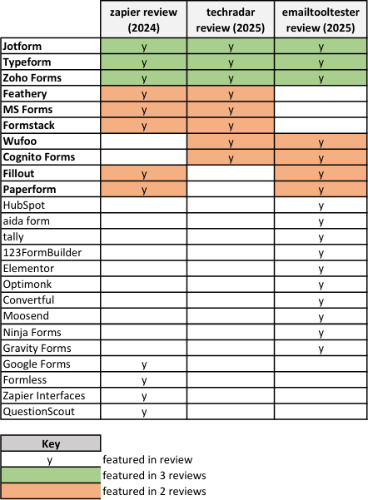

Appendix B - Microsoft Forms requirements
NB – Highlighted requirements have been incorporated into the project app.

User stories (6)
- Generate a form template from an imported PDF or Word document.  - Submit feedback to the system  provider. | - Receive form response notifications.  - Delete responses from forms.  - Forms I’m editing can be saved in draft.  - Respondent’s draft response is saved.

Constraints (5)
- User has an account.  - System stores the user’s form templates. | - System stores form responses.  - Any external user can respond to a form  - Can delete forms.

Epic 1: Configure form settings (8)
- Accept responses or not.  - Start / end date for responses.  - Time taken to respond.  - Allow respondents to save form. | - Shuffle questions.  - Get email notification of each response.  - Custom thank you message.  - Allow respondent to edit responses.

Epic 2: Use templates (9)
- Survey templates (14).  - Quiz templates (4).  - Invitation templates (7).  - Registration templates (11).  - View templates in a template gallery. | - See trending templates.  - Explore templates by category (e.g. “Feedback & evaluation surveys”).  - Select and use template as it is.  - Edit template questions.

Epic 3: See and organise forms I’ve interacted with (6)
- See the forms I’ve created.  - See the forms I’ve completed.  - Select and view favourite forms. | - Filter form templates by keyword.  - Show forms in list or tile view.  - Create a folder / collection of form templates.

Epic 4: Analytics (2)
1-See individual response analytics  (e.g. response time). | 2-See general response analytics (e.g.  number of responses).

Epic 5: See form responses (3)
- Open results in Excel.  - Print summary of results. | 3-Share a link to a summary of the  results.

Epic 6: Build a custom form (7)
- Customise form theme.  - Select from suggested themes.  - See desktop and mobile preview.  - Add background music. | - Choose from 6 different form layouts.  - Choose from 8 different input field types.  - Duplicate existing template.

Epic 7: Distribute a form (6)
- Email distribution.  - QR code distribution.  - Form can be embedded. | - Social media sharing (Facebook, X).  - Sharing link can be generated.  - Share as a presentation slide.

Appendix C - Forms app basic plan features

NB - the image shows the first 19 features of 89 only.
The following product pages were consulted: Jotform [128], Typeform [129], Zoho Forms [130], Feathery [131], MS Forms [132], Formstack [133], WuFoo [134],
Cognito [135], Fillout [136] and Paperform [137].
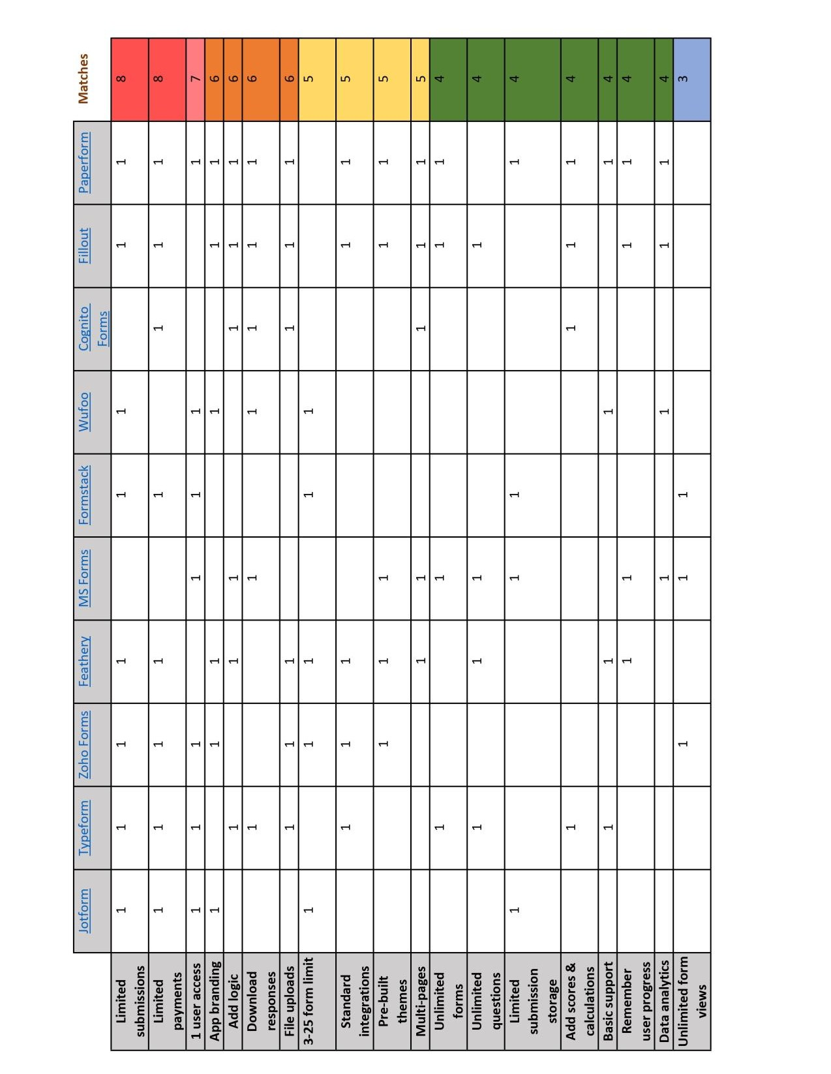

Appendix D - Forms app enterprise plan features

NB - the image shows the first 17 features of 143 only.
The same product pages as cited in Appendix C were consulted.
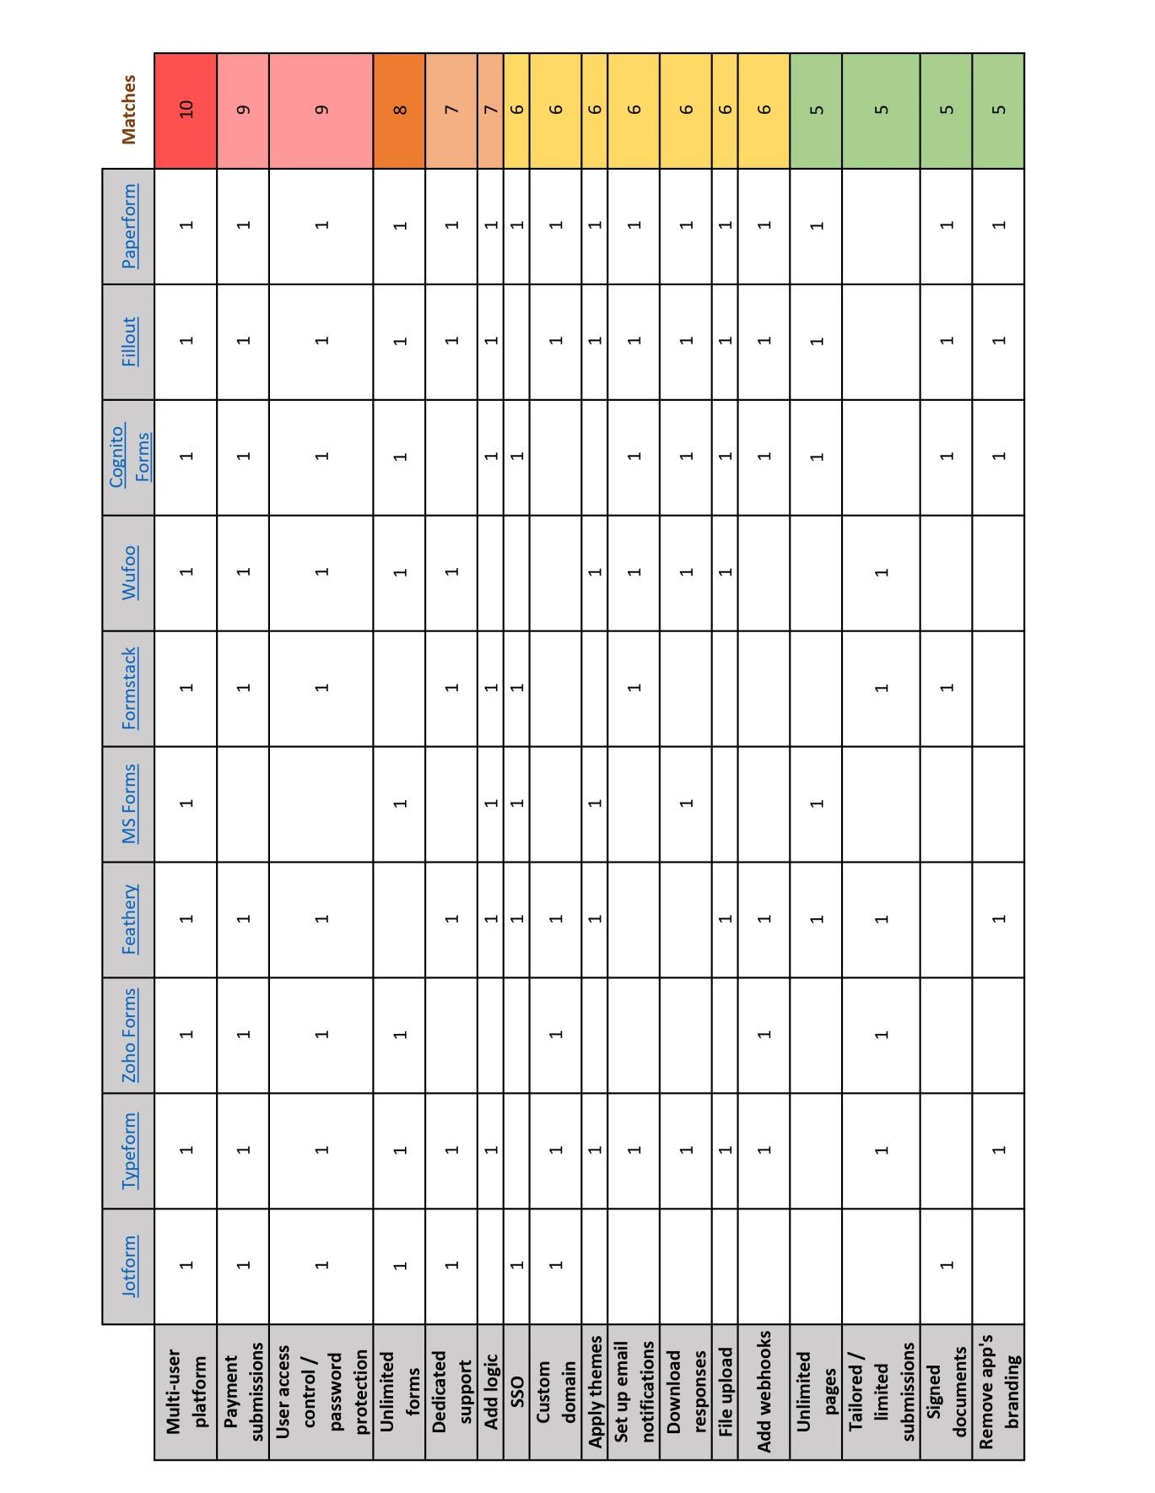

Appendix E - Forms app digital sustainability
analysis
The site landing page was used for the analysis in all cases. NB - Ecograder could not access Cognito Forms – Website Carbon Calculator [20] and an equivalent website (c40.org) were used as a representative substitute.
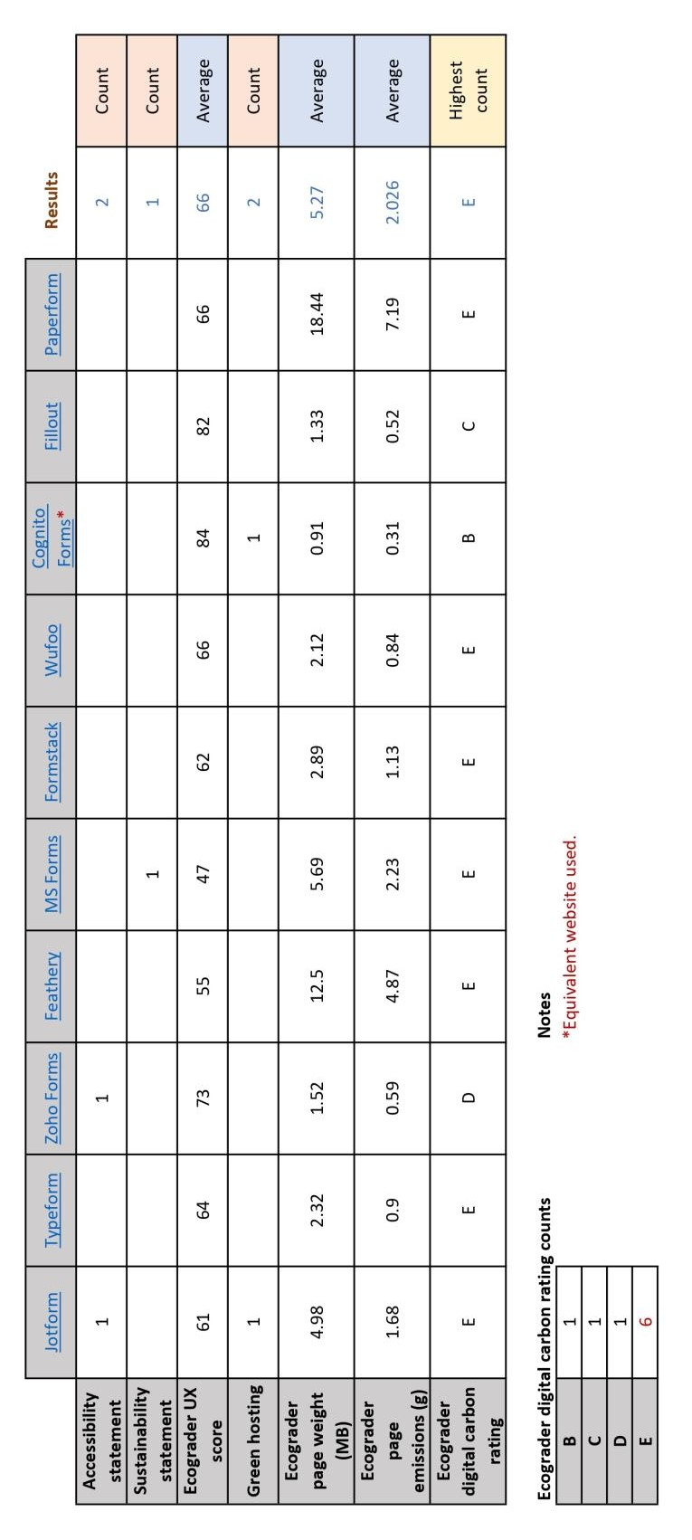

Appendix F - Web Almanac analysis
NB - WSGs are listed by their number in the leftmost column.
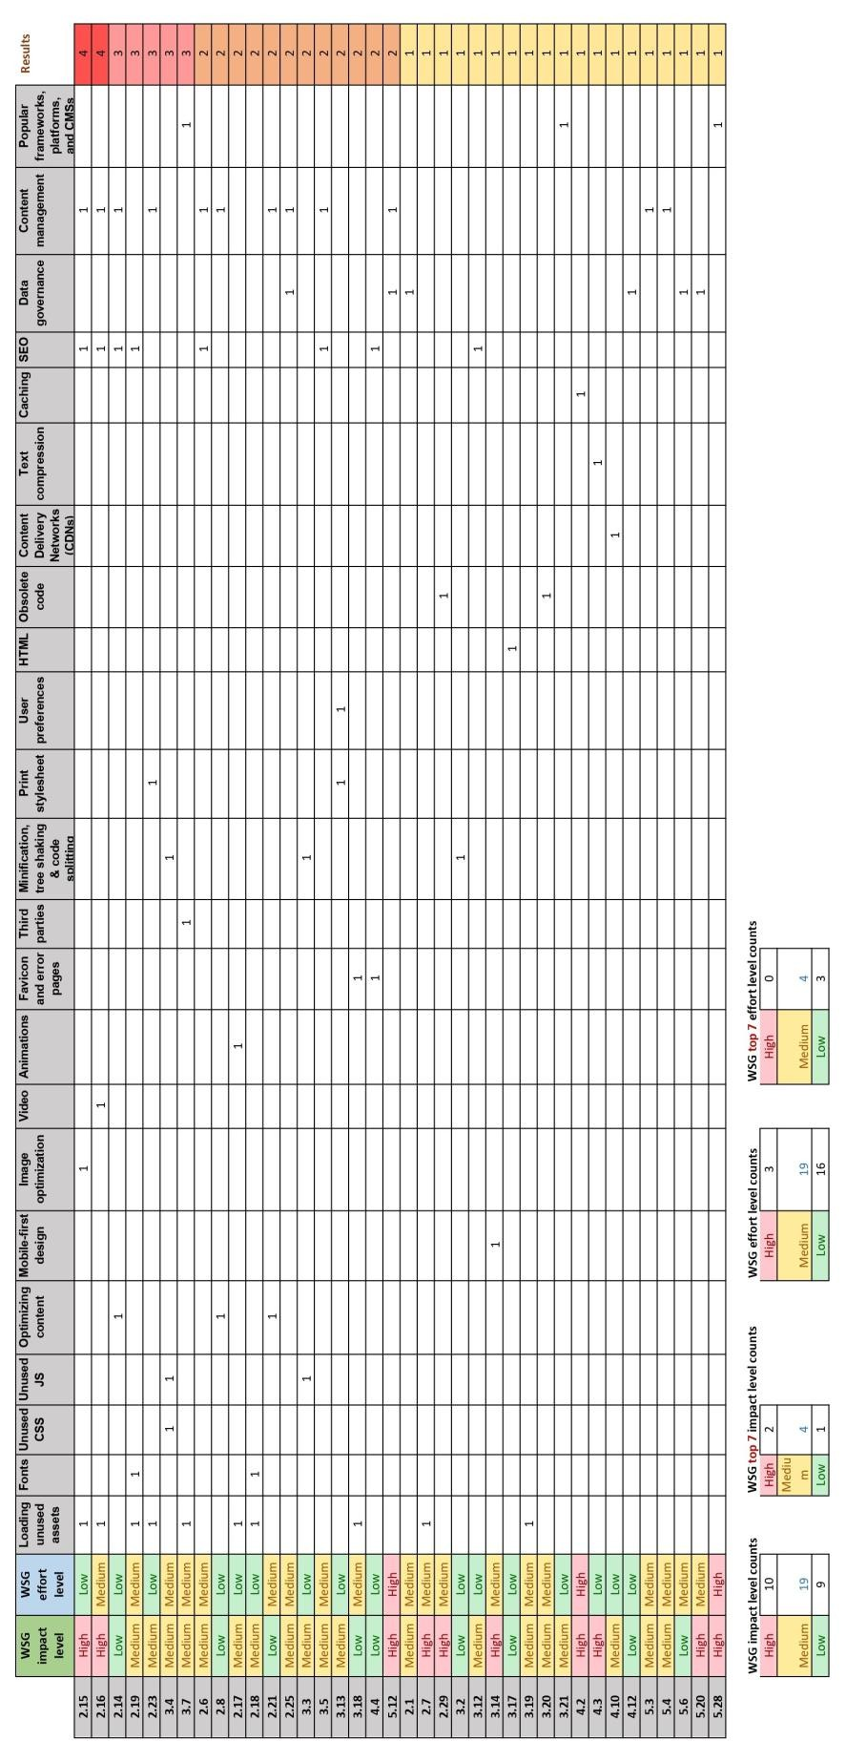

Appendix G - Requirements
KEY Completed, Progressed

MUST HAVE (11)
Functional requirements
- As a user, I want to select a template form, so that I can issue it to respondents.
- As a user, I want to see form templates I’m using, so that I can work on them.
- As a user, I want to issue a form to respondents, so that I can get responses.
- As a user, I want to receive a notification when a form response has been received, so that I don’t have to login to check.
- As a user, I want to see form responses, so that I can review the collected data.
- As a user, I want to read homepage information, so that I know what the app does.
Non-functional requirements
- The app should implement the following WSGs:
  - 2.20, Provide accessible, user-friendly, minimal web forms [94].
  - 3.7, Ensure code follows good semantic practices [96].
  - 3.10, Validate form errors and account for tooling requirements [95].
- The app should contain a sustainability statement explaining its conformance with the implemented WSGs in accordance with WSG conformance rules [39].
- The user has an account.
- Any form recipient should be able to respond without having an account.
- User personal data should be encrypted and a public data collection policy should be provided (in part satisfaction of WSG 2.20).

SHOULD HAVE (4)
Functional requirement
- As a user, I want to see how many responses my form has received, so that I can keep track.
Non-functional requirements
- Password validation and reset is in place.
- The user can delete forms, including all associated data.
- The app should implement the following WSGs:
  - 2.14, Provide clear, inclusive content with purpose [115].
  - 2.15, Optimize images for sustainability [138].
  - 3.4, Remove unnecessary code [53].

COULD HAVE (3)
Functional requirement
- As a user, I want to edit a template form’s questions, so that I can tailor the questions to my needs.
- As a user, I want to delete all responses from a form, so that I can reuse it.
Non-functional requirement
- Basic GDPR compliance is in place (supported by REQ-011).

WOULD LIKE TO HAVE (5)
Functional requirement
- As a user, I want to build a custom form, so that I can tailor all fields to my needs.
- As a user, I want to duplicate my form templates, so that I can build on them to make other forms.
- As a user, I want to export form responses, so that I can have a local copy.
Non-functional requirement
- Two factor authentication is in place (supported by REQ-004).
- WSG 2.23, Reduce the impact of downloadable and physical documents [139].

Appendix H - Sitemap
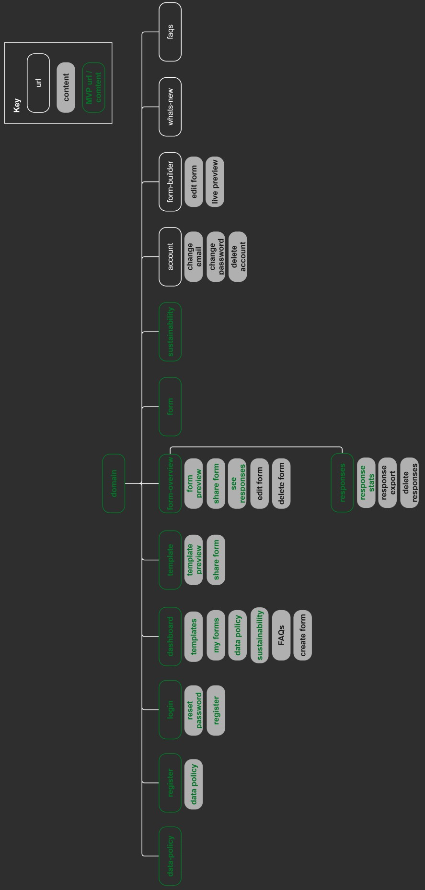

Appendix I - UML diagram
NB - This was generated using the Graph models tool contained in the django-extensions package [140]. The author designed models in the ‘minimeter’ section.
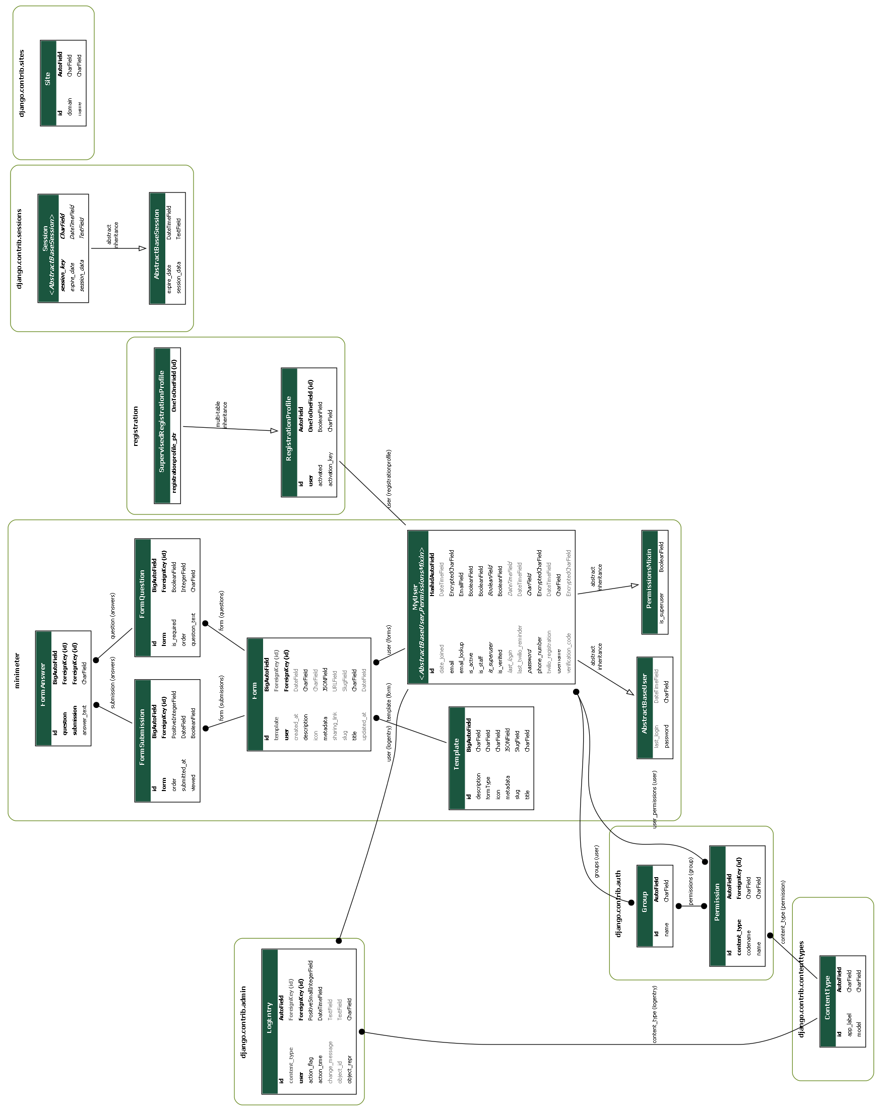

Appendix J - Iteration plan
NB – the iteration backlog can be viewed on minimeter’s Trello board.

Sprint | SP | User stories / workload
Sprint 1  Thurs 10/07 – Tues 15/07 | 6 | Frontend prototype – 1 SP REQ-001 – 4 SP  REQ-003 – 1 SP
Sprint 2  Wed 16/07 – Tues 22/07 | 7 | REQ-002 – 2 SP  REQ-007 WSG 2.20 – 1 SP REQ-009 – 2 SP  REQ-010 – 2 SP
Sprint 3  Wed 23/07 – Tues 29/07 | 7 | REQ-004 – 2 SP REQ-005 – 2 SP  REQ-007 WSG 3.10 – 2 SP  Additional testing – 1 SP
Sprint 4  Wed 30/07 – Wed 06/08 | 8 | REQ-007 WSG 3.7 – 2 SP REQ-008 – 0.5 SP  REQ-011 – 1 SP  Fixing – 4.5 SP
Sprint 5  Thurs 07/08 – Mon 11/08 | 5 | Deployment – 3 SP  Cross-browser testing – 0.33 SP Mobile & tablet testing – 0.33 SP API manual testing – 0.33 SP UAT guidelines – 1 SP
Sprint 6  Tues 12/08 – Fri 15/08 | 4 | Urgent GitLab issues & mobile responsivity – 3.5 SP  Improved web page copy – 0.5 SP

Total story points (SP):
37 (5 weeks, 2 days)

Velocity:
= number of developers x number of SPs per week x number of weeks in iteration
= 1 x 7 x 1 = 7 SP

Estimated project length:
= total SP / velocity
= 37 / 7
= 6 sprints

Appendix K - Initial frontend
The following prototype was adapted from the W3.CSS library’s Analytics Template by W3 Schools. A comparison can be made with the final version (c.f. Appendix L).
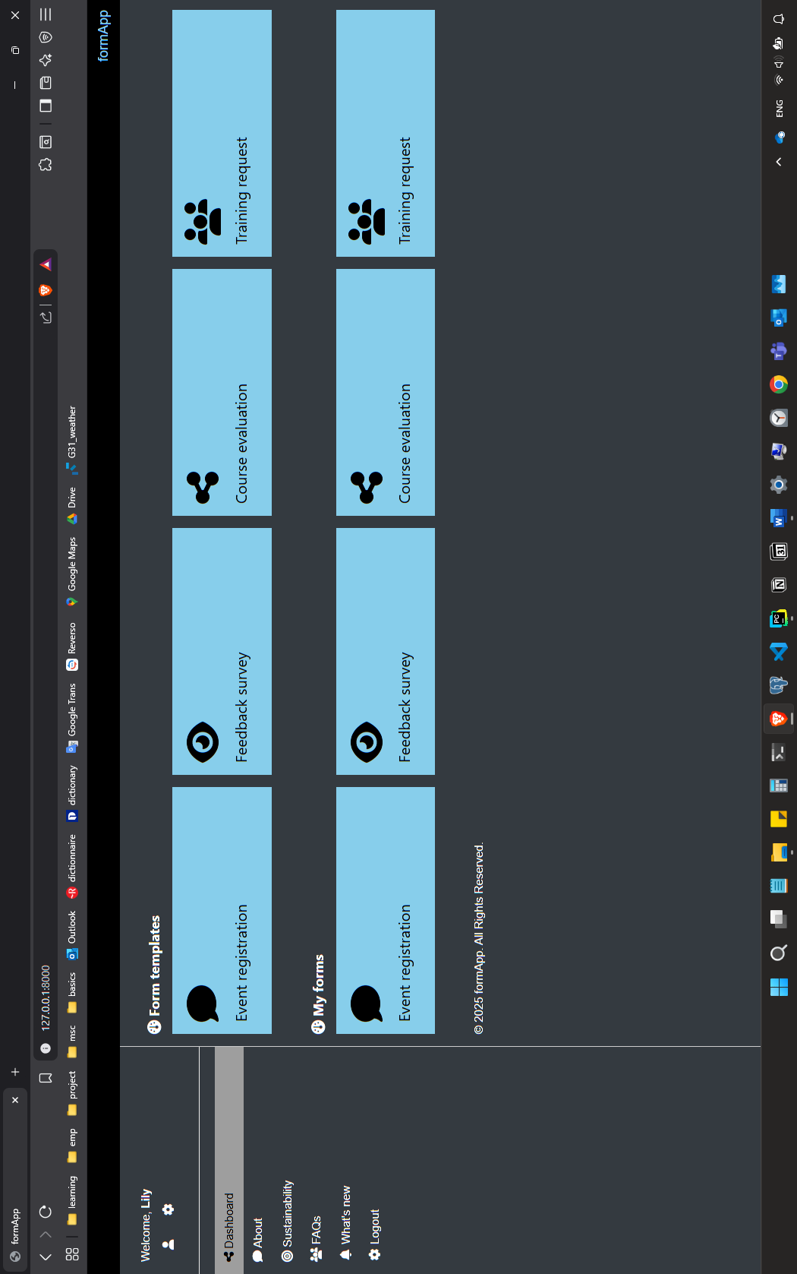

Appendix L - Final frontend
The deployed frontend. A comparison can be made with the original frontend prototype in Appendix K.
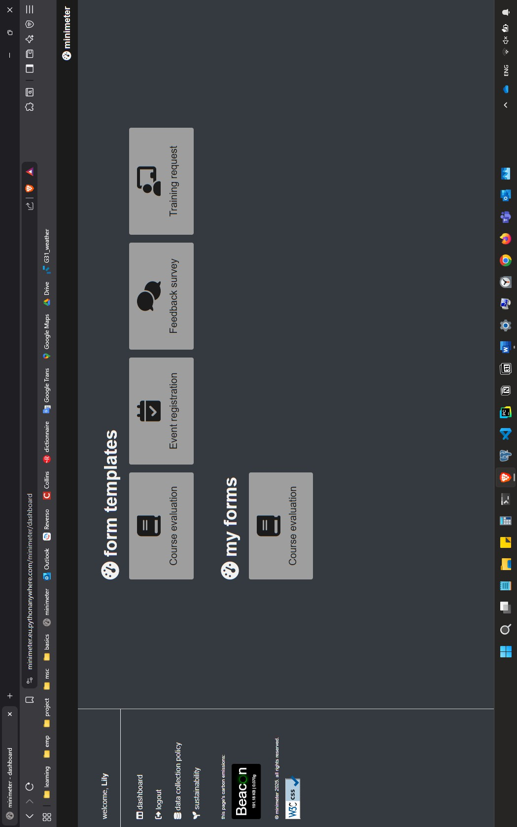

Appendix M - Validation tests
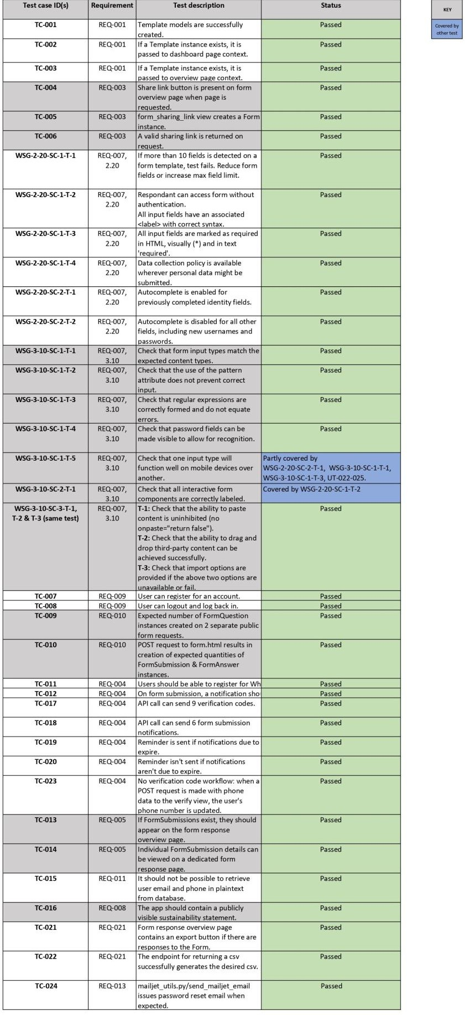

Appendix N - Unit tests
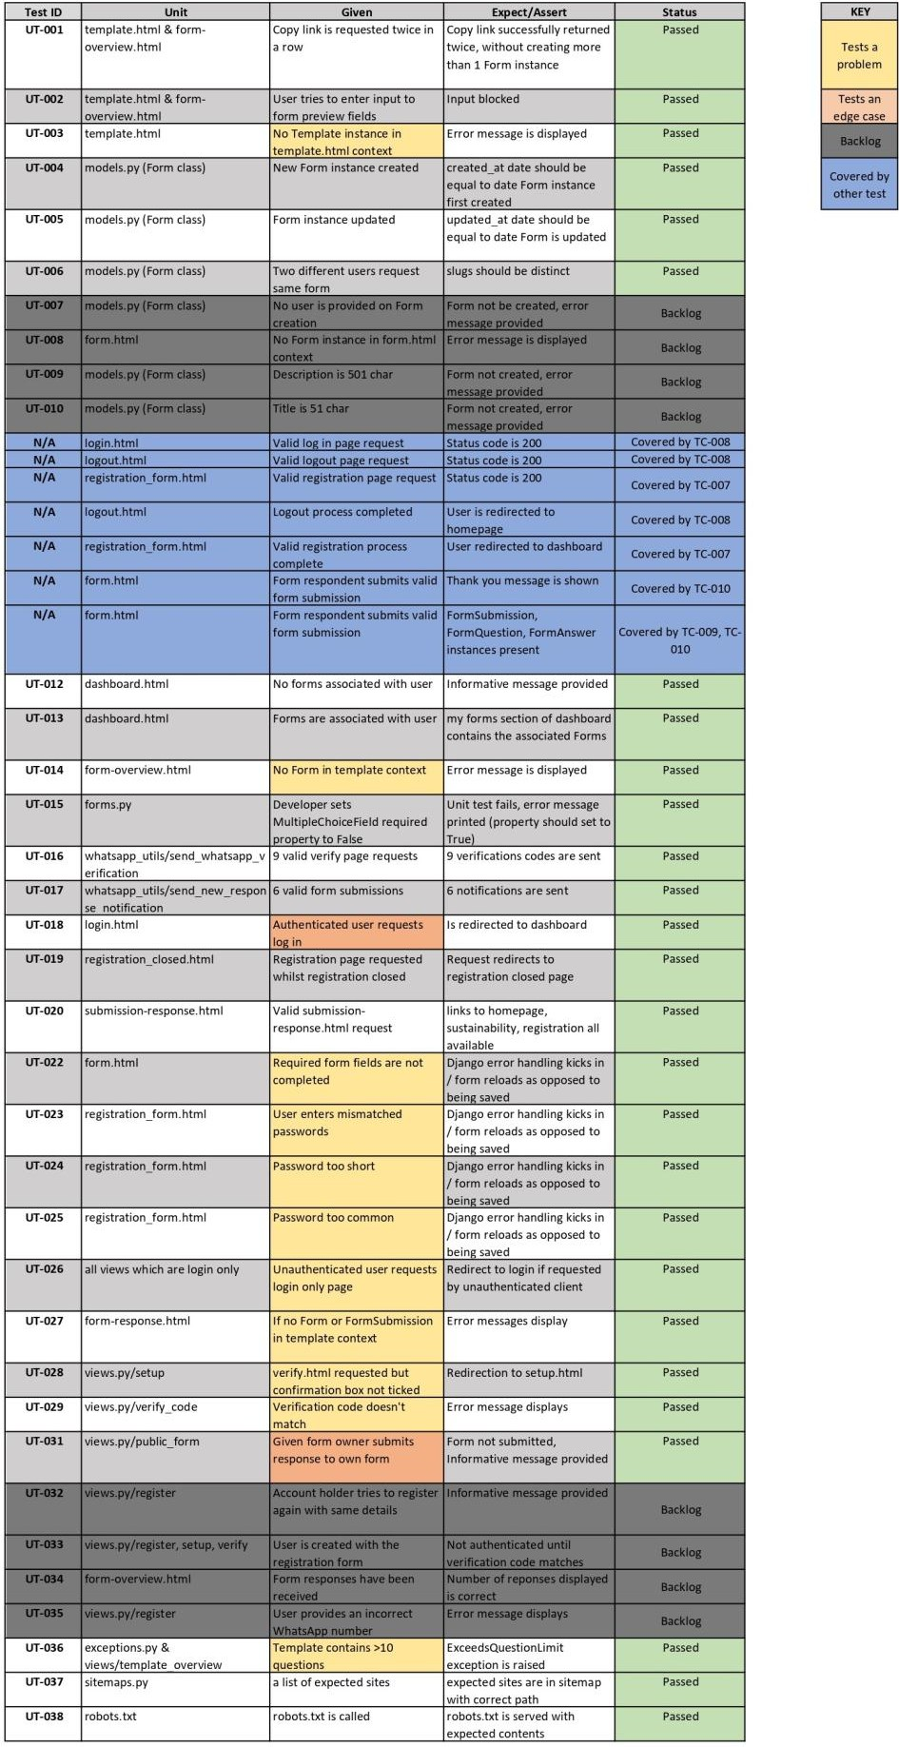

Appendix O - Automated test coverage
NB – all modules with less than 50% coverage are either tested via isolated tests scripts or do not require automated testing.
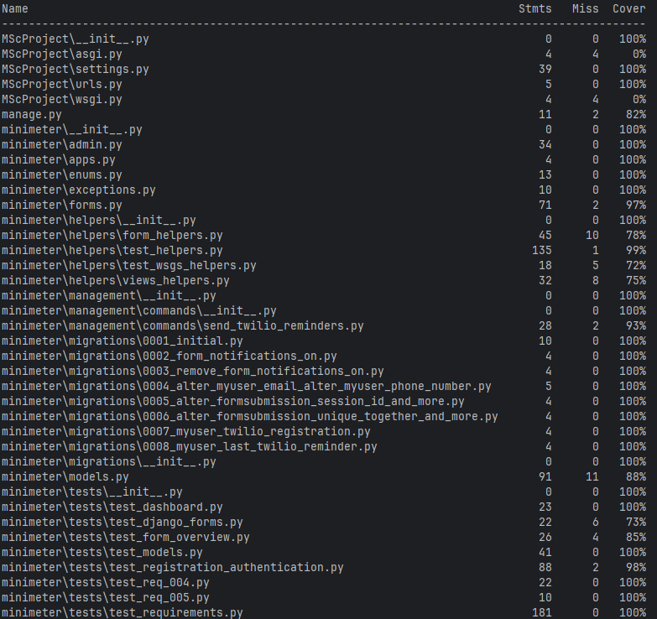
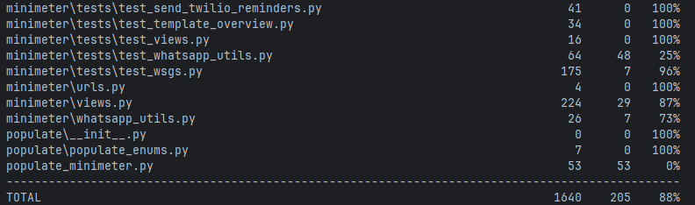

Appendix P - Traceability matrix
NB – Automated testing was not appropriate for REQ-007, WSG 3.7 – the minimeter WSG conformance statement (c.f. Appendix R) contains a full list of the validation performed.
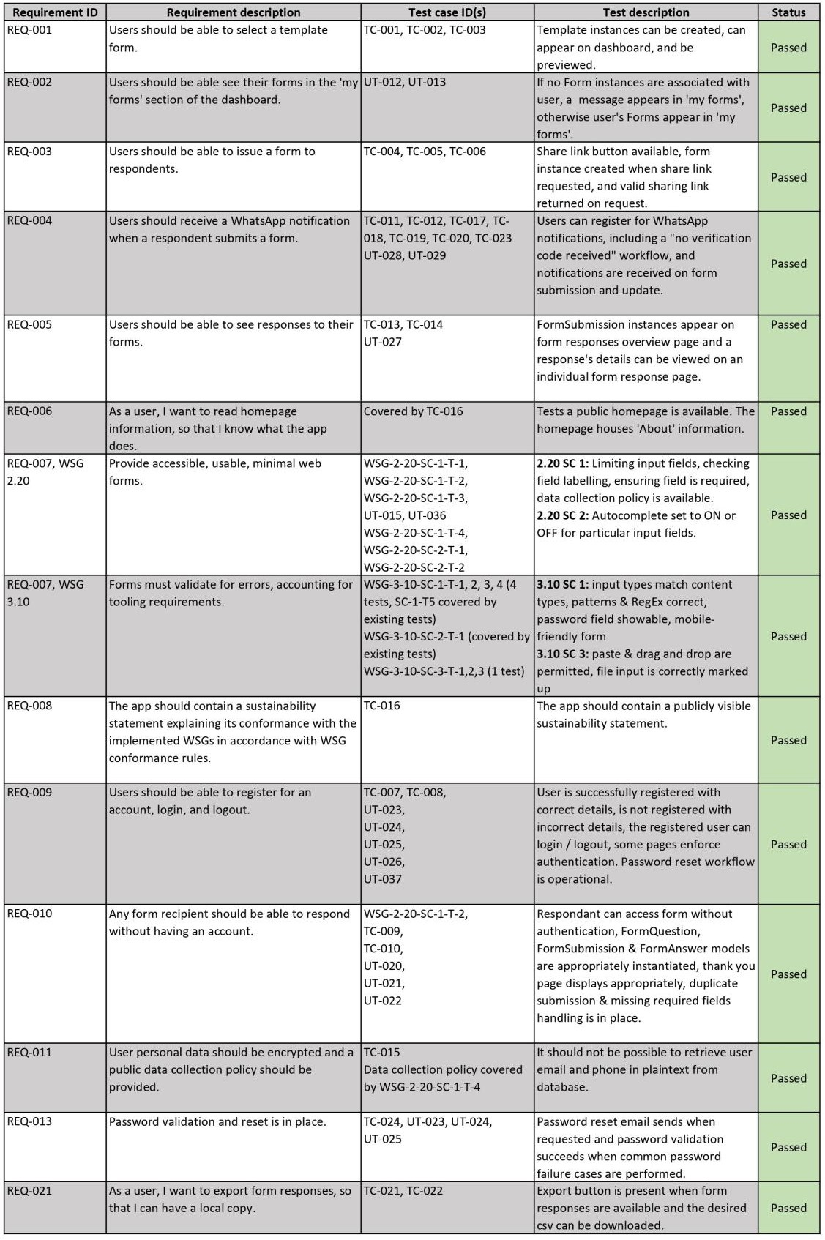

Appendix Q - minimeter sustainability statement
NB – On minimeter, this statement sits above the conformance statement included in Appendix R. They form one page that is visible at this URL.
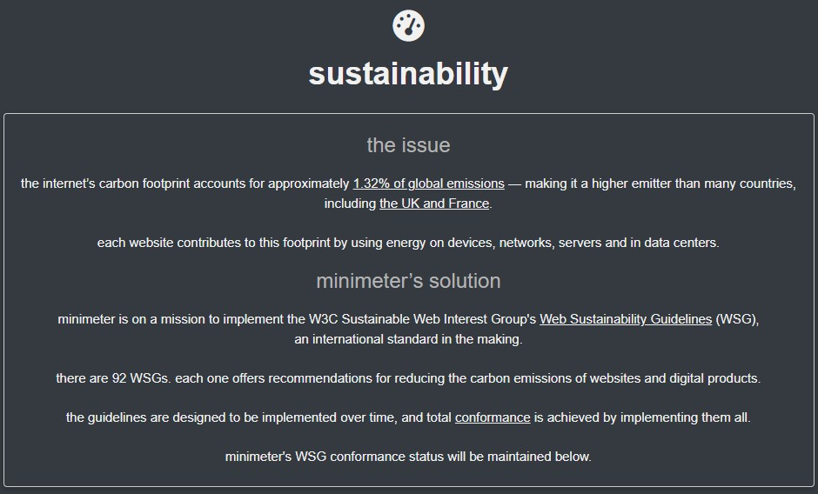

Appendix R - minimeter WSG conformance
statement
NB – the minimeter WSG conformance statement can also be viewed online.
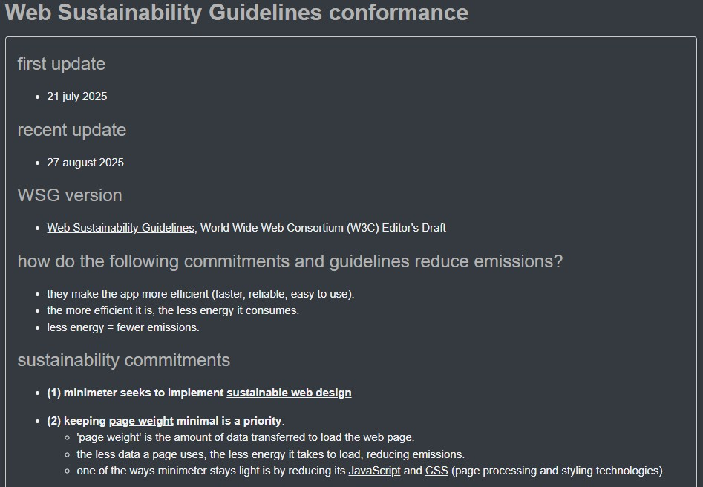
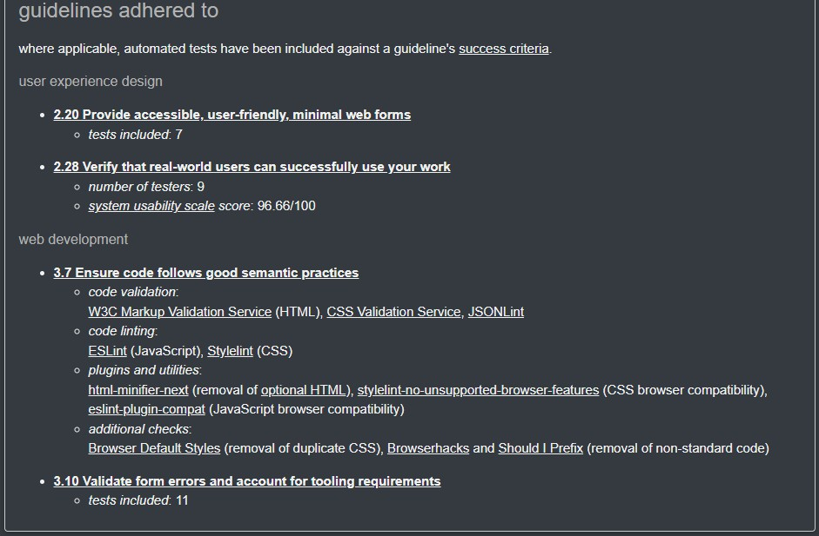

Appendix S - Beacon carbon analysis result
Generated on 29/08/25 using the Beacon [24] for the minimeter homepage.
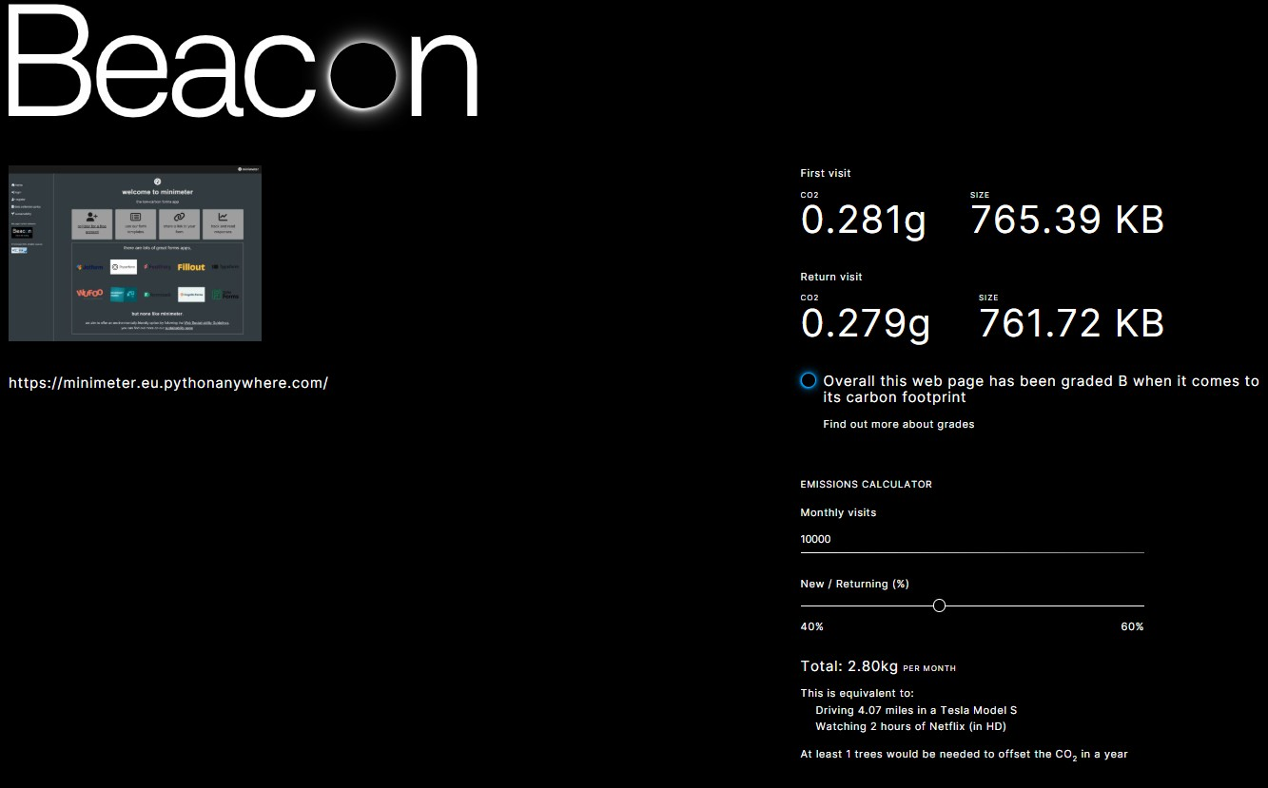

Appendix T - Research questionnaire
NB – this questionnaire was for testers with the role of account holder. An almost identical questionnaire was used for form respondents - the same questions were asked in both cases.
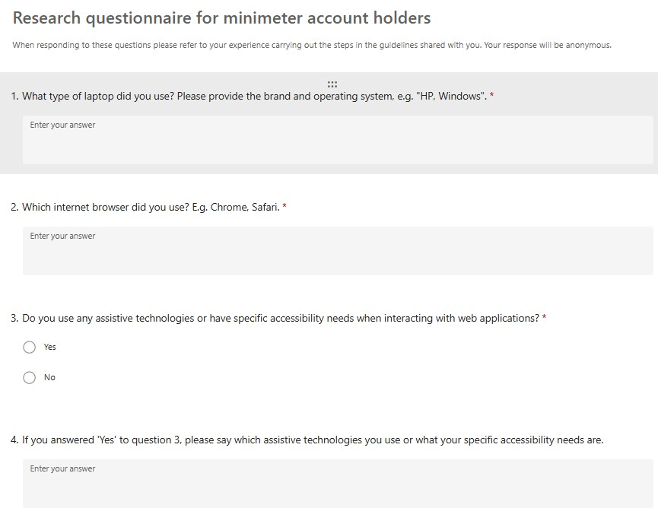
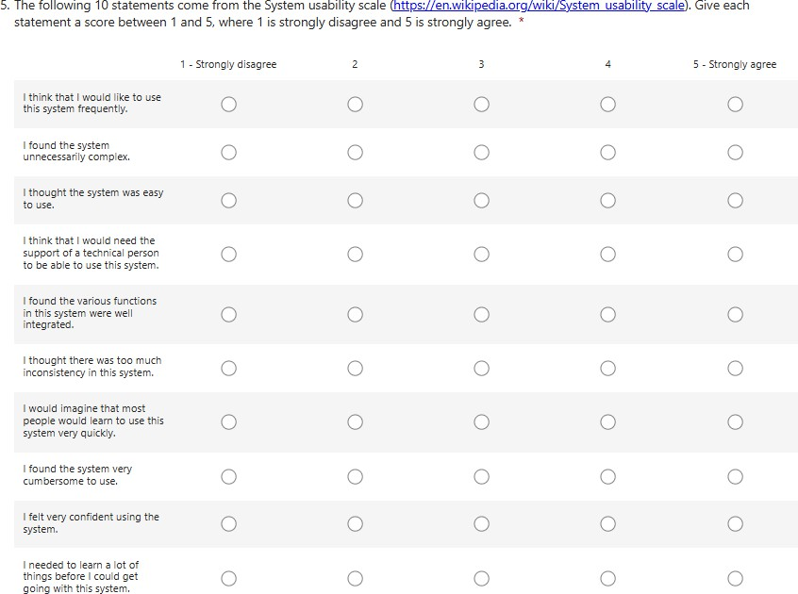

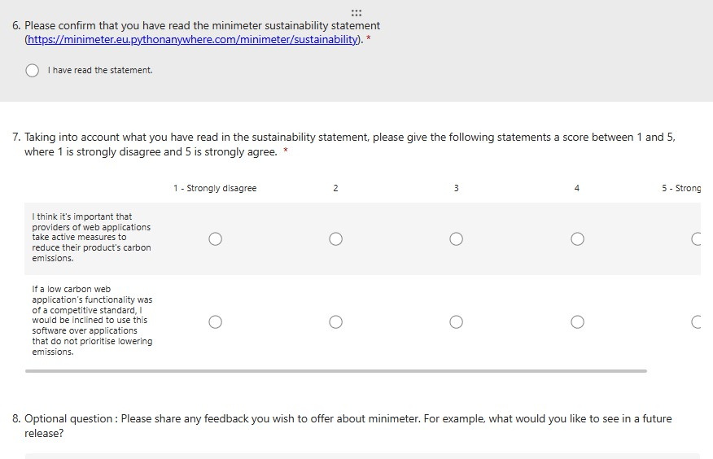

Appendix U - Test guide example
NB – this guide was used for testers with the role of account holder. A similar guide with a reduced number of steps was provided to testers with the role of form respondent.
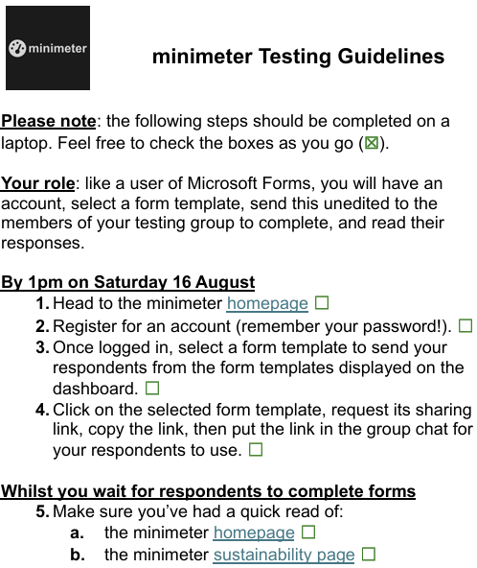
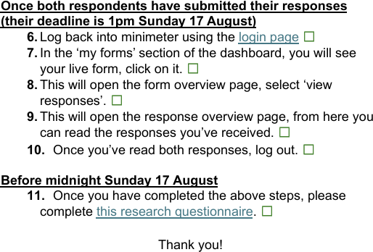

Appendix V - Summary of future work
NB – the summary is listed in an approximate priority order, with item 1 as the first piece of work that should be undertaken.

Second release
Time estimation: 42.5 SP
- If AI is to remain a part of development practice, establish an AI strategy conformant with WSG 5.22 [126].
- Low priority additional work recorded during the creation of the first release (i.e. 9 “try to make time” GitLab issues, 7 “if time” GitLab issues).
- Remaining product requirements (9 total – 2 should haves, 3 could haves, 4 would like to haves).
4-7 GitLab issues with “2nd release” label:
- Integration of a pre-commit hook for running tests [118] [119].
- Integration of Trusted Types API (c.f. System architecture diagram in section 3.1.1) [86].
- Conformity with accessibility Web Sustainability Guidelines.
- Improvement of system logging.
- Purging and minifying CSS.
- Integration of Selenium testing [122].
- Increased problem and edge case unit testing ahead of second UAT and release.
5-Review based on user feedback (3 “user feedback” GitLab issues).

Subsequent releases
6-3 GitLab issues with “future work” label:
- Transition to Posteo email service [93].
- Switch to alwaysdata green hosting [90].
- Transition to Vanilla CSS [87].
- Include additional functionality based on MS Forms requirements (c.f. Appendix B) and wider existing product review (c.f. Appendices C and D).
- Continuous WSG conformance guided by the 33 remaining priority WSGs highlighted by the Web Almanac analysis (c.f. section 2.3.3 and Appendix F).

Appendix W - Link to repository

Link to repository
Repository

Other key links
Project tracker Ethics checklist

