Screen 1

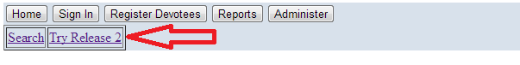

Screen 2

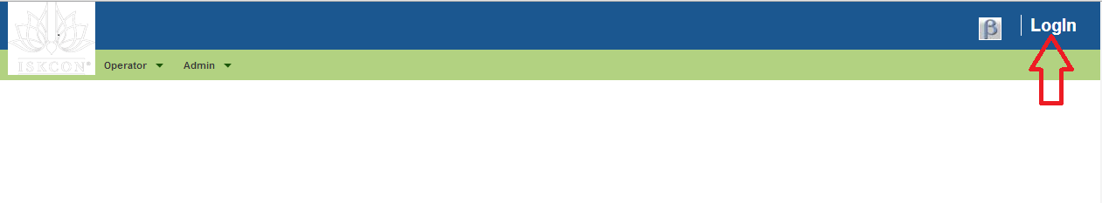

Screen 3

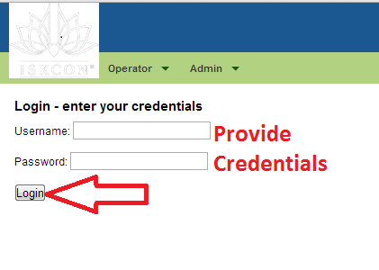

Screen 4

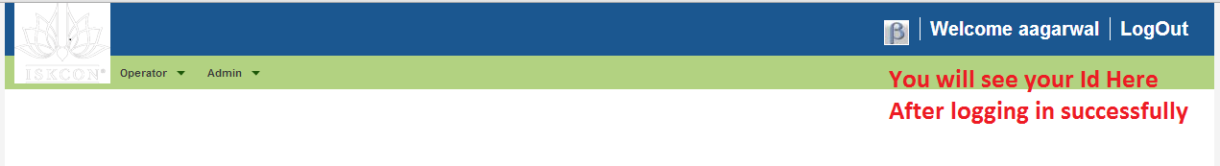

Analyzing Attendance & Devotees

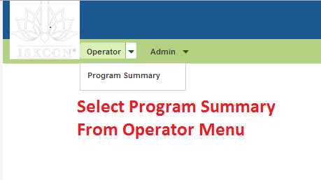

Resulting Screen Will let you do the following

* Download devotees associated with a centre & program
* View devotes in specific categories registered with a centre & Program
* View attendance for a centre & program Combination
* View devotees that attended a specific program
* View the devotees who did not attend the program after a certain date

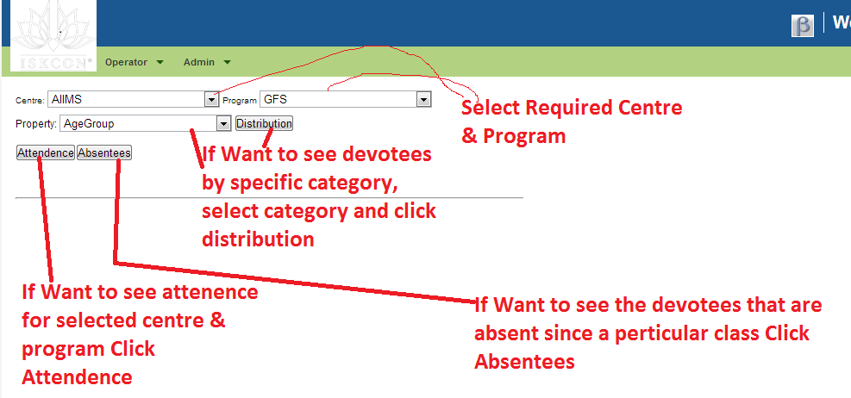

Sample Screen after clicking distribution button

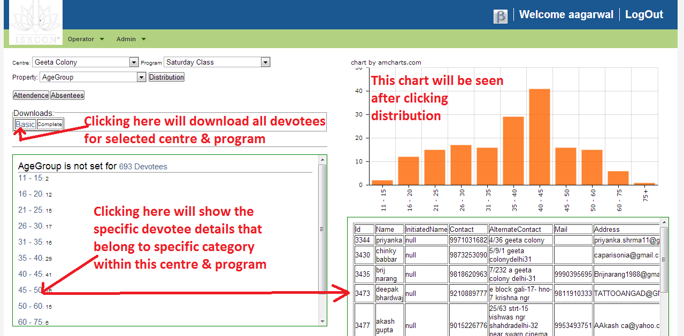

Sample Screen After clicking Attendence Button

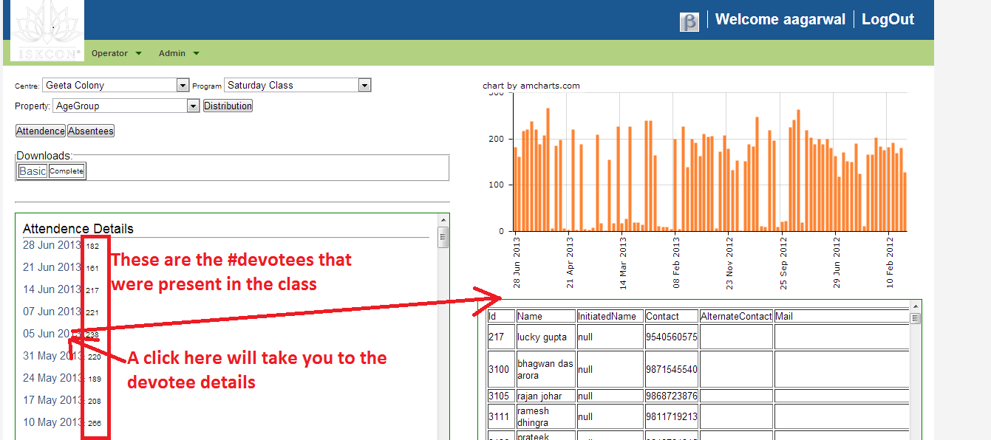

Sample Screen after clicking Absentees button

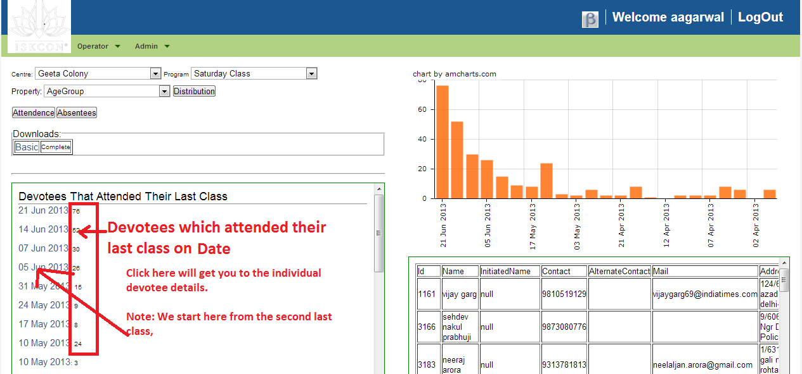

# Uploading devotee details

An excel workbook is made available on request, which should be populated correctly and returned to the system administrator / incharge of devotee registration

Upload feature is available to administrators only. If you need the permissions please contact the incharge.

To upload properly updated devotee details take following steps

Select correct menu as displayed below

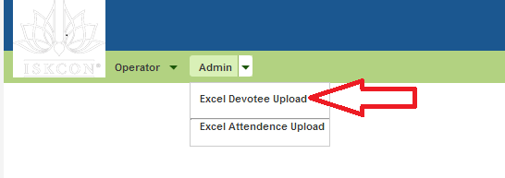

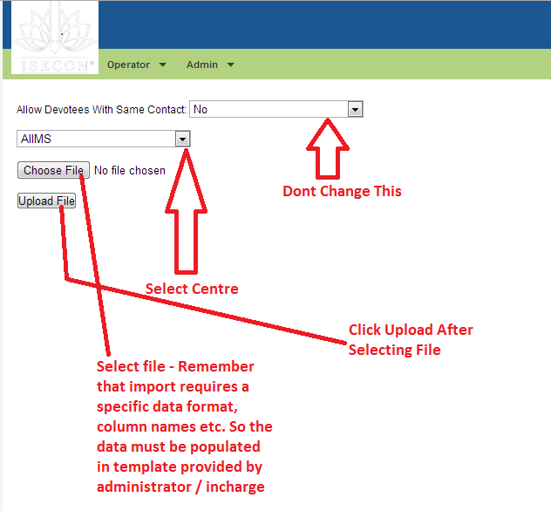

After the upload completes you will see following

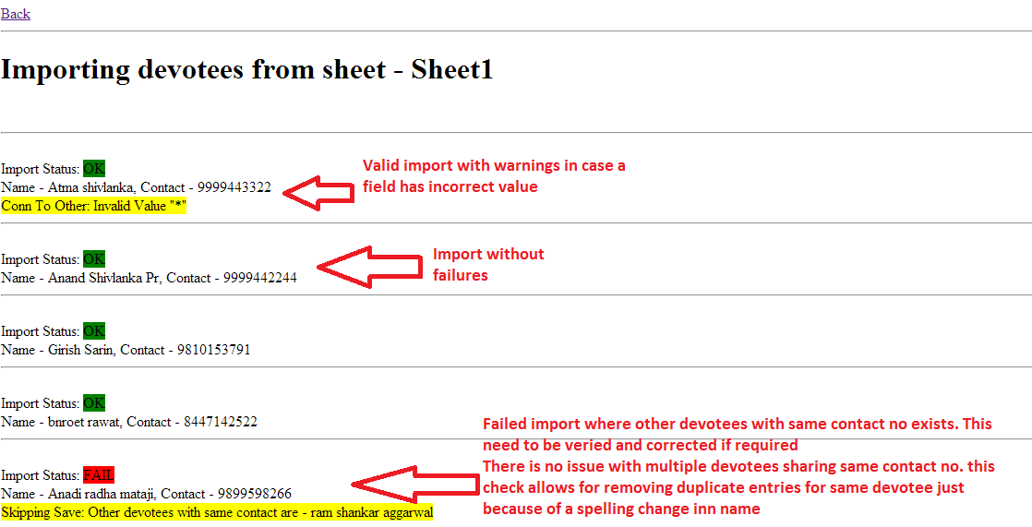

Than you must analyze the report above and fix any issues with data.

Import again – This time after setting “Allow Devotees With Same Contact: “ to “Yes”

# Uploading Attendance

Attendance can be uploaded in the same way as devotees. Just select the menu option “Admin -> Excel Attendance Upload”

Template for attendance upload is specified below



Best is to

* download the devotees registered with the centre & program
* Add dates in the first row for which attendance need to be booked
* Mark P in the cell corresponding to devotee and date
* Remove all columns except Name, Contact and attendance dates
* Import using the excel attendance upload feature

# Managing calling list from the help of this system

We must call the devotees who were present at least once in last n sessions. No other devotee must be called