Installation screenshots:

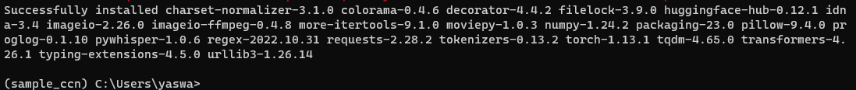

Installed packages in anaconda Navigator:

Program screenshots

