**Group – 9 (Iteration – 2)**

Below are the pictures that were displayed after executing the model.

During the initial phase, you will be presented with two choices in the output, and you must pick one.

If you opt for the first choice, you'll be required to provide a voice input via your device's microphone, and the model will convert the audio into text.

This is where you can see how the model provided us with the output by processing the audio, and furthermore, it has the ability to recognize the language being used.

The audio file that has been generated subsequent to recording the audio using the microphone.

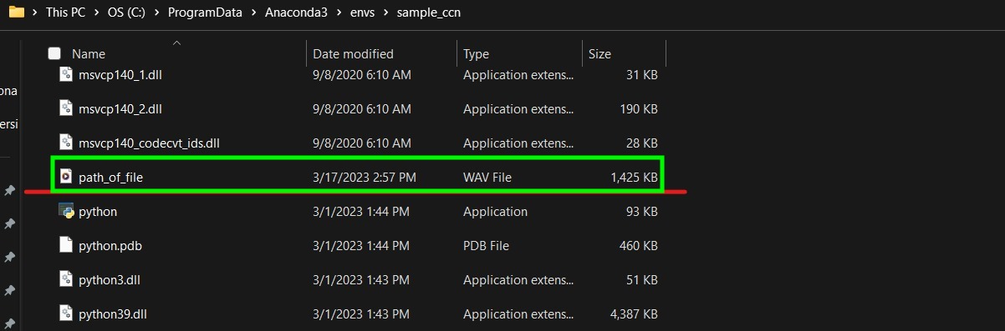

In case you go for the second option, you will have to provide an audio file as input, from which the model will extract the audio and convert it into the corresponding text.

